  Component One:  What are the key skills required when working in the housekeeping team? 750 words (+/- 10%)  Contribution to Overall Module Assessment: 25% | Student No: 2130342
 | Module | BMIH4006
 | Module Code:
 | Lecturer: | Lisa-Marie Bassler
A crucial division in the hotel sector, housekeeping is in charge of keeping the public areas, back of the house, and guest rooms clean and tidy. To provide exceptional service and live up to visitors' expectations, members of the housekeeping staff need a certain set of abilities and expertise. This learning journal serves as a summary of my knowledge of the primary competencies needed to be a member of the housekeeping team as well as my own personal reflections.

In the housekeeping sector, the ability to pay close attention to detail is essential since it ensures that visitors have a comfortable and enjoyable stay. "Attention to detail is the key to obtaining high-quality service in the hotel industry (Siguaw et al. 2012). Each guest room and public area needs to be thoroughly inspected by housekeepers to make sure that everything is immaculate, including the linens, carpets, and furnishings.

For instance, one of the biggest hotel chains in the world, Marriott International, emphasizes the value of meticulousness in its housekeeping standards. Housekeepers must "thoroughly inspect each room before it is released for occupancy and ensure that all surfaces are free from dust, debris, and other stains," according to Marriott's Housekeeping Standards Handbook (2018). This emphasizes how crucial it is to practice diligent housekeeping in order to uphold high levels of cleanliness and visitor happiness.

In addition to guest rooms, public areas like lobbies, corridors, and elevators also need to be well-maintained to offer a first-rate visitor experience. Upon entering the lobby, customers "create their initial impression of the hotel, and it is crucial to maintain high standards of cleanliness and presentation to match their expectations (Fernandez et al. 2016). Public areas must be periodically inspected and cleaned by housekeeping workers to ensure they are pristine and presentable.

The housekeeping department relies heavily on time management since it ensures that activities are carried out effectively and on schedule. Time management is a crucial ability that housekeeping staff members need to have in order to properly manage their workload and uphold the strict standards of cleanliness and guest pleasure (Tewari and Rana, 2018). Planning and prioritizing tasks is necessary for effective time management to make sure that vital chores are finished before less important ones.

For instance, the housekeeping team at Hilton Worldwide, a well-known global hotel corporation, is using a productive time management system. Housekeepers must "plan their work schedule efficiently and prioritize jobs according to their relevance and urgency," per Hilton's Cleaning and Maintenance Handbook (2019). This emphasizes the significance of work prioritization and planning to guarantee that all crucial chores are finished on time, improving guest happiness and upholding high levels of cleanliness.

Effective time management in housekeeping includes not just planning and prioritizing activities, but also reducing downtime and avoiding distractions. In order to ensure that jobs are completed effectively and on schedule, housekeeping workers must minimize needless breaks and distractions during working hours, according to Kumar and Kumar (2016). This emphasizes how crucial it is to avoid time-wasting hobbies and concentrate on crucial tasks to make sure that job is finished on time.

I've learned the value of the housekeeping division in the hospitality sector as a student studying hospitality. I've discovered that providing outstanding service to visitors calls for not only technical expertise but also people abilities. I now recognize the value of flexibility in addressing unforeseen circumstances and the meticulous attention to detail necessary to guarantee a guest's delight.

I will put my theoretical knowledge to use as I get ready for the workforce by realizing the value of each crucial skill needed to be a member of the housekeeping team. I'll try to hone these abilities even further by observing and collaborating with seasoned housekeeping staff members. To guarantee that I can finish duties effectively and to a high degree, I will also put my understanding of time management and prioritization to use (Hayes, 2008).

The success of the hospitality sector depends on the housekeeping division, which is in charge of making sure that the public areas and guest rooms are kept clean and maintained. A hotel runs the danger of losing customers and tarnishing its brand if it doesn't maintain high standards of cleanliness. Because of this, it's critical that housekeepers have the abilities needed to deliver excellent service and fulfill customers' expectations (Kusluvan et.al, 2010).

In conclusion, it needs flexibility, adaptability, time management, attention to detail, and communication skills to operate in the cleaning team. These abilities are essential for providing top-notch service and exceeding guests' expectations. I will use my theoretical understanding to further develop these abilities as a student studying hospitality so that I may contribute productively to the housekeeping staff. It is impossible to overestimate the significance of the housekeeping division in the hotel sector, and it is essential that housekeepers have the expertise required to provide first-rate service.

Word Count | 820

References
- Fernandez, J. R., Cater, J. J., & Krotz, J. (2016). Housekeeping: Operations, Design and Management. John Wiley & Sons.
- Hayes, D. K., & Ninemeier, J. D. (2008). Hotel operations management. Pearson Prentice Hall.
- Hilton Worldwide. (2019). Housekeeping and Maintenance Manual.
- Kumar, V., & Kumar, P. (2016). Managing Housekeeping Operations. Tata McGraw-Hill Education.
- Kusluvan, S., Kusluvan, Z., Ilhan, I., & Buyruk, L. (2010). The human dimension: a review of human resources management issues in the tourism and hospitality industry. Cornell Hospitality Quarterly, 51(2), 171-214.
- Marriott International. (2018). Housekeeping Standards Manual.
- Siguaw, J. A., Enz, C. A., & Namasivayam, K. (2012). Service quality in hospitality organizations. Routledge.
- Tewari, A., & Rana, M. (2018). Housekeeping Management. Educreation Publishing.

Component Two:
Contribution to Overall Module Assessment: 25%
In this scenario – You have just been promoted to team leader for a floor within the hotel. A guest complains that on their arrival, their room had not been properly cleaned. Create an action plan and answer the following questions.

Problem | Why did it happen? | What are you going to do? | How will you prevent this from happening in the future? | What measures would you introduce to improve team effectiveness?
A guest complains that on their arrival, their room had not been properly cleaned | Potential causes include a lack of attention to detail or a breakdown in communication among the housekeeping team members. | I will act right away as the team leader to handle the guest's issues and guarantee that the room is cleaned to their satisfaction | I will put the following actions into action to stop this from happening again:  Give the housekeeping staff further instruction on the value of paying attention to detail and the guest experience. | I would implement the subsequent methods to increase team effectiveness:  Opportunities for ongoing technical and interpersonal skill development for the team.
 |  | In addition, I'll look into the problem's underlying causes and take precautions to stop it from happening again. | Before the space is deemed clean, assign team members to double-check each other's work to make sure everything is pristine. | Defining clear expectations and objectives for the team and giving frequent performance feedback.
 |  |  | Promote open dialogue and feedback among team members to spot problems early and resolve them before they become complaints. | Encouraging team members to work together and communicate openly in order to share best practices and handle problems.

References
- J. Gallagher and M. A. Schreiner, "(2004): Designing effective action plans," Journal of Extension 42, no. 6 1-4.
- W. Tuckman, (1965). Developmental sequence in small groups," Psychological Bulletin 63, no. 6: 384-399.
- J. S. Armstrong, "(1982): The value of formal planning for strategic decisions: Review of empirical research," Strategic Management Journal 3, no. 3 197-211.
- R. J. Wirthlin and K. E. Wirthlin, "(2006): Action planning: A tool for building strategic agility," Journal of Business Strategy 27, no. 2 37-44.

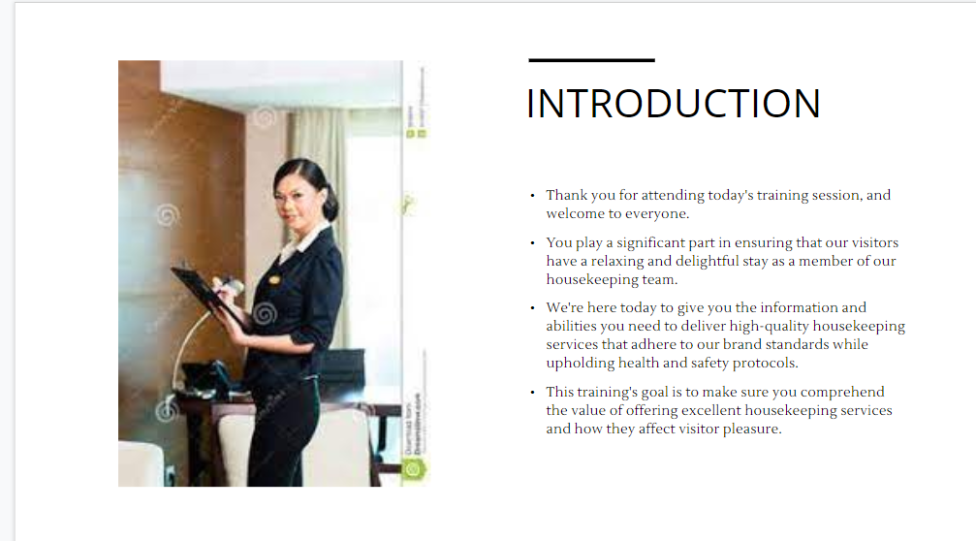

Training Notes: We appreciate your presence at today's training session and would like to extend a warm welcome to all of you.
As a member of our housekeeping team, you play a significant role in ensuring that our guests have a relaxing and enjoyable stay by contributing to the overall quality of the accommodations that we provide.
We are here today to provide you with the knowledge and skills you require in order to provide housekeeping services of a high quality that adhere to the standards set forth by our brand while also maintaining the protocols for health and safety.
The purpose of this training is to ensure that you are aware of the significance of providing superior housekeeping services and how such services contribute to the overall satisfaction of guests.

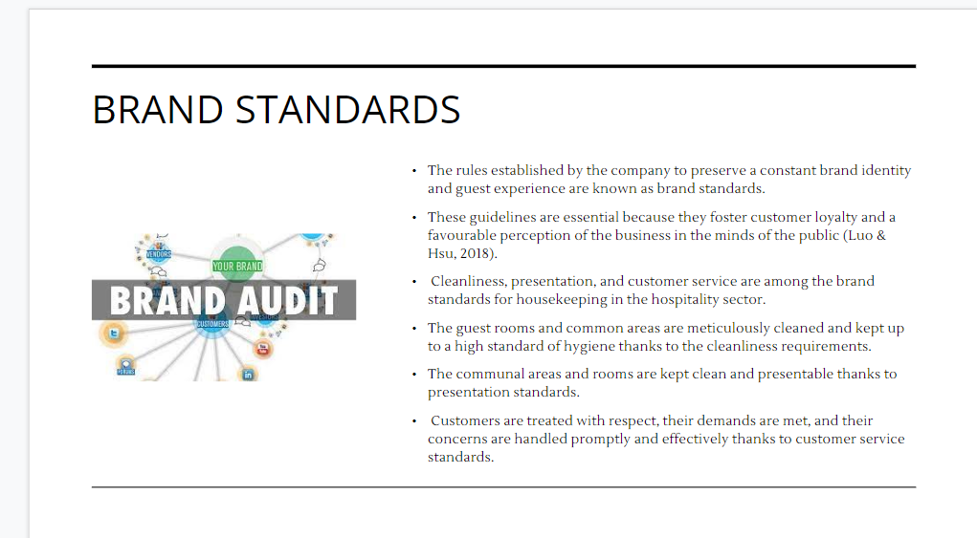

Training Notes: Brand standards are the guidelines that a company establishes in order to maintain a consistent brand identity and level of service for its customers.
These guidelines are essential due to the fact that they encourage customer loyalty and a positive perception of the company in the minds of the general public (Luo & Hsu, 2018).
Housekeeping in the hospitality industry is held to a number of brand standards, including cleanliness, presentation, and service to customers.
Because of the stringent requirements for cleanliness, both the guest rooms and the common areas of the hotel are meticulously cleaned and maintained to a high level of hygiene.
Because of the presentation standards, the common areas and individual rooms are always kept in a clean and presentable state.
Because of the customer service standards in place, customers are accorded respect, their requirements are satisfied, and their concerns are addressed in a prompt and efficient manner.

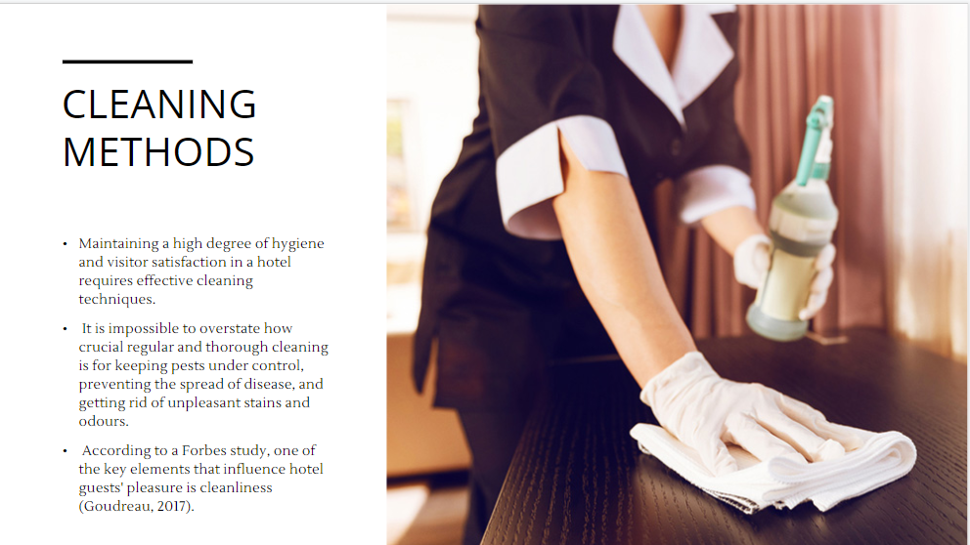

Training Notes: In order to keep a high level of hygiene and the satisfaction of hotel guests at a consistent level, an effective cleaning routine is required. It is impossible to overstate how important routine and comprehensive cleaning is for reducing the risk of disease transmission, removing unsightly stains and odors, and controlling the population of unwanted insects and other pests. A study by Forbes found that cleanliness is one of the most important factors that contribute to the overall satisfaction of hotel guests (Goudreau, 2017).
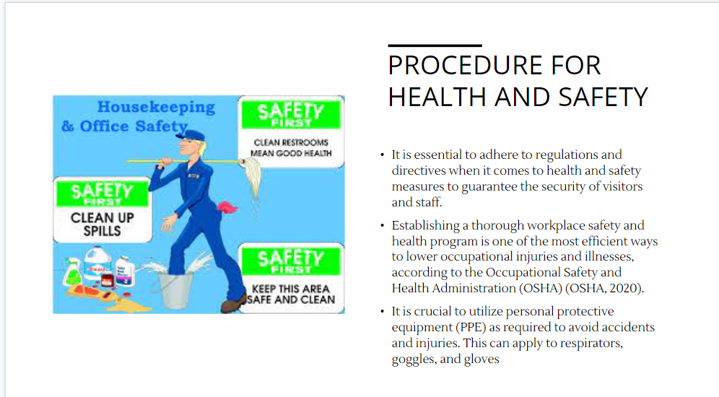

Training Notes: When it comes to the precautions that should be taken for people's health and safety, it is absolutely necessary to comply with all regulations and directives that are in place. This will ensure that both employees and visitors will be safe.
According to the Occupational Safety and Health Administration (OSHA), one of the most effective ways to reduce the number of occupational injuries and illnesses is to develop and implement a comprehensive safety and health program in the workplace (OSHA, 2020).
It is essential to make use of personal protective equipment (PPE) in the manner prescribed in order to reduce the risk of accidents and injuries. This is something that can apply to gloves, goggles, and respirators.

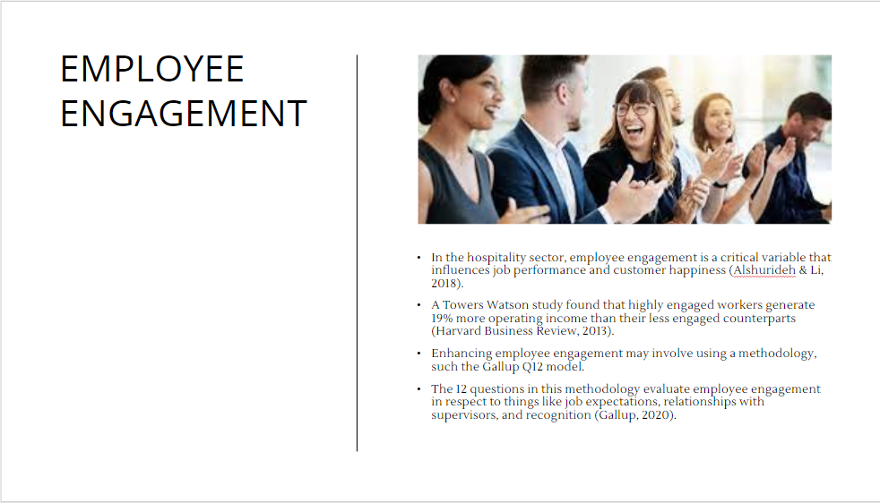

Training Notes: When it comes to the hospitality industry, employee engagement is a crucial factor that affects both job performance and the satisfaction of customers (Alshurideh & Li, 2018).
According to research conducted by Towers Watson, highly engaged workers are responsible for producing 19% more operating income than their counterparts who are less engaged (Harvard Business Review, 2013).
Utilizing a method such as the Gallup Q12 model is one possibility for increasing the level of employee engagement.
This methodology consists of a set of 12 questions that, when answered, provide an employee engagement score taking into account factors such as job expectations, relationships with supervisors, and recognition (Gallup, 2020).

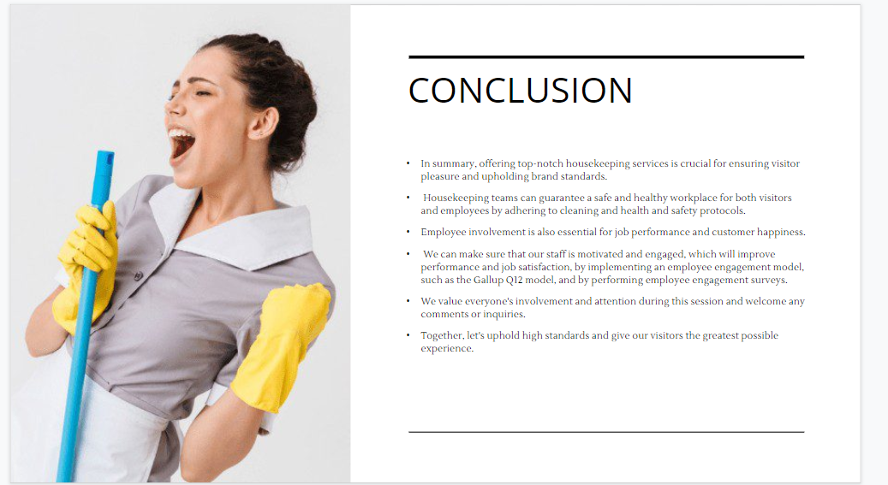

Training Notes: To summarise, providing exceptional housekeeping services is absolutely necessary for ensuring the satisfaction of guests and maintaining the integrity of the brand. By adhering to the cleaning and health and safety protocols in place, housekeeping teams can ensure that both visitors and employees are provided with a safe and healthy place of business.
Participation on the part of employees is necessary for both successful completion of work and satisfied clients.
By putting in place an employee engagement model, such as the Gallup Q12 model, and conducting employee engagement surveys, we will be able to ensure that our staff is both motivated and engaged, which will lead to an improvement in both their performance and their level of job satisfaction.
During this session, we appreciate everyone's participation and attention, and we are open to receiving any comments or questions you may have.
Let's uphold high standards together and provide the most enjoyable experience for our guests that is humanly possible.
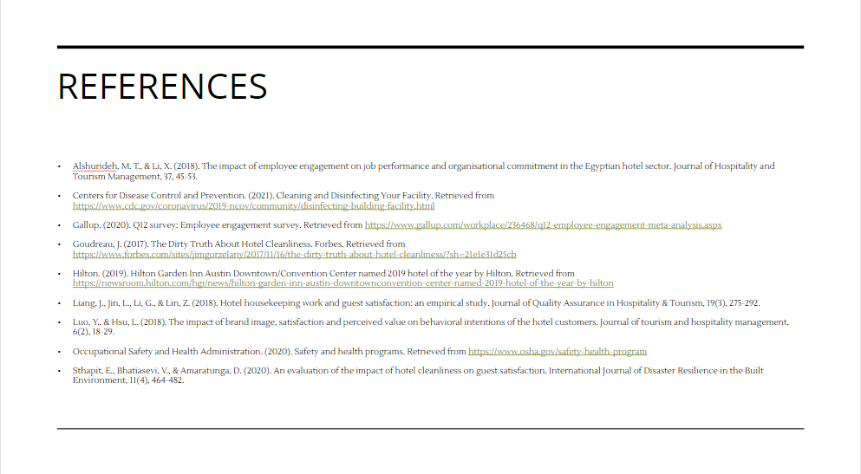

Training Notes:
Training Notes:
Training Notes:
Training Notes:

