

Presented
By
GROUP 2
NAME: AROCKIAN DAVID
ID NUMBER: 1604758
LECTURER : Anita nan

Table of Contents
1.0 Introduction 3
2.0 Aims and objectives, mission and vision 3
Aims and objectives 3
3.0 The Business 4
3.1 Description of business 4
3.2 Products/services 4
3.3 Market analysis 5
3.4 Market plan 7
3.7 Management and operation 11
4.0 Final data 14
4.1 Sources of finance for Windle & Moodie 2018 14
4.3 Forecasted Income Statement for Windle & Moodie- 2018 15
4.4 Estimated Balance Sheets for Windle & Moodie-2018 15
4.5 Break-event analysis 16
5.0 Concussion 17
Reference 18

Introduction
This assignment describes the business plan for Windle Moodie salon. Windle Moodie is the award winning and most reputed and popular salon in London city. They provides the best quality products to their customers and give them better treatment for hair, skin etc. in this assignment, it is discussed that how small business liken Windle Moodie increases and develops their business by using marketing strategies. It also describes the marketing plan and competitor analysis. How Windle Moodie manages its business operation is also described.

2.0 Aims and objectives, mission and vision

Aims and objectives

Aims
Windle and Moodie aim is to target the customers and satisfy the customers. This salon also aim is to recruit the skilled and professional hairstylists. Their aim is to gain profit 20% in each month. Attract the customers through online website is one of the aim of Windle and Moodie.

Objectives
Windle and Moodie has several main objectives. These are described as below:
- To increase customers rapidly.
- To recognize the salon in international market in February 2019.
- To increase 10% profit each month.
- To recruit skilled and professional staffs.
- To improve the share business within January 2019
- To improve the customers need and demand.
- To develop and establish the salon equipments and accessories within December 2018

Mission and vision
Windle and Moodie Salon mission is to have reasonable price hair cutting, different hairstyles, different colours, designs and shapes hairstyles and adopt in new trend. They desire to be capable to attract their regular customers with new approach and retain them. Regularly, they try to improve themselves by fulfilling their each task completely. They provide friendly and personalised and first class service (Windle & Moodie, 2017).

3.0 The Business

3.1 Description of business
Windle & Moodie’ is one of the most popular and well-recognized hairdressers. It is the award-winning salon in London city. It is situated in Covet Garden, London. This is voted as the best London hairdresser. They give their customers the best service like as they give services to the celebrity, models etc. The team of Windle and Moodie Salon creates fashion season in every year. Windle and Moodie works with the famous photographers in fashion and beauty magazines in order to achieve prestige. The Windle and Moodie range combines new performance-driven styling as well as hair treatments (Windle & Moodie, 2017).

3.2 Products/services
Windle Moodie range of products and the quality of products are increased day by day. There are major products in Winde Moodie. These are seven innovative shampoos, conditioners and masques. These products contain high quality antioxidants in order to protect, nurture and promote shine in hair. They have unique technologies and ingredients of the products. WAM is also provided by Windle Moodie salon. The other products are different types of shampoos such as, fortifying treatment shampoo, nourishing treatment shampoo, essential oil elixir, intense treatment masque, foundation spray, cream sheen, texture cream, curl enhancer, volcanic as wax, matte texture spray, sculpture hair spray etc. The provide the best customer service to their customers.

3.3 Market analysis

Customer analysis
Windle Moodie is a best hairdresser salon. Their main targeted customers are Men and Women and teenagers. Windle Moodie is situated in Covet, London. They have various ranges of products and customer services. Windle Moodie is an awarded salon. They work with renowned photographers and fashion beauty magazine in order to develop their salon strategies more and more. These are seven innovative shampoos, conditioners and masques. These products contain high quality antioxidants in order to protect, nurture and promote shine in hair. They have unique technologies and ingredients of the products. WAM is also provided by Windle Moodie salon. The other products are different types of shampoos such as, fortifying treatment shampoo, nourishing treatment shampoo, essential oil elixir, intense treatment masque, foundation spray, cream sheen, texture cream, curl enhancer, volcanic as wax, matte texture spray, sculpture hair spray etc. They provide services using these high quality products and also they sell these products and increases their revenues and profits. The product ranges and targeted customers are shown in the following chart below:
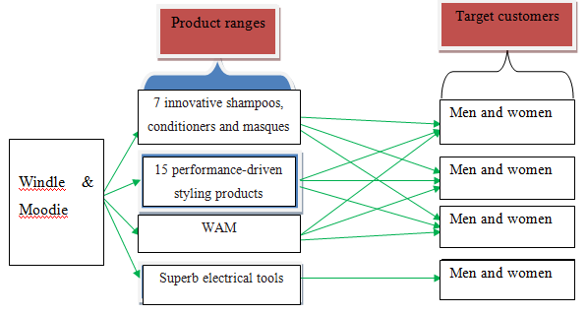
Diagram: Windle & Moodie’s target customer Source: Windle & Moodie (2017)

Market trends
A survey shows that women are now becoming more concern about their fashion and beauty. Beauty sales are now increasing day by day. According to 2015, in the worldwide, online beauty sales are about $301B. Day by day it increases. Beauty industry estimate that it should be around $352B within 2019 (Women’s Marketing). Nowadays, women are becoming more comfortable to go their best salons and want to use the best beauty products. So the market size of beauty industry and the customers demand for beauty products and best salons are increasing rapidly. Therefore, Windle & Moodie wants to develop their services and beauty products and want to do a research based on the needs and demands of customers that would be more competitive in the market.

Competitor analysis
Every business has their various competitors in market. So, the Windle & Moodie’ has been facing a large number of competitors in their marketing system. The main competiors of Windle Moodie hairdresser’s are Ena salon, Blade salon, Blow Ltd, Saco, Atherton Cox etc. The entire salons market share is different. The following graph shows the competitors of Windle Moodie and their market share.

Chart: Market share of Windle & Moodie Source: Windle & Moodie (2017)
Windle Moodie gained 25% market share of total market share in fashion and beauty salon. In the second position, 20% market share is gained by Ena Salon. Blade Sohor is in the 3rd position in market share and its market share is 18%. On the other hand, Blow Ltd market share is 15%, Saco’s market share is 12% and Atherton Cox’s market share is only 10% (Windle & Moodie, 2017).

3.4 Market plan
4P’s are known as the marketing strategy. Price, product, place and promotion are the four marketing strategy. Windle & Moodie uses 4Ps strategies in order to promote its services and products to target the potential customers. Marketing strategy of Windle Moodie is described as below:

Product strategy
Windle Moodie has made its own business strategy. They have various ranges of products. They sell these products to their customers and give them best customer services. In their online website, there have different types of products to attract the customers. They use all the branded products. The ingredients of the products are alcohol free, anti-oxidents, gluten free, paraben free, peptides, sulphate free, vegan and Vitamin C. the types of their products are shampoo, conditioner, hair treatment and styling. They also have different products such as, lotion, mask, oil, spray and wax. They require to develop more of their products quality.

Pricing strategies
The price of the Windle & Moodie’ hairdresser is always considers the capability of the customers in order to buy their products. The prices of Windle Moodie products are reasonable. The price range of these products are $25.00-49.00.

Cost-plus pricing
Windle Moodie is the most popular hairdresser in London City. Cost-plus pricing strategy are mostly supporting for the small businesses. So, Windle Moodie is using the cost plus pricing strategy in their business. It may create competitive advantage in the business marketplace.

Customer (demand)-based pricing
Customers always want the best products in low price. Customers demand for the good quality products. The price of the Windle & Moodie’ hairdresser is always considers the capability of the customers in order to buy their products. The prices of Windle Moodie products are affordable.

Competition- based pricing
Company always tries to sell their best products in low costs than the competitor one. Windle Moodie sells their various products in low price. To hold the marketplace, Windle Moodie uses competition-based pricing strategy. Supply and demand curve is depended on this strategy.
Suggested pricing policies for Windle & Moodie
Time scale (months) | Suggested pricing strategies | Proposed implementation
- 8 | Decoy pricing | To hold their customers, they should keep the products price same as before.
9- 16 | Time-based pricing | Time-based pricing strategy may make sure the optimum revenue for Windle Moodie.
17- 24 | Competitive pricing | In order to do competition with the competitors company, they should use the competitive pricing strategy.
Table: Pricing strategy developed for Peach Essentials

Promotion strategies
Windle & Moodie’ want to promote their products internationally. They can promote their products through different social media, for example, facebook, twitter, youtube etc. Windle Moodie has own online website. If they want to promote more products, they should make the website page more attractive. They offer sales and discount prices in their website.

3.5 Location
Easy way and reachable location prefers the best as marketing. Windle Moodie is situated in London city. So, it is the commercial place to market any business (Windle & Moodie’, 2017).

3.6 Competition
Every business has their various competitors in market. So, the Windle & Moodie’ has been facing a large number of competitors in their marketing system. The main competiors of Windle Moodie hairdresser’s are Ena salon, Blade salon, Blow Ltd, Saco, Atherton Cox etc. these competitors try to took the place of Windle Moodie. They always try to attract their customers by their honesty, uniqueness and customer service though there are lots of barriers to promote the business of Windle Moodie. They provide the good quantity products to their customers (Windle & Moodie, 2017).

3.7 Management and operation

Manpower need in Windle & Moodie
Windle Moodie salon is increasing day by day. They have now huge customers. They also provide services to the renowned models and artists. They want to recruit more skilled and professional staffs to provide customer services and the better management of their salon. They also want to increase their business in different areas in London. So, they should enhance the manpower (Windle & Moodie, 2017).

HR planning for Windle & Moodie
Windle Moodie use different business strategies for the improvement of their business. They need more skilled and professional staffs for each section. They attract the potential customers by their uniqueness of their products and services. They follow different steps of human resource management. They are concern about their competitors. They are scanning the external environment. The analyses the internal inventory of HR capabilities.
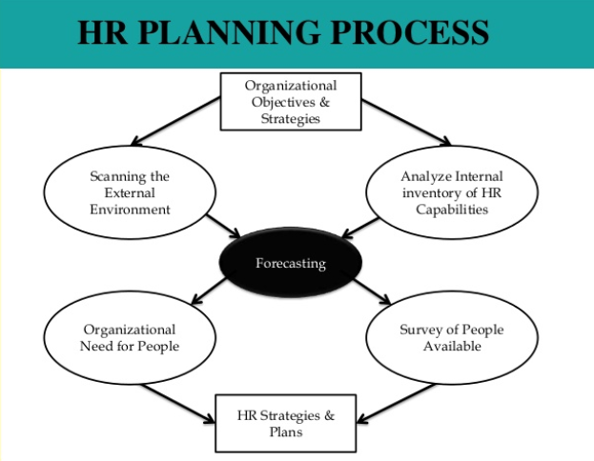
Diagram: Human Resource Planning process Source: Civil Service India (2017)

Recruitment and selection strategies

Diagram: Recruitment and selection process Source: Mullins (2014)
Windle Moodie first gives a job vacancy notice in their website. Then they analyses the job in different sectors. They attract the candidates to work in their salon by offering different incentives and promotions. After that, they select the most suitable staff for their salon. They select the most skilled, professional and friendly staff for their company. Then they give more training in order to the betterment of their customer service.

Staff motivational strategies
There should be strong relationship between the employer and employee. Employers always try to motivate their workers. Motivated workers are more dedicated and engaged in the company. Staff motivational strategy provides to the employees to motivate them to increase the better service and quality of the products.
Windle & Moodie’ makes sure the least rights to their employees. They provide safe and secured workplace for the employees. They provide various rewards and incentives basis on the working performance of the employees. They provide bonus on any occasions. They also give promotions of their work on the basis of the participation and performance of the work of staffs.
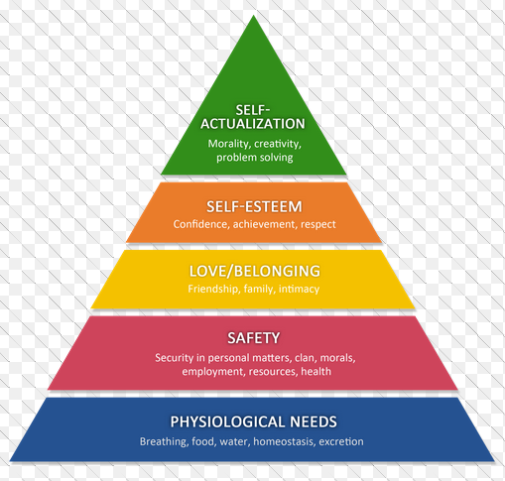
Diagram: Motivational Strategy by Windle & Moodie Source: Mullins (2014)

4.0 Final data

4.1 Sources of finance for Windle & Moodie 2018
Windle Moodie targets to invest about £60,000 in 2018 to extend their recent activities and enhance their performance. As Attril and McLaney (2014) suggestions, Windle & Moodie can manage this £60,000 from various types of sources. Firstly, the founders of this company have to invest money from their own pocket. They can manage this from their well wishers such as their father, mother and others. Secondly, they can borrow money from their friends. They can manage loans from bank; they can collect shareholders, stake holders at last.

4.2 Estimated Cash-Flows for Windle & Moodie- 2018
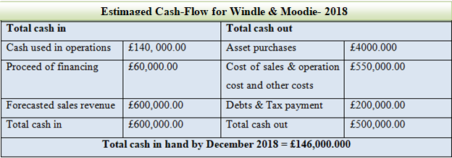

4.3 Forecasted Income Statement for Windle & Moodie- 2018
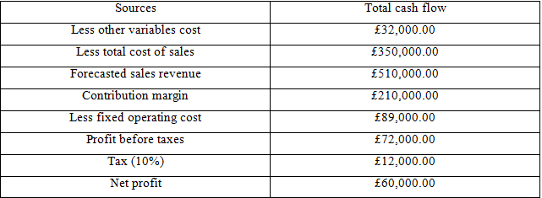
Table: Forecasted Income Statement for Windle & Moodie- 2018

4.4 Estimated Balance Sheets for Windle & Moodie-2018
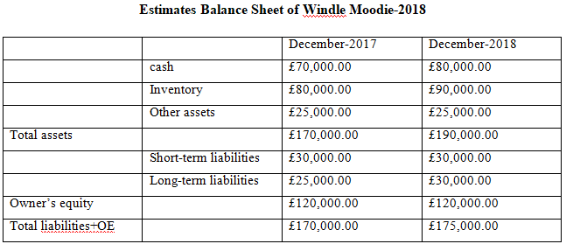Table: Estimated Balance Sheets for Windle & Moodie-2018

4.5 Break-event analysis
To calculate financial data of a company, every company should estimate break-even point. There are some formulas to calculate the break-even point. They should calculate fixed costs, unit sales costs, marginal cost and variable costs.
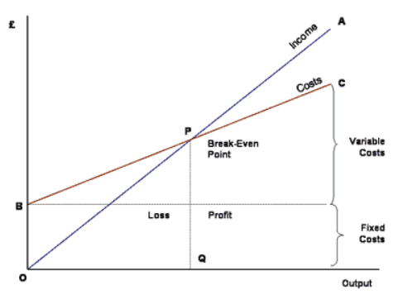
Diagram: Breakeven analysis
Breakeven Point in Units= Fixed Costs ÷ (Unit Sales Price - Variable Costs)
Monthly Fixed Expenses:
Rent £7,000
Utilities £5,000
Salary £3,000
Other £2,000
Total fixed Expenditure. £17,000
Unit sales price: £35
Less Cost of Goods Sold: £10
Less Material & Labour: £7
Less Other Variable Exp: £3
Marginal Cost (MC) = {£ 35-(£10+£7+£3)}
=£15
Breakeven point in units= £17,000 ÷ £15
=1133.33 units
Breakeven point in unit is 1133.33 units.

5.0 Concussion
Small businesses are increasing day by day in London. Small business entrepreneurs try to maximize their products and increases revenues and profits by using marketing strategies and provide the customers better service and product quality. Windle Moodie salon is the award-winning salon. They always try to develop their business in internationally by using the appropriate marketing strategies.

Reference
Cliffs Notes (2017) The Motivation strategy Available at: https://www.cliffsnotes.com/study-guides/principles-of-management/motivating-and-rewarding-employees/motivation-strategies. [Accessed on:1 January 2018]
Attril, P. and McLaney, P. (2014) Accounting and finance for non-specialists. 5th Ed. Pearson Education Ltd: Harlow.
Kotler, P. et al (2014) Principles of Marketing. 8th European Ed. Pearson Education Limited: London.
Mullins, J. (2014) Management and Organizational Behaviours. 8th Ed. Harlow: Prentice Hall
Windle & Moodie (2017) About Windle & Moodie. Available at: http://www.windleandmoodie.com /. [Accessed on: 2 January 2018]
Steve, M. and Caroline. G., (2012) Entrepreneurship: Starting and Operating a Small Business. 5th Ed. Pearson Education Ltd: Harlow

