EMR Report


Tegan Ingram

University of Wales Trinity Saint David
Ordinance, Munitions and Explosives Engineering

Supervisor: Stalin Jacob
March 2025

Table of Contents
Table of Figures 2
List of Abbreviations 4
Introduction 4
1. Overview – Waveguides and Dipole Antennas 5
2.1 EMR 5
1.2 Waveguides 5
2.3 Antennas 7
2.4 Relation to OME 7
3 Task 1a 8
3.1 Task Description 8
3.2 Method 8
3.3 Results 8
4 Task 1b 16
4.1 Task Description 16
4.2 Method 16
4.3 Results 17
5 Task 2 23
5.1 Task Description 23
5.2 Method 23
5.3 Results 24
6 Conclusion 25
Bibliography 26

Table of Figures
Figure 1 – relationships between properties of EM waves [2] 5
Figure 2 – Wave propagation and modes [7]. 6
Figure 3 – Vacuum Mode1, Port 1 8
Figure 4 – Vacuum Mode 1, Port 2 8
Figure 5 – Vacuum Mode 2, Port 1 9
Figure 6 – Vacuum Mode 2, Port 2 9
Figure 7 – Vacuum Mode 3, Port 1 9
Figure 8 – Vacuum Mode3, Port 2 9
Figure 9 – Mag E Mode 1 10
Figure 10 – Mag E Mode 2 10
Figure 11 – Mag E Mode 3 11
Figure 12 – Vector E Mode 1 11
Figure 13 – Vector E Mode 2 12
Figure 14 – Vector E Mode 3 12
Figure 15 -Mag H Mode 1 13
Figure 16 – Mag H Mode 2 13
Figure 17 – Mag H Mode 3 14
Figure 18 – Vector H Mode 1 14
Figure 19 – Vector H Mode 2 15
Figure 20 – Vector H, Mode 3 15
Figure 21 – Vacuum Cut-off Frequency 16
Figure 22 – Teflon Mode1, Port1 17
Figure 23 – Teflon, Mode 1, Port 2 17
Figure 24 – Teflon Mode 2, Port 1 17
Figure 25 – Teflon Mode 2, Port 2 17
Figure 26 – Teflon Mode 3, Port 3 18
Figure 27 – Teflon Mode 3, Port 3 18
Figure 28 – Mag E Mode 1 18
Figure 29 – Mag E Mode 2 18
Figure 30 – Mag E Mode 3 19
Figure 31 – Vector E Mode 1 19
Figure 32 – Vector E Mode 2 19
Figure 33 – Vector E Mode 3 20
Figure 34 -Mag H Mode 1 20
Figure 35 – Mag H Mode 2 20
Figure 36 – Mag H Mode 3 21
Figure 37 – Vector H Mode 1 21
Figure 38 – Vector H Mode 2 22
Figure 39 – Vector H, Mode 3 22
Figure 40 – Teflon Cut-off Frequency 22
Figure 41 – Antenna Radiation Pattern 24
Figure 42 – S-parameter Plot 25

List of Abbreviations
EMR – Electromagnetic Radiation
EM – Electromagnetic
OME – Ordnance, Munitions and Explosives
PEC – Perfect Electrical Conductor
RF – Radio Frequency
TE – Transverse Electric
TM – Transverse Magnetic

Introduction
Electromagnetic radiation (EMR) refers to an energy flow in the form of waves that propagate through either free space or a material. These waves are of an electric and magnetic field which in turn account for an electromagnetic wave. The electromagnetic spectrum is made up of radio waves, microwaves, infrared, visible light, ultraviolet, x-rays, and gamma rays. Modern communication heavily depends on electromagnetic wave propagation; equipment, including waveguides and dipole antennas, play a crucial role in ensuring their reliability and performance when transmitting signals to and from numerous platforms.
This report relates the basic idea of dipole antennas and electromagnetic wave guides to the results seen when such things are modelled and simulated in a computer software known as “Ansys”. The simulations are to be compared to theoretical principles, thus proving or disproving the accuracy of such software, considering factors such as material parameters, boundary conditions and accuracy of design.
The report will initially discuss a brief overview of waveguides and dipole antennas, detailing the functions and applications of them. An investigation regarding a vacuum and a Teflon waveguide is to be conducted and discussed, this is to be done via simulation through Ansys. A dipole antenna will later be modelled with the importance of accuracy when modelling being discussed. During all investigations, the simulated results are to be compared with theoretical results and calculations to emphasize the importance of validating results that are calculated on software such as Ansys.

Overview – Waveguides and Dipole Antennas

2.1 EMR
Electromagnetic waves are transverse waves. The vibrations and oscillations of these waves are changes in electrical and magnetic fields at right angles to the direction in which they are travelling [1]. The wavelengths of such waves are the determining factor in the properties observed of the waves, for example the size of the wave or what the wave can travel through. Figure 1 below shows the relationship between wavelength, frequency and the size of a wave with regard to the type of wave.
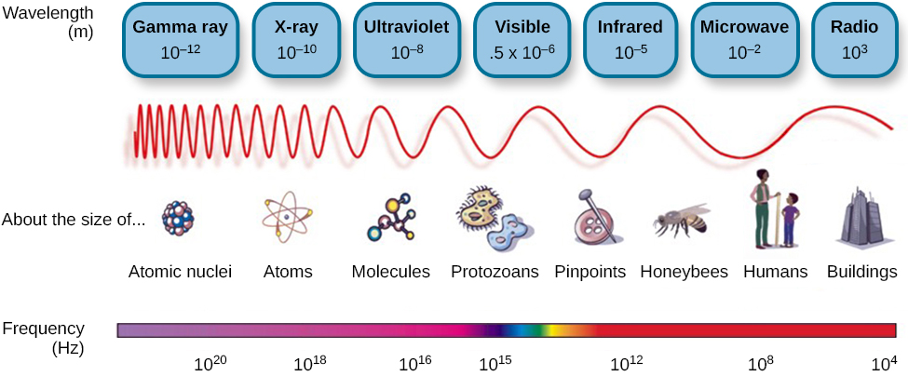
Figure 1 – relationships between properties of EM waves [2]

Waveguides
A waveguide is a transmission line that is used to direct radiation along the length of a tube [3]. Waveguides are of use when strengthening and guiding an electromagnetic signal to a receiver. Waveguides date back to the 19th century when Hertz carried out an experiment on radio waves; during this experiment he embedded a spark transmitter and detector into cylindrical metal mirrors in order to boost signals [4]. Having worked, modern waveguides have now become a crucial part of communication systems.

2.2.1 Structure of waveguides
The structure of a rectangular waveguide is typically that of a hollow metallic tube with a rectangular cross-section. The size of a rectangular waveguide tends to follow the trend that a>b, when a is the length and b is the breadth of the rectangle [5]. “The waveguide cross section should be as small as possible to permit high-density integration” [6]. For each wavelength there is an optimal design that incorporates the height and width as well as the shape and size of the cross section and will allow for the wave to be transmitted at the frequency required with the reliability ensured.

Waveguide Modes
During the propagation of an electromagnetic wave through a waveguide only a single field (electric or magnetic) can be transverse regarding the direction in which the wave is travelling. As a result of this, during propagation, the field that is not transverse will come back around longitudinally to the direction of travel, however, still perpendicular to the transverse field. The mode of the wave is determined by which field stays transverse, if the electric field remains transverse, it is in transverse electric mode (TE mode) and if the magnetic field remains transverse, then it is in transverse magnetic mode (TM mode) [7]. Figure 2 is a visual of how this works.
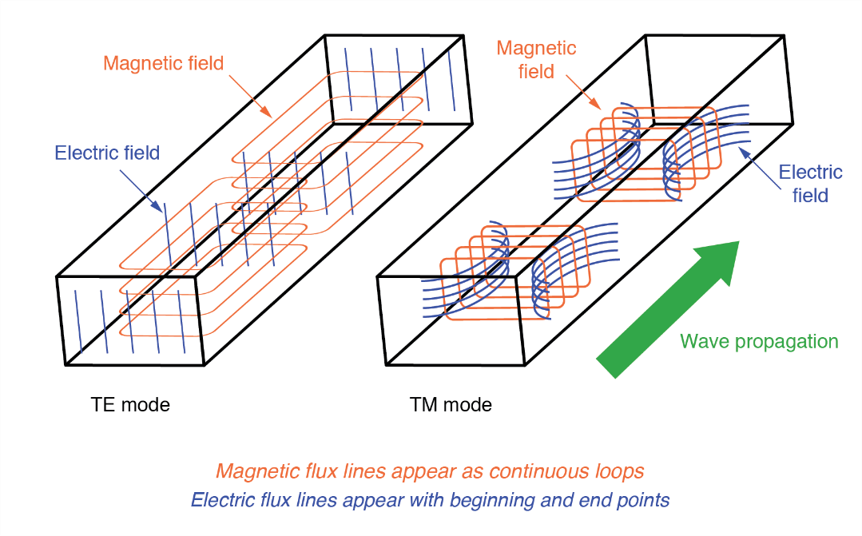
Figure 2 – Wave propagation and modes [7].

Cutoff Frequency
A waveguide acts as a high-pass filter and every waveguide has a frequency that must be reached for the wave to propagate, any wave that is below this frequency will not propagate. The frequency is known as the “cutoff” frequency and any energy above this frequency will be able to pass through the waveguide, whereas the majority of the energy below the cutoff frequency will be attenuated by the waveguide [8].

Functionality of Waveguides
One of the more common uses of a waveguide is within the telecommunications industry. A waveguide facilitates the transmission of a communication signal over large distances while minimizing any loses along the way [9]. It is important to minimise loses over a large distance to ensure that a full message is sent and that there is no lose in communication.

Antennas
An antenna is a particularized transducer used to convert electrical current into EM waves or vice versa [10]. The antenna functions by turning bound circuit fields into propagating electromagnetic waves [11]. Antennas are widely used, with one of the most common uses of an antenna being in communications. The antenna dates back to 1886 when Hertz proved Maxwell’s prediction that there were electromagnetic waves at radio frequency by creating the first ever radio system; the system was made up of the transmitting antenna (a dipole antenna) and a receiving antenna (a loop antenna) [12].

2.3.1 Dipole Antenna
A dipole antenna is wire antenna that is very often used in many different industries and fields of work. A dipole antenna is a type of radio frequency (RF) antenna that is made up of two conductive elements such as a wire in which the length of such wire is length is half of the highest wavelength approximately, in free space, at the operation of frequency [13]. There are multiple types of dipole antennas such as hartzian dipole, small dipole, half-wave dipole [14].

Half-Wave Dipole Antenna
As previously mentioned, a half-wave dipole antenna is a form of dipole antenna. “The "half-wave" term means that the length of this dipole antenna is equal to a half-wavelength at the frequency of operation” [15]. This type of antenna is one of the most frequently used antenna due to some of its advantages such as its frequency range, it operates at around 3KHz to 300GHz which is mostly used for radio receivers [16]. They are a crucial part of RF systems and are critical for the wireless reception and transmission of EM signals.

Relation to OME
There are multiple effects that electromagnetic radiation could potentially have on ordnance, munitions and explosives (OME). Due to the nature of what is being handled with regards to OME it is vital that no risk is overlooked. Electro-explosive devices have the potential to be actuated when transmitters are operating in the radio frequency (RF) spectrum [17]. Although it can create risk, EMR can also be utilised to improve and assist within the industry. An example of this would be using infrared (IR) tracking for detection of missiles and planes as well as using IR for night vision. Being able to see objects in the dark plays a pivotal role in war, enabling soldiers to fight and protect themselves at all hours.

Task 1a

3.1 Task Description
Task 1a instructs that a rectangular waveguide with perfect electrical conductor (PEC) wall, filled with a vacuum, be simulated and designed. The dimensions of the waveguide are as follows: width = 23mm, height = 8.5mm, length = 50mm. This was derived from the student number 2317699.

3.2 Method
At either end of the waveguide there are two ports configured. These two ports are there to support three different modes, with each of the modes being used to assist with the analysis of the propagation of the waveguide and its behaviour during the simulation. To abide with the brief for task 1a the waveguide has been designed with relative permeability is 1 and relative permittivity in a vacuum is 0. In order to minimise radiation loss and to satisfy the task description, boundary conditions such as PEC walls and a vacuum fill were added to the design. The frequency sweep was set up to be between 2GHz and 30GHz in order analyse the waveguide behaviour across a range of frequencies.

3.3 Results

3.3.1 Analysis of Mode Dominance
From Figure 3 and Figure 4 it can be seen that, in mode one, a TM01 mode is shown. This is calculated by observing the vertical lines indicating that the magnetic field is travelling in a direction that is vertical to the waveguide, with no field being horizontal to the waveguide.

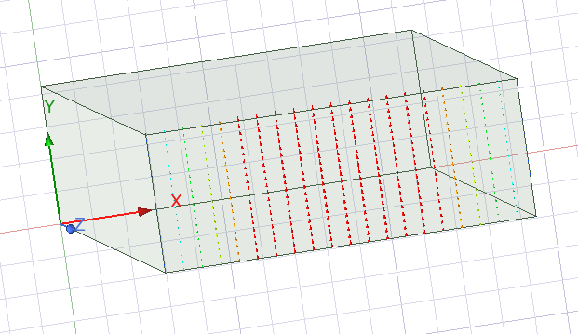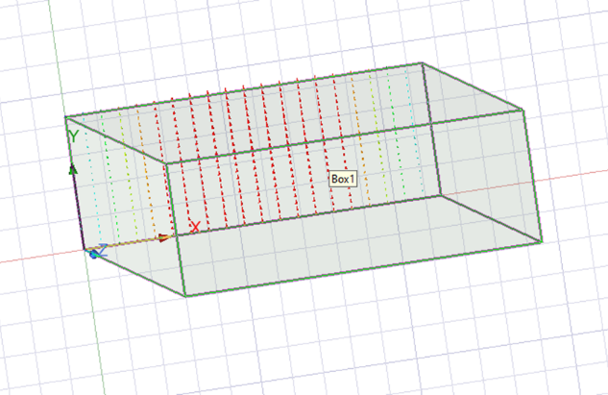
Figure 3 – Vacuum Mode1, Port 1
Figure 4 – Vacuum Mode 1, Port 2
In Figure 5 and Figure 6 below mode 2 was on display: The mode TM02 can be observed. There are two fields in the vertical direction thus leading to this result calculation.
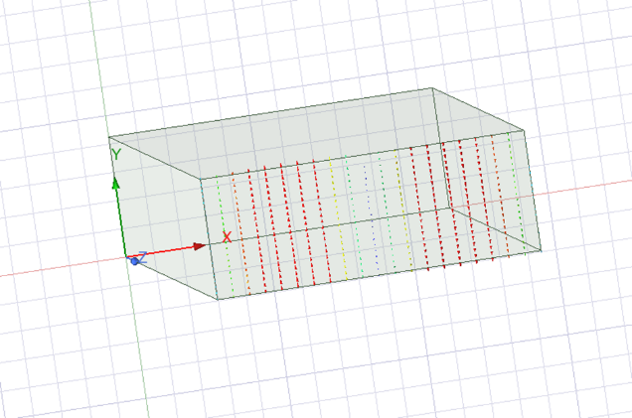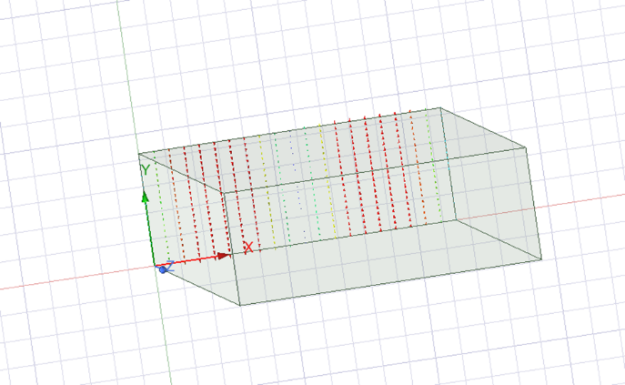
Figure 5 – Vacuum Mode 2, Port 1
Figure 6 – Vacuum Mode 2, Port 2
Looking at Figure 7 and Figure 8 where mode 3 is captured, the mode TE10 is observed. The horizontal line indicates that the magnetic field is running horizontally across the waveguide.
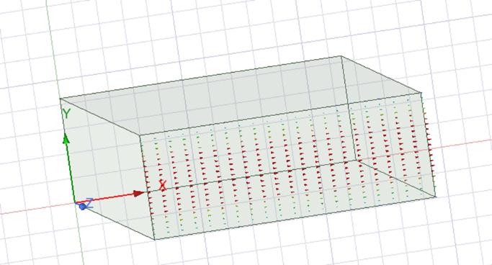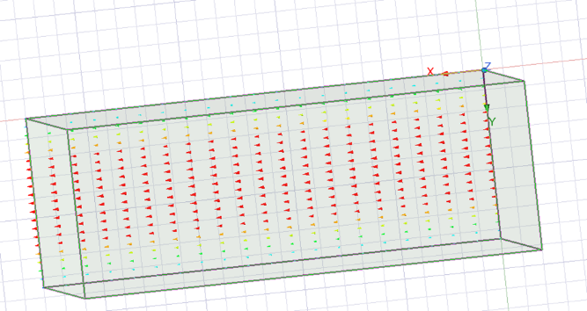
Figure 7 – Vacuum Mode 3, Port 1
Figure 8 – Vacuum Mode3, Port 2

3.3.2 Analysis of Electric and Magnetic Fields
At each port the evaluation of electric field (E) and magnetic field (H) can be completed for the simulation of the rectangular waveguide. This is done to help facilitate the understanding of the behaviours and distribution of the fields within the structure of waveguide.

3.3.2.1 Mag E
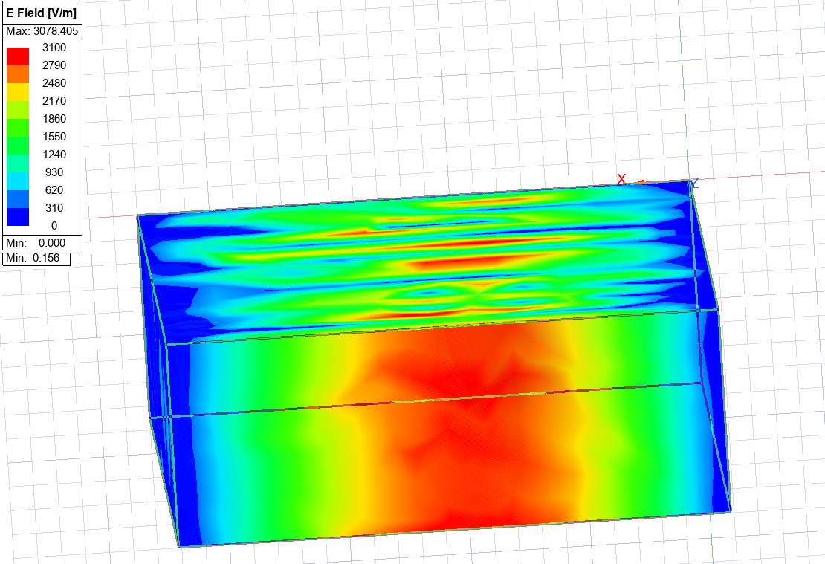
Figure 9 – Mag E Mode 1
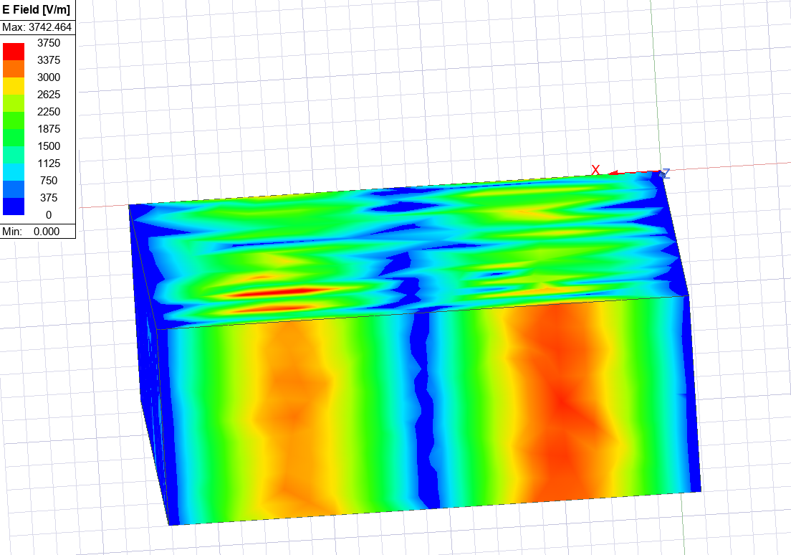
Figure 10 – Mag E Mode 2
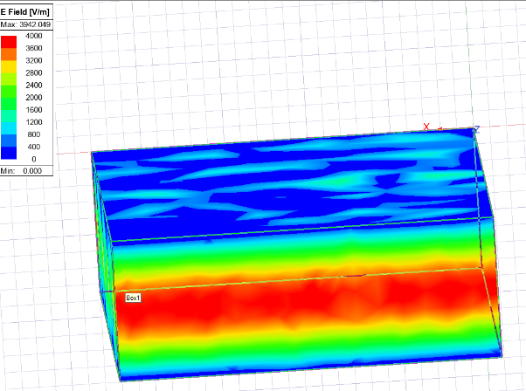
Figure 11 – Mag E Mode 3
From all the above figures it can be seen how the electric field propagates at each mode. This corresponds to the mode dominance and how this is the same throughout all of the analysis on ANSYS.

3.3.2.2 Vector E
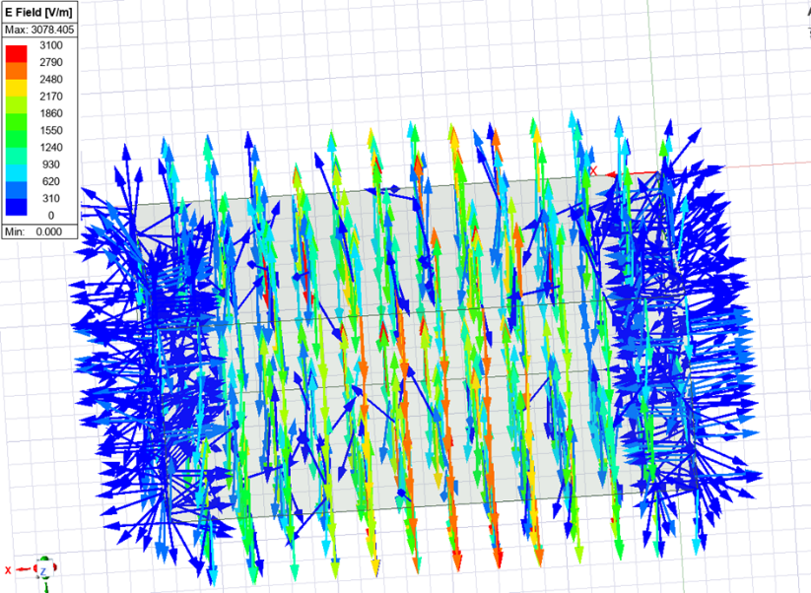
Figure 12 – Vector E Mode 1
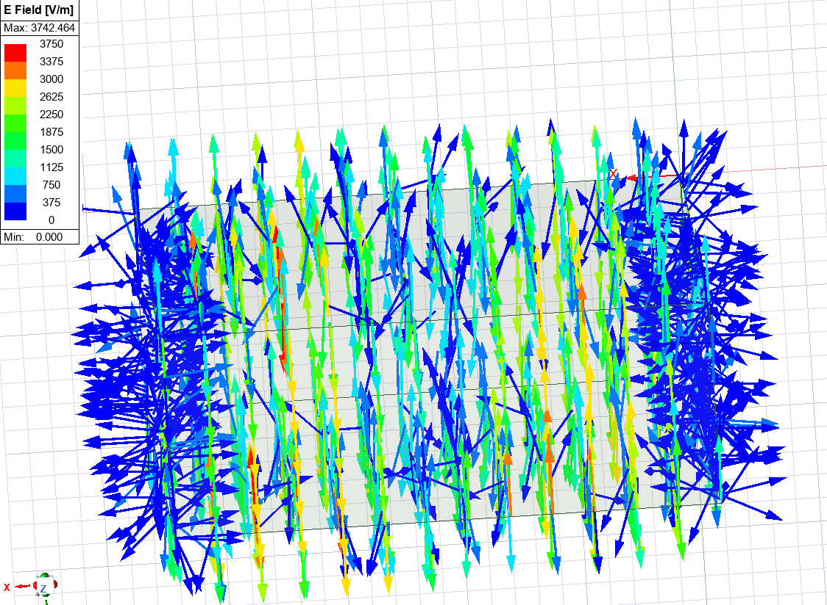
Figure 13 – Vector E Mode 2
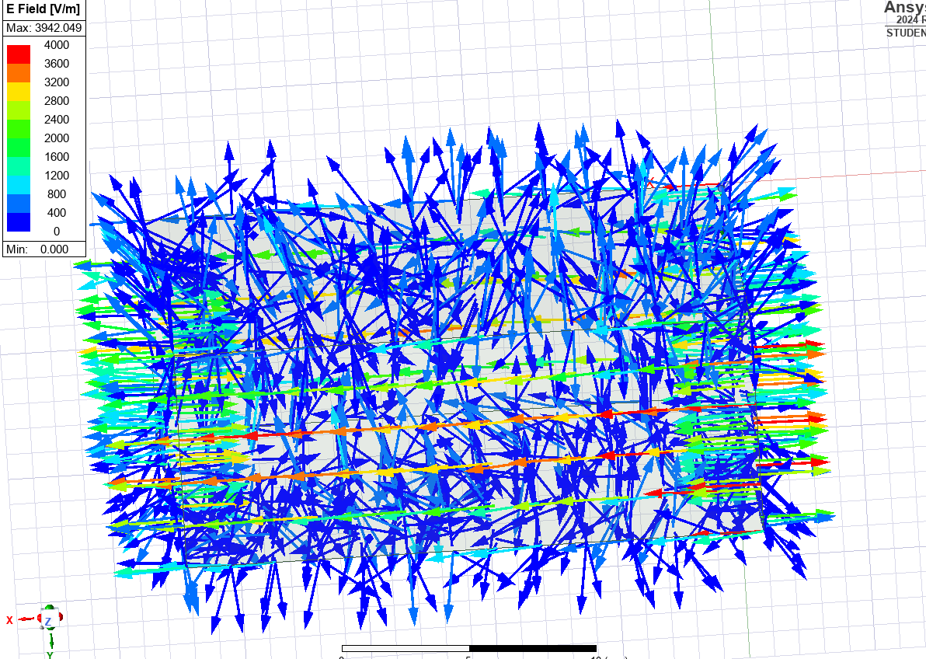
Figure 14 – Vector E Mode 3
Once again the above figures show that the propagating fields are all following the same pattern in each mode.

3.3.2.3 Mag H
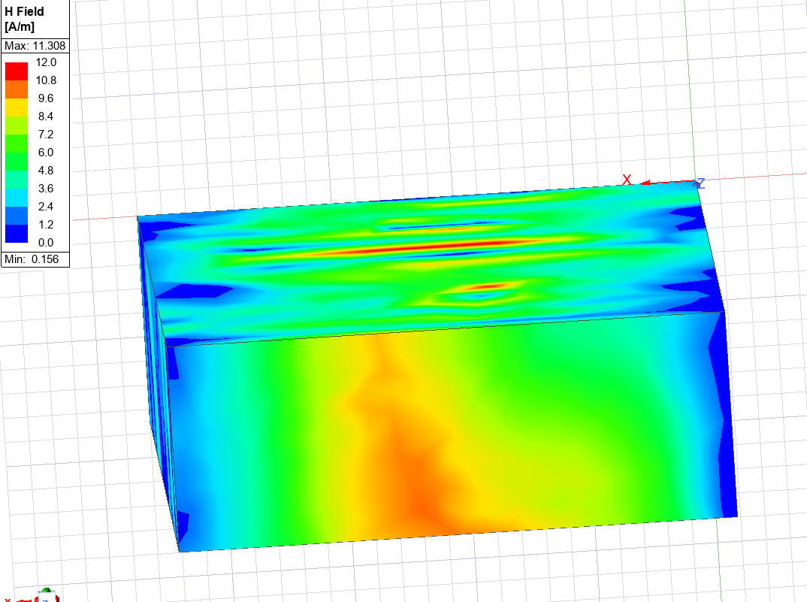
Figure 15 -Mag H Mode 1
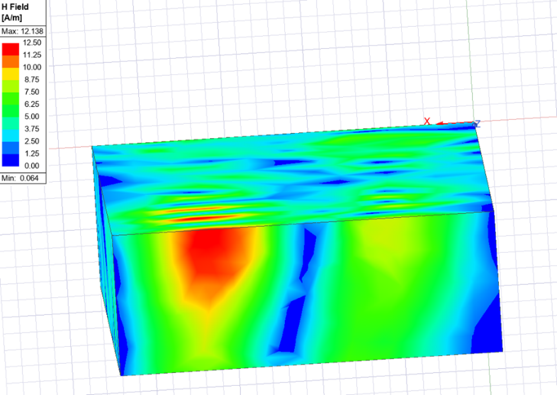
Figure 16 – Mag H Mode 2
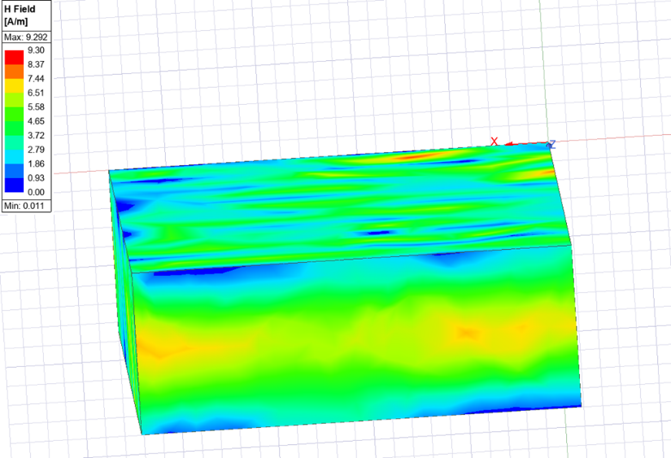
Figure 17 – Mag H Mode 3
The figures above show how magnetic fields propagate, once again it lines up with the modes shown previously however it can not be seen as prominently.

3.3.2.4 Vector H
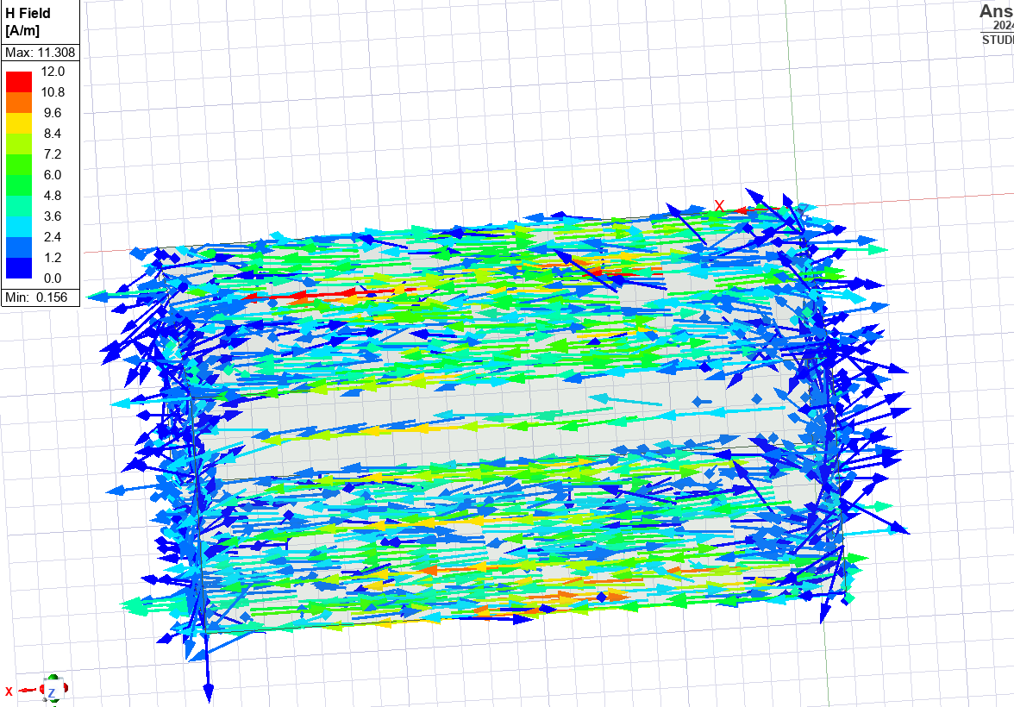
Figure 18 – Vector H Mode 1
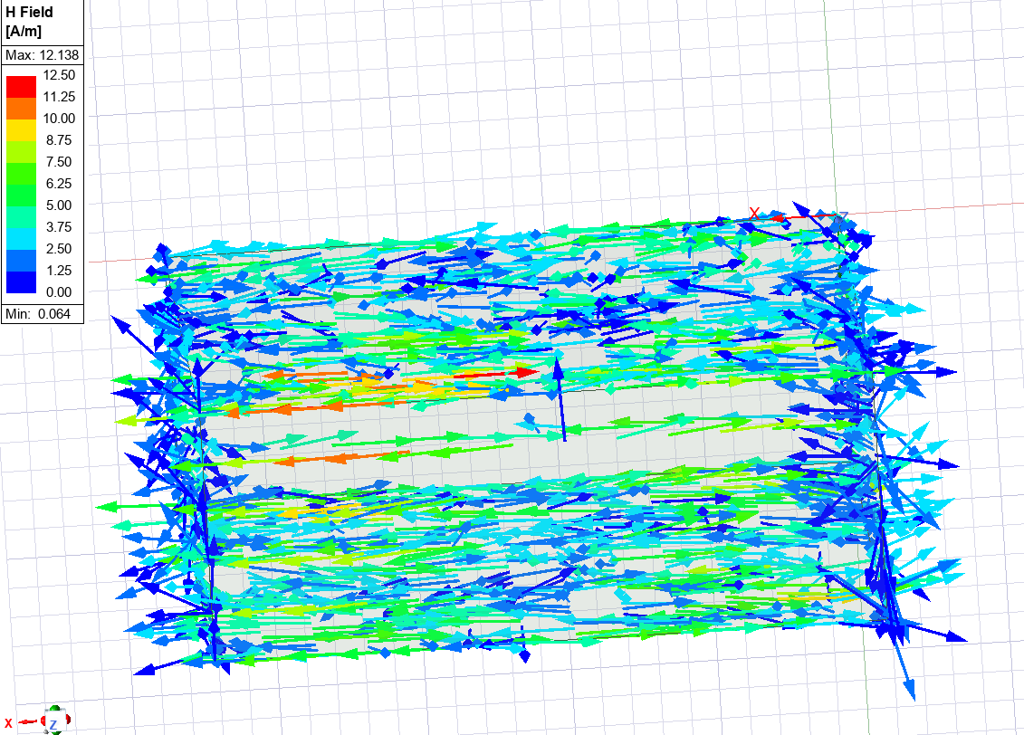
Figure 19 – Vector H Mode 2
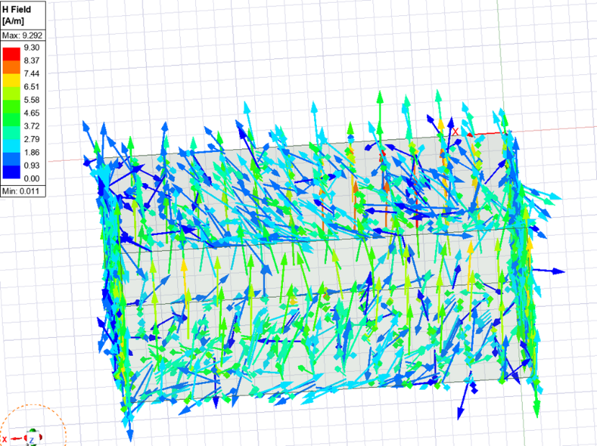
Figure 20 – Vector H, Mode 3
The above figures show propagation of the magnetic fields in each of the modes.

3.3.2.5 Cut-off Frequency
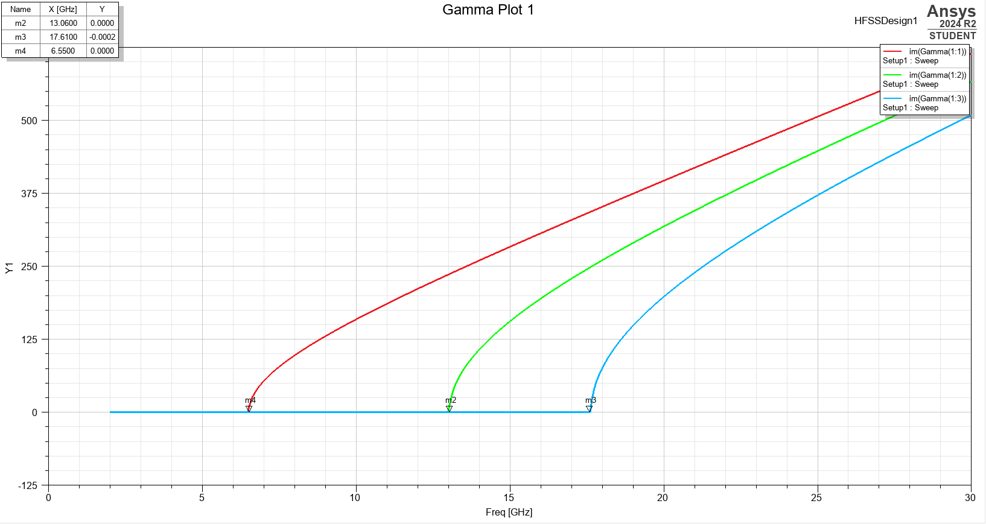
Figure 21 – Vacuum Cut-off Frequency
The graph in Figure 21 shows the cut-off frequency for each of the modes.

3.3.2.6 Vacuum Comparison
Consistency throughout each mode can be seen in the electric and magnetic field. There is variation between each of the modes which is expected due to the difference within the mode dominance.

Task 1b

4.1 Task Description
Task 1b asks for a rectangular waveguide model to be made of PEC wall, however, is filled with Teflon which has the relative permeability of 1 and relative permittivity of 2.1. The dimensions of the waveguide are as follows: width = 23mm, height = 8.5mm, length = 50mm. This was derived from the student number 2317699.

4.2 Method
As before at either end of the waveguide there are two ports configured. Once again these two ports support three different modes, with each of the modes being used to assist with the analysis of the propagation of the waveguide and its behaviour during the simulation. To abide with the brief for task 1b some changes needed to be made and some things had to be kept identical the waveguide has been designed with relative permeability is 1 and relative permittivity is 2.1 as this was specified. In order to minimise radiation loss and to satisfy the task description, boundary conditions such as PEC walls were added to the design however this time a change to the vacuum fill was made and in turn was set as a Teflon fill. The frequency sweep was set up to be between 2GHz and 30GHz in order analyse the waveguide behaviour across a range of frequencies.

4.3 Results

4.3.1 Analysis of Mode Dominance
The below figures ( Figure 21 and Figure 22) show that in mode 1 the mode dominance is TM01 and that the field is propagating in a vertical direction.
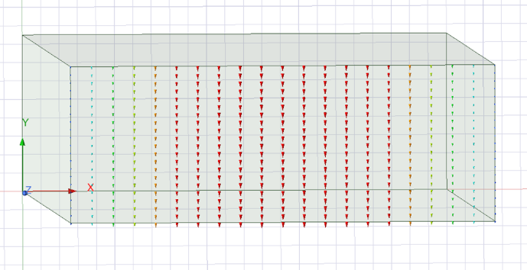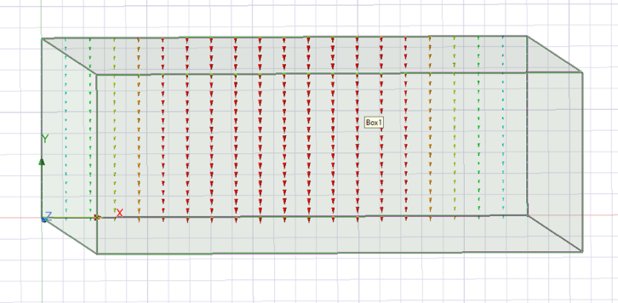
Figure 22 – Teflon Mode1, Port1
Figure 23 – Teflon, Mode 1, Port 2
Figure 23 and Figure 24 below show mode 2 of the waveguide containing a Teflon fill, this shows a mode dominance of TM02. This is calculated by observing the two vertical lines at both ports of the waveguide.
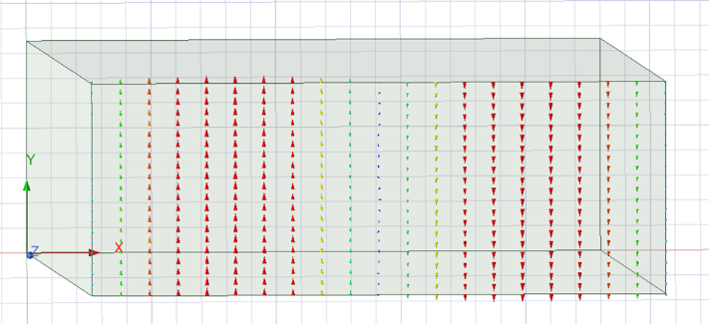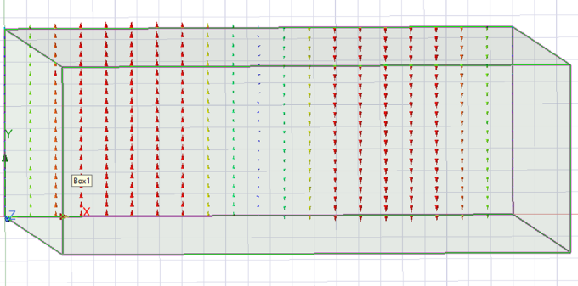
Figure 24 – Teflon Mode 2, Port 1
Figure 25 – Teflon Mode 2, Port 2
Below Figure 25 and Figure 26 can be seen. From observing these captures of the waveguides it can be calculated that the mode dominance is TE10. This is calculated from the horizontal lines representing the field running horizontally across the waveguide.
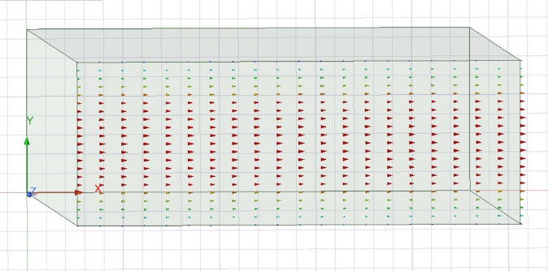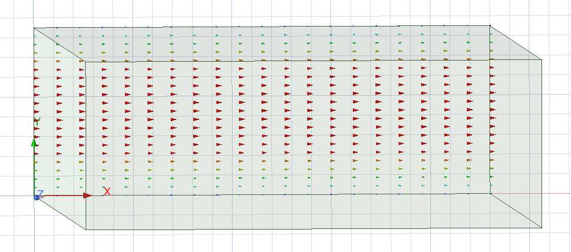
Figure 26 – Teflon Mode 3, Port 3
Figure 27 – Teflon Mode 3, Port 3

4.3.2 Analysis of Electric and Magnetic Fields
At each port the evaluation of electric field (E) and magnetic field (H) can be completed for the simulation of the rectangular waveguide. This is done to help facilitate the understanding of the behaviours and distribution of the fields within the structure of waveguide.

4.3.2.1 Mag E
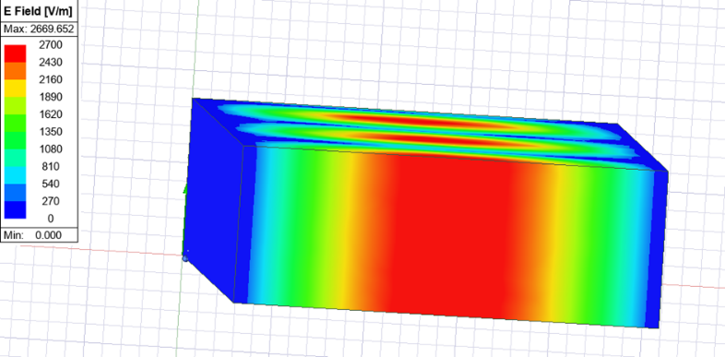
Figure 28 – Mag E Mode 1
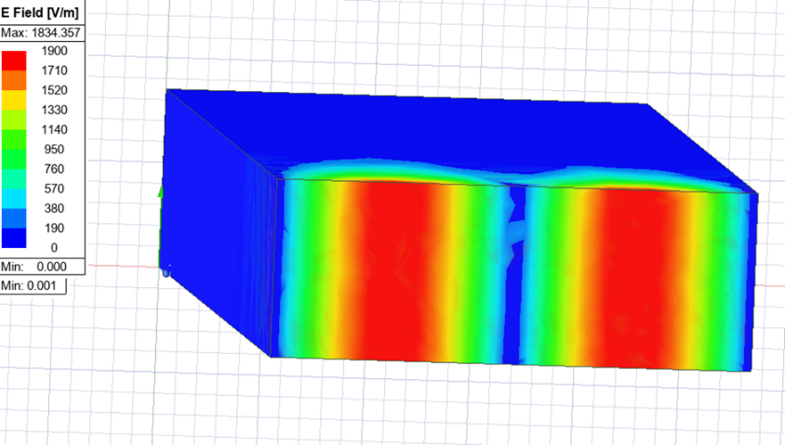
Figure 29 – Mag E Mode 2
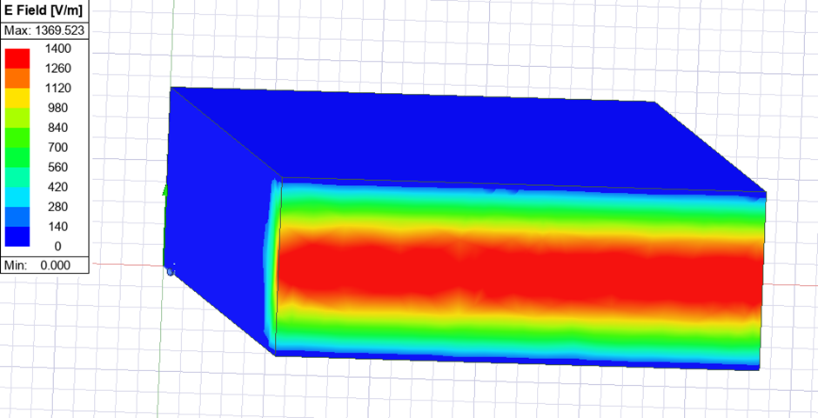
Figure 30 – Mag E Mode 3
The above figures show how the electric field propagates at each mode. There is a correspondance to the mode dominance and how this is the same throughout all of the analysis on ANSYS.

4.3.2.2 Vector E
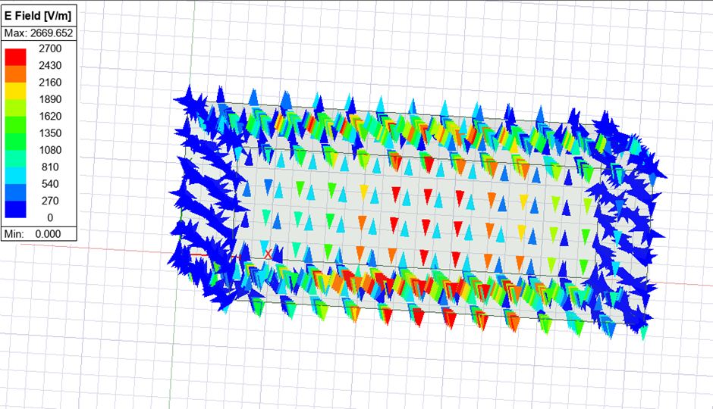
Figure 31 – Vector E Mode 1
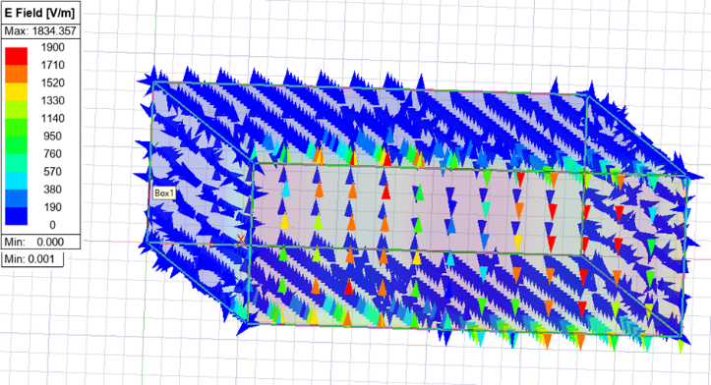
Figure 32 – Vector E Mode 2
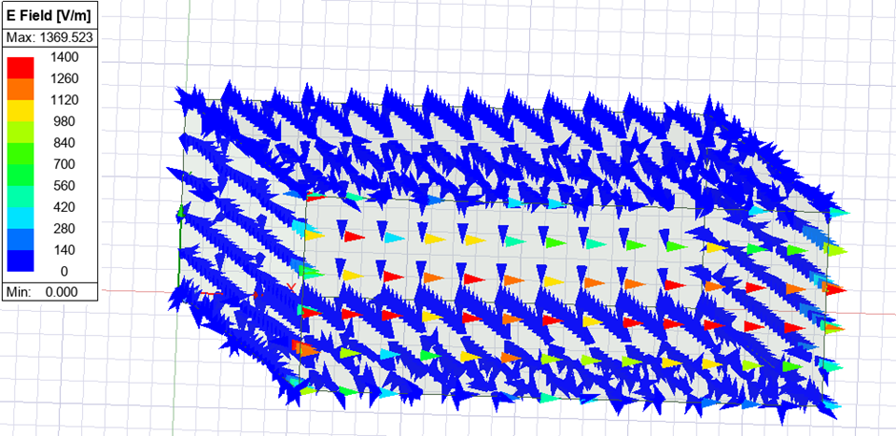
Figure 33 – Vector E Mode 3
Again, the above figures show that the propagating fields are all following the same pattern in each mode. In the figures above observations of the electric field can be made.

4.3.2.3 Mag H
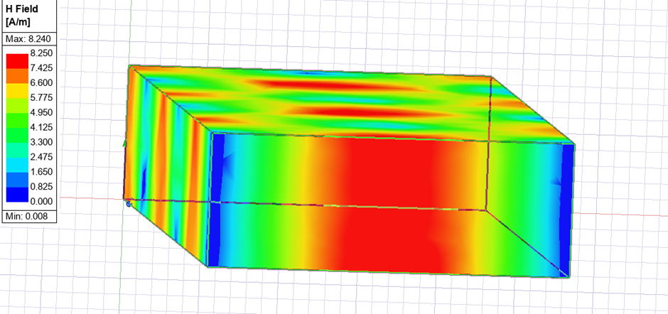
Figure 34 -Mag H Mode 1
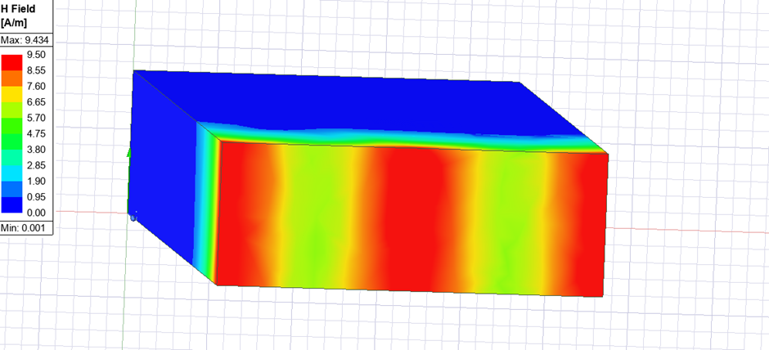
Figure 35 – Mag H Mode 2
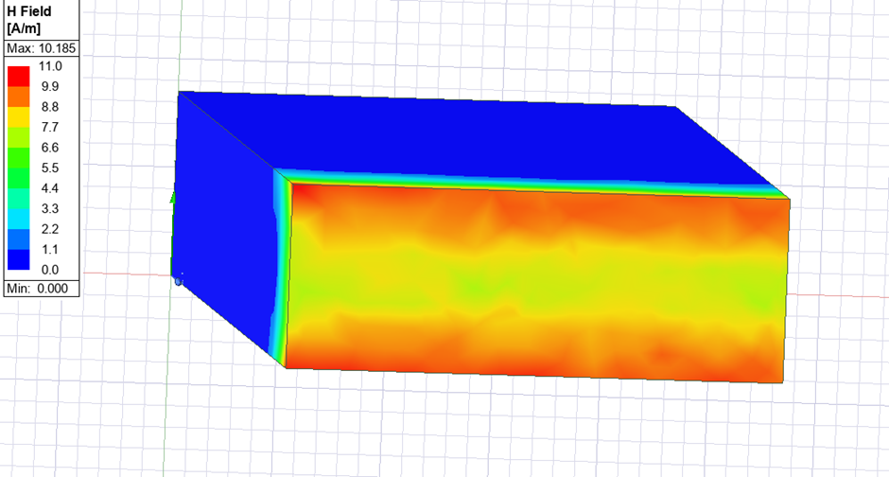
Figure 36 – Mag H Mode 3
The figures above show how magnetic fields propagate, these behaviours and movements all correspond with previous observations within the structure waveguide.

4.3.2.4 Vector H
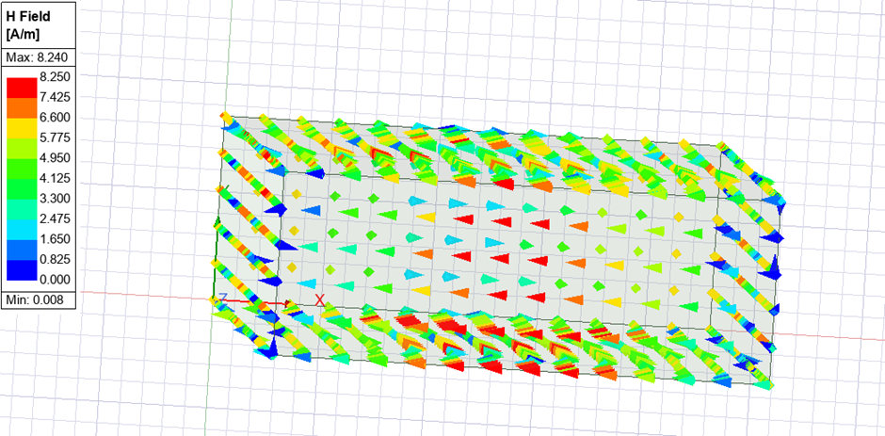
Figure 37 – Vector H Mode 1
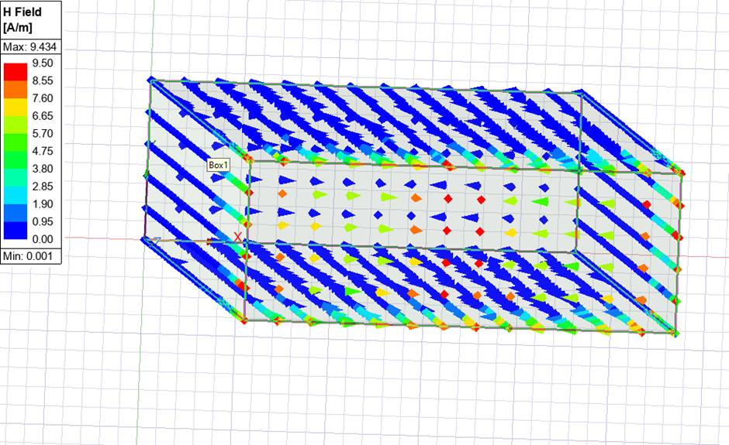
Figure 38 – Vector H Mode 2
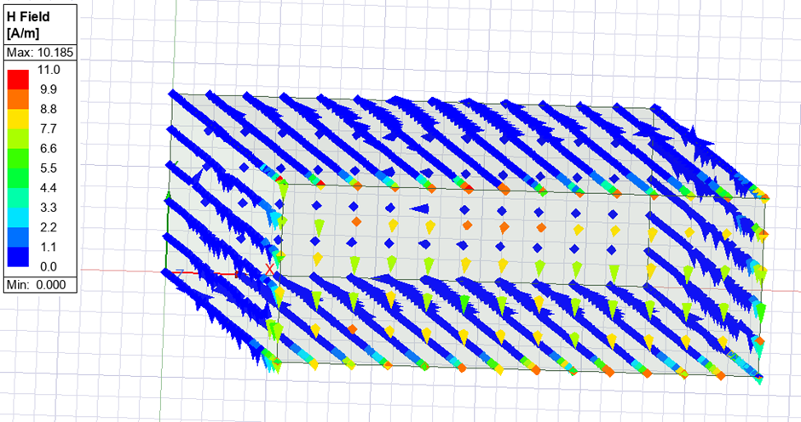
Figure 39 – Vector H, Mode 3
The above figures show propagation of the magnetic fields in each of the modes as well as the behaviour within the waveguide structure.

4.3.2.5 Cut-off Frequency
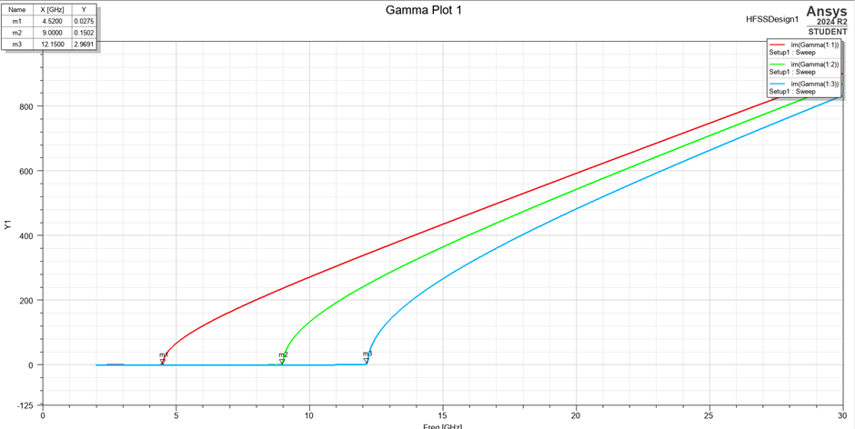
Figure 40 – Teflon Cut-off Frequency
Figure 40 indicates the frequencies at which the Teflon waveguide would see in order to work.
To calculate the cut-off frequency theoretically the equation below can be used.
$$fcmn=\sqrt{2C\frac{\left(a\right)}{n}2}+\frac{\left(n\right)}{b}2$$
Where $C=3×{10}^{8}$

4.3.2.6 Teflon Comparison
Consistency throughout each mode can be seen in the electric and magnetic field. There is variation between each of the modes which is expected due to the difference within the mode dominance.

4.3.4 Comparison – Teflon and Vacuum
From the above results the behaviour and propagation of the Teflon and Vacuum waveguide can be conducted. It can be seen that the mode dominance in both is almost identical. However, there is variation between the materials, when in their corresponding modes, in the way that the wave propagates throughout the entirety of the waveguide.

Task 2

5.1 Task Description
Task 2 asks that a halfwave dipole antenna with a radius of 1mm be designed. The intent of the antenna is to radiate electromagnetic waves with a wavelength of 231mm. The antenna is to be designed with PEC and excitation applied through the lumped port with the port impedance being 50 Ohms.

Method

5.2.1 Calculations
The length of a alf wave dipole antenna can be calculated using the following equation.
$$L=λ/2$$
Where $λ=wavelength$
And wavelength = 231mm
Thus :
$$L=\frac{231}{2}=115.5mm=0.1155m$$
The operating frequency for the waveguide can be calculated using the following equation.
$$f=\frac{C}{λ}$$
So $f=\frac{3×{10}^{8}}{231}= 1.3GHz$

Structure
The half-wave dipole antenna is designed with PEC material. A 50 Ohm excitation was applied via the lumped port of the antenna. A regular radiating surface was designed within ANSYS and the half-wave dipole was designed within this surface.

Results

5.3.1 Evaluation of Radiation
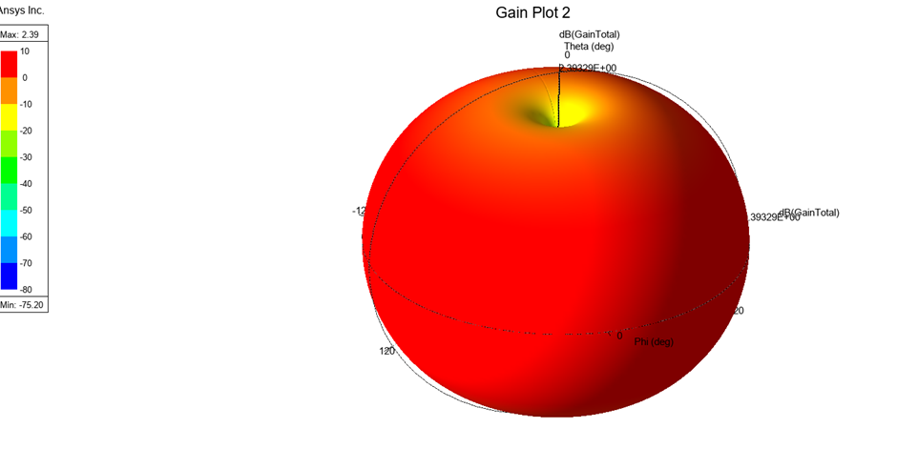
Figure 41 – Antenna Radiation Pattern
Figure 41 above shows the radiation of the antenna. It can be observed that a spherical radiation pattern has occurred. This type of radiation would be suitable for use when sending a signal to somewhere with specific coverage.

S-Parameter Plot
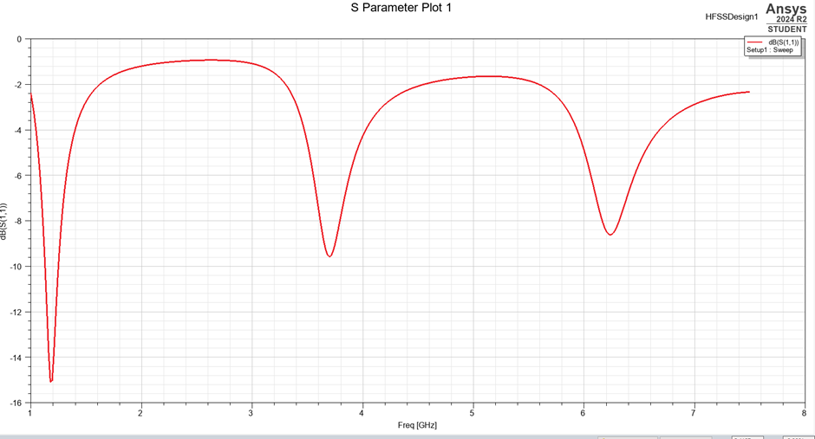
Figure 42 – S-parameter Plot
Figure 42 shows the S-parameter plot for the antenna. The operational frequency can be identified from this plot. This is done by locating where the reflection coefficient S11 reached its lowest value. ANSYS allows the user to make a pin at a certain point to see the exact coordinates of a peak or a trough. In this case this was not done however by reading from the graph, this can still be estimated. The graph shows a minimum at around 1.19GHz.

Comparison of Theoretical and Simulated Data
The simulated data on the S-Parameters plot showed that the operational frequency of the antenna was around 1.19GHz whereas calculated it was said that the operational frequency would be 1.3GHz. Although the results differ slightly there is a very small difference. The slight differential is to be expected when working with simulation boundaries.

Conclusion
From this report it can be said that ANSYS is a useful source for calculating and presenting results and behaviours within electronic systems. It allows the user to visualise more than what would be see if just theoretically calculating. However, there is some differences in results and the results seen from the simulation should always be checked and validated via mathematical calculations.
The variation between materials within the boundaries of the simulation showed just how much the boundary conditions can affect and alter results of a simulation. Thus, proving the need to ensure that accurate conditions are added when designing.

Bibliography

[1] | BBC Bitesize, “Electromagnetic waves - Properties, uses and hazards of electromagnetic waves - OCR Gateway - GCSE Combined Science Revision - OCR Gateway,” BBC Bitesizde, [Online]. Available: https://www.bbc.co.uk/bitesize/guides/zd2ddxs/revision/1. [Accessed 23 April 2025].
[2] | R. Hinrichs, P. P. Urone and S. Beceiro-Novo, “The Electromagnetic Spectrum,” in ISP 209: The Mystery of the Physical World, https://openbooks.lib.msu.edu/collegephysics/chapter/the-electromagnetic-spectrum/, 2012, p. 27.
[3] | R. Y, “What are Waveguides? Definition, Types, Modes, Parameters, Advantages and Disadvantages,” Electronics Desk, 29 December 2018. [Online]. Available: https://electronicsdesk.com/waveguides.html. [Accessed 17 April 2025].
[4] | R. Halir, P. J. Brock, P. Cheben, A. Ortega-Monux, C. Alonso-Ramos, J. H. Schmid, J. Lapointe, D.-X. Xu, J. G. Wanguemert-Perez, I. Molina-Fernandez and S. Janz, “Laser and Photonics Reviews,” vol. 9, no. 1, pp. 25-49, 2014.
[5] | “Basic Rectangular Waveguide Theory,” Cadence, 2021. [Online]. Available: https://resources.system-analysis.cadence.com/blog/msa2021-basic-rectangular-waveguide-theory. [Accessed 23 April 2025].
[6] | X. C. Tong, “Fundamentals and Design Guides for Optical Waveguides,” in Advanced Materials for Integrated Optical Waveguides, 2013, pp. 1-51.
[7] | Allaboutcircuits.com, “Waveguides | Transmission Lines | Electronics Textbook,” 2015. [Online]. Available: https://www.allaboutcircuits.com/textbook/alternating-current/chpt-14/waveguides/. [Accessed 23 April 2025].
[8] | “Waveguides,” www.antenna-theory.com, [Online]. Available: https://www.antenna-theory.com/tutorial/waveguides/waveguide.php. [Accessed 23 April 2025].
[9] | Creative AT, “Waveguide: A Look at Modern Applications,” Electrical & Electronics Engineering, 24 September 2023. [Online]. Available: https://www.engineeringdone.com/electronics/waveguide/. [Accessed 23 April 2025].
[10] | R. Sheldon, “What is antenna? - Definition from WhatIs.com,” SearchMobileComputing, February 2023. [Online]. Available: https://www.techtarget.com/searchmobilecomputing/definition/antenna. [Accessed 23 April 2025].
[11] | T. A. Miligan, “Modern Antenna Design,” Hoboken, N.J, Ieee Press, 2005, pp. 1-4.
[12] | H. J. Visser, “Antenna Theory and Application,” Chichester, West Sussex , John Wiley and Sons, 2012, pp. 1-2.
[13] | Elprocus , “Dipole Antenna : Design, Working, Types & Its Applications,” ElProCus - Electronic Projects for Engineering Students, 05 March 2022. [Online]. Available: https://www.elprocus.com/dipole-antenna/. [Accessed 2025 April 24].
[14] | S. Ramo, T. Van Duzer and J. R. Whinnery, “Fields and Waves in Communication Electronics,” Cananda, John Wiley & Sons, 1994.
[15] | Antenna Theory.com, “(Half-Wavelength) Half-Wave Dipole Antenna,” antenna-theory.com, [Online]. Available: https://antenna-theory.com/antennas/halfwave.php.
[16] | TutorialsPoint, “Antenna Theory - Half-Wave Dipole - Tutorialspoint,” www.tutorialspoint.com, [Online]. Available: https://www.tutorialspoint.com/antenna_theory/antenna_theory_half_wave_dipole.htm. [Accessed 24 April 2025].
[17] | R. Dickes, “Explosives Safety: Safety Strategies for Operating Electroexplosive Devices in a Radio-Frequency Environment,” SPE International Conference on Health, Safety, and Environment in Oil and Gas Exploration and Production, 2002.

