BMSK 5003

Understanding and Engaging in the Customer Experience

Student Name: Ekos-libinza Manzumba

Student Number: 1605765

Table of Contents
Introduction 3
Company Background 3
Critically analysing the factors that impact on organisations ability to maximise customer value 4
The Dimensions of Customer Value 4
Factors which impact customer value 4
Steps to Creating More Customer Value 8
Strategies to Cope with Large Variety 9
Critically understanding of organisations quality systems and their effectiveness in meeting customer requirements. 9
Effectiveness in meeting customer requirements 14
Critically evaluating the benefits and challenges of developing and maintaining good customer relationships 16
Benefits of CRM 17
Challenges of Customer Relationship Management 18
Conclusion 19
Reference 20

Introduction
The customer is very important for any organisation so, almost all the organisation desire to have a good and reliable strategy to maintain an effective and efficient relationship with them. One of the most important objective objectives of CRM is to manage or justifying the customers’ expectations and to offer them so, that they become a loyal and profitable customer for the organisation (Shen, Chen & Wang, 2016). But there are various variables that can directly or indirectly influence the customer-company relationship. Almost all the theories of CRM are to reduce the negative effect of those variables and to predict customer behaviour. Moreover, to manage the customer expectation organisation can use those theories and practises. CRM helps an organisation to create a competitive advantage over Quality, Price and Time so that organisation can increase market share.

Company Background
“The Golden Chippy” is one of those which are very popular Fish and Chips Takeaway in Greenwich, London and this restaurant offer variety of foods and beverage mostly Seafood, Fast Food, British local food. Use of theories and techniques to manage customer relationship with all customer enable this organisation to create maximum value for the customer. I am very happy and proud to be the manager of this restaurant.

Critically analysing the factors that impact on organisations ability to maximise customer value

The Dimensions of Customer Value
Before identifying the factors impact upon the customer value, we need to have good knowledge of Dimensions of Customer Value.
Conformance to requirements: As a manager before offering any product to my customer I must need to identify their wants and needs. Proper market mediation will enable me to analyse the nature of the demand of the customer (Duane Windsor, 2017). For this, I can use three principles which are…
- Closing the communication loop where I need to organised supply chain to have an appropriate track on material and product in real time.
- Sticking to a rhythm across the supply chain for which my organisation uses Zara’s SCM Strategy to make my supply chain fast and responsive.
- Leveraging capital assets which need me to invest me on in production and distribution facilities of my organisation.
Product selection: To create value for my customer I always try to bring proliferation and variation in my product options like for example I try to offer like mega-stores that allow “The Golden Chippy” one-stop shopping for a large variety of products.
Price and brand: I have noticed that price and brand value of the organisation influence customer in their buying decision (Worster, 1994).
Value-added services: Organisation which offers additional services like aftersales services can create more values for the customer and those organisations able to differentiate them from their competitor.
Relationships and experiences: Special custom features to improve customer relation makes it harder for customers to switch to another provider so, an organisation can increase customer value by influencing customer experience with them (Goodman, 2009).

Factors which impact customer value
Hallowell (1996) stated that the better the relationship with the customer, the easier it is to conduct business and produce revenue by making customer satisfied and loyal to the organisation. The variance between what a customer gets from the product of “The Golden Chippy”, and what he or she has to give like money in order to get it is the value for the customer. The overall business model of this restaurant will establish or define how will the organisation create value for the customer and various strategy of the organisation help to create value for the customer.
Accessibility: Like for example as a manager of “The Golden Chippy” I need to ensure that all possible customers can find and access our products and services efficiently, without barriers and resistance, on all available channels (Worster, 1994). Moreover, I ensure all the service so that they can take their purchase decision from my organisation.
Quality: “The Golden Chippy” always committed to providing the best product and service at a reasonable price to the customer so that I can offer a new customer. Moreover, to bring back lose customer I offer them with their desired product. This helps me to create values even for the lost customer and also help me to gain them mine by adding them in total customer base.
Navigation: I need to manage our web site navigations so that new customer get enough information to effective keyword search or filters the information from our online source. Moreover, navigation helps my organisation to influence new customer and to add them to the total customer base.
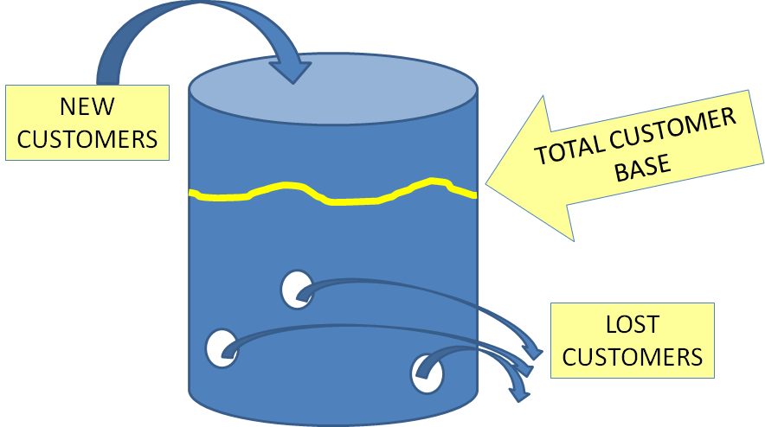
Figure: The Leaky Bucket Theory (Worster, 1994).
Language: In the city of London there are many visitors who visit my restaurant so, for the new customer from other countries I offer them with their native language which enables them to good communication with us. This is very helpful to make them include in our total customer base.
Memory: I store customer data and to do so I use the ERP system so that I can manage customer data and trach the buying behaviour of the customer. Like for example almost in most of the cases, existing customer need not repeat themselves which enable me by remembering customer’s needs and wants so that I can offer according to the buying behaviour (Christopher, and others 2012).
Price and Time: As a manager of “The Golden Chippy” I always try to supply the demanded product in time with reasonable time so that my customer does not think like they have west their money. Use of proper MIS and SCM my staff can handle various demand of the customer my maintaining total quality. SCM enables me to produce just in time product manufacturing which is very convincing for my new and existing product. The customer becomes satisfied by getting their desired product and services in time and with reasonable price.
But as “The Golden Chippy” is related with both product and service provider I do not think only Leaky Bucket Theory is enough for my organisation. So, I use Porter's Value Chain Model which I think very efficient for my organisation to understand the customer expectation of my customer. Lee & Yang (2000) stated that value chain model differences among competitor value chains are a key source of competitive advantage so, to create a competitive advantage I use this model for my organisation.
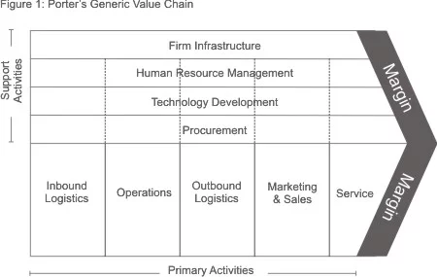
Figure: Porter's Value Chain Model (Rayport, & Sviokla, 1995).
In this model, we see a chain of activities and system which can be divided into primary and support activities for my organisation. All those activates helps my organisation to need the expectation of the customer by creating maximum value for them.
Primary Activities
In “The Golden Chippy” this activity is like physical creation, sale, conservation and support of a product or service and those activities can be divided into...
Inbound logistics: Activities, like receiving, storing, and distributing inputs like raw materials internally, are the key activates in my organisation (Christopher, and others 2012). For doing these activities properly I use effective SCM strategy. My supply chain management strategy enables me to respond to customer requirements by implementing just in time delivery system. I use Zara’s SCM strategy for effective SCM in my organisation.
Operations: The transformation activities of my organisation are very much productive with highly efficient cooker and quality full inputs also have a great contribution to creating maximum value for my customer. I try to create value for my organisation and for my customer to create value and I use the latest technology and lean production system for my restaurant.
Outbound logistics: These activities are related to all those activities which are anyhow related to delivering my product or service to the end user. Use of MIS with proper ERP in my organisation enables me to the collection, storage, and distribution systems very effectively and efficiently.
Marketing and sales: All the activities related to making clients visit my restaurant are part of these activities (Snipes and others 2002). Use of digital technology and ERP system enable my organisation to store customer data and use those to communicate them which create value for them. I am trying to create a compelling brand for my organisation and use of gap model service I am able to reduce the gap among my organisation and my customer.
Service: All the activities related to maintaining the value of my product or service to my customers are under these activities like for example after seals services, exchange offer, order cancellation and so on are part of this activity in my organisation. Moreover, to make every service available to all customer my organisation uses various promotional tools and care about customers and their outcomes.

Support Activities
Those activities support primary activities of “The Golden Chippy” this brings excellence in primary activities. So, while primary activities are used in my organisation supportive activities helps to measure, monitor, and well implementation of them.
Procurement: “The Golden Chippy” need to depend on various kind of supplier so as a manager of this organisation I need to find vendor and negotiation with them and even I need to manage conflict with them.
Human resource management: As a manager sometimes a need to manage the human resource for my organisation for which I need to implement strategic human resource management. Hiring the right people who have a positive attitude regarding managing human behaviour improve customer service and also reduce turnover.
Technological development: For maintaining technical excellence I always concentrate on latest technology moreover, I use social network marketing to increase web-based sales. To collect customer data, I use various kinds of equipment e.g. computers, electronics, telephones, social media etc. and to use those data I use eCRM like for example, I use ChatterBots which enable me to carry real-time conversations with the visitor of my website.
Infrastructure: Highly decorated infrastructure is needed for both legal, administrative, general management and to attract the customer. So, almost every year I change the layout of my restaurant structure so that my customer get pleasure in “The Golden Chippy”.

Steps to Creating More Customer Value
To drive the growth of my business, need to create more value for my customer so that I can create a true competitive advantage which will help to make customer satisfaction and loyalty (Long and others 2012). Here are some steps I follow to create value for my organisation…
- Understand what drives value for customers for which I talk to them, survey them, and watch their movements and reactions before and after use of my product. I use data mining to collect essential data about the perception of the product of “The Golden Chippy”.
- Understand my value proposition for which I always follow a formula which is like Value customers receive = benefits of a product or service – costs. So, I always try to provide a quality full product with lest price I can.
- Identify new customers for which I target different segments of my customer with a new product and sometimes I search for new segmentation of customer with the existing product.
- For creating a win-win price I always concentrate on reducing the operating cost of my organisation as there is a few to reduce when my strategy is to maintain the highest quality.
- I always invest in research and development to increase my product line as I am with the same opinion with Draganska & Jain (2006) that expanding a product line is an important growth strategy for small businesses that want to increase revenue or market share of them.

Strategies to Cope with Large Variety
Variety of the customer from different parts of the world I need to maintain large verity on my product moreover in various time of the working day I also require to offer separate food. Here are some strategies used by me for maintaining large verity in my product line.
Build-to-order model: As I use a pull strategy in my organisation in this model, we configure the cooking system and inputs only after orders comes. Like for example for this customer can bring change in the traditional menu of “The Golden Chippy” this also add value for the customer as they get the product as the desire. This also brings flexibility in our production system for which I am able to use just in time delivery to the customer.
Larger Inventories at Major DCs: Although this model is suitable for long manufacturing lead times, I use this to produce the same product. Like for example to deliver a big order in wedding parties or something like that.

Critically understanding of organisations quality systems and their effectiveness in meeting customer requirements.
As I am related with the management of the “The Golden Chippy” I am always trying to the main total quality of my organisation as I think only product quality is not enough to attract new customer and to fulfil their demand. I use various tools and techniques for Quality management system as like Assael (1995) I also think quality management system (QMS) is a collection of business processes focused on consistently meeting customer requirements and enhancing their satisfaction.

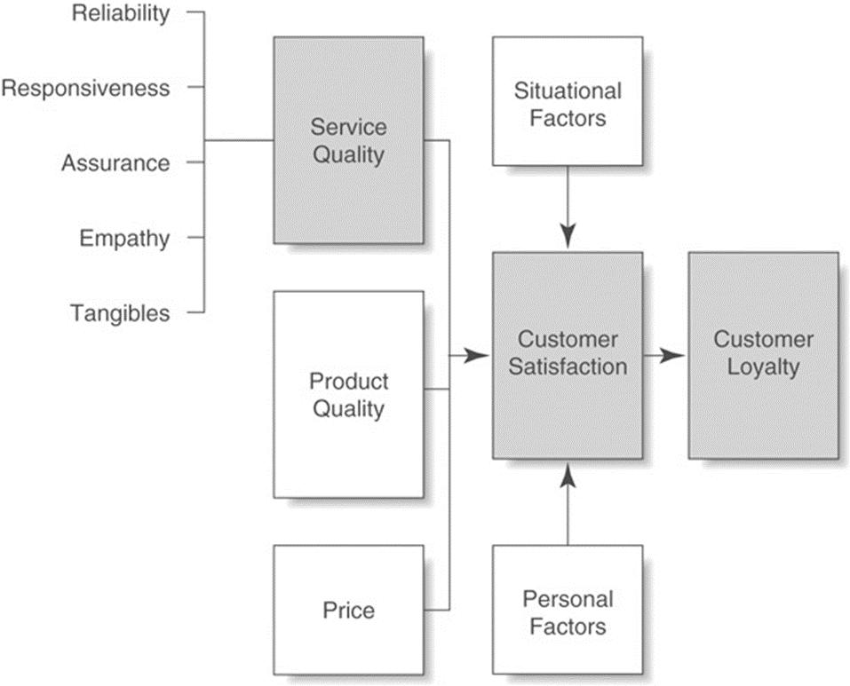
Figure: Customer Perceptions of Quality (Snipes and others 2002).
RELIABILITY: To increase reliability among my customer my organisation provides services that have been promised but in case if there arise any conflict regarding quality I response the problem and take steps to reduce the problem for future. By maintaining error-free records my organisation tries to deliver the right product and services at the right time.
RESPONSIVENESS: I always try to inform my customer what service and product will be available when but we also show our willingness to help customer any time of the day. Moreover, I redesign the process of responding to the customer so that they do not get bored (Greenberg, 2010).
ASSURANCE: To bring assurance in all the activities of my organisation I try to assign staffs who work to instil confidence in customers by making the customer feel safe in their transactions and those staffs have the knowledge to answer customer queries any time for anything.

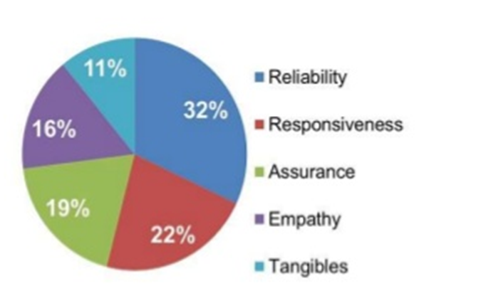
Figure: Service Dimensions customer care about (Christopher, and others 2012)
EMPATHY: I offer convenient business hours for my customer so that I can give customers individual attention and my staff always work to protect customer’s interest for which they are always ready to sacrifice their own interest.
TANGIBLES: Use of modern equipment in almost all the business activities enabling me to have visually appealing facilities which are associated with the service of the “The Golden Chippy”.
Besides those, I always committed to managing total quality for my organisation for which I work with the following element:
Quality policy and quality objectives: “The Golden Chippy” has a very strong quality policy and objectives by which customer can think that this organisation use every available resource to maintain the quality of the product and services of it. This brings a new customer and adds value to them (Christopher, and others 2012).
Quality manual: I fallow ISO 9001:2015 and ISO 9000:2015 quality management system standard and ISO/TS 16949 for maintaining quality management systems for automotive-related products as in my organisation I use the latest technology like ERP, enterprise system software, web-based sales, e-commerce revenue model.
Procedures, instructions, and records: Use of data management software enable me to store and manage procedures, instructions, and records of all the activities of my organisation. This enables me to enhance quality by using historical record regarding the quality of the product.
Data management: For achieving operational excellence and customer intimacy I need to manage customer data along with operational data for which I use Enterprise resource planning which enables me to maintain a centralised database (Shen, Chen & Wang, 2016).
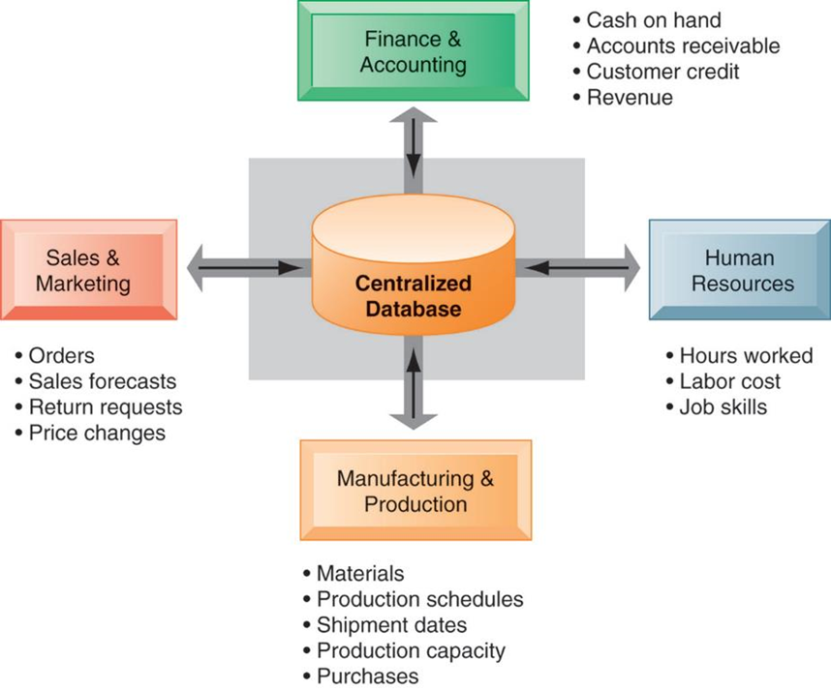
Figure: Enterprise resource planning (E R P) systems (Shen, Chen & Wang, 2016).
Internal processes: The Business value of enterprise systems of “The Golden Chippy” enabling it to increase operational efficiency which accelerates the firm-wide flow of information to support the decision making of my organisation. Moreover, rapid responses to customer requests, the use of appropriate analytical tools with the use of proper evaluation tools and techniques to evaluate overall organizational performance also help me to ensure the total quality of my organisation.
Improvement opportunities: Customers expectations are increasing day by day because of various factors and to cope with this increasing I want to concentrate on innovation. Moreover, the use of a good supply chain relationship strategy like Zara’s strategy is bringing flexibility to establish new relationships with a supplier which also enable me to make my product deafferentation by improving quality.
Quality analysis: For quality analysis, I use various model and techniques like Gaps Model of Service Quality which enables me to reduce the gap in the way of quality services for my customer.

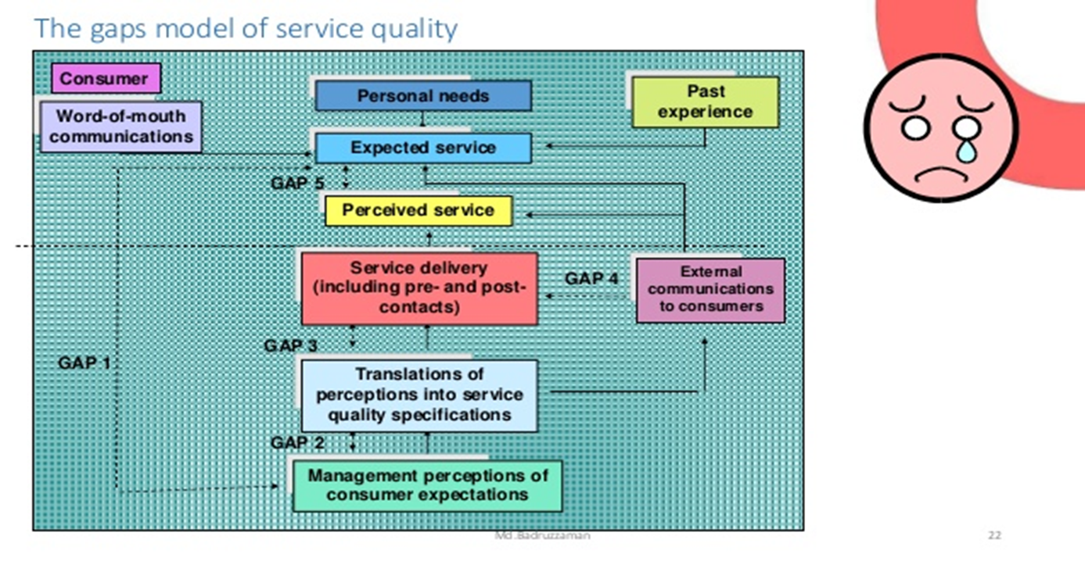
Figure: Gaps Model of Service Quality (Brogowicz, Delene & Lyth, 1990).
- Gap 1: To reduce the gap between customer expectations with the perceptions of the customer “The Golden Chippy” maintain good upward communication and use various tools for market research.
- Gap 2: This gap is between the perceptions of management of customer expectation which result in poor service design absence of customer-defined service standards and something like that. But to reducer this can I always try to understand that actual expectation of the customer and which will maximise their values.
- Gap 3: Use of ERP and other technology help my organisation to reduce this gap like for example human resources module of my organisation enable me to select the best candidate and to train them according to the demand of the organisation.
- Gap 4: To have better communication with the customer “The Golden Chippy” use customer touch point from where the customer can good communication with the management of my organisation. Proper customer management strategy enables my organisation to identify the actual expectations of the customer and to offer accordingly (Bishop, 2012).
- Gap 5: To feel the customer expectation I always try to know the expectation of the customer and I select the right service stander to serve them. This enables me to offer various product with the various price which also attracts the customer.

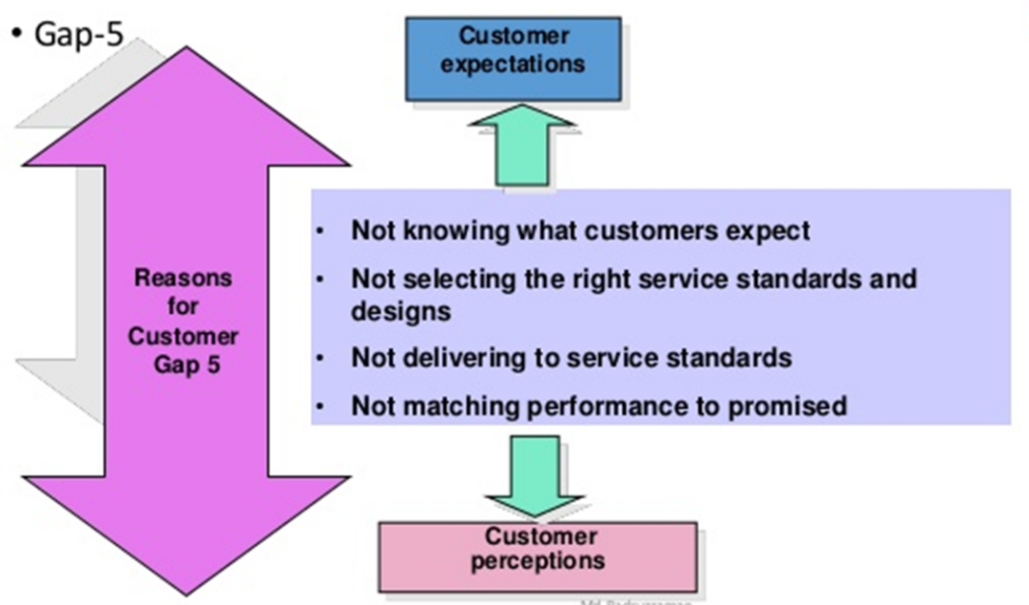
Figure: Reasons for customer Gap 5 (Snipes and others 2002)

Effectiveness in meeting customer requirements
The effectiveness of the quality system depends on how much the customer is satisfied for any organisation so, in my organisation I can measure the effectiveness of my quality system my seeing how much my customers are satisfied. But only reliance on satisfaction surveys can often be misleading as there are many other factors related to the quality measurement techniques (*Leppard and Molyneux, 1994).
The expectation of the customer: The total quality of my organisation enables to fulfil the expectation of my customer as they have their desired product with their lest resources. Moreover, as the quality system of my organisation enabling to improve the quality to cope with the changing demand, it will greatly help me to reduce any gap between customer expectation and our product.
Customer satisfaction: Although measurement of customer satisfaction is very complex quality activities of “The Golden Chippy” is bringing customer satisfaction so, now this organisation is making a customer more satisfied than any other time by creating value for them. As the internal business process is very effective and all resources in the organisation are using to productive work all in the organisation has become more productive (Snipes and others 2002).
Customer loyalty: This is simply analysing customer repurchase patterns based on internal databases or from external sources. Web-based sales, social network marketing e-commerce revenue model enabling me to collect more customer data to analyse their loyalty.
I stated earlier I use ISO 9000:2015 Principles of Quality Management in my organisation to meet the requirement of the customer. Here are some quality management principals under this stander of ISO 9000 which I always promote organizational improvement to meet the expectation of the customer.
Customer focus: Like for example I try to understand the needs and demand of the existing and future customer and align organizational objectives according to those expectations. I measure customer satisfaction to develop closer relation with customer. I use 5 principles that underpin Ethical Food Choices in my organisation (Harrison, 2005) they are-
- We provide all the data about how our food is produced and how much healthy those foods are. But we do not provide all the making process for some of our product to maintain secrecy.
- We try to bring fairness all over the organisation for which we do not impose an unfair price on our product so, we offer our food at a reasonable price.
- We focus on bringing sustainability in our business activities for which we do not influence unnecessary suffering on animals and the environment.
- All the staff in my organisation are entitled to decent wages and working conditions and they get an equal chance to show their excellence. Moreover, healthy and friendly work environment enables to show their best (Buttle, 2009).
- We want to make our customer preserving life and health justifies more than any other needs so, we try to bring good eating to practise for our customer.
Leadership: I have established trust all over the organisation and set challenging goals for my staff so, I can motivate them to do more than now by recognizing their contributions. By establishing a vision and direction for “The Golden Chippy” I try to empower employees but of course under proper accountability and transference (Harrison, 2005).
Engagement of people: To ensure the best use of abilities of my staff I enable their participation in continual improvement by enabling learning and knowledge sharing all over my organisation.
Process approach: All the production system is under a lean production system and just in time delivery system has enabled my organisation to create a pull-based marketing strategy. The capability of activities is frequently measured as all the resources are effectively deployed to create linkages between all the activities.
Improvement: To empower my staff to make improvements I align improvement activities and this helps me to improve organizational performance and capabilities which help me to create more value for my customer.
Evidence-based decision making: As all the data are stored in the central database in ERP, I can ensure accessibility of accurate and reliable data and this system also help me to analyse data from various dimension to used them on decision making.
Relationship management: Zara’s SCM strategy enable my organisation to select suppliers to manage costs, enhance resources, and create value for both my customer and for the organisation.
Berguson, (2002) said that the right CRM solution can help you deliver great and lasting relationships, and he has introduced us with various factors that influence to maintain customer relationship for any organisation especially for service organisation and most of the factors are also applicable for my organisation and as a manager of the organisation I try to concede those factors while developing a CRM strategy for my organisation.

Critically evaluating the benefits and challenges of developing and maintaining good customer relationships
Berguson, (2002) said that the right CRM solution can help any organisation to deliver great and lasting relationships, and he has introduced us with various factors that influence to maintain customer relationship for any organisation especially for service organisation and most of the factors are also applicable for my organisation and as a manager of the organisation I try to concede those factors while developing a CRM strategy for my organisation. But yet I need to face some challenges of developing and maintaining good customer relationships for my organisation.

Benefits of CRM
According to (Gummesson, 2002) Customer Relationship Management of “The Golden Chippy” represents a strategy that demands total devotion and acceptance of the concept from the management of this organisation and this CRM bring some benefits which are like…
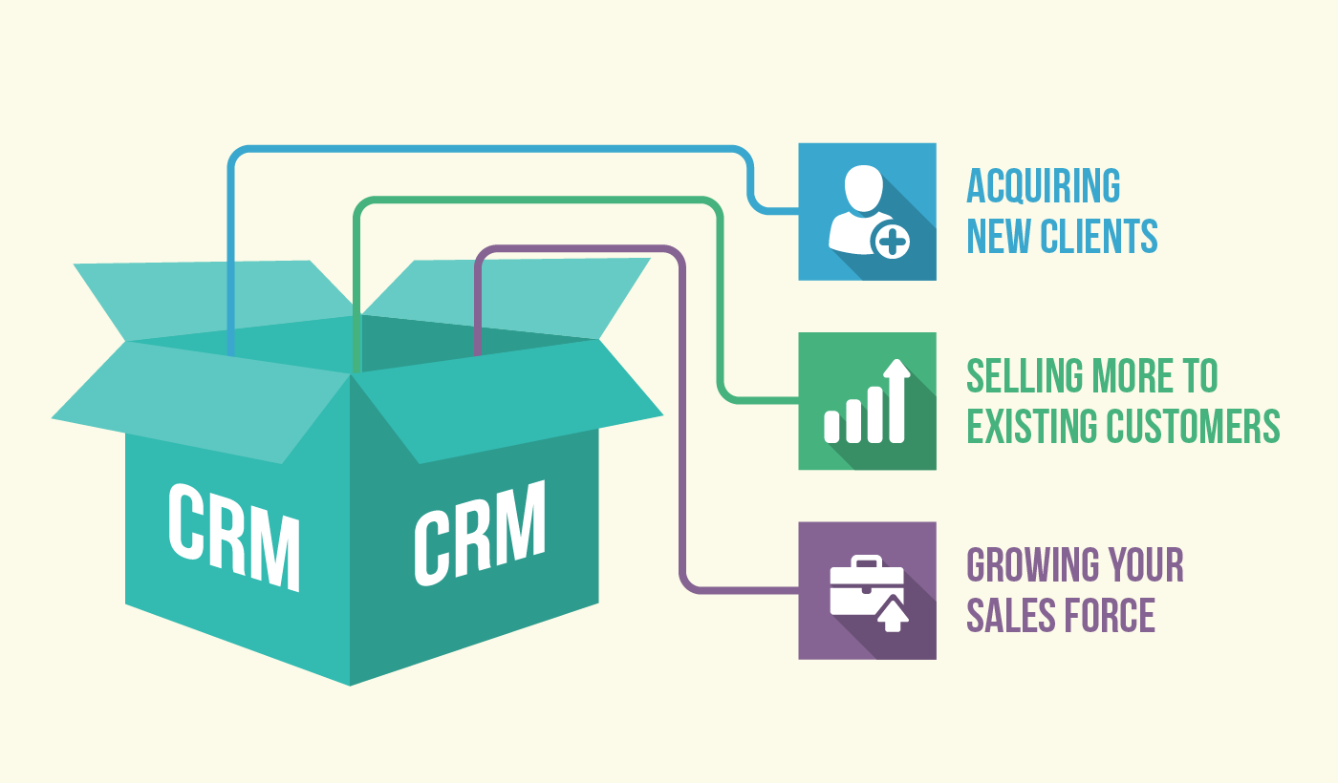
Figure: Benefits of CRM (Bishop, 2012)
- CRM can be used for enhanced communication with the possible customer which enable the organisation to attract them and to offer them with their product line. Quality database about customers enables my organisation to achieve interaction with customers.
- CRM able to acquire a new customer for “The Golden Chippy” in this regard Gummesson, (2002) stated that CRM for an organisation is a cyclic process implies running of various activities and he concentrates on 4Ps instead of redactional marketing activities.
- As a manager of “The Golden Chippy,” I always try to the identification of relationship partners to develop and maintain relationships with my existing customer which enable me to increase sales on an existing customer.
- Under CRM I make customer segmentation, target them and try to maximise value for them by increasing the sales force capacity of my organisation.
- Use of CRM strategic phases enables me to use technology to maintain relationships with my customer and to cullet and use customer data to build and strengthen the relationship.

Challenges of Customer Relationship Management
Here are some challenges I need to face while developing and maintaining good customer relationships...
- Assael, (1995) stated that buying behaviours of the customer are changing so, the introduction between organisation and customer is reducing. So, it is creating a problem to identify the requirements of the customer which create a problem for the organisation.
- Although “The Golden Chippy” use ERP for managing customer data this organisation needs to face the problem as there are too much data to analyse.
- Most of the organisation are using IT to create value for the customer but yet as value changes over time organisation need to invest in IT frequently which increasing operational cost. As investment in IT take a long time to get back the initial capital.
- Although my organisation various techniques to reduce the gap as it is a continuous process after reducing one gap, we see another gap (Bishop, 2012).
- In most of the cases, customers are not following Customer Purchase Cycle for which organisation are becoming fail to evaluate the value of a customer so, it is making the equation of cost and benefit of interactions unbalanced.
- Now the customer is less agreed to provide personal data in real life so it creates a problem to collect demographic information so, it creates problem to the target customer.
- Customers lifecycle has become very diverse so now organisation cannot predict it so, organisation fail to deliver appropriate products and services.

Conclusion
This report is prepared based on my understanding capabilities along with engaging with customer experiences. To have a comprehensive view of customers organisation now collect customers data like for example from customer touchpoint. Those data are used for customer target and to make relation with them (Goodman, 2009). But there should maintain privacy about the data of the customer for which there should be specific guidelines and instruction. And all the organisation must need to follow that guideline and instructions and they must be careful about the privacy of the customer data. Customer needs to be careful when they provide personal data through online media or another way.

Reference
Assael, H. (1995). Consumer Behavior and Marketing Action. 5th ed. Cincinnati, Ohio: South-Western College Pub.
Assael, H. (1995). Consumer Behaviours and Marketing Action. 5th ed. Cincinnati, Ohio: South-Western College Pub.
Berguson, B. P. (2002). Essentials of CRM: a guide to customer relationship management.
Bishop, T. (2012). Principles of Marketing Management New Delhi: World Technologies.
Brogowicz, A. A., Delene, L. M., & Lyth, D. M. (1990). A synthesised service quality model with managerial implications. International Journal of Service Industry Management, 1(1), 27-45.
Buttle, F. (2009). Customer Relationship Management: Concepts and Technologies. 2nd ed. Amsterdam: Butterworth-Heinemann.
Christopher, M., Payne, Adrian, & Ballantyne, David. (2013). Relationship Marketing: Creating Stakeholder Value. Saint Louis: Taylor and Francis.
Draganska, M., & Jain, D. C. (2006). Consumer preferences and product-line pricing strategies: An empirical analysis. Marketing Science, 25(2), 164-174.
Duane Windsor, (2017). Value Creation Theory: Literature Review and Theory Assessment, in (ed.) Stakeholder Management (Business and Society 360, Volume 1) Emerald Publishing Limited, pp.75 – 100
Goodman, J. A. (2009). Strategic customer service: managing the customer experience to increase positive word of mouth, build loyalty and maximize profits.
Greenberg, P. (2010). CRM at the speed of light: social CRM strategies, tools and techniques for engaging your customers.
Gummesson, E. (2002). Total Relationship Marketing: Marketing Strategy Moving from the 4Ps product, Price, Promotion, Place of Traditional Marketing Management to the 30Rs the Thirty Relationships of a New Marketing Paradigm. 2nd ed. Oxford: Butterworth-Heinemann.
Hallowell, R. (1996). The relationships of customer satisfaction, customer loyalty, and profitability: an empirical study. International journal of service industry management, 7(4), 27-42.
Harrison, R. (2005). The Ethical Consumer. London: SAGE.
Lee, C. C., & Yang, J. (2000). Knowledge value chain. The Journal of Management Development, 19(9), 783-794.
Leppard, J. and Molyneux, L. (1994). Auditing Your Customer Service: The Foundation for Success. London: Routledge.
Long, C. S., Khalafinezhad, R., Ismail, W. K. W., & Rasid, S. Z. A. (2013). Impact of CRM factors on customer satisfaction and loyalty. Asian Social Science, 9(10), 247.
Rayport, J. F., & Sviokla, J. J. (1995). Exploiting the virtual value chain. Harvard business review, 73(6), 75.
Shen, Y. C., Chen, P. S., & Wang, C. H. (2016). A study of enterprise resource planning (ERP) system performance measurement using the quantitative balanced scorecard approach. Computers in Industry, 75, 127-139.
Snipes, R. L., Oswald, S. L., LaTour, M., & Armenakis, A. A. (2005). The effects of specific job satisfaction facets on customer perceptions of service quality: an employee-level analysis. Journal of business research, 58(10), 1330-1339.
Worster, T. (1994). Modelling deterministic queues: The leaky bucket as an arrival process. In Teletraffic Science and Engineering (Vol. 1, pp. 581-590). Elsevier.

