Terrence Thomas report
This report is regarding effective communication in the workplace
Certificate of Higher Education – Skills for the Workplace
effective team-working and communication
05/07/19
BMSK4002

executive summary

This report is to assist you, with the growth of your business Mr Terrence Thomas. The report will include, teamwork strategies to create effective teams, including the Belbin and Dr Bruce Tuckman’s theory, also in this report will include communication strategies, including Shannon Weaver model, The Communication cycle and Berlos model, these will help the rapid expansion to prosper effectively.
Here I will share with you my business consultancy skills, to insure I assist you, with achieving a more formal approach with these aims, to ensure your business runs smoothly.
The major factors we face, are that there are no current communication strategies in place, and currently no formal teams, only ad hoc ones. In order to move forward, we must engage in communication strategies and create effective teams.
These findings will be applied, for his business to move forward. If he follows my recommendations, I have presented to him, his business should flourish.
As a business consultant I have offered to assist him in achieving these aims.
Yuens, (2017)

contents list
PAGE 0 – TITLE PAGE
PAGE 1 - EXECUTIVE SUMMARY
PAGE 2 – CONTENTS PAGE
PAGE 3 – INTRODUCTION
PAGE 4,5,6,7,8,9,10,11 – MAIN BODY
PAGE 12 – FINDINGS
PAGE13 – RECOMMENDATIONS
PAGE 14 – ACTION PLAN
PAGE 15/16 – REFERENCE LIST

introduction
The importance of strong communication runs deep within a business. Here are five key reasons you should be paying attention:
Team building – Building effective teams in your workplace will help massively by implementing strategies, it’s all about how employees communicate with each other, and how they can form successful teams from the team working theories, such as Belbin and The Tuckman theory.
Give everyone a voice – Have an open-door policy, where the employees can come to you with questions, and problems about the store. Employee satisfaction, they can rely a lot on having a voice, and be listened to. This shouldn’t matter with their position, level of ability to freely communicate with colleagues and managers such as yourself.
Innovation – Where employees can communicate freely without ridicule when bringing ideas to the table. Organisations such as yours should encourage communication, then it is likely to be an innovative one.
Growth = Communication internally and externally is very important, having strong lines of communication will ensure the message is consistent and that you’re getting the correct message across. Any growth in your company relies on strong communication with all employees and managers being on the same wavelength.

Strong communication - When managers are strong communicators, they are better able to manage their teams. The delegation of tasks, conflict management, motivation and relationship building (all key responsibilities of any manager) are all much easier when you are a strong communicator. Strong communication is not just the ability to speak to people but to empower them to speak to each other

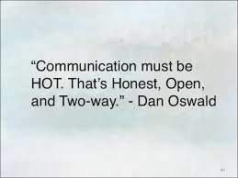(LinkedIn Corporation © 201

main body
I believe as a business consultant, effective communication and delegating in various zones of influence is required. For the continued success of your business, you must do the following, you must focus on results not politeness, if feelings get hurt that’s too bad there are bigger things at stake, many changes will happen with expansion. you must communicate with the 3 managers and give incentives. Communication between you and your managers is now of utmost importance. Firstly – arrange management meetings every week to plan and address problems from the previous week and a plan to move forward for the next week, email all details to managers regarding their next shifts and any changes that will affect them and their employees or the business. Secondly – you must arrange team meetings for staff once a week to resolve problems and plan for the near future. Everyone working for your business should have a voice, purpose and tasks to get on with. Always welcome new ideas from employees, managers and customers, have an open-door policy, where team members can come to you with new ideas and problems anytime. Workplaces who have better communication are more likely to be an innovative one. Checking in with your employees on a weekly or monthly basis is important, to discuss their thoughts on tasks or the organization, this will empower your employees and keep them comfortable in the position they are in.
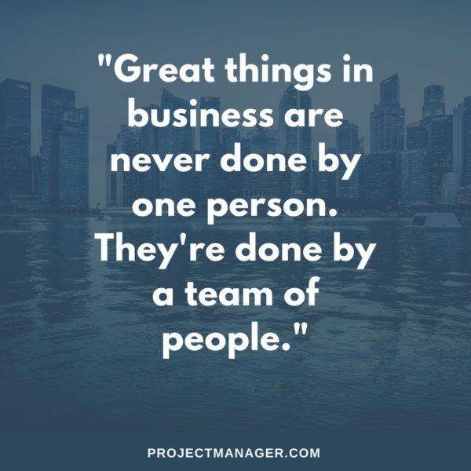
PayScale, (2019) ProjectManager.com, Inc. (2019)

The communication cycle

“What Is the Communication Cycle?
Communication is one of the most vital elements of society. People need people, and to interact, it's essential they be able to convey messages and understand each other. The communication cycle expresses how the system of conveying and understanding messages operates.” Study.com, (2019).

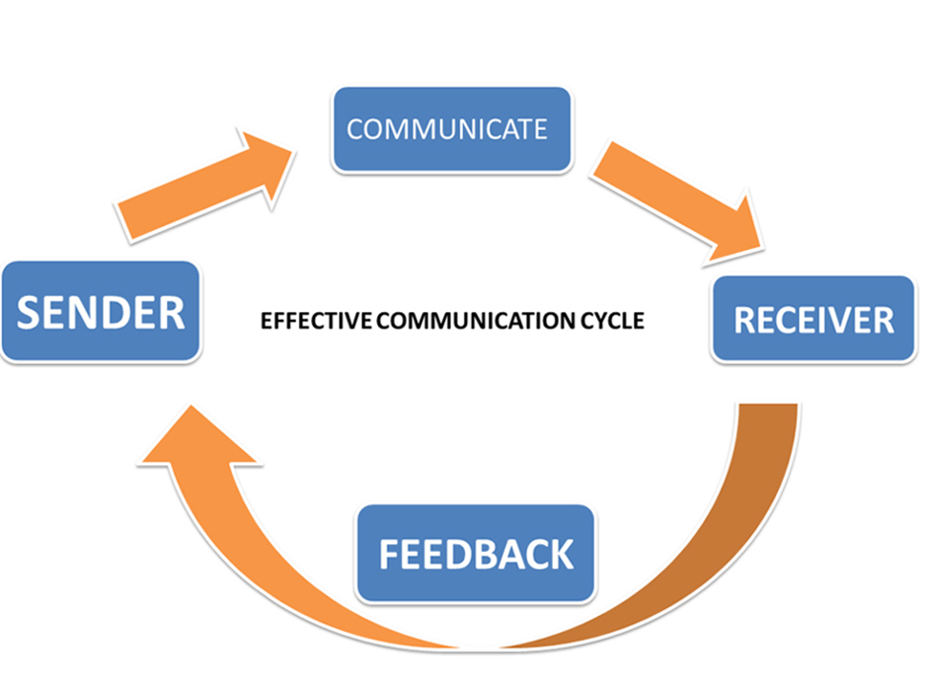study.com, (2019)

This basic model shows how we communicate to the receiver, give feedback to the sender and circulates to create conversation. This is an ongoing process and do this the correct way you should take on feedback for your rapid business expansion to run smoothly.

“Concepts in Shannon Weaver Model

Sender (Information source) – Sender is the person who makes the message, chooses the channel and sends the message.

Encoder (Transmitter) –Encoder is the sender who uses machine, which converts message into signals or binary data. It might also directly refer to the machine.

Channel –Channel is the medium used to send message.

Decoder (Receiver) – Decoder is the machine used to convert signals or binary data into message or the receiver who translates the message from signals.

Receiver (Destination) –Receiver is the person who gets the message or the place where the message must reach. The receiver provides feedback according to the message.

Noise –Noise is the physical disturbances like environment, people, etc. which does not let the message get to the receiver as what is sent.” Businesstopia,(2019)

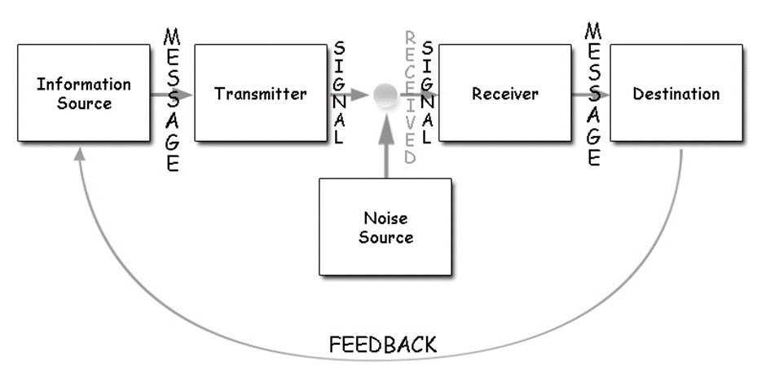 Businesstopia,(2019)

Tuckman Theory 1965

I strongly advise you to use team building exercises to bring together individuals and create strong teams. I would recommend a theory called Dr Bruce Tuckman’s theory, it’s the most influential model to build a team. This model represents the stages that groups need to go through to grow as a team, it consists of 5 steps, here are the 5 steps…

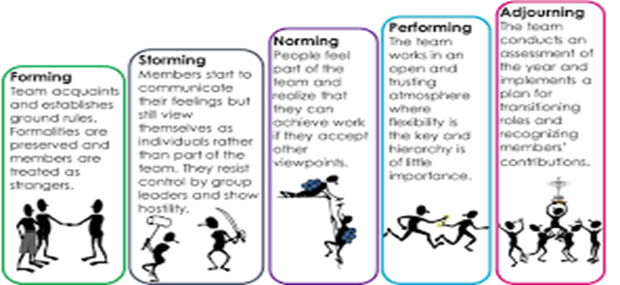 Linked In (2019)

The first stage is called Forming – This is stage is where your employees will discuss skills, background and interests, project goals, timeline, individual rules and team establish some ground rules.

The second stage is called Storming – This Is where teams communicate with their feelings, voice opinions, question guidance from group leaders and some conflict occurs.

The third stage is called Norming – people start to notice and appreciate their team members. Groups settle in the groove and the team starts to contribute with the task.

The fourth stage is called the Performing – Team members are motivated, confident and familiar. The team can also work without supervision. Everyone is on the same page and is driving full speed ahead to get to the end goal.

The fifth and final stage is called adjourning – This is where the team members reach the end of the task that’s been set. In many occasions’ employers wish to keep the momentum going and that will then keep the workforce happy, satisfied and bring together a solid team.

The Belbin Theory

I also would recommend you use the Belbin theory on team building, this theory was created in 1981 by Dr Meredith Belbin. This key conclusion that now forms an essential part of most businesses and management courses, is that effective team members must cover 9 roles.

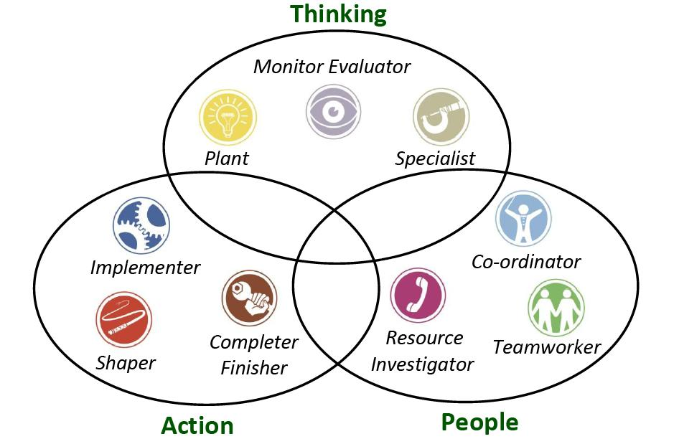
A Lean Journey Blog, (2019)

The 9 traits consist of 3 types of traits.
Using the correct personalities in the right teams will be much more effective and business will run a lot smoother.

Doing
Implementer – The implementer turns ideas into action, without one of these people in your team, you may get very little done. They are seen to be unimaginable.
Shaper – The shaper is a proactive achiever, high energy, courage to overcome obstacles. Sometimes conflict occurs as they can come across as difficult with aggression.
Completer – Finisher – The completer is a slow and meticulous person which can annoy team members and Keeps everyone to schedule, they always make sure the work is good quality and always finished on time.

Thinkers
Plant – The team communication is poor and overlook important detail. The plant is unorthodox they always think they have the right way and can’t see other team members ideas.
Monitor – Evaluator – They can dampen the mood of the group by being overly critical, most appear to lack drive and evaluate the progress.
Specialist – This trait often resists attempts to try any other roles. The Specialist brings skills in short supply, they only contribute on the technical front, but this is essential to the success of the team.

Relationships
The Co-Ordinator – This personality will be the leader of the group and work to co-ordinate the effects of others. Sometimes the role can be too controlling, and this can be difficult for other team members. This role will see the result, delegate and promote decision-making.
“Team Worker - This role is concerned with ensuring effective interpersonal relationships with the team. This role is the sensitive heart of the team and will console the slightly damaged team member and suggest that the aggressive shaper cools it abit. This role, being concerned with relationships, can lead to conflict with more task-orientated team members. This role creates team cohesion and generally eases conflict.
Resource – Investigator – This role is a supreme networker, enabling them to collect resources and external know-how. This ability to network and gain resources and political support is essential to successful teams. In many ways this role is the PR person for the team. They can appear to do very little real work because networking is an unseen art.” (The Business Skills Handbook)

Do you every wonder why some teams work, and others don’t?

That’s because in order to create an effective team you must add the correct personality traits, in order to do this, you must use this Belbin theory and a questionnaire and then carefully place individuals into teams and watch them grow.
For you (Mr Thomas) to run an effective business he must engage in these theories as stated in my recommendations. The first objective would be to form an effective strategic plan. This plan will include communicating effectively to the staff/employees, in order to communicate correctly I recommend that we should start by introducing the Shannon Weaver model on communication. Secondly in addition we must look at formulation an effective team strategy, this will include the Tuckman theory, which has five stages which the team must endure to become a competent team.
We must set goals, to keep employees working harder, better and to keep their spirits high with memorable incentives.

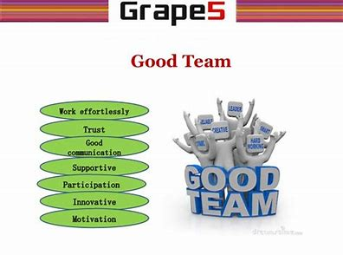Grapes (2019)

FINDINGS
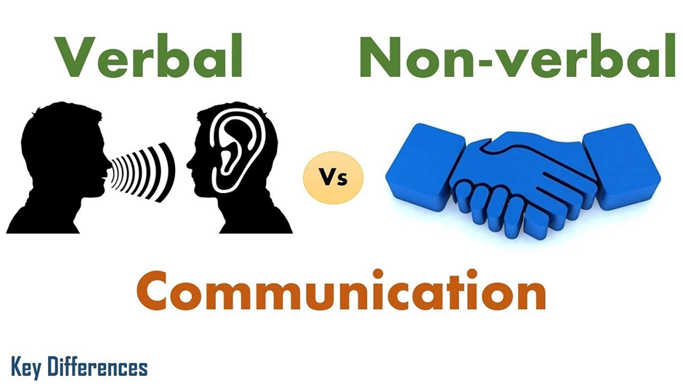

Key differences, (2019)

In business verbal and Non-verbal is very important, it should always be in line with what you are interpreting for employees, to receive the correct message.
Verbal communication is where thoughts are formulated before expressed verbally to others, this is a two-way process. I would advise you to verbally communicate with your managers and employees doing morning speeches such as a quick thank you for yesterday’s work and explain hitting targets today and give incentives. Weekly presentations should cover issues raised last week, any questions staff have, explain new products and how grateful you are for such good staff. You could take this time to also choose individuals for effective teams.
Communication must be consistent, straight to the point, non-offensive and strong.
Always inspire, persuade and resolve.

recommendations

- Allocate a manager on all shifts – To become a more effective workplace with structure.

- Get a temporary sales assistant to fill the position of the employee on long term sick.

- Start an open-door policy in near future – To be open to new ideas and employees can come to you will any problems they have.

- Communication strategies – The Shannon Weaver Model and Effective Communication Cycle. As you know communication is everything in business, verbal and non-verbal communication should be in line with what your interpreting to employees.

- Team building strategies – the best team building exercises to use are the Belbin theory and the Tuckman theory, these are great to form effective teams from individuals and use their traits to get tasks complete in a competent way.

Action plan

Here is the action plan to improve your business…

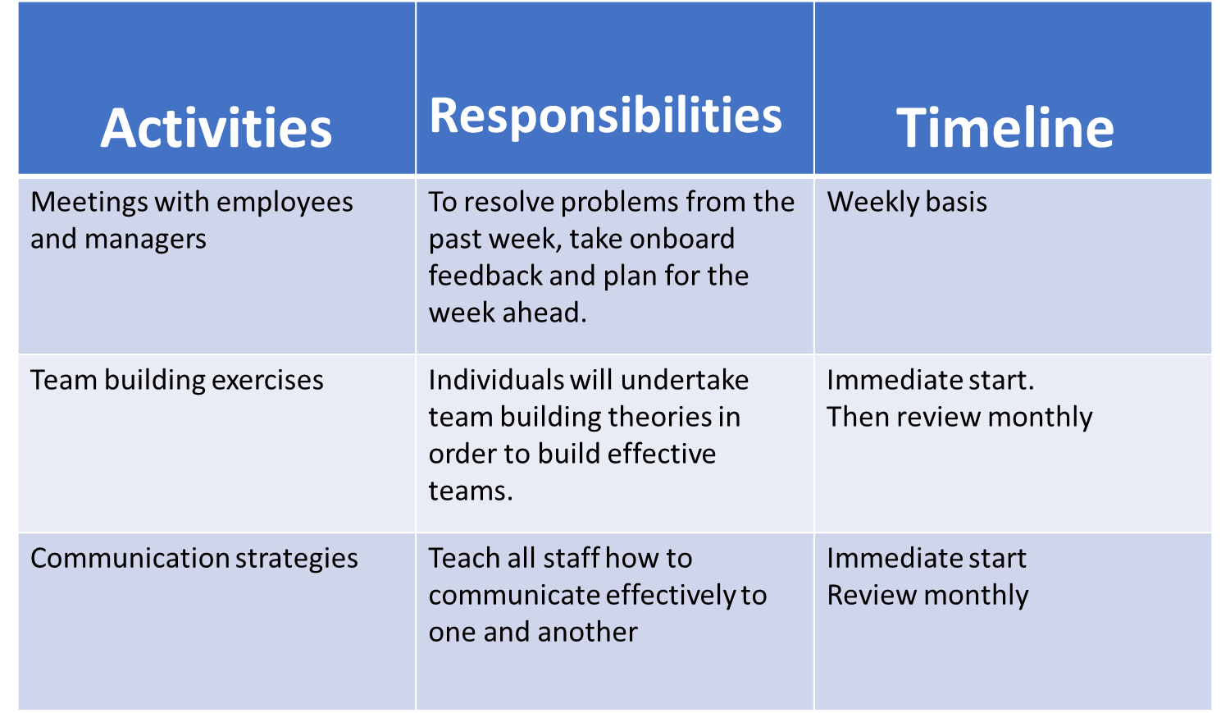

reference list
- (LinkedIn Corporation,2019). available online : https://www.slideshare.net/JeremyBalius/101-inspiring-quotes-about-communication (accessed on 23/06/19)

- (Payscale,2019) available online : https://www.payscale.com/data/employee-engagement (accessed on 24/06/19)

- (ProjectManager.com, Inc,2019)Available online : https://www.projectmanager.com/blog/teamwork-quotes-25-best-inspirational-quotes-working-together (accessed 24/06/19)

- (Study.com,2003-2019) Available online : https://study.com/academy/lesson/communication-cycle-definition-stages.html (accessed on 22/06/19)

- Available online : https://www.businesstopia.net/communication/shannon-and-weaver-model-communication (accessed on 20/06/19)

- (Linked In,(2019) available online : https://www.linkedin.com/pulse/forming-storming-norming-performing-adjourning-vishal-prajapati (accessed on 21/06/19)

- (A Lean journey Blog. 2019) Available online : http://www.aleanjourney.com/2018/05/9-team-roles-for-high-performance-teams.html (accessed on 19/06/19)

- (Key differences,2019) AVAILABLE ONLINE: https://www.google.co.uk/search?q=verbal+or+non+verbal+communication&source=lnms&tbm=isch&sa=X&ved=0ahUKEwjHm8WZtYPjAhXNasAKHXtMAg8Q_AUIECgB&biw=911&bih=437&dpr=1.5#imgrc=OZ_3r0ZKJFWtLM:(accessed on 24/06/19)

- (Yuens,2017) Available online : http://yuens.com.au/fruit-vegetable-shopping-yuens/ (accessed on 24/06/19)

- (Grapes,2019) available online : https://image.slidesharecdn.com/teamwork-130717023900-phpapp01/95/why-team-work-is-important-7-638.jpg?cb=1374029121 (accessed on 25.06/19)

Danielle Tooze (1812486)

