

University of Wales Trinity Saint David
Wales Institute of Science & Art

ACMA6000 – Advanced Processes & Materials

Manufacture of a Wind Turbine Blade
Student Name: Antony Gwilym Pugh
Student Number: 2221728
Programme: BEng (Hons) Mechanical Engineering
Lecturer: Dr Mohamed Gabr / Dr Phil Holden
Internal Verifier: Dr Jordan Jenkins
Submission Date: 7th September 2026
Word Count: 3193

Contents
Abstract 6
1. Introduction 7
2. Literature Review 7
2.1 Aerodynamic profiles 7
2.2 Optimal dimensions 8
2.3 Material properties of metals, ceramics and composites 9
2.4 Environmental factors 10
3. Design Specifications 10
4. Material Selection 11
5. Exploration of Manufacturing Routes 13
5.1 Metals — casting and extrusion 13
5.2 Ceramics — sintering / additive manufacturing 13
5.3 Polymer composites — RTM / vacuum infusion 14
5.4 Comparison of routes 14
6. Cost Evaluation 15
7. Mechanical Properties Analysis 15
8. Comparative Analysis 17
9. Blade Drawing 19
10. Conclusions and Recommendations 20
10.1 Conclusions 20
10.2 Recommendations 20
11. References 21
12. Appendices 24
Appendix A — Aerodynamic calculations 24
Appendix B — Stress calculations 27
Appendix C — Cost data 30
Appendix D — Additional CAD views and NACA 4412 Profiles 32

Table of Figures
Figure 1: Spanwise flapwise force distribution 16
Figure 2: CAD model of the NACA 4412 wind turbine blade showing the spanwise section profiles and 31.02 m modelled aerodynamic span. 19
Figure 3: Dimensioned NACA 4412 spanwise sections showing chord, maximum thickness and twist angle. Maximum thickness is 12% of the local chord and occurs at approximately x/c=0.30. 19
Figure 4: Comparison of the ideal BEM chord distribution and selected linear design taper. 26
Figure 5: Calculated spanwise blade twist distribution. 26
Figure 6: Excel-generated NACA 4412 aerofoil profiles at r/R=0.2," " 0.4," " 0.6," " 0.8 and 1.0, with a combined overlay of all blade sections. 32
Figure 7: Front, left, top and trimetric views of the completed NACA 4412 blade model. 32
Figure 8: General arrangement drawing of the NACA 4412 wind turbine blade showing the main blade views, overall modelled span and dimensioned spanwise aerofoil sections. 33

Table of Tables
Table 1: Mechanical properties of candidate material classes. 9
Table 2: Wind turbine blade design specification 10
Table 3: Principal blade sections derived from the BEM design 11
Table 4: Weighted decision matrix for material selection 12
Table 5: Comparison of manufacturing routes. 14
Table 6: Raw material cost comparison per blade 15
Table 7: Comparative summary of materials and manufacturing processes 17
Table 8: Spanwise BEM blade geometry showing local tip-speed ratio, inflow angle, twist, ideal chord, design chord, maximum thickness and relative wind velocity 25
Table 9: Spanwise aerodynamic forces, bending moment and pitching moment contributions 27
Table 10: Material strength and calculated safety factors at the blade root. 28
Table 11: Root torsional shear stress and calculated safety factor 29
Table 12: Calculated shell volume for each spanwise blade element. 30
Table 13: Material density, estimated blade mass, unit cost and calculated raw material cost per blade. 31

Abstract
This report presents a preliminary study into the design, material selection and manufacture of a next generation wind turbine. The study assessed the blade design parameters and compared three candidate materials. Manufacturing processes, potential defects and preliminary material costs were also evaluated. A 2 MW rotor was designed using the NACA 4412 aerofoil, with a calculated rotor radius of 38.78 m. Aluminium 6082-T6, silicon carbide and E-glass/epoxy GFRP were compared using a weighted decision matrix.
GFRP achieved the highest weighted score of 3.95, compared with 3.15 for aluminium and 2.40 for silicon carbide. It also produced the lowest estimated blade mass at 9,161 kg and the lowest raw material cost at approximately £20,612 per blade. Structural analysis gave a root bending stress of 102.61 MPa, with GFRP providing the highest calculated tensile safety factor of 12.08. Vacuum assisted resin infusion was identified as the most suitable manufacturing route due to its suitability for large composite structures.
Overall, E-glass/epoxy GFRP manufactured using vacuum assisted resin infusion is recommended as the preferred material and manufacturing route for the proposed blade.

1. Introduction
Wind energy has become an important part of the transition towards renewable electricity generation. Wind turbine blades play a critical role in this process by converting the kinetic energy available in the wind into rotational energy. Their aerodynamic and structural design therefore has a significant influence on turbine performance and reliability (Burton et al., 2001).
The objective of this report is to develop and evaluate a lightweight, durable and efficient wind turbine blade for Company X’s client. The study begins with a review of relevant literature and existing blade technologies to establish suitable design parameters. Candidate materials and manufacturing routes are then assessed. This is followed by a cost evaluation and a comparative analysis to determine the most suitable material and production method.
Material selection is particularly important because wind turbine blades experience repeated aerodynamic loading throughout their operating life. The selected material must provide sufficient strength and fatigue resistance without introducing excessive mass. Manufacturing must also be considered because the chosen process influences scalability, production cost and the likelihood of defects (Mishnaevsky et al., 2017).
The study therefore considers aerodynamic design alongside structural performance, manufacturability, cost and environmental factors. This provides a balanced engineering approach to the preliminary blade design while addressing the wider responsibilities associated with AHEP4 C5 and C7.

2. Literature Review

2.1 Aerodynamic profiles
The aerodynamic profile of a wind turbine blade directly influences rotor efficiency by controlling the lift and drag forces generated during operation. Lift produces useful rotational torque, while drag reduces aerodynamic performance. Consequently, aerofoil selection is a key design consideration. The NACA 4412 aerofoil is widely used in small and medium scale horizontal axis wind turbines (HAWTs). This is because of its well documented aerodynamic characteristics, and it provides a favourable lift-to-drag ratio (Tira and Patraman, 2025).
The NACA 4412 profile has a 4% maximum camber located at 40% of the chord length and a maximum thickness of 12% of the chord (Widiyanto, Pramonohadi and Ridwan, 2021). Studies report a peak lift-to-drag ratio of approximately 120 at an angle of attack near 8° while the maximum lift coefficient of approximately 1.6 occurs at a higher angle approaching stall (Tira and Patraman, 2025). Other studies have reported lift-to-drag ratios of up to 155 under different operating conditions (Widiyanto, Pramonohadi and Ridwan, 2021). However, performance varies with Reynolds number and analysis method. A high lift-to-drag ratio contributes to an increased power coefficient (Cp), helping the rotor approach practical efficiencies of 0.45-0.50. However, the theoretical Betz limit remains 0.593 (Burton et al., 2001).

2.2 Optimal dimensions
Rotor dimensions significantly influence wind turbine performance because the power available in the wind is proportional to the swept area of the rotor and therefore, the square of the rotor radius (P ∝ R²) (Manwell, McGowan and Rogers, 2010). Modern onshore turbines typically operate with rotor diameters between 50 and 140 m. The selected rotor diameter of approximately 78 m for the proposed 2 MW turbine is representative of current industry practice (Hartman, 2026).
The tip-speed ratio (TSR), defined as the ratio of blade-tip speed to wind speed (λ = ωr/V), is a key design parameter affecting aerodynamic efficiency. Three-bladed HAWTs commonly operate at TSR values between 6 and 8 to maximise the power coefficient (Cp). The selected design value of λ = 7 lies within the optimum range (Manwell, McGowan and Rogers, 2010).
Wind turbine blades are tapered from root to tip to balance structural and aerodynamic requirements. A wider root withstands high bending loads, while a narrower tip reduces drag at higher local blade speeds. The chord distribution used in this design was derived from blade element momentum theory and subsequently linearised to improve manufacturability (Bakırcı and Yılmaz, 2018).

2.3 Material properties of metals, ceramics and composites
There are many different properties to consider when selecting wind turbine blade materials. Some of which are, low density, sufficient stiffness, strength, and fatigue resistance. This is due to continuous cyclic aerodynamic and gravitational loading. Fatigue is particularly important because blades can experience approximately ${10}^{8}$ load cycles during their service life (Nijssen and Brøndsted, 2023).
Table 1: Mechanical properties of candidate material classes.
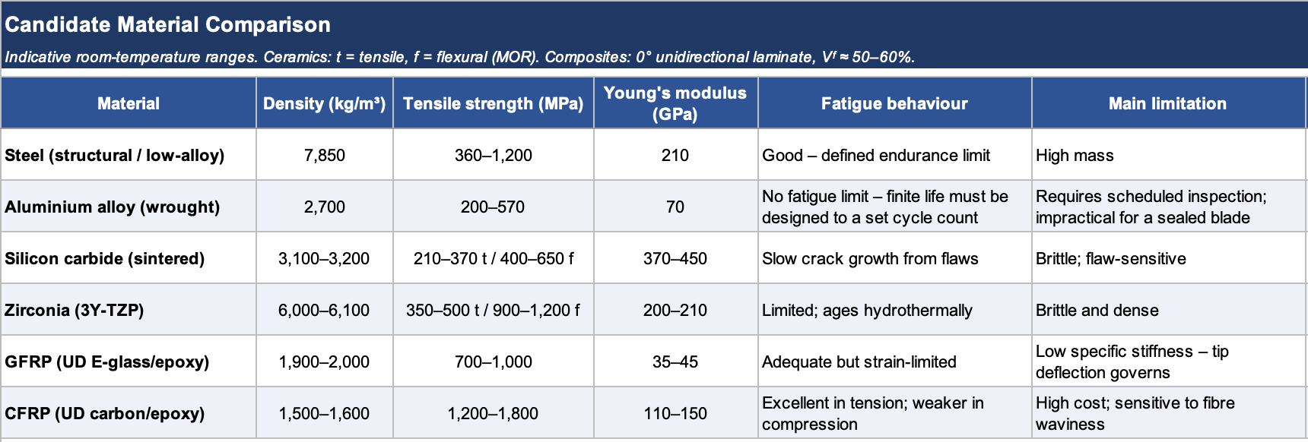
Source: BSI (2005; 2007; 2019b), Ashby (2011), Mishnaevsky et al. (2017), CoorsTek (2024), 3M (no date), MakeItFrom (2026), Morgan Advanced Materials (no date) and Professional Plastics (2026).
Metals provide high strength and stiffness; however, their limitations differ considerably. Steel has the highest density at 7,850 ${kg/m}^{3}$, increasing blade mass. While aluminium reduces weight but has no defined fatigue limit. This means it requires consideration of finite-life cyclic loading (Ashby, 2011). Ceramics provide high stiffness, particularly silicon carbide. However, their brittle and flaw sensitive behaviour limits their suitability for cyclically loaded blades (Ashby, 2011). In comparison, GFRP and CFRP have the lowest densities while maintaining high tensile strength and adequate to excellent fatigue performance (Mishnaevsky et al., 2017; Nijssen and Brøndsted, 2023). CFRP provides greater stiffness and tensile strength than GFRP but has a higher cost (Mishnaevsky et al., 2017; Nijssen and Brøndsted, 2023). These comparisons demonstrate the trade-offs between weight, mechanical performance and fatigue behaviour that must be considered during material selection.

2.4 Environmental factors
Wind turbine blades operate under continuously changing environmental conditions. The blade sees many different applied loads. Wind speed and direction can cause turbulence that produces fluctuating aerodynamic loads, while blade rotation introduces cyclic gravitational loading. Gusts can also generate short duration peak loads. IEC 61400-1 requires wind turbines to be designed for both normal and extreme wind conditions. Turbulence and gusts must be included in the design parameters to ensure structural integrity throughout their operating life (BSI, 2019a). Repeated variable loading contributes to progressive fatigue damage. With this in mind fatigue should be a major consideration throughout the blade’s operating life (Nijssen and Brøndsted, 2023). Blades are also exposed to rain, humidity and weathering. This can cause surface degradation and leading edge erosion (Mishnaevsky et al., 2021). Fibre reinforced composites are therefore well suited to blade construction due to their low density, high stiffness and good fatigue performance (Nijssen and Brøndsted, 2023).

3. Design Specifications
The proposed wind turbine uses a three bladed rotor design to produce 2 MW at a rated wind speed of 12 m/s. The air density used for the design was 1.225 ${kg/m}^{3}$ with a target power coefficient $(C_{p})$ of 0.40. The calculated rotor radius is 38.78m, giving a rotor diameter of 77.56 m and a swept area of approximately 4,724 $m^{2}$. A design tip speed ratio (TSR) of 7 gives a rotor speed of approximately 20.69 rpm.
Table 2: Wind turbine blade design specification
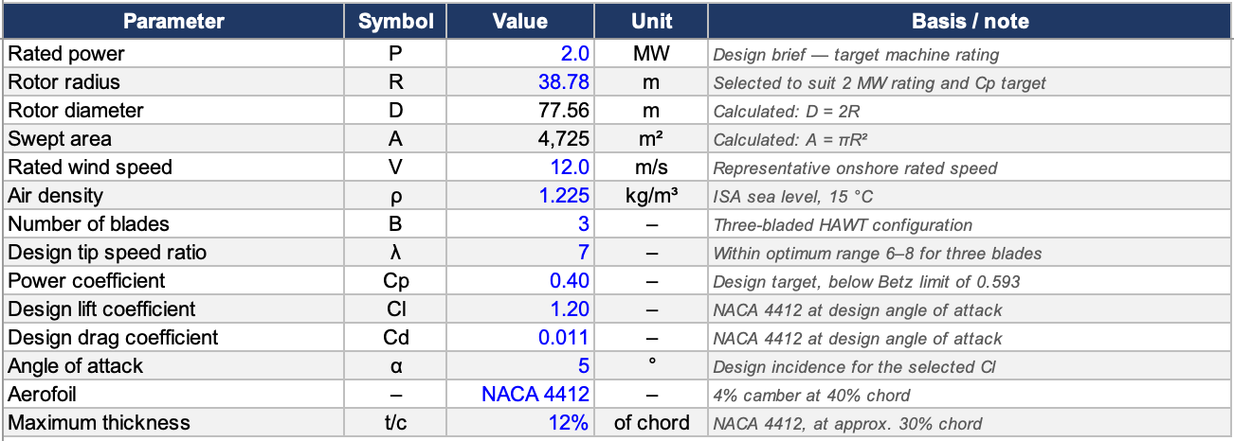
A NACA 4412 aerofoil was selected, with a maximum camber of 4% located at 40% of the chord and a maximum thickness of 12% located at approximately 30% chord. A design angle of attack of 5° was selected because it lies within an efficient operating region for the aerofoil. XFOIL analysis predicts maximum lift-to-drag ratio at approximately 5.25°. A design lift coefficient of $C_{L}=1.20$ was adopted for the BEM calculations.
Blade geometry was determined using Blade Element Momentum (BEM) theory and the calculated chord distribution was subsequently linearised to provide a more practical geometry for manufacture. The blade tapers from a chord of 3.20 m at $r/R=0.2$ to 0.60 m at the tip. The corresponding maximum aerofoil thickness therefore reduces from 0.384 m to 0.072 m.
Table 3: Principal blade sections derived from the BEM design
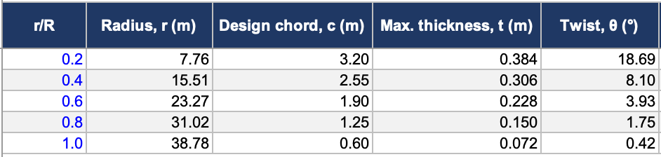
The reduction in chord and twist reflects the increasing local blade speed towards the tip. The complete BEM geometry and calculations are provided in Appendix A.

4. Material Selection
A weighted decision matrix (WDM) was used to compare three candidate materials. The materials reviewed were aluminium 6082-T6, silicon carbide (SiC) and E-glass/epoxy glass fibre reinforced polymer (GFRP). Seven criteria were considered: specific strength, specific stiffness, fatigue resistance, density, raw material cost, manufacturability and recyclability. Scores from 1 (poor) to 5 (excellent) were assigned relative to the competing materials and multiplied by the corresponding weighting.

Table 4: Weighted decision matrix for material selection
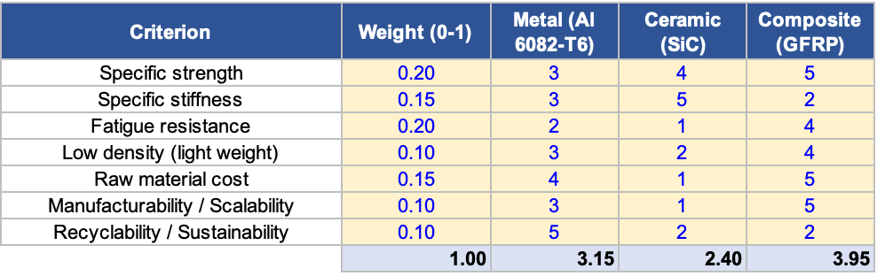
Specific strength and fatigue resistance received the highest individual weightings of 0.20. This reflects the need for the blade to withstand aerodynamic and cyclic loading while minimising structural mass. Specific stiffness was weighted at 0.15 because sufficient blade stiffness is required to limit deflection under aerodynamic loading. Raw material cost was also weighted at 0.15, while density, manufacturability and recyclability were each assigned 0.10.
Material datasheets were used to support the quantitative scores. Specific strength was determined from tensile strength divided by density, while specific stiffness was determined from Young’s modulus divided by density. Worked examples of these calculations are provided in Appendix A. Fatigue resistance, cost, manufacturability and recyclability were ranked comparatively using published material and processing literature (Ashby, 2011; Mishnaevsky et al., 2017).
E-glass/epoxy GFRP achieved the highest weighted score of 3.95, compared with 3.15 for aluminium and 2.40 for SiC. GFRP performed particularly well in specific strength, fatigue resistance, low density, cost and manufacturability. Its main limitations are comparatively low specific stiffness and poor recyclability. Aluminium offers superior recyclability, while SiC provides excellent specific stiffness. However, neither achieved the overall balance required for the blade. GFRP remained the highest-ranked material when all seven criteria were weighted equally, indicating that the selection does not depend on the chosen weighting distribution. Therefore, E-glass/epoxy GFRP was selected as the primary blade material, demonstrating AHEP4 C13 by selecting an appropriate material while recognising its limitations.

5. Exploration of Manufacturing Routes

5.1 Metals — casting and extrusion
Metallic blade components could be manufactured using casting or extrusion. Casting would require a dedicated casting alloy such as EN AC-42100, since 6082 is a wrought alloy not suited to casting. In casting, aluminium is melted in a furnace and then poured into a mould and allowed to solidify. The finishing process can involve trimming, heat treatment and machining. Casting can produce complex shapes, although defects are sometimes found. Some of the defects are gas porosity, shrinkage and inclusions. These defects can reduce mechanical and fatigue performance (Groover, 2020). For the proposed blade, casting would be more appropriate for smaller fittings or root components rather than the complete blade structure. Extrusion instead forces a heated aluminium billet through a shaped die using a hydraulic press. This produces continuous sections with a consistent cross section. These can subsequently be cut, formed and machined. However, extrusion is less suitable for the complex tapered and twisted geometry of a complete wind turbine blade. Both routes require significant energy for heating, while molten metal handling presents burn, fume and fire hazards (Groover, 2020).

5.2 Ceramics — sintering / additive manufacturing
Silicon carbide (SiC) components are commonly manufactured through powder processing and sintering. SiC powder is mixed with binders, compacted into the required shape and heated in a high-temperature furnace to bond and densify the particles (Callister and Rethwisch, 2020). Additive manufacturing can alternatively build complex ceramic geometries layer-by-layer before subsequent debinding and sintering. These methods exploit SiC’s high stiffness and thermal resistance. However, care should be taken to avoid defects. Pores and microcracks can act as fracture initiation sites, and shrinkage during sintering must be controlled carefully. SiC’s brittleness also makes it unsuitable for a large blade subjected to impact and cyclic loading. Ceramic powders require suitable dust control measures, while the high processing temperatures contribute to the environmental impact.

5.3 Polymer composites — RTM / vacuum infusion
E-glass/epoxy GFRP blades can be manufactured using resin transfer moulding (RTM) or vacuum-assisted resin transfer moulding (VARTM). Reinforcement fibres are first positioned within the blade mould, with fibre orientation selected according to structural loading. In RTM, resin is injected into a closed mould under pressure, whereas VARTM uses a vacuum to draw resin through the dry reinforcement before curing (Mishnaevsky et al., 2017). VARTM is particularly suitable for large wind turbines because the process can be scaled by increasing the number of resin inlets and vacuum points (Mishnaevsky et al., 2017). Potential manufacturing defects include voids, dry regions and fibre wrinkling. Another problem is that delamination may develop within the composite structure and reduce its structural performance (Mishnaevsky et al., 2017; Nixon-Pearson et al., 2022). Resin handling requires appropriate PPE and ventilation, while thermoset composite waste presents recycling challenges.

5.4 Comparison of routes
Table 5: Comparison of manufacturing routes.
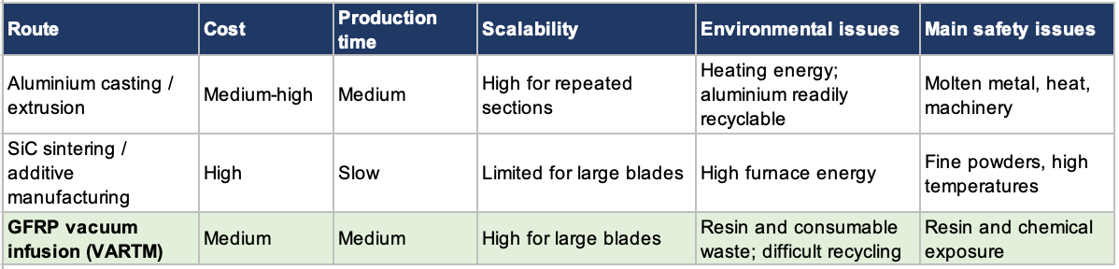
Note: Cost refers to the manufacturing process and associated equipment, rather than the raw material cost assessed in Table 4.
Overall, vacuum infused GFRP provides the most appropriate manufacturing route for the proposed blade. Unlike extrusion, it can accommodate the tapered and twisted aerodynamic geometry. It also avoids the brittleness and furnace temperatures required for SiC sintering. It also allows fibre orientation and laminate thickness to be tailored to local blade loads. Vacuum infusion is well suited to the manufacture of large wind turbine blades. The process offers good scalability and allows the blade structure to be tailored to meet specific design requirements (Mishnaevsky et al., 2017; Nixon-Pearson et al., 2022).

6. Cost Evaluation
The simplified shell model gives a total material volume of approximately 4.82 m³ per blade. Applying the selected material densities gives estimated blade masses of 13,018 kg for aluminium 6082-T6, 15,477 kg for silicon carbide (SiC) and 9,161 kg for GFRP.
Table 6: Raw material cost comparison per blade
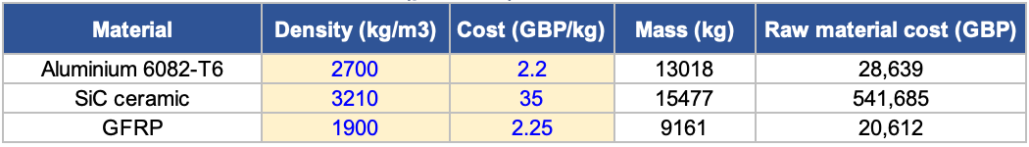
GFRP provides the lowest estimated raw material cost despite having a slightly higher unit price than aluminium. Its lower density reduces the mass of material required for the same estimated blade volume. The GFRP unit cost was derived using a fibre volume fraction of 0.56, giving a fibre weight fraction of approximately 0.75. Using glass fibre at £2/kg and epoxy resin at £3/kg gives an estimated laminate cost of £2.25/kg (Clarke et al., 2020). These prices are based on 2018 data and exclude material waste. The calculated value should therefore be considered a baseline estimate rather than a final production cost.
Manufacturing would increase the total cost for all three materials. GFRP vacuum infusion also introduces additional production costs due to the need for large moulds and specialist equipment. Labour and quality control must also be considered. Bortolotti et al. (2019) show that these factors can make a significant contribution to the overall cost of composite blade production.
Overall, GFRP provides the strongest cost-performance balance, combining the lowest raw material cost and blade mass with good fatigue performance.

7. Mechanical Properties Analysis
Aerodynamic loading was calculated at each blade section using the relative wind velocity, local chord and the NACA 4412 lift and drag coefficients. Lift and drag were resolved into normal and tangential forces (Burton et al., 2001). The normal force represents the main flap wise loading and was used to calculate the bending moment at the blade root.
A worked example was completed at $r/R=0.6$. At this section, the local radius is 23.3 m, chord is 1.9 m and relative wind velocity is 51.6 m/s. The section width is 3.9 m. The lift force was calculated as:
$$dL=\frac{1}{2}ρW^{2}cC_{L}dr$$
$$dL=\frac{1}{2}(1.225)(51.6^{2})(1.9)(1.2)(3.9)$$
$$dL≈14.4 kN$$
Using a drag coefficient of 0.011, the corresponding drag force was:
$$dD=\frac{1}{2}ρW^{2}cC_{D}dr$$
$$dD≈0.132 kN$$
The resolved normal force at this section was approximately 14.25 kN. The same method was applied to each blade section in Excel. Figure 1 shows that the flapwise force increases along the blade before reaching a maximum of approximately 16.43 kN at $=0.8.$The force then reduces towards the blade tip.
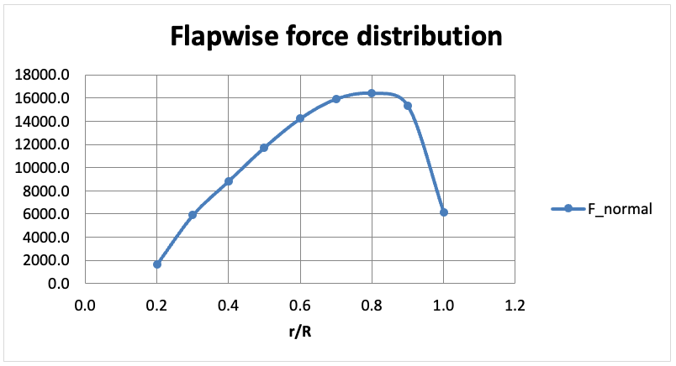
Figure 1: Spanwise flapwise force distribution
The bending moment contribution from each section was summed to give a root bending moment of 2.492 MN.m. The resulting root bending stress was calculated using the elastic bending relationship $σ=M/Z$ (Hibbeler, 2017). Using the calculated root section modulus of 0.024289 m³, the maximum bending stress was:
$$σ=\frac{M}{Z}$$
$$σ=\frac{2.492×{10}^{6}}{0.024289 }=102.61 MPa$$
The calculated stress was compared with the strength of each candidate material. Aluminium 6082-T6 gave a safety factor of 3.31, while SiC gave 3.90. GFRP produced the highest safety factor at 12.08, based on a longitudinal tensile strength of 1,240 MPa. This value is taken from a resin-infused unidirectional E-glass/epoxy laminate tested at a fibre volume fraction of 56.8–58.2%, consistent with the $V_{f}$ = 0.56 assumed in Section 6 (Samborsky, Mandell and Agastra, 2012). This indicates a substantial tensile strength margin under the simplified loading condition.
GFRP is anisotropic, meaning its strength varies with fibre orientation and loading direction. Samborsky, Mandell and Agastra (2012) report a longitudinal compressive strength of approximately 774 MPa for a comparable E-glass/epoxy laminate. Applying this value gives a lower compressive safety factor of approximately 7.54. However, this remains greater than the calculated margins for aluminium and SiC.
Tangential forces were also calculated in Excel and represent the torque-producing component of the aerodynamic loading. Torsional shear stress at the root was calculated from the spanwise pitching moment distribution using the Bredt-Batho thin-walled section relationship, giving 0.18 MPa against an in-plane shear strength of 55.8 MPa (Appendix B). Aerodynamic torsion is therefore not a governing load case for this geometry, and the section is dominated by flapwise bending. A detailed blade assessment would require combined bending and torsional loading together with fatigue and buckling analysis (Mishnaevsky et al., 2017). Overall, GFRP provides the greatest calculated strength margin and supports its selection as the preferred blade material.

8. Comparative Analysis
Table 7: Comparative summary of materials and manufacturing processes
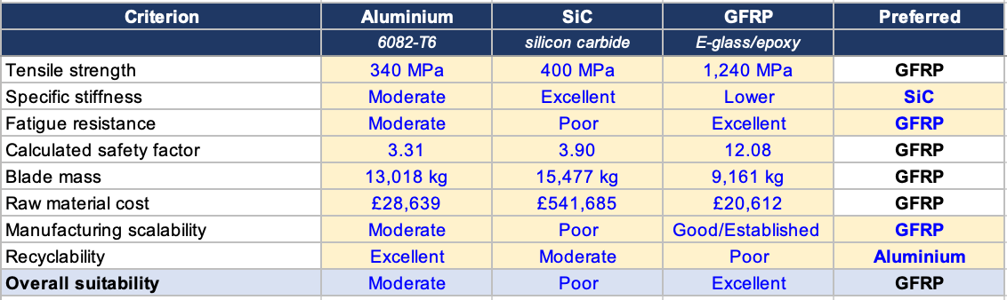
The comparison shows that no single material provides the best performance in every category. SiC offers the highest specific stiffness, while aluminium 6082-T6 provides the best recyclability. However, GFRP provides the strongest overall combination of mechanical performance, manufacturing scalability and cost.
Manufacturing also favours GFRP. Vacuum assisted resin infusion is widely used for large wind turbine blades and can be scaled to components with the size range considered in this study (Bortolotti et al., 2019). Production requires significant mould and curing time, but multiple moulds can be used to increase throughput. Voids, dry regions and fibre misalignment remain important limitations of GFRP, though these risks can be reduced through careful fibre placement, vacuum integrity checks and controlled resin flow.
From a health, safety and environmental perspective each material presents different challenges. Aluminium is readily recyclable, whereas thermoset GFRP is difficult to separate and recycle at the end of its service life (Mishnaevsky et al., 2017). Composite manufacturing also requires controls for resin exposure, dust and other process hazards. This demonstrates consideration of environmental, health, and safety responsibilities in accordance with AHEP4 C7.

9. Blade Drawing
The calculated blade geometry was transferred into SolidWorks to produce the CAD model shown in Figure 2. The rotor radius is 38.78 m, with the modelled aerodynamic section extending from $r/R=0.2$ to the blade tip. This gives a modelled span of approximately 31.02 m. The chord reduces linearly from approximately 3.20 m to 0.60 m over this region.
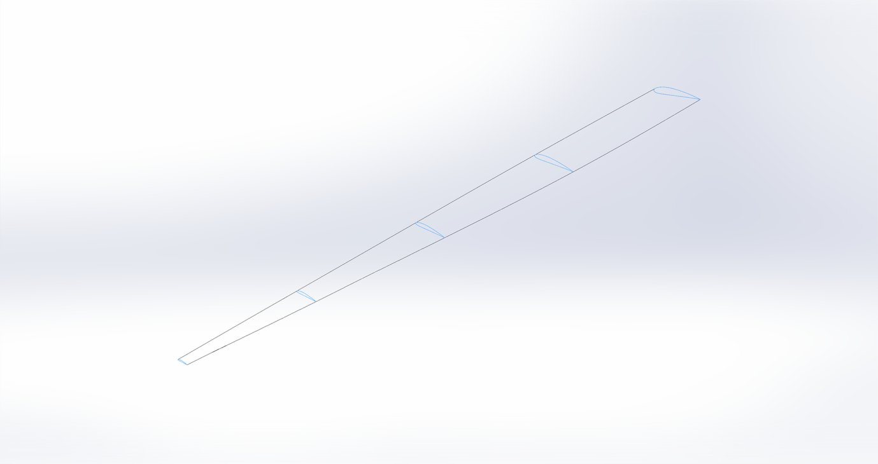
31.02 m
Figure 2: CAD model of the NACA 4412 wind turbine blade showing the spanwise section profiles and 31.02 m modelled aerodynamic span.
Dimensioned NACA 4412 sections were produced at $r/R=0.2, 0.4, 0.6, 0.8$and $1.0$, as shown in Figure 3. Each aerofoil was scaled to its calculated chord and rotated to the corresponding twist angle. The dimensions therefore correspond directly with the blade geometry calculated in Excel.
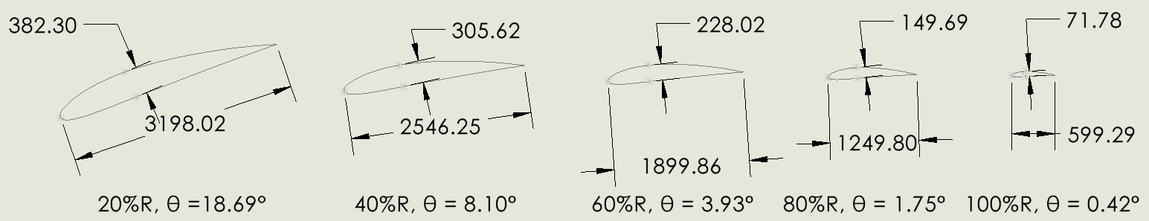
Figure 3: Dimensioned NACA 4412 spanwise sections showing chord, maximum thickness and twist angle. Maximum thickness is 12% of the local chord and occurs at approximately x/c=0.30.

10. Conclusions and Recommendations

10.1 Conclusions
This study developed a preliminary 2 MW wind turbine blade design using the NACA 4412 aerofoil and compared aluminium 6082-T6, SiC and E-glass/epoxy GFRP as candidate materials. The weighted decision matrix identified GFRP as the preferred material with a score of 3.95, compared with 3.15 for aluminium and 2.40 for SiC.
The cost evaluation also favoured GFRP. It produced the lowest blade mass and the lowest raw material cost of the three candidates, and the largest strength margin under the calculated root bending stress. GFRP provided the highest calculated tensile safety factor of 12.08, although its anisotropic behaviour and lower compressive strength were recognised.
Overall, E-glass/epoxy GFRP manufactured using vacuum assisted resin infusion is recommended. It provides the strongest overall balance of mechanical performance, low mass, cost and large scale manufacturability.

10.2 Recommendations
Future work should optimise the blade geometry for a defined wind class and site specific operating conditions. A more detailed structural model should assess combined bending and torsional loading. Fatigue, buckling and blade deflection should also be investigated. Finite element analysis could then be used to identify local stress concentrations and assess laminate behaviour.
Further work should investigate fibre orientation, laminate thickness and internal structural features, such as spar caps and shear webs. Manufacturing trials could evaluate resin flow and potential defects during vacuum infusion. Finally, lifecycle cost and end-of-life recycling should be investigated further to address the environmental limitations associated with thermoset GFRP.

11. References
3M (n.d.). 3M TM Silicon Carbide Material platform 3M advanced materials division typical material properties. [online] Available at: https://multimedia.3m.com/mws/media/993481O/3m-silicon-carbide-materials-properties [Accessed 29 Aug. 2026].
Ashby, M.F. (2011). Materials selection in mechanical design. Oxford: Butterworth-Heinemann.
Bakırcı, M. and Yılmaz, S. (2018). Theoretical and computational investigations of the optimal tip-speed ratio of horizontal-axis wind turbines. Engineering Science and Technology, an International Journal, 21, pp.1128–1142. doi:10.1016/j.jestch.2018.05.006.
Bortolotti, P., Berry, D., Murray, R., Gaertner, E., Jenne, D., Barter, G., Damiani, R. and Dykes, K. (2019). A detailed wind turbine blade cost model. NREL/TP-5000-73585. Golden, CO: National Renewable Energy Laboratory.
British Standards Institution (2005). BS EN 1993-1-1:2005 Eurocode 3: Design of steel structures – part 1-1: General rules and rules for buildings. London: BSI.
British Standards Institution (2007). BS EN 1999-1-1:2007 Eurocode 9: Design of aluminium structures – part 1-1: General structural rules. London: BSI.
British Standards Institution (2019a). BS EN IEC 61400-1:2019 Wind energy generation systems – part 1: Design requirements. London: BSI.
British Standards Institution (2019b). BS EN 10025-2:2019 Hot rolled products of structural steels – part 2: Technical delivery conditions for non-alloy structural steels. London: BSI.
Burton, T., Sharpe, D., Jenkins, N. and Bossanyi, E. (2001). Wind energy : handbook. Chichester Etc.: J. Wiley & Sons.
Callister, W.D. and Rethwisch, D.G. (2020). Materials science and engineering: An introduction. Hoboken, NJ: John Wiley & Sons.
Clarke, J., McIlhagger, A., Archer, E., Dooher, T., Flanagan, T. and Schubel, P. (2020). A feature-based cost estimation model for wind turbine blade spar caps. Applied System Innovation, 3(2), p.17. doi:10.3390/asi3020017.
CoorsTek (2024). Silicon carbides. [online] CoorsTek. Available at: https://www.coorstek.com/media/4249/silicon-carbides.pdf [Accessed 30 Aug. 2026].
Groover, M.P. (2020). Fundamentals of Modern Manufacturing: Materials, Processes, and Systems. Hoboken, NJ: John Wiley & Sons.
Hartman, L. (2026). Wind Turbines: the Bigger, the Better. [online] Energy.gov. Available at: https://www.energy.gov/cmei/wind/articles/wind-turbines-bigger-better [Accessed 6 June 2026].
Hibbeler, R.C. (2017). Mechanics of materials. Harlow: Pearson.
MakeItFrom (2026). Silicon carbide (SiC). [online] Material Properties. Available at: https://www.makeitfrom.com/material-properties/Silicon-Carbide-SiC [Accessed 29 Aug. 2026].
Manwell, J.F., McGowan, J.G. and Rogers, A.L. (2010). Wind Energy Explained. John Wiley & Sons.
Mishnaevsky, L., Hasager, C.B., Bak, C., Tilg, A.-M., Bech, J.I., Doagou Rad, S. and Fæster, S. (2021). Leading edge erosion of wind turbine blades: Understanding, prevention and protection. Renewable Energy, 169, pp.953–969. doi:10.1016/j.renene.2021.01.044.
Morgan Advanced Materials (n.d.). Nilcra® zirconia 3Y-TZP grade data sheet. [online] Morgan Technical Ceramics. Available at: https://www.morgantechnicalceramics.com/media/ql0imk0v/nilcra-zirconia-3y-tzp-grade.pdf [Accessed 29 Aug. 2026].
Nijssen, R.P.L. and Brøndsted, P. (2023). Fatigue as a design driver for composite wind turbine blades. Advances in Wind Turbine Blade Design and Materials, [online] pp.217–248. doi:10.1016/b978-0-08-103007-3.00006-9.
Nixon-Pearson, O., Greaves, P., Mamalis, D. and Stevenson, L. (2022). WP4 – D1.1. wind turbine blades design and manufacturing, current state-of-the-art literature review. Offshore Renewable Energy Catapult.
Professional Plastics (2026). Zirconia Y-TZP data sheet. [online] Professional Plastics. Available at: https://www.professionalplastics.com/professionalplastics/ZirconiaY-TZPDataSheet.pdf [Accessed 29 Aug. 2026].
Samborsky, D.D., Mandell, J.F. and Agastra, P. (2012). 3-D static elastic constants and strength properties of a glass/epoxy unidirectional laminate. Bozeman, MT: Department of Chemical and Biological Engineering, Montana State University. [online] Available at: https://www.montana.edu/composites/documents/3D%20Static%20Property%20Report-2.pdf [Accessed 5 Sep. 2026].
Tira, H.S. and Patraman, I.G.N.A.N. (2025). Q Blade-Based Simulation of a 7° Tapered Wind Turbine Blade Employing NACA 4412 Airfoil for Aerodynamic Performance Evaluation. Global Journal of Engineering and Technology Advances, 25(1), pp.239–246. doi:10.30574/gjeta.2025.25.1.0318.
Widiyanto, S., Pramonohadi, S. and Ridwan, K. (2021). Performance Analysis of Small Horizontal Axis Wind Turbine with Airfoil NACA 4412. International Journal of Science, Technology & Management, 2(1), pp.347–357. doi:10.46729/ijstm.v2i1.165.

12. Appendices

Appendix A — Aerodynamic calculations
The spanwise blade geometry was calculated using the Blade Element Momentum (BEM) method described in Section 3. Calculations were completed from $r/R=0.2$ to the blade tip at intervals of 0.1R. The local tip-speed ratio was calculated from:
$$λ_{r}=λ\frac{r}{R}$$
Where the design tip-speed ratio was $λ=7$.
The local inflow angle was calculated using:
$$ϕ=\frac{2}{3}\tan^{-1}(\frac{1}{λ_{r}})$$
The corresponding blade twist was determined from:
$$β=ϕ-α$$
Where the design angle of attack was $α= 5^{∘}$.
The ideal BEM chord was calculated from:
$$C_{ideal}=\frac{8πrsin(ϕ)}{3BC_{L}λ_{r}}$$
Where $B=3$ is the number of blades and $C_{L}=1.2$ is the design lift coefficient.
For practical manufacture, a linear chord distribution was adopted between 3.20 m at $r/R=0.2$ and 0.60 m $r/R=1.0$. The maximum aerofoil thickness was then calculated using the NACA 4412 thickness ratio:
$$t_{max}=0.12c_{design}$$
The relative wind velocity used for the subsequent aerodynamic loading calculations was determined from:
$$W=\frac{V91-a}{sin⁡(ϕ)}$$
Where $V=12$m/s is the rated wind speed and $a=0.333$ is the axial induction factor.
Specific strength was calculated as tensile strength divided by density, and specific stiffness as Young's modulus divided by density.
For aluminium 6082-T6, with a tensile strength of 340 MPa and a density of 2,700 kg/m³:
Specific strength = 340 × 10⁶ / 2,700 ≈ 126 kN·m/kg (Callister and Rethwisch, 2020).
For silicon carbide, with a Young's modulus of 410 GPa and a density of 3,150 kg/m³ (CoorsTek, 2024):
Specific stiffness = 410 × 10⁹ / 3,150 ≈ 130 MN·m/kg
Each score was then multiplied by its criterion weighting. For example, the GFRP specific strength score contributes 5 × 0.20 = 1.00 to its weighted total.
Table 8: Spanwise BEM blade geometry showing local tip-speed ratio, inflow angle, twist, ideal chord, design chord, maximum thickness and relative wind velocity
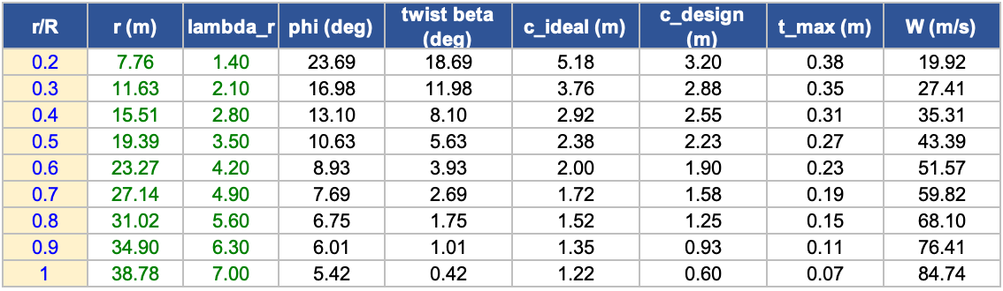
The BEM calculation produced a curved ideal chord distribution along the blade span. For the final design, this was simplified to a linear taper from 3.20 m at $r/R=0.2$ to 0.60 m at the blade tip. This provides a simpler geometry for manufacture while retaining the required reduction in chord towards the tip. Figure A1 compares the ideal BEM chord with the adopted linear design.
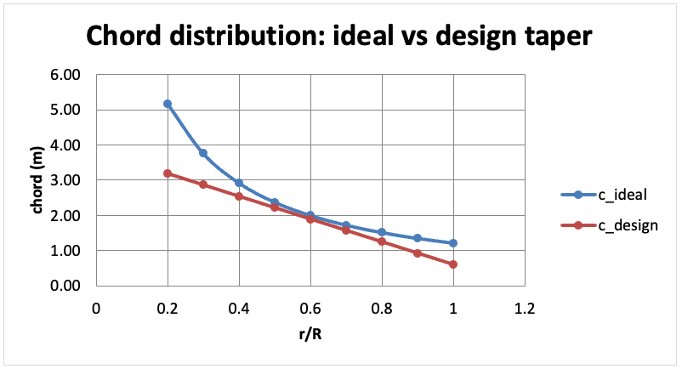
Figure 4: Comparison of the ideal BEM chord distribution and selected linear design taper.
The calculated twist also reduces progressively along the blade span. The twist decreases from 18.69° at $r/R=0.2$ to 0.42° at the blade tip, as shown in Figure 5. These values were used to orientate the NACA 4412 sections in the CAD model.

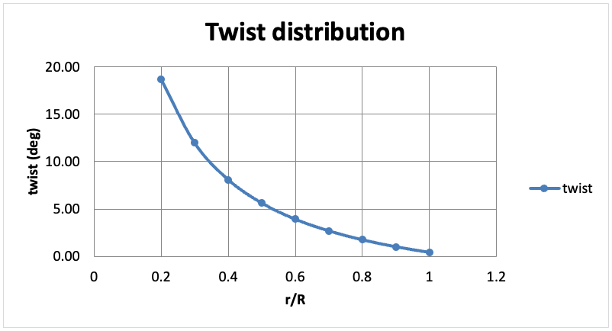
Figure 5: Calculated spanwise blade twist distribution.

Appendix B — Stress calculations
The aerodynamic forces calculated at each blade section were used to determine the structural loading. Lift and drag were calculated from:
$$dL=\frac{1}{2}ρW^{2}cC_{L}dr$$
$$dD=\frac{1}{2}ρW^{2}cC_{D}dr$$
where ρ = 1.225 kg/m³, C_{L} = 1.2 and C_{D} = 0.011.
Lift and drag were resolved into normal and tangential force components:
$$F_{normal}=dL\cos\left(ϕ\right)+dD\sin\left(ϕ\right)$$
$$F_{tangential}=dL\sin\left(ϕ\right)-dD\cos\left(ϕ\right)$$
The normal force represents the primary flapwise loading. The bending moment contribution from each blade section was calculated from:
$$M_{i}=F_{normal,i}r_{i}$$
The individual contributions were then summed to determine the total bending moment at the blade root:
$$M_{root}=∑M_{i}$$
This produced a calculated root bending moment of:
$$M_{root}=2.492 MN·m$$
Table 9: Spanwise aerodynamic forces, bending moment and pitching moment contributions
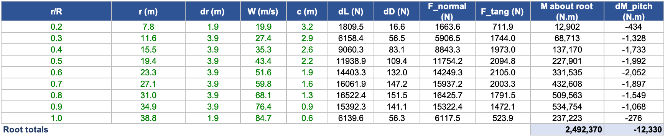

The resulting root bending stress was calculated using:
$$σ=\frac{M_{root}}{Z}$$
where Z = 0.024289 m³ is the root section modulus. Therefore:
$$σ=\frac{2.492×{10}^{6}}{0.024289}=102.61 MPa$$
The calculated stress was compared with the material strength used for each candidate. The safety factor was calculated from:
$$SF=\frac{material strength}{σ}$$

Table 10: Material strength and calculated safety factors at the blade root.
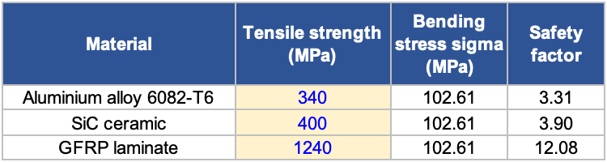
The resulting safety factors were 3.31 for aluminium 6082-T6, 3.90 for SiC and 12.08 for E-glass/epoxy GFRP. GFRP therefore provided the greatest tensile strength margin under the simplified bending condition.
Torsional loading
Aerodynamic torsion was estimated from the pitching moment of the NACA 4412 aerofoil:
$$dM = \frac{1}{2}ρW^{2}c^{2}C_{m} dr$$
where C_{m} is the quarter-chord pitching moment coefficient. A value of C_{m} = −0.09 was used for NACA 4412. The section moments were summed to give a root torque of:
$$T = \sum{dM} = 12.33 kN·m$$
Torsional shear stress was calculated using the Bredt–Batho relationship:
$$τ = \frac{T}{2A_{m}t}$$
The enclosed root area was approximated as:
$$A_{m} ≈ 0.7ct_{max} = 0.7\left(3.20\right)\left(0.384\right) = 0.86 m^{2}$$
where the factor 0.7 accounts for the aerofoil shape. Using the assumed shell thickness of 0.04 m:
$$τ = \frac{12,330}{2\left(0.86\right)\left(0.04\right)} = 0.18 MPa$$
Using a GFRP in-plane shear strength of 55.8 MPa (Samborsky, Mandell and Agastra, 2012):
$$SF = \frac{55.8}{0.18} = 311$$

Table 11: Root torsional shear stress and calculated safety factor
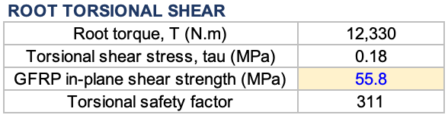
The calculated torsional stress is substantially below the GFRP shear strength. Flapwise bending therefore remains the dominant load in this simplified analysis.

Appendix C — Cost data
The blade material volume was estimated using the simplified shell model applied in the mass cost worksheet. The volume of each spanwise element was calculated from:
$$V_{i}=k_{p}c_{i}t{dr}_{i}$$
where k_{p} is the NACA 4412 perimeter factor, c_{i} is the local chord, t is the assumed shell thickness and dr_{i} is the width of the blade element. The individual element volumes were summed to give the total material volume:
$$V=∑V_{i}$$
The calculated material volume was:
$$V=4.821 m^{3}$$
Table 12: Calculated shell volume for each spanwise blade element.
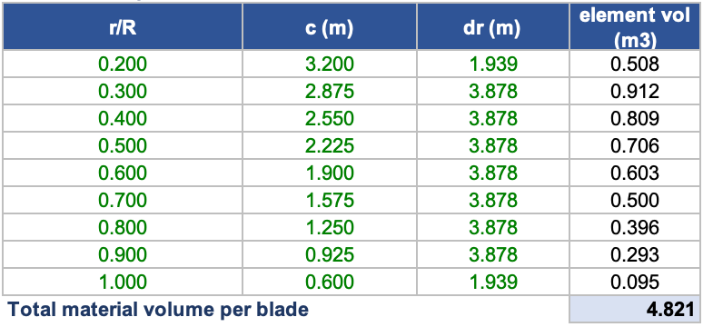
The mass of each candidate blade was calculated using:
$$m=ρV$$
where ρ is the material density.
For example, the estimated GFRP blade mass was:
$$m=1900×4.821$$
$$m≈9,161 kg$$
Raw material cost was then calculated from:
$$C=mC_{kg}$$
where C_{kg} is the assumed material cost per kilogram.
For GFRP:
$$C=9161×2.25$$
$$C≈£20,612$$

Table 13: Material density, estimated blade mass, unit cost and calculated raw material cost per blade.
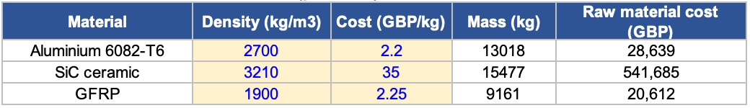
The GFRP unit cost of £2.25/kg was estimated from its constituent materials. A fibre volume fraction of 0.56 gives an approximate fibre weight fraction of 0.75. Using glass fibre at £2.00/kg and epoxy resin at £3.00/kg gives:
$$C_{GFRP}=\left(0.75×2.00\right)+\left(0.25×3.00\right)$$
$$C_{GFRP}=£2.25/kg$$
These constituent prices were taken from Clarke et al. (2020) and are based on 2018 material prices. The value therefore represents a baseline estimate rather than a current supplier quotation.
The £2.20/kg value for aluminium 6082-T6 and £35.00/kg for SiC were used as indicative cost assumptions for the preliminary comparison. Material prices vary with grade, order quantity and market conditions. The calculated costs should therefore be treated as comparative estimates rather than current commercial quotations.

Appendix D — Additional CAD views and NACA 4412 Profiles
The NACA 4412 aerofoil profiles used to generate the blade geometry were calculated and plotted in Microsoft Excel. Figure 6 shows the profiles at the five required spanwise positions. The combined overlay demonstrates the reduction in chord and thickness towards the blade tip.
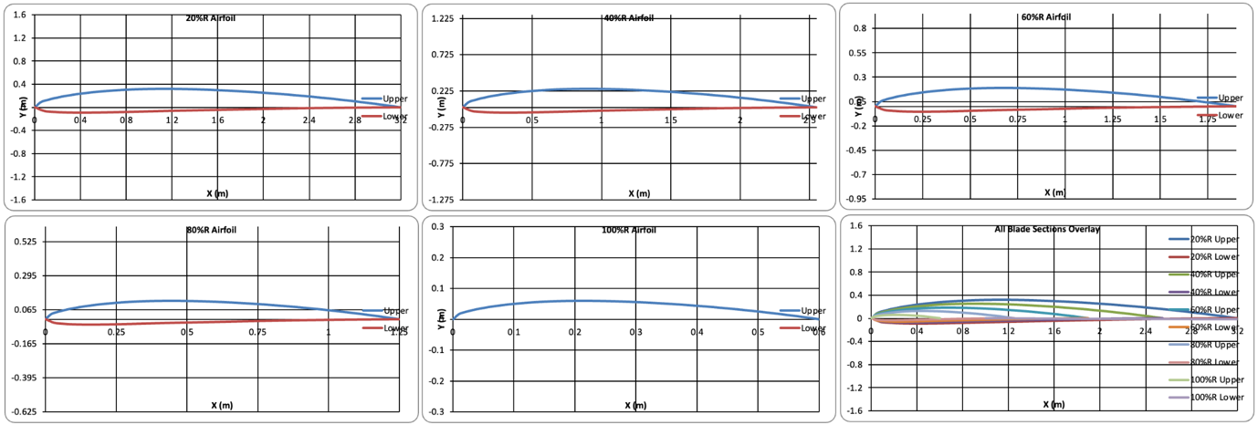
Figure 6: Excel-generated NACA 4412 aerofoil profiles at r/R=0.2," " 0.4," " 0.6," " 0.8 and 1.0, with a combined overlay of all blade sections.
The calculated aerofoil profiles were used to construct the blade geometry in SolidWorks. Figure 7 shows the completed model from the front, left, top and trimetric orientations. These views demonstrate the spanwise taper and twist incorporated into the blade geometry.
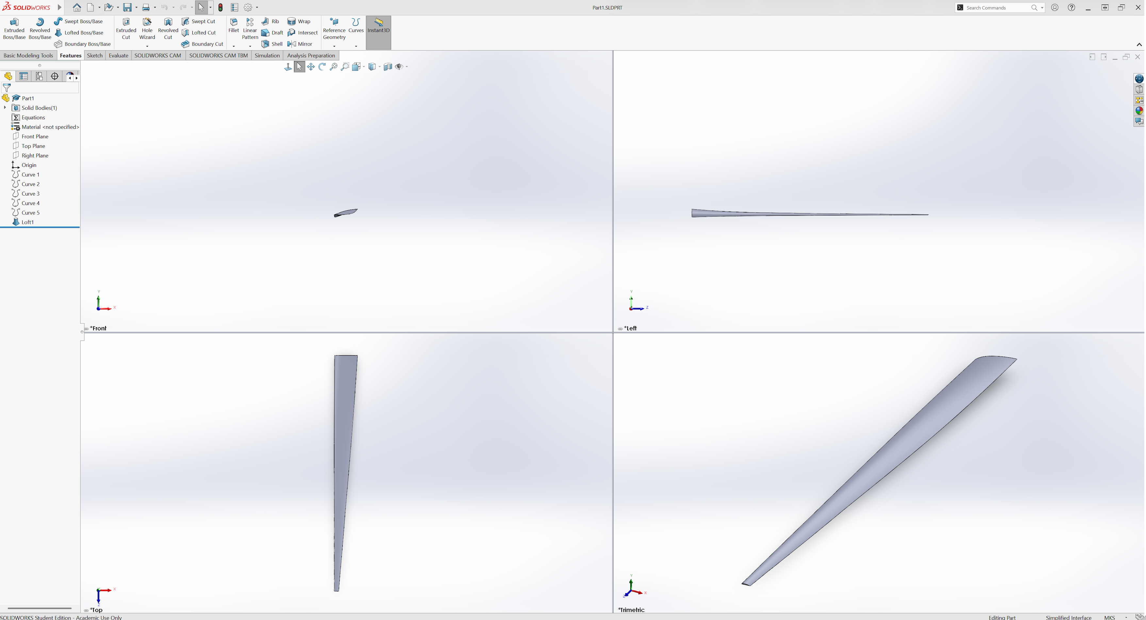
Figure 7: Front, left, top and trimetric views of the completed NACA 4412 blade model.
The complete general arrangement drawing is provided in Figure 8. It shows the main blade views and the 31,020 mm modelled span. The drawing also contains the five required NACA 4412 sections at $r/R=0.2, 0.4, 0.6, 0.8$ and $1.0$. The local chord, maximum thickness and corresponding twist angle are identified for each section.
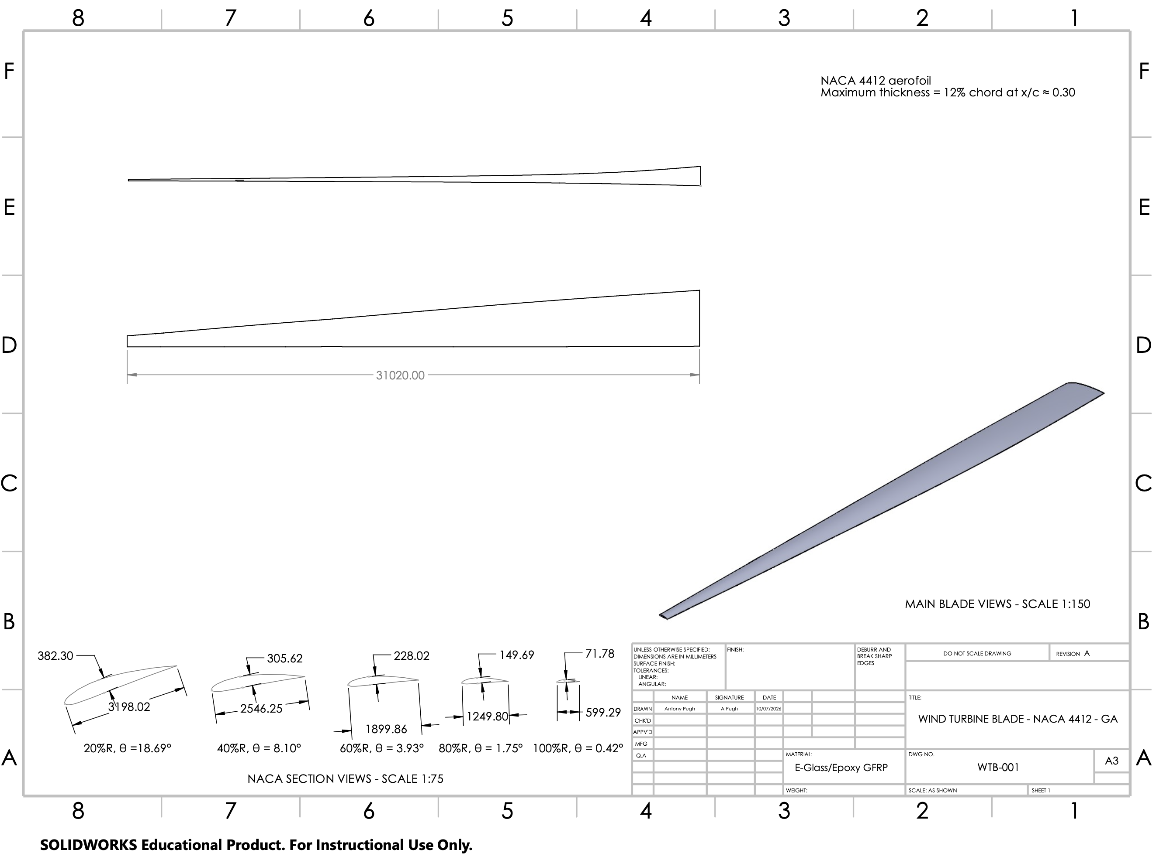
Figure 8: General arrangement drawing of the NACA 4412 wind turbine blade showing the main blade views, overall modelled span and dimensioned spanwise aerofoil sections.

