
UNIVERSITY OF WALES
TRINITY SAINT DAVID

Examining the Role of Artificial Intelligence in Transforming Digital Marketing in the UK's Retail Industry

Student Name: Parmod Kumar
Student No: 2229251
Dissertation Supervisor: Tushara Balendran

Master’s Degrees by Examination and Dissertation
Declaration Form.
1. This work has not previously been accepted in substance for any degree and is not being concurrently submitted in candidature for any degree.
Signed…….…………Parmod kumar……………………………………………...
Date ……28-01-2024………………………………………………...

2. This dissertation is being submitted in partial fulfilment of the requirements for the degree of Master in Business Administration.
Signed ………………Parmod Kumar………………………………….
Date ………………28-01-2024….………………………..…………...
3. This dissertation is the result of my own independent work/investigation, except where otherwise stated.
Other sources are acknowledged by footnotes giving explicit references.
A bibliography is appended.
Signed candidate: ……………parmod kumar…….……………….
Date: ………………28-01-2024………….……………………….

4. I hereby give consent for my dissertation, if accepted, to be available for photocopying, inter- library loan, and for deposit in the University’s digital repository
Signed (candidate)……………Parmod Kumar….………….…………...
Date…………………………………28-01-2024….…………….……………..
Supervisor’s Declaration.
I am satisfied that this work is the result of the student’s own efforts.
Signed: …………………Tushara Balendran………………………………..
Date: ………………………28-01-2024……..………………………………...

Abstract
Artificial Intelligence has a known dynamic field where adaptation to changing market conditions is imperative. Beyond holding task-specific relationships with sentient entities, Artificial Intelligence has facilitated the creation of models and algorithms to enable sound reasoning, problem-solving and critical thinking, thereby fostering a revolutionary transformation within the digital marketing landscape. Successful consumer outreach, better engagement and enhanced brand awareness in the evolving business environment depend on the firms’ ability to comprehend and leverage a variety of digital platforms. In congruence with the retail industry in the UK, the transition towards digital marketing has allowed majority of the UK retailers, especially Tesco, to inculcate Artificial Intelligence as a mode of interacting with current and potential customers, using a range of online platforms, including social media, websites, emails and search engines. Accessibility to retail products and services is attributed to the strategic and innovative use of Artificial Intelligence, raising the essentiality of predictive analytics to determine the scope of understanding customers’ demands and expectations. Retaining competitiveness and dominance by the UK retailers is made accessible through AI-driven marketing algorithms to continually assess and adjust to shifting market conditions. However, despite the challenges of customers’ data privacy and cyberthreats, the research findings of the study attest the positive relationships developed between the dependent variable of “Artificial Intelligence played a significant role in marketing” and its independent variables, suggesting the acceptance of the alternative hypothesis (H1). Therefore, Artificial Intelligence has been a prevailing aspect of digital marketing that has positively influenced the UK retail industry through its proactive and profitable marketing endeavours.

Acknowledgment
Firstly, I would like to express my gratitude to my supervisor Tushara Balendran for her ardent mentorship and encouragement that motivated me to successfully complete my coursework. Special thanks to the university for extending vital resources and constructive feedback and providing resources for the completion of my research discussion. I would like to thank my friends whose unwavering support and encouragement has been instrumental as this dissertation stands as a testament to the collaborative efforts of those mentioned and I am profoundly thankful for their commitment to academic excellence.

Table of Contents
Chapter 1: Introduction 9
1.1 Research Background 9
1.2 Research Rationale 10
1.3 Research Significance 10
1.4 Problem Statement 11
1.5 Aims and Objectives 11
1.6 Research Questions 12
1.7 Chapter Review 12
Chapter 2: Literature Review 13
2.1 Introduction 13
2.2 Artificial Intelligence and Digital Marketing 13
2.3 Role of AI in the process of Digital Marketing in the UK Retail Industry 16
2.4 Digital Marketing Strategies Implemented in the UK Retail Industry 20
2.5 Opportunities and Challenges in Incorporation of AI for Digital Marketing Transformation 23
2.6 Literature Gap 26
2.7 Significance of AI in the UK Retail Industry 27
2.8 Conclusion 31
Chapter 3: Research Methodology 32
3.1 Introduction 32
3.2 Research Onion 32
3.3 Research Philosophy 33
3.4 Research approach 33
3.5 Research Strategy 34
3.6 Research Design 34
3.7 Type of Investigation 34
3.8 Methodological Choice 35
3.9 Time Horizon 36
3.10 Population and Sampling Technique 36
3.11 Data collection method 36
3.12 Data Analysis 37
3.13 Research Ethics 37
3.14 Research Limitations 37
Chapter 4: Analysis and Discussion 39
4.1 Introduction 39
4.2 Specification of Hypotheses 39
4.3 Specification of Variables 40
4.4 Descriptive Statistics 40
4.5 Graphical Interpretation 42
4.6 Correlation Analysis 57
4.7 Regression Analysis 59
4.8 Collinearity Diagnostics 60
4.9 Residual Statistics 61
4.10 Discussion 62
4.11 Conclusion 65
Chapter 5: Conclusion and Recommendations 66
5.1 Introduction 66
5.2 Discussion 66
5.3 Recommendations 68
5.4 Limitations of study 68
5.5 Further research 69
References 70
Appendices 90
Appendix 1: Survey Questionnaire 90

Table of Figures and Grades

Figure 1: Artificial Intelligence 14
Figure 2: Digital Marketing 15
Figure 3: Role of AI in Digital Marketing 17
Figure 4: Role of AI and ML for Online Fraud Detection 19
Figure 5: Varying Digital Marketing Strategies 20
Figure 6: Opportunities of AI in digital transformation 23
Figure 7: Challenges of AI in Digital Marketing Transformation 25
Figure 8: Race Model 28
Figure 9: Honey Comb Model 30
Figure 10: Saunder’s Research Onion 32
Grade 1: Working Year 42
Grade 2: Ideas About AI 43
Grade 3: Importance of AI in marketing 44
Grade 4: Role of AI in marketing 46
Grade 5: Relation between AI and Digital Marketing 47
Grade 6: Methods of AI that affect the company 49
Grade 7: Methods utilised to instill change 50
Grade 8: Beneficial measures implemented by the Corporation 51
Grade 9: Faces challenges when using AI 53
Grade 10: Challenges encountered 54
Grade 11: Steps taken to counter challenges 55
Grade 12: Mitigations are useful for the company 57

List of Tables
Table 1: advantages and disadvantages of primary and secondary research 35
Table 2: Advantages and Disadvantages of Quantitative method 36
Table 3: Hypothesis specification 40
Table 4: Variable Specification 40
Table 5: Descriptive statistics 41
Table 6: Correlation Analysis 58
Table 7: Regression Analysis 59
Table 8: Coefficients Analysis 60
Table 9: Collinearity Diagnostics 61
Table 10: Residual Statistics 62

Chapter 1: Introduction

1.1 Research Background
The modern era features "Artificial intelligence" as a pinnacle of scientific inventions which provide various effective services to different companies to improve their decision-making procedures and cope with uncertain as well as unprecedented situations. From the opinion of Kriebitz and Lütge, (2020), AI technology assists companies in generating recommendations as per the previous purchases as well as searches considering the search engine aspects. artificial intelligence efficiently analyses and accesses Data to provide a clear concept of customer Trends and accordingly, a business organisation can formulate a set of effective strategies to run the business and marketing strategies to attract new customers (Malenkov et al. 2021). New customer acquisition helps in strengthening the financial structure by generating more revenue and profit margin. In this highly competitive business market, Digital marketing strategies help in connecting with potential clients effectively with the help of the most appropriate touch point these days which is social media platforms. Other touch points of digital marketing are email as well as websites which are quite effective in communicating with potential consumers resolving their queries regarding the products and services and influencing their purchasing decisions by a considerable amount.
According to the statistical information, during the financial year 2022, the net profit margin of the UK retail sector was approximately 132.8 billion dollars. During the first quarter of 2022, the net sales of the Retail Industry of the United Kingdom were down by 10.7% which was highly concerning for the industry because the industrial rivalry is rapidly increasing (ons.gov.uk, 2023). In the second quarter of 2022, UK retail companies encountered a decrease of 8.4% in the net return. all these notable aspects have impacted the decision-making procedures of the business organisations by a considerable amount and as a consequence of that, the importance of the modern tools and pieces of equipment considered by the industry. The retail business Enterprises were unable to meet the demands of the consumers effectively effective efficiently apprehending the requirements and as a consequence of that, the industry was losing, huge amount of customers, even the loyal ones. Clarke, (2019) stated that grievance among the customers can lead to a sharp downturn in the profit and revenue margin of a company and also negatively affect long-term sustainability.
Artificial intelligence utilises machine learning algorithms which are highly efficient in evaluating financial as well as operational data in a precise manner and developing a clear estimation (Bharadiya, 2023). With the help of forecasting, the retail company can decide Which marketing strategies will be suitable for a particular business model as well as the necessary sector where investments are required to be done to accelerate the brand equity and overcome all the losses the industry faces.

1.2 Research Rationale
The study aims to evaluate and offer a concise overview regarding the significance of artificial intelligence in transforming traditional marketing strategies into digital promotional approaches in the UK retail sector. According to the viewpoint of Cubric, (2020), "Artificial Intelligence", in this era of digitalisation, holds a notable position in accelerating the proactiveness and productivity of a business organisation by a considerable amount. The retail sector of the United Kingdom is going through significant transitions because of the ever-changing customer needs and preferences and market trends (Soni et al. 2019). Considering the fluctuations in the preferences of the customers, the rationale lies in the fact of looking through the organisations of the retail industry and the needed considerations that are generally adopted in terms of AI. Thus, the rationale of this research involves in looking into the position of Artificial Intelligence technology in transforming digital marketing strategies in UK retail.

1.3 Research Significance
The rapid changes in the preferences, as well as interests of consumers, have forced business organisations to transform traditional as well as manual operations to digital strategies to perform more efficiently. The inclusion of modern and advanced tools and software assists business enterprises to act in a faster manner and meet the expectations of the customers effectively to enhance the strength of the customer base while engaging them further (Soni et al. 2020). This initiative further leads to more customer acquisition and increases brand equity and reputation across the globe. The Retail Industry of the United Kingdom needs effective influence to accelerate the pace of enactment Because the interests of the clients of the UK retail companies are significantly changing. The incorporation of artificial intelligence assists in comprehensively accumulating the needs of the customers and accordingly, the business firms can significantly include products as well as services in the menu to solve the customers and generate adequate financers to strengthen the infrastructure of the companies (Wamba-Taguimdje et al. 2020). Thus, the study is significant enough as this provides more insights into the role of artificial intelligence in the UK retail market. The study is significant as, this can be beneficial for the managerial authorities as well as audiences to apprehend the importance of this particular modern technology, and its ability to increase client retention as well as customer engagement for long-term sustainability in this market.

1.4 Problem Statement
In this rapidly changing Marketplace, apprehending the interests of the customers adequately is highly vital for every business organisation to stand out in the competition as well as maintain a healthy relationship with the consumers. Offering the customers their preferred products as well as services to enhance brand equity and reputation in the competitive international platform (Loureiro et al. 2021). The UK Retail Industry is encountering a significant amount of challenges to start the customers with satisfactory products as well as services which is impacting the financial statements as well as infrastructure of the business organisations to a certain extent. Due to increasing inflation and living costs, the consumption efficiency of the customers has decreased to a considerable extent. In this scenario comprehending the customer's interest and needs can be beneficial for the UK retail companies to maintain their brand value. According to the viewpoint of Enholm et al. (2022), artificial intelligence poses an effective amount of power to impact the performance and productivity of a company by offering various significant services. So, the main objective of conducting this research is to analyse, evaluate and evaluate the significance of AI in improving the digital marketing strategies of UK retail companies to overcome their problems and mitigate those issues in the long run.

1.5 Aims and Objectives
Aim
The research aims to evaluate the impact of artificial intelligence on the changing trends of transforming digital marketing in the retail industry of the UK. Therefore, the aim of the study is to analyse the role that AI plays in transforming the concept of Digital Marketing, in terms to the Retail market of UK.
Objectives
- To understand the significance of artificial intelligence in the UK retail industry.
- To analyse the digital marketing strategies currently implemented in the UK retail industry.
- To identify the opportunities and challenges in incorporating artificial intelligence for digital marketing transformation.

1.6 Research Questions
- What is the significance of Artificial Intelligence in business systems?
- What is the role of digital marketing strategies currently implemented in the UK retail industry?
- What are the opportunities and challenges regarding digital marketing transformation while incorporating artificial intelligence?

1.7 Chapter Review
Introduction
The introduction chapter deals with the significance and goal of the study topic and has been discussed to provide a comprehensive overview (Kaur et al. 2020). In addition to this, The introduction section has discussed the research priorities as objectives and questions, that have been followed to gather information regarding the “Impact of Artificial Intelligence on the performance and productivity of the UK returns sector”.
Literature Review
In the literature review section, collecting relevant and relative data as well as information regarding the research topic has been discussed along with related aspects. Moreover, various conceptual and theoretical frameworks are used in the section to provide a considerable evaluation of the research.
Research Methodology
The research methodology elaborates on the methods and strategies that have been considered to accomplish the underlying objectives (Dwivedi et al. 2021). Additionally, the procedure of collecting data as well as the process of analysing the acquired data have been followed to perform this assessment and has also been covered in this portion of the research.
Findings and analysis
In the findings and analysis section, with the help of various statistical information as well as graphs and charts, the accumulated data and information that have been collected from authentic and reliable databases on resources are evaluated for authenticity and validity.
Conclusion and Recommendation
In the conclusion, all the operations that have been performed are discussed along with the limitations of the investigation. A set of recommendations was also put forward to mitigate these issues in future.

Chapter 2: Literature Review

2.1 Introduction
Artificial intelligence transforms consumer targeting, personalized suggestions, and data analytics in the UK's retailing digital marketing industry, improving productivity, customer satisfaction, and overall edge in the ever-changing retail sector. This particular research chapter will focus on the impacts and key areas of challenges and opportunities while incorporating (AI) into digital marketing. To better comprehend the relevance and function of artificial intelligence (AI) in digital advertising, this section of the article will further demonstrate the Race and Honeycomb model with many operational advantages and downsides. There will also be a literature gap along with this study paper's shortcomings and restrictions.

2.2 Artificial Intelligence and Digital Marketing
As stated by Helm et al. (2020), AI is a technological revolution that is bringing about a paradigm change by using computer systems to mimic human intellect processes. In addition to "machine learning", "speech recognition", "natural language processing", "expert systems", and "vision", it highlights the wide range of applications of artificial intelligence. The authors emphasize that AI is a knowledge project that replicates human intellectual activity through knowledge acquisition, analysis, and expression. With applications spanning "computer science", "logic", "biology", "psychology", and "philosophy”, AI has yielded remarkable outcomes in the areas of “speech recognition”, “picture processing”, “natural language understanding”, “automated theorem proving”, and the development of “intelligent robots”. (Barinua et al. 2023). Artificial Intelligence is a ubiquitous technology, as seen by the 77% of common gadgets that use it. The 14-fold growth in AI companies since 2000 is indicative of the field's expanding innovation and pace (marketsplash.com, 2023).
On the other hand, Coleman (2021) defines AI as “the imitation of human intelligence by machines”, a concept that is frequently limited by contemporary dictionary definitions as a subfield of computer science. But by focusing only on AI's ability to simulate cognitive processes similar to those of humans, this description risks oversimplifying the technology's complexity. An understanding of AI from a more sophisticated standpoint would see it as a dynamic, transdisciplinary subject rather than just a computer science subfield. A description like this would highlight artificial intelligence's larger goals, such as enhancing human potential, tackling social issues, and encouraging the creation of autonomous systems with a variety of uses. As reported by Akter et al. (2022), the worldwide AI market is expected to develop at a compound annual growth rate of 36.62% and reach an estimation of “$190.61 billion” by 2025. With a 14 % growth rate predicted, By 2030, It is anticipated that AI will boost the global GDP by “$15.7 trillion”, cementing its revolutionary role in reshaping technology and international economies (prnewswire.com, 2023).
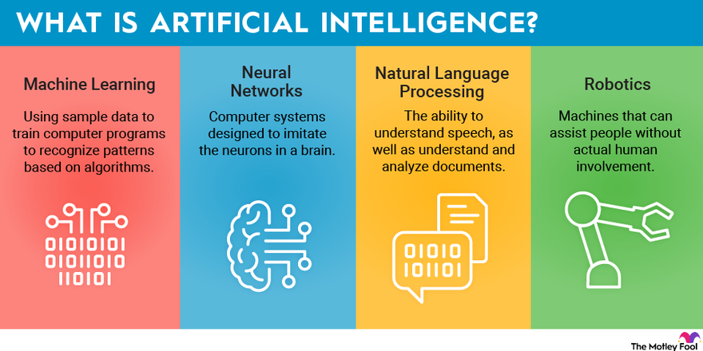

Figure 1: Artificial Intelligence
(Source: fool, 2023)

In contrast to Stamova and Draganov's (2020) viewpoint, artificial intelligence (AI) is conceptualized as a complex field that goes beyond task-specific relationships with sentient entities. More broadly, "AI" is the synthesis of "computer science" and cognitive science to give "robots cognitive" abilities similar to those of humans. It includes the creation of models and algorithms that enable learning, reasoning, and problem-solving in addition to the execution of activities often associated with intelligent creatures (Oosthuizen et al. 2021). According to this definition, AI is a dynamic field where adaptation to changing conditions is essential. It presents AI as more than just a machine that does preprogrammed tasks; rather, it recognizes that AI can understand, learn from, and react intelligently in a variety of contexts.
As per Cao (2021), AI can completely transform digital marketing in the retail sector of the United Kingdom. The fact that 54% of retail marketers use AI-driven customization across channels, according to a Forrester Consulting report that Emarsys commissioned, highlights the strategic importance of AI (emarsys.com, 2023).
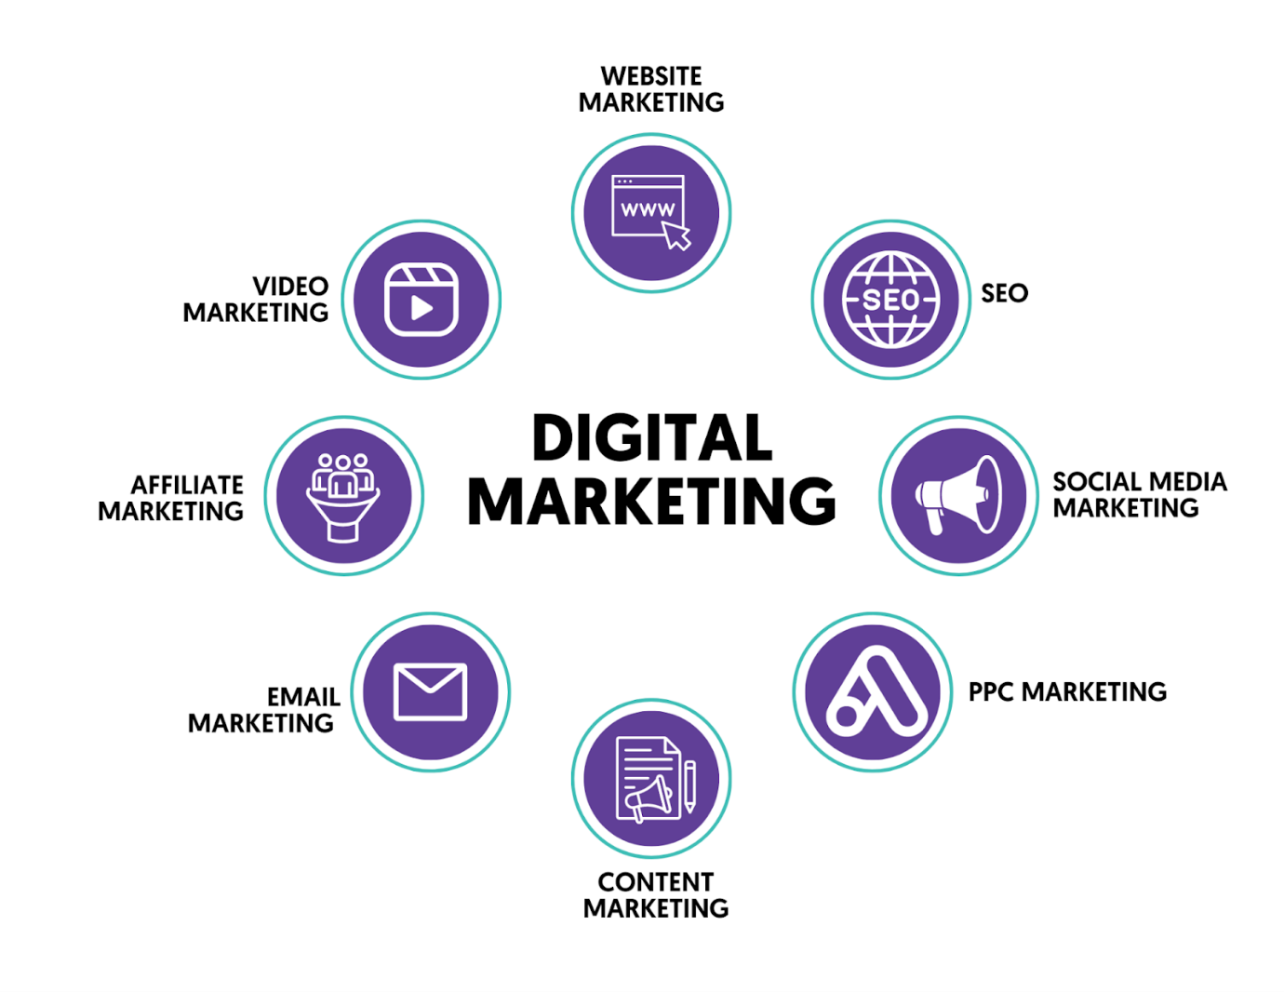

Figure 2: Digital Marketing
(Source: reliable soft, 2023)

As described by Panda and Mishra (2022), "Digital Marketing" interacting with current and potential customers using a range of online platforms, including "social media", "websites", "email", and "search engines". It is projected that the digital advertising industry will total US$679.80 billion by 2023, with US$279.30 billion going to search advertising. With projections of US$271.20 billion in 2023, the US is expected to top the world in ad expenditure (statista.com, 2023). The industry's critical significance in modern company operations is shown by these statistics, which also highlight the significant financial commitment made to digital marketing methods. Successful consumer outreach and engagement in this ever-changing business landscape depend on firms' ability to comprehend and leverage a variety of digital platforms. Gupta et al. (2021) criticize the definition's simplicity, pointing out that it ignores the complex methods used in digital marketing in favor of focusing only on technologies and channels. They contend that the essence transcends online platforms, highlighting the need for a deep understanding of consumer behavior, analytics, and a flexible strategy to traverse the quickly changing digital environment and highlighting the complex nature of successful digital marketing.
Conversely, a viewpoint that differs from the previously stated definition is provided by Grandhi et al. (2021). Digital marketing, in their opinion, is a planned, data-driven strategy that is carefully crafted for online engagement with a target audience rather than merely being a tool-centric exercise. The broad objectives of spurring company growth, raising brand recognition, and cultivating enduring consumer loyalty are strongly emphasized in this sophisticated definition. A carefully thought-out plan based on data insights is the foundation of digital marketing, recognizing the modern use of analytics and accuracy in negotiating the complex terrain of online audience engagement. In the UK, 2.1 billion British pounds were spent on digital retail media advertising in 2021. Spending is expected to increase at an average "CAGR" of more than "21%" between 2021 and 2027, totaling 6.45 billion pounds at that point (statista.com, 2023).
Digital marketing is described by Duyen (2021) as a comprehensive, customer-focused approach. Providing people with individualized experiences entails combining several web channels and technology smoothly. In addition to encouraging quick engagement and conversion, the objective is to develop long-lasting brand advocacy. The interconnectedness of digital marketing is highlighted by this term, which goes beyond simple transactions to foster enduring bonds and brand loyalty.
As a result, the amalgamation of “digital marketing” and “artificial intelligence (AI)” signifies an important change inside the UK retail sector. (Dumitriu and Popescu, 2020). This confluence highlights the critical role AI plays in fostering innovation and efficiency within digital marketing tactics, revolutionizing consumer involvement, changing economic landscapes, and highlighting a significant shift in industry dynamics.

2.3 Role of AI in the process of Digital Marketing in the UK Retail Industry
As per the opinion of Dwivedi et al. (2021), the Retail Industry in the United Kingdom is undergoing a significant transformation in its advertising approaches, which can be mostly attributable to the usage of “artificial intelligence” (AI) technology. AI is transforming the way retailers interact with consumers, streamlining operations, and spurring corporate development as the digital age drives to alter customer behavior and demands. On this note Kaufman et al. (2023), state, that AI is starting to change the digital marketing landscape by giving merchants new tools and skills to help them deal with the complexity of today's marketplace.

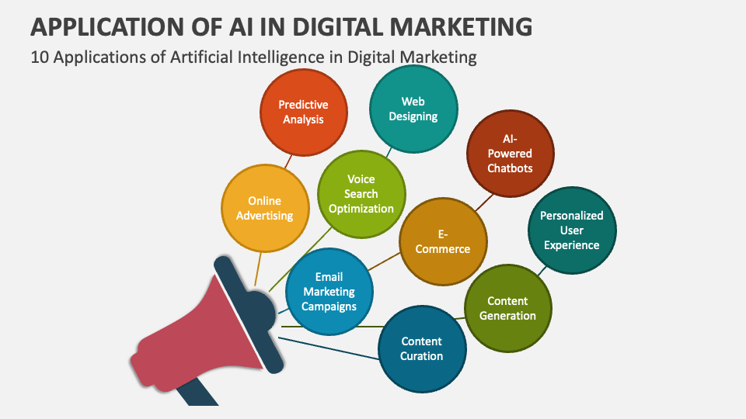

Figure 3: Role of AI in Digital Marketing
(Source: collide, 2023)

Algorithms powered by AI have completely changed how merchants locate and serve their consumer base. More advanced techniques, where AI analyses large information to comprehend unique tastes and behaviors, have supplanted conventional demographic-based marketing. Campbell et al. (2020), state that retailers in the UK can develop extremely specific and customized marketing strategies because of this finely detailed degree of data. Retailers may offer personalized user experience, merchandise suggestions, and incentives by using machine learning techniques that anticipate consumer tastes based on previous encounters. On the other hand, LEE, (2021), exposes that showing customers offers and items that match their interests, not only improves the consumer's experiences but also raises the chance of acquisition. “Target” marketing analysts have successfully utilized the personalized user experience for its consumers as already they form a "pregnancy prediction score" which enables the expecting mothers to determine which purchasing patterns to follow in an early expectant stage (target.com, 2023).
Accurate demand forecasting is essential for managing inventory in the fast-paced retail industry since it guarantees that products are accessible when and when consumers want them. For UK merchants, Guha et al. (2021), mention artificial intelligence (AI), especially using predictive analytics, has grown essential. Artificial intelligence (AI) systems can predict desire having a high degree of precision by examining past sales data, business patterns, and outside variables like weather and events. Responding to this note Mostafa et al. (2019) highlight the fact that companies enjoy the advantages of increasing the efficiency of their supply chains, minimizing excess or shortages of goods, and optimizing inventory levels as a result. Retailers are better able to fulfill customer needs and take advantage of market possibilities owing to this data-driven strategy. In the UK retail industry, chatbots and virtual assistants driven by AI are developing into more and more essential parts of consumer interaction strategies.
Campbell et al. (2020), emphasize that these AI apps help consumers in real-time by responding to their questions, offering details about products, and even streamlining purchases. Such as ordering a preferred drink or snack from coffee stores is simple, regardless of whether one chooses to use spoken instructions or texting. The chatbot will let know the entire cost as well as when the purchase will arrive ready. NLP, or Natural Language Processing, is a tool that chatbots use to comprehend and converse with customers. Whereas, on the other perspective Lee and Lee, (2020), mention that offering prompt assistance, not only improves the client experience but additionally opens up staff members to work on more difficult assignments.
This makes communication easier and more conversational, which encourages a feeling of individualization in consumer encounters. Dynamic pricing techniques rely heavily on artificial intelligence (AI) algorithms, which enable UK businesses to instantly modify prices in response to a range of variables, including market circumstances, rival prices, and desire. “Amazon” for instance has made up its company’s name on the headlines for using this dynamic pricing, which changes multiple times a date depending on rivalry factors or the customer's demands (amazon.co.uk, 2023). According to Wood et al. (2021), retailers may optimize revenues by aligning pricing with consumer sentiment and market conditions, owing to this flexibility. Retailers are kept competitive and accessible by AI-driven marketing algorithms, which are continually assessing and adjusting to shifting market conditions. Nevertheless, Ananthakumar, (2023), states that by giving customers fair, market-driven rates, this dynamic pricing strategy improves customer happiness in addition to aiding in revenue optimization.

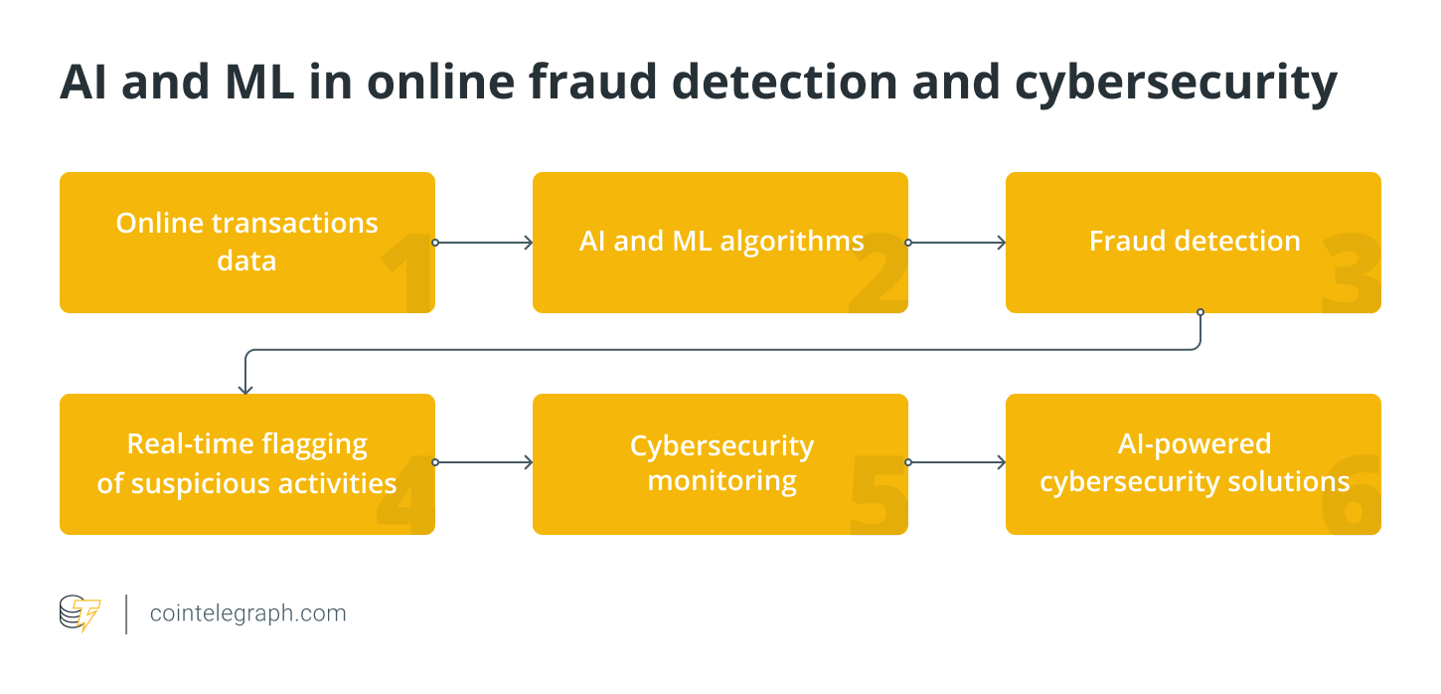

Figure 4: Role of AI and ML for Online Fraud Detection
(Source: Cointelegraph, 2023)

Retailers are becoming increasingly concerned about the danger of fraud as online purchases grow more common. AI is essential for bolstering safety precautions since it uses sophisticated algorithms to instantly identify and stop fraudulent activity. Machine learning algorithms look for abnormalities that can point to fraud by analyzing transactional patterns, user behavior, and other pertinent data. Trawnih et al. (2022), state that "AI" plays an important part in providing a safe and reliable online purchasing experience for consumers in the UK by quickly recognizing and reducing any dangers. Contrarily Stone et al. (2020), state that AI makes it easier to extract useful information from large databases, enabling merchants to decide on their marketing strategy with knowledge. AI-powered advanced analytics technologies can recognize patterns, consumer preferences, and the efficacy of different marketing channels. Retailers better organize their resources with this data-driven strategy, maximizing their advertising spending and improving their return on investment (ROI).
Retailers better connect their message and marketing with customer expectations by knowing what appeals to their audience. Artificial Intelligence (AI) tools have a crucial part in tracking and “examining social media platforms” to comprehend consumer attitudes and patterns. Ibrahim and Wang, (2019), mention that retailers determine the public's impression of their brand, goods, and market trends by combining sentiment research with social media monitoring. Critics like Mujtaba and Cavico, (2023), emphasize that retailers in the United Kingdom can spot emerging patterns, solve customer problems quickly, and capitalize on favorable emotions to improve their reputations by proactively monitoring social media discussions. Marketing is becoming more nimble and responsive as a result of AI's immediate feedback loop. "AI" plays a bigger part in digital marketing as it develops, opening up new opportunities for creativity and productivity in the UK retail industry.

2.4 Digital Marketing Strategies Implemented in the UK Retail Industry
In the UK, there have been large-scale developments in communication between organizations and customers. The integration of digital marketing, Alghizzawi (2019) states that the conveyance of information through promotional strategies has witnessed fundamental growth through the utilization of various digital tools to engage with customers on digital platforms. Retail firms have to increase their presence and promotion on social media medium for UK customers effectively through internet-based technology. The development of the accessibility of digital marketing strategies, and the detailing of varying digital promotional strategies differ from one retail organization in the UK to another.
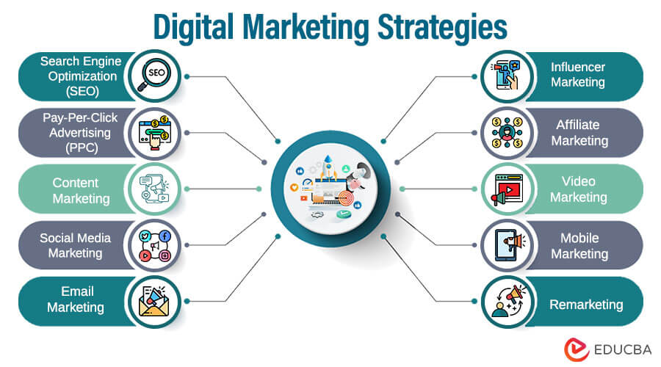

Figure 5: Varying Digital Marketing Strategies
(Source: educate, 2023)
Emphasizing digital marketing and promotional strategies plays an imperative role in various retail firms in the UK as it is perceived as making or breaking business practices. One of the largest UK retail firms Tesco has been perceived as operating at the peak of the UK Retail Industry through strategic marketing practices. Rosnizam et al. (2020) mention that Tesco implements market opportunity analysis over its competitors. Tesco performs an in-depth evaluation of its competitors and places them into various strategic groupings. Following a structured assimilation, Tesco analyses various marketing objectives of its competitors' business strategies and creates enhanced market profiles that proliferate measures for business optimization. Alexander (2020) states that Tesco has retained its position at the peak of the retail market in the UK by utilizing the analysis gained towards its marketing practices. Tesco advertises its cost-efficiency by advertising products on a digital scale and promoting itself as a far more affordable and accessible business alternative.
Another key proponent of the UK retail environment is H&M, headquartered in Sweden and actively operating across the UK. As per Islam (2020), one of the brand's pivotal marketing strategies has been an integrated approach to influencer and affiliate marketing. H&M has implemented a strategic marketing strategy that has focused on commercial collaboration for the brand to propel itself forward. To attain cohesive and sustainable traction from consumers, the brand implements joint partnerships that focus on promoting H&M towards new customer demographics as well as reiterating its quality and trust potential to loyal customers. H&M has forged various collaborative strategies with other famous brands as well as with well-renowned designers and celebrities, while simultaneously implementing targeted advertising on various social networks. In the contemporary online marketing environment, H&M has engaged with audiences by bridging the gap and utilizing influences and celebrities as marketers to increase traction and engagement with H&M products and services. The organization further promotes an Affiliate Program to promote and market itself as a digitally reliable firm and seeks to develop more collaborative ties (getlasso. co, 2023).
A contending retail organization in the UK that is renowned for its multi-category retailing and expanding apparel catalog is Marks and Spencer. As Joshi et al. (2022) contend, the organization has implemented various social media channels to compete for the peak position of the UK retail industry. Social media marketing has proliferated Marks and Spencer in sustaining effective customer loyalty, retention, and engagement. To enhance the business's marketing facets, Marks and Spencer consistently performs various strategies that allow customers to engage with the firm. Surveys or polls have acted as imperative contributors to engagement for the organization, and simultaneously attract new customers. Along with performing active CRM measures, Wibowo et al. (2020) state that Marks and Spencer implement social media marketing strategies that utilize customer engagement analytics towards enhancing product appeal and designs, and simultaneously promote campaigns that implement customer interests. It motivates customers to engage with the enterprise and facilitates the construction of customer reliance and faith in the organization due to Marks and Spencer shedding a proficient light on customer demands via its digital promotions and SMM.
One of the largest glowing fashion retailers in the British clothing industry is ASOS. As Parker and Alexander (2022) state, the brand has gained its notoriety primarily on digital platforms and it's considered to be an online-only success story due to ASOS being considered one of the UK's largest temporary retail organizations. Alongside its unique social media marketing strategies and omnichannel marketing facets, the brand has implemented innovative content promotional tools that have proliferated the business in retaining its cyber consistency and strengthened its brand equity. ASOS upholds the motto of "AsSeenOnScreen", and advertises clothing that has been seen on various media avenues. Zilinskaite and Spanellis (2020) effectively add that this approach of content marketing has enabled ASOS to reinvent digital marketing strategies and has consistently improved customer decision-making processes. ASOS has introduced engagement measures and policies that have allowed customers to build market equity for the brand. ASOS utilizes various marketing campaigns that focus on building social media content for customers in younger demographics to associate with. Structured collaboration with influencers and the promotion of particular hashtags has established ASOS in constructing a two-way communication channel built off proficiency, developing stronger customer outreach (medium.com, 2023).
Lidl is one of the UK's largest retail organizations and prominently operates across the nation by expanding quality fresh groceries and product offers for UK citizens. According to Ahmed (2021), Lidl originated in Germany and attained evolving and record-breaking financial performance in the UK through the utilization of its brand image through digital campaigns. The organization has developed customer retention by motivating UK customers and influencing effective trust in Lidl's products through effective digital marketing. The organization has impacted consumer purchase behavior by building market equity. This has facilitated customer behavior as a dependent variable by utilizing various independent variables such as brand association, public perception, perceived product quality, and brand awareness. As per Ali et al. (2021), brand image has functioned as an effective method of generating organizational trust and reputation between Lidl and UK customers, and has influenced better resilience and depends on the brand. It has led to Lidl being considered as one of the UK's most prominent retail firms.

2.5 Opportunities and Challenges in Incorporation of AI for Digital Marketing Transformation
In current times, it has been monitored that there has been an impactful transformation in the operational dynamics of the UK's retail sector which is characterized by the increasing implementation of AI in the industry of digital marketing. This paradigm shift has presented a myriad of opportunities and challenges for UK retailers who are striving to maintain competitiveness in the consistently evolving market landscape.
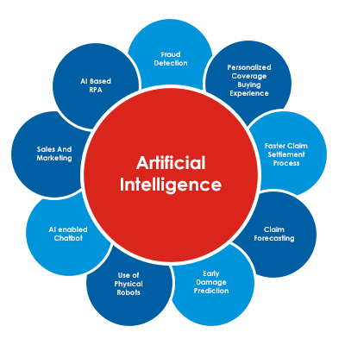

Figure 6: Opportunities of AI in digital transformation
(Source: analytics vidya, 2023)
On one hand, as stated by Ameen et al. (2021), one of the key advantages that artificial intelligence offers to the United Kingdom's retail sector is its capability to deliver exceptionally tailored customer experiences. Retail establishments have the opportunity to employ AI algorithms for the examination of customer data which encompasses past transactions, preferences, and online browsing activities. One of the prominent online fashion retailers ASOS exemplifies the implementation of AI to deliver personalized product suggestions which further helps in augmenting customer interaction and enhancing the probability of successful transactions (asosplc.com, 2022). On the other hand, it has been suggested by Gerke et al. (2020) that due to this reason, businesses accumulate and scrutinize extensive amounts of customer data, therefore, the paramount consideration becomes the assurance of customers’ data privacy and security. Implementing artificial intelligence requires careful handling of customer information to adhere to data protection regulations. Otherwise, UK retail businesses can not establish resilient cybersecurity measures to protect sensitive data which became an impediment to preserving customer trust.
As per the reports of Nair and Gupta, (2021), Artificial Intelligence helps retailers in developing their inventory management with the help of predictive analytics. Through the examination of historical sales data and considering external variables like - weather and trends, AI systems have the capability of providing more precise forecasts of demand. Further, it helps in the optimization of stock levels, overcoming overstock situations along decreasing instances of running out of stock. One of the prominent UK supermarket chains, Tesco, has successfully applied AI-driven predictive analytics into its managerial operations to streamline its supply chain and boost inventory management (tescoplc.com, 2023). On the contrary, as suggested by Fountaine et al. (2019), the inclusion of AI into the already established digital marketing frameworks needs a vast amount of costs and complexities. There are several UK retailers especially those belonging to smaller scales may encounter difficulties because of the limitation of financial resources and the requisite expertise which are essential for a smooth integration process. The UK-centric supermarket chain Asda experienced initial obstacles in integrating AI into its operational processes but these challenges were successfully mitigated by strategic investments in employee training activities and enhancements to the technological infrastructure (prolificnorth.co.uk, 2021).
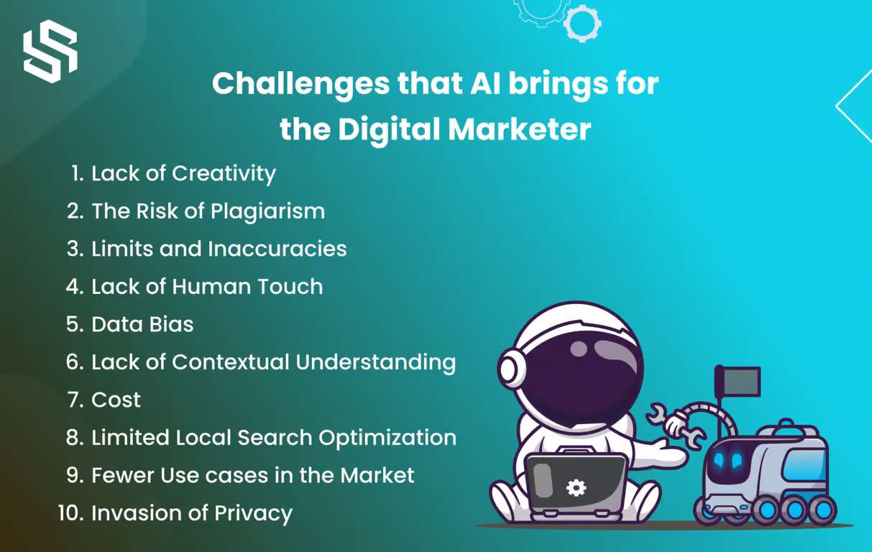

Figure 7: Challenges of AI in Digital Marketing Transformation
(Source: syndelltech, 2023)
It has been mentioned by Goktas et al. (2023), that Artificial Intelligence-driven chatbots have an important significance in delivering prompt and effective customer service. There is a prominent retailer Marks & Spencer which has seamlessly incorporated chatbots into its digital interfaces which helps the brand offer real-time assistance to customers by addressing inquiries and offering product recommendations (marksandspencer.com, 2021). It not only boosts customer satisfaction but also allocates human resources to more complicated responsibilities. Whereas, Pelau et al. (2021), argue that although the implementation of AI in customer interactions has the capability of optimizing efficiency, it has been observed that there is an existence of a segment of customers who prefer human interactions over talking with chatbots. The key challenge lies in the achievement of an optimal equilibrium between AI-driven automation and securing a personalized human touch. There is an example of Next Corporation, a prominent fashion retailer, has successfully developed various tactics for seamlessly incorporating AI technologies while simultaneously offering readily available human assistance for customers who prioritize such interactions (thenextorganization.com, 2021).
Further, Davenport et al. (2020) mentioned that AI brings the opportunity to examine trends in the market, pricing strategies of competitors, and the behavior of customers for the reason of executing dynamic pricing strategies. Retail establishments can easily modify prices in response to market fluctuations in demand, the pricing strategies adopted by competitors, and other pertinent variables. Corporations such as Amazon is one of the corporation which employ this dynamic pricing methodology which helps the brand in adapting as per the shifts in the market and optimize their revenue (amazon.com, 2019). Whereas the reports of Ntoutsi et al. (2020), suggested that, Artificial intelligence algorithms are programmed to exhibit bias influenced by the data used for their training. In the context of the retail industry, biased algorithms led to increasing the risk of producing discriminatory pricing or recommendations. Therefore, if retailers do not proactively confront algorithmic bias, then it will hinder the prioritization of fairness and transparency in the deployment. There is a company named Boat that has concentrated its efforts on overcoming bias concerns by consistent monitoring and adjustment of its AI algorithms (boat-lifestyle.com, 2020).
Further, added by Mohammad and Mahjabeen, (2023), the incorporation of visual search enhancements which are mainly powered by artificial intelligence empowers consumers to explore products through images as opposed to textual input. This technological advancement proves to be a great advantage in the sector of fashion. There are notable retailers like John Lewis which have incorporated visual search functionalities, by which the organization can afford customers the ability to upload images and discover comparable products within their inventory which is overall a very elevating shopping experience for customers (reuters.com, 2023). Whereas, Inês et al. (2020), stated that the retail industry of the United Kingdom is subject to diverse regulations which oversee the incorporation of data, marketing methodologies, and the protection of consumer rights. Those retail establishments that are integrating artificial intelligence into their digital marketing approaches need to adeptly navigate these regulatory frameworks.

2.6 Literature Gap
2.6.1 Weakness of the current research
The current research on the part of “Artificial Intelligence” while transforming "Digital Marketing" in the “UK's Retail Industry” exhibits notable weaknesses. Firstly, a few “long-term” consequences are tracked via “longitudinal” investigations of AI deployments on retail marketing tactics. Furthermore, the study frequently ignores the consequences for customer confidence and society's perceptions, in favor of skipping over ethical issues and potential biases in AI-driven marketing strategies, which is considered to be an important notion (De Bruyn et al. 2020). Furthermore, the majority of the attention now is being paid to bigger, more established businesses, more thorough evaluations of the difficulties and obstacles smaller merchants encounter when implementing AI technology are needed.

2.6.2 Limitations of the current research
The current study on the use of "artificial intelligence" (AI) in digital advertising has some limitations and gaps in the literature. First, a common shortcoming is the absence of standardized assessment measures and procedures, which makes it difficult to compare and generalize study results. Furthermore, a lot of research ignores possible negative effects and ethical issues in favor of highlighting the advantages of "AI" in "digital marketing", an important concern that needs emphasis (Dwivedi et al. 2021). There aren't many thorough studies on the challenges faced by smaller organizations, in particular, when attempting to use AI-driven marketing techniques. Moreover, a proactive viewpoint is frequently absent, with little investigation of new trends and the potential impacts of "AI" in the dynamic sector of "digital marketing." It is critical to close these gaps to promote a thorough comprehension of the long-term implications and intricacies of AI integration in digital marketing.

2.7 Significance of AI in the UK Retail Industry
The UK retail industry has been prevailing through growing digital disruption to entail significant AI tools such as "Analytics", "Machine learning Programmes" and "RPA software" for personalizing product experiences for consumers. Rautela, (2021) mentioned that the UK retail industry lacks a proper understanding of the market culture and that it fails to distinguish itself from external customers and internal customers. However, Suh and Chow, (2021) commented that knowing the external customers is more important than the internal customers to generate sales and market integration that can be fulfilled using proper predictive AI technology.

The Race Model
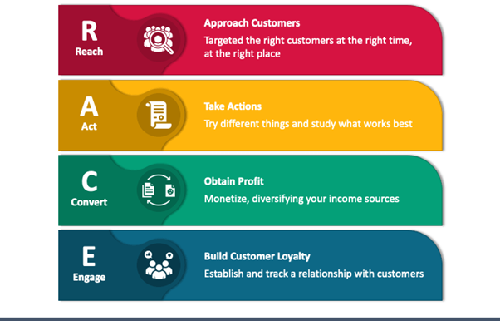

Figure 8: Race Model
(Source: Meghaganguli23, 2023)
AI transforms the digital marketing of the UK retail industry into an affiliated marketing zone leading to filling the gap due to a lack of market knowledge and consumer preferences. AI has transitioned the digital marketing system in the UK retail industry by enhancing shopper’s experience and work-in-progress inventory management digitally saving time and cost process. According to Safanta et al. (2019), AI has created a significant growth opportunity for the UK retail industries by introducing the first-ever “RFID technology” and “demand forecasting analytical software” similar to the stock market to gather information about the sentiments of the consumers without irrespective and hassling acquiescence, as can be observed in the case of Aldi (Aldi.com, 2023). However, Fedoryshyna et al. (2021) mentioned that, according to the incorporation of the RACE model, the UK retail industries utilize the AI functioning system to locate customers and approach the tentative set of consumers.
The Race model speaks of using AI technology to foster less skewness in the sales growth based on the international market conditions and likewise, leads the UK retail industry into taking gradual growth actions. For instance, Mhlauli and Ezeuduji, (2022) stated that 65% of the major retail market in the UK lacks a convenient method of advertisement and blurb promotion that is prompted through AI technology. However, the UK Retail Industry has a dearth of proper market knowledge regarding the seasonal inquisitiveness of the consumers leading to the ultimate utilisation of AI skills and contrivances. The concept can be further illustrated with the help of the “Honeycomb Model”. As Rizvanović et al. (2023) mentioned customer benefits have been expedited through the framework of the "Honeycomb model" that features membership norms and protocols to build efficient building blocks of social promotion of the UK retail brands, for example, as can be seen in the case of Asda (Asda..com, 2023).
As per the model, the UK retail industry lacks closed and structured branches leading to an increase in the communication gap and prejudices. As per Talwar et al. (2020), unlike the Race model, the reputation stage of the Honeycomb model has the advantage of valuing the networks of intimacy and immediacy with the customers through machine learning tools such as “Chatgpts” and the “Personalised AI system” that the UK retail industries are mainly lacking. In contrast, Erdmann and Ponzoa, (2021) exemplified that the conversation and sharing stage of the Honeycomb model has an advantage in accentuating the use of social media through AI integration in a limited manner to eliminate the risk of sharing and joining the networks. However, Clark et al. (2020) commented that the Race model manages the key and primate functions such as Search optimization and customer identification that are mainly absent in the UK retail industry. The identity and relationship stage in the Honeycomb model has the advantage of being used by Asda for generating its presence in social media by being aware of data protection slants. In contrast, Fletcher, (2021) mentioned that the Race model is used by retail sectors such as Marks & Spencer and Tesco to carry out insufficient organizational planning in methodical and technological manners using "mapping tools" and "project management software".

Honeycomb Model
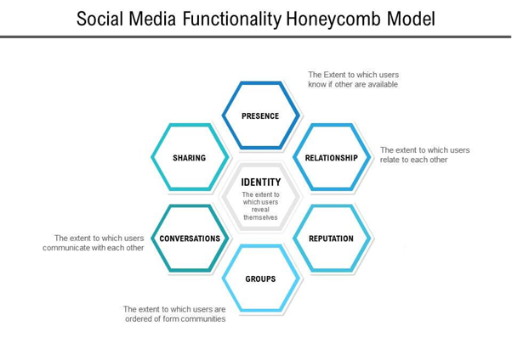

Figure 9: Honey Comb Model
(Source: Smart insights, 2023)
The UK retail industry lacks a specific manner of implementing communication tools and technology to gain benefits in understanding both the effectiveness of social media and consumer terminologies (Furr et al. 2022). It might gain access to the needs of the consumers, however, it is too piddling and exiguous to understand the approach of the consumers. The significance of the AI tools lies in the process of the doting task of evaluating the main structure by gaining access to the consumers through social media platforms on the condition that the same effort has to be made by the latter by participating in polls and surveys. Alessandrini et al. (2021) exemplified that such polls and surveys dedicated to Aldi and Asda also form a part of its brand image and any malfunctioning of its services can lead to a data loss of the subscribed participating consumers gradually leading to decreased brand value. Ahmed et al. (2020) stated that, as per the notions of the model, to avoid such circumstances specific AI tools are implemented.
The Honeycomb model is disintegrated into key seven stages that determine the extent to which sharing of data can be applicable during advertisement to prevent future mislaying of consumer loyalty. However, Mariani and Wamba, (2020) exemplified that the honeycomb model has a disadvantage if observed from the perspective of Aldi and Asda, in terms of distinguishing social media activities from a wider social media technology, through certain tools such as “digital Qulatrics”, “Semrush” and “Brand research analytics” at a steady and quick pace. As per Purcărea et al. (2022), the Honeycomb model lacks a steady customer position such that the latter being scattered uses the converting stage of the Race Model to distinguish between the portion of sales to the net sales generation. Rahmanov et al. (2021) mentioned that certain disadvantages such as the distribution and receiving of marketing information become ductile through analytical tools due to the extensive market structure. Moreover, “Aldi” and “Asda” lack close branches which the Honeycomb model finds it being at a disadvantageous position for implementing communication networks. However, Samoggia et al. (2021) stated that the Race model operates on a macroeconomic basis taking into account the position of the operational branches leading to the sustainable use of the analytical tools. AI has a huge significance in leading through operational growth and technological development among the majority of the UK retail sector.

2.8 Conclusion
In summary, whereas recent studies highlight the revolutionary possibilities of "Artificial Intelligence" (AI) in "digital marketing", significant constraints still exist. A thorough understanding is hampered by the lack of standardized assessment measures, inadequate investigation of ethical issues, and a paucity of research on the difficulties faced by smaller enterprises. The paper consists of a detailed analysis of "Artificial intelligence" and "Digital marketing". Highlighting different roles along with the significance of AI which also delves into various issues and opportunities for the retail sector of the UK. Also, the research consists of various real UK retail company examples along with the advantages and disadvantages faced while practicing operations with AI tools for their digital marketing.

Chapter 3: Research Methodology

3.1 Introduction
The respective segment “research methodology” defines the process that has been critically incorporated and integrated into the particular study. The methodology includes “research philosophy, research approach, research design, research strategy, data collection method, data analysis, and more”. This is the process of collecting proper data and together these processes are termed “research methodology.

3.2 Research Onion

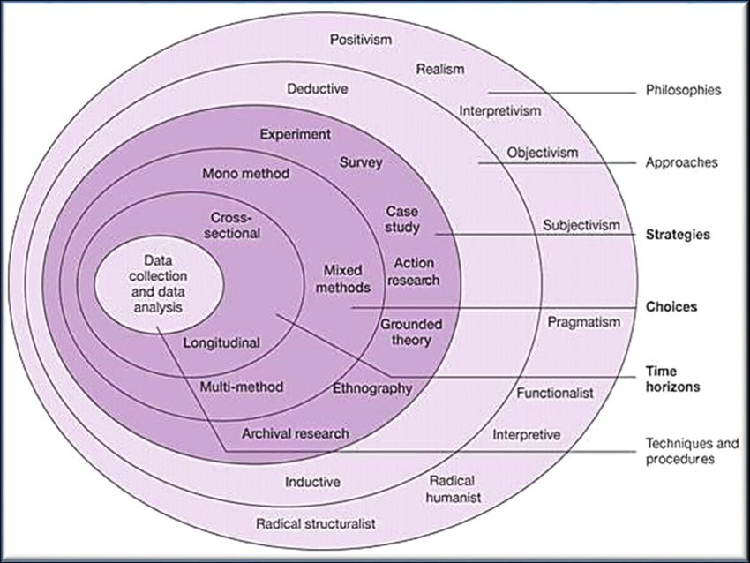

Figure 10: Saunder’s Research Onion
(Source: Saunders et al. 2019)
“Research onion” as a framework critically depicts the layers through which an investigation or research has to go while conducting a study (Mardiana, 2020). Moreover, the layers contain various methods through which proper information is obtained precisely. As the framework defines, the outermost layer for research starts with choosing the suitable philosophy that can guide the study, later on, the approach that is suitable, then strategies, choices, time horizon, and the innermost layer or the core has techniques and procedure for data collection and analysis. Hence, this depicts that the respective framework guides the researcher to work in layers and obtain necessary information.

3.3 Research Philosophy
A “research philosophy” is associated with a fixed principles that underlie the manner in which a researcher approaches the study (Khatri, 2020). The distinct types of “research philosophies” are “interpretivism”, “positivism” and “pragmatism”. For this study, “positivism philosophy” has been considered, which is a paradigm that relies on measurement and reasoning. As per this philosophy, knowledge can be derived only from measurable observation (Park et al. 2020).
The “positivism philosophy” has been chosen for the study because it encourages objectivity and empirical evidence in research. Moreover, this philosophy allows the investigator to “generalize” the findings to a wide number of people and assists in formulating and testing hypotheses and theories through empirical evidence (Marsonet, 2019). Therefore, by adopting this philosophy, the researcher is able to objectively examine AI’s role in digital marketing transformation in the UK retail industry. The “interpretivist philosophy” has not been chosen because it has a subjective approach and creates room for bias and “pragmatism philosophy” lacks a foundational principle with a narrow focus.

3.4 Research approach
A “research approach” essentially involves the way in which a researcher obtains, evaluates and interprets data (Sileyew, 2019). The “research approaches” exists in two categories, “inductive” and “deductive”. This study uses “deductive approach” wherein the researcher begins with a theory and evaluates its impact with empirical observation (Casula et al. 2021).
The investigator has made use of the “deductive approach” as it allows the establishment of a theory or a hypothesis with regard to AI integration in digital marketing and its effectiveness for retail industry in the UK. Moreover, this approach allows gathering relevant data and evidence that can determine if the theory or hypothesis is true in the context of the study (Mehrad and Zangeneh, 2019). As compared to “deductive approach” that fosters a more controlled investigation, the “inductive approach” is not selected because it starts from a specific theory and moves to a more generalized notion which does not allow more exploration into the subject matter.

3.5 Research Strategy
A “research strategy” relates to a particular “action plan” that the investigator undertakes to search and assess information gathered in a systematic manner (Al-Ababneh, 2020). Researchers generally utilize either “survey”, “archival”, “experimental” or “case study” strategies for their studies. In the context of this study, the “survey strategy” has been taken into consideration. This is a quantitative research strategy that collects data from a predefined group using a questionnaire (Mishra and Alok, 2022).
The researcher has opted for a “survey research strategy” as this strategy is flexible and adaptable and allows the researcher to acquire information from a wide range of population as per the research needs (Brenner, 2020). Moreover, it allows greater generalizability of the findings and is more reliable for a study involving insights from retailers on digital marketing and AI. The other strategies are not suited for this study as they limit the sample size and issues regarding data availability arise along with the problem of time constraints.

3.6 Research Design
A “research design” pertains to the entire study’s “research methodology framework” and the measures taken by a researcher for conducting a study (Bloomfield and Fisher, 2019). It performs as a blueprint for the investigator to follow during the various stages of the research. The study has implemented a “descriptive design” through “primary investigation” using the “survey method”. This design focuses on description and exploration of in-depth data by involving primary investigation (Siedlecki, 2020).
The researcher has chosen the “descriptive design” because it enables the research worker to gain a holistic comprehension of the role of AI in the UK retail industry’s digital marketing. The primary research through “method” further allows collection of relevant and updated information on the subject matter enabling accurate study results (Aggarwal and Ranganathan, 2019). On the other hand, a secondary researcher has not been selected for the study as it lacks specificity and may carry outdated information which cannot fulfil the researcher’s objectives.

3.7 Type of Investigation
Primary Research (survey)
Primary research is a process where a researcher communicates with research participant with acquire real-time information regarding the research subject. Survey is a technique of primary research where a well-structured questionnaire is distributed to collect information from the participants to enhance the relevance of the study.
Secondary research (literature review)
Secondary research is a procedure where data is collected from multiple secondary resources such as research papers, articles, websites and so on (Del et al. 2023). In literature review, relevant and relative information is collected from various databases to elaborate the topic of the study in a better way.
 | Advantages | Disadvantages
Primary Research | It increases the relevance of the study as a significant amount of confidential data can be gather through this research strategy which is a notable advantage | The major disadvantage of Primary research is the research higher cost. In addition to this, this strategy is time-consuming.
Secondary Research | The main advantage of secondary research is cost-efficiency | Lack of confidential information and speciality is the noteworthy drawback of secondary research.

Table 1: advantages and disadvantages of primary and secondary research

3.8 Methodological Choice
Mono Methodology comprises of collection of single data and analysis either qualitative or quantitative. Qualitative research is a pattern of investigation that explore and gives deeper insights into real-world issues and human behaviours (Lobe et al. 2020). It focuses on examining non-numerical information to evaluate experience, opinions and concepts. Quantitative research is the method of gathering and examining numerical information and it is utilised for finding averages, pattern, testing casual relationships and making predictions
In research, “methodological choice” is the option selected by the researcher with regard to the method and technique to be used in a study. Generally, they are either a “quantitative method” that relies on numerical data and a “qualitative method” that analyses non-numerical data. For this study, “quantitative method” is chosen as it is scientific, focused and relatable.
 | Advantages | Disadvantages
Quantitative method | It is fast, relatable scientific and focused method. Its efficiency and speed are preferred by many researchers (Kurzhals and Kurzhals, 2021) | The main disadvantage of this method is the tests in this method can be manipulated which can generate inappropriate result (Mohajan, 2020).

Table 2: Advantages and Disadvantages of Quantitative method

3.9 Time Horizon
A “cross-sectional time horizon” is selected for the study in order to gain comprehensive knowledge on the subject matter clearly. This time horizon is considered effective for the large sample size of the study and assists in resource allocation (Spector, 2019). It further helps in identifying the latest trends in digital marketing of the UK retail sector. This research is completed in one go.

3.10 Population and Sampling Technique
Sampling critically depicts the small fraction of people from a big population that is going to be a part of certain research (Campbell et al. 2020). This research has conducted a survey of 50 participants, marketing employees from the UK retail industry regarding the application of AI in digital marketing. The method of collecting the data is to inculcate the “primary quantitative method” which provides positive outcomes in a primary data collection that is through surveys, interviews, or questionnaires. The particular data collection can be less inclusive as it is strictly based on preliminary sources directly but it can provide authentic data for the respective research. The Data collection is done by “snow ball sampling method” in which once you have the data from one person in industry he/she can help to contact more employees from the same industry or also known as chain-referal. This can help to save time and Resources but the Disadvantage of this method is that this is subjective so it is hard to detect the error.

3.11 Data collection method
When conducting a research investigation, collection of adequate and appropriate data is most crucial. Therefore, for this investigation, the “primary data collection method” has been the choice to obtain information on the topic from “50 participants” belonging to the UK retail industry. For this research a survey questionnaire consisting of “8 to 10 questions” was prepared in which some questions are based on likert scale, rating scale and closed ended questions. The respondents of the survey, that is the “50 marketing employees” from the retail sector of the UK, are allotted a time limit of 5 to 7 minutes for providing unbiased honest answers that can present a detailed insight on the topic of inquiry. The first participant was selected by visiting in person seeking help from the registered Retailer in UK.

3.12 Data Analysis
The next vital step post collection of data consists of analyzing data for achieving desired results. Usually, researchers delve into either “statistical analysis” or “thematic analysis” methods. For this study, “statistical data analysis” has been considered that allows researchers to identify patterns and trends within the collected data guaranteeing the validity of the research (Peck et al. 2020). The “statistical analysis” provides a systematic approach to analysing data using the SPSS software tool for understanding the influence of AI on digital marketing in UK retail. Contrarily, the subjective nature and lack of quantifiable precision like the statistical method of analysis has discouraged the researcher from using “thematic analysis method”.

3.13 Research Ethics
The research aims to maintain proper ethical parameters while collecting information from the participants. The research considers participants who willingly participated in the survey and are free to answer the questionnaires. The respective research ethics is the process that is considered to support the study in being authentic and free from any unethical procedure that can negatively affect the study (Brandenburg, and McDonough, 2019). Conducting an ethical process of research can also provide positive outcomes as this ensures that the information gathered holds the essence of the research which is highly significant as well. Hence, ethical research is required for every study.

3.14 Research Limitations
The research has been conducted by keeping every ethics of research in mind, however, the research experienced a few gaps that resulted in the limitation of the research process. Primary research provides authenticity and proper data as well but on the other hand, collecting data from direct primary sources can be time-consuming. This research has conducted the primary data for providing authentic and redundancy-free information (Skinner, 2020). However, in the process of doing so, the research took a lot of time that could have been utilised in other areas as well. Hence, the limitation of the research is time consumption for the utilisation of the primary research technique.

Chapter 4: Analysis and Discussion

4.1 Introduction
The data obtained for identifying the role and functions of artificial intelligence in the transformation of “digital marketing” especially in the retail sector of the UK has been focused on and explained in detail in the “analysis and discussion” section. This part of the study reviews the gathered data using suitable evaluation measures. Additionally, the variables are examined in relation to the theory. The survey responses of “50 marketing employees” of UK retail are effectively evaluated and analysed with the help of “SPSS software” to determine the results. Moreover, to assess the data efficiently and draw meaningful inferences, several statistical techniques have been deployed in this section.

4.2 Specification of Hypotheses
As a result of the hypothesis, the specific areas that can be investigated in this particular study are delineated which in turn aids in the finding appropriate answers to the research question (Syafriandi et al. 2020). For an in-depth investigation into the statistical characteristics of the research, the hypotheses were created using the SPSS approach. As can be observed from the table, two sets of hypotheses namely, “null hypothesis” and “alternate hypothesis” are created. This method allowed for a more comprehensive analysis which enhances the research setting.
Hypothesis | Statement | p-value | Result
H0 | Artificial Intelligence has no role in transforming digital marketing in the UK retail sector. | 0.00 | Rejected
H1 | Artificial Intelligence has a significant role in transforming digital marketing in the UK retail sector. | 0.00 | Accepted

Table 3: Hypothesis specification
The “p-value” taken into account is “0.05” and on this basis, the hypothesis formulated for this study has been tested. The “null hypothesis (H0)” with “p-value” that is “>0.05” is rejected in the study whereas the “alternate hypothesis (H1) with “p-value” that is “<0.05” has been accepted.

4.3 Specification of Variables
The assessment of variables as Buch et al. (2023) mentions is critical for statistical research as these variables are important components of the study under consideration. For effective research and a comprehensive analysis, the researchers incorporate both the “dependent variables” and its corresponding “independent variables”. The analysis focuses primarily on the evaluation of “dependent variable” which is intrinsically connected with the “independent variables” (Duncan and Kefford. 2021). As opposed to “dependent variables”, the “independent variables” are under the control of researchers and are not affected by other factors. The table below highlights the variables of this particular investigation.
Dependent Variables | Artificial intelligence played significant role in marketing
Independent Variables | Taken steps to resolve issues, Challenges that faced by company, Ways that affected company, Ways that utilized to bring changes

Table 4: Variable Specification
The table above clarifies that both “dependent” and “independent variables are crucial for the study and are connected to each other. In the study, Q4 is the “dependent variable (DV)” and Q6, Q7, Q10 and Q11 act as the “independent variables (IV)”.

4.4 Descriptive Statistics
Within the context of regression analysis, the “descriptive statistics” tool is useful in streamlining and interpreting data effectively. This tool helps in discovering the “mean”, “median”, “standard deviation” and other distributed frequencies. As per Cooksey and Cooksey, (2020), using this technique, researchers are able to simplify complex data, derive more meaningful patterns and make comparative analysis allowing revelation of its key characteristics. As such, the purpose of “descriptive statistics” is primarily to make the data easy for understanding and provide important insights.
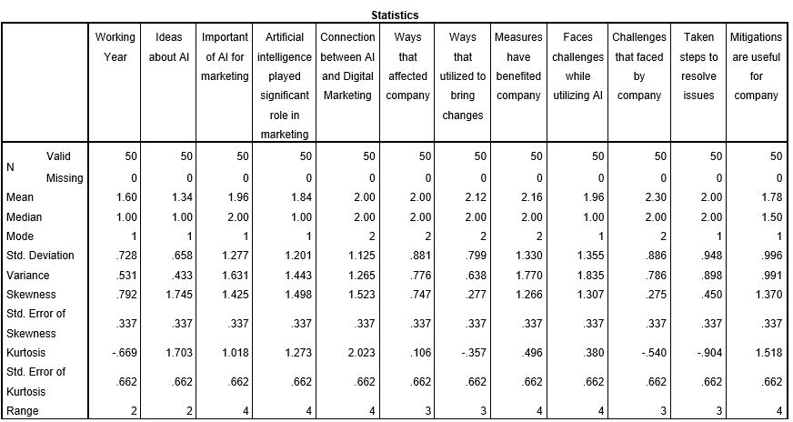

Table 5: Descriptive statistics
(Source: created through SPSS)
As can be observed from the table above, the “mean value” of “Artificial intelligence played significant role in marketing” which is the “dependent variable” is 1.84 while its “median value” is 1.00 and “standard deviation” is 1.201. Moreover, the “skewness value” of this variable is noted to be 1.498 and “kurtosis” is 1.273. Furthermore, in the case of “independent variable” “Taken steps to resolve issues” the “mean and median value” noted are 2.00, while its “standard deviation” is less at 0.948 value. Similarly, for variable “Challenges that faced by company”, the descriptive statistics are 2.30, 2.00 and 0.886 and “skewness” is 0.275 and “kurtosis” is at a negative value of -0.540. Additionally, the “mean and median” of “independent variable” “Ways that affected company” is same at 2.00 and SD is 0.881 while “skewness” is 0.747 and “kurtosis” is 0.106. Furthermore, the “mean, median, standard deviation, skewness and kurtosis” values of variable “Ways that utilized to bring changes” are 2.12, 2.00, 0.799, 0.277 and -0.357 respectively. Thus, from the “mean”, “median” and “standard deviation” scores of the “dependent” and “independent variables”, it is understood that “artificial intelligence” has a moderate influence on the “transformation of UK retail digital marketing” strategies. As Kaur et al. (2020) points out, AI significantly impacts the way UK retailers approach digital marketing and by incorporating AI, these organisations benefit and also face challenges.

Graphical Interpretation
Q1. What duration of time have you been working in this industry?
- 1 to 3 years
- 4 to 5 years
- 6 years and above
Summary | Responses | Average%
1 to 3 years | 27 | 54%
4 to 5 years | 16 | 32%
6 years and above | 7 | 14%

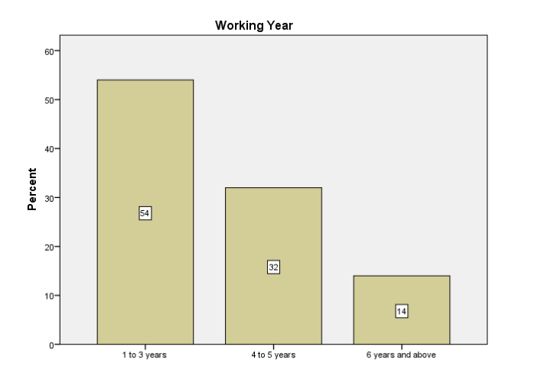

Grade 1: Working Year
(Source: created through SPSS)
2023 was a breakout year for AI, whereas, 2024 is going to prove as a maturity period for the AI in terms of digital marketing. The graph shows that in the past 3 years, AI has progressed tremendously with an average of 55%, however, it gradually declared it terminated in 4 to 6 years with an average of 33% to 15%. The picturesque depiction of the working years of “Digital Marketing” in AI fields is yet to bypass the 55% as is evident from the passing initial 3 years of observance.

Q2. Do you have enough ideas regarding Artificial Intelligence?
- Yes
- No
- Maybe
Summary | Responses | Average%
Yes | 38 | 76%
No | 7 | 14%
Maybe | 5 | 10%

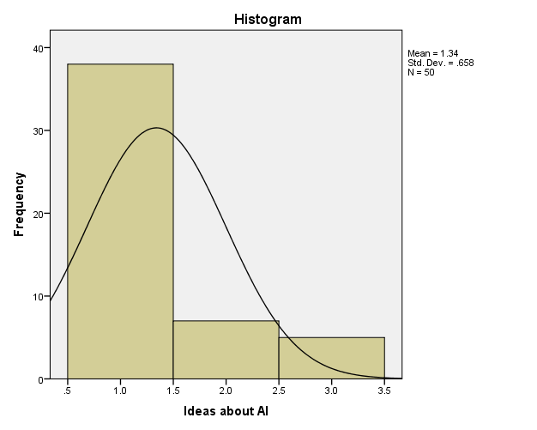

Grade 2: Ideas About AI
(Source: created through SPSS)
The histo-graph shows that lamentations and latency in AI have been increasing with a new generation of the physical evolution of “Digital Marketing”. The graph depicts positive skewness as the mean is greater than 1 with an average value of 1.34 indicating a growth prospect of AI in the “Digital Marketing” with a new perspective. It further indicates that the AI might face a small frequency of losses at the rate of 5% to 6%, whereas, a few gains of an overall 30% from long-term investments. Such losses in “Digital Marketing” might occur for lesser terminals as the “standard deviation” tends to be less than 1 by 0.658, tending to be located closer to the mean.
Q3.Do you agree that there is an importance of Artificial Intelligence for marketing?
1 2 3 4 5
- 5
Summary | Responses | Average%
1 | 24 | 48%
2 | 16 | 32%
3 | 3 | 6%
4 | 2 | 4%
5 | 5 | 10%

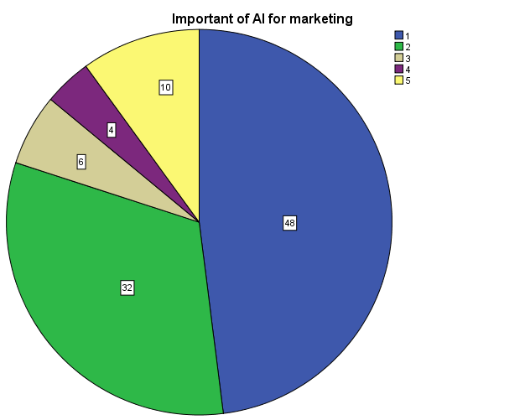

Grade 3: Importance of AI in marketing
(Source: created through SPSS)
The dependency on AI for digital marketing is increasing and has reached a saturated level of 48%. The figure depicts that 32% of the marketing professional or intelligence are yet to use AI, whereas, 6% are yet to be sure of its marketing presence and its utilisation factors. Moreover, the majority of 10% of the digital marketing departments are unsure of its importance and are unlikely to use it as it is based on the traditional methods of marketing. The remaining 4% of the global population seems to have adopted a unit culture, resulting in unawareness and independence on such contraptions.

Q. Do you agree artificial intelligence has played a significant role in developing digital marketing efforts in the retail industry over the past year?
Summary | Responses | Average%
Strongly Agree | 27 | 54%
Agree | 14 | 28%
Neutral | 2 | 4%
Disagree | 4 | 8%
Strongly Disagree | 3 | 6%

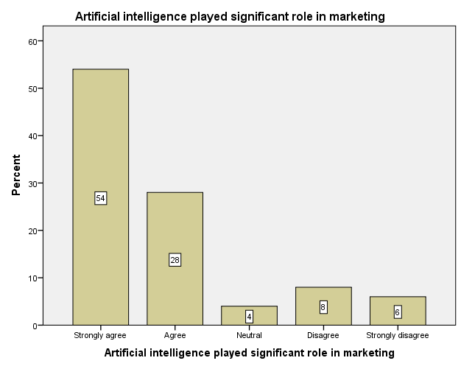

Grade 4: Role of AI in marketing
(Source: created through SPSS)
AI plays a vital role in marketing factors as it is responsible for managing data and handling misuse of such data from time to time. 54% of the global population strongly agrees that AI has upcoming scope into digital media and marketing fields, whereas, 26% of the population only agrees that AI can be extremely useful only under certain circumstances. 4% population are for and in favour of AI in “Digital Marketing”, whereas, 8% disagree that the upcoming generation is the leading epoch for AI due to haggling cybercrime. The rest 6% of the population strongly disagrees with the use of AI which hampers the antique and traditional viewpoint of marketing.

Q4. Do you agree that there is a connection between AI and Digital marketing?
- Strongly agree
- Agree
- Neutral
- Disagree
- Strongly disagree
Summary | Responses | Average%
Strongly Agree | 18 | 36%
Agree | 23 | 46%
Neutral | 4 | 8%
Disagree | 1 | 2%
Strongly Disagree | 4 | 8%

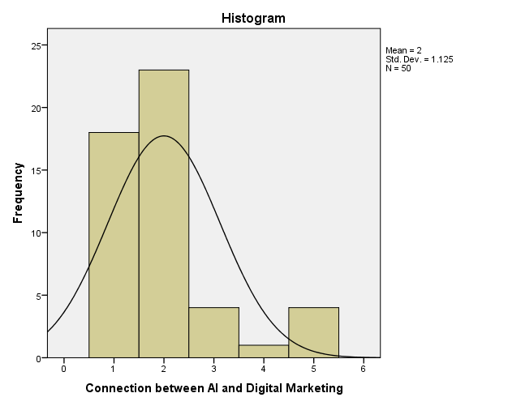

Grade 5: Relation between AI and Digital Marketing
(Source: created through SPSS)
AI is the centre of content optimisation and has helped marketing analysis reach its peak and gain superintendency. The picturesque depiction of the relationship of AI with “Digital Marketing” remarks on the frequency by which AI has been progressing in the “Digital Marketing” units. It has a typical symmetrical skewness indicating the existence of risks and fluctuating “Return on Investment”. The mean is 2, greater than 1 indicating the existence of bimodal riks in case the profit and loss are uncertain by a rate of 17.5% and -3%. Moreover, the “Standard Deviation” tends to stand at 1.125, which is greater than 1 and nearer to the mean, depicting a surplus loss during revenue generation.

Q5. What different ways do you thin digital marketing has affected company?
- Increase in brand recognition
- Upliftment of customer base
- Vivid marketing and generation of appeals
- All of the above
Summary | Responses | Average%
Increased in brand recognition | 15 | 30%
Upliftment of customer base | 24 | 48%
Vivid marketing and generation of appeals | 7 | 14%
All of the above | 4 | 8%

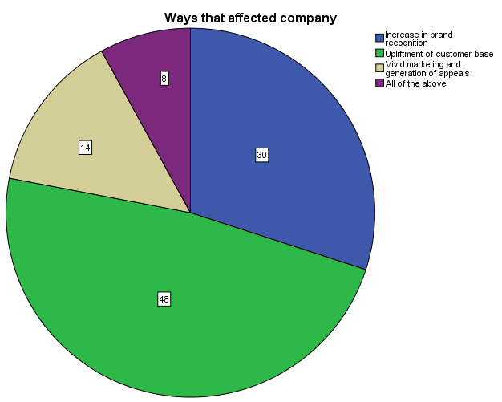

Grade 6: Methods of AI that affect the company
(Source: created through SPSS)
AI affects both the marketing status and the company with its ability to generate leads and market benefactions. There is probably a 48% upliftment of new customers from being stringent to felicity in AI adoption. 30% increase in the brand awareness of the “digital marketing company” is due to the wise utility of AI. Furthermore, there is a 14% haul in the generation of appeal and vividity in the market’s lead generation after the appliance of AI into it. Meanwhile, AI has led the company to change its methodical perspective of podcasting and exacting its content by an overall rate of 8%.

Q6. In what ways you utilized AI to bring changes in digital marketing for your company?
- Algorithms utilization to identify different patterns
- Deeper insight into customer behaviour
- Future behaviour predictions
- All of the above

Summary | Responses | Average%
Algorithms utilization to identify different patterns | 11 | 22%
Deeper insights into consumer behaviour | 24 | 48%
Future behaviour prediction | 13 | 26%
All of the above | 2 | 4%

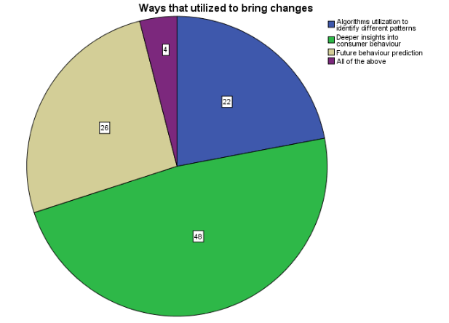

Grade 7: Methods utilised to instill change
(Source: created through SPSS)
There are various strategies implemented that utilise the adaptability and flexibility of the business in bringing dynamic changes and measures to cope with evolving business statuses. 48% represents the use of deeper analytical strategies to attain comprehensive data information surrounding consumer behaviour and purchasing intentions. 26% represents a strategy that focuses on navigating business conditions to predict future market conditions and dynamics and strategically implement decision-making capacities. 22% dictate the implementation of an efficient corporate algorithm that utilises various strategies to identify different patterns and forecast corporate steps moving forward, with 4% overall displaying a conjunction and amalgamation of all aforementioned strategies to create an overall approach of technological resilience.

Q7. Do you think these measures have benefited your company?
1 2 3 4 5
- 5
Summary | Responses | Average%
1 | 18 | 36%
2 | 21 | 42%
3 | 3 | 6%
4 | 1 | 2%
5 | 7 | 14%

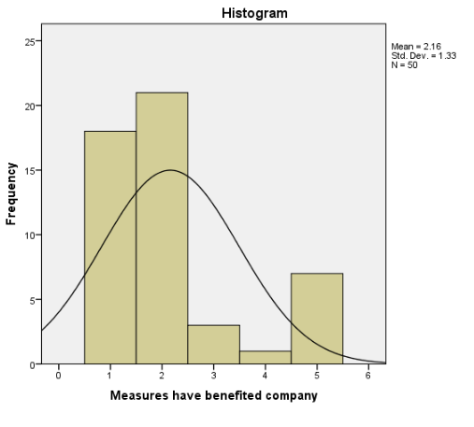

Grade 8: Beneficial measures implemented by the Corporation
(Source: created through SPSS)
In the graph showcased above, 18 have agreed with the sentiment that various Strategies and measures that have been implemented to benefit the company have been advantageous with an additional 21 displaying strong approval and agreement with the Method implemented. 3 have showcased a neutral sentiment of neither disagreeing nor agreeing with the measures being beneficial for the firm. 1 disagreed with the statement, with an additional 6 strongly disagreeing with the fact that these measures have aided the company, with the mean displaying a 2.16% average overall and a standard deviation of 1.33.

Q8. Do you agree that you have faced challenges while utilizing AI for transforming digital marketing?
a. Strongly agree
b. Agree
c. Neutral
d. Disagree
e Strongly disagree
Summary | Responses | Average%
1 | 27 | 54%
2 | 12 | 24%
3 | 2 | 4%
4 | 4 | 8%
5 | 5 | 10%

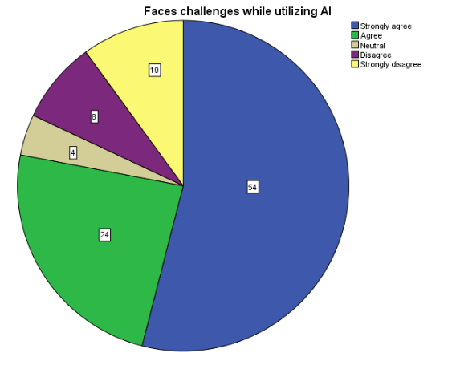

Grade 9: Faces challenges when using AI
(Source: created through SPSS)
From the comprehensive survey, 54% have displayed a sentiment of agreeing with the statement that there are various challenges encountered when utilising AI in any business domain. The large majority showcase a strong agreement with the statement, with 24% agreeing with the statement. A minority of 4% display a neutral sentiment on the potential of challenges that are encountered when utilising AI. However, alternatively, 10% have displayed a strong disagreement with any challenges encountered with the implementation of artificial intelligence. Further, 8% have disagreed with this statement.

Q9 . what are the different challenges faced by your company?
- Lack of creativity
- Concers of biases and inaccurate content
- Data breach possibility
- All of the above
Summary | Responses | Average%
Lack of creativity | 9 | 18%
Concerns of biases and inaccurate content | 22 | 44%
Data breach possibility | 14 | 28%
All of the above | 5 | 10%

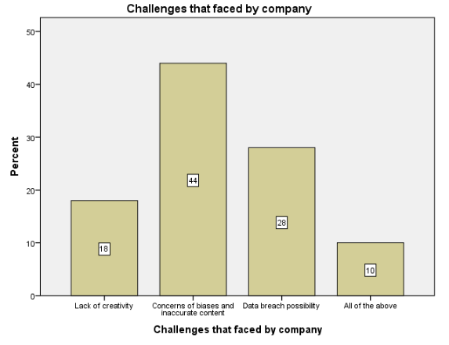

Grade 10: Challenges encountered
(Source: created through SPSS)
In the graph, 44% showcase a concern about workplace bias and inaccurate content for proactive action by the workforce. 18% of the challenges recorded are experienced by a lack of workplace creativity and innovation. 28% experience a critical challenge of a potential data breach experience of imperative data. 10% display an amalgamation of all aforementioned hindrances.

Q10. What mitigation steps have your company taken to resolve these issues?
- Providing the needed training
- Incorporation of high quality data
- Ensuring privacy of data
- All of the above
Summary | Responses | Average%
Providing the needed training | 19 | 38%
Incorporation of high-quality data | 15 | 30%
Ensuring privacy of data | 13 | 26%
All of the above | 3 | 6%

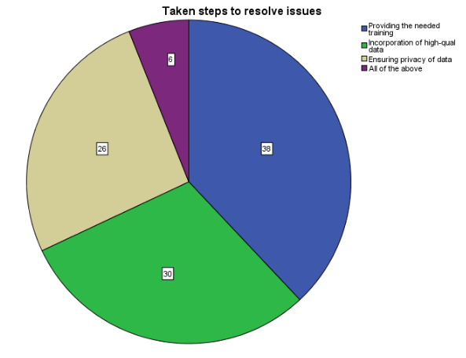

Grade 11: Steps taken to counter challenges
(Source: created through SPSS)
There are multifarious steps implemented for the business to resolve various workplace issues. 38% represent the provision of efficient and influential training strategies that significantly boost the potential of productivity and flexibility attached to the workforce. 30% represent the incorporation of high-quality data and its influence in raising the operational performance of the corporation. 26% ensure the privacy of noteworthy and imperative data that represent various influential analytics by introducing various cybersecurity measures. 6% of the graph represents an amalgamation of all steps noticed in resolving various issues to designate an approach that uses several attributes to generate effective countermeasures.
Q11. Do you think these mitigations are useful for your company?
1 2 3 4 5
- 5
Summary | Responses | Average%
1 | 25 | 50%
2 | 16 | 32%
3 | 5 | 10%
4 | 3 | 6%
5 | 1 | 2%

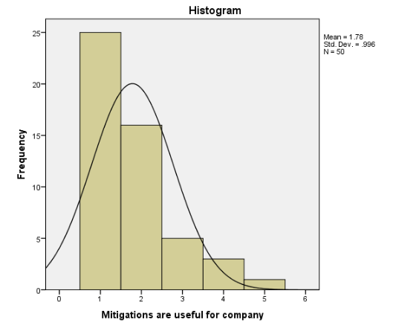

Grade 12: Mitigations are useful for the company
(Source: created through SPSS)
In the graph, a gauge of such mitigations being beneficial for the company has been evaluated. 25 have displayed a strong agreement of the mitigations being beneficial for the cooperation. 15 additionally agree with the statement provided, with an overall 25 majority showcasing a comprehensive acceptance of these strategies and their valuable influence on the corporation overall. 5 display a neutral stance on the advantages of such mitigative measures. 3 disagree with the mitigative strategies effectively aiding the company overall, with 1 strongly disagreeing with the notion. The standard deviation is valued at .996, and an overall mean of 1.78.

4.6 Correlation Analysis
Effectively managing extensive datasets necessitates a judicious selection of statistical software to ensure optimal representation. The utilisation of a “correlation matrix” emerges as a crucial tool for meticulously examining the statistical associations among various data points, as elucidated by Saccenti et al. (2020). This framework facilitates a thorough “correlation analysis”, unveiling the significance of relationship between the “dependent variable” of “Artificial Intelligence played a significant role in marketing” and its linked independent factors. The observed positive correlation in the matrix, particularly between “Artificial Intelligence played a significant role in marketing” and “ways that affected company”, stands at 0.868, establishing a direct link between Artificial Intelligence and digital marketing environment within the UK retail industry.
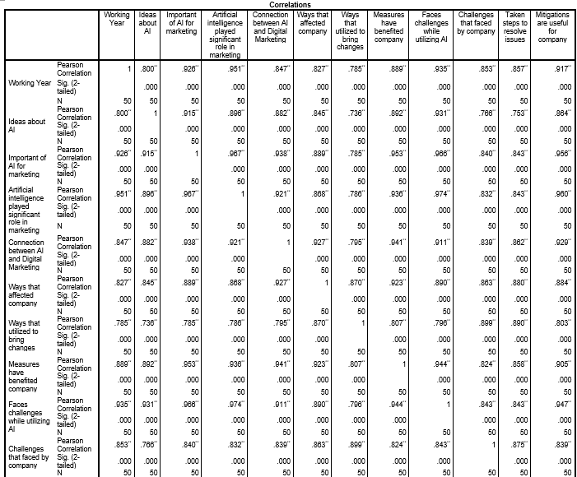
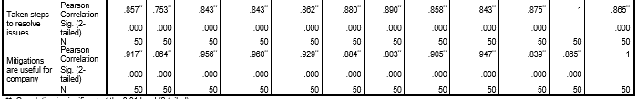

Table 6: Correlation Analysis
(Source: Created through SPSS)
Similarly, the correlation value of 0.786 between “Artificial Intelligence played a significant role in marketing” and “ways that utilised to bring changes” implies on a highly positive relationship, indicating a parallel progression. The statistical significance threshold of 0.00 substantiates this finding, confirming its statistical relevance. The significant scores, all below 0.05, further reinforce the statistical validity of the connection, stating that Artificial Intelligence, as an integral part of digital marketing, is inherently tied with transformational changes that shape the perspectives of UK retail companies within their operational regime. Additionally, a correlation coefficient of 0.832 is noted between “Artificial Intelligence played a significant role in marketing” and “challenges that faced by company”, suggesting a coherent movement of these factors. Examining the independent variable of “taken steps to resolve issues”, a notable positive correlation of 0.843 is observed with “Artificial Intelligence played a significant role in marketing”. The clinical relevance of this association is underscored by a significance value of 0.00, surpassing the standard criteria of 0.05. The resultant correlation value, therefore, indicates a significant and positive relationship between the two elements.

4.7 Regression Analysis
As a crucial aspect that shapes the statistical analysis of a research study, the “regression analysis” is pursued as an instrumental technique that assists in procuring the vital connection between the “dependent” and the “independent” variables. In the opinion of De Menezes et al. (2021), the “regression analysis” tool sheds light on the propensity of the variable’s “value and stance” for persistent lucrative interactions among each other. In adherence with the principles of the “regression analysis”, the close proximity of “regression values” of “R value” and “R square value” to the standard value of “1” facilitates the tendency of acquiring a positive correlation between the variables.
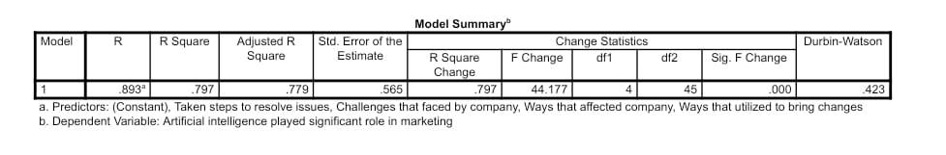

Table 7: Regression Analysis
(Source: Created through SPSS)
Therefore, in terms of the regression table above, discussion on the perceived “R value” of 0.893 and “R square” value is 0.797 showcases a contiguity of the variables towards the standard value of “1”, therefore, highlighting a directly proportionate correlation between the “dependent variable” of “Artificial Intelligence played a significant role in marketing”, and “independent variables”, comprising “Taken steps to resolve issues”, “Challenges that faced by company”, ways that affected company” and “ways that utilised to bring changes”. Consequently, the results constitute a positive relationship developed between the “dependent variable” and its independent factors, owing to both “R” and “R square” being in close proximity to “1”, thereby, fostering the potential for successive and continuous relationship between variables and building a viable link between DV and IV which affects each other’s relevance and variability within the research process.
In congruence with the regression as mentioned above table, the “analysis of variance” has been implemented to assess predictor variables’ significance and reliability, therefore, dividing the total variability into nuanced components to ascribable regression and residual errors (Shrestha, 2020). As per the findings of the particular study, it can be observed that the “mean square” values for “regression value” and “residual value” are stipulated at 14.09 and 0.319, respectively. This outcome indicates that both the values either close to or greater than 1, thereby fostering a “secure interconnectivity” among the various variables. Therefore, in compliance with the findings, the chance of accepting the “alternative hypothesis” (H1) becomes higher.
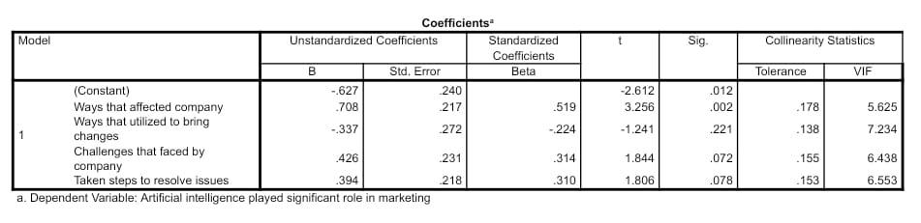

Table 8: Coefficients Analysis
(Source: Created through SPSS)
In connection with the regression analysis process, the coefficients section enables changes in “dependent variables” amidst the consistency of “independent variables” (Shrestha, 2020). Considering the above analysis, the values propel a positive relationship between the variables as all the influencing factors have affected “Artificial Intelligence played a significant role in marketing”, as majority of the “significant values” of the “independent variables” are 0.00.

4.8 Collinearity Diagnostics
The “collinearity diagnostics” serves as a “statistical” machinery which detects the scope of “multicollinearity” or discrepancy in the recorded data by benchmarking the findings against standard patterns (Salmerón-Gómez et al. 2020).
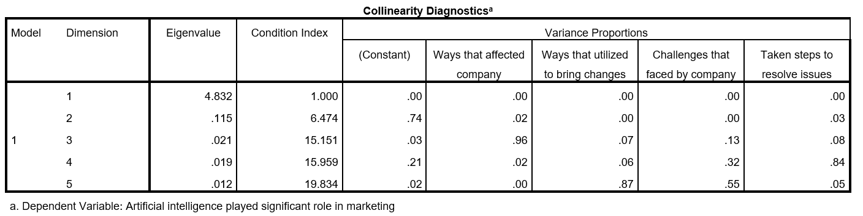

Table 9: Collinearity Diagnostics
(Source: Created through SPSS)
The tabular representation of “eigenvalue” and “condition indices” respective to the linear relationship between the “dependent” factor of “artificial intelligence played a significant role in marketing” and corresponding “independent variables” is portrayed through “collinearity diagnostics”. The “eigenvalues” of 4.832, 0.115, 0.021, 0.019 and 0.012 are distant from the minimum limit of 0.00, implying lower variations. Meanwhile, the “condition indices” of 1.000, 6.747, 15.151, 15.959 and 19.834 are also farther away from the threshold of 30, which denotes uniformity of recorded data without any severe fluctuation from the original trend. The evaluation of the strength of association between the variables is a testament to the preciseness of research findings.

4.9 Residual Statistics
In terms of research credibility, the variation in the “predicted” and “authentic” results associated with the interconnection of “dependent” and “independent” variables is considered as the “residual” value (Watkins, 2021). The “statistical interpretation” of the degree of disparity in the recorded values is captured in the “residual statistics” through the calculation of “mean”, “range”, and “standard deviation” for a specific sampling size.
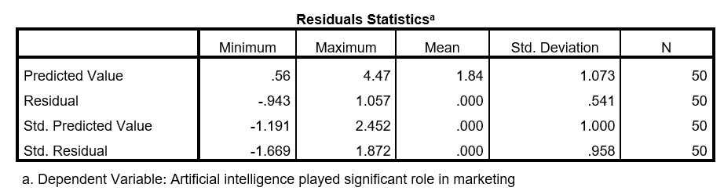

Table 10: Residual Statistics
(Source: SPSS Generated)
The “residual statistics” for this research presents a “minimum” and “maximum” limit of 0.56 and -4.47 for the “predicted value”, while the same for “residual value” ranges from -0.943 to 1.057. The “standard deviation” for “predicted” value is 1.073, which corresponds to 0.541 for the “residual value”. Out of a sample of 50 participants, the “mean” estimate for “standard predicted value” stands at 0.000, which is same for the “standard residual value”.

4.10 Discussion
Discussion on the graphs
By employing machine learning to replicate human cognitive processes, artificial intelligence (AI) is a technological revolution that, according to Helm et al. (2020), is changing the standard operating procedure in the field of marketing. 48% of the survey respondents, marketing employees working in the UK retail industry, strongly supported this point of view, citing the significance of artificial intelligence in marketing. In addition, 54 percent of them supported the idea that artificial intelligence has a big impact on marketing. Grandhi et al. (2021) asserted that digital marketing is not only a tool-centric activity but a deliberate, data-driven approach meticulously designed for virtual interaction with a specific audience. Besides, as per LEE, (2021), digital marketing focuses a lot on fostering long-term customer loyalty, increasing brand recognition, and accelerating business growth. Real-world statistics, which show that 48% of the selected participants acknowledged the importance of digital marketing in expanding the consumer base, support the general advantages of this strategy. As stated by Kaufman et al. (2023), AI is beginning to alter the digital marketing scene by providing retailers with new resources and competencies to assist them navigate the intricacies of the modern market. As evidence of this, 48% of marketing staff members said that AI had impacted digital marketing in the UK retail sector by providing greater insights into customer behaviour.
Discussion on correlation analysis
In the opinion of Dwivedi et al. (2021), the UK retail Industry has been undergoing transformational changes within its marketing and advertising approaches, attributed to “Artificial Intelligence” spurring corporate development in the digital age. Kaufman et al. (2023) elucidate that AI has pursued bringing transitions within the digital marketing landscape by implementing merchants’ new tools and skills to aid them in dealing with the complexities of the competitive business environment. In addition, Campbell et al. (2020) mention that retailers in the UK have altered their market projections through algorithms, powered by AI, to comprehend large information detecting unique tastes and behaviour of the consumers to tailor strategic marketing decisions. Therefore, in this context, the correlations analysis runs parallel to the secondary perspectives within the Literature Review, by highlighting a positive relationship between the dependent and independent variables, thereby attesting that AI has been instrumental in streamlining operations, altering customer demands, expectations and interactions with the UK retailers.
Discussion on regression analysis
According to Alghizzawi, (2019), large-scale developments in digital communication channels between the UK retailers and the customers is promulgated by the integration of digital marketing, in compliance with Artificial Intelligence. Rosnizam et al. (2020), believe that emphasising on digital marketing and promotional strategies has played an imperative role in either making or breaking a business through the utilisation of varied digital tools to engage with customers on digital platforms. In accordance with the literary perspectives, similarities were drawn in the outcome of the regression analysis, indicating the positive values of “R-value” and “R-Square value” and thereby, accepting that UK retailers are increasing their presence and promotion on social media medium, with the help of Artificial Intelligence, through internet-based technology. In addition, the result also declares that by applying the analysis gained from digital market practices, UK retailers, such as Tesco, can advertise on a digital scale to counter cost-efficiency issues and facilitate accessibility to traiditional business alternatives.

Discussion on collinearity diagnostics
In the context of “statistical interpretation”, the “collinearity diagnostics” critically evaluates the “nature” and “viability” of the linear associations established between the “dependent” and “independent” components of the research (Sadriddinovich, 2023). The methodical evaluation of the “relationships” established between variables unravel the paucity of “multicollinearity”, due to the “gap” between recorded and threshold limit for “eigenvalues” and “condition indices”. While the smallest “eigenvalue” recorded stands at 0.012 for the 5th dimension, the highest “condition index” accounts for 19.834 for the same dimension. The threshold limits for “eigenvalue” is 0.000, while that of “condition index” is 30.
Comparative Analysis
The reflection of “primary research findings” compared to the theoretical guidelines established in the literature review consummates the authenticity of the recorded data and its precise interpretation. The research finds interesting viewpoint associated with the “influence of artificial intelligence” in the reformation of the digital marketing sector of the UK. In this regard, Barinua et al. (2023), enlist the multifarious advantages such as “automated theorem proving”, “manufacturing of intellectual robots”, “speech robotics” and “picture processing” for delineating the advancements in the sector of technology. The purpose of integrating “AI” in the realms of “digital marketing” is further propagated by 48% of the participants surveyed for providing their opinion regarding the “importance of AI in marketing”. The analysis of Akter et al. (2022), further upscale the propensity of AI’s market reach by citing the “compound annual growth rate” of 36.62%, which has generated an estimation of “$190.61 billion” valuation by 2025. While the cosmic revenue predictions seem scopious, the “connection between AI and Digital Marketing” has been acknowledged by 82% of the participants. Moreover, Oosthuizen et al. (2021), elaborate on the principle framework of AI which integrates the aspects of “learning, reasoning, and problem-solving in addition to the execution of activities” by mimicking the intellectual properties of humans.
To reflect on this evaluation, a “mean” value of 2.12 for the “Ways utilized to bring changes” through AI in the marketing stream as presented in the “descriptive statistics”, implying the proficiency of digital expertise in the AI-based algorithms. To further justify the significance of “AI” in digital domain of UK-based retail sector, Cao (2021), cite the data of 54% of retailers improvising their customisation services through AI-based digital platforms published by a “Forrester Consulting report”. Out of 50 participants surveyed for collecting data, 48% of the professionals employed in the retail industry appreciate the “upliftment of customer base” as a result of AI-generated marketing techniques. The perspective of 22% of the candidates who have endorse AI-based algorithm to detect the variations in consumer data patterns reflect the outlook of Duyen, (2021), regarding a “customer-focused” approach presiding over the mechanism of “digital marketing”. The “positively significant” alliance gained from the “Pearson” coefficient of 0.941 for “statistical connection” between “Connection between AI and Digital Marketing” and “Measures have benefited company” in the “correlation matrix” further sustain the affirmations regarding the prowess of Artificial Intelligence in renovating “digital marketing practices”.

4.11 Conclusion
In conclusion, it can be affirmed that substantial implications of Artificial Intelligence are attributed to transforming the digital marketing landscape within the UK retail sector. The utilisation of statistical methods, in accordance with the hypothesis, has resulted in the firm acceptance of the alternate hypothesis (H1) on substantiated grounds. It is noteworthy to acknowledge the deployment of various analytical models that have systematically assessed the research issue, establishing that these models have led to the determination of significant values. Additionally, a comprehensive examination was conducted through a correlation matrix, elucidating the relationships between the variables, a conclusion further supported by the implementation of the regression model.

Chapter 5: Conclusion and Recommendations

5.1 Introduction
The scope of “artificial intelligence” in the domain of “digital marketing” is elaborate and highly appreciable due to its capability to redefine “customer-centric marketing techniques” through sophisticated technology. On this basis, this research delves into the intricacies of measures adopted by the retail sector operating in the UK to integrate “AI” in the forum of “digital marketing” archetype established within the organisations. The respective segment of “conclusion and recommendation” will consolidate the discussion revolving around the fruitful interpretations meeting the objectives. Besides, the study will ponder over the avenue of improvement necessary for future investigations.

5.2 Discussion
To comprehend the necessity of “artificial intelligence (AI)” in the UK retail industry
It can be further stated that “AI has become one of the most chosen and preferred technological aspects in the business industry. Every organisation has been adopting this technology as this is known to analyse market preference and provide relative suggestions for the developments and changes in the economy. According to Har et al. (2022), The respective technology analyses, evaluates, and processes certain changes and performs as a suggestive measure as well for which the respective technology is preferred in the respective retail industry. Through certain segments in the research, it can be evaluated that the respective technology has been a groundbreaking alteration in the respective retail industry. Furthermore, as Surahman et al. (2023) mention, Certain segments have defined the role of AI as well as the definition of AI in digital marketing. the “collinearity diagnosis” also highlights that customers prefer this particular intelligence of innovative technology to obtain suggestions and to prosper in the process of online purchase intentions. While analysing the “p-value” in the “hypothesis specification”, which is “0.05” the relation of AI with digital marketing through variables was strictly analysed. The respective intelligence does not solely act as a suggestive measure but also ensures that impulsive buying is within limits as people buy solely the things they see and by analysing the preferences through the AI it can be said that the suggestions are related to the preferences and tastes of the people (Zhang, and Lu, 2021). It can be also measured through the “descriptive statistics” by thorough analysis and findings that AI has genuinely supported the digital marketing of the UK retail industry.
To evaluate the strategies of digital marketing currently implemented in the UK retail industry
The UK retail industry is known for adopting marketing strategies more prominently and that too under digital marketing aspects. Moreover, it can be also further known that the industry has been analysing customer necessities more innovatively through the incorporation of the respective innovation. Hence, to further analyse this, the study has mentioned certain segments through which it can be analysed. As per Cao, (2021), The segments clearly mention that there are certain digital marketing strategies adopted by the retail sector such as “search engine, influencer marketing, mobile marketing, media marketing, and more” where such marketings support the growth of the retail industry. In order to further analyse this, the study has mentioned certain aspects like joint partnerships as well which can enhance the scope of digital marketing and increase profitability in the respective retail sector of the particular country. As Oosthuizen et al. (2021) mention, the research through the “correlation analysis”, did meet the objective, the study has mentioned certain strategies like improving “CRM” measures and other alternatives so that the digital aspect through mapping the research and drawing certain variables related to the context. Furthermore, through “Regression analysis”, it can be seen that the study has drawn certain variables that are dependent and independent that relate to the context more rigidly specifying a positive relation that highlights the digital marketing strategies in the respective UK retail sector. The study also focuses on the proper hypothesis of “R-value and R square value” where the segment denotes the “alternative hypothesis” to meet the demands of the objective that further describes the context as well.
To identify the issues and opportunities in inculcating “artificial intelligence” for the transformation of digital marketing.
The opportunities of digital marketing involve certain profitability, productivity, and enhancements in services. Such as to elaborate, it can be said that AI ensures that the preferences of customers are concretely analysed, and comprehended and hence the outcomes are positive and favourable as well (Verma et al. 2021). These opportunities also ensure that the customers are satisfied with the outcomes coming through the digital marketing aspects in the economy. Furthermore, it can be also said that there are certain challenges that this study has mentioned thoroughly. “Chatbots” which are the most favoured form of communication between an organisation and customer can be said supportive to some extent but to understand this more closely, it can be said that it is one of the major challenges that people face as customers expect a more direct solution to the more detailed issues. Chatbots are not programmed like that and hence create issues of connectivity, communication, and comprehension. To further analyse this, the study performed and “quantitative mono method” to ascertain the data from “50 participants” belonging to the UK retail industry claiming that the challenges and opportunities are equally present in this aspect. Through this, the variables such as “dependent and independent” showed a positive correlation in “correlation analysis” claiming that “AI is supportive of digital marketing (Shrestha, 2021). To draw the hypothesis the “R-value and R square values” are analysed along with the “p-value” which is “0.05”. Hence through these processes, the study met the last objective.

5.3 Recommendations
The attempt to inculcate the paramount records associated with the calibre of “artificial intelligence” in refining the measures of digital marketing for the retail industry based in the UK has generated a detailed review of prevailing literary sources as well as the meticulous interpretation of data collected through primary research. The commendable attribute of this study is embedded in the delineation of potential challenges thwarting the installation of such sophisticated digital architecture besides illustrating the pioneering contributions of AI. However, the study resonates the need to extend its findings to the scope of global reach of AI in terms of retail industry spanning across different countries, rather than restricting the data to a specific territory (Soni et al. 2020).
The research can amplify the viability of its outcomes by exploring the tenets of “qualitative” research to compare the potential of gathered information through the review of “theoretical framework” related to digital marketing as illustrated in authentic scholarly resources (Maxwell, 2021). Moreover, the application of the research findings can be augmented by the improvisation of the discussion through the articulation of specific models which can assist the retail organisations in alleviating the drawbacks associated with this convoluted technology (Saura et al. 2021). To elucidate, the sectors of “email marketing”, “content marketing” and “web designing” can be correlated with the implementation of “artificial intelligence”. Overall, the research transcends a comprehensive investigation with the availability of dimensions for improvement to amplify the credibility of the research findings.

5.4 Limitations of study
The research has solidified its foundation by reflecting thoroughly on the data gathered by conducting a survey including professionals employed in the retail sector of the UK. Yet, the applicability of the research outcomes is impeded by the restriction of the investigative domain to the retail industry of the UK. While the market reach of artificial intelligence has acclaimed global appraisal, the research constrains the discussion to the developed market of the UK, meanwhile neglecting the efficacy of AI in revamping the budding marketplace (Klaus and Zaichkowsky, 2020). Besides, the research adjusts the comprehensive nature of this analysis to the “quantitative” methods, thereby hindering the study to utilise the holistic approach of mixed method (Cupp-Sutton and Wu, 2020). The study resorted to the interpretation of market-derived data, meanwhile, the research overlooked the critical deliberation integrated in journals and published papers, which undermined the report’s sustainability.

5.5 Further research
With decent scope for further improvements regarding the quality of the research, this particular study can serve as the foundation for auxiliary investigations. The study can refer to credible databases for framing advanced discussions based on the significance of “artificial intelligence” in revamping the conventional domain of marketing in the business field. Besides, future studies can take into account the retail industry spanning over the global framework stand as an “all-inclusive report”. The prospects of future study depend on the precise utilisation of appreciable resources to forecast ingenious information associated with the development of technological architecture, which were neglected in this study.

References

Aggarwal, R. and Ranganathan, P., (2019). Study designs: Part 2–descriptive studies. Perspectives in clinical research, 10(1), p.34. [Available at: https://www.ncbi.nlm.nih.gov/pmc/articles/PMC6371702/] [Accessed on: 17.11.2023]
Ahmed, M., (2021). An analysis of the Impact of Brand Image on Consumer Purchase Behavior: The case of Lidl, Sweden. [Available at: https://www.diva-portal.org/smash/get/diva2:1582255/FULLTEXT01.pdf] [Accessed on: 20.11.2023]
Ahmed, S., Bangassa, K. and Akbar, S., (2020). A study on trust restoration efforts in the UK retail banking industry. The British Accounting Review, 52(1), p.100871. [Available at: https://www.researchgate.net/profile/Saeed-Akbar-2/publication/336878467_A_Study_on_Trust_Restoration_Efforts_in_the_UK_Retail_Banking_Industry/links/5dbc4da74585151435ddb965/A-Study-on-Trust-Restoration-Efforts-in-the-UK-Retail-Banking-Industry.pdf] [Accessed on: 06.01.2024]
Akter, S., Michael, K., Uddin, M.R., McCarthy, G. and Rahman, M., (2022). Transforming business using digital innovations: The application of AI, blockchain, cloud and data analytics. Annals of Operations Research, pp.1-33. [Available at: https://link.springer.com/article/10.1007/s10479-020-03620-w] [Accessed on: 09.01.2024]
Al-Ababneh, M., (2020). Linking ontology, epistemology and research methodology. Science & Philosophy, 8(1), pp.75-91. [Available at: http://eiris.it/ojs/index.php/scienceandphilosophy/article/viewFile/500/732] [Accessed on: 11.11.2023]
Aldi.com, (2023). Aldi Company. [Available at: https://www.aldi.co.uk/] [Accessed on: 20.11.2023]
Alessandrini, R., Brown, M.K., Pombo-Rodrigues, S., Bhageerutty, S., He, F.J. and MacGregor, G.A., (2021). Nutritional quality of plant-based meat products available in the UK: a cross-sectional survey. Nutrients, 13(12), p.4225. [Available at: https://www.mdpi.com/2072-6643/13/12/4225?trk=public_post_share-update_update-text] [Accessed on: 30.10.2023]
Alexander, I.N., (2020). The influence of technological innovations on organization's competitive advantage: A case study on Irish food retail company (Tesco) (Doctoral dissertation, Dublin, National College of Ireland). [Available at: https://norma.ncirl.ie/4717/1/ibrahimngashangalexander.pdf ] [Accessed on: 30.10.2023]
Alghizzawi, M., (2019). The role of digital marketing in consumer behavior: A survey. Int. J. Inf. Technol. Lang. Stud, 3(1), pp.24-31. [Available at: https://www.researchgate.net/profile/Mahmoud-Alghizzawi/publication/332593102_The_role_of_digital_marketing_in_consumer_behavior_A_survey/links/5cbf533e4585156cd7ad23c0/The-role-of-digital-marketing-in-consumer-behavior-A-survey.pdf] [Accessed on: 18.11.2023]
Ali, H., Zainal, V.R. and Ilhamalimy, R.R., (2021). Determination of Purchase Decisions and Customer Satisfaction: Analysis of Brand Image and Service Quality (Review Literature of Marketing Management). Dinasti International Journal of Digital Business Management, 3(1), pp.141-153. [Available at: https://www.dinastipub.org/DIJDBM/article/download/1100/744] [Accessed on: 29.11.2023]
Amazon.co.uk, (2023). Amazon’s dynamic pricing strategy. [Available at: https://www.amazon.co.uk/] [Accessed on: 20.12.2023]
amazon.com (2019). Artificial Intelligence Services. [Available at: https://aws.amazon.com/machine-learning/ai-services/] [Accessed on: 16.01.2024]
Ameen, N., Tarhini, A., Reppel, A. and Anand, A., (2021). Customer experiences in the age of artificial intelligence. Computers in Human Behavior, 114, p.106548. [Available at: https://www.sciencedirect.com/science/article/pii/S0747563220302983] [Accessed on: 18.11.2023]
analyticsvidhya.com (2023). Learn How AI for Social Media can Boost your Next Campaign. [Available at: https://www.analyticsvidhya.com/blog/2023/04/ai-in-social-media/ ] [Accessed on: 31.10.2023]
Ananthakumar, R., (2023). An Optimal Resource Scheduling and Dynamic Pricing Auction Mechanism for Supporting Emergency Demands in Cloud Computing. [Available at: https://shodhgangotri.inflibnet.ac.in/bitstream/20.500.14146/11107/1/r.%20ananthakumar%20synopsis%20final-cd.pdf] [Accessed on: 20.11.2023]
Asda.com, (2023). Asda Company. [Available at: https://www.asda.com/] [Accessed on: 20.12.2023]
asosplc.com (2022). ASOS continues to drive forward future growth with the Microsoft Cloud. [Available at: https://www.asosplc.com/news/asos-continues-drive-forward-future-growth-microsoft-cloud/ ] [Accessed on: 31.12.2023]
Barinua, V., Miriam, U.C., Obiageli, O.A. and Stella, N.N., (2023). ARTIFICIAL INTELLIGENCE AS A COMTEMPORARY ISSUES IN ORGANISATIONAL BEHAVIOUR. BW Academic Journal, pp.9-9. [Available at: https://bwjournal.org/index.php/bsjournal/article/view/1467] [Accessed on: 30.10.2023]
Bharadiya, J.P., (2023). Machine learning and AI in business intelligence: trends and opportunities. International Journal of Computer (IJC), 48(1), pp.123-134. [Available at: https://www.researchgate.net/profile/Jasmin-Bharadiya-4/publication/371902170_Machine_Learning_and_AI_in_Business_Intelligence_Trends_and_Opportunities/links/649afb478de7ed28ba5c99bb/Machine-Learning-and-AI-in-Business-Intelligence-Trends-and-Opportunities.pdf?origin=journalDetail&_tp=eyJwYWdlIjoiam91cm5hbERldGFpbCJ9] [Accessed on: 17.12.2023]
Bloomfield, J. and Fisher, M.J., (2019). Quantitative research design. Journal of the Australasian Rehabilitation Nurses Association, 22(2), pp.27-30. [Available at: https://search.informit.org/doi/abs/10.3316/INFORMIT.738299924514584] [Accessed on: 16.11.2023]
boat-lifestyle.com (2020). boAt Acquires Singapore-Based KaHa to Develop IoT-Enabled Wearables. [Available at: https://www.boat-lifestyle.com/blogs/news/boat-acquires-singapore-based-kaha-to-develop-iot-enabled-wearables] [Accessed on: 31.10.2023]
Brandenburg, R. and McDonough, S., (2019). Ethics, self-study research methodology and teacher education (pp. 1-14). Springer Singapore. [Available at: https://link.springer.com/chapter/10.1007/978-981-32-9135-5_1] [Accessed on: 11.11.2023]
Brenner, P.S., (2020). Understanding survey methodology. Springer International Publishing. [Available at: https://link.springer.com/content/pdf/10.1007/978-3-030-47256-6.pdf] [Accessed on: 16.11.2023]
Buch, G., Schulz, A., Schmidtmann, I., Strauch, K. and Wild, P.S., (2023). A systematic review and evaluation of statistical methods for group variable selection. Statistics in Medicine, 42(3), pp.331-352. [Available at: https://onlinelibrary.wiley.com/doi/pdf/10.1002/sim.9620] [Accessed on: 09.01.2024]
Campbell, C., Sands, S., Ferraro, C., Tsao, H.Y.J. and Mavrommatis, A., (2020). From data to action: How marketers can leverage AI. Business horizons, 63(2), pp.227-243. [Available at: https://www.researchgate.net/profile/Colin-Campbell-16/publication/338290896_From_data_to_action_How_marketers_can_leverage_AI/links/5e4c8ac492851c7f7f456b8e/From-data-to-action-How-marketers-can-leverage-AI.pdf] [Accessed on: 10.11.2023]
Campbell, S., Greenwood, M., Prior, S., Shearer, T., Walkem, K., Young, S., Bywaters, D. and Walker, K., (2020). Purposive sampling: complex or simple? Research case examples. Journal of research in Nursing, 25(8), pp.652-661. [Available at: https://www.ncbi.nlm.nih.gov/pmc/articles/PMC7932468/] [Accessed on: 11.11.2023]
Cao, L., (2021). Artificial intelligence in retail: applications and value creation logics. International Journal of Retail & Distribution Management, 49(7), pp.958-976. [Available at: https://www.emerald.com/insight/content/doi/10.1108/IJRDM-09-2020-0350/full/html] [Accessed on: 09.01.2024]
Casula, M., Rangarajan, N. and Shields, P., (2021). The potential of working hypotheses for deductive exploratory research. Quality & Quantity, 55(5), pp.1703-1725. [Available at: https://link.springer.com/article/10.1007/s11135-020-01072-9] [Accessed on: 11.11.2023]
Clark, N., Trimingham, R. and Wilson, G.T., (2020). Incorporating consumer insights into the UK food packaging supply chain in the transition to a circular economy. Sustainability, 12(15), p.6106. [Available at: https://www.mdpi.com/2071-1050/12/15/6106/pdf] [Accessed on: 11.11.2023]
Clarke, R., (2019). Principles and business processes for responsible AI. Computer Law & Security Review, 35(4), pp.410-422. [Available at: https://www.sciencedirect.com/science/article/pii/S026736491930127X] [Accessed on: 26.10.2023]
Cointelegraph.com, (2023). Role of AI and ML in Fraud Detection. [Available at: https://s3.cointelegraph.com/storage/uploads/view/75749c95024ea24dd31cade9101d397a.jpg] [Accessed on: 26.11.2023]
Coleman, J.P., (2021). AI and our understanding of intelligence. In Intelligent Systems and Applications: Proceedings of the 2020 Intelligent Systems Conference (IntelliSys) Volume 1 (pp. 183-190). Springer International Publishing. [Available at: https://link.springer.com/chapter/10.1007/978-3-030-55180-3_15] [Accessed on: 17.01.2024]
Collidu.com, (2023). Role of AI in digital marketing image. [Available at: https://www.collidu.com/media/catalog/product/img/1/1/1136d46d402fb8ef44093d2fc8bd80db8b1a7278e0b1726d258d84b5f543a9e0/application-of-ai-in-digital-marketing-slide1.png] [Accessed on: 06.12.2023]
Cooksey, R.W. and Cooksey, R.W., (2020). Descriptive statistics for summarising data. Illustrating statistical procedures: Finding meaning in quantitative data, pp.61-139. [Available at: https://www.ncbi.nlm.nih.gov/pmc/articles/PMC7221239/] [Accessed on: 09.01.2024]
Cubric, M., (2020). Drivers, barriers and social considerations for AI adoption in business and management: A tertiary study. Technology in Society, 62, p.101257. [Available at: https://www.sciencedirect.com/science/article/pii/S0160791X19307171] [Accessed on: 24.11.2023]
Cupp-Sutton, K.A. and Wu, S., (2020). High-throughput quantitative top-down proteomics. Molecular omics, 16(2), pp.91-99. [Available at: https://pubs.rsc.org/en/content/articlelanding/2020/mo/c9mo00154a/unauth] [Accessed on: 09.01.2024]
Davenport, T., Guha, A., Grewal, D. and Bressgott, T., (2020). How artificial intelligence will change the future of marketing. Journal of the Academy of Marketing Science, 48, pp.24-42. [Available at: https://link.springer.com/article/10.1007/s11747-019-00696-0] [Accessed on: 31.10.2023]
De Bruyn, A., Viswanathan, V., Beh, Y.S., Brock, J.K.U. and Von Wangenheim, F., (2020). Artificial intelligence and marketing: Pitfalls and opportunities. Journal of Interactive Marketing, 51(1), pp.91-105. [Available at: https://www.sciencedirect.com/science/article/am/pii/S1094996820300888] [Accessed on: 10.12.2023]
De Menezes, D.Q.F., Prata, D.M., Secchi, A.R. and Pinto, J.C., (2021). A review on robust M-estimators for regression analysis. Computers & Chemical Engineering, 147, p.107254. [Available at: https://www.sciencedirect.com/science/article/pii/S0098135421000326] [Accessed on: 23.01.2024]
Dumitriu, D. and Popescu, M.A.M., (2020). Artificial intelligence solutions for digital marketing. Procedia Manufacturing, 46, pp.630-636. [Available at: https://www.sciencedirect.com/science/article/pii/S2351978920309689] [Accessed on: 18.12.2023]
Duncan, R.P. and Kefford, B.J., (2021). Interactions in statistical models: three things to know. Methods in Ecology and Evolution, 12(12), pp.2287-2297. [Available at: https://besjournals.onlinelibrary.wiley.com/doi/pdf/10.1111/2041-210X.13714] [Accessed on: 09.01.2024]
Duyen, N., (2021). How Digital Marketing adds value to Customer Experience. [Available at: https://www.theseus.fi/handle/10024/508177 ] [Accessed on: 23.11.2023]
Dwivedi, Y.K., Hughes, L., Ismagilova, E., Aarts, G., Coombs, C., Crick, T., Duan, Y., Dwivedi, R., Edwards, J., Eirug, A. and Galanos, V., (2021). Artificial Intelligence (AI): Multidisciplinary perspectives on emerging challenges, opportunities, and agenda for research, practice and policy. International Journal of Information Management, 57, p.101994. [Available at: https://www.sciencedirect.com/science/article/pii/S026840121930917X] [Accessed on: 16.01.2024]
Dwivedi, Y.K., Ismagilova, E., Hughes, D.L., Carlson, J., Filieri, R., Jacobson, J., Jain, V., Karjaluoto, H., Kefi, H., Krishen, A.S. and Kumar, V., (2021). Setting the future of digital and social media marketing research: Perspectives and research propositions. International Journal of Information Management, 59, p.102168. [Available at: https://www.sciencedirect.com/science/article/pii/S0268401220308082] [Accessed on: 15.12.2023]
Educba.com, (2023). Various Digital Marketing Strategies. [Available at: https://www.educba.com/digital-marketing-strategies/] [Accessed on: 10.12.2023]
Emarsys.com, (2023) [Available at: https://emarsys.com/press-release/new-study-reveals-retailers-ready-ai-marketing-70-regard-technical-skills-barrier-mainstream-adoption/] [Accessed on: 30.10.2023]
Enholm, I.M., Papagiannidis, E., Mikalef, P. and Krogstie, J., (2022). Artificial intelligence and business value: A literature review. Information Systems Frontiers, 24(5), pp.1709-1734. [Available at: https://link.springer.com/article/10.1007/s10796-021-10186-w] [Accessed on: 13.11.2023]
Erdmann, A. and Ponzoa, J.M., (2021). Digital inbound marketing: Measuring the economic performance of grocery e-commerce in Europe and the USA. Technological forecasting and social change, 162, p.120373. [Available at: https://www.ncbi.nlm.nih.gov/pmc/articles/PMC7572302/] [Accessed on: 30.10.2023]
Fedoryshyna, L., Halachenko, O., Ohiienko, A., Blyznyuk, A., Znachek, R. and Tsurkan, N., (2021). Digital marketing in strategic management in the field of the tourism. Journal of Information Technology Management, 13(Special Issue: Role of ICT in Advancing Business and Management), pp.22-41. [Available at: https://jitm.ut.ac.ir/article_80735_8f3e23e6c434afcbc070d993a00f9178.pdf] [Accessed on: 24.12.2023]
Fletcher, A., (2021). Market investigations for digital platforms: panacea or complement?. Journal of European Competition Law & Practice, 12(1), pp.44-55. [Available at: https://ueaeprints.uea.ac.uk/id/eprint/79789/1/Accepted_Manuscript.pdf] [Accessed on: 18.11.2023]
Fool.com, (2023) Artificial Intelligence [Available at: https://www.reliablesoft.net/digital-marketing-guide/ ] [Accessed on: 30.10.2023]
Fountaine, T., McCarthy, B. and Saleh, T., (2019). Building the AI-powered organization. Harvard Business Review, 97(4), pp.62-73. [Available at: https://wuyuansheng.com/doc/Databricks-AI-Powered-Org__Article-Licensing-July21-1.pdf] [Accessed on: 01.11.2023]
Furr, N., Ozcan, P. and Eisenhardt, K.M., (2022). What is digital transformation? Core tensions facing established companies on the global stage. Global Strategy Journal, 12(4), pp.595-618. [Available at: https://onlinelibrary.wiley.com/doi/pdf/10.1002/gsj.1442] [Accessed on: 19.10.2023]
Gerke, S., Minssen, T. and Cohen, G., (2020). Ethical and legal challenges of artificial intelligence-driven healthcare. In Artificial intelligence in healthcare (pp. 295-336). Academic Press. [Available at: https://www.sciencedirect.com/science/article/pii/B9780128184387000125] [Accessed on: 11.10.2023]
Getlasso.co, (2023). [Available at: https://getlasso.co/affiliate/hm/] [Accessed on: 30.10.2023]
Goktas, P., Kucukkaya, A. and Karacay, P., (2023). Leveraging the efficiency and transparency of artificial intelligence‐driven visual Chatbot through smart prompt learning concept. Skin Research and Technology, 29(11). [Available at: https://www.ncbi.nlm.nih.gov/pmc/articles/PMC10587733/] [Accessed on: 14.10.2023]
Grandhi, B., Patwa, N. and Saleem, K., (2021). Data-driven marketing for growth and profitability. EuroMed Journal of Business, 16(4), pp.381-398. [Available at: https://www.emerald.com/insight/content/doi/10.1108/EMJB-09-2018-0054/full/html] [Accessed on: 30.11.2023]
Guha, A., Grewal, D., Kopalle, P.K., Haenlein, M., Schneider, M.J., Jung, H., Moustafa, R., Hegde, D.R. and Hawkins, G., (2021). How artificial intelligence will affect the future of retailing. Journal of Retailing, 97(1), pp.28-41. [Available at: https://www.sciencedirect.com/science/article/pii/S0022435921000051] [Accessed on: 03.12.2023]
Gupta, S., Leszkiewicz, A., Kumar, V., Bijmolt, T. and Potapov, D., (2020). Digital analytics: Modeling for insights and new methods. Journal of Interactive Marketing, 51(1), pp.26-43. [Available at: https://journals.sagepub.com/doi/abs/10.1016/j.intmar.2020.04.003] [Accessed on: 29.12.2023]
Har, L.L., Rashid, U.K., Te Chuan, L., Sen, S.C. and Xia, L.Y., (2022). Revolution of retail industry: from perspective of retail 1.0 to 4.0. Procedia Computer Science, 200, pp.1615-1625. [Available at: https://www.sciencedirect.com/science/article/pii/S1877050922003714/pdf?md5=56c589da87d840baf027c2de2108553a&pid=1-s2.0-S1877050922003714-main.pdf] [Accessed on: 09.01.2024]
Helm, J.M., Swiergosz, A.M., Haeberle, H.S., Karnuta, J.M., Schaffer, J.L., Krebs, V.E., Spitzer, A.I. and Ramkumar, P.N., (2020). Machine learning and artificial intelligence: definitions, applications, and future directions. Current reviews in musculoskeletal medicine, 13, pp.69-76. [Available at: https://link.springer.com/article/10.1007/s12178-020-09600-8] [Accessed on: 03.01.2024]
Ibrahim, N.F. and Wang, X., (2019). A text analytics approach for online retailing service improvement: Evidence from Twitter. Decision Support Systems, 121, pp.37-50. [Available at: https://www.sciencedirect.com/science/article/pii/S0167923619300405] [Accessed on: 26.12.2023]
Inês, C., Guilherme, P.L., Esther, M.G., Swantje, G., Stephen, H. and Lars, H., (2020). Regulatory challenges and opportunities for collective renewable energy prosumers in the EU. Energy Policy, 138, p.111212. [Available at: https://www.sciencedirect.com/science/article/pii/S0301421519307943] [Accessed on: 17.10.2023]
Islam, M., (2020). Digital Brand Management: Impact of Social Media Marketing on Brand Image. [Available at: https://www.theseus.fi/bitstream/handle/10024/355419/Thesis_Islam_Manirul.pdf?sequence=2] [Accessed on: 25.11.2023]
Joshi, N., Gabhane, D. and Somashekhar, C., (2022). How Social Media Marketing is Helping in Customer Retention and Customer Engagement: A Case of Marks and Spencer. ECS Transactions, 107(1), p.17027. [Available at: https://iopscience.iop.org/article/10.1149/10701.17027ecst/pdf] [Accessed on: 20.11.2023]
Kaufman, I., Horton, C. and Soltanifar, M., (2023). Digital Marketing: Integrating Strategy, Sustainability, and Purpose. Taylor & Francis. [Available at: https://books.google.com/books?hl=en&lr=&id=AVbGEAAAQBAJ&oi=fnd&pg=PP1&dq=AI+is+starting+to+change+the+digital+marketing+landscape+by+giving+merchants+new+tools+and+skills+to+help+them+deal+with+the+complexity+of+today%27s+marketplace&ots=9mAuBiFGk5&sig=Aqz4s6wAe0xwGtV1krvtNHwT-aY] [Accessed on: 30.10.2023]
Kaur, V., Khullar, V. and Verma, N., (2020). Review of artificial intelligence with retailing sector. Journal of Computer Science Research, 2(1), pp.1-7. [Available at: https://journals.bilpubgroup.com/index.php/jcsr/article/download/1591/pdf] [Accessed on: 09.01.2024]
Khatri, K.K., (2020). Research paradigm: A philosophy of educational research. International Journal of English Literature and Social Sciences (IJELS), 5(5). [Available at: https://journal-repository.theshillonga.com/index.php/ijels/article/view/2497/2360] [Accessed on: 11.11.2023]
Klaus, P. and Zaichkowsky, J., (2020). AI voice bots: a services marketing research agenda. Journal of Services Marketing, 34(3), pp.389-398. [Available at: https://www.emerald.com/insight/content/doi/10.1108/JSM-01-2019-0043/full/html] [Accessed on: 09.12.2023]
Kriebitz, A. and Lütge, C., (2020). Artificial intelligence and human rights: a business ethical assessment. Business and Human Rights Journal, 5(1), pp.84-104. [Available at: https://www.cambridge.org/core/journals/business-and-human-rights-journal/article/artificial-intelligence-and-human-rights-a-business-ethical-assessment/33D07AB42FC76A4BA49B03F600186E1B] [Accessed on: 26.11.2023]
LEE, J.H., (2021). Effect of sports psychology on enhancing consumer purchase intention for retailers of sports shops: Literature content analysis. Journal of Distribution Science, 19(4), pp.5-13. [Available at: https://koreascience.kr/article/JAKO202110655042515.pdf] [Accessed on: 06.11.2023]
Lee, S.M. and Lee, D., (2020). “Untact”: a new customer service strategy in the digital age. Service Business, 14(1), pp.1-22. [Available at: https://digitalcommons.unl.edu/cgi/viewcontent.cgi?article=1252&context=managementfacpub] [Accessed on: 28.11.2023]
Loureiro, S.M.C., Guerreiro, J. and Tussyadiah, I., (2021). Artificial intelligence in business: State of the art and future research agenda. Journal of business research, 129, pp.911-926. [Available at: https://www.sciencedirect.com/science/article/pii/S0148296320307451] [Accessed on: 22.11.2023]
Malenkov, Y., Kapustina, I., Kudryavtseva, G., Shishkin, V.V. and Shishkin, V.I., (2021). Digitalization and strategic transformation of retail chain stores: Trends, impacts, prospects. Journal of Open Innovation: Technology, Market, and Complexity, 7(2), p.108. [Available at: https://www.mdpi.com/2199-8531/7/2/108] [Accessed on: 30.10.2023]
Mardiana, S., (2020). Modifying Research Onion for Information Systems Research. Solid State Technology, 63(4), pp.5304-5313.[Available at: https://www.researchgate.net/profile/Siti-Mardiana/publication/359542575_Modifying_Research_Onion_for_Information_Systems_Research/links/62432dc07931cc7ccf033406/Modifying-Research-Onion-for-Information-Systems-Research.pdf] [Accessed on: 11.11.2023]
Mariani, M.M. and Wamba, S.F., (2020). Exploring how consumer goods companies innovate in the digital age: The role of big data analytics companies. Journal of Business Research, 121, pp.338-352. [Available at: https://centaur.reading.ac.uk/93071/1/24Sep2020Anonymous_manuscript_revised_Centaur.pdf] [Accessed on: 21.11.2023]
Marketsplash.com, (2023) [Available at: https://marketsplash.com/emerging-technologies-statistics/] [Accessed on: 21.11.2023]
marksandspencer.com (2021). Launching the world’s first data science & AI academy in retail. [Available at: https://corporate.marksandspencer.com/launching-worlds-first-data-science-ai-academy-retail ] [Accessed on: 25.11.2023].
Marsonet, M., (2019). Philosophy and logical positivism. Academicus International Scientific Journal, 10(19), pp.32-36. [Available at: http://dspace.epoka.edu.al/bitstream/handle/1/1829/Academicus-MMXIX-19-032-036.pdf?sequence=1] [Accessed on: 11.11.2023]
Maxwell, J.A., (2021). Why qualitative methods are necessary for generalization. Qualitative Psychology, 8(1), p.111. [Available at: https://psycnet.apa.org/record/2020-36022-001] [Accessed on: 09.01.2024]
Medium.com, (2023). [Available at: https://medium.com/digital-society/asos-where-customers-content-is-our-marketing-tool-3e8e060d4ea7] [Accessed on: 19.11.2023]
Meghaganguli23.com, (2023). RACE model. [Available at: https://meghaganguli23.medium.com/use-of-race-model-for-digital-marketing-strategy-d2c1ce73f7a6] [Accessed on: 12.10.2023]
Mehrad, A. and Zangeneh, M.H.T., (2019). Comparison between qualitative and quantitative research approaches: Social sciences. International Journal For Research In Educational Studies, Iran, 5(7), pp.1-7. [Available at: https://www.academia.edu/download/61373947/33Comparison_between_Qualitative_and_Quantitative_Research_Approaches_Social_Sciences20191129-122378-1f2hepc.pdf] [Accessed on: 11.11.2023]
Mishra, S.B. and Alok, S., (2022). Handbook of research methodology. [Available at: http://74.208.36.141:8080/jspui/bitstream/123456789/1319/1/BookResearchMethodology.pdf] [Accessed on: 17.11.2023]
Mohammad, A. and Mahjabeen, F., (2023). Revolutionizing Solar Energy with AI-Driven Enhancements in Photovoltaic Technology. BULLET: Jurnal Multidisiplin Ilmu, 2(4), pp.1174-1187. [Available at: https://journal.mediapublikasi.id/index.php/bullet/article/view/3427] [Accessed on: 31.10.2023].
Mostafa, N., Hamdy, W. and Alawady, H., (2019). Impacts of internet of things on supply chains: a framework for warehousing. Social sciences, 8(3), p.84. [Available at: https://www.mdpi.com/2076-0760/8/3/84/pdf] [Accessed on: 30.10.2023]
Mujtaba, B. and Cavico, F., (2023). E-Commerce and Social Media Policies in the Digital Age: Legal Analysis and Recommendations for Management. Journal of Entrepreneurship and Business Venturing, 3(1). [Available at: https://jebv.pk/index.php/JEBV/article/download/37/19] [Accessed on: 25.10.2023]
Nair, K. and Gupta, R., (2021). Application of AI technology in modern digital marketing environment. World Journal of Entrepreneurship, Management and Sustainable Development, 17(3), pp.318-328. [Available at: https://www.emerald.com/insight/content/doi/10.1108/WJEMSD-08-(2020)-0099/full/html] [Accessed on: 31.10.2023].
Ntoutsi, E., Fafalios, P., Gadiraju, U., Iosifidis, V., Nejdl, W., Vidal, M.E., Ruggieri, S., Turini, F., Papadopoulos, S., Krasanakis, E. and Kompatsiaris, I., (2020). Bias in data‐driven artificial intelligence systems—An introductory survey. Wiley Interdisciplinary Reviews: Data Mining and Knowledge Discovery, 10(3), p.e1356. [Available at: https://wires.onlinelibrary.wiley.com/doi/abs/10.1002/widm.1356] [Accessed on: 27.11.2023]
ons.gov.uk, (2023). [Available at: https://www.ons.gov.uk/economy/nationalaccounts/uksectoraccounts/bulletins/profitabilityofukcompanies/julytoseptember2022] [Accessed on: 26.11.2023]
Oosthuizen, K., Botha, E., Robertson, J. and Montecchi, M., (2021). Artificial intelligence in retail: The AI-enabled value chain. Australasian Marketing Journal, 29(3), pp.264-273. [Available at: https://scholar.sun.ac.za/bitstream/handle/10019.1/124902/oosthuizen_artificial_2022.pdf?sequence=1&isAllowed=y] [Accessed on: 09.01.2024]
Panda, M. and Mishra, A., (2022). Digital marketing. See discussions, stats, and author profiles for this publication at: https://www. researchgate. net/publication/358646409. [Available at: https://www.researchgate.net/profile/Manasmita-Panda/publication/358646409_DIGITAL_MARKETING/links/620d4a334be28e145c982d43/DIGITAL-MARKETING.pdf ] [Accessed on: 23.10.2023]
Pandey, P. and Pandey, M.M., (2021). Research methodology tools and techniques. Bridge Center. [Available at: http://dspace.vnbrims.org:13000/jspui/bitstream/123456789/4666/1/RESEARCH%20METHODOLOGY%20TOOLS%20AND%20TECHNIQUES.pdf] [Accessed on: 11.11.2023]
Park, Y.S., Konge, L. and Artino Jr, A.R., (2020). The positivism paradigm of research. Academic medicine, 95(5), pp.690-694. [Available at: https://journals.lww.com/academicmedicine/fulltext/2020/05000/the_positivism_paradigm_of_research.16.aspx/%22] [Accessed on: 18.11.2023]
Parker, G.L. and Alexander, B., (2022). Digital Only Retail: Assessing the Necessity of an ASOS Physical Store within Omnichannel Retailing to Drive Brand Equity. Bloomsbury Fashion Business Cases. [Available at: https://ualresearchonline.arts.ac.uk/id/eprint/17978/1/ASOS%20case%20study%20accepted%20version%2C%20BFBC.pdf] [Accessed on: 28.10.2023]
Peck, R., Short, T. and Olsen, C., (2020). Introduction to statistics and data analysis. Cengage Learning. [Available at: https://thuvienso.hoasen.edu.vn/bitstream/handle/123456789/12547/Contents.pdf?sequence=1&isAllowed=y] [Accessed on: 19.11.2023]
Pelau, C., Dabija, D.C. and Ene, I., (2021). What makes an AI device human-like? The role of interaction quality, empathy and perceived psychological anthropomorphic characteristics in the acceptance of artificial intelligence in the service industry. Computers in Human Behavior, 122, p.106855. [Available at: https://www.sciencedirect.com/science/article/pii/S0747563221001783] [Accessed on: 11.12.2023].
prolificnorth.co.uk (2021). Asda recruits AI and IoT specialists to understand the future of retail - Prolific North. [Available at: https://www.prolificnorth.co.uk/news/asda-recruits-ai-and-iot-specialists-understand-future-retail/] [Accessed on: 31.10.2023].
Purcărea, T., Ioan-Franc, V., Ionescu, Ş.A., Purcărea, I.M., Purcărea, V.L., Purcărea, I., Mateescu-Soare, M.C., Platon, O.E. and Orzan, A.O., (2022). Major Shifts in Sustainable Consumer Behavior in Romania and Retailers’ Priorities in Agilely Adapting to It. Sustainability, 14(3), p.1627. [Available at: https://www.mdpi.com/2071-1050/14/3/1627] [Accessed on: 26.10.2023]
Rahmanov, F., Mursalov, M. and Rosokhata, A., (2021). Consumer behavior in digital era: impact of COVID 19. Marketing i menedžment innovacij, (2), pp.243-251. [Available at: http://www.zbw.eu/econis-archiv/bitstream/11159/6847/1/1796174688_0.pdf] [Accessed on: 13.11.2023]
Rautela, S., (2021). Social Media for New Product Launch: A Study of Social Media Platforms Across the RACE Planning Framework. International Journal of Interactive Mobile Technologies, 15(5). [Available at: https://pdfs.semanticscholar.org/b954/bb3bba5da4fa65435fd7e2cba4cbd0032bc9.pdf] [Accessed on: 30.10.2023]
Reliablesoft.net, (2023) Digital Marketing [Available at: https://www.reliablesoft.net/digital-marketing-guide/] [Accessed on: 28.11.2023]
reuters.com (2023). UK retailer John Lewis boosts AI capability with Google deal. [Available at: https://www.reuters.com/business/retail-consumer/britains-john-lewis-signs-deal-with-alphabets-google-cloud-2023-08-09/] [Accessed on: 31.10.2023].
Rizvanović, B., Zutshi, A., Grilo, A. and Nodehi, T., (2023). Linking the potentials of extended digital marketing impact and start-up growth: Developing a macro-dynamic framework of start-up growth drivers supported by digital marketing. Technological Forecasting and Social Change, 186, p.122128. [Available at: https://www.sciencedirect.com/science/article/pii/S0040162522006497] [Accessed on: 24.11.2023]
Rosnizam, M.R.A.B., Kee, D.M.H., Akhir, M.E.H.B.M., Shahqira, M., Yusoff, M.A.H.B.M., Budiman, R.S. and Alajmi, A.M., (2020). Market opportunities and challenges: A case study of Tesco. Journal of the community development in Asia, 3(2), pp.18-27. [Available at: https://ejournal.aibpmjournals.com/index.php/JCDA/article/download/807/772] [Accessed on: 05.01.2024]
Saccenti, E., Hendriks, M.H. and Smilde, A.K., (2020). Corruption of the Pearson correlation coefficient by measurement error and its estimation, bias, and correction under different error models. Scientific reports, 10(1), p.438. [Available at: https://www.nature.com/articles/s41598-019-57247-4] [Accessed on 09.01.2024]
Sadriddinovich, J.T., (2023). Capabilities of SPSS Software in High Volume Data Processing Testing. American Journal of Public Diplomacy and International Studies (2993-2157), 1(9), pp.82-86. [Available at: https://grnjournal.us/index.php/AJPDIS/article/view/1256] [Accessed on: 09.01.2024]
Safanta, A., Shihab, M.R., Budi, N.F.A., Hastiadi, F.F. and Budi, I., (2019), March. Digital marketing strategy for laboratories marketplace. In Journal of Physics: Conference Series (Vol. 1196, No. 1, p. 012078). IOP Publishing. [Available at: https://iopscience.iop.org/article/10.1088/1742-6596/1196/1/012078/pdf] [Accessed on: 30.10.2023]
Salmerón-Gómez, R., Rodríguez-Sánchez, A. and García-García, C., (2020). Diagnosis and quantification of the non-essential collinearity. Computational Statistics, 35(2), pp.647-666. [Available at: https://link.springer.com/article/10.1007/s00180-019-00922-x] [Accessed on: 09.01.2024]
Samoggia, A., Monticone, F. and Bertazzoli, A., (2021). Innovative digital technologies for purchasing and consumption in urban and regional agro-food systems: A systematic review. Foods, 10(2), p.208. [Available at: https://www.mdpi.com/2304-8158/10/2/208/pdf] [Accessed on: 30.10.2023]
Saunders, M.N.K., Lewis, P. and Thornhill, A. (2019) Research Methods for Business Students. 8th Edition, Pearson, New York [Available at: https://www.researchgate.net/] [Accessed on: 11.11.2023]
Saura, J.R., Palos-Sanchez, P. and Rodríguez Herráez, B., (2020). Digital marketing for sustainable growth: Business models and online campaigns using sustainable strategies. Sustainability, 12(3), p.1003. [Available at: https://www.mdpi.com/2071-1050/12/3/1003] [Accessed on: 09.01.2024].
Sephora.co.uk, (2023). Sephora official site. [Available at: https://www.sephora.co.uk/] [Accessed on: 30.10.2023]
Shrestha, N., (2020). Detecting multicollinearity in regression analysis. American Journal of Applied Mathematics and Statistics, 8(2), pp.39-42. [Available at: https://www.sciencedirect.com/science/article/pii/S0098135421000326][Accessed on: 10.01.2024]
Shrestha, N., (2021). Factor analysis as a tool for survey analysis. American Journal of Applied Mathematics and Statistics, 9(1), pp.4-11. [Available at: http://article.sciappliedmathematics.com/pdf/AJAMS-9-1-2.pdf] [Accessed on: 09.01.2024]
Siedlecki, S.L., (2020). Understanding descriptive research designs and methods. Clinical Nurse Specialist, 34(1), pp.8-12. [Available at: https://journals.lww.com/cns-journal/Fulltext/2020/01000/Understanding_Descriptive_Research_Designs_and.4.aspx] [Accessed on: 11.11.2023]
Sileyew, K.J., (2019). Research design and methodology. Cyberspace, pp.1-12. [Available at: https://www.intechopen.com/chapters/68505] [Accessed on: 11.11.2023]
Skinner, C., (2020). Quantitative research. In Handbook for research students in the social sciences (pp. 215-224). Routledge. [Available at: https://www.taylorfrancis.com/chapters/edit/10.4324/9781003070993-21/quantitative-research-chris-skinner] [Accessed on: 18.01.2024]
Smartinsights.com, (2023). Honeycomb Model. [Available at: https://www.smartinsights.com/social-media-marketing/social-media-strategy/digital-marketing-models-honeycomb-model/] [Accessed on: 17.01.2024]
Soni, N., Sharma, E.K., Singh, N. and Kapoor, A., (2019). Impact of artificial intelligence on businesses: from research, innovation, market deployment to future shifts in business models. arXiv preprint arXiv:1905.02092. [Available at: https://arxiv.org/abs/1905.02092] [Accessed on: 30.10.2023]
Soni, N., Sharma, E.K., Singh, N. and Kapoor, A., (2020). Artificial intelligence in business: from research and innovation to market deployment. Procedia Computer Science, 167, pp.2200-2210. [Available at: https://www.sciencedirect.com/science/article/pii/S1877050920307389] [Accessed on: 09.01.2024].
Spector, P.E., (2019). Do not cross me: Optimizing the use of cross-sectional designs. Journal of Business and Psychology, 34(2), pp.125-137. [Available at: https://link.springer.com/article/10.1007/s10869-018-09613-8] [Accessed on: 11.11.2023]
Stamova, I. and Draganov, M., (2020), September. Artificial intelligence in the digital age. In IOP Conference Series: Materials Science and Engineering (Vol. 940, No. 1, p. 012067). IOP Publishing. [Available at: https://iopscience.iop.org/article/10.1088/1757-899X/940/1/012067/meta ] [Accessed on: 06.01.2024]
Statista.com, (2023) [Available at: https://www.statista.com/outlook/dmo/digital-advertising/worldwide ] [Accessed on: 30.11.2023]
Statista.com, (2023) [Available at: https://www.statista.com/statistics/1370352/digtial-retail-media-advertising-spending-uk/#:~:text=In%202021%2C%20digital%20retail%20media,the%20end%20of%20that%20period] [Accessed on: 13.11.2023]
Stone, M., Aravopoulou, E., Ekinci, Y., Evans, G., Hobbs, M., Labib, A., Laughlin, P., Machtynger, J. and Machtynger, L., (2020). Artificial intelligence (AI) in strategic marketing decision-making: a research agenda. The Bottom Line, 33(2), pp.183-200. [Available at: https://research.stmarys.ac.uk/id/eprint/3892/1/AI%20in%20strategic%20marketing%20decision%20making%20final%20V2.pdf] [Accessed on: 28.11.2023]
Suh, T. and Chow, T.E., (2021). Developing a digital marketing tool for ethnic ventures' mixed business model and market-shaping: A design scientific approach of web demographics. Industrial Marketing Management, 93, pp.10-21. [Available at: https://www.sciencedirect.com/science/article/pii/S0019850120309172] [Accessed on: 30.10.2023]
Surahman, S., Hariyadi, S., Barus, B., Sarlivia, S., Meidinata, R. and Kartina, D., (2023). Digital marketing strategy and implementation of multi-channels for traditional retail. Community Empowerment, 8(10), pp.1512-1517. [Available at: https://journal.unimma.ac.id/index.php/ce/article/download/10434/4630] [Accessed on: 09.01.2024]
Syafriandi, S., Fauzan, A., Lufri, L. and Armiati, A., (2020), May. Designing hypothetical learning trajectory for learning the importance of hypothesis testing. In Journal of Physics: Conference Series (Vol. 1554, No. 1, p. 012045). IOP Publishing. [Available at: https://iopscience.iop.org/article/10.1088/1742-6596/1554/1/012045/pdf] [Accessed on: 09.01.2024]
syndelltech.com (2023). The Future of Digital Marketing: AI Challenges to Keep an Eye on in 2023. [Available at: https://syndelltech.com/ai-challenges-the-future-of-digital-marketing/ ] [Accessed on: 01.11.2023].
Talwar, S., Dhir, A., Singh, D., Virk, G.S. and Salo, J., (2020). Sharing of fake news on social media: Application of the honeycomb framework and the third-person effect hypothesis. Journal of Retailing and Consumer Services, 57, p.102197. [Available at: https://www.sciencedirect.com/science/article/pii/S0969698920306433] [Accessed on: 17.11.2023]
Target.com, (2023). Target’s official website. [Available at: https://www.target.com/] [Accessed on: 30.10.2023]
tescoplc.com (2023). Find out more. [Available at: https://www.tescoplc.com/innovation/find-out-more ] [Accessed on: 31.10.2023].
thenextorganization.com (2021). Strategic Consulting. [Available at: https://thenextorganization.com/en/ ] [Accessed on: 31.10.2023].
Trawnih, A., Al-Masaeed, S., Alsoud, M. and Alkufahy, A., (2022). Understanding artificial intelligence experience: A customer perspective. International Journal of Data and Network Science, 6(4), pp.1471-1484. [Available at: http://growingscience.com/ijds/Vol6/ijdns_2022_65.pdf] [Accessed on: 25.11.2023]
Verma, S., Sharma, R., Deb, S. and Maitra, D., (2021). Artificial intelligence in marketing: Systematic review and future research direction. International Journal of Information Management Data Insights, 1(1), p.100002. [Available at: https://www.sciencedirect.com/science/article/pii/S2667096820300021] [Accessed on: 19.01.2024]
Wamba-Taguimdje, S.L., Fosso Wamba, S., Kala Kamdjoug, J.R. and Tchatchouang Wanko, C.E., (2020). Influence of artificial intelligence (AI) on firm performance: the business value of AI-based transformation projects. Business Process Management Journal, 26(7), pp.1893-1924. [Available at: https://www.emerald.com/insight/content/doi/10.1108/BPMJ-10-2019-0411/full/html] [Accessed on: 26.12.2023]
Watkins, M.W., (2021). Astep-by-step guide to exploratory factor analysis with SPSS. Routledge. [Available at: https://books.google.co.in/books?hl=en&lr=&id=BaEsEAAAQBAJ&oi=fnd&pg=PP11&dq=correlation+analysis+spss&ots=un_93qFXt6&sig=2A-Qp01sAUeGGW1RArMXuNXnoQ8&redir_esc=y#v=onepage&q=correlation%20analysis%20spss&f=false] [Accessed on: 09.01.2024].
Wibowo, A., Chen, S.C., Wiangin, U., Ma, Y. and Ruangkanjanases, A., (2020). Customer behavior as an outcome of social media marketing: The role of social media marketing activity and customer experience. Sustainability, 13(1), p.189. [Available at: https://www.mdpi.com/2071-1050/13/1/189/pdf] [Accessed on: 30.10.2023]
Wood, S., Watson, I. and Teller, C., (2021). Pricing in online fashion retailing: implications for research and practice. Journal of Marketing Management, 37(11-12), pp.1219-1242. [Available at: https://www.tandfonline.com/doi/pdf/10.1080/0267257X.2021.1900334] [Accessed on: 29.11.2023]
Zhang, C. and Lu, Y., (2021). Study on artificial intelligence: The state of the art and future prospects. Journal of Industrial Information Integration, 23, p.100224. [Available at: https://www.sciencedirect.com/science/article/abs/pii/S2452414X21000248] [Accessed on: 19.01.2024]
Zilinskaite, A. and Spanellis, A., (2020, May). Can classification of player types inform the gamification design of a marketing intervention? ASOS Case. In Proceedings of the 34th Annual Conference of the British Academy of Management (pp. 1-33). [Available at: https://www.researchgate.net/profile/Agnessa-Spanellis/publication/343893573_Can_Classification_Of_Player_Types_Inform_The_Gamification_Design_Of_A_Marketing_Intervention_ASOS_Case/links/5f46d25e92851c6cfde1b1c7/Can-Classification-Of-Player-Types-Inform-The-Gamification-Design-Of-A-Marketing-Intervention-ASOS-Case.pdf] [Accessed on: 30.10.2023]

Appendices

Appendix 1: Survey Questionnaire
1. What duration of time have you been working in this industry?
a.1 to 3 years
b. 4 to 5 years
c. 6 years and above
2. Do you have enough ideas regarding Artificial Intelligence?
a. Yes
b. No
c. Maybe
3. Do you agree that there is an importance of artificial intelligence for marketing?
a. 1
b. 2
c. 3
d. 4
e. 5
4. Do you agree artificial intelligence has played a significant role in developing digital marketing efforts in the retail industry over the past year?
1. Strongly agree
2. Agree
3. Neutral
4. Disagree
5. Strongly disagree
5. Do you agree that there is a connection between AI and Digital Marketing?
a. Strongly Agree
b. Agree
c. Neutral
d. Disagree
e. Strongly Disagree
6. What different ways do you think digital marketing has affected your company?
a. Increase in brand recognition
b. Upliftment of customer base
c. Vivid marketing and generation of appeals
d. All of the above
7. In what way have you utilized AI to bring changes in digital marketing for your company?
a. Algorithms utilization to identify different patterns
b. Deeper insights into consumer behaviour
c. Future behaviour prediction
d. All of the above
8. Do you think these measures have benefited your company?
a.1
b. 2
c. 3
d. 4
e. 5

9. Do you agree that you have faced challenges while utilizing AI for transforming digital marketing?
a. Strongly Agree
b. Agree
c. Neutral
d. Disagree
e. Strongly Disagree
10. What are the different challenges faced by your company?
a. Lack of creativity
b. Concerns of biases and inaccurate content
c. Data breach possibility
d. All of the above
11. What mitigation steps have your company taken to resolve these issues?
a. Providing the needed training
b. Incorporation of high-quality data
c. Ensuring privacy of data
d. All of the above
12. Do you think these mitigations are useful for your company?
a. 1
b. 2
c. 3
d. 4
e. 5

