Student Name: Abdul Quiyum  Student ID: 2229328  Module Title: Foreign Language and Cultural Awareness  Module Code: BMIH5003  Lecturer: Lisa Bassler  Date: 07.02.2024 | 
ASSIGNMENT 1: PORTFOLIO
(4 Components)

Component 1: Professional Reflection (500 words +/- 10%)

Weighting: 25%
Outlining the scenario
Cultural misunderstandings mostly occur when two or more individuals speak similar languages but they fail to understand different things (Ineta, 2023). However, it depends on the cultural backgrounds and experiences of the individuals.
In the teeming lobby of the Hotel Grand, guests from across the world "check in" and are eager to experience the premium hospitality services. At this time, there is a "cultural misunderstanding" occurred between the brewer, named "John", and the guests in the bar of the hotel. However, John is a "Japanese" brewer in the bar of the hotel and "Martha" is from Germany and came with her two friends. John was excited to provide brewing services to his international guests and enthusiastically suggested their "chef’s special menu” for the starters, which has been praised by other guests. However, Martha and her friends were hesitant as they were not able to make "on-the-spot decisions" in terms of their "cocktail beverages" and "cuisines". During this, John was able to sense their "uncertainties" and interpreted it as "dissatisfaction" and decided to showcase her knowledge about diverse cuisines and cocktails. Meanwhile, John started to explain the cooking techniques and ingredients used for the cuisine in every detail to make Martha and her friends comfortable with their preferences. In this case, the language gap between John and Martha's friend created a "cultural misunderstanding" related to “language barriers” and John's effort contributed to the creation of confusion. During this, Martha strived to bridge the "language gap" between her friends and John and gave a polite smile against the efforts. Hence, it makes John think that his guests are unsatisfied with the suggestions and start to provide more options to them, which makes Martha and her friends more confused. As a result, Martha and her friends ordered random cuisines and felt disconnected from the services causing a "cultural misunderstanding".
Explanation of the ways cultural misunderstandings can occur
The interactions in the hospitality industry happen very frequently and are diverse, which can cause "cultural misunderstandings" between the staff and the guests. In this case, the variations of the culture in terms of expectations of service often lead towards "cultural misunderstandings" (De-La-Cruz-Diaz et al. 2023). I also think that "cultural misunderstandings" can also occur between F&B employees and guests due to communication as "language differences" or proficiency increase confusion between the individuals. Moreover, it can also occur in the said industry as the "hospitality industry" offers food services and different cultures have diverse types of dietary preferences (Piquemal et al. 2023). Hence, diverse dietary preferences often become the reason behind the occurrence of cultural misunderstandings.
Identification of the skills that are required to be developed to avoid cultural misunderstandings
I think that individuals are required to improve their skills in terms of languages, which increases the ability to conduct efficient communication. In this case, the F&M employees are required to focus on the development of their knowledge in terms of the preferences of their guests in terms of food. In terms of behaviours, individuals working in the F&B in a hotel are required to practice always having a smile on their face, which reflects a positive attitude towards the guests and makes them comfortable (Carlisle et al. 2023). On the other hand, I also think that improvement in confidence is also important to be developed among the F&M employees to efficiently conduct effective communication. Furthermore, I also think that the F&B employees are required to develop their active listening skills, which help in avoiding cultural misunderstandings with the guests.

References:
Carlisle, S., Ivanov, S. and Espeso-Molinero, P., 2023. Delivering the European Skills Agenda: the importance of social skills for a sustainable tourism and hospitality industry. Tourism & Management Studies, 19(3), pp.23-40.
De-La-Cruz-Diaz, M., Alvarez-Risco, A., Jaramillo-Arévalo, M., de las Mercedes Anderson-Seminario, M. and Del-Aguila-Arcentales, S., 2023. Cross-Cultural Impacts on Tourism, Hospitality, and Recreation. In Sustainable Management in COVID-19 Times (Vol. 30, pp. 255-264). Emerald Publishing Limited.
Ineta, L., 2023. Eliminating Intergenerational and Intercultural Communication Problems in Tourism and Hospitality Enterprises. Acta Universitatis Sapientiae, Philologica, 15(2), pp.14-32.
Piquemal, N., Zellama, F., Sall, L. and Bolivar, B., 2023. Multicultural hospitality and immigration in Winnipeg, Manitoba: Host–guest dynamics. Hospitality & Society, 13(1), pp.41-62.
Component 2: Training Plan (500 words +/- 10%)

Weighting: 25%

Identified cultural misunderstanding (in a few words):
There are several problems within the previous scenarios that lead to cultural misunderstanding. The first factor was the “language barrier” that existed between John and Martha as they failed to communicate with each other. Another problem was “Misunderstanding and Misinterpretation of non-verbal cues” which created further problems within the situation. The polite smile that Martha gave to John was also considered as dissatisfaction led to more confusion. Lastly when John failed to understand their hesitation of Martha in choosing a drink dissatisfaction showed “overenthusiasm” from the Brewer which needs to be controlled as the customer needs to give time to decide what they want from the menu.

Training plan (Why/What//Who/Where/When):
Why:
Cultural awareness and customer service training can help the hotel staff understand different languages and behaviours which can help them to handle and communicate with customers from different backgrounds in future which can effectively enhance customer satisfaction rate and value of the hotel (Lin et al. 2023).
What:
Language awareness training and programme:
It is important for the employees and hosts of the hotel to understand different languages at a basic level which is important for them to communicate with the customers and understand their needs (Zhang et al. 2023). It can help them to satisfy the customers and avoid such future circumstances. Moreover, I also think that understanding different languages can also help the staff to recognise the non-verbal cues that often differ for different cultures.
Development programme on customer service skills:
Through the “customer serve skills developmental programme”, the staff and bartenders can effectively help the customers to feel welcome at the hotel by establishing trust with them. It can also help them to provide a sense of hospitality to customers from different cultures (Zhang et al. 2023). The training programme can also help the staff to realise and understand the importance of giving time to the customers to decide their choice of drinks and food. It can help them to avoid such future incidents.
Training on cultural sensitivity:
Through cultural sensitivity, the staff can know more about respecting other cultures and preferences. It can also help them to implement and adopt the serving style according to the cultural background of the customers (Henriksen et al. 2023). Moreover, I think through cultural sensitivity training, the staff can also communicate and understand the customers even through non-verbal communication by reading their facial expressions and cultural understanding.
Who:
The training can be given to the F&B, bartenders, receptionists and waiters. Moreover, I think, the training can be given to all staff that are associated with the work of customer service and hospitality on behalf of the hotel to handle and understand the customers.
Where:
The hotel can conduct the training sessions through online training and development modules which can be convenient for all the staff to attend the training sessions according to their convenience. Moreover, I think the management can also hold workshops through which the staff can perform role-playing exercises after the compilation of the training programmes.
When:
The management of the hotel can introduce the training programme to the existing staff immediately after the previous incident took place. Moreover, I also think that the management can also provide these training and development programmes to the new joiners with their general training at the time of onboarding which can help them to understand different cultures and non-verbal cues at the time of customer service.

References:
Henriksen, L., Kisa, S., Lukasse, M., Flaathen, E.M., Mortensen, B., Karlsen, E. and Garnweidner-Holme, L., 2023. Cultural sensitivity in interventions aiming to reduce or prevent intimate partner violence during pregnancy: a scoping review. Trauma, Violence, & Abuse, 24(1), pp.97-109.
Lin, B., Wang, S., Fu, X. and Yi, X., 2023. Beyond local food consumption: the impact of local food consumption experience on cultural competence, eudaimonia and behavioral intention. International Journal of Contemporary Hospitality Management, 35(1), pp.137-158.
Zhang, J.J., Følstad, A. and Bjørkli, C.A., 2023. Organizational factors affecting successful implementation of chatbots for customer service. Journal of internet commerce, 22(1), pp.122-156.
Zhang, Y., Zhang, M., Li, W., Wang, S. and Tao, R., 2023. Language-aware domain generalization network for cross-scene hyperspectral image classification. IEEE Transactions on Geoscience and Remote Sensing, 61, pp.1-12.
Component 3: Student Self-Reflection (500 words +/- 10%)

Weighting: 25%
For the completion of the “self-reflection” regarding the entire experience, I have chosen the “Gibb’s Reflective Cycle” in this component. However, this model of “self-reflection” includes six different stages for the evaluation of the individuals’ experiences, which are “description”, “feelings”, “evaluation”, and “analysis”, “conclusion” and “action plan” (Dominguez Picart et al. 2023).
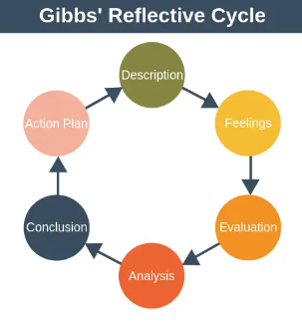
Figure 1: Gibbs' Reflective Cycle; Source: (Back, 2023)
Description:
Cultural awareness refers to the sensitivity and identification of the differences and similarities between diverse cultures and using the “sensitivity”, which helps in creating an “inclusive communication” and facilities (Eren, 2023). From the entire experience, I have understood that individuals require to have “cultural awareness”, specifically those who are working in the “hospitality industry” because it helps in identifying the needs of the guests a conducting an effective conversation. Furthermore, I have also identified the F&B employees are also required to have knowledge in terms of the diverse languages, cultures and preferences of the guests, which showcases the “cultural awareness” and providing appropriate services to them with a huge level of satisfaction in the hospitality industry.
Feelings:
While participating in this module, I felt overjoyed as it was able to learn about different languages, preferences, and culture of the customers in the hospitality as it has potential of helping me to understand the ways through which I will be able to make effective communication in the future. Moreover, I also felt excited as I was able to conduct effective interactions with my batch-mates, who came from different types of cultural backgrounds.
Analysis:
It is analysed from the experience that individuals working in the hospitality industry are required to have active listening skills, which help in mitigating any communication gap and also providing the feeling of comfortable to the guests from diverse backgrounds. On the other hand, I also analysed that the improvement of the skills related to communication, cultural awareness, confidence and positive attitude are necessity because they help in attracting the guests towards the hospitality services more.
Evaluation:
I have also evaluated my experience of working with diverse people, from which I have found that having understanding about multi-cultural factors help in the improvement of the professional relationships. Additionally, I have identified my skills in verbal communication, and critical thinking, which may help me to establish a great conversation with the guests in the said industry.
Action plan:
SL No. | Areas to improve | Actions to improve | Timescale
1. | Communication | Participating personal development classes in offline mode | 3 months
2. | Language | Enrolling in “Italian” class | Six months
3. | Cultural knowledge | Reading more about different cultures | Five months
The above table reflects my plan for the development of the “cultural awareness” skills, including “communication”, “learning new language”, and gaining “cultural knowledge” by enrolling in classes and reading more about different cultures.
Conclusion
It is concluded that the hospitality staffs are also required to stay calm and patient while dealing with the guests because it helps them to make them feel comfortable and avoiding any type of conflicts. Furthermore, it is also concluded that I was overwhelmed to learn about different culture and the professional skills that are required to provide efficient services to the guests in the future organisation in hospitality industry.

References:
Back, M., 2023. Identity Work and Intercultural Awareness Through Cultural Excavation: Teacher Candidates Studying Abroad. The New Educator, 19(4), pp.368-387.
Dominguez Picart, G., Fornells Herrera, A., Ferreras-Garcia, R. and Sales-Zaguirre, J., 2023. Discover, Reflect, and Live. A Tailored, Active, and Transversal Learning Approach to Develop Relevant Hospitality Competencies. Journal of Hospitality & Tourism Education, pp.1-12.
Eren, Ö., 2023. Raising critical cultural awareness through telecollaboration: Insights for pre-service teacher education. Computer assisted language learning, 36(3), pp.288-311.
Component 4: Training Presentation (6 Slides)

Weighting: 25%
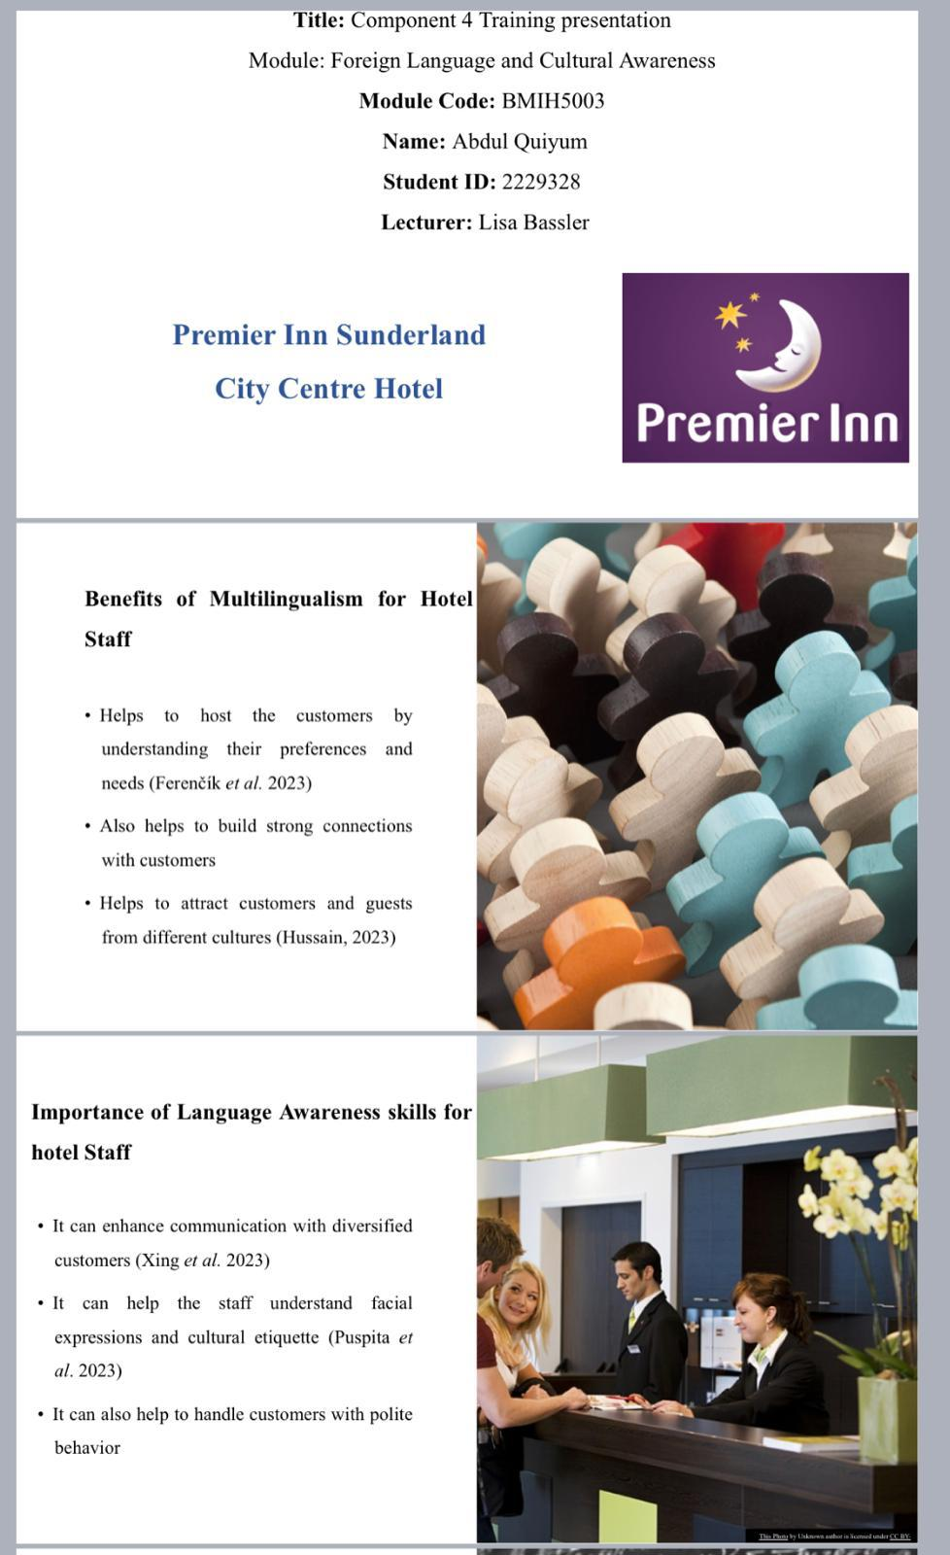

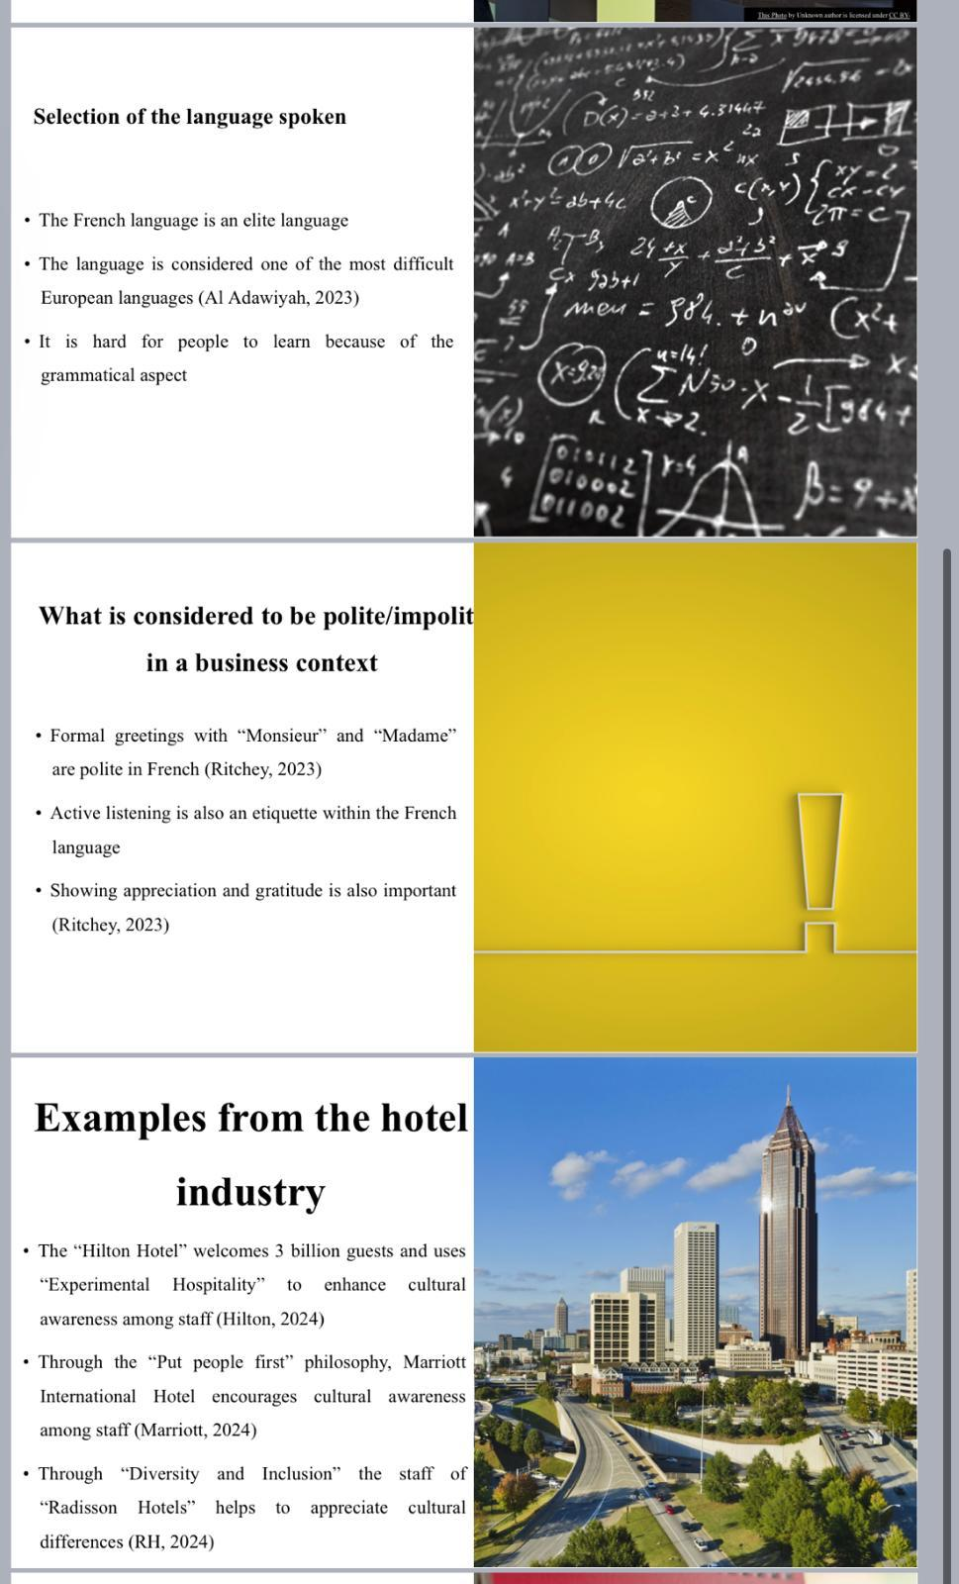
References (no screenshots):
Al Adawiyah, A., 2023. CIRC Learning Model for Reading Comprehension of French Language. Journal of Languages and Language Teaching, 11(1), pp.104-113.
Ferenčík, M. and Bariová, D., 2023. Managing multilingualism in a tourist area during the COVID-19 pandemic. Journal of Pragmatics, 210, pp.52-70.
Hilton (2024). OUR CULTURE Available at: https://jobs.hilton.com/us/en/culture [Accessed on: 30 January, 2024]
Hussain, A., 2023. The Impact of Multilingualism on Personality Development. Strength for Today and Bright Hope for Tomorrow Volume 23: 6 June 2023 ISSN 1930-2940, p.146.
Marriott (2024). Core Values & Heritage Available at: https://www.marriott.com/culture-and-values/core-values.mi [Accessed on: 30 January, 2024]
Puspita, A.M., Mukminatien, N. and Anugerahwati, M., 2023, May. Developing English Vocabulary Application to Enhance Speaking Skills for Students of Hospitality Program. In 20th AsiaTEFL-68th TEFLIN-5th iNELTAL Conference (ASIATEFL 2022) (pp. 31-53). Atlantis Press.
RH (2024). People Available at: https://www.radissonhotels.com/en-us/corporate/responsible-business/people [Accessed on: 30 January, 2024]
Ritchey, E., 2023. Building the Politeness Repertoire Through the Linguistic Landscape. In Spatializing Language Studies: Pedagogical Approaches in the Linguistic Landscape (pp. 21-41). Cham: Springer Nature Switzerland.
Xing, B., Xie, D., Li, S. and Wang, Q., 2023. Why you leave and what can we do? The roles of job burnout and vocational skill in hotel internships. Journal of Hospitality, Leisure, Sport & Tourism Education, 32, p.100424.

