Natalie Wellbeloved
Research Methodology
A critical analysis of whether evidence-based policing helps with fighting criminality in the UK

Chapter three: Research Methodology
3.1 Introduction
In the previous chapter of this study, it was clearly demonstrated that there was a gap in the academic understanding of how crime reduction is still neglected and not always a policing priority. With the use of available literature concerning the topic of criminality in the UK in today’s society, a review was conducted to critically analyse whether or not evidence-based policing helps with tackling such disorder. In order to progress this study, the main focus is to develop an enhanced awareness of this subject by analysing specific methods and methodology.
3.2 Aims and objectives
The main aim throughout this chapter is to achieve the second objective:
- To select an appropriate research method to explore evidence-based policing, criminality and understand the methods and theories in place.
To ensure a better understanding of the overall research process behind this study, this chapter will now discuss the chosen methods and intended methodology including the limitations which rose during the research process.
3.3 Methods
3.3.1 The Research Onion
When researching techniques regarding collection of both primary and secondary data, the ‘Research Onion’ was one method which was used quite often in studies. Lewis, Thornhill and Saunders introduced the ‘research onion’ model as a way of processing the data that has been obtained and “symbolically illustrates the ways in which different elements involved in the research could be examined to develop the final research design” (Understanding the Research Onion | Writing Guides | 15 Writers, 2020) of a research study.
This model consists of six layers which include philosophy, approach, strategy, choices of methods, time horizons, data collection and analysis, all of which are equally important to achieving the most from data (Understanding the Research Onion | Writing Guides | 15 Writers, 2020). In short Lewis, Thornhill and Saunders discuss that “how you collect your data belongs in the centre of the research ‘onion’, the diagram we use to depict the issues underlying the choice of data collection techniques and analysis procedures” (Lewis, Thornhill & Saunders, 2019, p. 128). This model played an active role in determining what research method to take, resulting in the decision to use Secondary Data only.

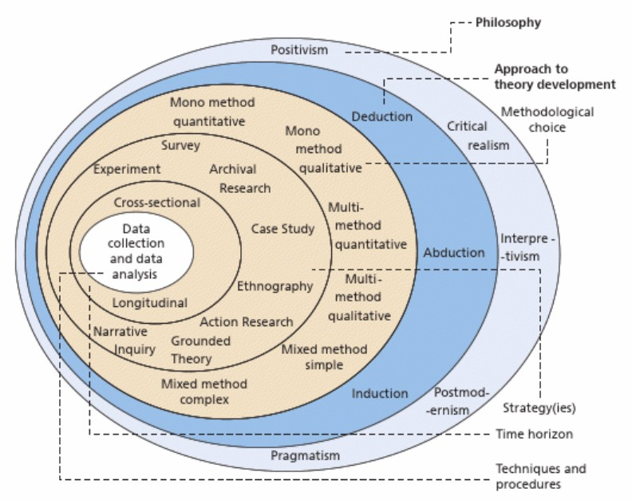
Figure 2 – ‘The Research Onion’ (source Research methods for business students, 2019)
3.3.2 Secondary Data
To conduct a thorough review of whether evidence-based policing helps with fighting criminality in the UK, the approach to carry out the necessary research through predominately secondary data was taken. In this study, the decision to limit the collection of data to include only secondary data was a result of the opportunity to explore what appeared to be an under-researched topic area. Consideration was made into whether primary data would need to be sourced however this proved irrelevant to answer the research question set out originally.
Secondary data has been described as “the data that has already been collected through primary sources and made readily available for researchers to use for their own research. It is a type of data that has already been collected in the past” (What is Secondary Data? + [Examples, Sources, & Analysis], n.d.). Further discussion has been had that such secondary data “can be carried out quantitatively or qualitatively depending on the kind of data the researcher is dealing with. The quantitative method of secondary data analysis is used on numerical data and is analyzed mathematically, while the qualitative method uses words to provide in-depth information about data” (What is Secondary Data? + [Examples, Sources, & Analysis], n.d.).
There are many benefits of utilising secondary data when researching a topic. For example, this will save a lot of time and money not only to save on resources being obtained but also given the short turn around for this piece of work to be produced, this appeared the most appropriate method. Another benefit would be that of being able to produce longitudinal and comparative studies without the need to wait a long period of time to draw up the conclusions, outcomes or answers for research. By using secondary data in this research topic allowed an ease of access. For example, the majority of research was easy accessible through books, university libraries or online webpages. Lastly, by obtaining secondary data gives the reader an opportunity to re-evaluate that specific data “through another person’s lens or point of view” resulting in “new things uncovered” (What is Secondary Data? + [Examples, Sources, & Analysis], n.d.).
On the other using secondary data through the use of literature reviews, case studies and available information such as webpages can also have the opposite effect. For example, David L. Barkley has discussed that using case studies “may have shortcomings that limit their usefulness in understanding a situation or evaluating a program” by not identifying “all reasonable rival hypotheses and/or give appropriate consideration to the role of external factors” (Barkley, 2006, p. 10). Therefore this could result in an “inadequate review of the relevant literature and/or inattention to the appropriate theoretical model” (Barkley, 2006, p. 10). To minimise the chance of this occurring, it is significant to keep the research issue straightforward and to the point which in turn will limit the amount of time and resources required to obtain such data.
3.3.3 Strategy
“Research methods are specific procedures for collecting and analysing data” (An introduction to research methods, n.d.). As discussed this study relied upon secondary data which created the research behind the topic. When obtaining such data, consideration was given about how the data would be analysed.
Qualitative analysis methods is “used to understand words, ideas, and experiences”, for example through methods such as “open-ended survey and interview questions, literature reviews, case studies, and other sources that use text rather than numbers” (An introduction to research methods, n.d.).
On the other hand, there is method by way of a quantitative analysis. This method “uses numbers and statistics to understand frequencies, averages and correlations” (An introduction to research methods, n.d.). This means that researchers can interpret data that was collected either “during and experiment” or by “using probability sampling methods” (An introduction to research methods, n.d.).
This study will utilise a qualitative analysis method approach, as this study does rely upon secondary data which is in the public domain already such as case studies, already existing literature reviews and sources such as webpages. Within chapter two, the study highlights a drop in percentage when discussing a specific case study. Therefore, this would mean this analysis approach would fall into the quantitative analysis research method approach but overall the study will not rely solely on this style of research method.
3.4 Limitations
As already discussed within the previous chapter, the literature which has been critically analysed within this study has relied upon a significant amount of material that is unquestionably specific to that particular sector and written by representatives from that sector. As already highlighted, this will undoubtedly cause an element of bias within found literature.
Throughout the collation of research for evidence-based policing certainly showed a lack of current literature which discusses whether or not such style of policing is effective when it came down to dealing with crimes with that being of a serious and complex nature. Further limitations do suggest that collecting data through tools as mentioned within this study, may not be as reliable or authentic as if it were to be collected directly from a source such as a questionnaire.
As discussed that choosing secondary data posed a benefit in regards to time keeping it also has its disadvantages. For example, as already discussed some data may not be as reliable and therefore this would utilise a lot of time to examine all data to find that which is most relevant. However, if I did carry out primary data approach through the use of questionnaire this would have posed harder deadlines with timings by the distribution and analysis of information obtained.
Fielding, Raymond and Blank disagree with the fact that secondary data can be beneficial when obtaining research and these are certainly areas in which have been identified for this study. They argue that there are many ethical issues which need to be considered as “the internet is still in a formative phase and a new phenomena continue to emerge” (Fielding, Raymond and Blank, 2017, p. 19). For example, to ensure correct ethical decision making through the use of the internet would need to ensure “the necessity to respect and incorporate diverse cultural practices, ethical governance and legal frameworks” (Fielding, Raymond and Blank, 2017, p. 32).
3.5 Conclusion
This chapter has successfully identified and demonstrated the most appropriate route to take for the methodology used in this study therefore achieving the chapter objective. Together with research methods and studies, it has discussed the reasons why secondary data is the most suitable for this type of study but highlighted the limitations imposed by doing so.
The next chapter of this study will produce, analyse and discuss the data which has been obtained during the overall research phase of the study.

Word Count 1,499 Words (with references) / 1,394 without references
Bibliography
Barkley D. (2006) The value of case study research on rural entrepreneurship: useful method, Clemson University: Clemson, South Carolina.
Fielding, Raymond & Blank, G. (2017) The SAGE handbook of online research methods, 2nd Ed. Los Angeles; London: SAGE.
Formpl.us. n.d. What is Secondary Data? + [Examples, Sources, & Analysis]. [online] Available at: <https://www.formpl.us/blog/secondary-data> [Accessed 19 August 2021].
Lewis, Thornhill & Saunders, M N K. (2019) Research methods for business students. 8th Ed. Harlow: Pearson.
Scribbr. n.d. An introduction to research methods. [online] Available at: <https://www.scribbr.com/category/methodology/> [Accessed 27 August 2021].
15 Writers. 2020. Understanding the Research Onion | Writing Guides | 15 Writers. [online] Available at: <https://15writers.com/research-onion/> [Accessed 19 August 2021].
Figures
Figure 2 – ‘The Research Onion’ Research methods for business students (page 2).

