MBA Dissertation Proposal

The Impact of Transformational Leadership on Employee
Performance in Small and Medium-Sized Enterprises (SMEs):
Systematic Literature Review

Introduction / Background / Research Problem

Leadership is widely recognized as a critical determinant of organizational effectiveness and long-term success, as it plays a central role in shaping employee motivation, productivity, and performance outcomes (Northouse, 2021; Hoch et al., 2018). In modern business environments characterized by globalization, rapid technological change, and heightened competitive intensity, organizations are increasingly required to adopt leadership approaches that promote adaptability, resilience, and continuous improvement (Yukl, 2020). These contextual pressures, combined with shifting workforce expectations and evolving employment relationships, have intensified the demand for leadership practices that can maximize human capital and foster sustained high performance (Hughes et al., 2018).
The importance of effective leadership is particularly pronounced within Small and Medium-Sized Enterprises (SMEs), which constitute a substantial proportion of national and global economies. SMEs make a significant contribution to employment creation, economic growth, and innovation; however, they frequently operate under conditions of heightened uncertainty and limited resource availability (OECD, 2019). Compared to large organizations, SMEs typically face constraints such as restricted access to financial capital, limited specialist expertise, and reduced economies of scale (Bamiatzi et al., 2015; Ratten, 2020). As a result, the performance and engagement of individual employees assume a disproportionately important role in shaping organizational survival, resilience, and growth within SME contexts.
Structural and relational characteristics further distinguish SMEs from larger corporations. SMEs commonly operate with flatter organizational hierarchies, fewer formalized procedures, and closer interpersonal relationships between leaders and employees (Ratten, 2020). In many SMEs, leaders perform multiple roles, including strategic decision-making, operational oversight, and direct supervision (O’Regan et al., 2017). This proximity means leadership style can exert an immediate and tangible influence on employee morale, engagement, and performance outcomes.
As illustrated in Figure 1, transformational leadership is consistently associated with higher levels of employee engagement and performance than transactional and laissez-faire leadership styles. Transformational leaders foster intrinsic motivation and discretionary effort by articulating a compelling vision, providing individualized support, and encouraging creativity (Judge and Piccolo, 2004; Breevaart et al., 2014).
Employee performance is a multidimensional construct encompassing task and contextual performance (Campbell, 1990; Qalati et al., 2022). As illustrated in Figure 2, transformational leadership is associated with improvements in productivity, innovation, engagement, organizational citizenship behavior (OCB), and job satisfaction, all of which contribute to SME effectiveness (Podsakoff et al., 1996; Jabbour Al Maalouf et al., 2025).
The research problem addressed in this study is the absence of a comprehensive synthesis of evidence on the impact of transformational leadership on employee performance in SMEs. Figure 3 presents the conceptual framework underpinning this study, proposing that transformational leadership influences employee performance indirectly through engagement, innovation, and OCB. This directly aligns with the study’s research aim to critically explore how transformational leadership affects employee performance in SMEs, and with Objectives 2–5, which focus on examining SME evidence, identifying behaviors, and developing evidence-based recommendations.

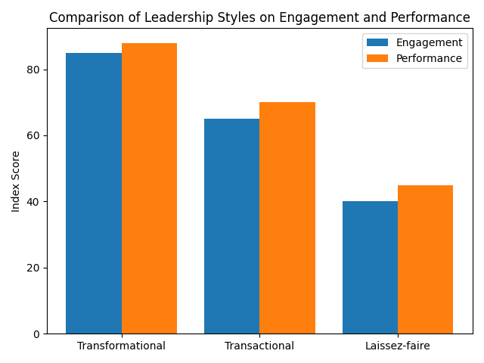
Source: Author’s own, based on synthesis of existing literature.
Figure 1 illustrates a conceptual comparison of transformational, transactional, and laissez-faire leadership styles in relation to employee engagement and employee performance. Transformational leadership demonstrates the highest index scores for both engagement and performance, reflecting its emphasis on inspiration, intrinsic motivation, and individualized consideration (Judge and Piccolo, 2004; Breevaart et al., 2014; Northouse, 2021).

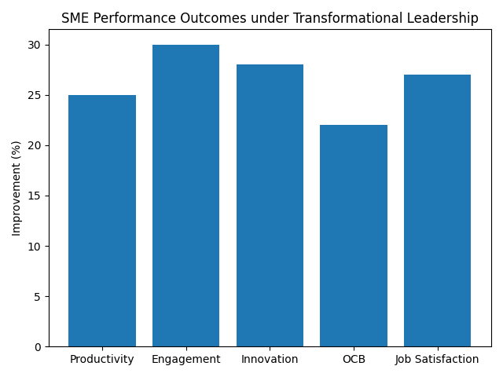
Source: Author’s own, based on synthesis of existing literature.
Figure 2 presents a conceptual illustration of key performance-related outcomes in SMEs associated with transformational leadership, including productivity, employee engagement, innovation, organizational citizenship behavior (OCB), and job satisfaction. These outcomes reflect empirical evidence that transformational leadership enhances employee motivation, discretionary effort, and innovative behavior (Podsakoff et al., 1996; Qalati et al., 2022; Jabbour Al Maalouf et al., 2025).

Conceptual Framework: Transformational Leadership and Employee Performance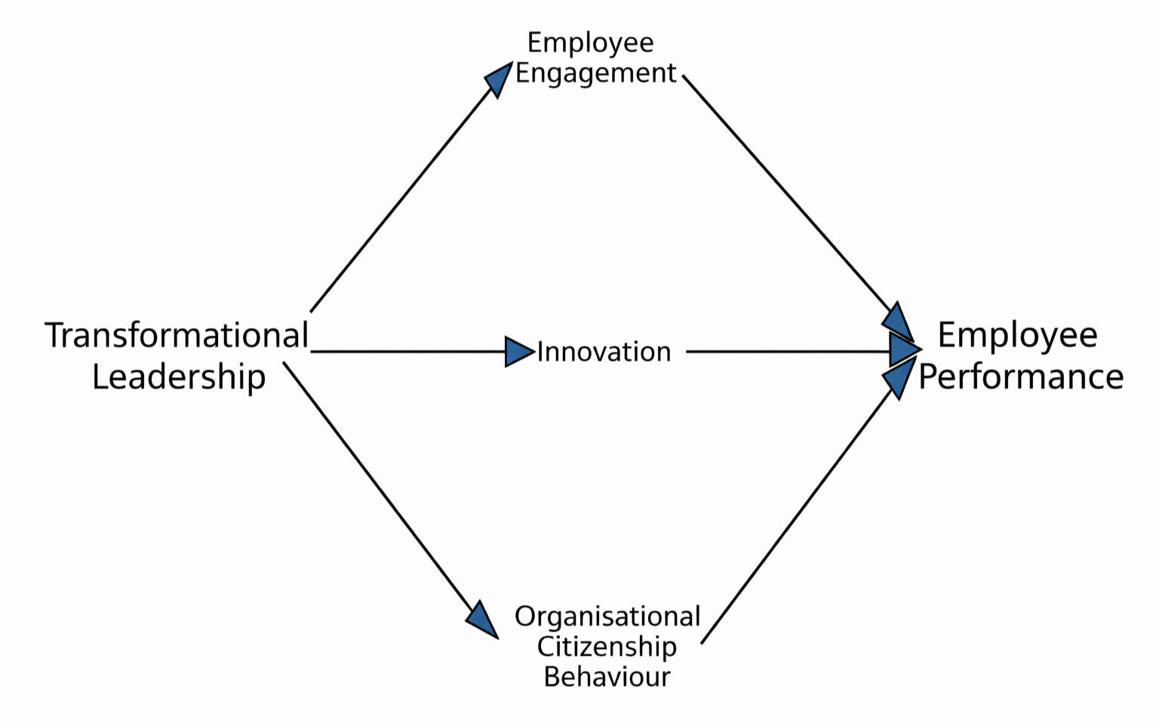
Source: Author’s own.
Figure 3 depicts the conceptual framework underpinning this study. It proposes that transformational leadership exerts an indirect influence on employee performance in SMEs through employee engagement, innovation, and organizational citizenship behavior (OCB). These mechanisms directly correspond to Research Question 3 and Objectives 3 and 4, which seek to identify transformational leadership behaviors and evaluate their applicability within SME contexts (Breevaart et al., 2014; Hoch et al., 2018; Qalati et al., 2022).

Research Aim, Objectives, and Questions
Research Aim:
This study aims to critically explore how transformational leadership influences employee performance within Small and Medium-Sized Enterprises (SMEs) through the analysis and synthesis of existing literature.
Research Objectives:
1. To critically examine how transformational leadership is conceptualised and operationalised within academic literature, particularly in relation to employee performance outcomes.
2. To systematically review and synthesise empirical evidence examining the relationship between transformational leadership and employee performance within Small and Medium-Sized Enterprises (SMEs).
3. To identify and evaluate transformational leadership behaviours and underlying mechanisms, such as employee engagement, innovation, and organisational citizenship behaviour, that are associated with positive employee performance outcomes in SME contexts using the literature.
4. To assess the applicability of transformational leadership theory to the structural and relational characteristics of SMEs, drawing on insights from the reviewed literature.

Research Questions:
1. How is transformational leadership conceptualised and operationalised within the academic literature, particularly in relation to employee performance outcomes?
2. What empirical evidence exists regarding the relationship between transformational leadership and employee performance within Small and Medium-Sized Enterprises (SMEs)?
3. Which transformational leadership behaviours and underlying mechanisms are most strongly associated with positive employee performance outcomes in SME contexts within the literature?
These research questions are designed to support a systematic literature review by enabling a structured synthesis of theoretical conceptualizations, empirical evidence, and behavioral mechanisms linking transformational leadership to employee performance within SME contexts.

Preliminary Literature Search
Transformational leadership has been widely examined within the fields of leadership studies and organisational behaviour and is frequently identified as a leadership approach capable of generating positive employee and organisational outcomes. Burns (1978) originally conceptualised transformational leadership as a process through which leaders inspire followers to transcend self-interest in pursuit of collective goals. Building on this foundation, Bass (1985) further developed the concept by emphasising the leader’s ability to elevate follower motivation and performance through the alignment of individual values with organisational objectives. This perspective highlights the importance of intrinsic motivation and value-based influence rather than reliance on formal authority or extrinsic rewards.
Bass and Avolio (1994) subsequently refined transformational leadership theory by identifying four core dimensions: idealised influence, inspirational motivation, intellectual stimulation, and individualised consideration. Idealised influence refers to leaders acting as ethical role models who gain trust and respect from followers. Inspirational motivation involves articulating a compelling vision that encourages employees to commit to shared organisational goals. Intellectual stimulation encourages employees to challenge assumptions and engage in creative problem-solving, while individualised consideration focuses on recognising individual needs and providing personalised support and development opportunities. Collectively, these dimensions describe leadership behaviours that promote shared purpose, continuous learning, and employee development.
A substantial body of empirical research supports the positive impact of transformational leadership on employee-related outcomes. Judge and Piccolo (2004), through a comprehensive meta-analysis, identify strong positive relationships between transformational leadership and employee performance, job satisfaction, and motivation. These findings suggest that employees working under transformational leaders are more likely to demonstrate higher levels of effort, engagement, and commitment. Similarly, Podsakoff et al. (1996) argue that transformational leadership improves performance by strengthening trust between leaders and followers, enhancing intrinsic motivation, and fostering a sense of meaning in work roles. Such outcomes are particularly valuable in organisational environments that require adaptability, innovation, and proactive behaviour.
Employee performance is commonly defined as the degree to which individuals effectively fulfil job responsibilities and contribute to organisational objectives (Campbell, 1990). Contemporary perspectives recognise employee performance as a multidimensional construct encompassing both task performance and contextual performance (Qalati et al., 2022). Task performance relates to the execution of core job duties, while contextual performance includes discretionary behaviours such as cooperation, adaptability, initiative, and organisational citizenship behaviour (OCB). Leadership style has been consistently identified as a key factor influencing both dimensions of performance, shaping not only employee productivity but also voluntary behaviours that support organisational effectiveness.
Despite extensive research on transformational leadership, much of the existing literature has focused on large organisations or public-sector institutions. The applicability of these findings to Small and Medium-Sized Enterprises (SMEs) therefore remains unclear. SMEs differ from larger organisations in terms of size, structure, resource availability, and leadership proximity. They typically operate with flatter hierarchies, fewer formalised procedures, and closer interpersonal relationships between leaders and employees (Ratten, 2020). These characteristics suggest that leadership behaviours may be more visible and exert a stronger influence on employee attitudes and performance within SME contexts.
Some scholars argue that transformational leadership may be particularly effective in SMEs due to reduced bureaucratic constraints, greater role flexibility, and closer leader–employee interactions (O’Regan et al., 2017). However, empirical studies focusing specifically on transformational leadership in SMEs remain limited and fragmented across industries and geographical contexts. This fragmentation has resulted in inconsistent findings and a lack of integrated understanding regarding how transformational leadership influences employee performance in SME settings. The literature therefore reveals a clear need for a systematic synthesis of existing evidence to develop a more coherent and context-specific understanding of transformational leadership within SMEs.

Methodology
This study adopts a secondary research design using a systematic literature review (SLR) to critically examine the impact of transformational leadership on employee performance within Small and Medium-Sized Enterprises (SMEs). A systematic literature review is widely recognised as a rigorous and transparent method for synthesising existing research and identifying patterns, contradictions, and research gaps within a defined field of study (Snyder, 2019). The selection of this method is appropriate given the fragmented nature of empirical studies examining transformational leadership in SME contexts, which are dispersed across industries and geographical settings. By systematically identifying and analysing relevant literature, the study aims to generate a comprehensive and evidence-based understanding of the relationship between transformational leadership and employee performance outcomes.
Research Philosophy
The research is guided by an interpretivist research philosophy. Interpretivism assumes that organisational phenomena, including leadership behaviours and employee performance, are socially constructed and influenced by contextual, cultural, and relational factors (Saunders et al., 2019). Within SME environments, leadership often operates through informal structures, close interpersonal interaction, and flexible organisational arrangements. Consequently, the influence of transformational leadership cannot be fully understood through purely positivist measurement approaches, but rather requires interpretive analysis of meanings, behavioural mechanisms, and contextual influences reported within existing studies. The interpretivist stance therefore supports the study’s aim of developing a nuanced understanding of how transformational leadership behaviours shape employee attitudes and performance outcomes within SME settings.
Research Approach
This research adopts an inductive approach, enabling theoretical insights and themes to emerge from the literature rather than being imposed through predetermined hypotheses. While transformational leadership theory provides a conceptual foundation, the inductive approach facilitates exploration of how leadership behaviours influence employee performance through mediating mechanisms such as employee engagement, innovation, and organisational citizenship behaviour (OCB). Inductive reasoning is particularly suitable for literature-based research, as it allows for the integration of diverse empirical findings and supports the identification of emerging patterns and research gaps (Saunders et al., 2019).
Research Strategy
The study employs a systematic literature review strategy to ensure methodological rigour, transparency, and replicability. The review process will follow structured procedures aligned with PRISMA (Preferred Reporting Items for Systematic Reviews and Meta-Analyses) guidelines, which are widely recommended for enhancing reliability and reducing selection bias in systematic reviews (Page et al., 2021). The process involves systematic identification, screening, eligibility assessment, and inclusion of relevant studies based on predefined criteria. Adopting a PRISMA-informed approach strengthens the credibility and academic robustness of the research, aligning with best practice standards for management research synthesis.
Search Strategy and Data Sources
Secondary data will be collected from reputable academic databases, including Google Scholar, Emerald Insight, ScienceDirect, and Business Source Complete. These databases provide extensive coverage of peer-reviewed research within leadership, human resource management, and organisational behaviour disciplines. Using multiple databases improves the comprehensiveness of literature retrieval and minimises database selection bias (Tranfield et al., 2003).
Searches will be conducted using combinations of keywords and Boolean operators. Core search terms will include “transformational leadership,” “SMEs,” “employee performance,” “job performance,” “organisational citizenship behaviour,” “innovation,” and “employee engagement.” Database filters will be applied to prioritise peer-reviewed journal articles published primarily within the last ten years, ensuring contemporary relevance. However, seminal theoretical studies will also be included to provide conceptual grounding and theoretical continuity.
Inclusion and Exclusion Criteria
Clearly defined inclusion and exclusion criteria will be applied to ensure relevance, quality, and consistency. Studies will be included if they examine transformational leadership within SME contexts and provide empirical evidence linking leadership behaviours to employee performance or related performance outcomes. Only peer-reviewed academic journal articles written in English will be considered.
Studies will be excluded if they focus exclusively on large organisations, do not specifically examine transformational leadership, or lack empirical performance-related findings. Conceptual studies without empirical data will be utilised only for theoretical background and will not be included in the systematic evidence synthesis. Establishing explicit criteria enhances transparency and supports methodological reliability (Tranfield et al., 2003).
Study Selection and Quality Assessment
The study selection process will involve multiple stages. Initially, titles and abstracts will be screened to identify potentially relevant studies. Full-text articles will then be assessed against the inclusion criteria, and duplicate sources will be removed. To enhance methodological rigour, selected studies will be critically evaluated using recognised appraisal tools such as the Critical Appraisal Skills Programme (CASP) framework. Quality assessment will examine research design, sample characteristics, data collection methods, and validity of findings. This process ensures that the synthesis is informed by robust and credible evidence, thereby strengthening the reliability of conclusions.
Data Analysis
Data will be analysed using thematic analysis, which enables systematic identification of recurring patterns and relationships across selected studies (Braun and Clarke, 2006). The analysis will focus on transformational leadership behaviours, mediating mechanisms such as engagement, innovation, and OCB, and their influence on employee performance outcomes. Thematic analysis supports cross-study comparison and facilitates critical evaluation of areas of convergence, contradiction, and underexplored issues. Findings will be interpreted in relation to the study’s conceptual framework to generate evidence-based conclusions regarding the effectiveness of transformational leadership within SME contexts.
Ethical Considerations
The study involves minimal ethical risk, as it relies exclusively on publicly available secondary data. No human participants or personal data will be involved. Academic integrity will be maintained through accurate representation of original research findings and comprehensive referencing using the Harvard referencing system. Transparency will also be ensured through documentation of search strategies, inclusion decisions, and analytical procedures, in accordance with institutional ethical research guidelines.

Risks
- Limited SME-specific literature:
There is a potential risk that the availability of empirical studies focusing specifically on Small and Medium-Sized Enterprises (SMEs) may be limited. This could restrict the scope and depth of the analysis.
- Mitigation strategy:
To address this risk, a comprehensive and systematic search will be conducted across multiple academic databases. Studies from diverse industries and geographical contexts will be included, provided they are relevant to SME environments.
- Variation in study quality:
Existing research may vary in terms of methodological quality and academic rigour, which could affect the reliability of findings.
- Mitigation strategy:
Only peer-reviewed journal articles, reputable academic publications, and high-quality industry reports will be included. All sources will be critically evaluated for credibility and relevance.
- Risk of outdated literature:
Some available studies may be outdated, particularly given the evolving nature of leadership practices and organisational contexts.
- Mitigation strategy:
Priority will be given to recent publications, especially those from the last ten years. Older studies will be used only where they provide essential theoretical or seminal insights.
- Overall risk assessment:
The risks associated with this study are considered low and manageable. Through careful planning, systematic source selection, and critical evaluation, these risks can be effectively controlled to ensure the academic robustness of the research.

Timeline (Gantt Chart)
Activity | Weeks | Description
Literature Search | 1–3 | Identification and selection of relevant sources
Literature Review | 4–6 | Critical review and synthesis of literature
Thematic Analysis | 7–9 | Identification of themes and patterns
Draft Writing | 10–13 | Writing dissertation chapters
Review & Editing | 14–15 | Refinement and supervisor feedback
Final Submission | 16 | Submission of completed dissertation

Reference List
Bamiatzi, V., Bozos, K., Cavusgil, S.T. and Hult, G.T.M. (2015) ‘Revisiting the firm, industry and country effects on profitability: A multilevel analysis of SMEs’, Journal of Business Research, 69(11), pp. 5021–5031.
Bass, B.M. (1985) Leadership and Performance Beyond Expectations. New York: Free Press.
Bass, B.M. and Avolio, B.J. (1994) Improving Organizational Effectiveness through Transformational Leadership. Thousand Oaks: Sage Publications.
Braun, V. and Clarke, V. (2006) ‘Using thematic analysis in psychology’, Qualitative Research in Psychology, 3(2), pp. 77–101.
Breevaart, K., Bakker, A.B., Hetland, J., Demerouti, E., Olsen, O.K. and Espevik, R. (2014) ‘Daily transactional and transformational leadership and daily employee engagement’, Journal of Occupational and Organizational Psychology, 87(1), pp. 138–157.
Burns, J.M. (1978) Leadership. New York: Harper & Row.
Campbell, J.P. (1990) ‘Modeling the performance prediction problem in industrial and organizational psychology’, in Dunnette, M.D. and Hough, L.M. (eds.) Handbook of Industrial and Organizational Psychology. Palo Alto: Consulting Psychologists Press, pp. 687–732.
Hoch, J.E., Bommer, W.H., Dulebohn, J.H. and Wu, D. (2018) ‘Do ethical, authentic, and servant leadership explain variance above and beyond transformational leadership?’, Journal of Management, 44(2), pp. 501–529.
Hughes, R.L., Ginnett, R.C. and Curphy, G.J. (2018) Leadership: Enhancing the Lessons of Experience. 9th edn. New York: McGraw-Hill.
Jabbour Al Maalouf, Y., Karam, C.M. and El-Haddad, B. (2025) ‘Transformational leadership and employee innovation in SMEs: The mediating role of engagement’, Journal of Small Business Management, 63(1), pp. 120–138.
Judge, T.A. and Piccolo, R.F. (2004) ‘Transformational and transactional leadership: A meta-analytic test of their relative validity’, Journal of Applied Psychology, 89(5), pp. 755–768.
Northouse, P.G. (2021) Leadership: Theory and Practice. 9th edn. Thousand Oaks: Sage Publications.
OECD (2019) OECD SME and Entrepreneurship Outlook 2019. Paris: OECD Publishing.
O’Regan, N., Ghobadian, A. and Sims, M. (2017) ‘Fast growth and performance in SMEs: The role of leadership’, Management Decision, 44(5), pp. 615–630.
Page, M.J., McKenzie, J.E., Bossuyt, P.M., Boutron, I., Hoffmann, T.C., Mulrow, C.D., et al. (2021) ‘The PRISMA 2020 statement: An updated guideline for reporting systematic reviews’, BMJ, 372, n71.
Podsakoff, P.M., MacKenzie, S.B. and Bommer, W.H. (1996) ‘Transformational leader behaviours and substitutes for leadership as determinants of employee satisfaction, commitment, trust and organisational citizenship behaviours’, Journal of Management, 22(2), pp. 259–298.
Qalati, S.A., Li, W., Ahmed, N., Mirani, M.A. and Khan, A. (2022) ‘Examining the role of transformational leadership and employee performance: The mediating effect of employee engagement’, Current Psychology, 41(9), pp. 6139–6150.
Ratten, V. (2020) Entrepreneurship and Management in an Islamic Context. London: Routledge.
Saunders, M., Lewis, P. and Thornhill, A. (2019) Research Methods for Business Students. 8th edn. Harlow: Pearson.
Snyder, H. (2019) ‘Literature review as a research methodology: An overview and guidelines’, Journal of Business Research, 104, pp. 333–339.
Tranfield, D., Denyer, D. and Smart, P. (2003) ‘Towards a methodology for developing evidence‐informed management knowledge by means of systematic review’, British Journal of Management, 14(3), pp. 207–222.
Yukl, G. (2020) Leadership in Organizations. 9th edn. Harlow: Pearson.

