Stress Analysis and Dynamics

Introduction.

Task A.

Centrifugal and Electromagnetic Clutches in Modern Applications
Although centrifugal clutches applied in small motor equipment have only been used within the last century, they offered a significant step towards automation for other industries also including the rail and automotive.
The centrifugal clutch has been used in the rail industry for the best part of over one hundred and sixty years just before 1858. However, the use of the first automative centrifugal clutch was some thirty years later and patented in the USA in 1898. Below are a list of notable dates in relation to the advancement and patents of the centrifugal clutch’s history.

*1899 – A Patent issued for the centrifugal clutch as associated with that of electrical driven motors.
*1934 – A design for a toy automatic clutch was published in Meccano magazine.
*1936 – Armstrong Suddley cars began to feature the automatic centrifugal clutch.
1940 – Thomas Fogarty invented a centrifugal clutch for small motor applications.
This paper will discuss the development of the centrifugal friction clutch, including its operating principles, material selection, and typical applications. It will then examine the advantages of centrifugal clutches and, finally, explore the application of electromagnetic clutches in modern manufacturing automation.
Development of the Centrifugal Friction Clutch
The centrifugal clutch, as its name suggests, utilise the principle of centrifugal force for its operation. Though the provided sources lack details about its exact origin and early development, they highlight its widespread adoption in the 20th century.
How a Centrifugal Clutch Works
A centrifugal clutch automatically engages and disengages the connection between a driving shaft (typically connected to an engine) and a driven shaft (connected to the load) based on the rotational speed of the driving shaft.12 This eliminates the need for manual clutch operation. At low speeds, the clutch remains disengaged, allowing the engine to idle without driving the load. Only when the engine speed reaches a predetermined level (the engagement speed) does the clutch engage, transmitting power to the load.1

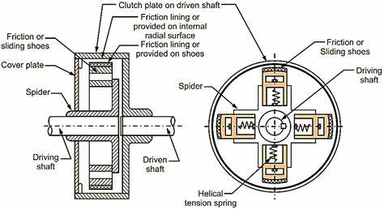
This automatic operation is achieved through the interplay of several key components:
Shoes: Sliding components within the clutch, equipped with friction linings.3
Springs: These exert force to disengage the clutch at lower speeds.3
Spider or Guides: Located on the driving shaft, they hold the shoes and their respective springs.4
Friction Lining: Found on the outer surface of the shoes, these engage with the drum to transmit torque.4
Drum: Encloses the clutch components and is connected to the driven shaft.4
The operation is achieved in stages which have been broken down in the following paragraph. At low speeds, the springs hold the shoes inward.5 The shoes don't contact the drum, and the clutch remains disengaged. As the driving shaft rotates and the speed increases, the shoes begin to rotate as well. The centrifugal force acting on the shoes increases with the rotational speed.5 When the centrifugal force overcomes the spring force, the shoes are pushed outwards.5 The friction linings on the shoes contact the inner surface of the drum. The friction between the shoes and the drum transmits torque from the driving shaft to the driven shaft.56
As the driving shaft speed decreases, the centrifugal force diminishes, allowing the springs to pull the shoes back inward, disengaging the clutch.7
Choice of Materials for the production of clutches.
The materials used for the different components of a centrifugal clutch are chosen to ensure durability and efficient operation under various conditions. The shoes for example are often made made from robust materials like steel or cast iron, which can withstand the high centrifugal forces generated during operation.89
●
Linings: These require materials with high friction coefficients to effectively transmit torque. Asbestos-based linings were common in the past, but due to health concerns, they have been replaced by non-asbestos organic materials such as Kevlar and fibreglass.41011 The wear would cause the asbestos fibers to be released causing horrendous health conditions such as mesothelioma and other asbestos related diseases. Asbestos was banned in the UK at the end of 1999, with the official cut-off date often cited as 2000. From late November 1999, it became illegal to buy, sell, import, or export any materials containing asbestos. However, as per SCH environmental surveys there are some countries who still use an implement asbestos in some of their products . (Ltd, 2024)
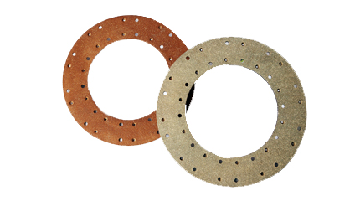

Springs: Typically made from steel for their strength and resilience.3
Housing: Can be constructed from aluminium for lightweight applications or steel for heavier-duty use.46

Typical Applications and Operating Conditions
Centrifugal clutches are well-suited for situations where the load has high starting inertia and the ability to avoid engine stalling is important.1213 They are frequently found in machinery driven by small petrol or diesel engines.13 Typical applications include:
●
Construction Equipment: Vibratory plate compactors, rammers, concrete finishers, and compact road cleaners.13
●
Groundcare Equipment: Rotary and flail mowers, turf cutters, and scarifiers.13
●
Other Applications: Go-karts, woodchippers, milling cutters, transport refrigeration units, and mobile water pumps.13
Operating Conditions:
●
Engagement Speed: This is predetermined by the spring tension and the mass of the shoes.5912
●
Temperature: Operational temperature needs to remain within the limits of the friction material and any lubrication used.1014 Special high-temperature grease is often used.14
●
Environment: Depending on the application, the clutch may need to be protected against environmental factors like dust and moisture.1415
Advantages of Centrifugal Clutches
Several advantages make centrifugal clutches suitable for their specific applications:
●
Automatic Operation: Eliminates the need for manual clutch control, simplifying operation, especially for inexperienced users.121617
●
Smooth Engagement: The gradual engagement of the centrifugal clutch helps prevent sudden jerks and reduces stress on the engine and drivetrain.1216
●
Protection Against Stalling: Enables the engine to continue running even when the output shaft is stopped or slowed down, preventing stalling.121618 This is particularly beneficial for equipment like lawnmowers or chainsaws.
●
Cost-Effectiveness: Centrifugal clutches are generally simpler and more cost-effective to manufacture compared to other clutch types.1619
Electromagnetic Clutches in Modern Automation
Electromagnetic clutches, leveraging the principles of electromagnetism, have become essential components in modern manufacturing automation. Their ability to provide precise control, rapid response, and remote operation has made them indispensable in various industrial processes.
Principles of Operation
Electromagnetic clutches operate by utilising an electromagnet.20 When an electric current is passed through the coil of the electromagnet, it generates a magnetic field that attracts a ferrous armature. This attraction pulls the armature into contact with the rotor, engaging the clutch.2122 This engagement enables the transmission of torque between the driving and driven shafts.2022 When the current is removed, the magnetic field collapses, allowing the armature to disengage from the rotor, thus disengaging the clutch.22
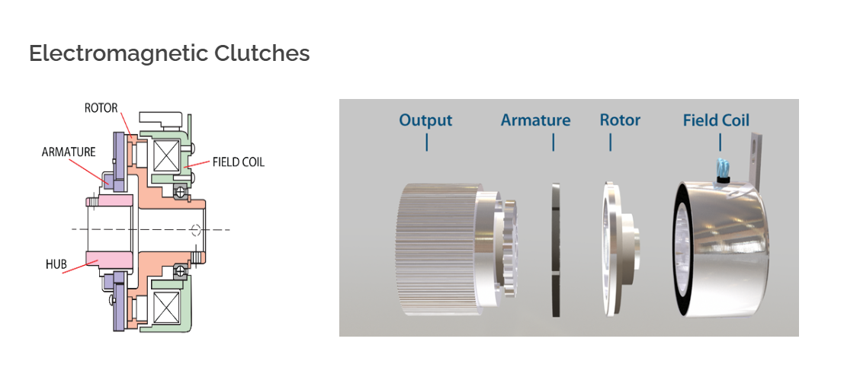

Advantages in Manufacturing Automation
Electromagnetic clutches offer several key benefits in manufacturing automation:
Precise Control: Electromagnetic clutches allow for highly accurate and repeatable control of motion and positioning, essential for precise manufacturing operations, such as repetitive high precision parts.2324
Fast Response Times: These clutches can engage and disengage extremely quickly, significantly improving cycle times in automated processes.24
●
Remote Actuation: The ability to control electromagnetic clutches electronically makes them easy to integrate into automated systems, enabling centralised control and programming.24
●
Clean and Quiet Operation: Their operation doesn't produce noise or particulate contamination, making them ideal for environments with specific requirements for cleanliness and noise levels.24
Application in Modern Manufacturing Processes
The versatility and advantages of electromagnetic clutches have led to their adoption in various manufacturing processes:
●
Packaging Machinery: Used for controlling the precise feeding and indexing of packaging materials.25
●
Printing Presses: Enable accurate control of paper feed mechanisms and the engagement of printing rollers, critical for high-quality printing.25
●
Robotics: Employed in robotic arms and joints to control their movements with accuracy and repeatability.25
●
Machine Tools: Facilitate the engagement and disengagement of spindles and tool changers in CNC machines and other machine tools.25
●
Conveyor Systems: Allow for smooth starting and stopping of conveyor belts, ensuring efficient material handling.25
Conclusion
Centrifugal clutches, with their automatic operation and stall prevention capabilities, have found significant applications in small engine equipment over the last century. However, they are being gradually replaced by other clutch types in many applications. In contrast, electromagnetic clutches have become integral components of modern automation in the manufacturing sector. Their precision, speed, and remote controllability make them ideal for a wide range of industrial processes. As automation continues to advance in manufacturing, electromagnetic clutches will likely play an increasingly vital role in shaping the future of production.

Task B.

Calculating the Radius of the outer drum to then find the diameter.

Radius of the outer drum = R1 + Clearance + drum thickness
Radius of the outer drum = 95mm + 9mm + 4mm
Radius of the outer drum = 108mm

Diameter = Radius X 2
Diameter = 108mm X 2
Diameter = 216mm Diameter = 0.216 Meters

- Determine the engagement speed of the centrifugal clutch.
To find the engagement speed of the centrifugal clutch, is the same as saying when the shoe overcomes the spring force. So they have to travel 9mm to touch inner drum case.

- Calculate the radial force acting on the clutch when the driving shat is rotating at a speed of 500RPM.

- At the driving shaft speed of 550RPM, what will be the value of torque transmitted to the driven shaft?

5.
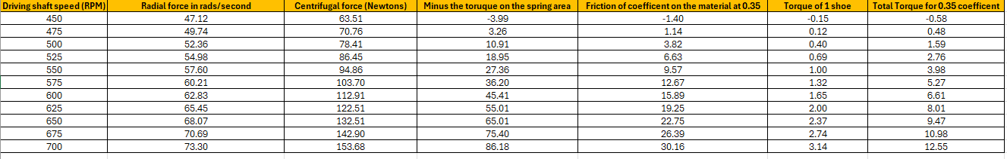

6.
Firstly, we need to understand the term coefficient in terms to friction, a simplified version of this being that it is a numerical value that represents the frictional force between two surface when in contact. It is a numerical magnitude of representing how much one surface resists sliding over the other. There are two main forms of friction which are static and kinetic, the static force simply means how much force is going to be required to overcome the initial resistive force. For example, if an individual was to push a heavy box on the floor, the ground would require a large initial force to overcome the static friction of the rough floor surface.
There are also kinetic or dynamic force acting on an object as it is traveling in its path, usually the coefficient of friction for a moving object is typically less to keep an object moving than overcoming its starting initial coefficient.

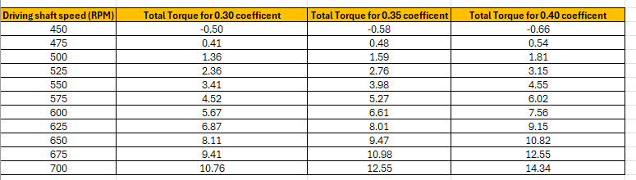

The tabulated data above shows a direct correlation between increasing the coefficient of friction and the magnitude of total torque. As the coefficient of friction was increased in increments of 0.5 the total torque increased.
The increase in torque does not automatically mean there is less efficiency in the designed system. However, increased load resistance can reduce the efficiency due to frictional losses and the greater the amount of friction then potentially there is more heat being created.
The sources illustrate a clear connection between torque and the coefficient of friction within the context of centrifugal clutches.
The torque transmitted by a centrifugal clutch largely depends on the friction between the clutch shoes and the drum1.
The friction material on the clutch shoes increases the friction between the surfaces, allowing for greater torque transmission12.
●
This frictional force is directly influenced by the coefficient of friction between the materials used3.
A higher coefficient of friction means a greater frictional force for a given normal force, resulting in a higher torque that can be transmitted.
For example:
●
In mobile clutch applications, friction material is often omitted to avoid swelling and reduced torque that can occur when the material gets wet4.
●
Conversely, using a high coefficient friction material can increase the torque a clutch can transmit3.
Essentially, the relationship between torque and the coefficient of friction in a centrifugal clutch can be summarised as follows:
Higher Coefficient of Friction = Greater Frictional Force = Higher Torque Transmission

