Model | Content of the Model | Model Diagram
Basic Communication Cycle | Is the model simple or complex?  Is the shape linear or circular?  Does it  Include non-verbal communication?  Consider barriers to communication?  Take the receiver’s knowledge into account?  Deal with noise or distractions?  Take feedback into account? | 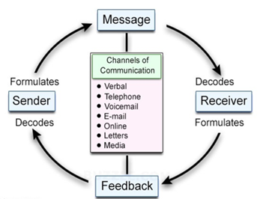  .
Shannon & Weaver | Is the model simple or complex?  Is the shape linear or circular?  Does it  Include non-verbal communication?  Consider barriers to communication?  Take the receiver’s knowledge into account?  Deal with noise or distractions?  Take feedback into account? | 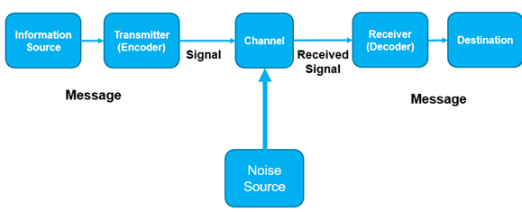
Schramm | Is the model simple or complex?  Is the shape linear or circular?  Does it  Include non-verbal communication?  Consider barriers to communication?  Take the receiver’s knowledge into account?  Deal with noise or distractions?  Take feedback into account? | 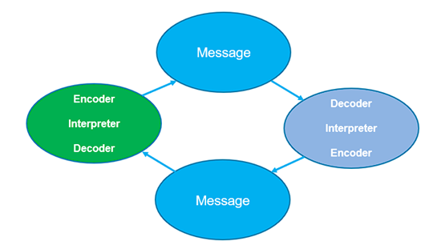
Berlo  (SMCR) | Is the model simple or complex?  Is the shape linear or circular?  Does it  Include non-verbal communication?  Consider barriers to communication?  Take the receiver’s knowledge into account?  Deal with noise or distractions?  Take feedback into account? | 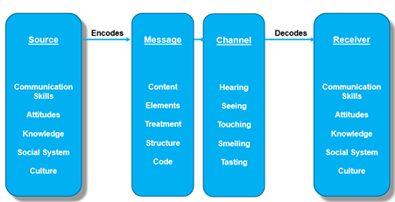

Consider a workplace example where a communication problem led to a major issue at work, either personally or technically, due to a message not being sent or received incorrectly.
What was the issue? Describe what went wrong.

Why was the message not received or understood correctly?
(E.g. Unclear message sent (encoding), or wrong channel of transmission, or not understood by the receiver (decoding) or distractions or barriers getting in the way (noise) of the message being understood correctly?

How could it have been communicated better? (What would you do next time?)

Which model best explains the problem and why?

Model | Feedback | Noise Importance | Best Use | Main Differences with Other Models | Example | Why Use This Model | Particular Characteristics (Compared to Other Models)
Basic Comms Cycle | Yes | Basic | General explanation | Simpler than the others; | Misunderstanding due to unclear feedback in a casual conversation. | Useful for explaining simple miscommunication without interference. | Emphasises feedback loop and simplicity
Shannon & Weaver | No | High | Technical systems | More technical than others; focuses on transmission of signals and effects of noise. Lacks feedback. Treats communication as linear. | Miscommunication during a phone call due to static or poor signal. | Useful when the issue is technical interference or noise disrupting the message. | Introduced the concept of noise and linear models, designed for electronic and media communication.
Schramm | Yes | Moderate | Team communication | Adds shared fields of experience and encoding/decoding. Builds on the basic model by recognising individual interpretation. | Breakdown in a meeting when team members misinterpret jargon due to different backgrounds. | Helps explore how meaning is constructed and misinterpreted between people with differing experiences. | Circular and interactive model; feedback and shared meaning are core components, accounting for the ‘cognitive’ processing of messages  Considers what other should already understand. Using language, terms or knowledge both sender and receiver understand
Berlo (SMCR) | No | Moderate | Leadership/Managerial | Breaks message into Source, Message, Channel, Receiver components. No feedback loop. More psychological than technical (unlike Shannon-Weaver). | Manager gives instructions using complex language the team doesn't understand. | Suitable for identifying how source credibility or channel choice affects message clarity. | Emphasises the personal characteristics of the sender and receiver (attitudes, knowledge, social system); no feedback or noise elements explicitly shown.

