University of Wales
Trinity Saint David



Program: BSc Applied Computing

Module: Creativity and Value Creation
MODULE CODE: ACCA5033
Assignment Title: Innovation & Research

Project Title:
A Cybersecurity Awareness Web App for Small Businesses

Name: SELOMON DAWIT

Student ID: 2323551

Submission Date: Friday, 28th December 2025

Lecturer: Dr Fahad Ahmad
Internal Verifier: Dr Sana Jokhio

Table of Contents

- Introduction
- Project Scope and Aims
- Problem Statement
- Planned/proposed Solution
- Goal/Target Users
- Project Deliverables
- Project Timeline and Milestones
- Innovation Aspects
- Encounters and Risk Management
- Conclusion
- References

Introduction

Cybersecurity Awareness Web App Project
Small businesses face growing cyber risks due to inadequate resources and minimal staff awareness, making them vulnerable to phishing, malware, and data breaches. To focus this, the Cyberwar Web App provides a clear, collaborative platform presenting education modules, quizzes, development tracking, and simulated phishing exercises. The system shapes practical skills and organises everyday digital resilience. By merging successful learning design with shaped project management, Cyberwar invests in small businesses to improve their cybersecurity defences and better guard their operations from developing threats.

Task 1: Project Management & Planning
Project Scope

Project Title: A Cybersecurity Awareness Web App for Small Businesses (Cyberwar)
Problem Statement: Small organisations are repeatedly deprived of the resources to train staff in cybersecurity, putting them vulnerable to attacks.
Proposed Solution: Cyberwar resolution provides:
- Useful guidance on common threats
- Interactive quizzes to reinforce learning.
- Simulated phishing emails for hands-on awareness
- A dashboard to track engagement and progress.
Target Users: Workers in small businesses with restricted IT support.

Component | Technology/Tool
Frontend | HTML, CSS, JavaScript
Backend | Python (Flask) or Node.js
Database | SQLite or Firebase
Design | Figma
Project Tracking | Trello or Jira
Hosting | GitHub Pages or Heroku
Gantt Chart | GanttProject or MS Project

Table 1: Technologies & Resources

Phase | Duration | Key Activities
Research & Planning | Week 1–2 | Requirements, literature review
Design & Prototyping | Week 3–4 | Wireframes, UI mock-ups
Proposal & Approval | Week 5–6 | Proposal preparation
Data Collection | Week 7–8 | User needs, cybersecurity data
Development | Week 9–10 | Frontend, backend, database
Testing | Week 11 | Usability testing, fixes
User Training Demo | Week 12 | Demonstration and feedback
Final Submission | Week 13–14 | Documentation and upload

Table2: Project Timeline

Constraints: Limited time, no access to significant business data, and ethical handling of feedback.

WBS ID | Task Name | Start Date | Duration (Days)
1.0 | A Cybersecurity Awareness Web App for Small Businesses | 20/02/2025 | —
1.1 | Research & Planning | 20/02/2025 | 10
1.2 | Design & Prototyping | 02/03/2025 | 15
1.3 | Project Proposal & Approval | 17/03/2025 | 8
1.4 | Data Collection & Analysis | 25/03/2025 | 12
1.5 | Development | 06/04/2025 | 15
1.6 | Testing & Feedback | 21/04/2025 | 25
1.7 | User Training / Demo | 16/05/2025 | 22
1.8 | Final Report & Submission | 07/06/2025 | 14

Table3: Work Breakdown Structure (WBS)

Creating a Gantt Chart for the given project: I use Excel to develop the following Gantt chart.

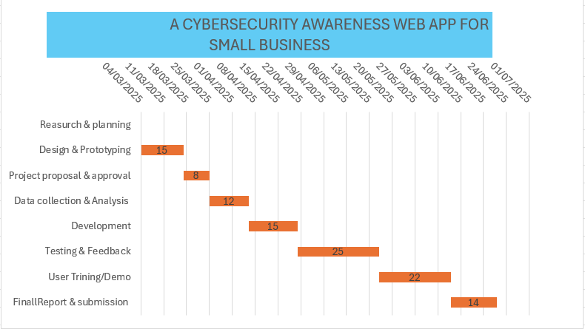
Figer1: Gantt Chart

Development Methodology: Agile
Agile supports tractability and continuous advancement through:
- Race planning and weekly goals.
- Each day stand-ups (Dialling)
- Client stories for feature clarity
- Race reviews for feedback!
- Demonstrations for process enhancement
This guarantees primary testing, rapid iteration, and alignment with user requirements.
Juan. Garbajosa, Xiaofeng. Wang and Ademar. Aguiar, Eds., Agile Processes in Software Engineering and Extreme Programming: 19th International Conference, XP 2018, Porto, Portugal, May 21–25, 2018, Proceedings, 1st ed. 2018. Cham: Springer Nature, 2018. doi: 10.1007/978-3-319-91602-6.

Task 1 – Q2: Project Design

Desires Specification and a Flowchart Diagram.
1: Requirements Specification
The requirements document includes both functional and non-functional descriptions of the project. It helps as a blueprint for improvement and confirms alignment with client needs and project goals.

Requirement ID | Description
FR1 | Users must be able to register and log in securely.
FR2 | Users can access cybersecurity learning modules.
FR3 | Each module includes interactive quizzes.
FR4 | The system tracks user progress and quiz scores.
FR5 | Admins can view analytics on user engagement.

Table4: Functional Needs

Requirement ID | Description
NFR1 | The app must be responsive across devices.
NFR2 | Data must be stored securely and comply with GDPR.
NFR3 | The system should load within 2 seconds on average.
NFR4 | The interface should be intuitive and accessible.

Table5: Non-Functional Needs

User Roles
- General User: Admittance modules, take quizzes, and view progress.
- Administrator: Operate content, view analytics, moderate users
Technology Stack
- Frontend: HTML, CSS, JavaScript
- Backend: Python (Flask)
- Database: SQLite
- Hosting: Heroku or GitHub Pages
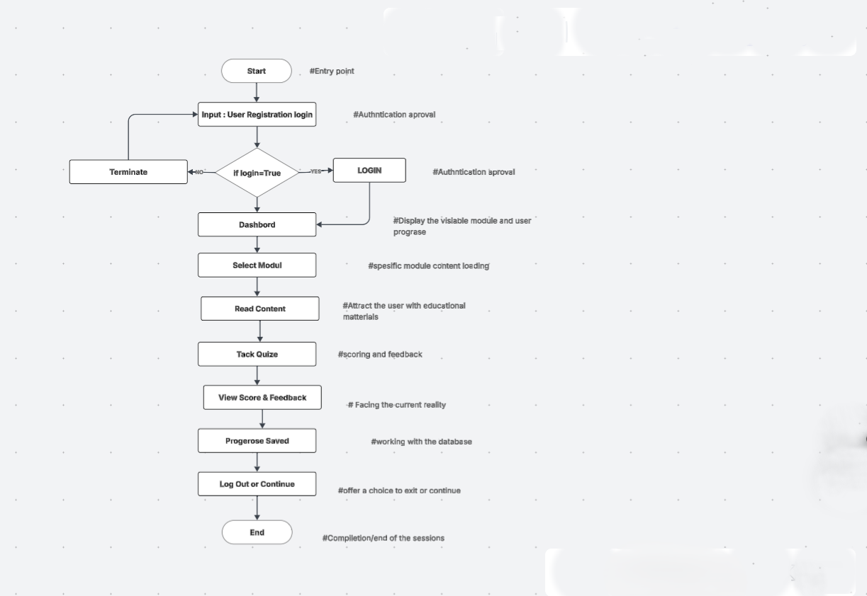

Flow Chart Diagram

Conclusion: Reflect on software design
These objective things supply a structured foundation for improvement. The requirements ensure clarity and completeness, while the flowchart supports effective coding and testing.

Task 2: Enterprise
Q1: PEST & SWOT Analysis: I can refer to Cisco Systems and confirm with you that I am Palo Alto eLearning certified.
To recognise the external and internal components that manipulate tech companies, we investigate Cisco Systems, a large-scale leader in networking and cybersecurity solutions.

Factor | Key Considerations
Political | Data protection laws (e.g., GDPR), international trade regulations, and cybersecurity mandates
Economic | Global demand for secure infrastructure, inflation affecting tech budgets
Social | Rising awareness of digital threats, remote work trends increasing security needs
Technological | Rapid innovation in AI, cloud computing, and threat detection tools

Table6: PEST Analysis

Category | Details
Strengths | Strong brand reputation, global presence, and advanced R&D capabilities
Weaknesses | High cost of enterprise solutions, complexity of integration
Opportunities | Expansion into SME markets, partnerships with educational institutions
Threats | Fast-changing threat landscape, competition from agile startups

Table7: SWOT Analysis
Legal & Ethical Considerations (example: Virtual cybersecurity Lab GitHub, sourced from Google)
- Legal: Agreement with GDPR, HIPAA, and other data protection laws is critical. Cisco must safeguard lawful data supervision across jurisdictions.
- Ethical: Ethical use of AI in risk detection, clarity in data collection, and accessibility for underserved communities are key concerns.

Conclusion
This brief reveals how enterprise exploration tools such as PEST and SWOT feed a defined lens for understanding the strategic environment of major technology companies like Apple. By inspecting political, economic, social, and technological influences, these outlines reveal the outside pressures that form corporate decision-making, from governing compliance and customer prospects to rapid improvement cycles and global market shifts. Similarly, the SWOT analysis highlights domestic strengths and weaknesses that determine a company’s reasonable position and long-term sustainability.
When these insights are associated to the Cyberwar Web App start-up idea, their significance becomes even more apparent. Just as universal tech firms traverse legal responsibilities, cybersecurity mandates, and ethical reflections, immediate data governance, the Cyberwar Web App must also adopt responsible practices from the outset. Ethical design, visible data usage, availability, and accordance with privacy regulations are necessary to establish user trust—an instrumental asset in any cybersecurity-related venture.
Intentionally, the lessons obtained from start-ups reinforce the importance of defining a clear company model and strong branding for the start-up. A well-sharpened identity, reinforced by coherent messaging and a focused value proposition, helps emergent businesses sit themselves in a crowded market. Furthermore, identifying the threat landscape and identifying occasions—whether through partnerships, positioning markets, or innovative features—can guide the start-up regarding balanced growth.
Financing is another significant aspect shaped by these insights. Just as sizable companies rely on expanded revenue streams, the Cyberwar Web App can look at multiple avenues such as grants, educational partnerships, incubators, sponsorships, or subscription-based models. This multiplicity enhances resilience and decreases reliance on any separate finance source.
Generally, applying PEST and SWOT analysis not only grows a deeper identification of how global leaders achieve but also equips new ventures with practical strategies to overcome challenges and take advantage of on opportunities. For the Cyberwar Web App, these systematic tools support the expansion of an accountable, modern, and ecological organisation capable of flourishing in an increasingly digital and security-focused world.

TASK3

Project Reflection using Gibbs’ Reflective Cycle for Cyberwar Web App
1. Description
The Cyberwar Web App project is focused on developing a collaborative cybersecurity training platform shaped for small businesses. My part involves both technical and project-management duties, specifically increasing the application’s front-end using React and implementing secure back-end functionality with Node. Besides development tasks, I oversee surrounding Agile project-management approaches, conduct risk assessments, and guarantee the app meets security and governing standards. This project not only aims to supply a functional training tool but also reports the wider issue of low cybersecurity awareness, including small organisations.
2. Feelings
At the start, I sensed a combination of keenness and uncertainty. The project’s cybersecurity focus excited me, as it proposed a chance to grow in a progressively critical field. However, I was also concerned about the sheer learning curve involved. Particularly in protected coding, encoding, and creating engaging training modules. Over time, the amalgamation of technical exploration and cooperative development increased my confidence. I became more self-confident in applying Agile practices, interacting with peers, and adapting to evolving project requirements.
3. Evaluation
There were numerous positive aspects of the experience. Reinforcing my knowledge of React and Joint expanded my ability to create accessible, responsive applications. The project also recognised me to search cybersecurity fundamentals such as secure authentication, phishing detection, and penetration testing, all of which are important for protecting user data. From a project-management scene, using Agile frameworks heightened collaboration, carried structured planning, and aided the team in navigating change over significances effectively.
However, there were encounters. Improving interactive training modules needed extensive research into instructional design and gamification to deepen user commitment. In addition, resourcefulness confines made it difficult to implement every required feature. Verifying full agreement with GDPR also required cautious attention to privacy-by-design principles.

4. Analysis
The objective highlighted significant public value. Experience reports show that over 40% of UK businesses experience cyber breaches yearly. Often due to human error, the Cyberwar app has the potential to reduce vulnerabilities by educating employees through accessible, functional training. Improving digital literacy among non-technical users contributes to broader resilience and supports commercial stability by guarding sensitive data.
[1]
S. Kemp, D. Buil-Gil, F. Miró-Llinares, and N. Lord, “When do businesses report cybercrime? Findings from a UK study,” Criminology & criminal justice, vol. 23, no. 3, pp. 468–489, 2023, doi: 10.1177/17488958211062359.

From a skills depth, the project strengthened the importance of the iterative aspect stage, threat-aware design, and cross-functional interaction. My work on creating training modules proved how gamification and real-world virtual reality can enhance engagement and long-term retention. At the same time, the risks confronted technical flaws, low user engagement, evolving cyber threats, and regulatory requirements, illustrating the need for effective risk-management practices.
5. Conclusion
Assessing the positive reflections on the overall encounter, the Cyberwar project has been both a beneficial learning opportunity and an example of technology referring to real-life disputes. I reinforced key technical skills, expanded my estimation of cybersecurity principles, and expanded my practical knowledge to manage projects using Agile methods. The collective values of the app strengthen the prominence of developing solutions that are not only practical but also inspire users and improve organisational security. Although encounters remained, specifically with resources and advancing threat environments, they presented necessary education moments that will assist my professional growth.
6. Action Plan
To develop on this involvement, I plan to:
- Persist in building expertise in React, Node, and secure encryption methods.
- Improve my insight into encryption, verification, and threat-intelligence instruments.
- Beyond polishing my project-administration skills by concerning Agile methodologies more regularly.
- Apply permanent update cycles to guarantee educating matter remains relevant.
- Reinforce user-engagement approaches through extra research into instructional design and gamification.
By applying these steps, I aim to progress my qualifications to supply secure, engaging, and socially speaking digital solutions leading forward.

References

[1]
M. Moore, Cybersecurity breaches and issues surrounding online threat protection. Hershey, Pennsylvania: Information Science Reference, 2017. doi: 10.4018/978-1-5225-1941-6.
[2]
R. K. Wysocki, S. Kaikini, and R. Sneed, Effective project management: traditional, agile, extreme, Seventh edition. Indianapolis, Indiana: Wiley, 2014.

[3]
B. Jerman Blažič and A. Jerman Blažič, “Cybersecurity Skills among European High-School Students: A New Approach in the Design of Sustainable Educational Development in Cybersecurity,” Sustainability, vol. 14, no. 8, p. 4763, 2022, doi: 10.3390/su14084763.

[4]
B. Rocco, M. C. Moschovas, S. Saikali, G. Gaia, V. Patel, and M. C. Sighinolfi, “Insights from telesurgery expert conference on recent clinical experience and current status of remote surgery,” Journal of robotic surgery, vol. 18, no. 1, Art. no. 240, 2024, doi: 10.1007/s11701-024-01984-w.

[5]
E. Verzuh, The fast forward MBA in project management: the comprehensive, easy-to-read handbook for beginners and pros, Sixth edition. Hoboken, New Jersey: Wiley, 2021.

