Electro Hydraulics and Pneumatics Project -
The Use of Directional Control Valves and Time Delay Circuits in Pneumatic Process Control

Andrew Bryant
Contents
Background 3
The 9-step classic method 3
Applying the 9-step method 4
Pneumatic Designs OFT2 6
Pneumatic Design Mechatronics 9
Electro-Pneumatic Design OFT2 11
Electro-Pneumatic Design Mechatronics 11
Costings 13
References 14

Introduction
In a polymer processing plant, blister pack thermoplastic sheets are to be welded together. The two sheets are placed onto a fixture which contains a heating element. Another heating element is lowered to make contact with the sheets. The mobile heating element is fixed to two double acting cylinders, A and B, which extend and retract simultaneously. Upon contact with the mobile element the sheets receive 12 seconds of heat and are welded together. Then the mobile element retracts to its start position. The whole process is contingent on a guard being lowered which initiates the extension of the mobile element. At the completion of the cycle, the guard should be raised to allow new sheets to be placed in position.
Using the 9-step classic method of circuit design, analyse the circuits requirements and determine an optimum design solution. Research methods of pneumatic process control and design the circuit using OFT2 pneumatics software. Upon successful design, build the circuit on the Mechatronics rig. Test the operation and fault-find where necessary. Finally replace your pneumatic solution for an electro-pneumatic solution.

Background

The 9-step classic method

Step 1: Problem Statement
Step 2: Draw positional layout
Step 3: Represent the task using notational form
Step 4: Draw the displacement-step diagram
Step 5: Draw the displacement-time diagram
Step 6: Analyse and draw pneumatic circuit
Step 7: Draw the power circuit
Step 8: Draw the control circuit
Step 9: Analysis of pneumatic circuit

Applying the 9-step method

Step 1: There will be 3 DACs (Double Acting Cylinders) in the circuit marked A, B and C. A and B are part of the mobile heating element, whilst C is the guard. C extends completely first, then initiates the simultaneous extension of A and B. When A and B are fully extended, a timer counts 12 seconds. After this, all three cylinders retract completely.
Step 2:
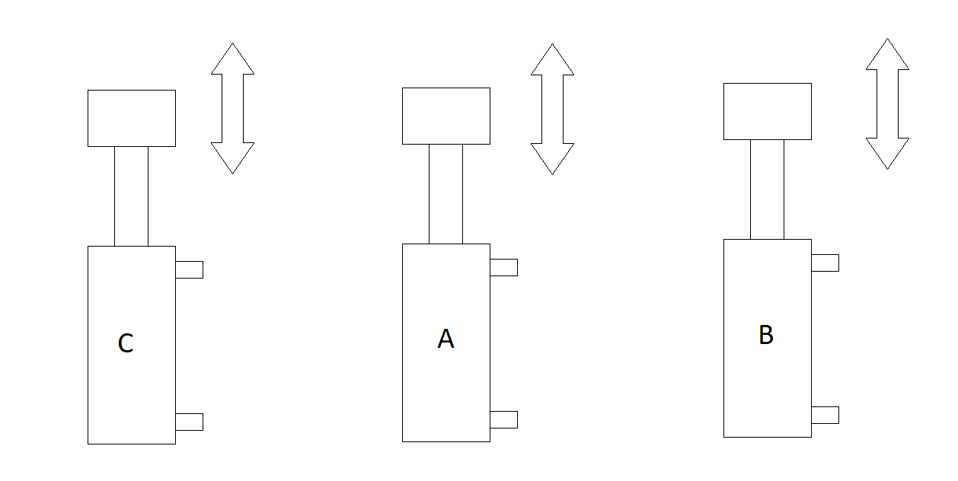
Step 3:
DAC C advancing step is designated as C+ DACs A and B advancing steps are designated as AB+ DAC A, B and C retracting steps are designated as ABC-
The sequence for this circuit is C+AB+ABC-
Step 4:
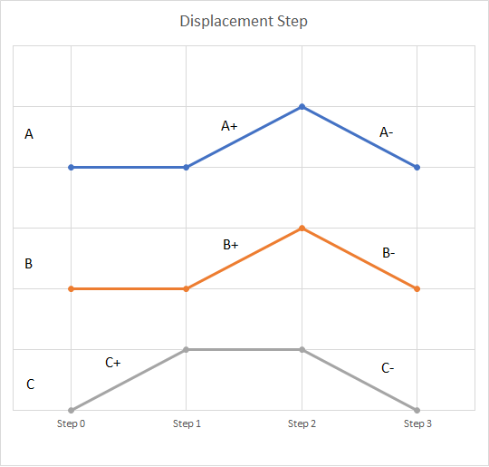
Step 5:
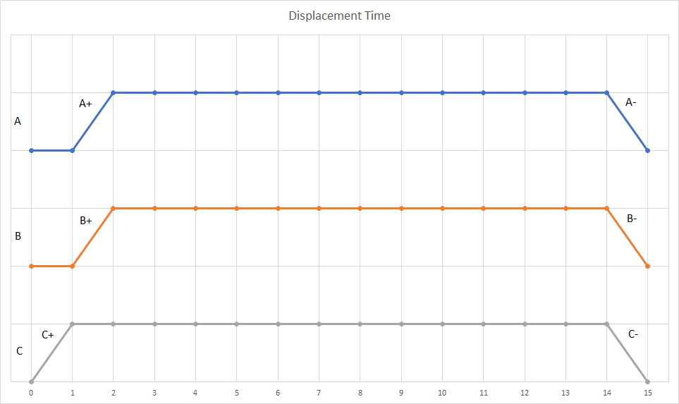

Step 6:
Input Signals
Cylinder A – Limit switch at position A1 (Fully extended) Cylinder A – Limit switch at position A0 (Fully retracted) Cylinder B – Limit switch at position B1 (Fully extended) Cylinder B – Limit switch at position B0 (Fully retracted) Cylinder C – Limit switch at position C1 (Fully extended) Cylinder C – Limit switch at position C0 (Fully retracted)
Output Signals
Forward motion of cylinder A (A+) Return motion of cylinder A (A-) Forward motion of cylinder B (B+) Return motion of cylinder B (B-) Forward motion of cylinder C (C+) Return motion of cylinder C (C-)
A start signal is usually required to start the process
- C+ action causes C1 position which starts A+ and B+
- A+ and B+ causes B1 and A1 position which starts timer T
- Timer T outputs signal A-B-C- (simultaneously) causing positions A0 B0 C0
- Position C0 causes output signal C+
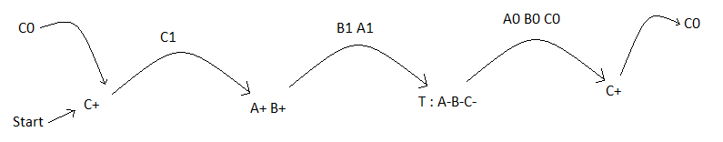

Pneumatic Designs OFT2 – Steps 7, 8, 9
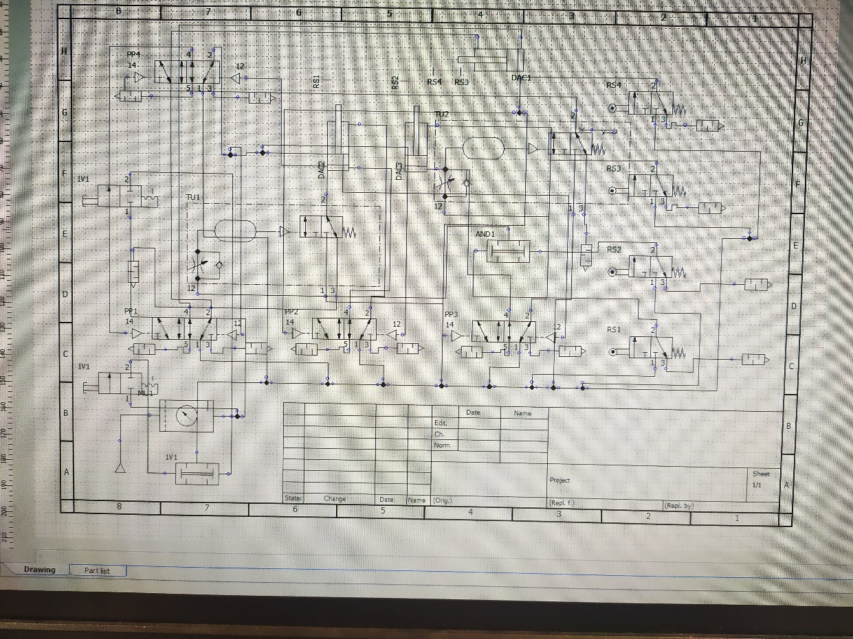
Through addition of AND gates and 2 timer circuits a conflict appeared from the finishing of one cycle and beginning of the next. The circuit was not automated because of this.
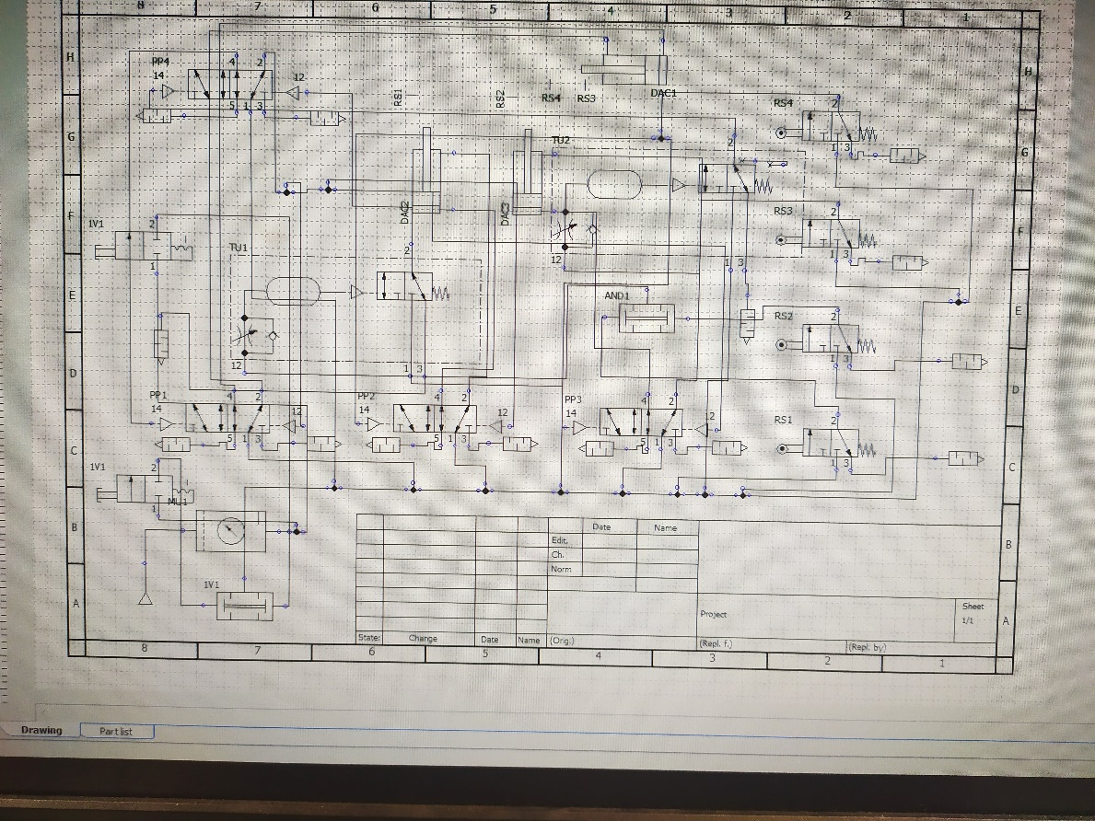
Various additions and removals were made to the circuit but problems kept appearing at the same point.
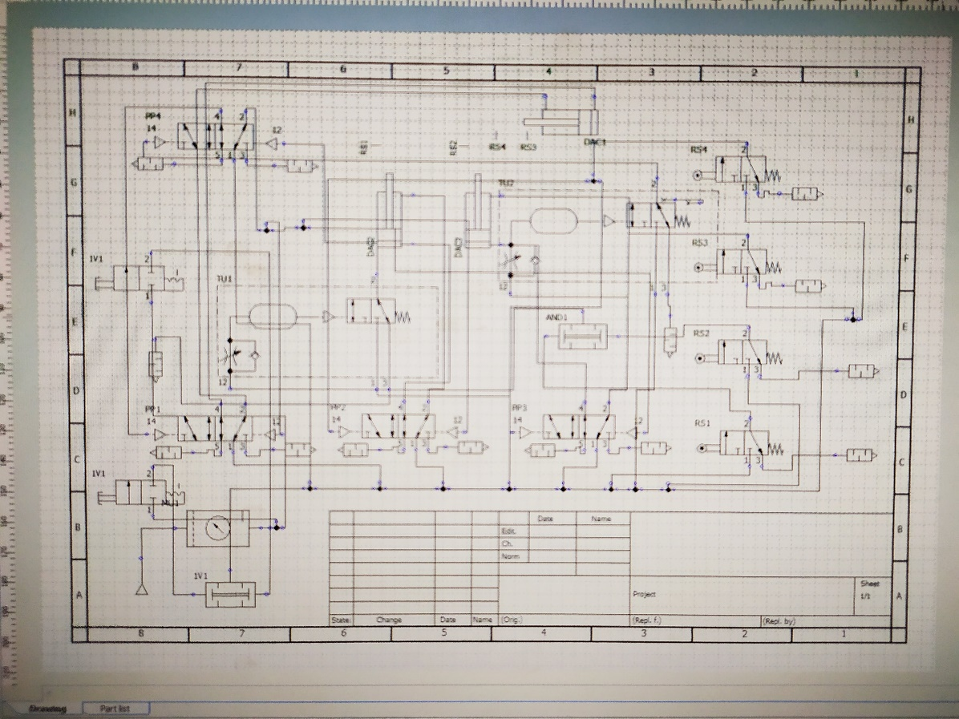
Failsafe’s were added as switches to start but these only overcomplicated the design creating conflicts between the pilot-pilot valves.
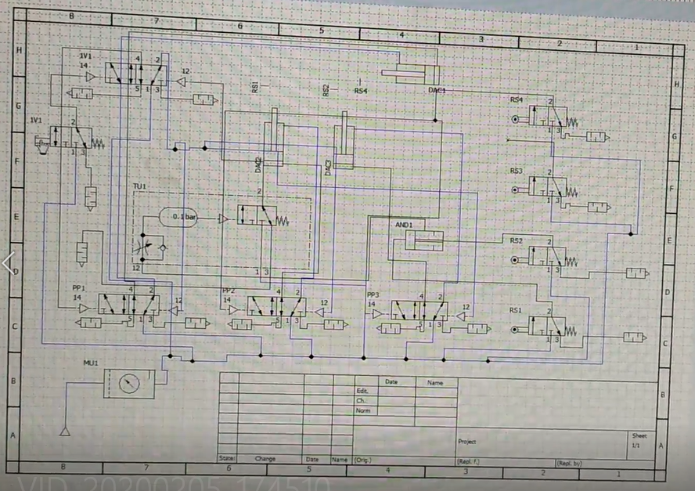
A simplified design was created that removed any extra switches, timer circuits or AND gates. The design worked better but the cycle was too quick.
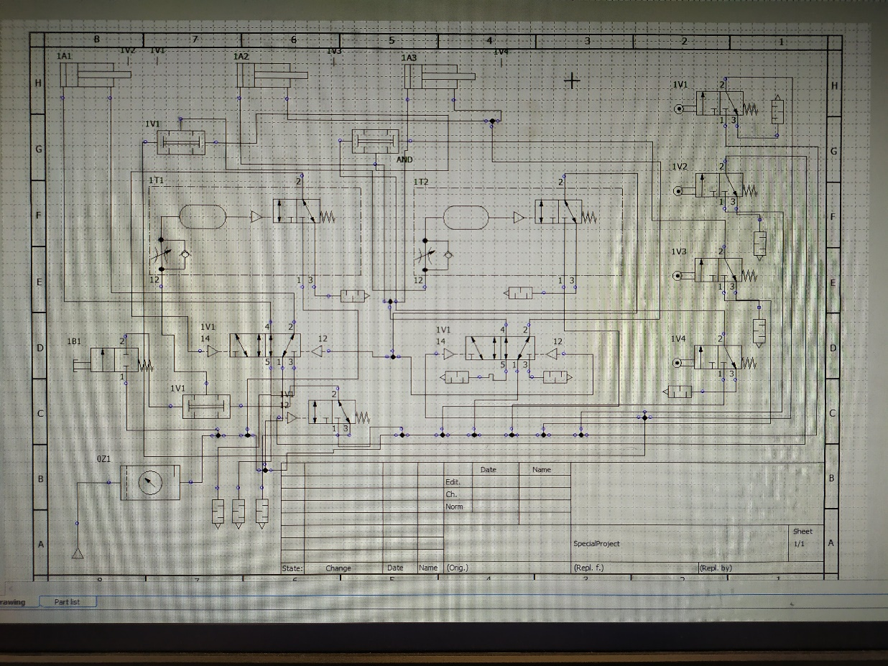
A final design was created as a mixture between the two previous designs. It automated well between cycles but an effect within the program was causing valves to move at different speeds.

Pneumatic Design Mechatronics – Steps 7, 8, 9
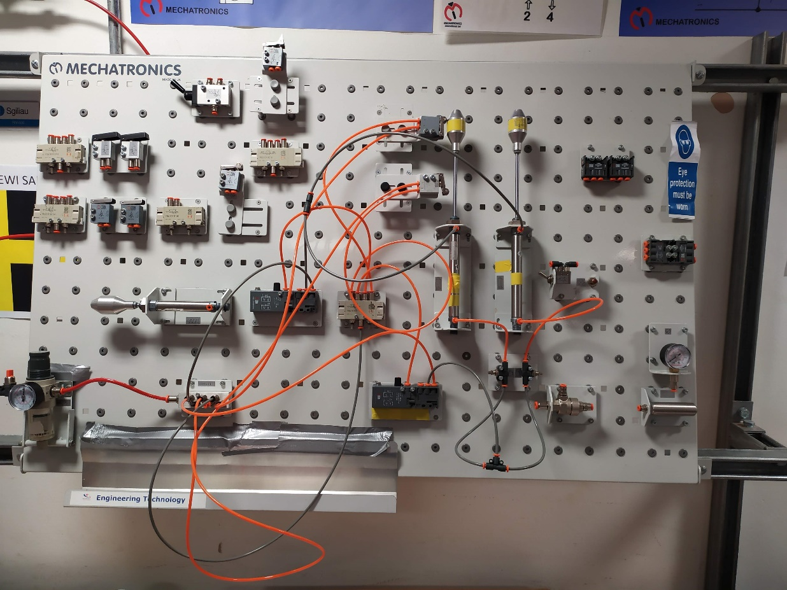
The design was built on the mechatronics rig using 2 roller motion valves, 2 timer circuits and a flow control valve. It was found to be difficult to regulate the flow control correctly between the valves.

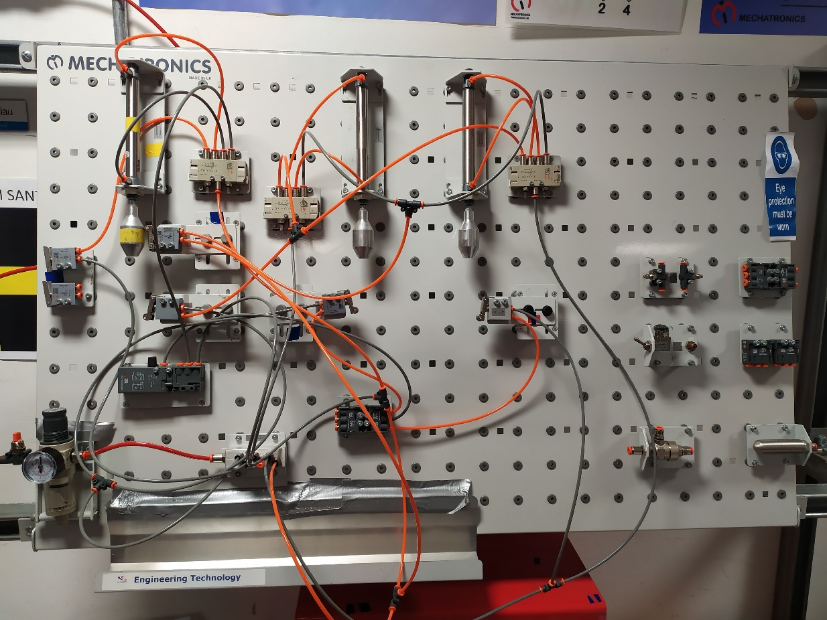
The next design was built with the extra double acting cylinder, 4 roller motion and an AND gate. The 2 roller motion valves on the guarding cylinder were conflicting against each other.
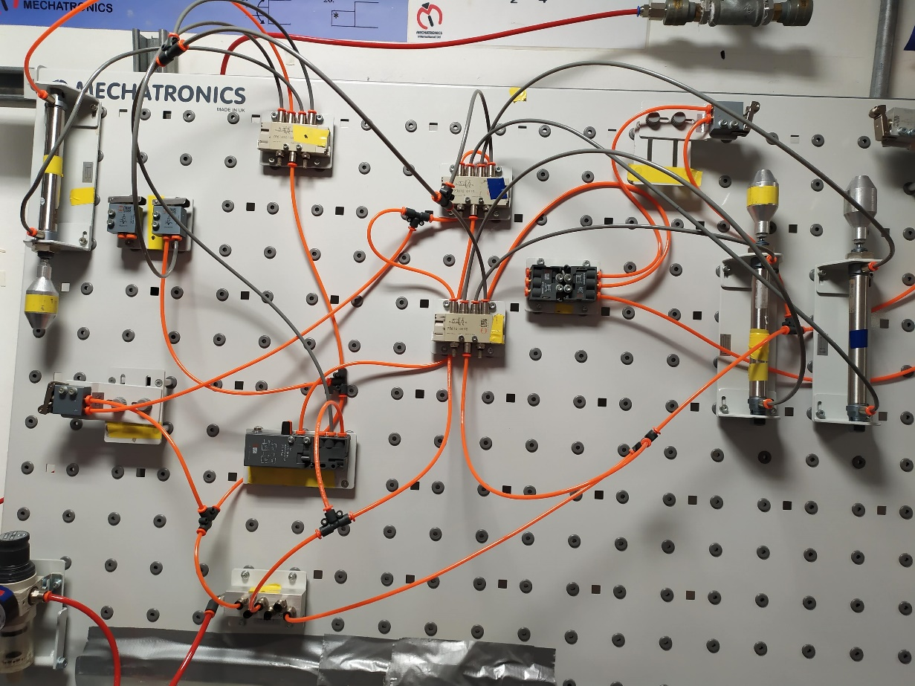
By removing a roller motion valve and push switch, then adjusting the timing circuit, the cycle worked correctly with no automation or conflict issues.

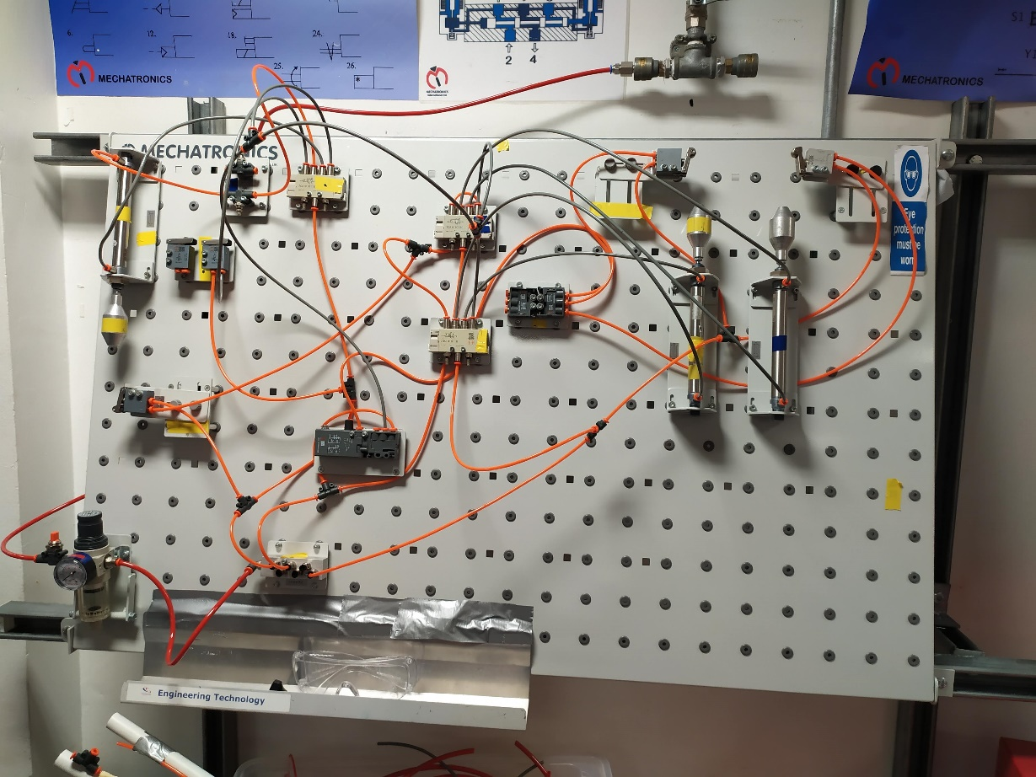

Electro-Pneumatic Design OFT2 – Steps 7, 8, 9
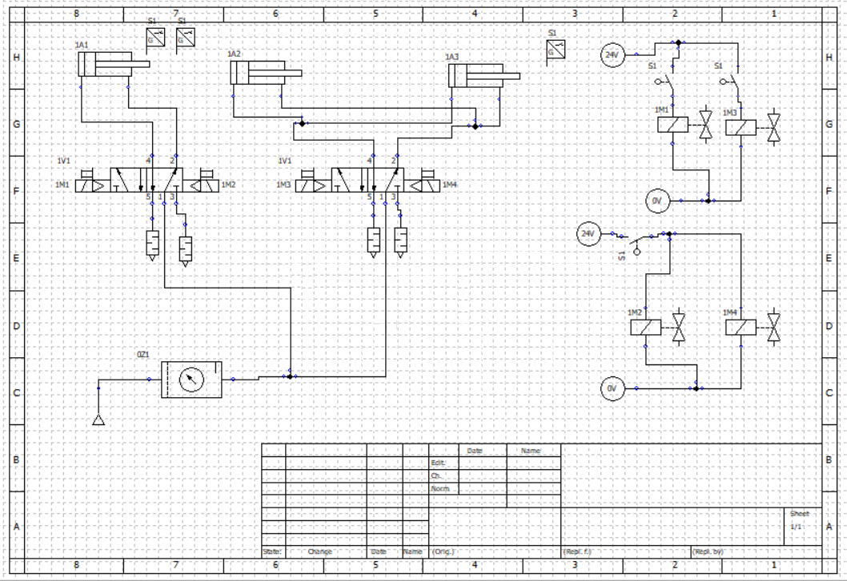
The design allows for 1 switch to start the process, moving the guarding then the other 2 cylinders. Another switch is then pressed 12 seconds later to allow all cylinders to retract. The initial part is facilitated by end position switches although an issue with timer delayed relays caused a conflict.
Electro-Pneumatic Design Mechatronics – Steps 7, 8, 9
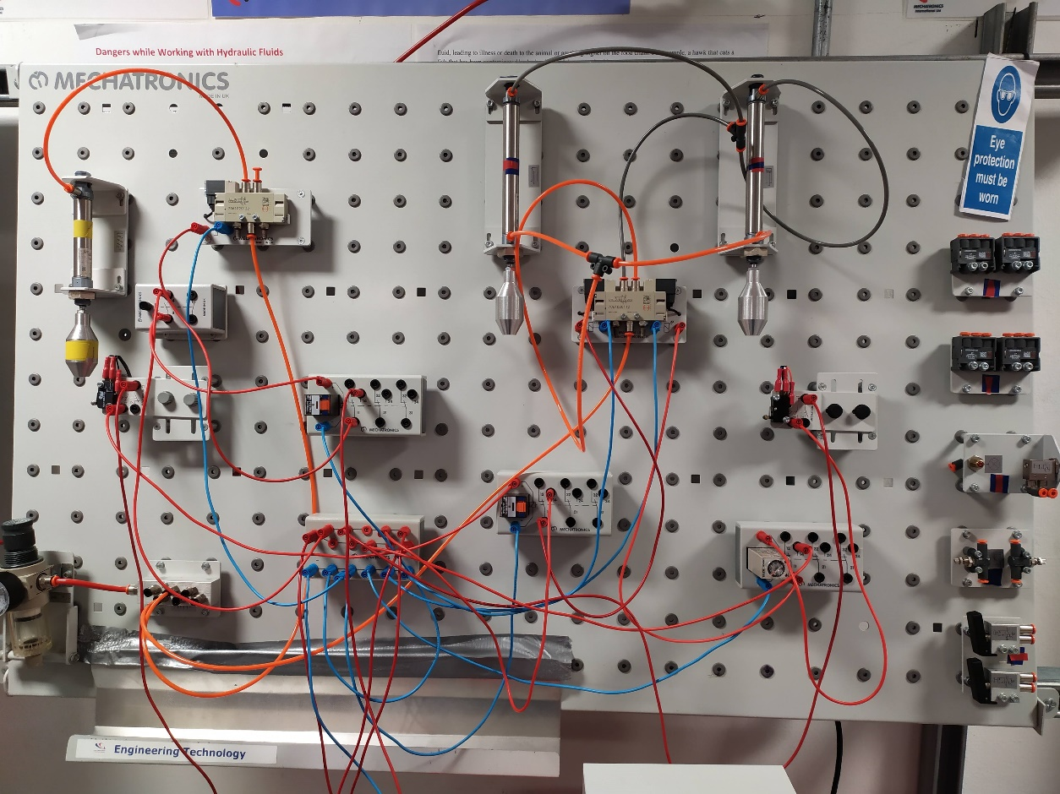
This was ported to the mechatronics rig using the electro pneumatic equipment.
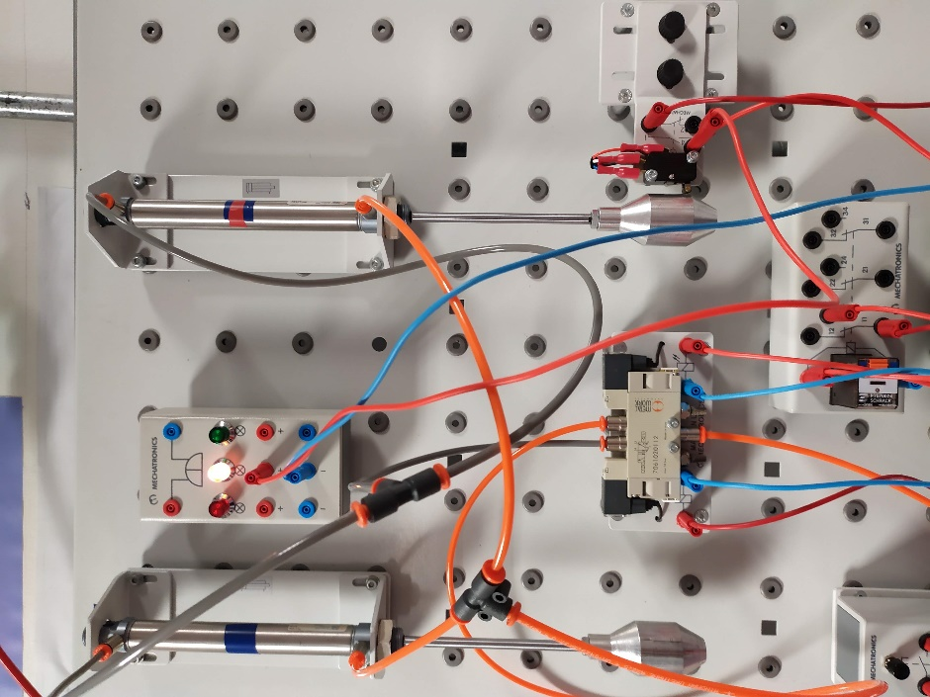
Lamps were used to alert the user when the guarding was in place, so that the second stage (mobile heating) could be initiated.

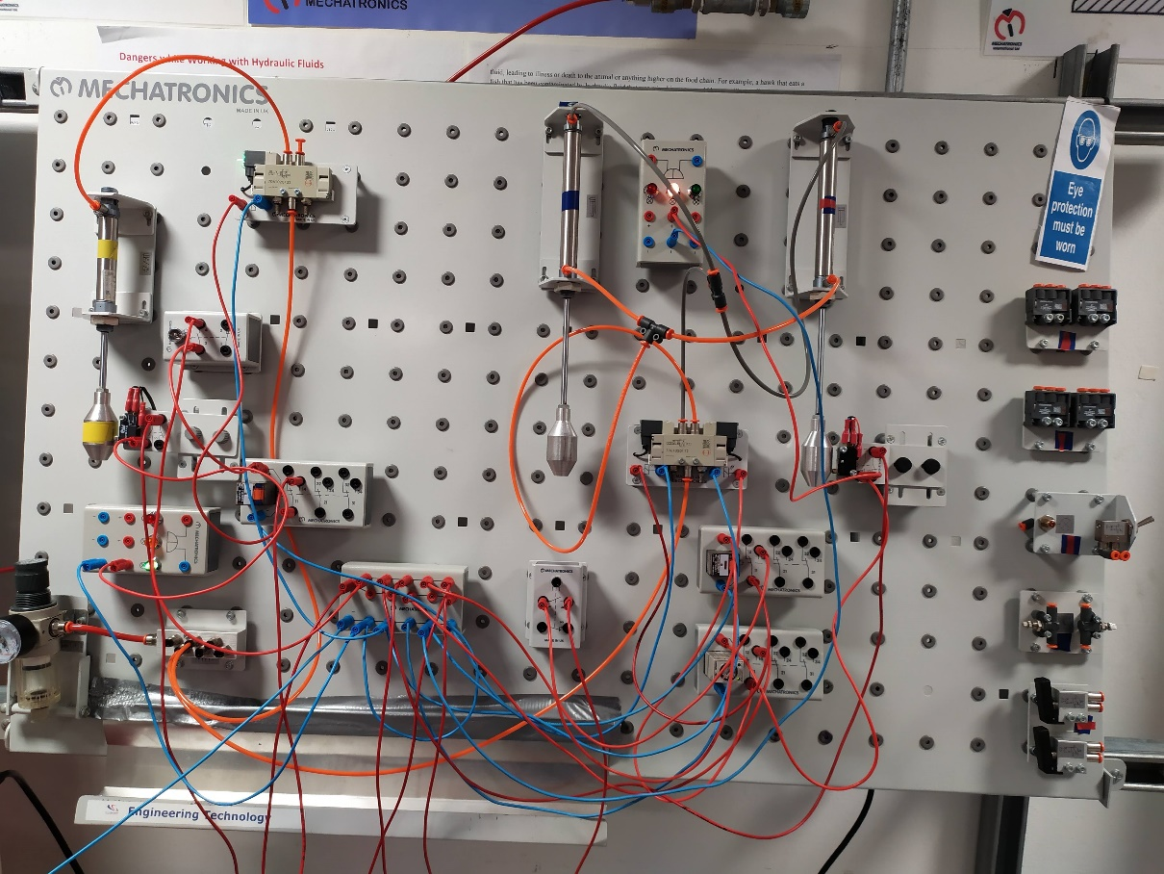
Another lamp notifies the user that the mobile heating element is in place and is counting to 12 seconds. At the end of the cycle both lamps switch off and the cylinders retract notifying the user that the cycle has finished. A push button is required for each cycle. The circuit has been designed successfully.

Costings
Part Number | Item | Quantity | Price £ | Total £
M210007 | 25 x 100 DAC | 2 | 131.39 | 262.78
M210009 | 20 x 100 DAC | 1 | 121.83 | 121.83
M220005 | 5/2 Valve Solenoid/Solenoid | 2 | 194.03 | 388.06
M210073 | 4mm Tubing 30m | 1 | 20.64 | 20.64
M220027* | Electrical Distribution Module | 3 | 98.38 | 295.14
M220023* | Relay Module | 2 | 127.17 | 254.34
M220025* | Timer Relay Plug | 1 | 72.22 | 72.22
M220029 | Cable Set Red | 1 | 147.85 | 147.85
M220030 | Cable Set Blue | 3 | 70.38 | 211.14
M210097 | Compressor | 1 | 669.76 | 669.76
M220031 | Power Supply | 1 | 260.00 | 260.00
M220026* | Electrical Indicator Module | 2 | 198.11 | 396.22
M220022* | Toggle Switch | 1 | 96.20 | 96.20
M220021* | Push Button | 1 | 93.82 | 93.82
M210082 | 4mm T Connector | 2 | 2.95 | 5.90
M210083 | Push in Plug | 1 | 0.77 | 0.77
MTP2010 | Large Building Panel | 1 | 411.01 | 411.01
M210058 | Filter/Pressure Regulator | 1 | 132.82 | 132.82
M210057 | Quick Exhaust Valve | 1 | 39.00 | 39.00
M210062 | 6 Way Manifold | 1 | 141.59 | 141.59
M210074 | 6mm Tubing 10m | 1 | 12.16 | 12.16
M210084 | Tube Cutter | 1 | 15.60 | 15.60
M210087 | Valve Baseplate 80mm x 60mm | 1 | 14.00 | 14.00
M210092 | Mounting Peg M | 64 | 1.62 | 103.68
MSTEP02* | Tutor Kit – Electro Pneumatics | 1 | 1568.32 | 1,568.32
Grand Total |  |  |  | £ 5,734.85
(Mechatronics International 2015 Price List, 2015) *Items may be duplicated as content unknown

References

fluidsys, V., 2020. How To Develop Multiple-Actuator Pneumatic Circuits Using The Cascade Method?. [online] FLUIDSYS TRAINING CENTRE. Available at: <https://fluidsys.org/2017/09/05/development-of-multiple-actuator-pneumatic-circuits-using-cascade-method/> [Accessed 20 April 2020].
Mechanicalengineering120.files.wordpress.com. 2020. [online] Available at: <https://mechanicalengineering120.files.wordpress.com/2017/11/lecture-40_multi-actuator-circuits.pdf> [Accessed 20 April 2020].
2015. Mechatronics International 2015 Price List.

