What shared experiences and common challenges do peripatetic singing teachers face during initial vocal lessons in mainstream secondary education settings?

An investigation into how teachers perceive school singing and the progression route of developing singers in mainstream education.

Contents Page
Project Proposal 4
List of figures and tables 1
Project Report
Introduction 3
Literature Review 3
Methodology and Methods 6
Presentation of Findings and Analysis 10
Questionnaire Analysis 10
Primary Teacher – Research Questionnaire Analysis 1
Secondary Music Lead - Research Questionnaire Analysis………………………….
Interview Analysis
Cross-referenced Analysis of Data
Conclusion 37
References
Report Appendices 38
Appendix 1: ‘Social Science Research Guide’ by Blackman and Moon (2014)
Appendix 2: Summary of the enabling ethical governance at different stages of research
Appendix 3: Primary Teacher - Research Questionnaire
Appendix 4: Secondary Music Lead - Research Questionnaire
Appendix 5: Interview Information and Consent Form
Appendix 6: Interview Topic Guide
Appendix 7: Researcher Approach to Transcript Edits
Appendix 8: Ethics Approval Form
Appendix 9: Workplace Approval Form - signed

Additional appendices (see attached folder):
Appendix 10: Primary Questionnaire - Blank Copy
Appendix 11: Primary Questionnaire - Completed Forms with consent
Appendix 12: Primary Questionnaire - All Responses
Appendix 13: Primary Questionnaire - Data Analysis
Appendix 14: Secondary Questionnaire - Blank Copy
Appendix 15: Secondary Questionnaire - Completed Forms with consent
Appendix 16: Secondary Questionnaire - All Responses
Appendix 17: Secondary Questionnaire - Data Analysis
Appendix 18: Interview Information and Consent Forms - signed
Appendix 19: Highlighted Interview Transcripts
Appendix 20: Interview Thematic Analysis

Project Proposal

Context:
Hull Music Service’s primary school singing provision is delivered through large group or whole class tuition. One-to-one and small group singing lessons are offered in secondary settings. Therefore, a direct focus on students’ individual singing ability is not commonly addressed prior to the transition into KS3, where a drop in singing engagement is widely acknowledged (Cyster, 2012; Marshall and Hargreaves, 2007; Poole, 2019). This research will explore the question:
What are the shared experiences and common challenges faced by peripatetic singing teachers when teaching beginner students in mainstream secondary education settings?
Research will be conducted with teachers from the music services and schools within the Humber Music Hub.
Throughout the research the following terms and definitions will be used:
Peripatetic lessons: Weekly, 20 - 30 minute, individual/small-group (2 - 4) lessons delivered by a music service teacher.
Initial singing ability: knowledge, understanding and skills demonstrated in the first ten weeks of lessons.

Justification:
Much of the literature regarding teaching singing in mainstream education, focuses on the viewpoints of students (Kokotsaki, 2017; Legg, 2013), schoolteachers (Finney, 2000; Morris-Campbell, 2022) and music specialists (Lamont, Daubney and Spruce, 2012; Mills, 2000). The perspectives of peripatetic singing specialists in mainstream education and the impact that prior pedagogical approaches have on their students, is less closely examined. As a previous primary school teacher, and current music service teacher, the researcher has a multi-faceted experience of teaching singing through different roles and across all key stages. This study will examine teachers’ perspectives from three differing viewpoints.

Intended Impact:
The research aims to gain knowledge to address ‘real-world issues’ (Gurgevich, Hyman and Alter, 2019) by highlighting potential correlating factors in the challenges faced by peripatetic singing teachers and consider the impact that pedagogical decisions have on the individual ability of students learning to sing. The findings will lead to reflective evaluation of current provision, and inform future practice and support offered to schools.

Outlined Intention:
The methodology of this study will follow a relativist ontological view; built on intersubjective perspectives of the researcher and participants. The methods will follow a pragmatic design with problem solving at the core (Morgan, 2007; Winter, 2021). For the purpose of inquiry, a reflective journal will document the researcher’s initial questions arising from observation and reflection of practice. A literature review will examine existing research, consolidate findings, highlight relevant themes and identify gaps ( Snyder, 2019; Walliman, 2001), forming a continuing point of reference within the report. Initial data gathering will focus on collecting variable, descriptive data, through open interviews conducted with peripatetic singing teachers using purposive sampling. Use of open-ended questions will enable more complex answers regarding the perceived initial ability of students and common challenges faced within their practice, allowing analysis of emerging themes and common factors. Subsequent mixed-methods questionnaires will be distributed to secondary school music teachers and primary teachers using quota sampling. Closed question responses will be standardised using a Likert scale to explore common practice when teaching singing; open-ended questions will enable further detail of pedagogical approach (Walliman, 2001). Quantifiable questionnaire responses will be statistically analysed to identify the central tendency and assess for relationships. Thematic analysis (Braun and Clarke, 2006) will be used across the collected data through response analysis, transcript summaries and coding to search for possible patterns, themes and relationships (Saunders, Lewis and Thornhill, 2019). The findings will be consolidated into a written report and presentation. Due to the qualitative nature of the research, triangulation of mixed methods will strengthen the validity of findings and allow more detailed analysis (Jick, 1979; Walliman, 2001).

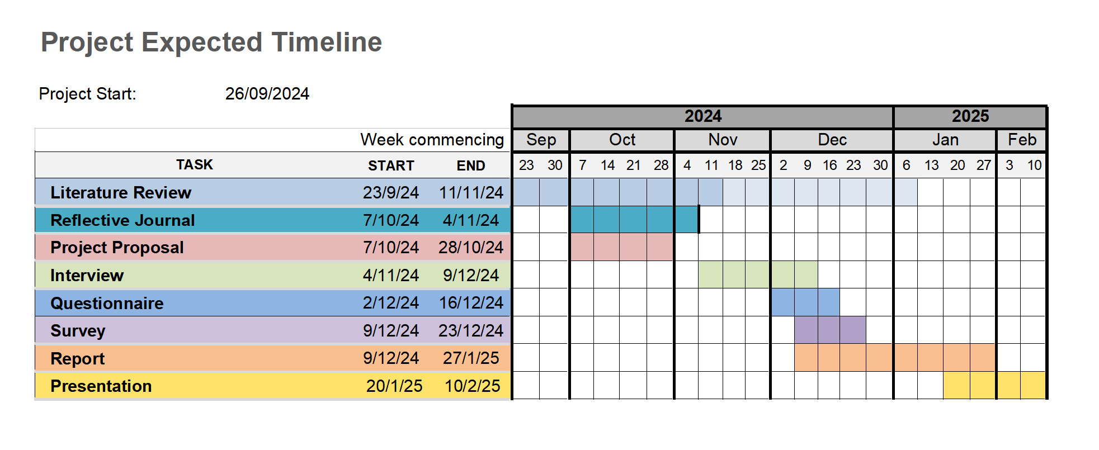

Ethics and Insider Research:
The research is motivated by a desire to inform and enhance practice (Berg, 2001). The prospect of bias will be accounted for and transparency will be integral to ensure that the research is valid (Cohen, Manion and Morrison, 2009). Participants will be informed of the nature of the research prior to giving consent. Participation will be voluntary and can be stopped at any time. Questions asked will remain objective and impartial towards bias. The use of open-ended questions will allow unplanned information to be given. Survey and questionnaire responses will be anonymous and interview transcripts will be coded to ensure participants are unidentifiable. Knowledge of the environment to be researched will be valuable in the design of the questionnaires and interviews (Bonner and Tolhurst, 2002).

Personal Learning Outcomes:
- Build awareness of existing literature on teaching singing in school by conducting a literature review
- Improve analysis skills of qualitative data
- Develop reflective practice through triangulation of the differing perspectives within the work setting.

References:
Berg, B.L. (2001) Qualitative Research Methods For The Social Sciences. Fourth. Needham Heights, MA: Allyn and Bacon.
Bonner, A. and Tolhurst, G. (2002) ‘Insider-outsider perspectives of participant observation’, Nurse Researcher, 9(4), pp. 7–19. Available at: https://doi.org/10.7748/nr2002.07.9.4.7.c6194.
Braun, V. and Clarke, V. (2006) ‘Using thematic analysis in psychology’, Qualitative Research in Psychology, 3(2), pp. 77–101. Available at: https://doi.org/10.1191/1478088706qp063oa.
Cohen, L., Manion, L. and Morrison, K. (2009) Research methods in education. 6. ed., reprint. London: Routledge.
Cyster, D. (2012) ‘Striking the right balance: issues of transition for the beginner secondary music teacher’, British Journal of Music Education, 29(3), pp. 293–301. Available at: https://doi.org/10.1017/S0265051712000368.
Finney, J. (2000) ‘Curriculum Stagnation: The case of singing in the English National Curriculum’, Music Education Research, 2(2), pp. 203–211. Available at: https://doi.org/10.1080/14613800050165659.
Gurgevich, E.A., Hyman, D. and Alter, T.R. (2019) ‘CREATION OF UNISCOPE: A MODEL FOR REWARDING ALL FORMS OF SCHOLARSHIP’, Online Learning, 7(2). Available at: https://doi.org/10.24059/olj.v7i2.1849.
Jick, T.D. (1979) ‘Mixing Qualitative and Quantitative Methods: Triangulation in Action’, Administrative Science Quarterly, 24(4), p. 602. Available at: https://doi.org/10.2307/2392366.
Kokotsaki, D. (2017) ‘Pupil voice and attitudes to music during the transition to secondary school’, British Journal of Music Education, 34(1), pp. 5–39. Available at: https://doi.org/10.1017/S0265051716000279.
Lamont, A., Daubney, A. and Spruce, G. (2012) ‘Singing in primary schools: case studies of good practice in whole class vocal tuition’, British Journal of Music Education, 29(2), pp. 251–268. Available at: https://doi.org/10.1017/S0265051712000083.
Legg, R. (2013) ‘Reviewing the situation: a narrative exploration of singing and gender in secondary schools’, Music Education Research, 15(2), pp. 168–179. Available at: https://doi.org/10.1080/14613808.2012.737774.
Marshall, N.A. and Hargreaves, D.J. (2007) ‘Crossing the humpback bridge: primary–secondary school transition in music education’, Music Education Research, 9(1), pp. 65–80. Available at: https://doi.org/10.1080/14613800601127536.
Mills, J. (2000) ‘Secondary singing inspected’, British Journal of Music Education, 17(1), pp. 61–66. Available at: https://doi.org/10.1017/S0265051700000152.
Morgan, D.L. (2007) ‘Paradigms Lost and Pragmatism Regained: Methodological Implications of Combining Qualitative and Quantitative Methods’, Journal of Mixed Methods Research, 1(1), pp. 48–76. Available at: https://doi.org/10.1177/2345678906292462.
Morris-Campbell, A.L. (2022) Developing singing competence, confidence, motivation and self-identity for teaching music in the primary school. Professional Doctorate. Queensland University of Technology. Available at: https://doi.org/10.5204/thesis.eprints.228678.
Poole, L. (2019) The primary to secondary school transition: Continuity and participation in singing. UCL Institute of Education. Available at: https://www.researchgate.net/profile/Lucy-Poole-2/publication/344207289_The_primary_to_secondary_school_transition_Continuity_and_participation_in_singing/links/64e25b6014f8d1733812975f/The-primary-to-secondary-school-transition-Continuity-and-participation-in-singing.pdf (Accessed: 21 October 2024).
Saunders, M., Lewis, P. and Thornhill, A. (2019) Research Methods for Business Students. 8th end. Harlow: Pearson Education Limited. Available at: https://ebookcentral.proquest.com/lib/trinity/detail.action?docID=5774742# (Accessed: 28 November 2024).
Snyder, H. (2019) ‘Literature review as a research methodology: An overview and guidelines’, Journal of Business Research, 104, pp. 333–339. Available at: https://doi.org/10.1016/j.jbusres.2019.07.039.
Walliman, N. (2001) Your Research Project: A Step-by-step guide for the first-time researcher. London: Sage Publications Ltd.
Winter, D. (2021) ‘UNDERSTANDING RESEARCH METHODS: FROM COACH TO PRACTITIONER RESEARCHER’, Voice and Speech Review, 15(1), pp. 76–88. Available at: https://www.tandfonline.com/doi/full/10.1080/23268263.2020.1843270.
Project Report

What shared experiences and common challenges do peripatetic singing teachers face during initial vocal lessons in mainstream secondary education settings?

An investigation into how teachers perceive school singing and the progression route of developing singers in mainstream education.

Introduction
Despite the prominent position of singing within the statutory UK national curriculum for music for music (DfE, 2021b), research indicates persistent challenges related to teacher confidence and the establishment of a positive singing culture in schools, particularly during the transition from primary to secondary education (Cyster, 2012; Kokotsaki, 2016; Marshall and Hargreaves, 2007; Poole, 2020). As a core element across Key Stages 1, 2 and 3, singing has been the subject of considerable research over many years (Cooksey and Welch, 1998; Daubney, Spruce and Annetts, 2019; Hughes, 2008; Finney, 2010; Ashley, 2014; Savage, 2020).
As a music service peripatetic singing teacher and singing lead, the researcher has experience of teaching as a singing specialist across primary and secondary settings in the UK. This is complemented by previous experience as a mainstream primary teacher and music coordinator, where they were responsible for the planning and delivery of singing as part of a whole school curriculum. This multi-faceted perspective provides valuable insight into the realities faced by both specialist and non-specialist teachers.
This study evaluates singing provision across three key educational phases through analysis of pedagogical practices and teacher perspectives. It explores the potential impact on students who choose to pursue specialist vocal tuition, through examination of peripatetic singing teachers’ experiences and challenges, and aims to raise awareness of current provision in response to questions raised by the Music Commission (2019):
[W]e want to see questions asked about where we are heading, how we support all learners to realise their potential and what we want music education to look and sound like over the next ten years (Music Commission, 2019, p. 22).
Finally, this study considers whether current practices enable all learners to reach their potential and reflects on recommendations for future research.

Literature Review
The field of singing and music education in UK schools has generated a significant amount of research, with focus on policy, practice and specialist knowledge. This review examines both scholarly publications and educational grey literature to allow analysis from the combined perspectives of researcher and teacher. Informed by Snyder (2019) and Walliman (2001), it examines existing research; identifies and explores key themes; highlights gaps in the current literature; and will serve as a continued point of reference throughout this report.

School singing over the last 25 years
Since the start of the 21st century, numerous initiatives, reports, and policies on music education have been released. A key contribution, The National Plan for Music Education (NPME) The Importance of Music, (DfE, 2011), aspired to enhance music education through a coordinated approach across schools, local authorities, music services/hubs, organizations, and educators. Despite positive progress across many areas, the subsequent 2022 NPME, The Power of Music to Change Lives identified that “more needs to be done” (HM Government, 2022, p5)
In 2006, the Music Manifesto report, Making Every Child’s Music Matter (2006), identified singing as a key priority in music education. This led to the 2007 National Singing Programme (Sing Up) which aimed to establish a 'Singing School' culture, with weekly singing for all primary children in England. By 2011, Sing Up had engaged over 96% of state primary schools in the programme (Sing Up Ltd, 2011, p. 6). Research reported positive impacts on students, which included advanced development, increased positivity towards singing and improved self-image (Welch, et al., 2010, p. 29). However, despite the increased profile and enjoyment of singing, the quality and quantity of provision in schools remained inconsistent (Ashley, 2015; Music Commission, 2019; Savage, 2020). This prompted the researcher to question: What does 'singing' mean? What should we expect from school singing pedagogy?
What is ‘singing’?
Ashley (2015) categorised singing into three contexts; choral work, vocal work and 'just singing' (Ashley, 2015, p. 15 – 18). Choral work implied advanced instruction in musical knowledge and vocal technique. 'Just singing', in contrast, involved minimal instruction: students join in to learn the melody and lyrics. Vocal work, centred on the voice as an instrument and the main vehicle for wider musical tuition. Turton and Durrant (2002), in their study on adult recollections of singing in secondary school, found that all participants viewed school singing as fundamentally worthwhile and emphasised the importance of “vocal training and development rather than just having a singalong” (Turton and Durrant, 2002, p. 47). Reported positive reflections included increased confidence, enjoyment, and sense of communal identity; however, negative experiences were primarily attributed to the teacher. The study highlighted the importance of teacher attitude, expertise, and further professional development opportunities in singing and choral conducting, which raises the question: Does the current teacher training provision impart the knowledge and skills needed for vocal instruction to ensure it is more than 'just singing'?
Teacher Training in the UK
The topic of teacher training is a noted issue in the literature (Cooksey & Welch, 1998; Finney, 2010; Lamont et.al. 2012; Morris-Campbell, 2022). Furthermore, the limited time allocated to primary music within teacher training programmes is a recurrent concern (Ashley, 2015; Daubney, Spruce and Annetts, 2019; Downing et al. 2003).
A historical perspective on teacher training practice is provided by Cox (2005), who reviewed methods in England, Wales and Scotland from 1883 - 1899. Annual reports by the "Inspector of Music", Sir John Stainer, documented rigorous instruction in music and singing, which included tests in aural, note reading, music theory, and song performance skills. In contrast, a review of recent music reports published between 1998 – 2004, revealed a disparity in provision, which was noted as ‘ambiguous’ (Cox, 2005, p.25). Despite evidence of good practice, inconsistent levels of teacher confidence and expertise are reported, with music described as a subject “feared” by some generalist teachers (Downing et al. 2003, p.26). This evidence prompted Cox to ask: "Should we expect generalist teachers to teach singing or is it better suited to specialists?" (Cox, 2005, p.26).

Generalists versus Specialists
The debate surrounding specialist versus generalist teachers in music education is explored by Mills (2005, p. 27 – 31), who outlines typical role expectations: secondary music teachers are usually expected to be a specialist, whereas primary music is more commonly taught by generalist teachers. Whilst subject expertise is acknowledged as valuable, the presumption that ‘specialist’ teachers deliver superior lessons is challenged by Mills, who notes that more effective planning, classroom management and delivery may be a strength of regular class teachers. Moreover, generalist practitioners, Mills claimed, demonstrate that all subjects are accessible to all students, regardless of natural disposition.
A broader perspective is adopted by Lamont et al. (2012), who identified supportive staff, committed teachers, and access to specialists as key factors contributing to successful school singing. However, the paramount importance of specialist vocal training is stressed by Phillips, Williams and Edwin (2012), who raised ethical concerns about singing instruction delivered by teachers who lack personal vocal training. The argument that “singing is a learned behaviour and not a “gift” for the privileged” (Phillips, Williams and Edwin, 2010, p. 10) asserts that all children deserve access to specialist instruction, regardless of background. The literature also reveals ongoing concerns about insufficient understanding of the child and adolescent voice (Ashley, 2013; Phillips, 1985); with the lack of a systematic, research-informed approach identified as a barrier to effective singing teaching (Ashley, 2013, p. 312; Mills, 2000, p.63).

Peripatetic teachers are acknowledged for their value (NPME, 2011, p.23) and described as “a vital part of the wider music education eco-system [who contribute] enormously to the pipeline of creative talent in our world-renowned music industry” (ISM, 2022, p. 3). Despite this, detailed research specifically focused on peripatetic vocal teachers in mainstream education settings appears to be limited.
In conclusion, this literature review confirms the recognised value of high-quality singing in schools and the critical role of teacher practice. Despite the contributions of a “hugely diverse music education workforce” (DCEM, DfE, 2011, p. 21) and a collaborative national vision for musical excellence (HM Government, 2022, p.2), implementation remains disparate across the UK. This research seeks to contribute towards a deeper understanding of the combined pedagogy of peripatetic, specialist, and generalist teachers and address the need for shared agendas to ensure all teachers provide the best possible musical education for their students (Gane, 1996, p. 65).

Methodology and Methods
Wyse et al. (2017) discussed the complex relationship between research, policy, and practice in education and identified accountability, professionalism and intellectual curiosity as driving forces behind research motivation (Wyse et al. 2017, p. 40). These incentives are key considerations to this study: the accountability to demonstrate that music service provision is an effective use of public funds; the professional commitment to ensure that practices result in the best outcomes for students; and the intellectual pursuit of a greater understanding of teachers’ roles within the landscape of music education.
Recognising the strong correlation between education research and social science (Hitchcock and Hughes, 1995), the methodology of this research was informed by the Social Science Research Guide (see appendix 1) as a template for its ontology, epistemology and theoretical perspective (Blackman and Moon, 2014, p.1169). This study, which originated from observations in practice and a desire for a deeper understanding, embodies “a reflexive loop” (Steier, 1991, p.163), in which the researcher acts as both inquirer and observer. With reflection at its core, the study follows a relativist ontology and constructionism/subjectivism epistemology and explores multiple realities through the intersubjective perspectives of teachers within a naturalistic inquiry.
To navigate the theoretical perspective, the following comparison table was used:
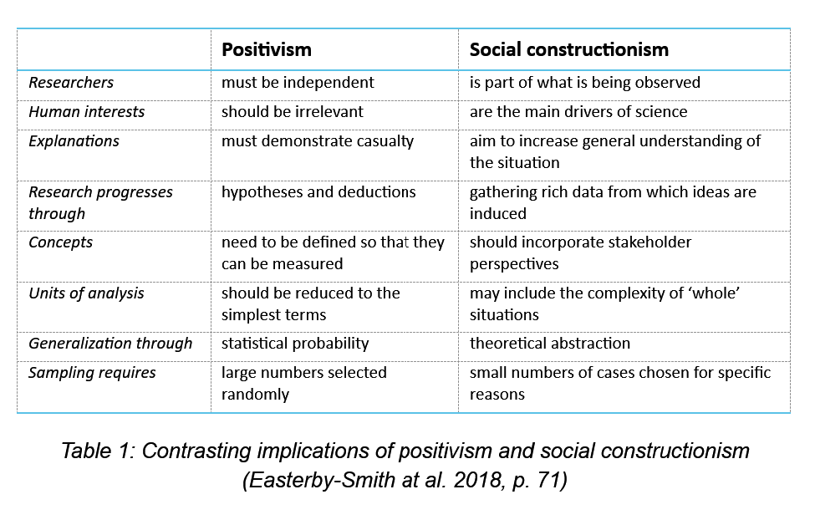

As the lived experience of teachers formed the body of research, the positivist quest for a ‘logical truth’ was unsuitable and multiple methods were needed to form a ‘valid belief’ (Blackman and Moon, 2014, p.1169). With “practitioner-based problems […] central to the research process”, this study sought understanding from which “strategies for change and development” may originate (Winter, 2020, p.3). To maximise the validity and value of the research, a pragmatic mixed-methods design was used in preference to one method, which could limit the potential of variable and descriptive data (Feilzer, 2010, p.13). To capture the diverse experiences and perspectives of teachers and ensure validity within a constructionist framework of multiple realities, this research employed a triangulation across qualitative and quantitative methods (Easterby-Smith et al. 2018, p.73).
The researcher first reflected on personal observations as the origins of reflection-in-action (Schӧn, 1983), using the Borton (1970) model:
- What?
- So what?
- Now what?
This introspective and critical evaluation of everyday situations included the enquiry of natural assumptions made by practitioners (Finlay, 2008) and informed the investigative nature of the literature review and data collection.
Subsequent interviews were conducted with peripatetic singing teachers, selected through purposive sampling from the researcher’s workplace, to explore their experiences teaching singing in mainstream school settings. The researcher, also the singing lead for the music service, recognised the potential influence of power dynamics on participant responses, as well as the constraints imposed by a highly structured interview format. In contrast, an unstructured approach, could risk too broad a discussion and irrelevant content. Therefore, inspiration was drawn from the ‘open interview’ approach. Grounded in feminist research, ethnography and narrative theory, this method was selected to empower participants to share their knowledge collaboratively (Robinson, Baron and Pottinger, 2021). Consequently, a semi-structured interview format was adopted with a topic guide provided to participants in advance. This identified key areas in current practice of relevance to the study and promoted reflection on the challenges and experiences associated with teaching initial singing lessons to new students.
Practical considerations and the necessary level of detail informed the interview transcription approach. Two methods were considered: a naturalist approach, which meticulously records both verbal and non-verbal interaction, and a denaturalist method, which focuses solely on core content and allows omissions of disfluencies (Widodo, 2014). Given the focus of the study on information content rather than communication style, and the presence of unintended interruptions and informal conversation in the workplace interview recordings, a denaturalist approach was adopted. Draft transcriptions were composed with Restream (Restream, Inc. 2025) and edited by the researcher using Express Scribe (NCH Software).
During the completion of the interviews, two separate, anonymised primary and secondary questionnaires were developed using Google Forms and piloted to avoid malfunctions and ensure question clarity. Questionnaire links were distributed via email to schoolteachers from within the music hub demographic, who were selected through quota sampling. A mixed-methods approach was employed to gather both measurable and descriptive data on practice, confidence, expertise, pedagogy, and school singing ethos. The questionnaires included multiple-choice, Likert scaling and open-ended questions to maximise the potential for unpredictable and original insights and therefore strengthen the validity of the research.
Systematic thematic analysis (Braun and Clarke, 2006) was applied across the collected data to examine the personal observations, interview transcripts and questionnaire responses. Codes were used to represent “interesting features” and form the “building blocks” of emergent themes (Clarke and Braun, 2016, p. 297). The flexible nature of this method, which can be utilised across multiple qualitative data types, facilitated the identification of both exact and implicit meanings and the interpretation of patterns.

Research began in September 2024 and initially planned to use sequential data collection, to allow each phase to inform the next. Unforeseen circumstances required adjustments; however, the personal observations and literature review provided a sufficiently comprehensive foundation for the interview and questionnaire design. Questionnaires were completed by 39 primary teachers and 11 secondary teachers. Of the planned five interviews, four were conducted due to scheduling difficulties. Although a larger sample of participants overall would have strengthened the validity of the research, the demanding schedules of teachers suggest that more time might not have significantly increased participation. In contrast, too many participants may have had implications on the data analysis timeframe.
Motivated by a desire to inform and enhance practice (Berg, 2001), this study prioritised transparency to mitigate potential bias and ensure validity (Cohen, Manion and Morrison, 2009). Ethical considerations guided by Sivasubramaniam, Dlabolová, Kralikova, et al. (2021, p.3) were incorporated at each stage (see appendix 2)
Prior to commencement, an ethics form and project proposal, adhering to the university and workplace policies, were submitted and approved. Participants were fully informed of the nature of the research and provided voluntary consent, with the right to withdraw clearly communicated. Interviews followed an open format, which allowed participants to guide their responses within suggested topic areas. Questionnaires were designed to be objective and impartial and included open-ended questions for additional information. Questionnaire responses were collected anonymously, and interview transcripts were coded to ensure participant and workplace anonymity. Consent was obtained before data collection, and all data was stored securely.

Presentation of Findings and Analysis

Questionnaire Analysis
Two questionnaires were published online using Google forms on 27/01/2025 to gather data on current primary and secondary school singing instruction. Potential participants were recruited through quota sampling, with invitations sent via email to schoolteachers within the researcher’s music hub. Following closure (23/02/2025), 39 primary and 11 secondary questionnaires were collected for analysis. While participation consent was mandatory, all other questions were optional and largely completed, with optional comments providing additional detail. A mixed methods approach was undertaken for data analysis with statistical analysis of quantitative data and thematic analysis of qualitative responses. The integration of both methods allowed a more comprehensive interpretation of the findings.

Primary Teacher – Research Questionnaire Analysis

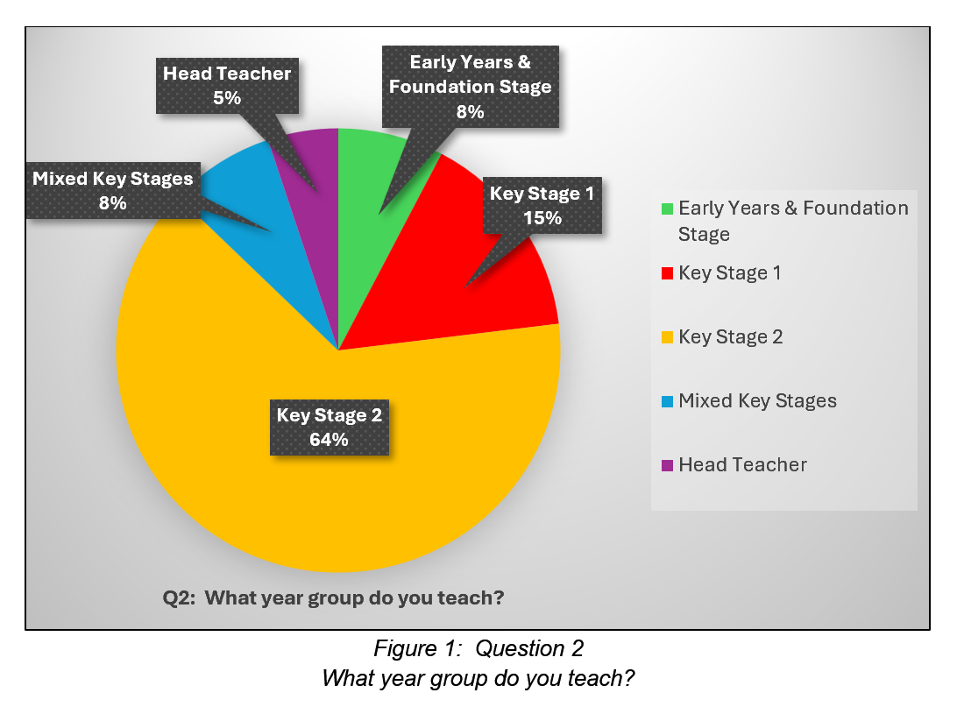

In response to the year group taught, 39 responses were recorded. The majority (64%) taught across Key Stage 2 (Years 3 – 6). 15% taught across Key Stage 1 (Years 1-2), 8% taught across Early Years and Foundation Stage (EYFS), and 8% taught mixed year groups. 5% of respondents were head teachers. Two respondents included choir lead and music lead responsibilities, which were not categorised separately from their teaching roles.

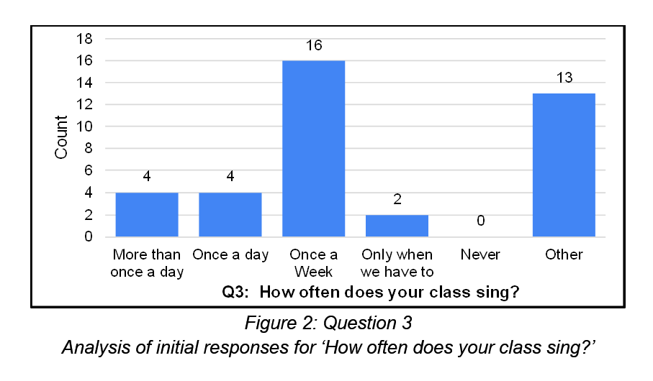
Of 39 responses, most classes sang weekly (16). Further analysis of 13 ‘other’ comments showed 11 sang more than weekly but not daily, and 2 only when required. With revised categories, ‘only when we have to’ and ‘only when needed in lessons’ both had 5%, 10% sang daily, 11% more than daily, and the majority (41%) sang weekly, consistent with the median and mode.
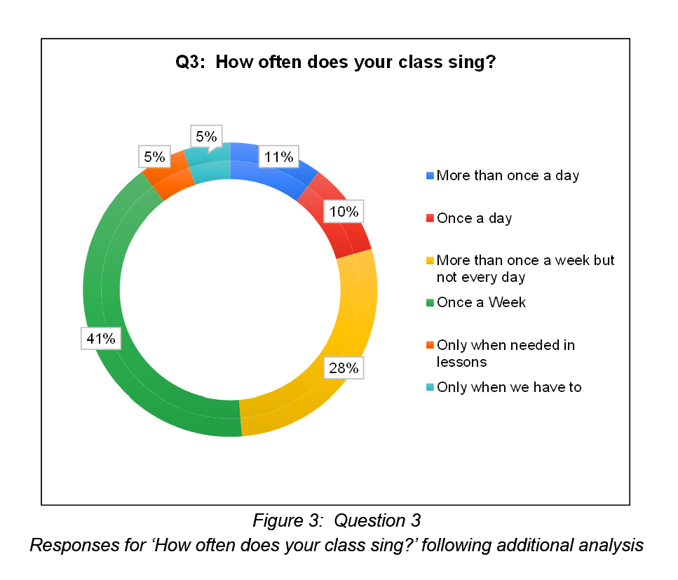
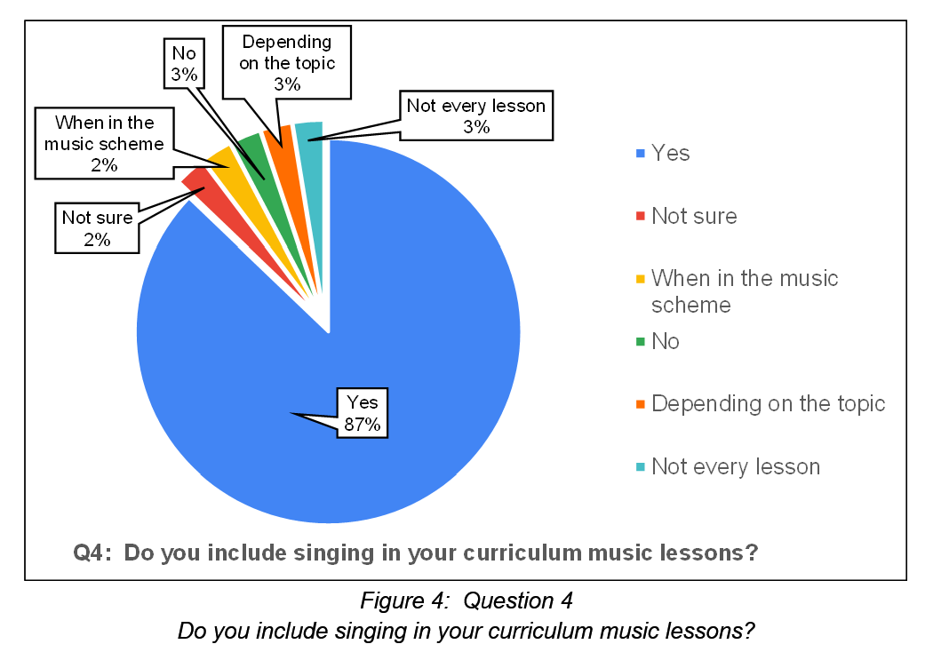
87% of 39 respondents incorporate singing in curriculum music lessons. The remaining respondents indicated that singing is included only when required in the scheme of work or topic (5%), is included but not in every lesson (3%), is not included (3%) or were unsure (2%).
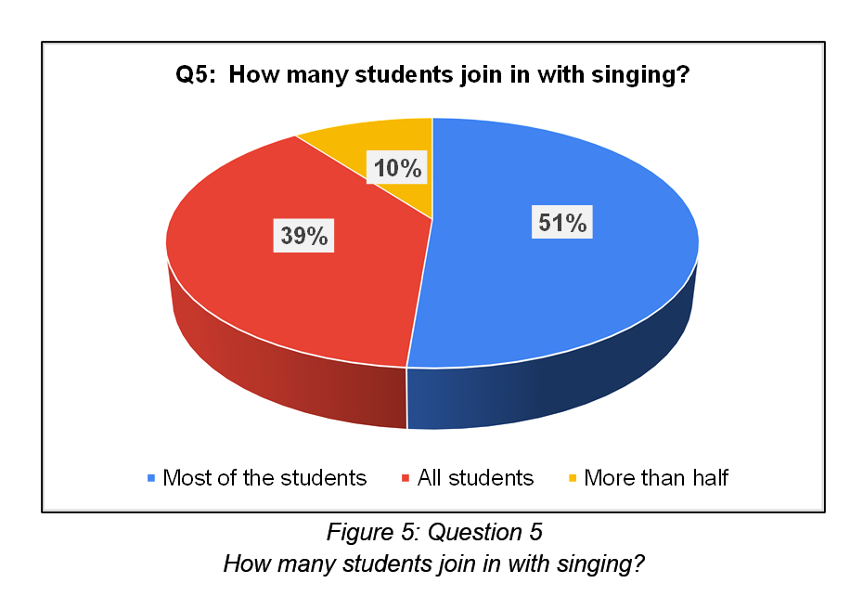
Student participation in singing was reported from the 39 participants as: most students (51%), all students (39%), and more than half (10%).
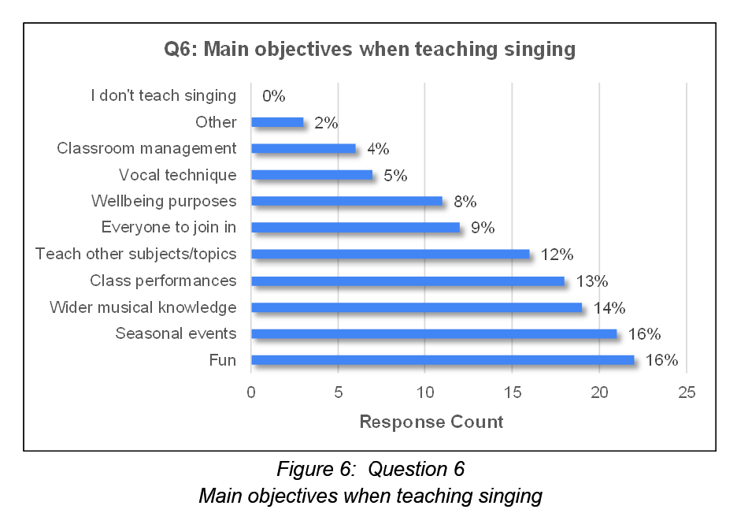

Respondents were asked to choose 3 of 11 provided objectives when teaching singing resulting in 135 responses. Analysis showed the most popular objectives were fun and seasonal events (both 16%), wider musical knowledge (14%), class performances (13%) and to teach other subjects/topics (12%). Less popular were participation (9%), wellbeing (8%), vocal technique (5%) and classroom management (4%). Additional comments (2%) included worship, enjoyment and breaktimes.

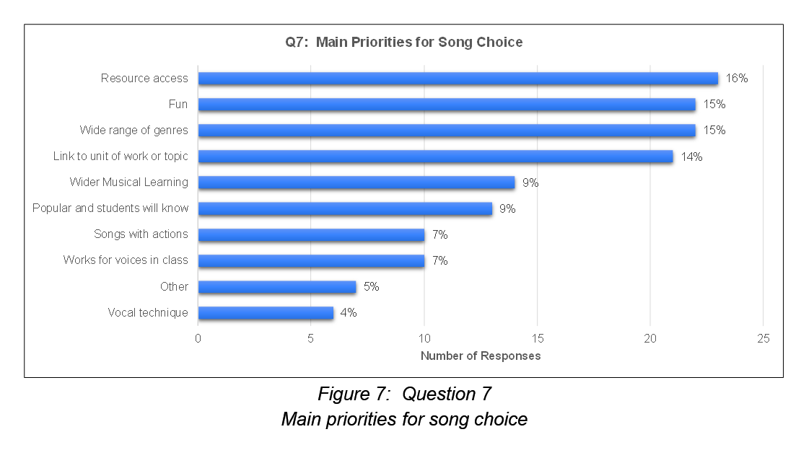
When asked for up to four priorities for song choice (out of 10), the 148 selections highlighted resource access (18%), fun and range of genres (both 15%) and links to a units/topic (14%) as the most common priorities. Wider musical learning and popularity each received 9%, action songs and songs suited to the class voices were both at 7%, and vocal technique at 4%. Other comments (5%) cited the need to follow MAT curriculum guidance, school resources and schemes of work. One respondent included self-composed songs.

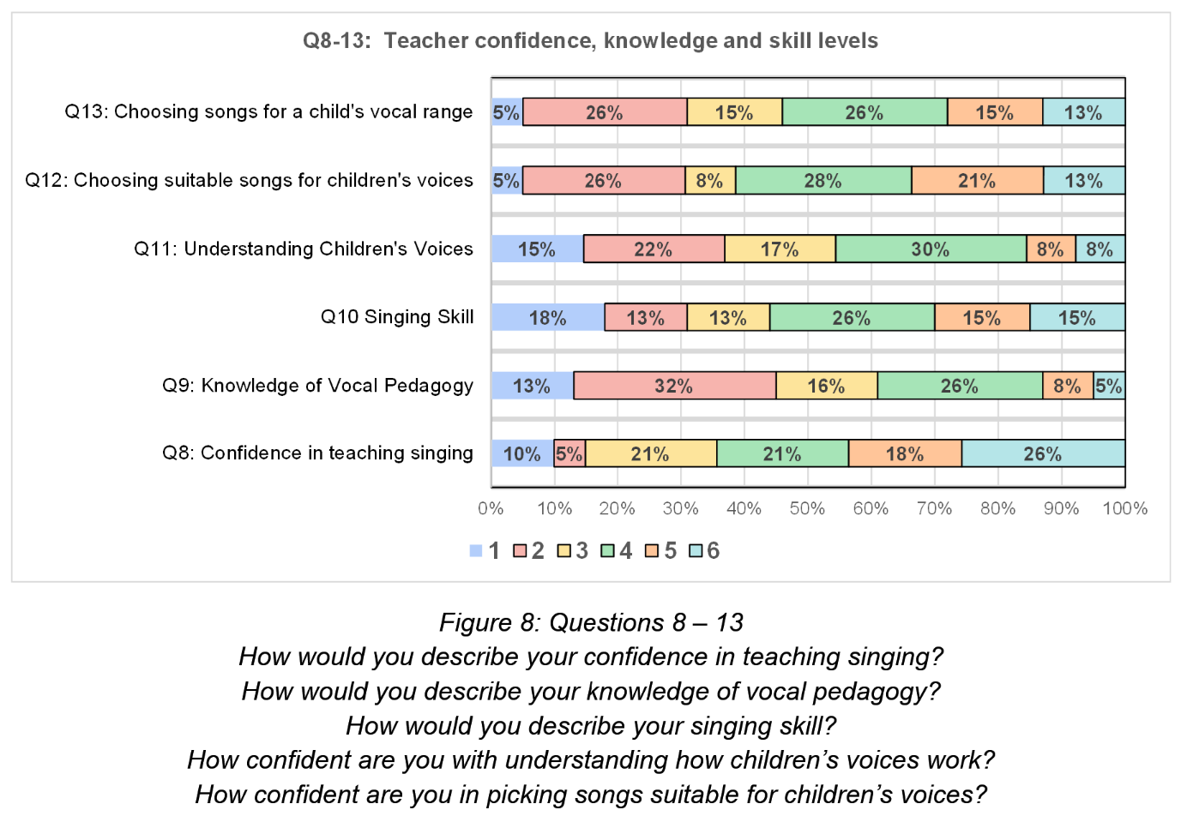
A 6- point scale was used to for participants to rate their knowledge, understanding and skill levels (1=lowest, 6=highest).
- Confidence in teaching singing: 39 responded, with 57% in the higher levels (4 = 21%, 5 = 18%, 6 = 26%). 21% chose level 3, 5% chose level 2, and 10% chose level 1. The median average was 4.
- Knowledge of vocal pedagogy: Most (61%) respondents (n=38) rated themselves on the lower scales (1 = 13%, 3 = 16%), with level 2 being the most frequent (32%). 26% rated themselves at level 4, and the higher levels (5-6) were less common (8% and 5% respectively). The median was level 3.
- Singing skill: This showed relatively evenly spread responses (39) with 44% on the lower half (level 1 = 18%, level 2 =13%, level 3 = 13%). Level 4 was the most frequent (26%), followed by levels 5 and 6 (both 15%). The median level of skill was 4.
- Confidence in understanding children’s voices: Most respondents (54% of 39) rated themselves at lower scales (1 = 15%, 2 = 22%, 3 = 17%). Level 4 was the most frequent (30%): levels 5 and 6 the least (both 8%). The median level of understanding was level 3.
- Confidence in picking songs suitable for children’s voices: Of 39 respondents, most (62%) were in the upper half (4 = 28%, 5 = 21% 6 = 13%). In the lower half, level 2 was the most frequent (26%), with levels 3 (8%) and 1 (5%) less frequent. The median average was 4.
- Confidence choosing songs for a child’s vocal range: 39 were mainly spread across levels 2 – 4, with 54% at levels 4 – 6. Least frequent were levels 1 (5%) and 6 (15%). Levels 2 and 4 were the most popular (both 26%), followed by levels 3 and 5 (both 15%). The median level was 4.

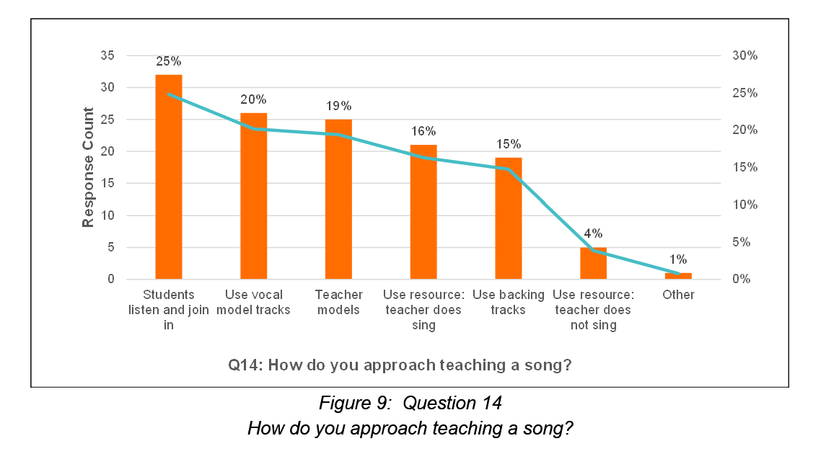
When teaching a song, 129 responses from 39 respondents indicated the most popular approach was listening and joining in with a song/artist (25%), followed by using vocal model tracks (20%) and the teacher as the model (19%). 16% of teachers use a resource but also sing themselves: 15% use backing tracks without model voices. 4% do not sing while teaching a song. One respondent noted: “Use keyboard to slow it down and teach tricky parts”.

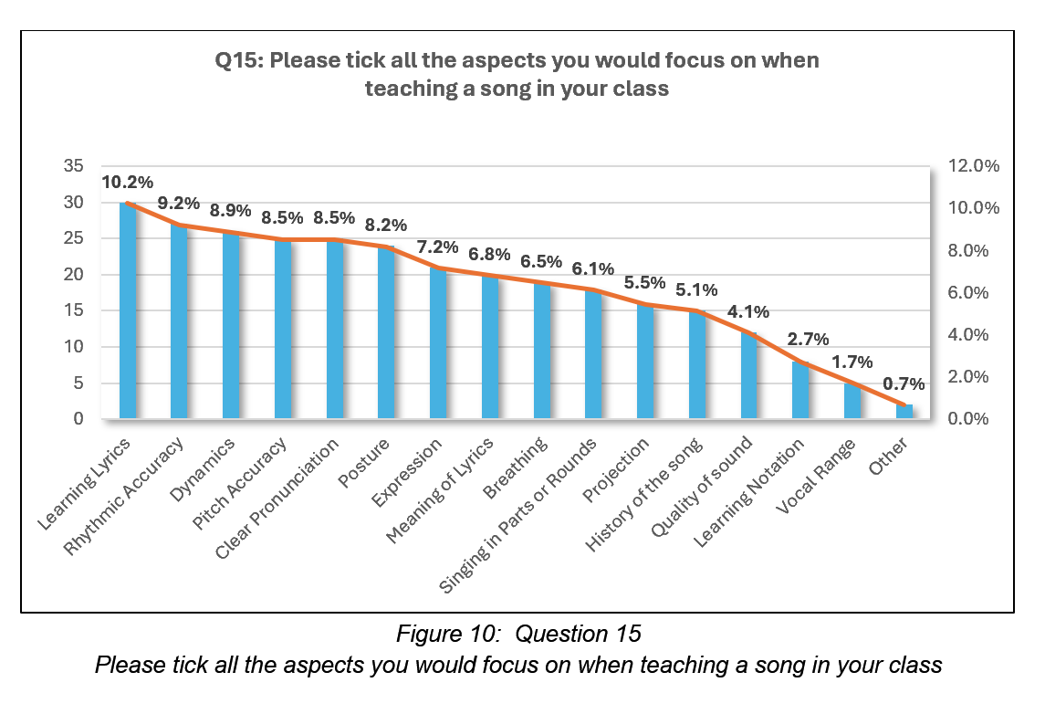

From 16 options, 38 respondents made 293 selections regarding aspects they focus on when teaching a song. The most popular aspects were learning lyrics (10.2%), rhythmic accuracy (9.2%), dynamics (8.9%), pitch accuracy (8.5%), clear pronunciation (8.5%) and posture (8.2%). Moderately popular were expression (7.2%), meaning of lyrics (6.8%), breathing (6.5%) and singing in parts/rounds (6.1%). The least popular were projection (5.5%), history of the song (5.1%) and quality of sound (4.1%), with learning notation (2.7%) and vocal range (1.7%). Other comments (0.7%) included focus given in the scheme of work and enjoyment.
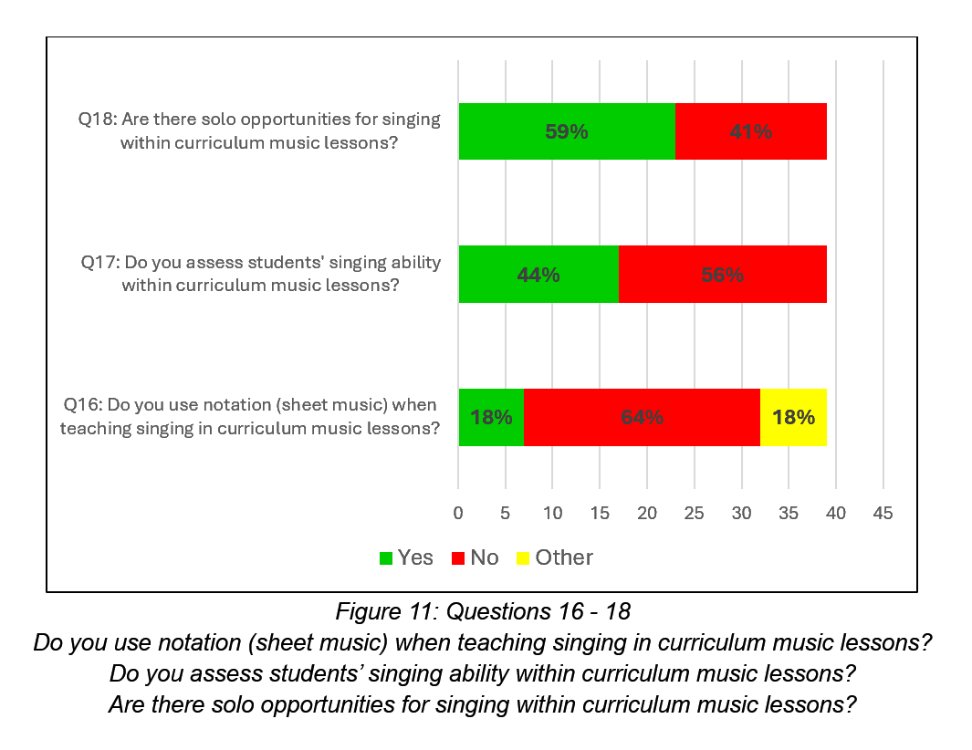
All 39 respondents reported specific aspects of teaching singing in curriculum music lessons. Notation was not used by the majority (64%), with yes and other responses both at 18%. Other’ responses indicated that notation was sometimes used; one respondent stated: “We are beginning to but find it challenging”. Access, student age, and song genre influenced the decision to use notation. One respondent used sheet music for personal use only.
While 44% of respondents assessed singing ability, 56% did not. One clarified this was within broader music assessment, whilst another stated assessment was in line with the national curriculum standards, not including vocal quality standard.
Solo opportunities were offered by 59% but not by 41%.
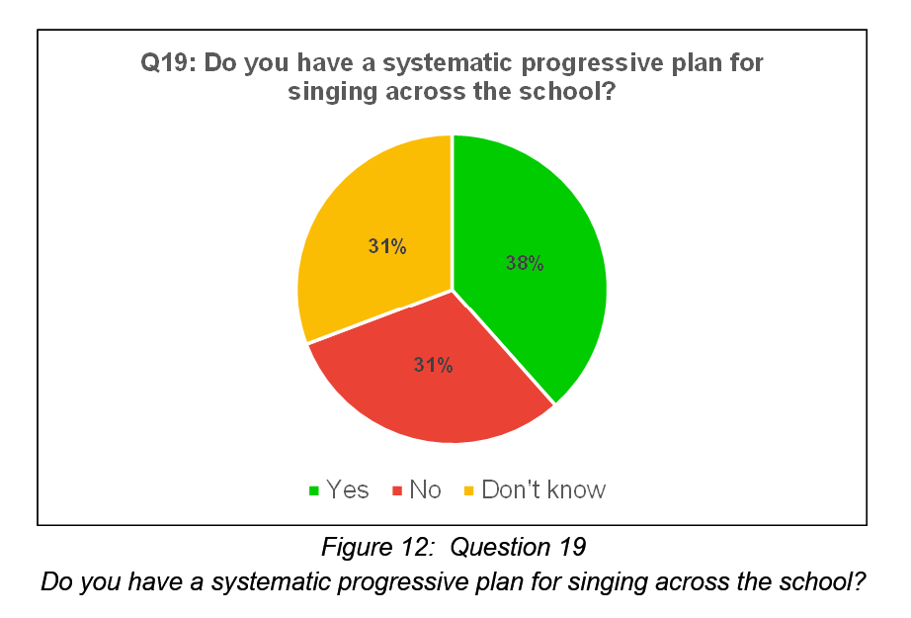
Respondents (n=39) answered if their school has a progressive plan for singing. The responses were relatively evenly distributed (38% = yes, 31% = no, 31% = don’t know).
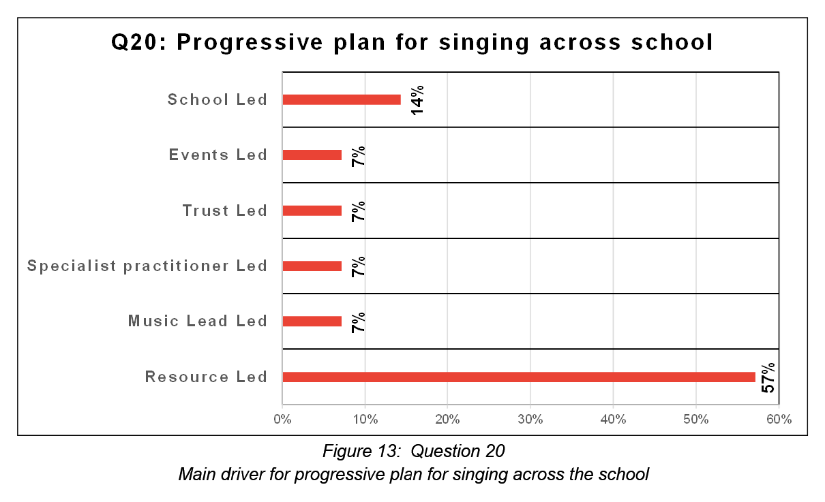

Further details from 14 participant comments showed resources (Charanga, Sing Up, Kapow) drove 57% of progressive singing plans. An equal proportion (7%) was attributed to events, and guidance from the trust, music lead, and specialist practitioner, with school guidance at 14%. One stated their plan “contains guidance for warmups, posture, breathing [, and] vocal health as well as progression for diction, phrasing, dynamics and stage craft”.
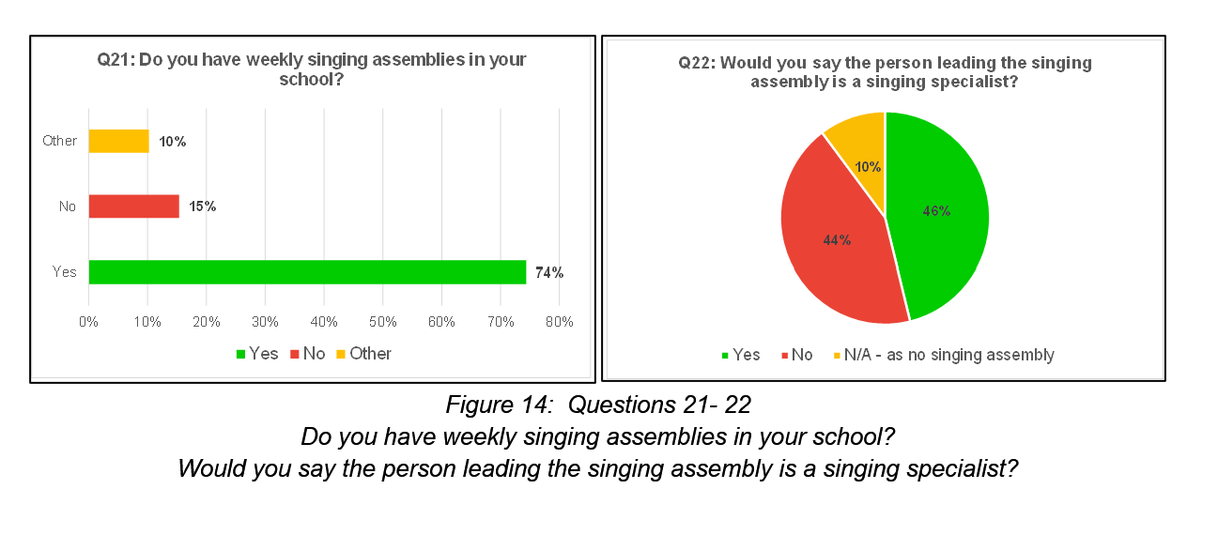
39 respondents indicated that 74% of schools hold weekly singing assemblies, compared to 15% that do not. 10% selected ‘other’ but did not elaborate. When asked about the assembly leader’s expertise, 46% responded that they considered the leader a singing specialist, 44% reported they were not a specialist, while 10% answered N/A due to the absence of a singing assembly.
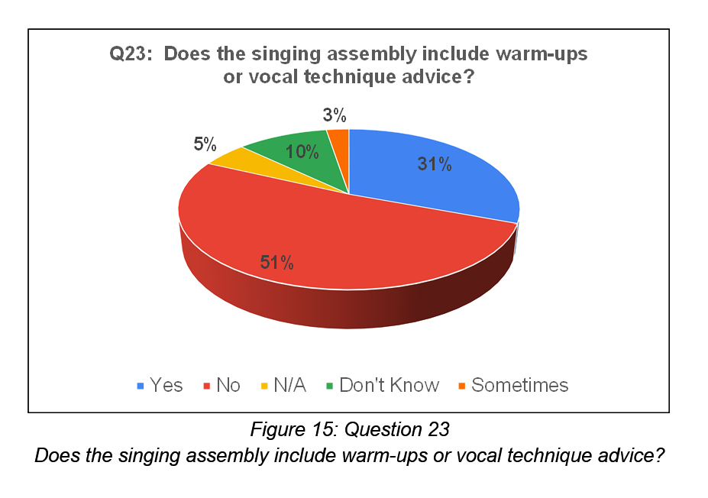
51% of participants (39) reported that warm-ups and vocal technique were not used in assembly singing, 31% noted they were and 3 % stated they were sometimes used. 5% answered as N/A due to no singing assembly and 10% did not know.
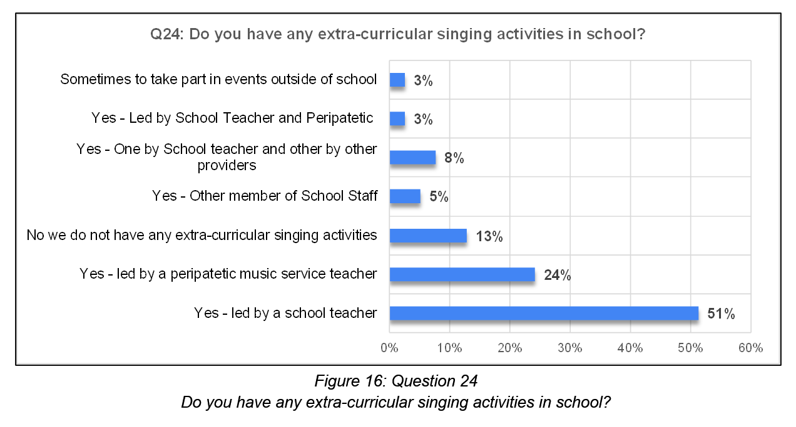
13% of participants reported that there were no extra-curricular singing activities in their school. 3 % said these were formed for special events. The majority (51%) of choirs were led by school staff, with 24% led by peripatetic staff. 3% were co-led by peripatetic and school staff. 5% reported other school staff led the activities and 8% had 2 choirs: 1 led by school staff and the other by an external provider.

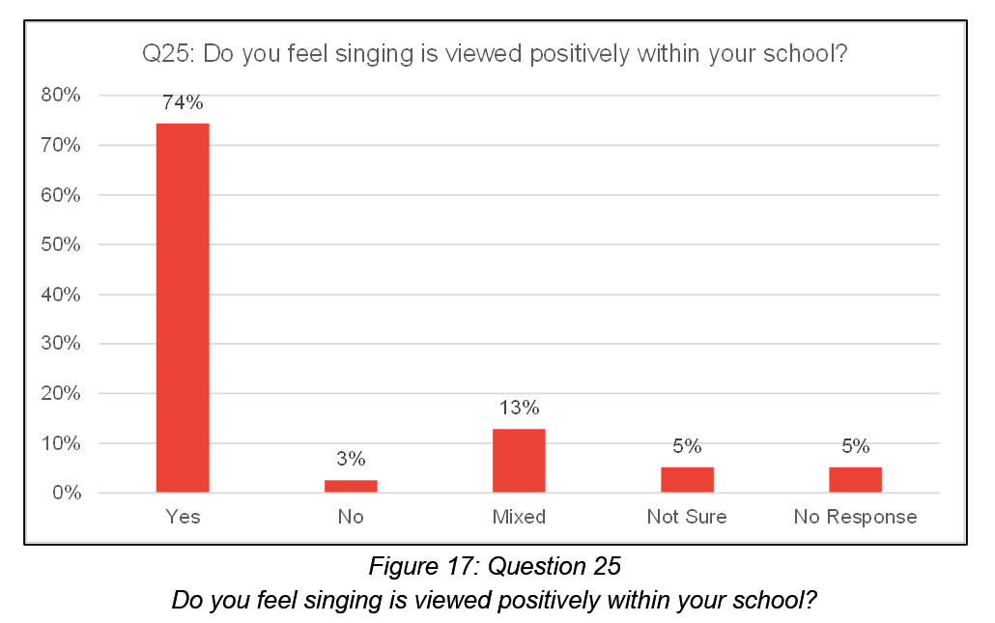

A large majority (74%) of the 39 participants felt that singing was viewed positively in their school, conversely 3% felt it was not and 13% felt views were mixed. 5% of participants were not sure and 5% did not respond.

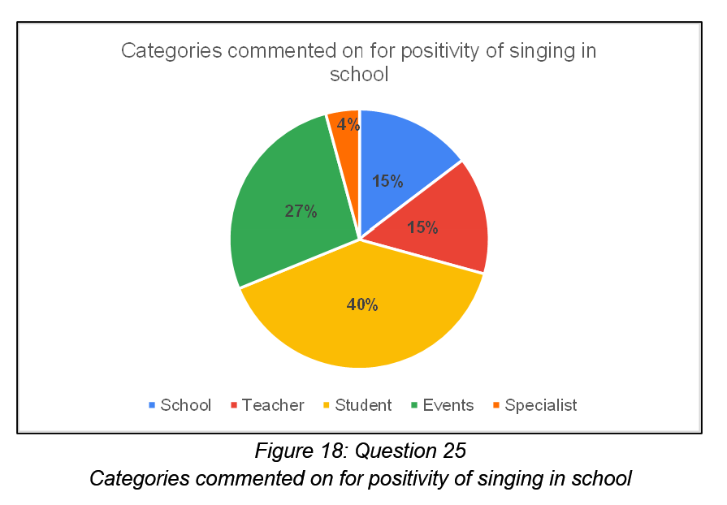

Analysis of 26 additional comments identified 5 influencing factors:
- Students (40%): mixed comments noted enjoyment, enthusiasm and confidence but declined engagement with age.
- Events (27%): positive comments included special occasions and performances.
- School (15%): comments varied from positive to it being a low priority.
- Teachers (15%): negative comments noted low staff confidence and negative attitudes, compared to one highlighting enthusiasm.
- Specialist input (4%): positive comments praised the hub choral strategy (“The positive impact is clear to see from […] specialist singing sessions”.)
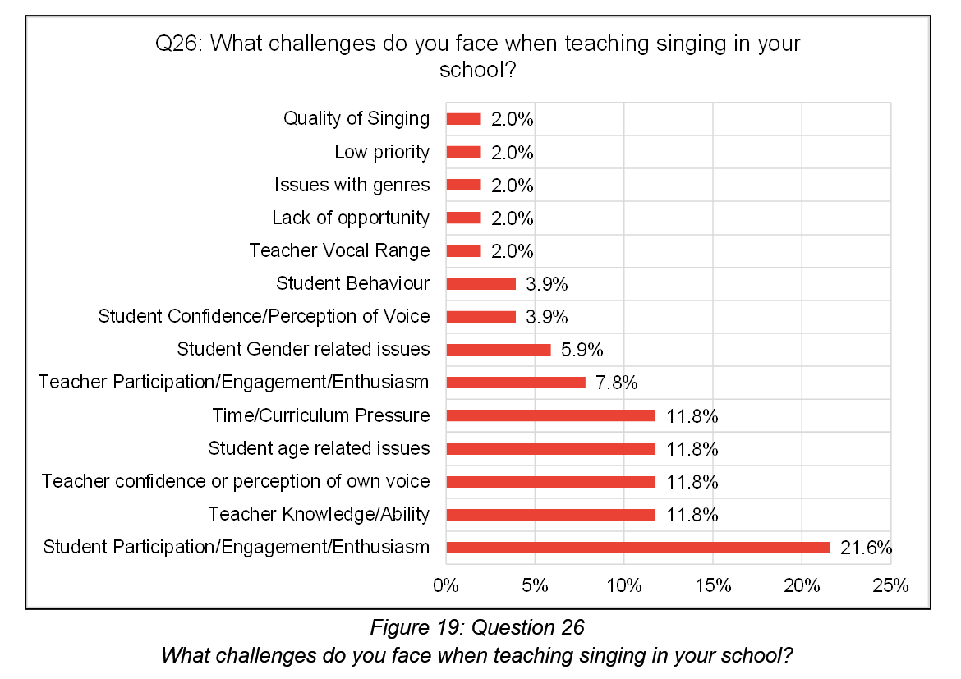

Thematic analysis of 34 comments on school singing challenges identified 14 categories. The majority (21.6%) related to student participation, engagement, and enthusiasm. Time/curriculum pressure; student age-related issues (older children less keen); teacher confidence; and teacher knowledge/ability were all at 11.8%. Mid-range challenges included teacher-related issues (Participation, enthusiasm, engagement) at 7.8%, student gender issues (boys less keen than girls) at 5.9%, and student confidence and behaviour (both 5.9%). The least frequent challenges, each at 2%, were teacher vocal range; lack of opportunity; gender issues (boys less keen than girls); low priority; and singing quality.
Five participants offered final comments. Three noted low adult confidence; use of songs from tv programmes; recording students to allow self-critique. Two comments positively noted the hub choral strategy with one stating it “drives the best singing work”.

Secondary Music Lead – Research Questionnaire Analysis
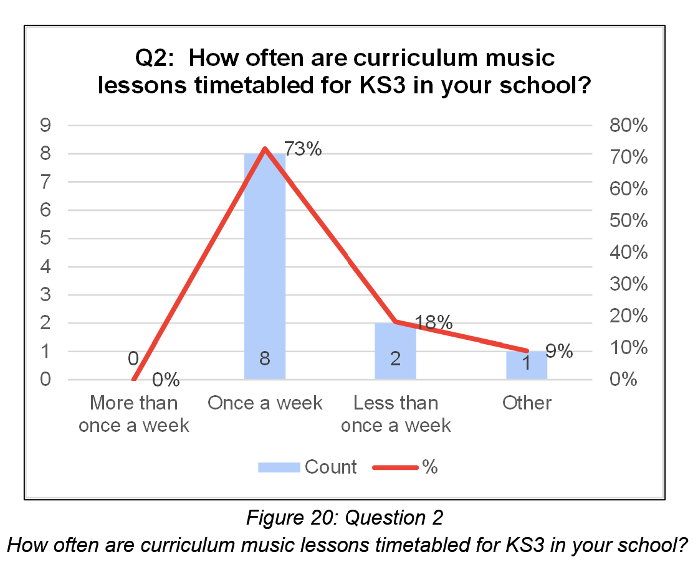
Of 11 respondents, the majority (73%) taught KS3 curriculum music lessons weekly, 18% less than once a week, and 9% reported weekly lessons for years 7/8 but only 2 terms for year 9.

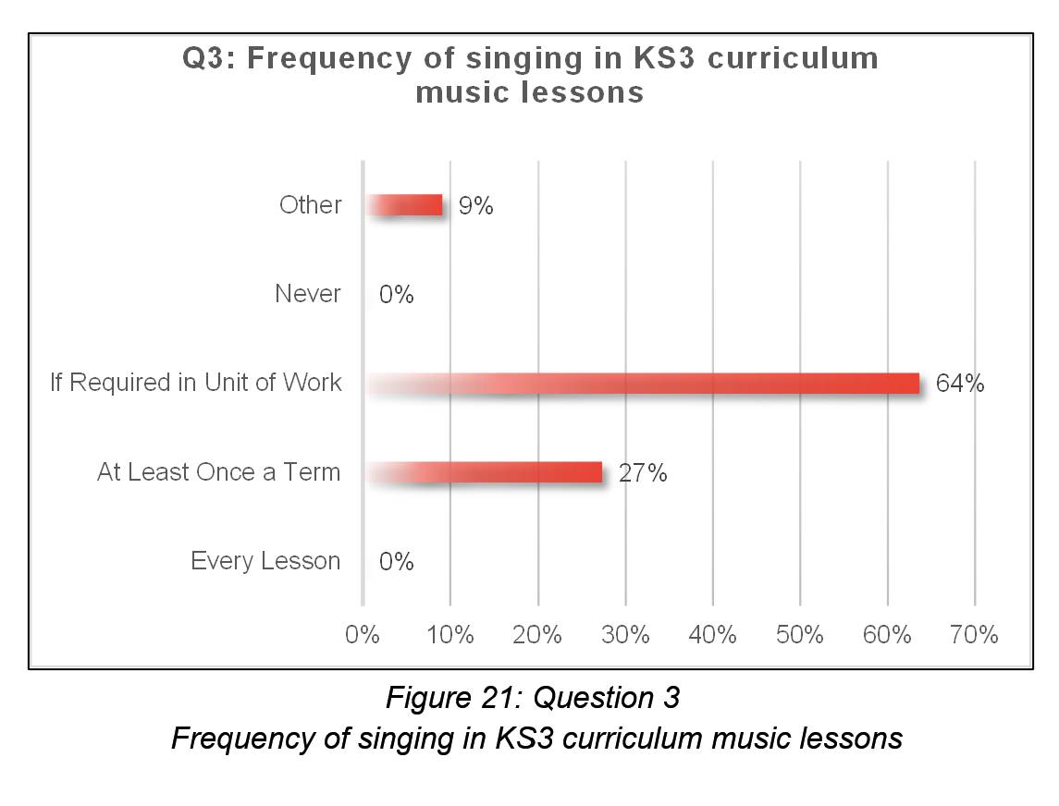
Responses (n=11) identified the majority of KS3 singing in lessons happened when required in the unit of work (64%). 27% respondents reported they sing at least once a term, whereas 9% stated they sing most lessons (other).
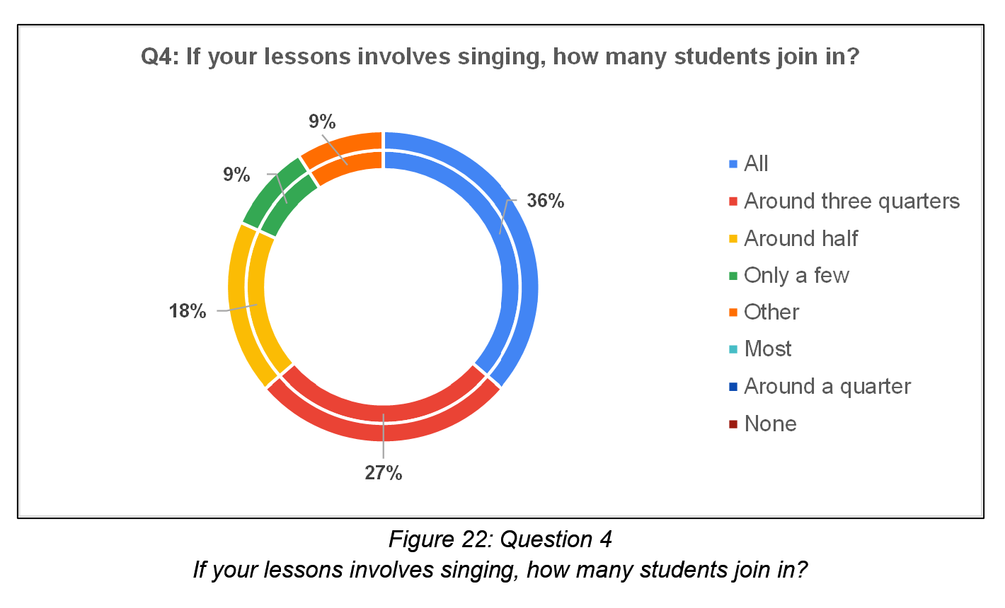
The 11 respondents reported KS3 student participation in singing as: all students (36%), around three quarters (27%), around half (18%), only a few (9%), and dependent on the year group (other, 9%). The median average was ‘around three quarters.

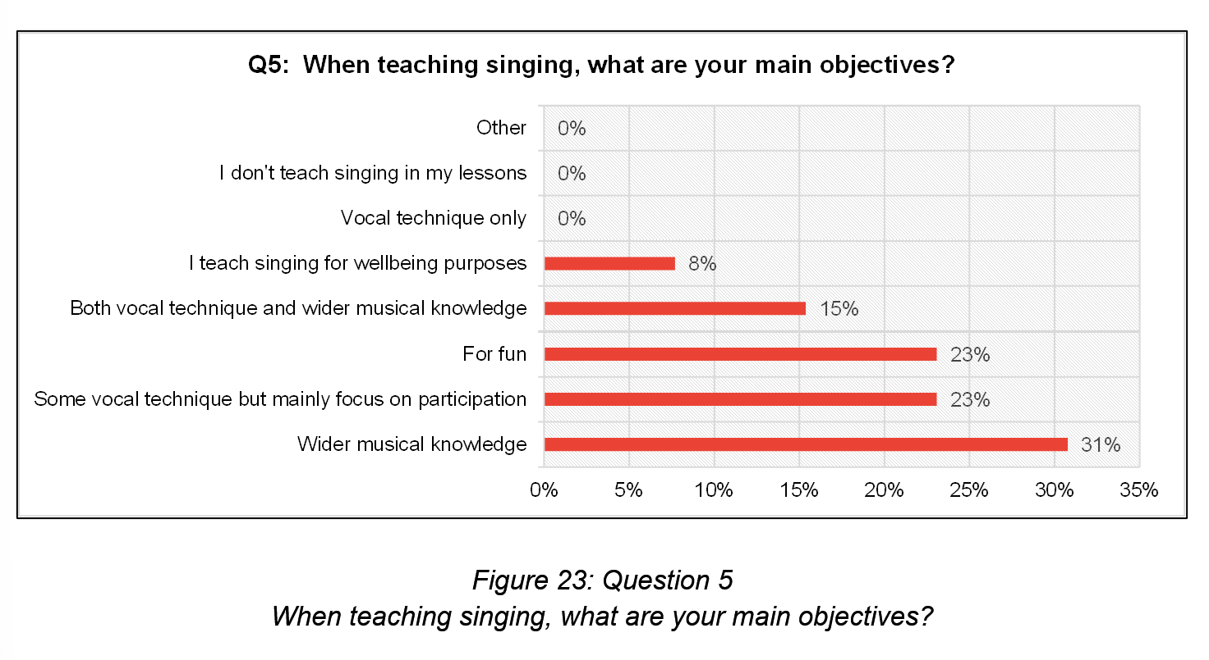

11 participants selected from 8 main singing objectives (26 responses). Wider musical knowledge (31%) was the most popular, followed by participation with some vocal technique, and fun (both 23%). Vocal technique and wider musical knowledge was chosen by 15%, and wellbeing by 8%.

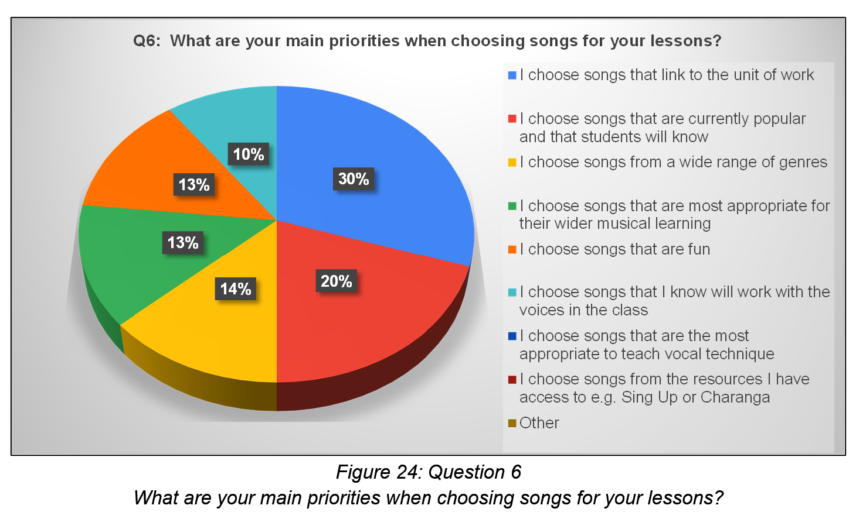
11 respondents chose 3 main song choice priorities (30 responses). The top priority was a link to the unit of work (30%), followed by a popular/well-known song (20%). Mid-range priorities were range of genres (14%), wider musical learning (13%), and fun (13%). Lower priorities were songs suited to class voices (14%), vocal technique and resources (both 0%).

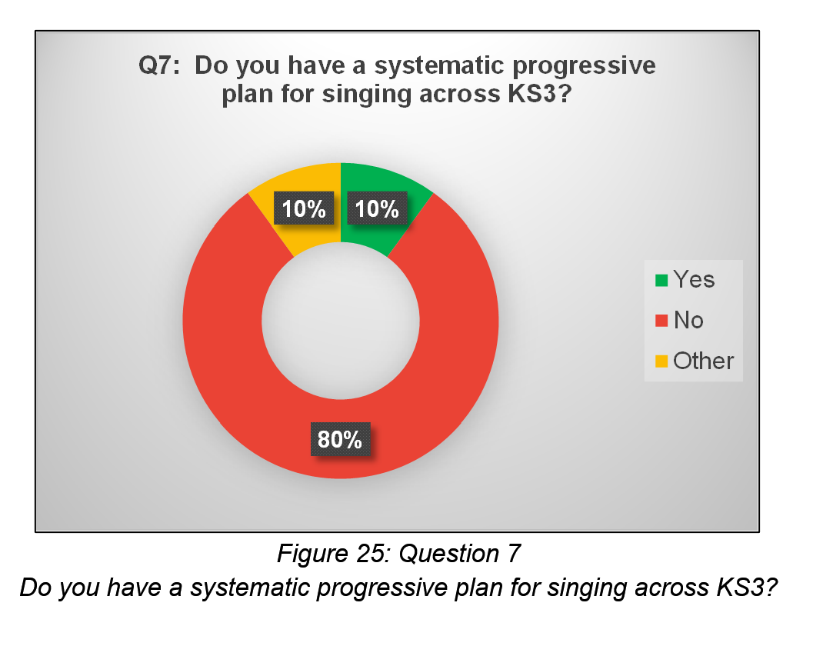
Of 10 respondents, 80% reported no systematic progressive plan for singing across KS3, 10% stated a plan was in place, whilst 10% answered this was under development (other).

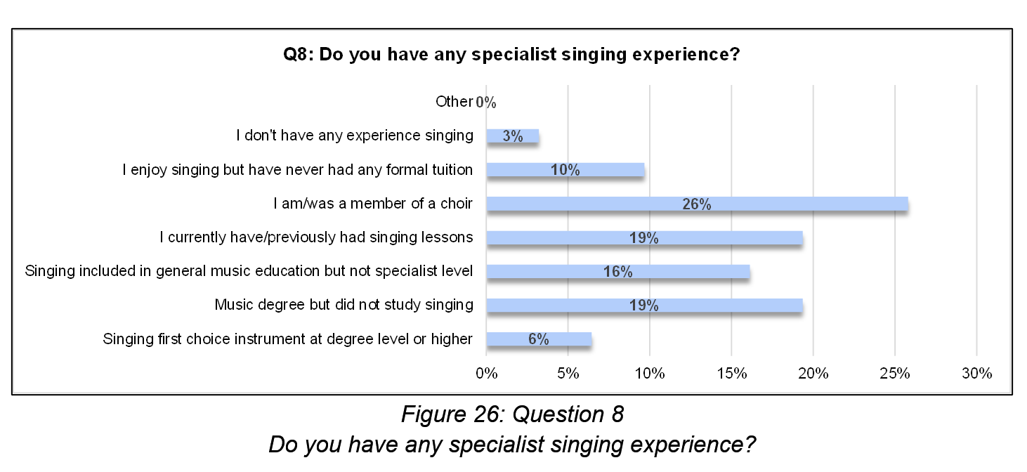
Specialist singing experience, from 31 responses (11 respondents, 8 options), comprised: degree level or higher (6%), choirs (26%), singing lessons (19%), and singing as part of music education (16%). A music degree was reported by 19%. Less common were those who enjoyed singing without formal tuition (10%) and those with no singing experience (3%).

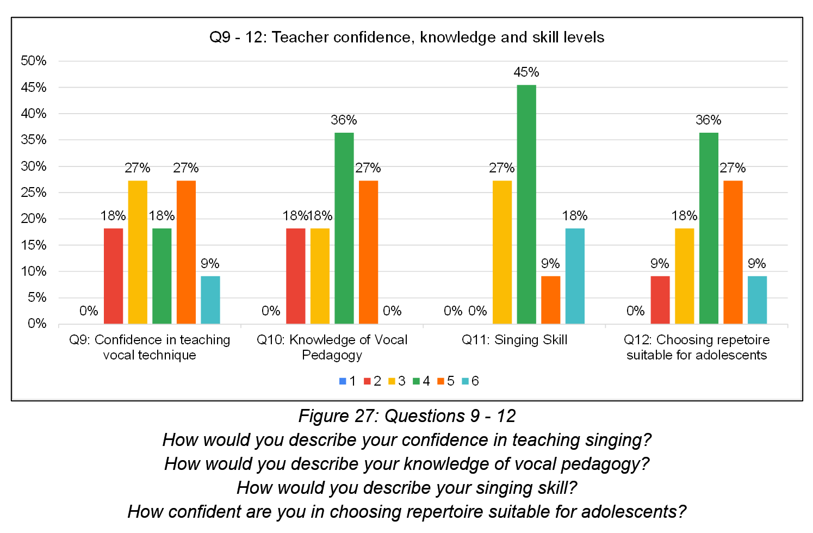
11 respondents rated their knowledge, understanding and skill levels, on a 6-point scale (1=lowest, 6=highest), with level 1 unselected.
- Confidence in vocal technique: Ratings showed a medium spread across levels 2 – 4 (levels 2 and 4 = 18%, levels 3 and 5 = 27%), with 9% at level 6. The median confidence level was 4, despite a bi-modal average of 3 and 5.
- Knowledge of vocal pedagogy: 36% rated themselves as level 4, with remaining responses at levels 2 and 3 (both 18%) and level 5 (27%). The median was 4.
- Singing skill: Most (72%) rated themselves in the upper half of the scale (level 4 = 45%, level 5 = 9%, level 6 = 18%), compared to 27% at level 3. No respondents chose levels 1 or 2. The median was 4.
- Confidence in repertoire selection suitable for adolescent voices: Ratings were mainly mid-range, 38% at level 4. On the higher end, 27% chose level 5, and 9% chose level 6. On the lower end, 18% chose level 2 and 9% chose level 1. The median was 4.

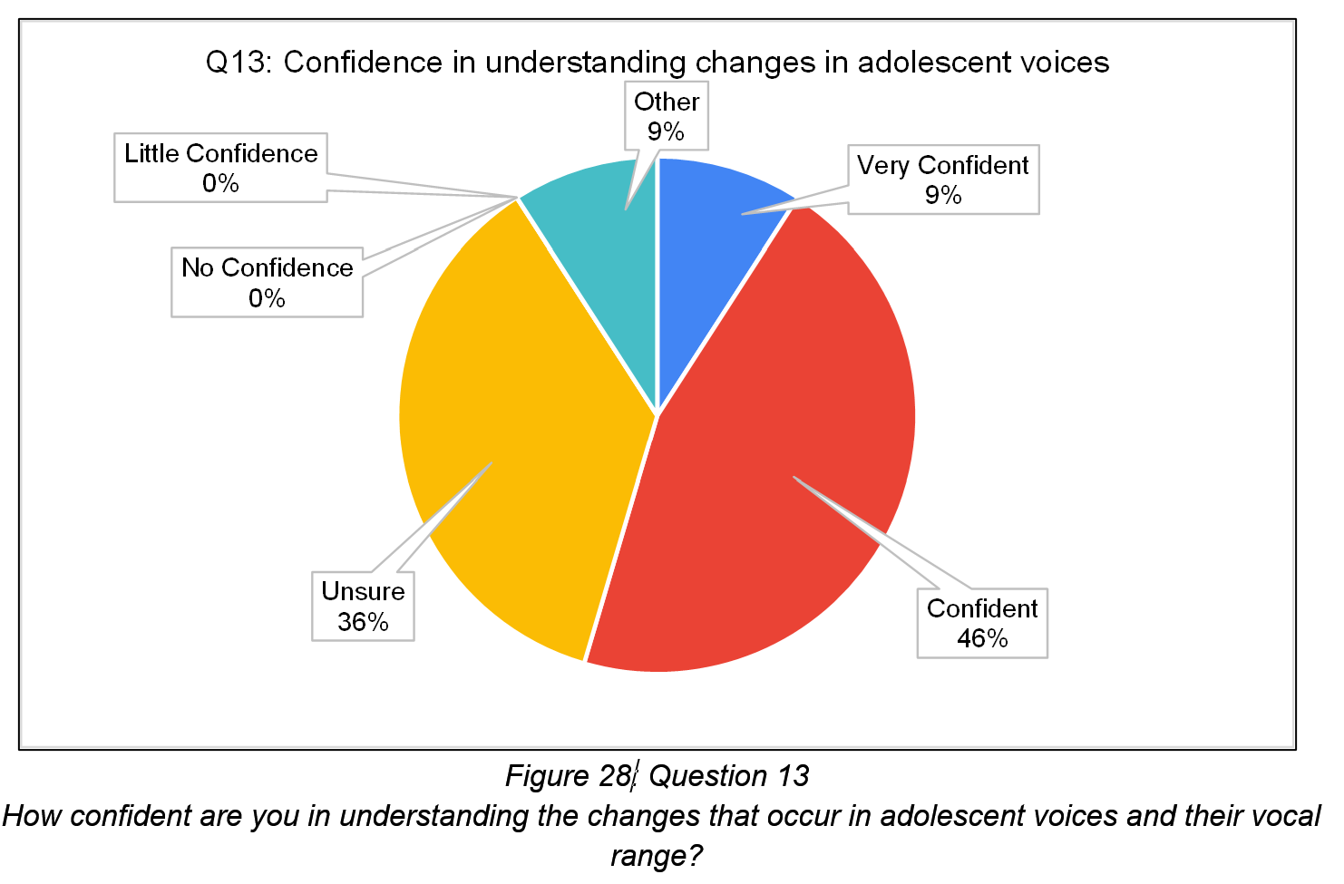
11 respondents rated their confidence levels in understanding adolescent voice changes. The majority (46%) rated themselves as confident, whilst 36% stated they were unsure. 9% were very confident, 0% had little to no confidence, whereas 9% (other) stated they had “some experience but little practice”.

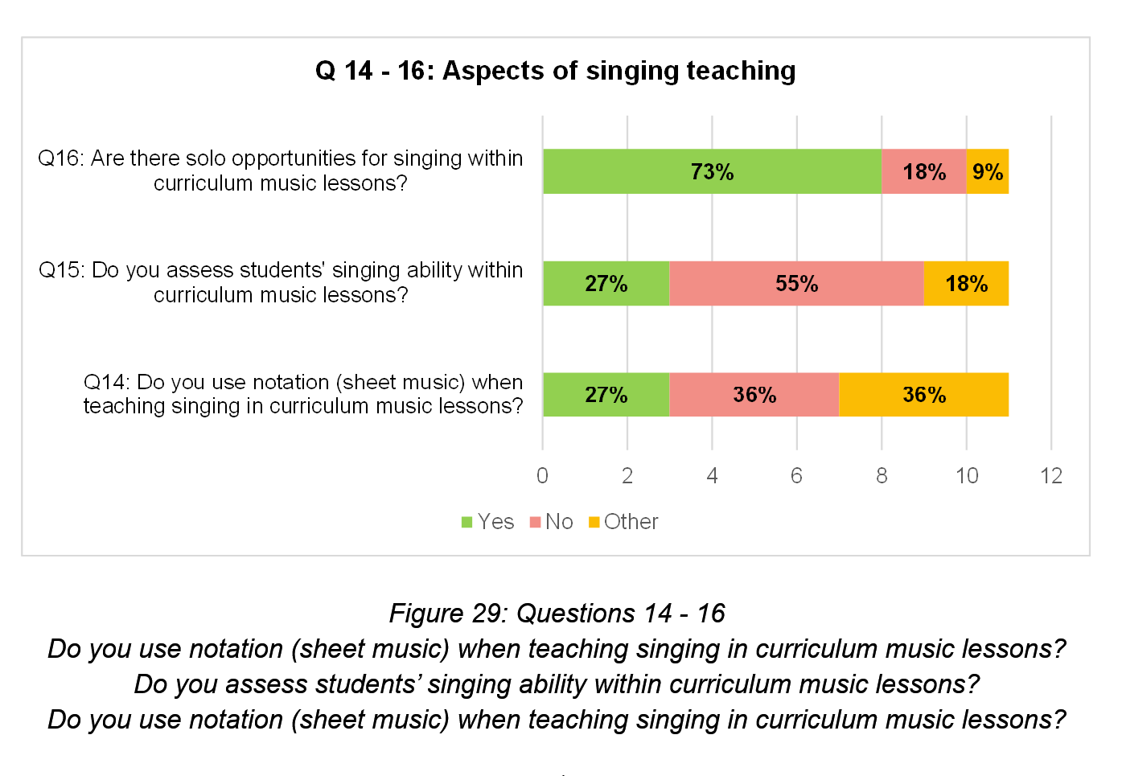
Specific aspects of teaching singing in curriculum music lessons were analysed from 11 respondents:
- Notation: Use was relatively even: no and other (36% each), yes (27%). ‘Other’ responses indicated notation was sometimes used or depended on genre.
- Assessment of singing ability: 27% of respondents assessed singing ability, 55% did not. ‘Other’ responses (18%) included year 7 assessment only and occasional assessment.
- Solo opportunities: 73% offered solos, in lessons, whilst 18% did not. 9% (other) reported use of solos to record vocal ideas.

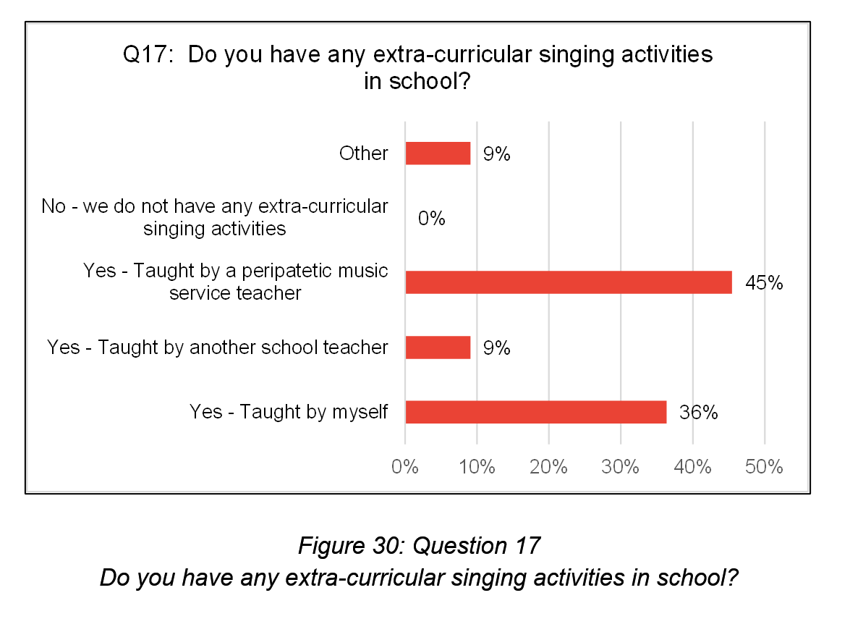
Of 11 respondents, 100% had extra-curricular singing activities: 45% led by peripatetic specialist teachers, 36% led the group themselves, and 9% were led by other school staff. 9% (other) has 4 separate singing groups but did not specify who led these.

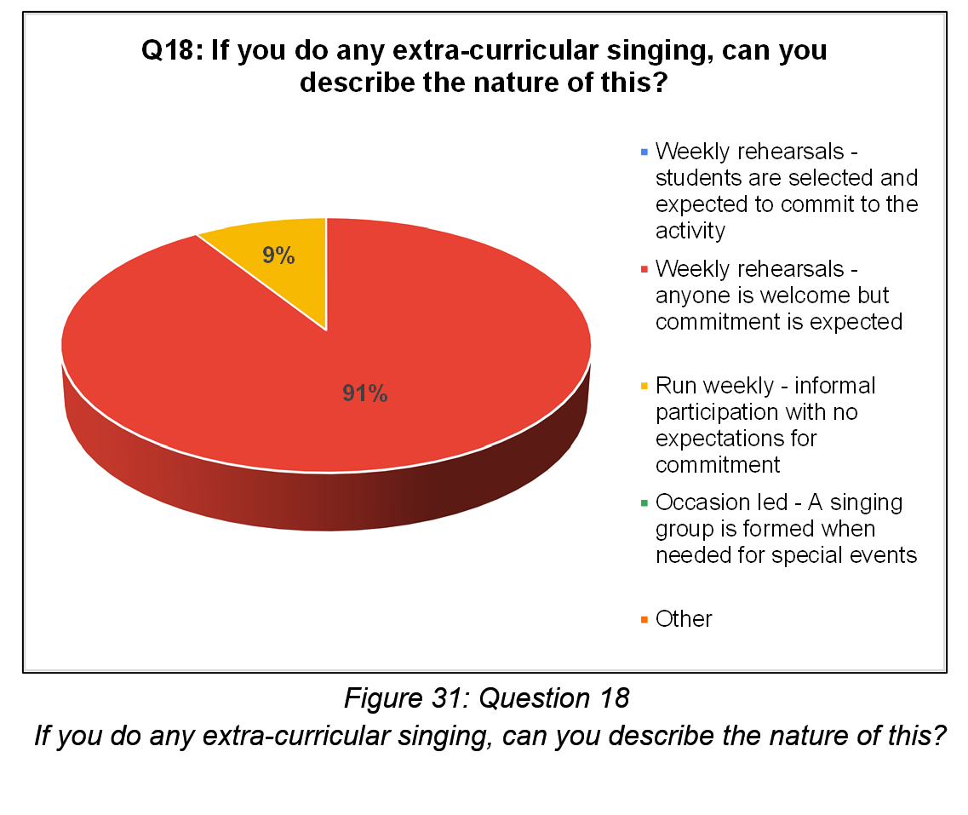
91% of respondents (n=11) hold weekly rehearsals for their extra-curricular singing activities, where anyone is welcome, but commitment is expected. In contrast, 9% are more informal with no commitment expectations.

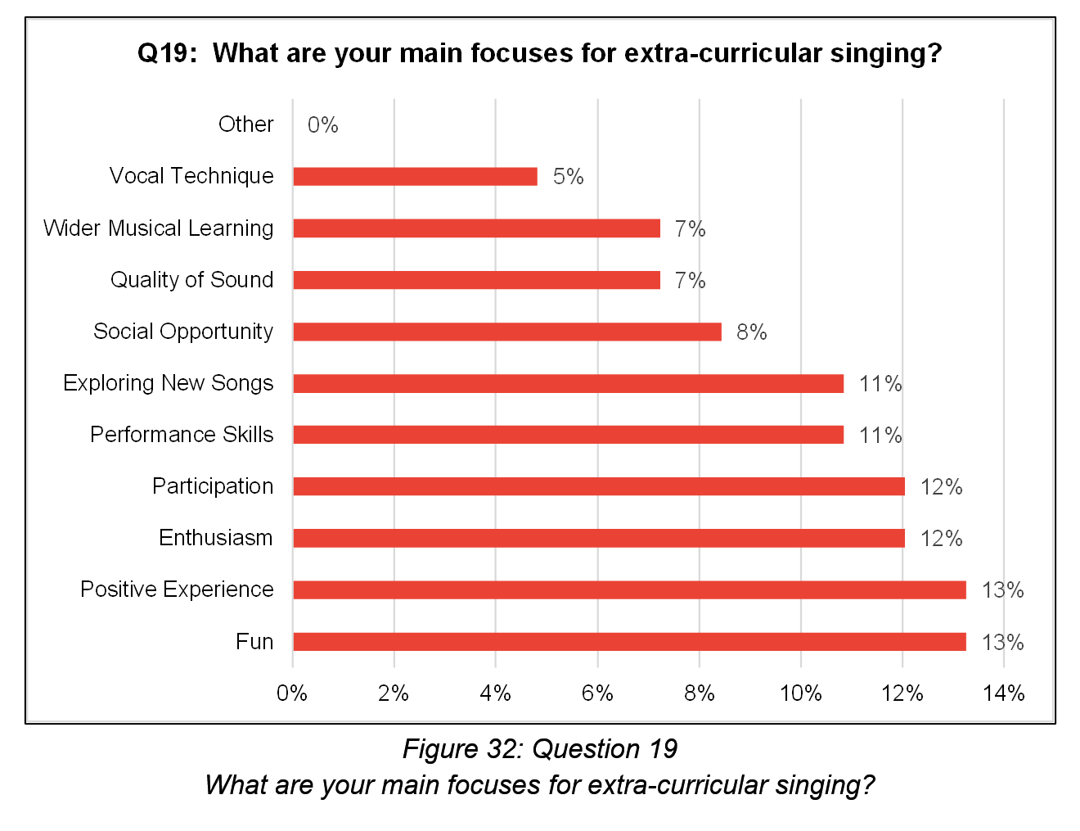

83 responses from 11 respondents reported their main focuses for extra-curricular singing (11 options). Most popular were fun and positive experience (both 13%), followed by enthusiasm and participation (both 12%), and performance skills and exploration of new songs (both 11%). Less common were social opportunity (8%), quality of sound (7%), wider musical learning (7%) and vocal technique (5%).

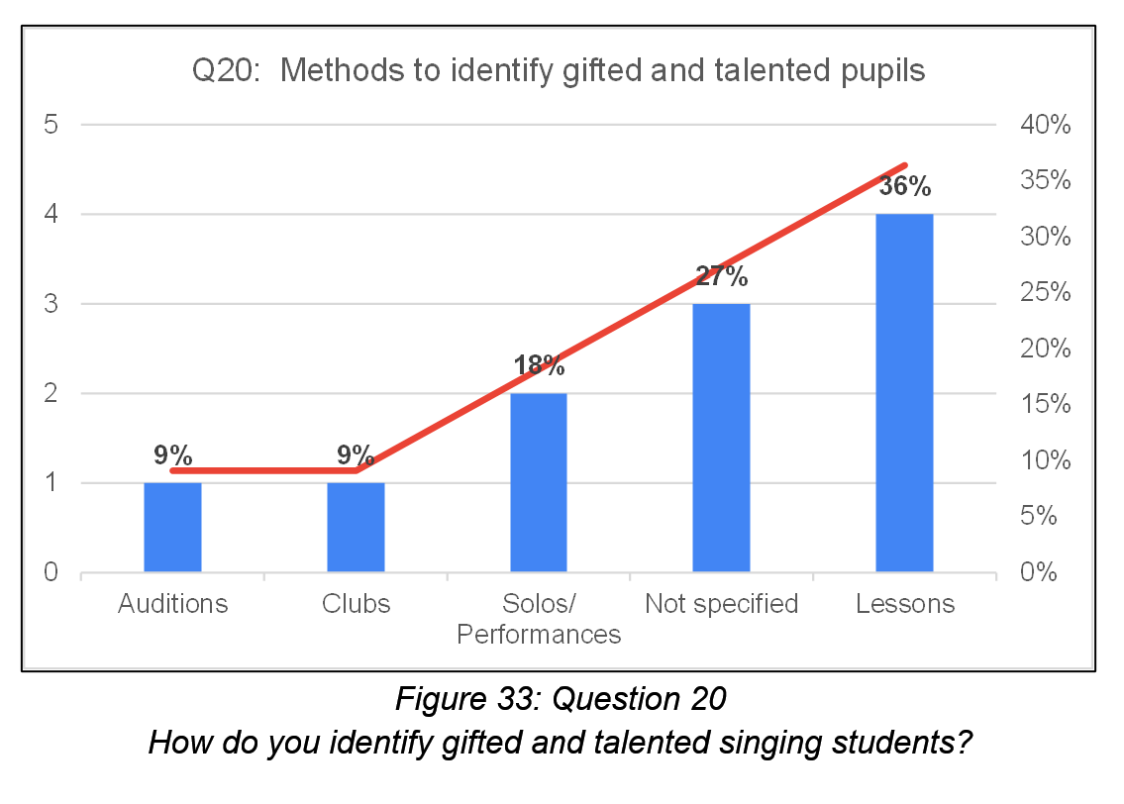
11 respondents commented on identification of gifted and talented (G&T) pupils and progression pathways. Thematic analysis resulted in 5 categories. The majority of identification occurred through lessons (36%), followed by solos and performances (19%). Clubs and auditions (both 9%) were also used. 27% of respondents did not specify assessment methods.

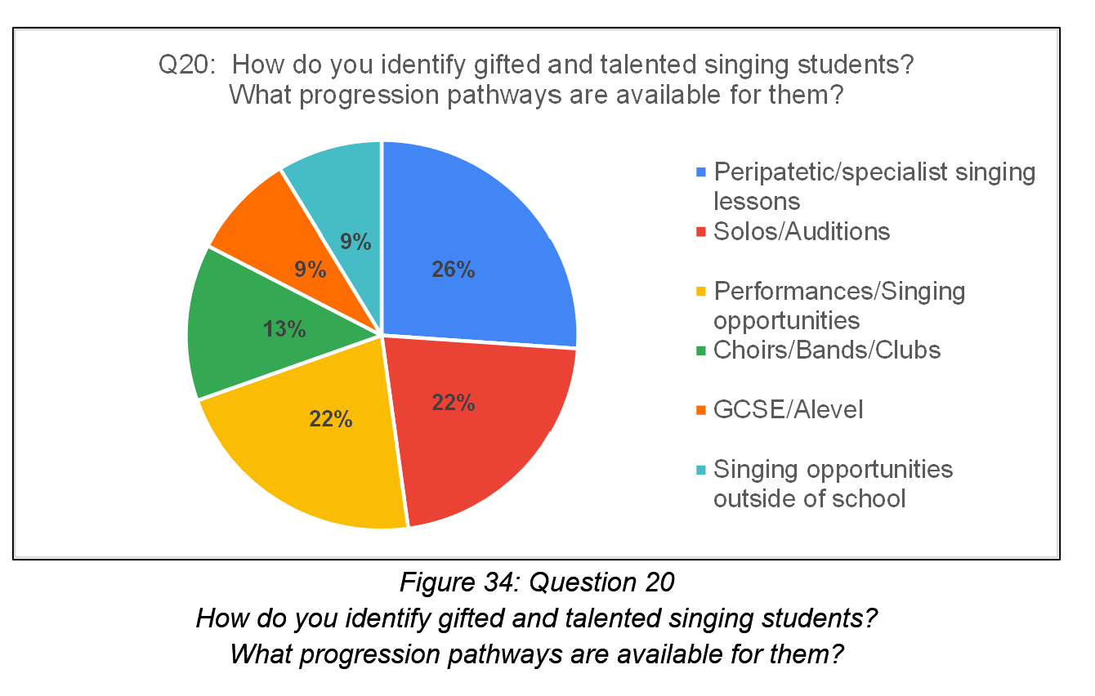
11 responses showed the most popular pathway available for G&T students was peripatetic/specialist singing lessons (26%), solos/auditions and performance/singing opportunities (both 22%). Less common were group participation (choirs, bands, clubs) at 13%, and routes to GCSE or A Level music, and singing opportunities outside of school (both 9%).

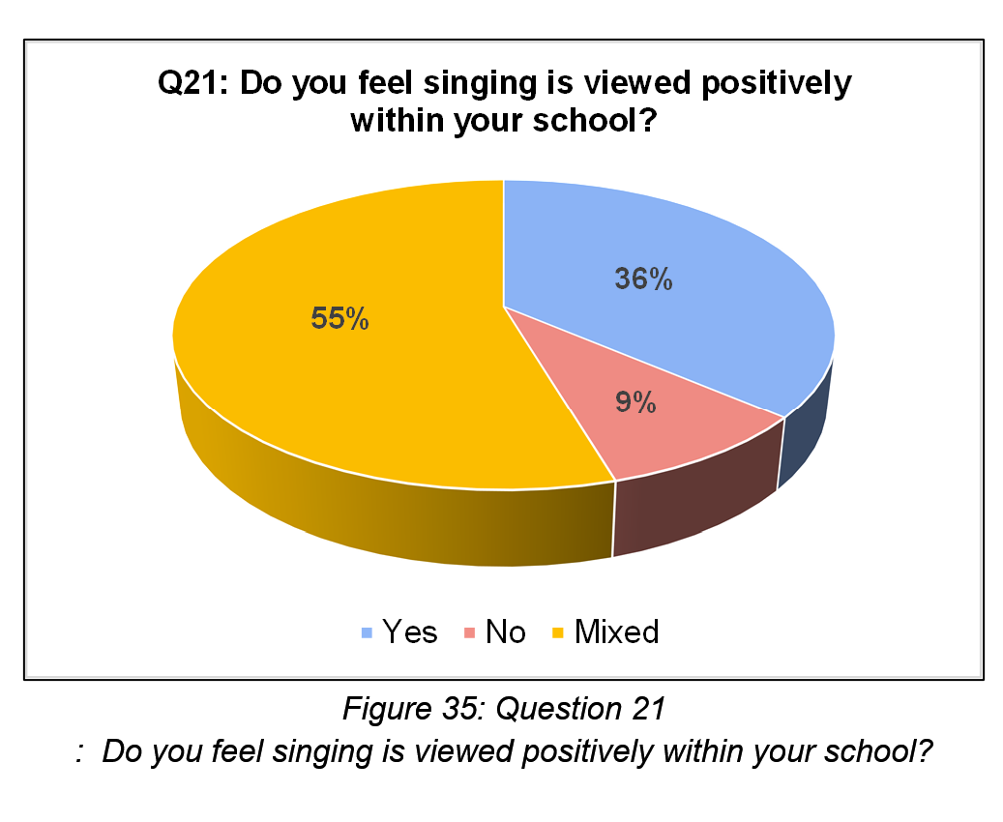
36% of 11 respondents felt singing was viewed positively within their school; 9% did not. The majority (55%) gave a mixed response. Thematic analysis of comments resulted in 4 negative categories and 5 positive categories.

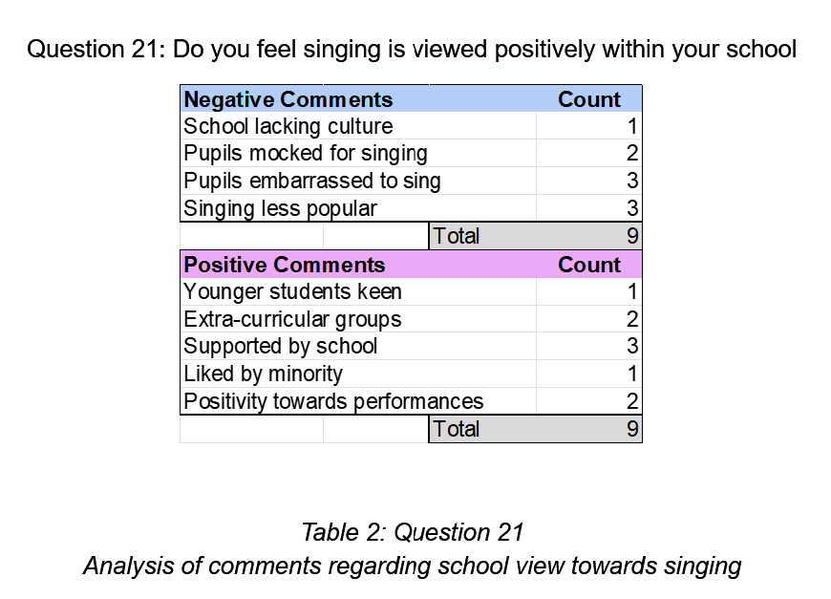
Negative comments:
- lack of singing culture
- singing viewed as unpopular
- student confidence
- negative attitudes: “some students are reluctant to participate and mock those involved in the school choir “.

Positive comments:
- Increased enthusiasm in younger students
- Singing supported by school
- Singing enjoyed by some
- Extra-curricular groups and performances: “the choir has grown massively, and we now have over 50 students participating on a weekly basis”.
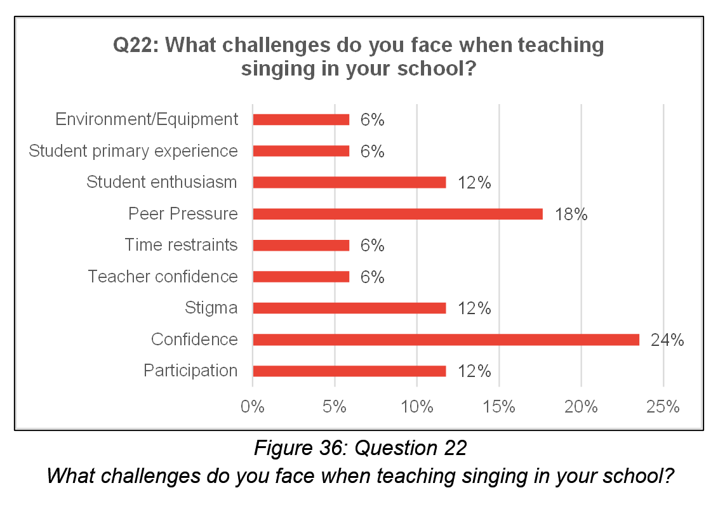
Challenges were reported by 9 participants and analysed into 9 categories. Most frequent were pupil confidence (24%), peer pressure (18%) and student enthusiasm, participation and stigma (all 12%). Less frequent were teacher confidence, time restraints, appropriate environment/equipment and amount of primary singing experience for students, all at 6%.
Final comments highlighted singing for inclusion, wellbeing and mental health, with consideration towards professional routes.

Interview Analysis
Four peripatetic singing teachers recorded interviews in form of open discussion, with a topic guide provided in advance. Transcriptions followed a denaturalistic approach and adhered to researcher-established guidelines (see Appendix 7), ensuring transcription consistency. Thematic analysis was employed to identify and categorise common factors and determine the frequency of comments for each theme.
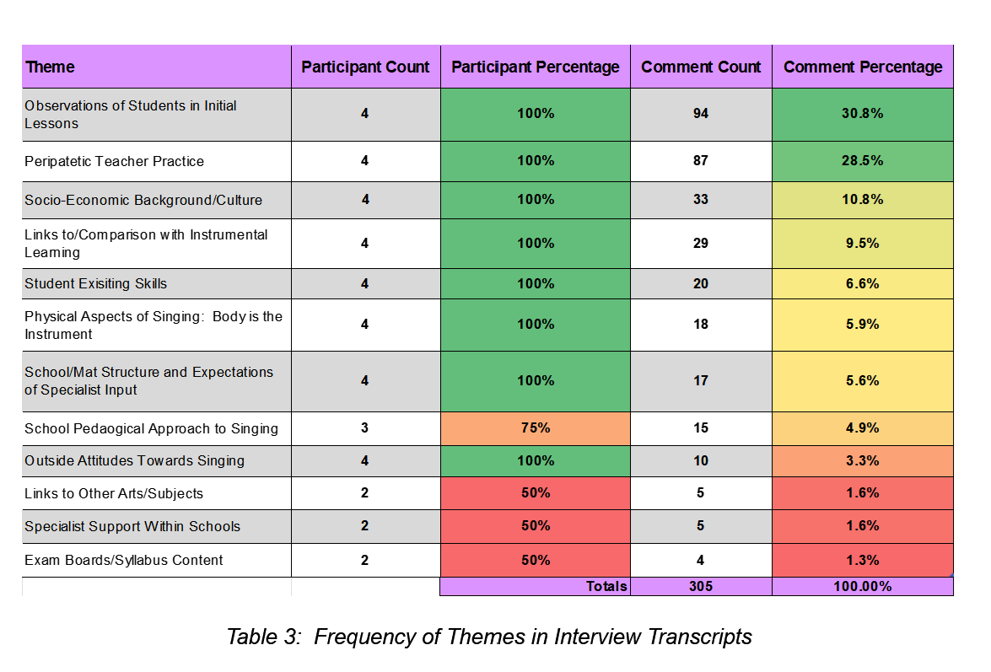
Interview comments focused on initial student observations (30.8%) and peripatetic teachers’ practice (28.5%), with mid-range themes including socio-economic background/culture (10.8%), comparison to instrumental learning (9.5%), initial student skills (6.6%), physical aspects of singing (5.9%), school/multi-academy trust (MAT) structure and expectations of specialist input (5.6%), and observations of school pedagogical approaches to singing (4.9%). Less common themes included external attitudes towards singing (3.3%), links to other arts/subjects and wider specialist support within schools (both 1.6%), and exam board and syllabus content (1.3%).
Common challenges experienced were noted by participants, as shown below in Table 9:

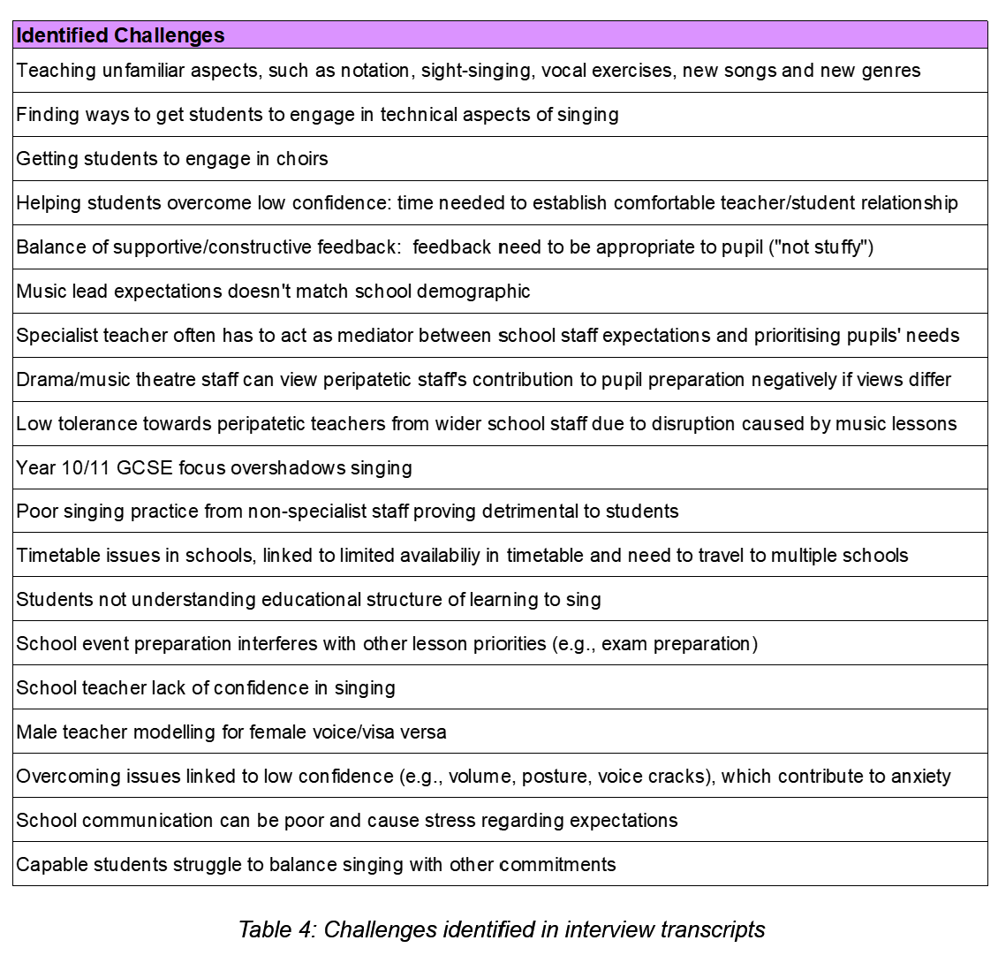
The summary below focuses on the main themes identified and participant observations linked to shared experiences and common challenges participants faced in initial vocal lessons, and the progression route for developing singers. Repetition across themes has been omitted.
Observations of Students in Initial Lessons
Initial student expectations varied between firm and unaware of what to expect, whilst many expected to “perform” rather than learn vocal technique. The embedded notion of needing to “already know” songs hindered learning new material and unsettled some students, but most students appeared motivated to make progress. Students commonly idolised singers (e.g., want to “sing like Whitney Houston”), desired a “big, belty sound”, and wanted advanced skills (e.g., fast runs, riffs, licks). Reliance on the lower register and reluctance to explore the higher range was common. Many were initially “scared” to sing alone, relying on vocal tracks or teacher support. Confidence issues affected volume, adjustment to small group/1:1 instruction, reluctance to share knowledge/goals, openness mindedness, and “fear of failure”.
Peripatetic Teacher Practice
Initial lessons included gentle introductions to notation, vocal exploration, musical learning, vocal exercises and basic technique to reduce anxiety and embed core skills. Differentiation was shaped by student confidence, character and existing skills, with emphasis on establishing a ‘safe space’ and good relationships. Additionally, balanced feedback and effective deliver were crucial for positive relationships and student progress. Skills aligned with future professional expectations were included where appropriate. Student progression and exam preparation were sometimes hindered by other commitments (e.g., GCSE/BTEC), and school priorities (e.g., performances). Teaching across multiple schools, travel and resultant inflexible timetabling caused difficulties. Mediation between school expectations and students’ needs was highlighted, with some external practice and lack of school singing expertise noted as detrimental to students.
Socio-Economic Background/Culture
Varied singing culture was observed across socio-economic settings. Singing was valued and consistent in faith-based schools due to collective worship, whilst students from choral pathways evidenced more embedded skills. One denominational MAT evidenced singing progression between primary/secondary levels, whilst school singing culture corresponded to staff attitudes towards peripatetic staff. Additionally, a lack of singing was noted in some secondary schools.
Links to/Comparison with Instrumental Learning
Participants found initial singing students more likely to have repertoire/genre preconceptions than instrumentalists. Singing students seemed to expect faster results compared to instrumentalists; however, singing was not viewed as “easier” by participants, with comparable difficulties noted (e.g., sight-singing). Initial singing students exhibited greater confidence issues, conversely instrumentalists tended to have a better understanding of music education structure/exams and greater musical investment.
Student Existing Skills
Initial students often lacked prior singing knowledge, awareness of inaccuracies and good technique. Many students had “learned” stylistic tendencies that restricted development and required correction.

Physical Aspects of Singing: Body is the Instrument
The lack of visual/tactile reference (unlike other instruments) challenged the notion that singing is “easy”. Many students were unfamiliar with vocal anatomy, the voice as an instrument and the effect of poor posture on voice production The voice’s personal nature (“it is a part of you”) was a key factor in low confidence and reluctance to sing, alongside adolescent voice challenges (e.g., accurate intonation and aspiration).
School/MAT Structure and Expectations of Specialist Teachers
A central MAT structure for music aided continuation; however, specialist views on best practice sometimes differed from the music lead’s expectations. Peripatetic staff supported teachers with choirs/events, but communication between school and peripatetic teachers was sometimes unclear and caused stress.
School Pedagogical Approach to Singing
Specialists reported use of age-appropriate pedagogical content and technique (e.g., vocal register use) in school singing activities. Some non-specialist singing provision observed followed a ‘karaoke’ approach, neglecting technique. Repertoire preference reflected prior exposure (e.g., songs from school/home).
Outside Attitudes Towards Singing
The attitude that singing is not a valid instrument or “proper” subject was noted and supported by perceived low tolerance from schoolteachers towards students leaving subject lessons for singing. Surprisingly, other arts departments (e.g., drama) sometimes resented peripatetic staff’s support in student preparation as advice often differed.

‘Just Singing’, Vocal work and Choral Work
The interview topic guide prompted considered into the definition of ‘singing’ and introduced Ashley’s (2015) three categories: ‘Just Singing’, Vocal Work, and Choral Work (Ashley, 2015, p. 15 – 18). Participants agreed that most singing observed in schools was ‘just singing’; furthermore, this was an expectation for some initial students starting peripatetic tuition. Age-appropriate Vocal Work was used in assemblies/class lessons, whilst 1:1/small group lessons incorporated it fully. Choral Work was less acknowledged, even in school choirs, but was noted in the hub choral strategy’s primary choirs and the minster children’s choir.

Cross-Analysis
Recurring patterns in the combined data were identified through correlation analysis to form observations on progression routes for developing singers in mainstream education settings. These were then categorised according to themes noted in the literature review.

What is ‘Singing’?
Analysis informed by Ashley’s (2015) classification, evidenced the three categories of singing:
- ‘Just Singing’: participants agreed this formed the majority of singing observed in schools and was also observed as an initial expectation for students starting vocal lessons
- Vocal Work: Used by interview participants in assemblies (age-appropriately), and as a core component of initial 1:1/small group vocal lessons, in contrast, vocal technique was a low priority within the schoolteachers’ questionnaire responses.
- Choral Work: While the majority of both primary (87%) and secondary (100%) schools reported extra-curricular singing groups, a significant proportion of these were led by school staff (67% primary, 54% secondary. The median level recorded for knowledge of vocal pedagogy was 3 (primary) and 4 (secondary). Given the implication that “Choral Work” requires advanced instruction in knowledge and vocal technique, consistent delivery by schoolteachers appears questionable. Notably, only one of the two teachers with degree-level singing specialism directly led a choir.

Teacher Training
Questionnaire analysis corroborated Cox’s (2005) finding regarding inconsistent provision and varied expertise. Teacher confidence was identified as a significant challenge by both primary and secondary staff, alongside teacher knowledge/ability and engagement/enthusiasm. A ‘fear’ of music, although not directly noted in teachers, was noted in students. Prior musical exposure was seen to influence student preferences and receptiveness to new repertoire and was frequently observed as a factor impacting singing development. Reluctance towards notation, vocal exercises and vocal technique was observed in both teachers and students.
Specialist vs Generalist
The research supported findings by Lamont et. al. (2012), with positive views of singing evident in students, events, and school culture. Similarly, specialist input was valued. Another corresponding factor in this study was the negative traits linking to teacher attitude.
Ethical consideration surrounding non-specialist singing tuition, as raised by Phillips, Williams and Edwin (2012), were evident in interview data. Participants reported a need to mediate between school expectations and student needs, with instances of non-specialist practice potentially having a detrimental effect on vocal health due to inappropriate demands.
Overall, specialist input was highly valued and perceived beneficial.

Conclusion
This study aimed to investigate current practice in school singing across three key stages with the following objectives:
- Identify current state of singing and common practice in schools
- Explore the experiences and challenges faced by peripatetic singing teachers when teaching initial lessons to students
- Identify common shared aspects and search for themes
- Use existing research to build current knowledge and understanding of practice
- Explore the progression route of developing singers and the impact of teachers at each stage
Through the literature review, data collection and thematic analysis, common themes emerged on shared experiences through work-based practice. With reflection at the core of the study, the combined perspectives of teachers across different roles and levels of expertise, allowed wider and comprehensive review into the state of singing. The impact of teacher input at each stage of a developing singer’s journey is clear to see. This study aimed to use these observations to inform future practice and make recommendations for the future.
Reflection on the study has identified certain factors that could have been done differently. More participants for the questionnaires would have strengthened the research validity, particularly secondary responses. The proportion of responses from each group links with the respective amount of primary and secondary schools within the hub. Broadening the demographic area of participant selection would help but results would be less tailored to the researchers’ workplace. Less questions with more concise wording would have aided the analysis timeframe. The open interview structure was a positive experience and helped prevent a perceived imbalance of power.
The study has highlighted the value of a consistent approach across school settings and the impact that inconsistencies and reduced opportunities has on the potential of pupils. Shared practice and communication between schools and specialist staff is beneficial to all, but most importantly the students in our care.

References
Ashley, M. R. (2014) ‘Broken voices or a broken curriculum? The impact of research on UK school choral practice with boys’, 30(3), p. 311. doi: 10.1017/s0265051713000090.
Berg, B. L. (2001) Qualitative Research Methods For The Social Sciences. Fourth. Needham Heights, MA: Allyn and Bacon.
Blackman, D. and Moon, K. (2014) ‘A Guide to Understanding Social Science Research for Natural Scientists’, Conservation Biology, 28(5), pp. 1167–1177. doi: 10.1111/cobi.12326.
Borton, T. (1970) Reach, touch, and teach; student concerns and process education. New York: Graw Hill, p. 228. Available at: https://archive.org/details/reachtouchteachs00bort.
Braun, V. and Clarke, V. (2006) ‘Using thematic analysis in psychology’, 3(2), p. 77. doi: 10.1191/1478088706qp063oa.
Braun, V. and Clarke, V. (2016) ‘Thematic Analysis’, 12(3), pp. 297–298. doi: 10.1080/17439760.2016.1262613.
Cohen, L., Manion, L. and Morrison, K. (2009) Research methods in education. 6. ed., reprint. London: Routledge.
Commission, M. (2019) Retuning our ambition for music learning: every child taking music further, p. 64. Available at: www.musiccommission.org.uk/wp-content/uploads/2019/03/WEB-Retuning-our-Ambition-for-Music-Learning.indd_.pdf (Accessed: 04/10/24).
Cooksey, J. M. and Welch, G. F. (1998) ‘Adolescence, Singing Development and National Curricula Design’, 15(1), p. 99. doi: 10.1017/s026505170000379x.
Cyster, D. (2012) ‘Striking the right balance: issues of transition for the beginner secondary music teacher’, 29(3), p. 293. doi: 10.1017/s0265051712000368.
Daubney, A., Spruce, G. and Annetts, D. (2019) Music Education: State of the Nation. UK: Incorporated Society of Musicians, p. 37.
Downing, D. (2004) ‘Saving a place for the arts?’, 18(3), pp. 23–27. doi: 10.1177/089202060401800306.
Education, D. for (2021) National curriculum in England: music programmes of study. Department for Education. Available at: https://www.gov.uk/government/publications/national-curriculum-in-england-music-programmes-of-study/national-curriculum-in-england-music-programmes-of-study (Accessed: 2024).
Education, D. for and Department for Culture, M. and S. (2011) The Importance of Music: A National Plan for Music Education. UK: Department for Education, p. 54. Available at: https://assets.publishing.service.gov.uk/media/5a7af6c240f0b66a2fc04178/DFE-00086-2011.pdf (Accessed: 2024).
Finney, J. (2010) ‘Curriculum Stagnation: The case of singing in the English National Curriculum’, 2(2), p. 203. doi: 10.1080/14613800050165659.
Gane, P. (1996) ‘Instrumental teaching and the National Curriculum: a possible partnership?’, 13(1), p. 49. doi: 10.1017/s0265051700002941.
Government, H. (2022) The power of music to change lives A National Plan for Music Education. UK: HM Government, p. 80.
Hughes, D. (2008) ‘Considerations for school singing activities: an integrated pedagogical model’. Melbourne: Proceedings of the XXXth Annual Conference: innovation and tradition : music education research (Australian and New Zealand Association of Medieval and Early Modern Studies). Available at: https://anzarme.com.au/wp-content/uploads/2020/02/2008-Australian-and-New-Zealand-Association-for-Research-in-Music-Education-Melbourne.pdf (Accessed: 2024).
Kokotsaki, D. (2016) ‘Pupil voice and attitudes to music during the transition to secondary school’, 34(1), p. 5. doi: 10.1017/s0265051716000279.
Lamont, A., Daubney, A. and Spruce, G. (2012) ‘Singing in primary schools: case studies of good practice in whole class vocal tuition’, 29(2), p. 251. doi: 10.1017/s0265051712000083.
Manifesto, M. (2006) Making every child’s music matter: Music Manifesto Report no. 2. UK: Music Manifesto, p. 92. Available at: www.spurin.co.uk/PDF%20&%20Word%20Files/manifesto%20report%202.pdf (Accessed: 2025).
Marshall, N. A. and Hargreaves, D. J. (2007) ‘Crossing the humpback bridge: primary–secondary school transition in music education’, 9(1), p. 65. doi: 10.1080/14613800601127536.
Mills, J. (2000) ‘Secondary singing inspected’, 17(1), p. 61. doi: 10.1017/s0265051700000152.
Morris-Campbell, A.L. (2022) Developing singing competence, confidence, motivation and self-identity for teaching music in the primary school. Professional Doctorate. Queensland University of Technology. Available at: https://doi.org/10.5204/thesis.eprints.228678.

Phillips, K. H. (1985) ‘Training The Child Voice’, 72(4), pp. 19–57. doi: 10.2307/3400517.
Phillips, K. H., Williams, J. and Edwin, R. (2016) ‘The Young Singer’. Oxford University Press. doi: 10.1093/oxfordhb/9780199730810.013.0036.
Poole, L. (2020) The primary to secondary school transition Continuity and participation in singing. UCL Institute of Education. Available at: https://www.researchgate.net/profile/Lucy-Poole-2/publication/344207289_The_primary_to_secondary_school_transition_Continuity_and_participation_in_singing/links/64e25b6014f8d1733812975f/The-primary-to-secondary-school-transition-Continuity-and-participation-in-singing.pdf (Accessed: 2024).
Robinson, J., Barron, A. and Pottinger, L. (no date) ‘Methods for Change’.
Savage, J. (2020) ‘The policy and practice of music education in England, 2010–2020’, 47(2), pp. 289–305. doi: 10.1002/berj.3672.
Schön A., Donald (1992) The Reflective Practitioner. London, UK: Routledge, p. 384. doi: https://doi.org/10.4324/9781315237473.
Sivasubramaniam, S. et al. (2021) ‘Assisting you to advance with ethics in research: an introduction to ethical governance and application procedures’, 17(14). doi: 10.1007/s40979-021-00078-6.
Snyder, H. (2019) ‘Literature review as a research methodology: An overview and guidelines’, 104, p. 333. doi: 10.1016/j.jbusres.2019.07.039.
Steier, F. (1991) Reflexivity and Methodology: An Ecological Constructionism. Edited by F. Steier. London, UK: Sage Publications (Research and Reflexivity), p. 276. Available at: https://archive.org/details/researchreflexiv0000unse_y4j6/page/162/mode/2up (Accessed: 2025).
Turton, A. and Durrant, C. (2002) ‘A study of adults’ attitudes, perceptions and reflections on their singing experience in secondary school: some implications for music education’, 19(01). doi: 10.1017/s0265051702000128.
Up, S. (2007) Sing_Up_2007-11_Executive_Summary_01. UK: Sing Up. Available at: https://www.singup.org/fileadmin/user_upload/Blog/PDFs/Sing_Up_2007-11_Executive_Summary_01.pdf (Accessed: 2025).
Walliman, N. (2001) Your Research Project: A Step-by-step guide for the first-time researcher. London: Sage Publications Ltd.
Winter, D. (2021) ‘UNDERSTANDING RESEARCH METHODS: FROM COACH TO PRACTITIONER RESEARCHER’, Voice and Speech Review, 15(1), pp. 76–88. Available at: https://www.tandfonline.com/doi/full/10.1080/23268263.2020.1843270.

Welch, G. F. et al. (2010) Researching the impact of the National Singing Programme ‘Sing Up’ in England: Main findings from the first three years (2007 - 2010). Great Britain: International Music Education Research Centre. Available at: www.researchgate.net/publication/255710317_Researching_the_impact_of_the_National_Singing_Programme_’Sing_Up’_in_England_Main_findings_from_the_first_three_years_2007-2010 (Accessed: 2025).
Winter, D. (2021) ‘UNDERSTANDING RESEARCH METHODS: FROM COACH TO PRACTITIONER RESEARCHER’, Voice and Speech Review, 15(1), pp. 76–88. Available at: https://www.tandfonline.com/doi/full/10.1080/23268263.2020.1843270.

Wyse, D. et al. (2017) Reasons for Education Research. Edited by I. Menter. UK: SAGE Publications Ltd (The BERA/SAGE Handbook of Educational Research: Two Volume Set), pp. 37–52. doi: https://doi.org/10.4135/9781473983953.n2.

Appendices

Appendix 1: ‘Social Science Research Guide’ by Blackman and Moon (2014)
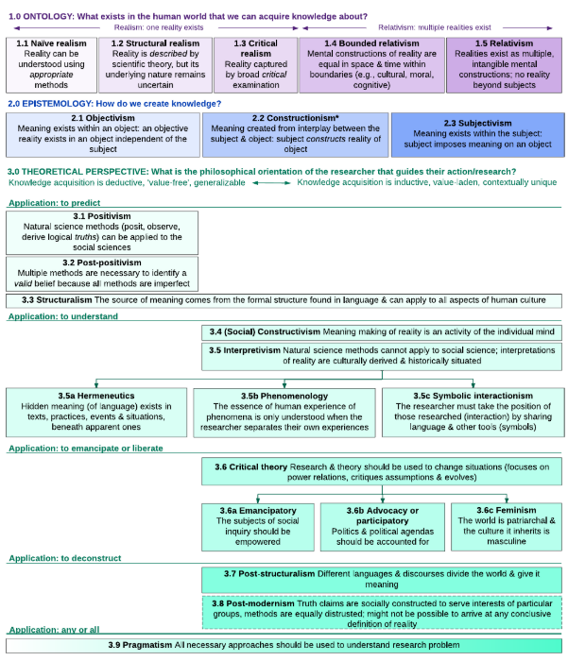
Source: A Guide to Understanding Social Science Research for Natural Scientists (Blackman and Moon, 2014, p. 1169)

Appendix 2: Summary of the enabling ethical governance at different stages of research (Sivasubramaniam, Dlabolová, Kralikova, et al. 2021)

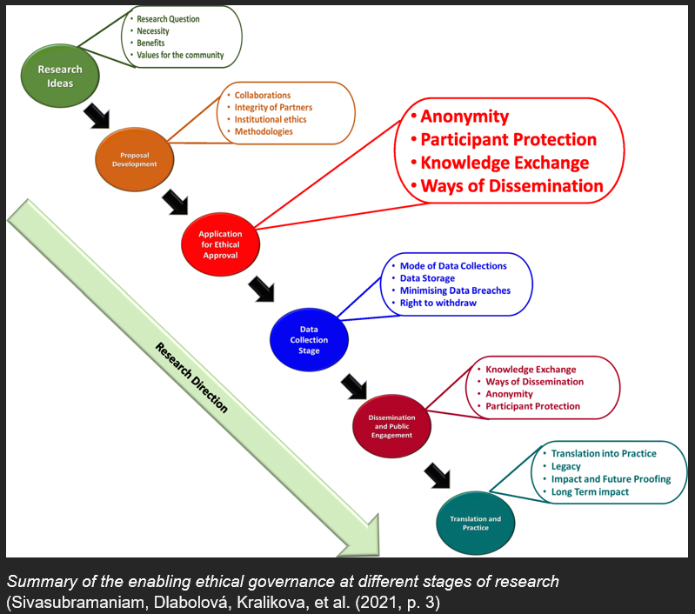
Source: Assisting you to advance with ethics in research: an introduction to ethical governance and application procedures (Sivasubramaniam, Dlabolová, Kralikova, et al. (2021, p. 3)

