
Louisa Clearwater (2519339)
University of wales trinty stant david
COP - ADAPTATION TO CLIMATE CHANGE
MSc Environmental Conservation & Management ACBA 7007 Strategic Management for Conservation
Tutor Elanor Alun
May 25, 2026

Contents
1 COP action on Adaptation to Climate Change (ACC) 3
2 What is Adaptation to Climate Change 3
2.1 Forms of Adaptation 4
2.2 Forms of Adaptation Actions 4
3 Adapting to Climate Change – The Journey so Far 5
3.1 COPs that made a difference 6
COP7 6
3.2 COP16 7
3.3 COP21 - Paris 7
3.4 COP26 8
3.5 COP28 8
4 Position leading to COP30 9
5 COP30, Belem: The COP of Implementation 11
6 COP30 Outcomes 12
6.1 12
7 What Next for ACC 12
7.1 Realistic Trajectories For ACC 12
7.2 Barriers and Funding Concerns 13
8 How ACC Relates to Other Themes 14
8.1 Interlinkages with Mitigation, Low-Carbon Development, and Technology 14
8.2 Forests, Biodiversity, and Ecosystem-based ACC 14
8.3 Climate Justice and Social Impacts 15
9 Conclusion 15
10 References 16
11 Glossary 16

COP action on Adaptation to Climate Change (ACC)
The 30th was held on 10-21 November 2025 in Brazil; this will be an important event for ACC, as studies show that global temperatures continue to rise, increasing the need for ACC (Mander et al., 2025). The United Nations Framework Convention on Climate Change (UNFCCC) is an international treaty that convenes the Conference of the Parties (COP) annually, bringing together world leaders, business, civic, and academic representatives to debate global climate governance and to set policies and frameworks, such as the Global Stocktake. ACC finance is negotiated and mobilised via the Green Climate Fund, the Adaptation Fund, the Least Developed Countries Fund (LDCF), and the Special Climate Change Fund (SCCF). Along with financial aid, COP advocates for vulnerable countries by prioritising the Small Island Developing States (SIDS), Least Developed Countries, and communities facing climate-induced displacement in decision-making. COP encourages countries to integrate ACC into all development and core actions, such as infrastructure, water management, agriculture, health systems, and urban planning. COP uses frameworks such as the Cancun Adaptation Framework, National Adaptation Plans, and the Paris Agreement’s Global Goals on Adaptation to guide countries' plans, finance, and the implementation of resilience measures (Grantham Research Institute, 2023).
This report aims to address the following two questions.
- To what extent have previous COP meetings delivered on ACC
- What are the prospects for ACC after COP 30
It will begin with an examination of ACC, including its forms and applications, followed by an exploration of the COP ACC journey, focusing on the pivotal summits. ACC’s position pre-COP 30 will be established before reviewing the outcomes and ACC's prospects. The report will finish with a reflection on the relationship between ACC and the other main topics at COP 30.

What is Adaptation to Climate Change
According to UNFCCC (2025), ACC is the proactive or reactive changes in environmental, social or economic systems as a result of actual or anticipated climate change, which protect against negative impacts, optimise opportunities, and reduce vulnerability to climate change through increased resilience. COP promotes actions in infrastructure, such as building flood defences and protective structures, in agriculture, mixing crops to reduce vulnerability and the use of more resilient seed varieties, systems, through the development and installation of early warning systems for natural disasters such as flooding, and in management, changing policies and practices, such as communication systems, to reduce the risk of harm or damage. It is important to recognise that the need to tailor responses to the situation, that there are no one-size-fits-all answers and action is needed at multiple levels of governance.

Forms of Adaptation
ACC is a core pillar of climate policy. As climate impacts intensify despite mitigation efforts, the impacts of climate change are unavoidable; therefore, ACC is imperative to protect lives, food systems, ecosystems, and infrastructure. Each impact situation is different, so ACC needs to take many forms and actions to support a bespoke adaptation plan. The different adaptation forms are shown in Table 1.
Table 1Adaptation Forms and their application
Relates to the time of intervention | Reactive | post-impact, such as rebuilding bridges after flooding
Relates to the time of intervention | Anticipatory | pre-impact installation of early warning systems, resilience infrastructure, and flood defences.
Level of change within a system or sector | Incremental | adjustments within a system while the core structure, technology, or location remains the same, such as increasing the height of existing sea walls, changing planting dates to adjust to changing weather patterns or creating firebreaks to protect existing homes and buildings from wildfires
Level of change within a system or sector | Transformational | refers to a seismic shift in which the core of the system is altered, such as the shift to renewable energy or farmers leaving agriculture to make a living (Fedele et al., 2019).
Tangible and Intangible | Hard | physical, such as sea walls, flood protection, or covered carparks for sun protection
Tangible and Intangible | Soft | policies, governance, and behavioural shifts.

Each form has an appropriate use and should be considered and applied in conjunction; hard and soft can be used together with the physical production of covered parking and the behavioural shift to parking undercover, reactive after the unpredictable, anticipated where the dangers are known. More controversial is the decision to apply incremental or transformational adaptation; transformational adaptations, such as the move to renewable energy, are desirable. Still, it will negatively impact the communities living beside the windfarms or below the pylons.

Forms of Adaptation Actions
As CC affects almost all life systems, practices, and sectors in myriad ways, ACC, as a tool, needs to take multiple forms. The Global Centre on Adaptation (GCA) (2024) proposes several forms of Adaptation actions, as shown in Table 2.
Table 2 Adaptation Actions
Anticipatory and proactive actions | Early warning systems, climate-resilient infrastructure – building designed for increased temperatures and rising water levels, water-management reforms – rainwater harvesting and developing water supply systems resilient to volatile weather patterns, and heat-resilient urban planning
Nature-based solutions | Restoring wetlands, reforesting degraded land, and green infrastructure, such as mangroves and coastal salt marshes, to act as buffer zones.
Social and institutional ACCs | Strengthen governance, updating building codes to ensure new buildings are as sustainable as possible, support vulnerable communities and integrate climate risk into planning and finance.
Economic and technological ACCs | Moving to climate-smart agriculture, drought-tolerant crops, and insurance and risk-transfer mechanisms, Ocean Finance Company used a combination of financing types to offer investors a range of risk levels in its Galapagos enterprise (Lane, 2024).

ACC should be seen as a crucial aspect of development to reduce poverty which will increase if the impacts of CC are not addressed, to secure food and water availability, protect against health and wellbeing impacts such as increased risks form infectious diseases, non-infectious diseases causing more harm and anxiety induced mental health (Maslin et al., 2025), CC can cause economic instability through increased insurance costs, loss of production and widening inequality which can be elevated though proactive adaptation (Fuldauer, Thacker and Hall, 2021), and by embedding ACC in the core of sustainable development to reduce vulnerability whilst protecting natural resources.

Adapting to Climate Change – The Journey so Far
Initially, overshadowed by mitigation, the need for ACC was realised after the Intergovernmental Panel on Climate Change (IPCC) 2001 report, which offered hard evidence of climate impacts, including irreversible damage to ecosystems, threats to human life systems such as food production through flooding, droughts, etc., as mitigation would not alleviate impacts already occurring (McCarthy et al., 2001). The report acted as a catalyst, and ACC gained greater attention, with it featuring prominently at future summits. Figure 1 illustrates how ACC has evolved over the course of COP.
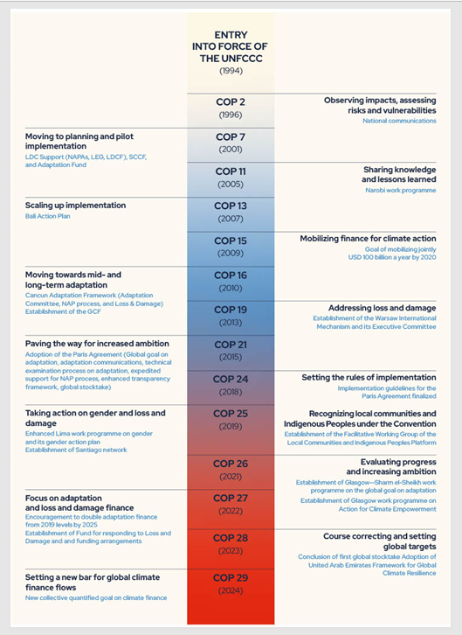
Figure 1Selected adaptation milestones since 1994 (Adaptation Committee, 2024, p. 17)

COPs that made a difference
Following the IPCC 2001 report, ACC gained greater attention, as illustrated in Figure 1. This report will now consider five summits which were meaningful to CC Adaptation development.
COP7
It was at COP7 (2001) in Marrakesh that ACC transitioned into an international climate response pillar with institutional structures and financial mechanisms. This was pivotal, as the IPCC 2001 report demonstrated that, without a time machine, some aspects of CC could not be reversed; therefore, a change in practices and behaviours was needed. It exposed the irony that communities that had contributed the least to CC were often both the most at risk and the least able to counter the impacts (Greentech Lead, 2025). In response, COP7 established the Least Developed Countries Fund (LDCF) to support LDCs prepare and implement National Adaptation Programmes of Action (NAPAs), the Special Climate Change Fund (SCCF) to fund adaptation, technology transfer, and economic diversification projects, and the Adaptation Fund was established and later launched in 2007. Under Decision 5/CP.7, the Least Developed Countries Expert Group (LEG) was formally set up to aid the most vulnerable countries to draft NAPAs outlining the most immediate ACC needs, and from workshops focused on ACC guidelines for disaster planning and readiness, the collection and dissemination of climate data, and installing or upgrading extreme weather warning systems (Siegele, 2023). The purpose of the decision and the

COP16
Following the underwhelming COP 15 in Copenhagen (Vaughan and Adam, 2009), which ended without a commitment to reduce emissions or a substantial agreement, with high conflict between the developed and less developed countries, Lumumba Di-Aping from G77, calling it CC scepticism in action (Vidal, Goldenberg and Stratton, 2009). COP 16 in Cancun was a more cordial conference; the need for countries to negotiate and reach agreements was clearly recognised.
The Cancun Adaptation Framework and the Adaptation Committee were established here. Both are to assist LDCs in creating and delivering NAPs with technical support, sharing best practices and information, and counselling the COP on ACC issues. Technology and information sharing would be facilitated by the Climate Technology Centre and Network (CTCN) established here, and the earlier-proposed Green Climate Fund was formally established, securing funding for adaptation and mitigation projects (United Nations Climate Change, 2025).
Providing LDCs with the tools required to produce and implement NAPs is as essential as producing robust NAPs. The process includes complex assessments and modelling of potential risks using localised meteorological data, and infrastructure not found in many LDCs, as most LDCs do not have the finances to fund these and other CC monitoring capabilities, nor the skills to attract private funding (Yassin, 2019).

COP21 - Paris
Seen as a pivotal summit, COP 21 was heralded as a turning point where legal agreements were made on limiting global warming and emissions – net zero emissions with a transition away from fossil fuels, to track process and on funding (Kinley, 2016).
Here, ACC was recognised as equally important as mitigation, and the Global Goal on Adaptation was established, a framework that obliged all countries to establish an iterative programme of ACC planning, implementation, and review. This way, the programmes were tailored to the needs of that country rather than prescribing generic measures for all countries. The framework required countries to set NAPs that address medium- and long-term ACC needs, regularly reporting in detail their priorities, plans, and actions, with a five-yearly progress assessment to track the collective ACC process and ensure vulnerable countries receive sufficient support.
Critics of the ACC results called them weak; framed as recommendations, they lacked definition, leaving too much room for independent interpretation; adaptation finance was not set; and too much emphasis on planning and reporting inhibited adaptation action (Persson, 2019). The global collation of reports on adaptation activities and their results appears to be a straightforward endeavour. Yet studies have found that interpretations of outcomes differ depending on the metrics and objectives. For example, grants for creating farm ponds in India are considered effective actions when viewed through an ecosystem-based adaptation lens. Still, issues with grant availability make it ineffective when measured through a justice/equality lens (Singh et al., 2021).

COP26
The COP 26 held in Glasgow saw the first quantified international agreement on Adaptation finance, with a collective commitment from developed countries to double finance to 2019 levels by 2025. Article 6 secured a 5% share of proceeds from new carbon market mechanisms to go directly to supporting LDCs via the Adaptation Fund. The two-year GGA Glasgow-Sharm el-Sheikh Work Programme is set to establish the means to define and assess global progress in protecting vulnerable communities. This programme is important as studies have identified a global north-south divide in the measurement of CC impacts and dangers, with Global North countries reticent to engage due to liability fears. At the same time, the Global South are motivated by the prospect of imminent impacts. Also highlighted are concerns about quantitative measurement methods that oversimplify complex issues, ignore the political positions of the Global South, and disproportionately empower experts who formulate measurement goals and indicators, who undervalue local and cultural values (Falzon, 2024). Set to prioritise frontline and indigenous communities in adaptation funding and decision-making, the Principles for Locally Led Adaptation were endorsed by over 70 countries and organisations. This is important as they are the communities facing the greatest immediate risk and are the least able to manage the impacts independently. Twenty years on from COP7 (2001) in Marrakesh, most COP ACC discussions are still focused on governance, policy, and procedure, with limited implementation a point recognised in academic literature reviewing the summit (Wang, Liu and Gu, 2022).

COP28
The UAE Framework for Global Climate Resilience was set up during COP 28. It is an iterative ACC assessment process to monitor the impact, planning, implementation and assessment of seven key themes: food, water, health, ecosystems, infrastructure and settlements, poverty, livelihood, and cultural heritage. Studies showed that much of this information is already collected and available for analysis from different sources. It shows that most reporting focuses on the first phase of the iterative adaptation cycle: 73% on risk or vulnerability assessment, 16% on planning, 36% on implementation, and just 9% on follow-up observation. The coverage of the proposed themes has a narrower range, with 32% focusing on livelihoods, 29% on water and sanitation, 25% on health, 21% on ecosystems, 20% on infrastructure, and lagging way behind, cultural heritage on 4%, see figure 2 (Biesbroek et al., 2025). From the collected data, it is clear to see who, what or where the risk or vulnerabilities are, with some understanding of the implementation, but very little on the planning and almost none on the results of the intervention, the gap in monitoring data is especially problematic as it is from the monitoring of initiatives that allows the creation of best practices, and prevents the application of less successful initiatives elsewhere.

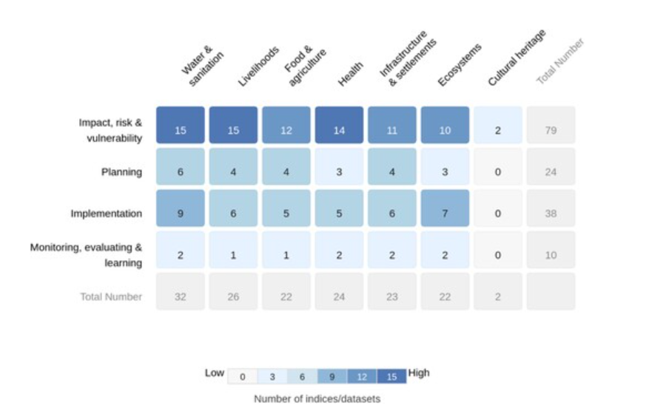
Figure 2 Analysis of data collected by adaptation cycle iteration stage and theme (Biesbroek et al., 2025)

Position leading to COP30
2025 marked a decade since the introduction of the Global Goal on Adaptation (GGA) at COP21 in Paris, and the jointly produced Adaptation Gap Report (AGR). An analysis of the AGR from 2014 to 2024 charts the development of climate adaptation over its first decade. Following the iterative adaptation cycle, which focuses on awareness, policy development, financing and implementation, the analysis found policy development (33.8%) and financing (34.8%) received significantly greater coverage than awareness (13.7%) and implementation (17.7%). See figure 3. While many countries have ambitious ACC goals, policy development is generally poor, with inconsistent planning and weak governance structures due to a lack of vertical integration - the links between local to national levels, and horizontal integration – between sectors and regions.
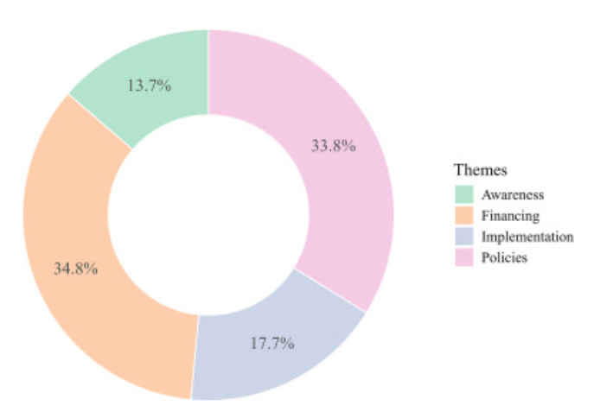
Figure 3 AGR 2014-2024 Focus distribution
Progress has been stunted by debates over governance, policies, tracking, and funding, as well as by a lack of urgency from developed countries and technical know-how from LDCs. As a result, ACC actions are not progressing fast enough in either developed or developing countries,
Here in the UK, the Climate Change Committee (CCC)'s 2025 report has found that climate impacts are intensifying faster than the UK can respond, with many sectors' ACC either regressing or stalled. This means the country is not prepared for extreme climate events such as heatwaves and droughts. The UK’s lack of investment in the infrastructure and management systems needed leaves UK residents at greater risk of harm from CC events (Climate Change Committee, 2025).
In developing countries, there is rapid urbanisation, as populations move for economic or displacement purposes, the towns and cities are growing and without due care and planning, residents' quality of life is affected by pollution, and stagnant CO2 emissions causing heat dome effects, traffic congestion, rising housing costs and reducing housing availability. To prevent this, developing countries should build robust governance, including transparent, stable leadership, stakeholder alignment, and sustainable network management (Choi, 2021).
ACC costs are rising, with the gap between needs and available resources widening as funding remains insufficient, as illustrated in Figure #, where red bars represent needs and dark blue bars represent available finance (Carbon Brief, 2025).
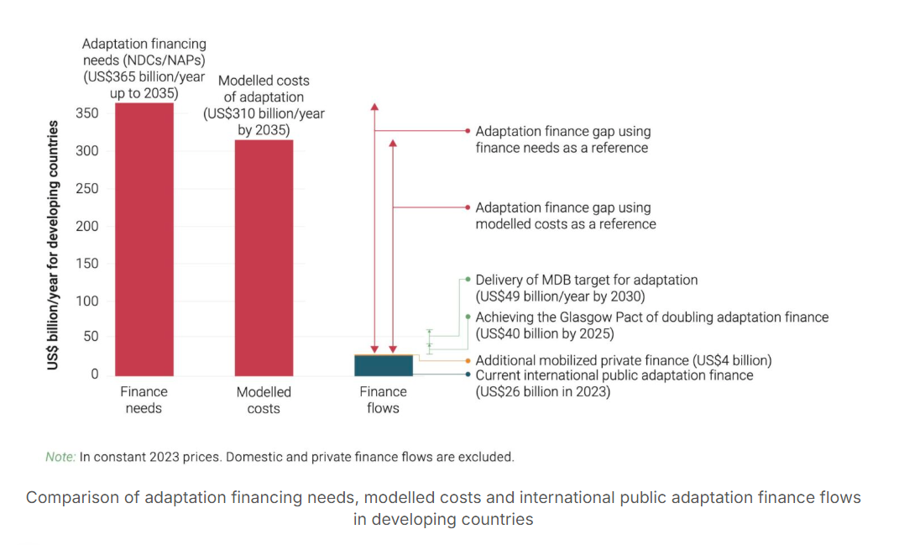
Figure 4 Adaptation needs vs funding flow
While awareness of the impacts of CC on issues such as health (Smeeth and Haines, 2023) is increasing, promoted by COPs with themes such as COP 29's Enhance Ambition, Enable Action, access to knowledge remains fragmented across regions and poorly integrated across sectors. Thus, implementation is hampered by poor monitoring and evaluation methods. The 2023 AGR reported that 40% of adaptation implementation projects lack the data to detail their programs, reducing accountability. Poor alignment of actions has led to increased poverty and community disempowerment, as seen in Bangladesh's water management initiatives. These factors also inhibit the upscaling of projects (Wang et al., 2025).

COP30, Belem: The COP of Implementation
Going into COP 30, little had changed in the ACC situation from COP 28. ACC has gained another framework, the Baku Adaptation Roadmap (BAR), but ACC remains under-resourced, with political action and ACC needs continuing to widen (Khan et al., 2026). COP 29 failed to prevent the escalation of climate impacts. LDCs were confronted with growing inequalities and awareness of the injustice that, despite being the least responsible for CC, they faced the greatest challenges (Villagra, 2025). Going into COP 30, it is clear talks must move from a stuttering political side topic to the headlining stage, with ironclad financial commitments and clearer implementation pathways. Moving LDCA funding from loans to grants will promote equality and prevent long-term debt, as financial costs have been identified as the leading barrier to implementing NAPs (Earth.Org, 2025). GGA is being weakened by party apathy toward the submission of the new, more ambitious National Determined Contributions (NDCs), with only 21 countries having complied, including major emitters China and the EU (Cuff, 2025). This is concerning because it delays resilience planning, weakens the integration of ACC into national development, and reduces clarity about global adaptation goals.
At the summit, ACC was a major topic with the COP President-Designate Andre Correa do Lago calling for negotiation to transition into implementation, for the need to support the most vulnerable communities to be recognised, for forests to be seen as resilience engines as well as carbon sinks, and for the alignment with Global Adaptation Governance (GAG) (Mirza, 2026). These goals require behavioural change, stronger governance, and financial investment. To help vulnerable communities, adaptation finance needs to be increased, access to adaptation technology ensured, and resilience reinforced through ecosystem restoration. Forest restoration is important as it strengthens ecosystems, creates bioeconomy opportunities, and improves local livelihoods while protecting against climate impacts such as flooding, heat, and biodiversity loss. To align with GAG, the NDCs need strengthening with adaptation components, by linking the NDC, the what, with their domestic NAPs, the how. This prevents duplication and meshes with broader national development.

COP30 Outcomes
The COP30 summit closed with two main adaptation-related outcomes: one finance-based and the other focused on progress tracking. The first was to secure the agreement of $300bn pa for developing nations by 2035 and a recommitment to $1.3tn pa from public and private sources by 2035 (Carlin, 2025). Many LDCs will be disappointed with the extended deadline to meet the commitment pushback from 2030, and they may have concerns about access to the funds, as funding has been committed, but access to other funds has been slow and frustrating.
The summit also adopted 59 of the 100 recommended ACC indicators proposed by technical experts. The last-minute alterations, which excluded some and altered others for adoption, were driven by concerns from some LDCs about the intrusive nature of the indicators that would monitor their domestic CC legislation and spending, without secured funding support. The last changes meant the details and possible alternatives could not be discussed (Wyns, 2026). The adaptation indicators are voluntary, non-prescriptive metrics that can be tailored to different situations and are used to measure progress on the UAE Framework for Global Climate Resilience.

What Next for ACC
ACC is now unavoidable, as global temperatures rise, locking in worsening climate impacts and driving the need to make ACC a central pillar of climate governance rather than a secondary concern. Yet a number of barriers to ACC remain. These include structural barriers, the need to reform climate financing, the integration of mitigation and biodiversity goals, and the need to address deep social inequalities, as ACC outcomes are shaped by finance, inequality, political economy, justice, and climate science.

Realistic Trajectories For ACC
Going forward, it is probable that reactive, hard, incremental adaptation measures, such as increasing flood protection or upgrading irrigation systems, will be more favourable to governing and financing bodies. Where the need has been demonstrated, and there is minimal disturbance to behaviours or practices with a tangible end product, fits short-term political cycles and are more palatable to voters and less disruptive in practice compared to proactive, soft, transformational measures, such as moving communities from flood-affected areas, or phasing out fossil fuel-powered cars, which are politically sensitive and costly (Fedele et al., 2019). The need can be challenged, the changes to behaviours and practices can be challenging, and the intangible changes to policy or governance can be invisible to voters.
Structural change is needed to depoliticise ACC and encourage long-term planning, with proactive, hard and soft initiatives that balance tackling the root causes of climate threats with heritage values and user discomfort for radical change.

Barriers and Funding Concerns
Despite growing recognition of ACC's importance, progress is frequently hindered by governance and institutional barriers, as well as by challenges in climate finance. LDCs face governance and institutional barriers, including insufficient institutional capacity, that inhibit planning, monitoring, and implementation. Such as limited access to relevant local climate information and risk assessment, social inequalities that lead to additional vulnerability, and short-term political cycles that prevent long-term planning (Grantham Research Institute, 2021). Climate finance challenges include the increasing gap between needs and resources, see section 4. Between 2016 and 2022, only 10% of the flow of Adaptation funding, which is less than 10% of all global climate financing, went to LDCs (Larsen, Brandon and Carter, 2025). Increasingly, funding is offered in the form of loans, which risks LDCs falling into a poverty trap (Carbon Brief, 2025). Often, finance providers prefer larger projects because they offer better investment returns, easier impact tracking, and lower administrative costs. However, LDC’s schemes are more often small as they lack the institutional capacity to complete the complex applications required for larger project funding applications (Micale, Tonkonogy and Mazza, 2018).
Going forward, the COP plan for ACC will be focused on localised action, with countries self-managing NAPs, the new GGA indicators tracking resilience across suppliers, food and agriculture, ecosystems, etc., and diligent reporting, knowledge gaps will be eliminated, and the global stocktake will record progress.
However, the success of these plans is not guaranteed, as they rely on securing long-term political commitments, building institutional capacity, and obtaining reliable, grant-based finance.

How ACC Relates to Other Themes
The need for ACC does not arrive in isolation; therefore, it should not be applied or reviewed in isolation from other climate change themes. Below is an examination of how ACC interacts with COP 30’s other main topics.

Interlinkages with Mitigation, Low-Carbon Development, and Technology
Mitigation and Adaptation are both tools for managing climate change. While mitigation focuses on the causes and aims to prevent or reduce the production of harmful gases, ACC focuses on mitigating or reducing their harmful effects. Opposing targets that frequently clash, requiring trade-offs and risk management. Large-scale renewables can displace communities or degrade ecosystems if poorly sited. Bioenergy and hydropower can cause water security issues and undermine biodiversity. Carbon-centric policies compete with urgent ACC funding needs. The two can interconnect synergistically. Nature-based adaptation solutions, such as mangrove and wetland restoration and the transition to agroforestry, offer both mitigation through carbon sequestration and adaptation through resilience. COP 30’s commitments to strengthen mitigation should reduce the need for adaptation measures, but this must be balanced against the risk of rising adaptation costs and impacts when mitigation fails; therefore, it is essential that the two are aligned.
While there are many technological adaptation benefits, such as the means to move away from fossil fuels, issues of access lead to inequality, as many LDC’s are blocked from them through cost, patents, and supply chain factors. Green extraction, the mining of transitional materials like copper, which is essential in the production of green technology, also threatens local communities and ecosystems (Moulton, 2024). COP 30 promoted increases in renewables but failed to confirm a pathway to end fossil fuel dependence.

Forests, Biodiversity, and Ecosystem-based ACC
Forests, biodiversity, and ecosystem-based ACC measures form the ecological dimension of ACC, bringing resilience benefits and political tensions. The benefits of Ecological Adaptation (EA) include mangroves and woodlands providing flood buffer zones, stabilising soil, enhancing food security, and regulating disease. These benefits are cost-effective and socially positive but remain underfunded. Market-driven conservation vehicles such as carbon offsets and Reducing Emissions from Deforestation and forest Degradation (REDD+), support local communities to keep their forests, but can also undermine them by overstating results, not securing permanent protections, and the transition of habitat loss from one area to another (West, Bomfim and Haya, 2024).
EA can also have a negative impact, such as prioritising carbon storage over local resilience and Fortress conservation, which locks out all non-conservation endeavours, leading to the disempowerment and displacement of Indigenous people (Robbins, 2007), which in turn can lead to resistance to ACC projects (Mills‐Novoa and Mikulewicz, 2024). COP 30 outcomes for ecological adaptation included new Tropical Forests Forever Facility (TFFF) funding, increased monitoring cooperation of the Amazon, promotion of carbon market and nature linkage, and improvements in the recognition of Indigenous land roles (Platt and Poe, 2025). COP 30 supports rights-based, locally led conservation and ACC.

Climate Justice and Social Impacts
Climate justice highlights the unequal vulnerabilities of SIDs, LDCs, women and children, Indigenous people, disabled people, and those in informal settlements, fragile communities – those affected by conflict, as they experience disproportionate impacts such as displacement, resettlement, rising costs of climate-protection infrastructure, and exclusion from decision-making (Reda and Wong, 2021). Frameworks should include distribution justice, which examines who should receive funding; procedural justice, which examines who holds authority and whose knowledge counts; and recognition justice, which ensures the inclusion of historical and structural inequalities.
Positive justice action at COP 30 includes establishing the Belem Action Mechanism (BAM) to coordinate global efforts to protect workers and vulnerable communities during the transition away from carbon-based economies, ensuring decent jobs that secure their well-being, and adopting the Adaptation Indicators discussed in section 6. Unfortunately, there was no agreement on the phase-out of fossil fuels, nor any financial structural reforms.
Climate Justice and social reforms are essential elements of ACC, as failure to incorporate justice into ACC leads to more injustice through maladaptive infrastructure, forced relocation, exclusion from planning and rising adaptation costs.

Conclusion
This report has considered the extent to which previous COP meetings have delivered on ACC and the prospects for ACC after COP 30. It has charted the growing recognition of ACC's importance in CC management and its slow progress into CC actions. Despite the growing awareness of ACC's importance, many developed countries are slow to create and implement NAPs, while LDCs struggle to access the funding and technical support required to take meaningful action. Tensions between climate experts who exclude local inhabitants from action planning are leading to resistance to climate action. Funding remains problematic in both its acquisition and the flow to the most vulnerable.
To overcome these barriers, ACC needs to be a critical, multidimensional response, grounded in long-term planning and monitoring, with strong governance, adequate financing, and inclusive and equitable approaches integrated across sectors and scales. Funding for LDCs needs to be through grants rather than debt-incurring loans, which widen inequality gaps. Failure to address these issues will lead to greater inequalities instead of reducing them. As Luiz Inacio Lula da Silva stated, the time for talking was over; now is the time for action (Lula, 2025).

Reference List
Adaptation Committee (2024) 30 Years of Adaptation under the Convention and the Paris Agreement. Available at: https://unfccc.int/sites/default/files/resource/AC_2024_30YearsOfAdaptation.pdf.
Biesbroek, R. et al. (2025) ‘Assessment of existing datasets for tracking progress towards the Global Goal on Adaptation (and beyond)’, Climate Policy, 26(4), pp. 1–15. Available at: https://doi.org/10.1080/14693062.2025.2517644.
Carbon Brief (2025) UN report: Five charts which explain the ‘gap’ in finance for climate adaptation - Carbon Brief, Carbon Brief. Available at: https://www.carbonbrief.org/un-report-five-charts-which-explain-the-gap-in-finance-for-climate-adaptation/.
Carlin, D. (2025) Your quick guide to the outcomes of COP30 | Feature from King’s College London, Kcl.ac.uk. Available at: https://www.kcl.ac.uk/your-quick-guide-to-the-outcomes-of-cop30.
Choi, Y. (2021) Energy Efficiency and Urban Climate Adaption, Proquest.com. Available at: https://www.proquest.com/docview/2554769355/abstract/C133006388D14645PQ/1?accountid=130472&sourcetype=Scholarly%20Journals (Accessed: 5 May 2026).
Climate Change Committee (2025) Progress in adapting to climate change: 2025 report to Parliament - Climate Change Committee, Climate Change Committee. Available at: https://www.theccc.org.uk/publication/progress-in-adapting-to-climate-change-2025/.
Cuff, M. (2025) ‘Is the COP30 climate summit in crisis?’, London, 266(3544), pp. 8–10. Available at: https://www.proquest.com/docview/3207753524?accountid=130472&parentSessionId=ZhtJN9UQDYM9ivcjLavXd86JSza5pqz4Gx6hdIOzYw8%3D&pq-origsite=primo_ra&sourcetype=Magazines.
Earth.org (2025) Climate Adaptation at COP30: What to Expect, Earth.org. Available at: https://earth.org/climate-adaptation-at-cop30-what-you-need-to-know/.
Falzon, D. (2024) ‘How to track progress on the Global Goal on Adaptation?: a stocktaking of Parties’ positions on measurement one year into the GlaSS work programme’, Climate and Development, 16(10), pp. 1–10. Available at: https://doi.org/10.1080/17565529.2024.2326852.
Fedele, G. et al. (2019) ‘Transformative adaptation to climate change for sustainable social-ecological systems’, Environmental Science & Policy, 101(101), pp. 116–125. Available at: https://doi.org/10.1016/j.envsci.2019.07.001.
Fuldauer, L.I., Thacker, S. and Hall, J.W. (2021) ‘Informing national adaptation for sustainable development through spatial systems modelling’, Global Environmental Change, 71, p. 102396. Available at: https://doi.org/10.1016/j.gloenvcha.2021.102396.
Global Center on Adaptation (2024) What is climate adaptation?, Global Center on Adaptation. Available at: https://gca.org/what-is-climate-adaptation/.
Grantham Research Institute (2021) What is climate change adaptation?, Grantham Research Institute on climate change and the environment. London School of Economics and Political Science. Available at: https://www.lse.ac.uk/granthaminstitute/explainers/what-is-climate-change-adaptation/ (Accessed: 27 January 2026).
Grantham Research Institute (2023) What are the UN ‘COP’ climate change conferences?, Grantham Research Institute on climate change and the environment. Available at: https://www.lse.ac.uk/granthaminstitute/explainers/what-are-the-un-cop-climate-change-conferences/.
Greentech Lead (2025) Top 10 Highlights from COP30 in Brazil: Key Themes on Climate Action, Finance, and Energy Transition, Proquest.com. Available at: https://www.proquest.com/trade-journals/top-10-highlights-cop30-brazil-key-themes-on/docview/3270076942/se-2?accountid=130472 (Accessed: 18 May 2026).
Khan, M.I. et al. (2026) ‘COP29 at the climate crossroads: achievements, gaps, and implications for a warming world’, Frontiers in Climate, 7. Available at: https://doi.org/10.3389/fclim.2025.1685999.
Kinley, R. (2016) ‘Climate change after Paris: from turning point to transformation’, Climate Policy, 17(1), pp. 9–15. Available at: https://doi.org/10.1080/14693062.2016.1191009.
Lane, K.J. (2024) Mechanisms to de-risk investment in local adaptation: Why and how?, Devex. Available at: https://www.devex.com/news/mechanisms-to-de-risk-investment-in-local-adaptation-why-and-how-108039.
Larsen, G., Brandon, C. and Carter, R. (2025) Adaptation Finance: 11 Key Questions, Answered, www.wri.org. Available at: https://www.wri.org/insights/adaptation-finance-explained.
Lula (2025) The era of fine speeches and good intentions is over. Brazil’s Cop30 will be about action, the Guardian. The Guardian. Available at: https://www.theguardian.com/commentisfree/2025/nov/06/brazil-cop-30-truth-world-leaders-climate-crisis-president-lula.

Mander, Ü. et al. (2025) ‘Human‐Impacted Natural Ecosystems Drive Climate Warming’, Global Change Biology, 31(8). Available at: https://doi.org/10.1111/gcb.70449.
Maslin, M. et al. (2025) ‘Understanding the health impacts of the climate crisis’, Future Healthcare Journal, 12(1), p. 100240. Available at: https://doi.org/10.1016/j.fhj.2025.100240.
McCarthy, J.J. et al. (2001) CLIMATE CHANGE 2001: IMPACTS, ADAPTATION, AND VULNERABILITY. Intergovernmental Panel of Climate Change.
Micale, V., Tonkonogy, B. and Mazza, F. (2018) A CPI Report Understanding and Increasing Finance for Climate Adaptation in Developing Countries. Climate Policy Initiative.
Mills‐Novoa, M. and Mikulewicz, M. (2024) ‘The Promise of Resistance: A New Lens for Climate Change Adaptation Research and Practice’, Wiley Interdisciplinary Reviews Climate Change, 16(1). Available at: https://doi.org/10.1002/wcc.922.
Mirza, Z. (2026) Redirecting, Proquest.com. Available at: https://www.proquest.com/docview/3176432389?accountid=130472&parentSessionId=lnGK2I9osnfiI8G50IWh57AVkC1PW42nLAhhQ6RBFpE%3D&pq-origsite=primo&sourcetype=Trade%20Journals (Accessed: 18 May 2026).
Moulton, H. (2024) ‘Indigenous women are the “guardians of Pachamama”: Territorial sovereignty is indispensable for just climate change adaptations in Peru’, Global Environmental Change, 89, p. 102934. Available at: https://doi.org/10.1016/j.gloenvcha.2024.102934.
Neufeldt, H. et al. (2025) ‘Adaptation Gap Report 2025: Running on Empty - The World is Gearing up for Climate Resilience — without the Money to get there’, United Nations Environment Programme eBooks [Preprint]. Available at: https://doi.org/10.59117/20.500.11822/48798.
Persson, Å. (2019) ‘Global adaptation governance: An emerging but contested domain’, Wiley Interdisciplinary Reviews: Climate Change, 10(6). Available at: https://doi.org/10.1002/wcc.618.
Platt, A. and Poe, K. (2025) Forests and Grasslands at UNFCCC COP30: Spotlighting the value of terrestrial ecosystems for climate change adaptation and mitigation, IUCN. Available at: https://iucn.org/story/202512/forests-and-grasslands-unfccc-cop30-spotlighting-value-terrestrial-ecosystems-climate (Accessed: 25 May 2026).
Reda, D. and Wong, C. (2021) Climate Finance for Sustaining Peace Making climate finance work for UNDP AND THE CLIMATE SECURITY MECHANISM 57.
Robbins, P. (2007) ‘Encyclopedia of Environment and Society’, Encyclopedia of Environment and Society, 5, pp. 705–705. Available at: https://doi.org/10.4135/9781412953924.
Siegele, L. (2023) ‘Financing for loss and damage under the UNFCCC: Have we come full circle?’, Review of European, Comparative and International Environmental Law, 32(3), pp. 403–415. Available at: https://doi.org/10.1111/reel.12524.
Singh, C. et al. (2021) ‘Interrogating “effectiveness” in climate change adaptation: 11 guiding principles for adaptation research and practice’, Climate and Development, 14(7), pp. 1–15. Available at: https://doi.org/10.1080/17565529.2021.1964937.
Smeeth, L. and Haines, A. (2023) ‘COP 28: Ambitious climate action is needed to protect health’, BMJ, 383, p. p2938. Available at: https://doi.org/10.1136/bmj.p2938.
UNFCCC (2025) Adaptation and Resilience, United Nations Climate Change. United Nations. Available at: https://unfccc.int/topics/adaptation-and-resilience/the-big-picture/introduction.
United Nations Climate Change (2025) Three Decades of Climate Adaptation: Milestones and Progress, Unfccc.int. Available at: https://unfccc.int/news/three-decades-of-climate-adaptation-milestones-and-progress.
Vaughan, A. and Adam, D. (2009) ‘Copenhagen climate deal: Spectacular failure - or a few important steps?’, The Guardian, 22 December. Available at: https://www.theguardian.com/environment/2009/dec/22/copenhagen-climate-deal-expert-view.
Vidal, J., Goldenberg, S. and Stratton, A. (2009) Low targets, goals dropped: Copenhagen ends in failure, the Guardian. The Guardian. Available at: https://www.theguardian.com/environment/2009/dec/18/copenhagen-deal.
Villagra, P. (2025) ‘From COP29 to COP30: Rethinking Global Climate Solutions and Latin America’s Role’, Environment: Science and Policy for Sustainable Development, 67(4), pp. 10–17. Available at: https://doi.org/10.1080/00139157.2025.2496101.
Wang, T. et al. (2025) ‘Big ambitions and insufficient actions: A decade of climate adaptation progress’, Advances in Climate Change Research, 16(5). Available at: https://doi.org/10.1016/j.accre.2025.08.002.
Wang, Y., Liu, Y. and Gu, B. (2022) ‘COP26: Progress, Challenges, and Outlook’, Advances in Atmospheric Sciences, 39(8), pp. 1209–1216. Available at: https://doi.org/10.1007/s00376-022-2097-z.
West, T.A.P., Bomfim, B. and Haya, B.K. (2024) ‘Methodological issues with deforestation baselines compromise the integrity of carbon offsets from REDD+’, Global Environmental Change, 87, p. 102863. Available at: https://doi.org/10.1016/j.gloenvcha.2024.102863.
Wyns, A. (2026) COP30 agrees on framework to track global climate resilience, The Lancet Planetary Health. Elsevier Ltd. Available at: https://doi.org/10.1016/j.lanplh.2025.101419.
Yassin, L. (2019) National Adaptation Plans: LDCs need financing to turn words into reality, International Institute for Environment and Development. Available at: https://www.iied.org/national-adaptation-plans-ldcs-need-financing-turn-words-reality.

Glossary
AGR Adaptation Gap Report
BAM Belem Action Mechanism
BAR Baku Adaptation Roadmap
CC Climate Change
EA Ecological Adaptation
GAG Global Adaptation Governance
GGA Global Goal on Adaptation
IPCC Intergovernmental Panel on Climate Change
LDCF Least Developed Countries Fund
NAPA National Adaptation Programmes of Action
NAPs National Adaptation Plans
NDC National Determined Contribution
SCCF Special Climate Change Fund
SIDS Small Island Developing States
REDD+ Reducing Emissions from Deforestation and forest Degradation
UNFCCC United Nations Framework Convention on Climate Change

