
Management Innovation and Sustainability
Emily Thomas 2418089

April 27, 2025
University of Wales Trinity Saint David

Executive Summary

Table of Contents
Executive Summary 1
Introduction 3
Main Findings 4
Conclusion (average of 10% of word count) 11
Bibliography 12
UPDATE TABLE FREQUENTLY – CHECK IT HAS BEEN UPDATED PRIOR TO SUBMISSION

Introduction

The organisation is TATA Steel on Shotton, North Wales. At the Shotton site we have 3 coating lines where two are Colorcoat which is where the galvanised coils are coated with paint. There are different paint systems, colours and emboss patterns available to choose by a customer. As part of the end of line release specifications on the two Colorcoat lines we have machines that measure the colour of the strip compared to the standard that was agreed with the customer. My role within this organisation is a Technician within the Organics section of the Technical Department and part of my role is to load agreed standards into colour machines for the end of line release, monitor and control all standards. The change within my organisation that I will be discussing within this report is a change of colour machine used within my laboratory and the end of line laboratories. This change has had a huge impact on the manufacturing plant, the technical department and incoming supply of materials such as paint due to the new equipment being a different brand, measuring technologies, set up and operation. The colour machine is detrimental to the production line as the Colorcoat lines cannot run without this equipment. The brand of equipment is X-Rite and the Machines are called ERX-145 which I will refer to throughout this report.
This change is being viewed differently by different departments, Technical Dept anticipated a lot of work but good results, Manufacturing anticipated their quality being affected and did not want to change their current procedures.

Main Findings
The change of Colour Measurement equipment is a significant change as they are the most important part of the end of line release specification. The previous machine was a Datacolor Check 2 that was used for end of line colour release, this machine was handheld, measured with direct contact to the sample and it measured at an angle of 10°. The new machine is an X-Rite ERX-145 sits on a stand which does not come into contact with the sample being measured, it must sit exactly 50mm away, it measures at a 45° angle. Within the two Colorcoat end of line labs and the main Day Laboratory there would be 3 new lab machines. Another part of this change is the online measurement equipment will be replaced by these machines, the old online measurement equipment was X-Rite however they were old models. There is one online measurement head on each of the two Colorcoat lines. The new measuring technology was a lot more sensitive than the old as it measured at a different angle and takes the surface condition into consideration. For example, if the gloss was different between two samples, the colour measured on the X-Rite would be very different as the gloss would alter the appearance of the colour whereas the Datacolor would see them a lot closer as it doesn’t see the gloss.

There were several drivers for this change, the first being Datacolor were making their instruments obsolete while X-Rite were making their online measuring instruments obsolete. At this point there was no suitable handheld device available on the market that could be used for our processes. Both of these drivers for change were external however there were an internal drivers too, the first being that the number of colour complaints was increasing so better colour measurement technology was discussed, the other driver was that the two current technologies of colour measurement did not match up and any trends seen in the online measurements could not be seen with the laboratory equipment so it was necessary to find measurement devices that could be used both online and in a laboratory setting.
The intended goals for this change were to align online and laboratory colour measurement, improve number of colour complaints, and have more reliable colour equipment.
My role within this change was to support the manufacturing teams by training and supporting them using both machines alongside each other until confidence from the teams and higher management teams had grown and we would be able to use the new X-Rite equipment for end of line release. Another part of my role was to load all 800+ colour standards into the new machine, in doing so assessing the quality of the standards and creating a plan to replace all the lost/unusable standards. I was given the role to work with the support teams at X-Rite to be the most proficient member of technical using this new technology to create standard operating procedures, write risk assessments and roll out training to the teams.

The initial plan was to use both machines along side each other whilst assessing the quality of the standards that had been loaded into the machine. I was assigned to comparing the measured values from the Datacolor and comparing them to the X-Rite, these figures were entered into the Lab System used on the production lines, taking measurements from every coil. This was to be carried out until most of the standards of frequent runners were of good quality.
The equipment was being installed into the production line and laboratories at the end of January, after 3 months of standard updates and information from daily testing we were going to look at switching over to use the new equipment as release. During these 3 months, all operators would’ve been trained and had time to practise with the machine. However, this did not go to plan, there were several occasions throughout February where the old equipment failed, and the operators were given instructions to use equipment that not everyone was trained in until the next working day where the day teams could fix the old equipment.
The failures of the old equipment had not been factored into the time scales of preparation to use the new equipment, the plan failed 1st March where there were no more of the old equipment that were available as they had all broken beyond repair.
In preparation for this impromptu changeover, there had been a management of change carried out but there was no consideration for the failure of old machines. It was also noted that the training of all operators needed to be completed before the instruments went live, this did not happen. The operators on shift had to teach their other colleagues with the support of the two Technicians within the technical department who were able to train the shifts which changed daily. These technicians also had to manage the schedules to ensure that the standards had been loaded into the instrument the day before as not all standards had been loaded.
The plan in my opinion would’ve worked well and efficiently if there had not been such a large failure. This then led to poor management of who was trained and what was working well until this point. Manufacturing teams and management teams had the opinion that if production was not being disrupted the changeover was being managed sufficiently, however in Technical there was a lack of tracking of standards, what was being loaded, and no traceability of actions. One of the few benefits of this failure was that there was an increase in communication between the manufacturing teams and technical as both teams needed the others’ help either how to use the machine or communicating any issues with standards and keeping samples of any issues. This improved the speed at which the standards issues were resolved.

When applying Lewin’s Forcefield of analysis as a tool for organisational changes where there is a need to balance both forces supporting and against the changes.

Force | Type | Score (1-5)
New Technology | Driving | 2
Management pressure | Driving | 5
incentives | Driving | 2
Improved customer perception | Driving | 4
Old Habits of employees | Resisting | 4
Lack of training | Resisting | 2
Expensive | Resisting | 3
Organisational culture | Resisting | 3
No set time scale | Resisting | 5

The driving forces in this organisational change are new technology, pressure from management and incentives. New technology is always a good investment and even though replacing this much equipment at once is expensive it is justified and has many benefits. The pressure from management is due to the old equipment being unreliable and want to reduce the need for employees to be called in out of hours to temporarily fix any breakdowns until the day teams come back in. The other driving force being incentives is that the quarterly bonuses are partially calculated from customer complaints claims so an improvement in quality and reduction in complaints can improve the quarterly bonus for the site.
With the driving forces there are restraining forces, in this case there are a few including the old habits of employees and organisational culture. Regarding the old habits of employees, generally there is some resistance when there is any form of change especially one that affects their daily work. Many employees are unwilling to train and since this new equipment is more sensitive it means they will initially have more quality holds which is tracked for each shift. This is also where organisational culture comes in, many shifts and team leaders are not open to changing over to a machine they know will affect their quality numbers, opinions given when the initial roll out began was that they would use the old equipment until they possibly could as the numbers were ‘better’. Another resisting force is there was no set time scale, which meant there was resistance to using the new equipment.
Through this analysis, the score for driving forces was 13, with the resisting forces scoring at 17. This shows that the resisting forces were stronger than the driving forces which means there needed to be more effort for this change to be successful and by limiting the resistance. With the failure occurring, you can see that these resisting factors somewhat contributed to the change being not so successful. After a significant amount of time the outcome of this change has benefitted the company in the ways that it intended.

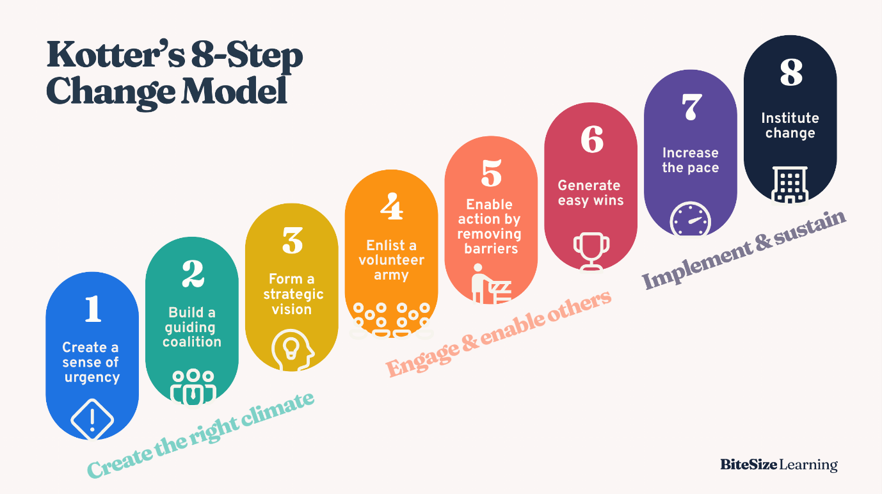
(BiteSize Learning, 2024)

Shown above is the Kotter’s 8-step change model, this is a structured approach to implementing changes. I will apply this to the change I am discussing.
- Creating a sense of urgency
An increase in customer complaints and obsolete instruments creates an urgent need for changing to an alternative that is more sensitive to changes in colour.
- Build a guiding coalition
This should be a small group, each section should nominate a manager, team leader and operator/technician.
- Form a strategic vision
The vision focuses on quality products delivered to customers and consistent results in the laboratory and in-line.
- Enlist a volunteer army
Employees are encouraged to trial the equipment as this gives valued feedback from experience.
- Enable action by removing barriers
Offer in-depth training with easy guides for use provided to operators, and constant support from Technical experts.
- Generate short term wins
Weekly track the number of operators trained, standards that had been improved, number of complaints (when trackable)
- Sustain acceleration
Through succession encourage suppliers to invest in the same equipment as to improve their quality performance. Better goalkeepers.
- Institute change
The new colour measurement equipment becomes end of line quality release and continuous training passed on to manufacturing teams.
(Kotter, JP, 2012)
Encouraging stakeholders’ involvement and communication would be to include employees early during the change especially during the planning stage as they have practical experience. Also, it would be beneficial to hold discussions where all involved are able to ask questions about the change for example why it is happening and how it affects them. The planning of this change had no formal plan such as Kotters’ 8-step change model, if there was then perhaps the failure could’ve been planned for better and more people included from the start.

To do :
Discuss how the change affected employee morale and motivation 300-400
Apply a relevant motivation theory (eg maslow, Herzberg)
Recommended ways to support and motivate employees through change.

Conclusion (average of 10% of word count)

Bibliography

BiteSize Learning (2024). Kotter’s 8-Step change model, explained. [online] BiteSize Learning. Available at: https://www.bitesizelearning.co.uk/resources/kotters-8-step-change-model.
Connelly, M. (2023). Lewin’s Force Field Analysis Explained. [online] Change Management Coach. Available at: https://www.change-management-coach.com/force-field-analysis.html.
Kotter, J.P. (2012). Leading Change. Boston, Massachusetts: Harvard Business Review Press.
Tahir, U. (2019). Lewin’s Force Field Analysis (Change Management). [online] Change Management Insight. Available at: https://changemanagementinsight.com/lewins-force-field-analysis-change-management/.

