

University of Wales. Trinity Saint David
School of Business: Carmarthen

An investigation in to how the rise of e-commerce has impacted the retail sector.

Undergraduate Dissertation

Author: James Cameron
Student Number: 1501039
Module Code: SBUS6108
Supervisor: Dr Roisin Mullins
Date: Tuesday 8th May 2018
Word Count = 12,023

Undergraduate Dissertation Declaration Form

In submitting this dissertation, I confirm that:

1. This work has not previously been accepted in substance for any degree and is not being concurrently submitted in candidature for any degree.
2. This dissertation is being submitted in partial fulfilment of the requirements for the degree of BA Business Management.
3. This dissertation is the result of my own independent work/investigation, except where otherwise stated.

Other sources are acknowledged by footnotes giving explicit references.
A bibliography is appended.

4. I hereby give consent for my dissertation, if accepted, to be deposited in the School dissertation library.

Name: James Cameron
Date of Submission: Tuesday 8th May 2018
Signature:

Acknowledgments
First I would like to thank my dissertation supervisor Dr Roisin Mullins. Throughout this whole process she has always been helpful. Dr Mullins knowledge on this subject is extensive and with her support and guidance I would not have been able to complete the module.
Secondly I would like to thank Dr Alex Bell. In his role as module co-ordinator he has always been willing to offer support and guidance has been extremely helpful and I would have not got started let alone finished it.
Thirdly I would like thank the rest of the staff at the Carmarthen business school. Throughout my three years at the University of Wales Trinity Saint David they provided a large amount of support. Without all of you this work would not have been possible.
Anthony Burns
Glenn Behenna
Sian Harris
Dr Louise Emanuel
Fourthly I would like to thank my fellow students on the course. They offered help, understanding and picked me up when things went wrong. Without them I would have not been able to complete this work.
Finally I would like to thank my friends and family. There love and support has been key throughout this work. From the bottom of heart thank you

Abstract
This report found that the rise of e-commerce has had a devastating but not fatal impact upon the retail sector. It found via diffusion of innovation that the main reason for the success of e-commerce brands is because that make the shopping experience better. E-commerce success was not a sure thing because technology is not created and changes thing just because it’s new but because it makes life better. The report also found that the change in the B2C relationship have given the consumer more power which E-commerce brands are better at exporting. Performed a questionnaire to seek the views of consumers. Made a number of recommendations on how the retail sector can fight back.

Contents
Undergraduate Dissertation Declaration Form 2
Acknowledgments 3
Abstract 4
Background 6
Chapter 1.1 Introduction 7
1.2 Aims 8
Chapter 2.1 Literature review: Digital marketing 9
2.2 Diffusion of innovation 11
2.3 Disruptive technology 14
2.4 Business to consumer (B2C) 17
Chapter 3.1 Case Study: Amazon 21
4.2 Case Study Tesco Online 23
Chapter 4.1 Methodology 26
4.2 Quantitative Research 26
4.3 Academic research 27
4.4 Questionnaire 28
4.5 Why not use qualitative research methods? 29
4.6 Limitations 29
Chapter 5.1 Data analysis 31
Chapter 6.1 Main findings: What has driven the growth of e-commerce? 40
6.2 The growth of e-commerce impact upon retail sector 42
6.3 How can the retail sector respond to the rise of e-commerce? 43
Chapter 7.1 Conclusion 45
7.2 Recommendations 47
References 49
Appendix 52

Background
It is often said that e-commerce is a relatively new force in business just like the internet is to society. However the early seeds of e-commerce where not planted by Amazon or even AOL. In 1971 two students at Stamford University used the campus ARPANET system which stands for Advanced Research Projects Agency Network, to arrange the sale of cannabis. This illegal first act was describe by author John Markoff as “The seminal act of e-commerce”. (Markoff 2005) From these shady roots e-commerce would grow wild and sprawling jungle that we see today. In 1985 Tesco became the first business in the world to use business to consumer network to sell its products. In 1990 the creation of the World Wide Web by Sir Tim Berners-Lee would help the use of the internet and of e-commerce brands and sites explode. In 1995 two brands which would become the faces of e-commerce when Ebay and Amazon where created. By 1999 worldwide e-commerce sales had reached $150 billion. Considering that many of the e-commerce brands at the time where less than five years old that was incredible. This money created both wealth and power and this can be best demonstrated in March of 2000 when AOL who did not exist a decade ago brought the media giant Time Warner “$164bn which is £104bn”. (Barnett and Andrews 2010) This was incredible and showed just how powerful e-commerce brands had become. E-commerce had entered the business mainstream and investors flocked to them, many could see the death physical sectors of the economy and how retail would move online and millions of workers across the western world would be left out of work because of e-commerce. Of course what came next was the near death of the e-commerce sector itself.

Chapter 1.1 Introduction
In March of 2000 the first E-commerce bubble burst and by November of that year E-commerce business had made “A loss of $1.755 trillion” (Kleinbard 2000) I would have been easy to say that while the ashes of so many prominent E-commerce business where still burning that E-commerce had been a fad and that business in the sector had no future. However, among many of the business that did survivor the crash where Amazon and Ebay two business which would go the change the landscape of not just the E-commerce industry but also the retail industry. At the start of the 21st century the retail sector was as healthy as it had ever been but just eighteen years later common wisdom holds that the retail sector is on life support and many well-known brands have left the high street or gone bust because of the impact of business like Amazon.
The retail sector in the UK operates in 290,315 stores as of 2016 and employed around 2.8 million people and sales were worth £358 billion. Now those figures on their own do not sound like a sector on life support as some analysts say. Instead of the rapid decent that some predicted in physical retail stores we have seen a much slower and manageable decent. Of course, some retail chains have suffered from the rise of E-commerce like HMV for example. Once a titian of the British high street HMV whole business model came under attack first from the rise of music piracy in the early 2000 and then from the rise of ITunes and later the likes of Spotify. “Throughout the late 90s and right up until today, HMV's single biggest mistake has been a lack of investment in their online offering” (Beeching 2013) Investing in online has been key to the survival of many brands. In 2016 alone 12% of all total retail sales came from online platforms. To see the strength of E-commerce brands and their impact upon the retail sector you only have to look at the success of Amazon. In 2016 the value of Amazon sales in the UK “£6.3 billion”. (Spanier 2016) Now compared to the total industry value of sales that might not seem like much but remember that Amazon is just one company and it produced £6.3 billion pounds of total retail sales. One of their main completers on the high street is John Lewis made only £1.63 billion in the value of their sales. As it is easy to see Amazon by far the dominate player in the industry and brand that most retail business who fail or struggle blame for their lack of success. The raise of E-commerce brands like Amazon and Ebay and embracement of online platforms for selling their products and services by most brands on the high street makes these changes irreversible. The question which this dissertation seeks to answer is just how the raise of E-commerce has impacted on retail sector. Has it been like the detonation of an area weapon destroying everything or is more like a mild virus slowing killing the weak and along time for the strong to adapt to it?

1.2 Aims
- How has the growth of E-commerce impacted upon the retail sector?
- What has driven this growth in E-commerce
- How is the retail sector responding and addressing the impact of E-commerce business

1.3 Objectives
- Review how relevant literature and theories apply in practise within the retail sector
- Assess the scale of the impact that E-commerce sales upon the retail sector
- Evaluate how effective is the retail sector response has been to this change.
- Propose how retail sector can better use new technology

Chapter 2.1 Literature review: Digital marketing
A number factors have played a role in the rise of e-commerce to what it is today but one factor which is often over looked is digital marketing. After all with so many people online in general in today’s world it’s not a huge leap of logic to say we should market to them online. However Digital marketing is so much more than just online advertising. “Digital marketing can be consider to have a broad scope since it refers to any use of technology to achieve marketing objectives and has an external and internal perspective. This is more consistent with the concept of e-business which involves managing both internal and external communications”. (Chaffey 2008) The rise of digital marketing and e-commerce are directly linked. After all if you are going to convince people to use and embrace e-commerce sites then it is better to do this online than by using more traditional advertising methods. Of course, digital marketing is a catch all term for any marketing that embraces the use of new technology and can be used to encourage people to go a physical store, however it mainly supports e-commerce because after all the business your advertising online could be just one click away. The main flaw with Chaffey work is simple and that is the fact that the information comes from a book published in 2008. That work is almost a decade old and consider the rapid change of technology it could be consider somewhat out of date. The big impact of digital marketing upon both the retail and e-commerce sectors of business comes from social media. Even a decade ago social media was a blip and could have been easily seen as fad, but the likes of Facebook and Twitter have gone on to change almost every aspect of the modern world including digital marketing. “Social media involves “boosting consumer relations on company’s personal website or in the course of its social existence”. Social media marketing is a major significant practice in digital marketing as companies can utilize social media form to allocate their communication to their target viewers without paying for the distributor. Digital marketing, e-marketing, Internet marketing and electronic marketing are all related in terms which, basically put; refer to “marketing online whether via websites e commerce pointed out promotion of products through digital media (Chaffey 2011) As pointed out social media allows retail and e-commerce brands as well as all business to reach the consumer directly. In the years gone by marketing involved hiring a marketing firm for a fee. Also there was the cost of where to market in newspapers of billboards etc. Social media cuts that out and allows a business to simply set up a social media page at little to no cost and from there reaching their consumers is easy. Of course there is the micro targeting tools which these services offer for a fee. For years the likes of Amazon and Ebay spent very little on marketing even on the internet. They were cool hip brands that almost everyone followed on social media so no need for micro targeting tools. Only as retail brands have got better at fighting back in more recent have Amazon and especially Ebay step up their marketing especially on the internet. Once more Chaffey is referenced here but this time his work is from 2011 making it a little more useful and relevant in the todays world. Chaffey nails even back in 2011 what impact social media was having upon digital marketing allowing business to target and connect with their consumers directly. It cannot be understated just how much the impact of digital marketing has had upon business especially those in the retail sector because simply it allows business to better track their campaigns. “Promoting your business online eventually will lead to an increase in product sales because you do the right targeting. If you placed your ads in a newspaper, you don’t know who will read your ads, or if you placed an outdoor sign in The University street-Amman, you don’t know who will see your ads. With digital marketing you do 100% true targeting, so your product will be profitable, and you will reach more people.” (Noaimi 2015) Digital marketing has changed how retail business try and reach their customers. They can now track how many people view their marketing and adjust the campaign quickly to meet their needs. Noaimi works is from 2015 this mean more recent developments in the field of digital marketing. While Noaimi is a senior academic in the field of digital marketing but the information used was taken from a link of their LinkedIn page. LinkedIn is a website for professional just advertise themselves for jobs. While the information does not come from an academic piece of work it can be somewhat trusted since they are an academic and the problems he could face for misinformation could be high. Also the information provided is basic information that almost everyone knows about digital marketing that you can track how many people view your campaign and then go on to buy products and services.

2.2 Diffusion of innovation
Niccolo Machiavelli once wrote “There is nothing more difficult to plan, more doubtful of success, nor more dangerous to manage than the creation of a new order of things. Whenever his enemies have the ability to attack the innovator, they do so with passion of partisans, while the others defend him sluggishly so that the innovator and his party alike are vulnerable”. (Machiavelli in The Prince 1513) Now upon seeing that one could ask a reasonable question of what does Machiavelli have to do with e-commerce? The answer of course is nothing, however Machiavelli words written over five hundred years ago does have an impact a theory created by Everett M. Rogers which is called diffusion of innovations. In his book Diffusion of Innovations Rogers writes that “Getting a new idea adopted, even when it has obvious advantages, is difficult. Many innovations require a lengthy period of time when they become available to the time when they are widely adopted. Therefore a common problem for many individuals and organizations is how to speed up the rate of diffusion of an innovation.” (Rogers 2003) To sum up what Rogers says in this article he is saying that no innovation just takes in one go. For example e-commerce is a perfect example of diffusion of innovation. It was not like e-commerce was invented overnight and everyone rushed to sell /their products or services though e-commerce. It was a slow decade’s long process which did not see rapid expansion until internet became widely available in most UK households in the late 1990s did e-commerce take a shape we would know today. Innovation is a constant process to use e-commerce once more first they embraced broadband and today most e-commerce business have apps on smartphones and who knows in ten years’ time how different the market will be. Rogers wrote his first book on the subject of diffusion of innovation in 1962. He has since refined his work over the years and the book used as reference in this work was the fifth edition published in 2003. This is the most recent edition available and it’s easy to ask how relevant the information here is to the topic area of e-commerce since this in an area of rapid change. However the basic principle that Rogers points out above is that innovation takes time to settle in and become widely used. Today however that time period is not decades or even five years, innovation can become widely adapted in an industry in in a year months and even in rare case weeks. Diffusion of innovation is not an out of date theory with no relevance in today’s world, it’s simply and an old theory which must be appalled differently in today’s world in order to be affective and useful. Rogers’s theory on the diffusion of innovation can be shown via a simple model which in this case was provided by Annmarie Hanlon an academic working for a marketing advice frim called Smart insights.
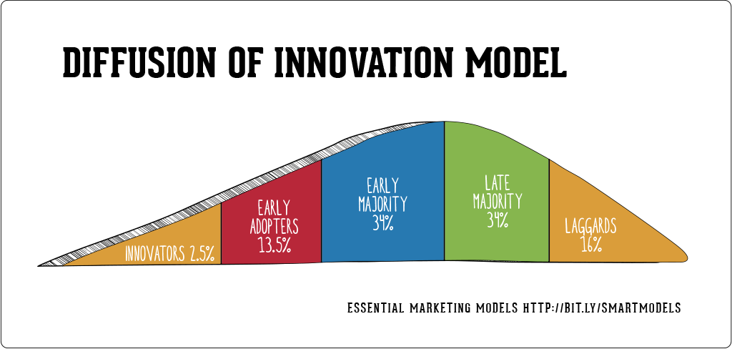
(Figure 1.1)
This model shows how innovation takes over time with percentages marking when followers embrace the innovation. The first phase of the diffusion of innovation model is of course the innovators stage. “They are a small group of people exploring new ideas and technologies. It includes "gadget fetishists!" In an online marketing context there are a lot of specialist blogs and media sites to engage them, Engadget and Gizmodo for examples.” (Hanlon 2013) As Hanlon points out innovation is about a person or group taking those first steeps to create something new. In the model she assigns only 2.5% of people to the innovators. This is because it’s a stage before a product or service would go on sale to the general market. The second stage is the early adopter’s stage. “This is the second fastest category of individuals who adopt an innovation. These individuals have the highest degree of opinion leadership among the other adopter categories. Early adopters are typically younger in age, have a higher social status, have more financial lucidity, advanced education, and are more socially forward than late adopters. More discrete in adoption choices than innovators. Realize judicious choice of adoption will help them maintain central communication position.” (Rogers 2003). As Rogers points out early adopters tend to be younger and more well off which is why they only account for 13.5% of people. A prime example of this the release of any new Apple products. The lines outside Apple stores all full of the young and well off as they rush to embrace these new products whereas the general market holds off until maybe a price drop or proof the innovation sticks. The third stage is early majority. “Individuals in this category adopt an innovation after a varying degree of time. This time of adoption is significantly longer than the innovators and early adopters. Early Majority tend to be slower in the adoption process, have above average social status, contact with early adopters, and seldom hold positions of opinion leadership in a system.” (Rogers 2003) Rogers view holds most consumers will not embrace innovation just because it’s new but will hold off to embrace innovation. This group is out outright hostile or sceptical of innovation unlike the late majority. “Individuals in this category will adopt an innovation after the average member of the society. These individuals approach an innovation with a high degree of scepticism and after the majority of society has adopted the innovation. Late Majority are typically sceptical about an innovation, have below average social status, very little financial lucidity, in contact with others in late majority and early majority, very little opinion leadership.” (Rogers 2003) This group adopts innovation when society adopts innovation. The last group is laggards. “Individuals in this category are the last to adopt an innovation. Unlike some of the previous categories, individuals in this category show little to no opinion leadership. These individuals typically have an aversion to change-agents and tend to be advanced in age. Laggards typically tend to be focused on “traditions”, likely to have lowest social status, lowest financial fluidity, be oldest of all other adopters, in contact with only family and close friends, very little to no opinion leadership.” (Rogers 2003) These people tend to adopt innovation well after the mass of society has. They may have a fear of change or in the case of the products and services the less well-off so only embrace an innovation when society moves on to the next one.

2.3 Disruptive technology
The role that technology is the rise of e-commerce is of course critical since if no new technology came along to enable e-commerce then it would next exist. “A continuing stream of information technology innovations from the internet to wireless networks to digital phone and cable systems are continuing to transform the business world. These innovations are enabling entrepreneurs and innovative traditional firms to create new products and services, develop new business models, destroy old business models, disrupt entire industries, build new business processes and transform the day to day conduct of business.” (C. Laudon and P. Laudon 2012) hat the Laudons describe are prefect examples of disruptive technology also known as disruptive innovation. “Disruption is the process whereby a small company with few resources successfully challenges a larger established incumbent business or invent entirely new markets. Often times, larger incumbent businesses are focused on their largest and most demanding customers, which opens the door for disruptive companies to target overlooked customer segments and gain a foothold. These incumbents often fail to respond very quickly to the new threats and disruptive companies eventually move upstream and cannibalize more customers segments over time.” (Christensen 1997) The rise of many of the e-commerce giants that we know today are prefect examples of disruptive technology. The likes of Amazon started may have embraced e-commerce meaning that the customer could shop and not even leave their home. That innovates over brick and mortar retail stores but also innovates over telephone sales and catalogue sales which before e-commerce provide a semi identical service. A prefect recent example of the role of disruptive technology can be found in the ride sharing service and app Uber. “Uber is a rapidly growing ride-sharing service, has become the poster child for disruptive innovation. The traditional taxi cab business has suddenly been changed forever by a mobile platform connecting consumers who need rides with drivers willing to provide them. A customer no longer needs to wave down a cab on the street, and a rider with an electronic Uber account does not even need to hand over cash. The trip is usually cheaper because regular cabs have to charge more to cover the huge upfront investment in a taxi license costing up to $800,000.” (Harris 2016) Uber impact upon the taxi industry has been incredible. Across the world its sparked protests, riots and even legalisation against it. In London alone thousands of black cab drivers have been beaten out of business by Uber. All this is because Uber can provide a better quicker experience while also undercutting the business already operating the market. Many of those once retail giant who have since gone out of business would blame e-commerce giants like Amazon for their failure. A recent example of how disruptive innovation works in the retail sector is the fate of Toys “R” Us. “One of Walmart's holiday strategies is to slash toy prices to lure consumers into its stores. One study found the retail giant discounted its popular toys by 54 percent on average compared with Amazon. In its bankruptcy filing, Toys "R" Us noted that Amazon is "not concerned with making a profit at this juncture, rendering their pricing model impossible to compete with." (Picchi 2017) Toys “R” Us went bust simply because it could not match the likes of Amazon who can provide a quick and cheap way for people to buy toys. It is easy to look upon an industry and see new products and services replacing the old products and services and say that’s disruptive innovation. “The problem with conflating a disruptive innovation with any breakthrough that changes an industry’s competitive patterns is that different types of innovation require different strategic approaches. To put it another way, the lessons we’ve learned about succeeding as a disruptive innovator (or defending against a disruptive challenger) will not apply to every company in a shifting market. If we get sloppy with our labels or fail to integrate insights from subsequent research and experience into the original theory, then managers may end up using the wrong tools for their context, reducing their chances of success. Over time, the theory’s usefulness will be undermined.” (Christensen, Raynor and Mcdonald 2015) New is not always better and we must understand the work of Rogers on the diffusion of innovation about what makes innovation stick. What makes innovation stick is not simply something that is new coming on the market. After all the Sinclair C5 was a new and revolutionary product and it fell upon the scrap heap of history forever to be joke. What makes innovation stick are factors such as is it cheaper than an existing product or service and is it better than an existing product or service. That is what makes disruptive innovation stick not just being new but being cheaper, better and more convenient to the customer. It’s way Amazon has been so successful because not only can it undercut its rivals but can provide a better service and experience for customers so that they keep coming back to them instead of the brick and motor retail store. “Disruptive innovations, on the other hand, are initially considered inferior by most of an incumbent’s customers. Typically, customers are not willing to switch to the new offering merely because it is less expensive. Instead, they wait until its quality rises enough to satisfy them. Once that’s happened, they adopt the new product and happily accept its lower price. This is how disruption drives prices down in a market.” (Christensen, Raynor and Mcdonald 2015) Disruptive products and services must in then end be better than the products and services they are replacing. If price is not marched with quality, then most consumers will not embrace the innovation thus it will fail. Clayton Christensen was the man who coined the phrase disruptive innovation in 1997. While a theory from over two decades ago in today’s rapid changing world of e-commerce may seem it out of date the core theory holds up. Clayton has also showed a wiliness to update his work most recently in 2015 so he can be trusted as a reliable source.

2.4 Business to consumer (B2C)
How the raise of e-commerce has impacted upon the business to consumer aspect of modern businesses is both interesting and disruptive to the old ways of doing business before the internet changed the world. B2C basically refers to how a business sells a product of service to the consumer and their interactions with each other. “B2C, or business-to-consumer, is the type of commerce transaction in which businesses sell products or services to consumers. Traditionally, this could refer to individuals shopping for clothes for themselves at the mall, diners eating in a restaurant, or subscribing to pay-per-view TV at home. More recently, the term B2C refers to the online selling of products, or e-tailing, in which manufacturers or retailers sell their products to consumers over the Internet.” (Hom 2013) B2C is one of the oldest and most basic aspects of business and no matter how technology changes how the process is undertaken it will remain a basic aspect of business transaction. However, the rise of the internet, new technology and e-commerce have all combined to change how business interact with their consumers. This change has been driven by the big internet brands such as Amazon and Ebay but its small business have also been able to take advantage of this change. Horn hits the nail on the head when describing business to consumer aspect of business. Horn work acts as a basic definition of the concept of B2C and at the end gives a hint to how the internet has change this aspect of business. There is no point is using Horn work to describe how internet has impacted upon the B2C aspect of business because that’s not he does not talk about that.
B2C aspect of business has changed by internet and this is not just something affects big business. “When the Internet our homes in the mid-1990s, the world of small business changed forever. For the first time, the ability of small businesses to market directly to consumers in a robust way became possible. Although there are services that are set up to provide direct-to-consumer services, such as eBay for selling goods or Amazon, for selling everything else, small business owners were given the opportunity to can create their own storefronts. With the ability to sell directly to consumers, the B2C model, in essence, got rid of the middleman and, often times, eliminates the need for eBay, Amazon, and others entirely.” (Duermyer 2017) Today I can do my weakly food shop without leaving the house and when Christmas time buy all my gifts from my phone with just one click. Until the early 20th century business interacted with consumers though a physical brick and mortar store. First came catalogues sales then telephone phone sales but none of these threatened stores on the high street but then came along the internet and the e-commerce of the late 90s. Not quite overnight but still a rapid speed of change compared to what had come before it, Amazon and Ebay started to change how the consumer interacted with business. HMV and American electronics giant Radio shack both quickly found there consumer base dry up and as Amazon grew and retail names started closing shops or closing down most of them rushed to embrace the new world. Most stores in the retail sector today engage with their consumers especially 18-25-year olds online and not though physical retail stores. This change in the B2C method has changed the relationship customers have with business. The internet gives the consumer power because of their ability to quickly compare price between stores something more difficult before the internet. Duermyer work is very recent having being published in 2017 which means any concerns about the age of his work is only a concern in that there has been little time for his work to be reviewed by any academics. Considering that concern the information he provides is still very useful. The rise of e-commerce has removed the middle man and given power to the consumer and thus has fundamentally changed the B2C aspect of the modern business environment. For those the small business owners who can take advantage of this can become very successful.
The rise of e-commerce and its impact upon B2C aspect of a business is not just in how products are sold but also the support structures that springs up around it like a business IT systems. “B2C e-commerce has its most immediate influence on a company’s IT structure. It is capable of supplementing or partly substituting all stages of transactions with final consumers, which requires adaptations of the internal IT structure that can support customer-centred processes in a company as much as possible.” (Strebinge and Treiblmaier 2006) This provides new problems for all retail business. First, they have design a platform for customers to use and then there is the cost of securing that platform from hackers. Adding to those are the traditional cost business run in to wages and delivery cost among many others. This is a cost and challenge that most big-name retail business like Tesco, Topshop and Game can adapt too. Smaller business often cannot afford this cost which is why many don’t have online platforms and most just decide to sell their products or services on other services such as Amazon. Strebinge and Treiblmaier work here was published by the University of Vienna. This means that the information provide can be seen as very useful as Austria is a western capitalist country. This means that Austria has experienced the same trends as the UK so information taken from there can be easily adapted to represent the UK and its trends. The work was published in 2006 and considering rapid speed change in the internet and its impact upon the business environment some might consider the information out of date. Even in the age of the internet an information age should not be counted against said information unless of course new information disproves it. With Strebinge and Treiblmaier work that is not the case. All business that take part in any form e-commerce must have an IT structure that can support a customer centred focus or their business will not be successful.

Chapter 3.1 Case Study: Amazon
Today we know Amazon as this monolithic brand of huge size, success and power. It conquers all before it and has left retail stores broken and obsolete by their success. Academics and journalists alike talk about the Amazon effect. Writing for Forbes Lin Grosman describes it as “The Amazon effect has dramatically changed the way we shop since the company debuted in 1994. This term describes the effect that the entire digital marketplace has had on traditional forms of commerce, like brick-and-mortar retail. Namely, the Amazon effect has introduced consumers to an almost completely frictionless shopping process with near-immediate results.” (Grosman 2018) Amazon has become such large name in the e-commerce and retail sectors that’s its getting academic theories named after it. That is the general pre-conception about Amazon and like most pre-conceptions there is an element of truth hiding a much large story. This case study comes from the work of Dave Chaffey and was published in 2018.
Chaffey work breaks down why Amazon has been successful and he starts with Amazon business strategies. According to Chaffey Amazon says its strategy is to “Relentlessly focus on customer experience by offering our customers low prices, convenience, and a wide selection of merchandise.” (Chaffy 2018) Anyone who’s ever used Amazon can see that strategy in affect especially on price since it often beats out much of its rivals in the retail sector. The reason they do this is simple, to build customer loyalty. “Of course, achieving customer loyalty and repeat purchases has been key to Amazon’s success. Many dot-coms failed because they succeeded in achieving awareness, but not loyalty. Amazon achieved both.” (Chaffey 2018) Amazon understands the value of making customers loyal to their brand. Loyal customers of course keep coming back over and over again and that is the key for any business success. To that end Amazon having taken a number steps to ensure that loyalty one of which is free shipping. “Free shipping offers are used to encourage increase in basket size since customers have to spend over a certain amount to receive free shipping. The level at which free-shipping is set is critical to profitability and Amazon has changed it as competition has changed and for promotional reasons.” (Chaffey 2018) Free shipping is an evolution on strategies that retail stores have used for decades to convince you to spend more such as value packs, price rollbacks and the classic buy one get one free. By getting rid of certain costs business like Amazon can convince you to buy more products, it’s getting more bang for your buck. Amazon offers free shipping to all its prime customers which for a straight up fee of £80 gives and free shipping and access to its streaming services. Chaffey also goes on to mention in this section “Key features of our websites include editorial and customer reviews; manufacturer product information; Web pages tailored to individual preferences, such as recommendations and notifications; 1-Click® technology; secure payment systems.” (Chaffey 2018) This may seem like small details but ask yourself in what retail store can you have a shopping experience tailored to you. Customer reviews also help drive business for Amazon since it’s a quick and easy way to review their products. This consumer first approach is of course helping Amazon become a giant and left the retail sector scrambling to survive, and this helped Amazon make history for “This focus on customer has translated to excellence in service with the 2004 American Customer Satisfaction Index giving Amazon.com a score of 88 which was at the time, the highest customer satisfaction score ever recorded in any service industry, online or offline.” (Chaffey 2018) Now in recent years that score according to the America customer satisfaction index has dropped and in 2017 was “85 overall” (ACIS 2018) but achieving such consistently high scores shows that good customer service, is in Amazon case very well for business.
An important factor that Chaffey points out later is that the customer for Amazon is not just those buying products from them, but are those that store their data on Amazon servers and sell their products on Amazon “Amazon defines what it refers to as three consumer sets customers, seller customers and developer customers. There are over 76 million customer accounts, but just 1.3 million active seller customers in its marketplaces and Amazon is seeking to increase this. Amazon is unusual for a retailer in that it identifies “developer customers” who use its Amazon Web Services, which provides access to technology infrastructure such as hosting that developers can use to develop their own web services. Members are also encouraged to join a loyalty programme, Amazon Prime, a fee-based membership program in which members receive free or discounted express shipping.” (Chaffey 2018) This is an important reminder that for a large chunk of sales Amazon is just the platform not the person selling the product.
Chaffey is keen to point out that unlike what most people think of Amazon is not a one man army destroying all that stand before it. Amazon success in its early years and even today is built upon partnership Amazon has built with other business. “Analysts sometimes refer to ‘Amazoning a sector’ meaning that one company becomes dominant in an online sector such as book retail such that it becomes very difficult for others to achieve market share. In addition to developing, communicating and delivering a very strong proposition, Amazon has been able to consolidate its strength in different sectors through its partnership arrangements and through using technology to facilitate product promotion and distribution via these partnerships. The Amazon retail platform enables other retailers to sell products online using the Amazon user interface and infrastructure through their ‘Syndicated Stores’ programme.” (Caffey 2018) What Chaffey raises here is important. Amazon works with many business you would consider rivals and allows them to sell on its platform. One could draw a conclusion that the rise of Amazon has been bad for the traditional brick and motor retail store but can be good for retail businesses.

4.2 Case Study Tesco Online
Tesco is a giant of the UK retail sector. From humble origins in London’s east end in 1919 it has grown in to a worldwide empire with stores in China, America, Hungary and many more. Tesco according to Statista “Holds around 28% of the UK market as of March 2017.”(Statista 2017) Tesco dominance of market is not a god given right and in recent its face competition for the budget supermarkets and have been force to adapt. Adapting to Change have also been something Tesco does well and to that end in 2000 Tesco launched Tesco online. Tesco online was launched at a time in 2000 where as mentioned before the dot.com bubble burst and many analyst saw dot.com as a fad. Yet as off 2014 according to Marc Wulfratt “Tesco.com has an estimated annual turnover of $US 4.3 billion within the United Kingdom.” (Wulfratt 2014) That puts Tesco behind only Ebay and Amazon in terms of online revenue.
Tesco online success has come about mostly because its run its e-commerce platform like an e-commerce platform instead of a retail business with an e-commerce platform. As Wulfratt points out “In the beginning customers place orders the evening before and beginning at about 4 a.m., Tesco associates travel through the store aisles with trolleys to pick and pack the orders. This strategy currently consists of a combination of dark stores to service remote regions of the country and dedicated dot-com depots to service densely populated urban markets – namely London. As time goes by, the pendulum will swing away from retail stores to dedicated depots which are more cost-effective to serve the market.” (Wulfratt 2014) Tesco used to pick items off store shelves and place them in vans and send out to deliver goods. That plan worked for a while but long term it was not efficient. Most Tesco stores today are massive out of town stores so taking stock from these stores racks up large costs on delivery. Tesco now employs a plan much like Amazon with lots of depo centres near or within large population centres making it more efficient for Tesco and more efficient for the consumer to use Tesco online.
Tesco online followed the example set by Amazon by embracing automation. Tesco online just like Amazon have very little interference from humans in the process of delivery. “ As soon as the outbound routing of the delivery vans is done and the delivery vans are ready to be loaded, the automated shuttle system releases totes to a conveyor that transfers the totes to their assigned truck doors. The release of totes is sequenced by temperature zone (frozen, chilled, ambient) so that the chilled totes are always placed closest to the nose of the trailer. As well, totes are sequenced to enable the driver to load the truck in reverse-delivery sequence (i.e. the first delivery is the last to be loaded). These investments in mechanization and automation enabled a 37% increase in productivity over the first generation of depot.” (Wulfratt 2014) This almost complete automation of the delivery process drives down costs and maximise profits for Tesco online as well speeding up the process which benefits the consumer.
Tesco online success shows that it is possible to compete with the e-commerce sector. Tesco online is almost a suppurate company to Tesco. It does not use the same stock and barely uses human input at all. Many might say that in order to compete with the likes of Amazon, Tesco online became just like Amazon and there is and an element of truth to that. Unlike Amazon however Tesco online has been able to successful capitalize on the brand of Tesco while developing its own brand. If retail companies want their e-commerce platforms to be successful they must follow Tesco lead and run them like e-commerce business.

Chapter 4.1 Methodology
Before talking about how the research will be conducted one must first understand what methodology means. “Describes actions to be taken to investigate a research problem and the rationale for the application of specific procedures or techniques used to identify, select, process, and analyse information applied to understanding the problem, thereby, allowing the reader to critically evaluate a study’s overall validity and reliability.” (Kallet and Richard 2004) This chapter will explain why research methods where chosen.

4.2 Quantitative Research
The aim of this research is to discover how and why the raise of e-commerce has happened from the consumer perspective. Since that is the case a quantitative research based approach back up by secondary academic research is the most useful to this study. With a chosen research method the only question to ask is, what quantitative research is. “Quantitative research is a structured way of collecting and analysing data obtained from different sources. Quantitative research involves the use of computational, statistical, and mathematical tools to derive results. It is conclusive in its purpose as it tries to quantify the problem and understand how prevalent it is by looking for projectable results to a larger population.”(SIS International research 2016) The main arm of this research will be a questionnaire which will be talk about a little later is this report. The main benefit of this research method as mention is that the results can be projected on to a larger population. With large sample size it’s possible to make generalizations about society as a whole and as such gives research and conclusion form that much more relevant and useful in the field of study. Also the method opens itself up to different analyse methods unlike with qualitative research method. “Qualitative interpretations are constructed, and various techniques can be used to make sense of the data, such as content analysis, grounded theory (Glaser & Strauss, 1967), thematic analysis (Braun & Clarke, 2006) or discourse analysis”. (McLeod 2008) One of these methods is content analyse. “When using content analysis, the aim was to build a model to describe the phenomenon in a conceptual form. Both inductive and deductive analysis processes are represented as three main phases: preparation, organizing and reporting. The preparation phase is similar in both approaches. The concepts are derived from the data in inductive content analysis. Deductive content analysis is used when the structure of analysis is operationalized on the basis of previous knowledge.” (Elo and Kynags 2007)
Content analysis is about talking raw data and using it to explain key core concepts. Content analysis will be a useful data analyse method along with some others when it comes time to understand the raw data that has been collected. Its main flaw is that only recently has it been used as analyse tool in business and such adapting could be a problem. It is important to point that all research including this one starts with a hypotheses. “The quantitative, naturalistic approach is used when observing and interpreting reality with the aim of developing a theory that will explain what was experienced. The quantitative approach is used when one begins with a theory (or hypothesis and tests for confirmation or disconfirmation of that hypothesis.” (Newman and Benz 1998 Page 3) As mentioned above the hypothesis for this research is that, the rise of e-commerce has been because of technology change that has made cheaper and more convenient for the consumer to buy products and services. The hypothesis is not a shot in the dark or based or on no research being performed. It was created based on the early research done for this project. The whole point of these research methods is to see wither or not the hypothesis is correct and if not to point that out and to explain why it was wrong.

4.3 Academic research
The use of quantitative research method can provide unique and valuable information but on its own it the data is relatively useless. This is where academic research including key theories and core concepts. The word and views of academics in all fields’ carriers’ great weight. “Decisions on whether to publish an author’s article in an academic journal are made by a process called peer review. When an author submits an article to the journal the article will be reviewed by other subject experts in the same field to verify that its methodology is sound and that its conclusions are valid. The author may be asked to re-draft the article several times before it is of a suitable standard to be published.” (Liverpool Hope University 2017) The theories and concepts they create and develop often have years of research behind them and find it difficult to entre any academicals journal with being reviewed by other academics. Of course some will slip though the net as with Andrew Wakefield work published in the British medical journal try to claim that the MMR vaccine was linked to Autism was based on false information and had not been reviewed by other researches. Academic research is often well trusted information especially when published in journals and can easily lead people down a wrong path. Thankfully cases like Wakefield are the exception not the rule. The academic research will be crossed reference with the quantitative research to see if the data is in line with the academic view. The benefit of doing this is that adds more weight to the data gathered if strong academic research can back it up. Non-academic research may be used but it’s important to note that this will carry much less weight than academic research.

4.4 Questionnaire
The data collection method for this research will be a questionnaire. The questionnaire will have ten questions presented to 110 people. The questions asked will be closed questions which means that those who answer will be ask to tick a box rather than write their own answers. This standardized approach to questions is the questionnaire best advantage. “The questions are standardized. All respondents are asked exactly the same questions in the same order. This means a questionnaire can be replicated easily to check for reliability. Therefore, a second researcher can use the questionnaire to check that the results are consistent.” (McLeod 2018) This fixed nature means that questions will have to process and seek clearly answers. The questionnaire was created online using a tool called Google forms and published online to social media websites Facebook and twitter for people to respond.

4.5 Why not use qualitative research methods?

The qualitative research approach is a research method which involves gaining a first hard account from people involving detailed questioning with interviews being the most common data collection method in this filed. However this data collection method does come with its flaws. First is a time considerations. “Because of the time and costs involved, qualitative designs do not generally draw samples from large-scale data sets.” (McLeod 2008) A qualitative approach requires first finding people with the qualifications or experience to be useful to a study and then finding some of them willing to talk. As such a qualitative approach would end up with maybe four or six people and while they may prove useful it’s still a very small sample size. Also there is problem with just how subjective data collected can be “Because of the subjective nature of qualitative data and its origin in single contexts, it is difficult to apply conventional standards of reliability and validity.” (McLeod 2008) A quantitative research approach with its sample size it’s very easy to extrapolate a trend and be confident with it. With qualitative approach the sample size while able to give more detail is so small that it would be difficult to extrapolate and general trend for a subject.

4.6 Limitations
As with any research method the chosen one does have its limitations and they must be acknowledge. The chosen data collection method is quantitative and its main flaw is that the research is difficult to replicate. “The problem of adequate validity or reliability is a major criticism. Because of the subjective nature of qualitative data and its origin in single contexts, it is difficult to apply conventional standards of reliability and validity. For example, because of the central role played by the researcher in the generation of data, it is not possible to replicate qualitative studies. Also, contexts, situations, events, conditions, and interactions cannot be replicated to any extent nor can generalizations be made to a wider context than the one studied with any confidence.” (McLeod 2008) Being able to repeat the method over and over again is important to academics. With the questionnaire for example it’s almost impossible to find everyone who answered the survey let get same variables present when they first answered. Also the questionnaire is relent on people answering serious or those making a joke of it. This questionnaire is online based so researchers will not be able to check the responder’s body language to see if they are serious. The report relies on academic research as well and needs information not just correct and up to date but also be easy to accesses. Lastly legal concerns must be acknowledge. The data cannot be used outside its intended purpose however responders will not be allowed to ask their information removed since the questionnaire does not identify people it would be impossible to know what information had to be removed.

Chapter 5.1 Data analysis
The data analysis will focus on the information taken via a questionnaire and will analyse and explain the results of the questions asked.
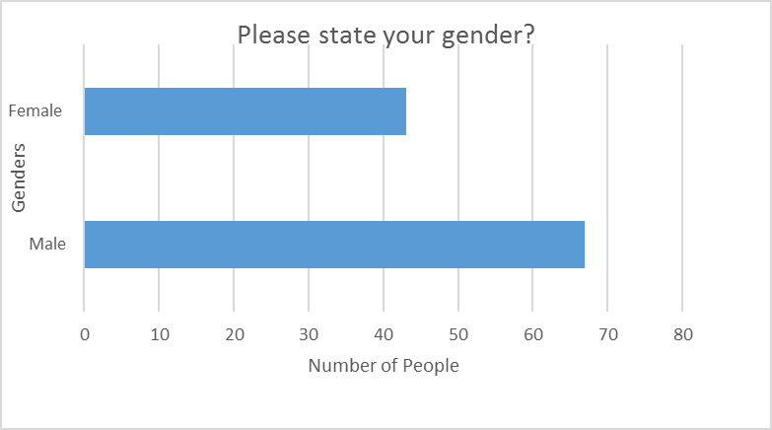

(Figure 2.1)
Here we see of the responses given that 67 said they were male and 43 said they were female. This question was asked in order to on the issue at hand there any differences between different genders.

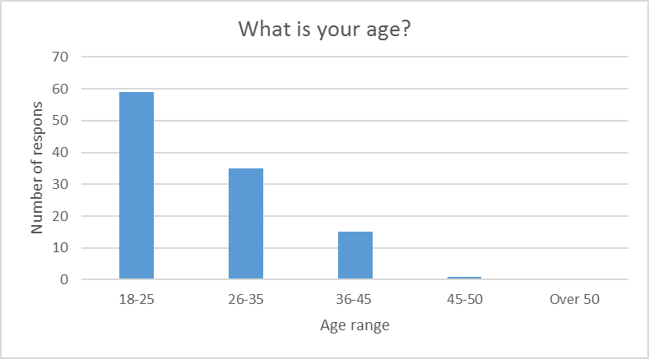
(Figure 2.2)

The second question was asking about the age of those partaking in the questionnaire. 59 listed their age between 18-25, 35 between 26-35, 15 between 36-45, 1 between 45-50 and 0 people listed their age as over 50. As mentioned above there is a possibility of sample basis given the platforms used to gain results.

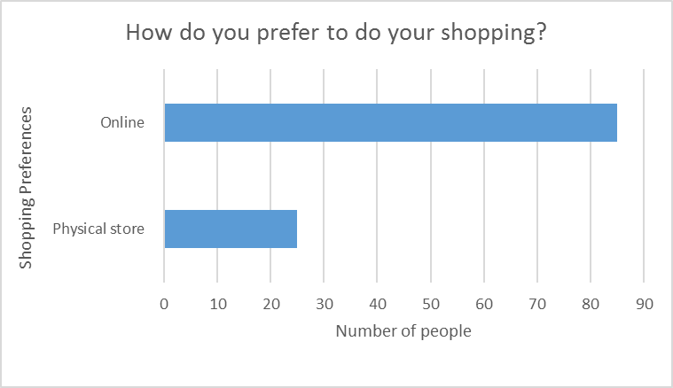 (Figure 2.3)
The third question was asking how those who responded prefer to their shopping. 85 people chose online while only 25 people chose a physical retail stores. The question here provides an interesting viewpoint which will examined in depth with later questions. Given how the demographics of those who responded are below the age of 35 this response rate is not such a surprise since in general young people prefer to use the internet for everything including shopping.

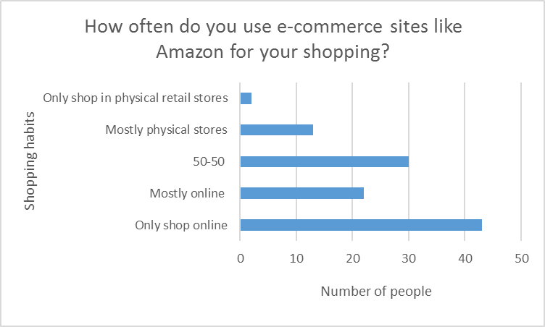 (Figure 2.4)
At face value question four looks like its seeking the same information as question 3. Question 3 was asking about the responder’s preference whereas this question went to more in depth about shopping habits. 43 said they only shop online, 22 said mostly online, 30 said 50-50, 13 said mostly physical stores and only 2 said only shop in physical stores. Given how this question had more than two answers it’s quite surprising that so many said they shopped only online. That only 2 said they used only physical retail stores is not so surprising considering the age range and that almost everyone does at least some shopping online according to the results.
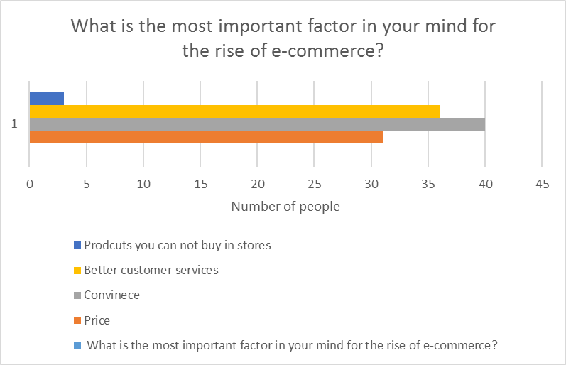
(Figure 2.5)
With question five those who responded where asked what their views on what was the main factor in the rise of e-commerce. A choice for technology was left out because it links in to convenience especially and it would be better to see why people use e-commerce sites other than because of technology. 31 chose price, 40 chose convenience, 36 better customer service and only 3 chose be able to buy products you cannot in stores. Convenience was the most popular result was not so surprising but that customer’s service and price where so close was and suggests that simply being able to shop at home is not the driving factor one might suspect. Also only 3 choosing products you can’t buy in stores suggest that the wider product range of e-commerce brands is not a massive general trend.

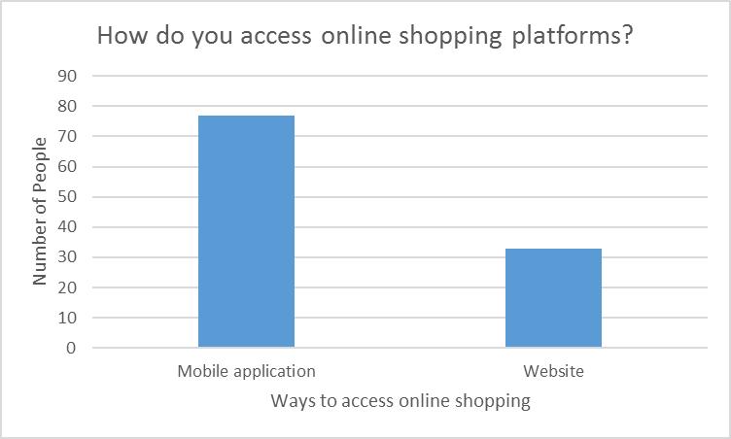(Figure 2.6)
The sixth question focused on how people access these online shopping sites. 77 said mobile application and 33 websites. This question can be used as example of disruptive technology since if one had asked that question a decade ago most would have no idea what an app was. The result here can also be linked backed to the last question since the most important factor for the rise of e-commerce is convenience according to those who responded and mobile applications are much more convenient to the consumer than using a website,
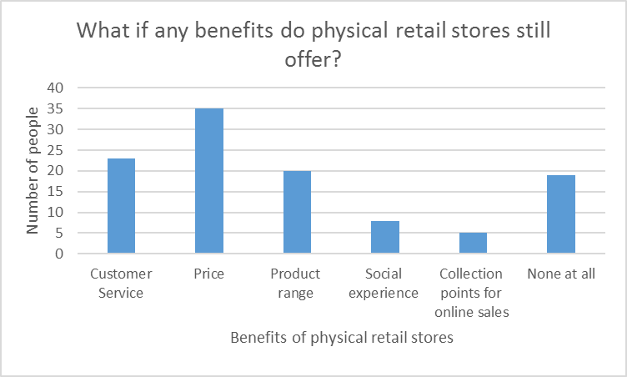 (Figure 2.7)
Question seven focuses if those who responded saw any benefits to using physical retail stores. This question was asked to help with one of the research objectives which was to find out how retail stores could adapt to the rise of e-commerce. 23 chose customer service, 35 chose price, 20 chose a stores product range, 8 chose a social experience, 5 chose collection points for online sales and 19 people saw no benefit at all to physical retail stores. Price proving to be the most popular was surprising. This is because one would suspect since you would be dealing with a real human being customer service would be the runaway leader. This suggests that while a physical retail stores have seen their customer services standards they have become much better at competing with e-commerce brands on price. That 19 saw no benefit to a physical retail store is surprising.

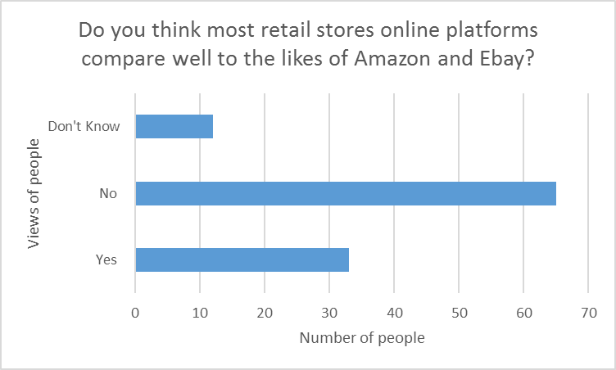(Figure 2.8)
Question eight was about asking those who responded do most retail stores online platforms compare well to the likes of amazon and eBay. Amazon and eBay where used as examples in the question simply because they are well known. 65 chose no, 33 said yes and 12 said they did not know. This will be useful when talking about diffusion of innovation. This seems to suggest that Wulfratt view that retail business should treat their e-commerce platforms like e-commerce platforms and not like retail outlets online
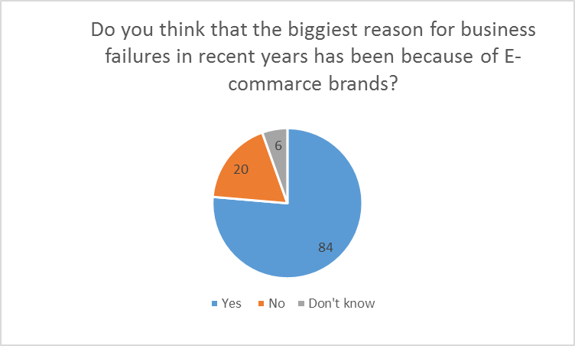(Figure 2.9)
Question nine focused on wither or not people thought e-commerce was responsible for most business failures. 84 people said yes, 20 said no and 6 said they did not know. This question will be useful in assessing the impact of e-commerce on the retail sector. The fact that so many believe that e-commerce is having a devastating impact upon the retail sector not all too surprising since that’s a widely held view in society and a view which inspired this research

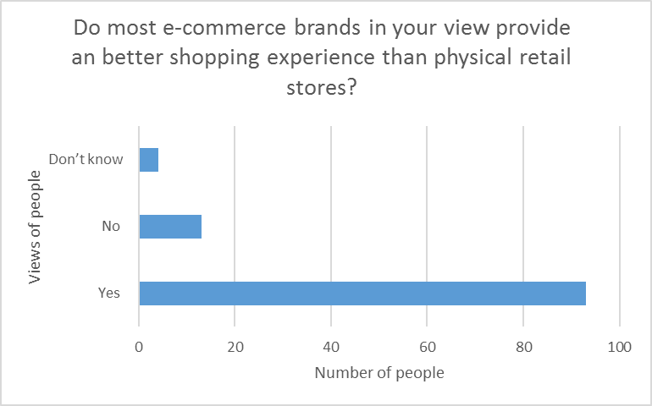
(Figure 2.10)
With the tenth the aim was to find out at a fundamental level do people think e-commerce brands offer a better experience than physical retail stores? 93 said yes, 13 said no while 4 said they did not know. 93 out of 110 people asked thinking that e-commerce brands offer a better shopping experience is damaging for the retail sector since the whole shopping experience factor is what people use as a generic defence of physical retail stores.

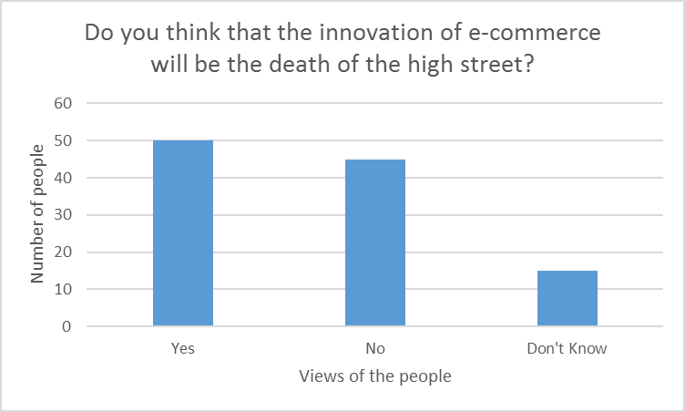 (Figure 2.11)
The eleven and final question asked that because of the innovation of e-commerce brands did they think that would kill the high street. 50 said yes, 45 said no and 15 said they did not know. The results here were surprising since it was the only question with a nearly 50-50 response that. While most think e-commerce will be the death of the retail sector it’s not a wildly held view.

Chapter 6.1 Main findings: What has driven the growth of e-commerce?
The academic research, quantitative research and contemporary research all point to the rise of e-commerce having an almost devastating impact upon the retail sector. The assumptions of most people in the academic field and outside it is that e-commerce is this all conquering giant who destroyers all that stands before it. It’s hard not to agree with that view after retail business such as Blockbuster, RadioShack, and HMV and more recently Toys R Us all of which have seen their business killed off by e-commerce sites to a certain extent. As Rogers pointed out “Many innovations require a lengthy period of time when they become available to the time when they are widely adopted. (Rogers 2003 page 5) Innovation and its diffusion process is not a simply factor of just creating a new products or service and it becoming widely used. Innovation must provide a benefit to the consumer and e-commerce certainly does that. “E-commerce allows consumers to make purchases without leaving their homes, at their convenience. Consequently, this results in less impulse purchases at adjacent stores when consumers shop at brick-and-mortar retail centres”. (Todd and Mehall 2017) This convenience factor is very important factor in understanding the rise of e-commerce. It’s the same reason why Supermarkets and big shopping centres have always proved popular since everything’s under one roof its more convenient for the consumer. Using e-commerce sites is more convenient for the consumer this is backed up by the quantitative research since 40 out of the 110 people asked said that convenience was the most important factor which was the most selected answer for that question. Of course there are more reason than just convenience that has driven this growth in e-commerce there is price, customer service, new products and services and of course technology itself. Technology on its own has been a massive innovation for the e-commerce sector but on its own it’s unlikely that it will have reached todays heights without having made the shopping experience better.
The rise of e-commerce has also been driven by the role that government has played. This goes beyond the simple building of infrastructure in 1999 during the first e-commerce boom period the UK government outlined a plant to grow the sector. “Establish a brand in e-commerce both domestically and international, transform existing business and foster e-commerce creation and growth” (Chaffey 2004) where just some of the points the government outlined. Since 1999 of course e-commerce has changed fundamentally not just but society and wider market as well. One way to judge the success of this plan is to see just how much e-commerce sales are worth. “The online retail industry is expected to grow by 10.5 percent this year to reach 173.7 billion euros. Last year, the British ecommerce industry increased by 11 percent to 157 billion euros.” (Koene 2016) 173.7 billion euros converts to £152.57 billion which is of course a lot of money.
Staying with the theme of technology its role in the rise of e-commerce cannot be understated. Technology advancement alone has not driven the rise of e-commerce but without it of course e-commerce would not exist. Disruptive technology has been the main driver in this field. “Apps are now affording retailers an opportunity to connect with consumers that goes beyond the boundaries of a brick-and-mortar business. Brands no longer have to wait for consumers to walk into their shop or spot an ad that prompts them to engage with the business.” (Agrawal 2017) Mobile applications are an examples of how technology keeps changing to become disruptive even with technology which was once disruptive. As Chaffy pointed with Amazons “1-Click® technology; secure payment systems” (Chaffey 2018) apps make the process of buying products quick and easy. Ten years ago no one even heard of a mobile applications and most people shopped online via computers and websites yet today as the quantitative research shows with 77 of those responding saying they used mobile applications over websites to shop online.

6.2 The growth of e-commerce impact upon retail sector
According to a report from the office of national statistics “The value of internet sales as a proportion of total retail sales rose from 2.7% in January 2007 to 17.1% in January 2018.”(Rhodes and Brien 2018) This figures applies to the retail sector itself meaning that sales from their own e-commerce platforms now account 17.1% of total retail sales. In 2016 total UK retail sales total “£358 billion” (Rhodes and Brien 2018) that same year Amazon made “£6.3 billion in sales in the UK alone.” (Spanier 2016) Businesses which where once retail giants in the UK such as Comet, Maplin, Toys R Us, Borders and HMV have all gone bust while others like Game, Clintons cards, Jessops and Woolworths have all suffered financial problems and in Woolworths case force in to an online only retailer. The fall of Game in to administration in 2011 showed the changes to the B2C aspect of business and disruptive technology. Much like with Toys R Us recently Game fell in to administration at a time when video games sales where at an all-time high 2012. First Game was hit by the disruptive technology aspect that the likes of Amazon bought to market but what hurt most was a change in B2C aspect of the market thanks to rise of digital distribution. As Duermyer pointed out early about the changing B2C landscape “With the ability to sell directly to consumers, the B2C model, in essence, got rid of the middleman and, often times, eliminates the need for eBay, Amazon, and others entirely.” (Duermyer 2017) Game was hit hard by big game publishers such as EA, Ubisoft and Valve all setting up their own digital distribution networks allowing the consumer to buy games directly from the publisher. Game survived only because the console platforms did not follow the PC model meaning that physical discs on those platforms remained the most used way of playing games.
The high street in general have faced the full force of the B2C changes in the market place. Business big and small have succeeded online as the internet has grown and grown and even the smallest business can become international because of the internet. One only has to take a walk down the high street and see bordered up empty retail stores. The rise of e-commerce also coincided with the great recession of 2008 and both combined to act as one two punch to retail sector. Academics Neil Wrigley and Dionysia Lambiri conducted research and found that “Between 2007 and 2014 there was 274 retail failures which lead to the shutting down of 24,762 stores.” (Wrigley and Lambri 2015) They also mentioned that stores hardiest hit are the likes of “Blockbuster, HMV and Jessops have suffered the most” (Wrigley and Lambri 2015) All business which this report has shown have suffered badly at the hands of e-commerce brands. The quantitative research backs up the changes in the B2C aspect of retail business and how e-commerce has impacted upon it. 84 out of our 110 responders said they thought that e-commerce success was the main reason for retail business in recent years. When asked how they did their shopping 43 said they only shop online while 22 said mostly online. This means 65 out our 110 responders shop more online than they did in physical retail store. Finally 85 said they prefer to do their shopping online. The consumer research paints a damming picture about the state of the retail sector.

6.3 How can the retail sector respond to the rise of e-commerce?
On the face of it the retail sector is in a dire state. Brands going bust, stores closing and job losses are not factors which would inspire confidence in the sector. Even the biggest beast in the sector is suffering on the face of it with John Lewis “While both sales and customer numbers rose at the group’s department stores and supermarkets in the year to January 27, pre-tax profits fell 77 per cent after taking into account staff bonuses.” (Pooley 2018) Profits falling hides the fact that in 2017 John Lewis sold more and had more customers than the year before. John Lewis success has been based on changed according to Mark Lewis the stores online director. “The core values of the John Lewis Partnership have remained and that’s what has helped us through the changes,” says Lewis. They’ve allowed us to invest for the long term and that has helped with Omni channel investments and allowed the retailer to scale innovations. This has been one of the key reasons for our success.” (Rigby 2014) Rigby also points out that innovations such as click and collected have proved popular with older consumers later on. The quantitative research however suggest that’s that not such a popular innovation with only five people out of 110 saying they thought that this was the main benefit of going to physical retail stores. This lack of coloration may be down to the age range of those taking part in the survey. Retail stores are also fighting a view that their online platforms are not as good as e-commerce brands such as Amazon with sixty five of those who responder saying that their sites did not compare well to e-commerce brands. Retail business need online platforms to succeeded today it’s what is expected of them but clearly according to the quantitative research that means little for physical retail stores.
When asked what was the main benefit of shopping at physical retail stores thirty five chose price the most of any answer. “When customers can touch items and view them closely, they feel more at ease with handing over large amounts of cash. For higher-end retail in particular, a storefront gives consumers the opportunity to feel out the items and decide what they want to buy. If they are new to a particular brand, a storefront allows them to peruse the merchandise and feel comfortable with the company before making a purchase.” (Lovering 2016) Price combined with the walk in the nature of retail stores seem to be the oldest and best assets retail stores have right now. The consumer does not think e-commerce will be the death of the high street since when asked fifty said yes but forty five said and fifteen where unsure. Retail stores must follow the lead of e-commerce brands and stay ahead of the innovation curve or those numbers will change.

Chapter 7.1 Conclusion
The view of most people is that the rise of e-commerce has had a devastating impact upon the retail. That view is true but lacks detail needed to truly understand why and how this change in the market has taken place. The clear view of the academic and of the quantitative research has been that the change in technology alone is not responsible for the rise of e-commerce. Instead it has been technology change combined with factors such as better customer service, better convenience and new product ranges have all combined to make e-commerce brands and EBay the giants of the sector that they are. The convenience factor as shown by Chaffy case study and the quantitative research conducted is an important factor to the consumer. Today the consumer go on to amazon and buy a product with just one click and in seconds. Most retail brands e-commerce platforms lag far behind the trend setters of Amazon and EBay. Morrison’s for example did not even have an online platform for shopping until 2012 and even then it was only click and collect instead of home delivery. This failure to full embrace the changes in the marketplace is the main reason that Morrison’s only 10.5% of the UK supermarket share. Toys R us, Blockbuster, Radio Shack, Comet and BHS are all big brands who in past few years have all gone bust thanks in part to their failure to embrace the changes that e-commerce has bought to the market place. Business like Tesco for example have embraced e-commerce and have been at the forefront of change and thus have still been successful despite a challenging business environment. The market place has been forever changed by the rise of e-commerce and those who adapt will find much easier survive while those that don’t will die off. Some in the retail sector must stop defending their dinosaur business models and use the advantage of their high street presence and combine it with a cutting edge online platform to successful in today’s world. As of now e-commerce brands are dictating the terms of competition to the retail sector but this not a god given right for e-commerce brands. The retail sector must become the drivers of innovation instead of reacting to it or e-commerce really might kill the physical retail sector at least.
You only have to take a walk down any high street in the land and you will see bordered up shops all over the place. At a time of economic growth that sight is very uncommon. E-commerce has devastated the high street and the physical retail but it’s not as of yet been killed off. Before the Internet and e-commerce there was telephone sales and before that catalogue sales. Both fundamentally changed the shopping experience and made it more convenient but both only made small dents in the retail sector. E-commerce is of course a much different beast to deal with but as mentioned above those that will adapt will. Those retail business who embrace the disruptive technology that is e-commerce and adapt to it will have a much better chance of survival than those we do not. Business have always adapted to change in the market place and while e-commerce in theory has the potential to kill off at least physical retail stores in reality it is hard to see it happening. Retail sector will survivor but it is and will be a lot smaller than before the arrival of e-commerce and many consumers especially those who are older and more middle aged will still prefer using a physical retail store.
The rise of digital marketing has also benefited the e-commerce brands especially the recent trend of micro targeting. A consumer’s presence can be traced around the internet and based on their searches the likes of Amazon and other business can target them on an individual basis. Once more this trend is one which the retail lags behind the e-commerce sector. Micro targeting like marketing is trying to get in the consumers head and make them buy something and e-commerce brands are ways ahead of the retail sector. Once a business understands their consumers’ needs and wants it’s very hard to win them back.
“E-commerce will not obliterate all retail trade. Stores that are distinctive in one way or another—because they offer excellent service, for instance, or unique products—will remain.” (The Economist 2017) The retail sector has not had a fatal blow struck against it yet but it is bleeding badly. To survive retail should emulate the e-commerce titans where needed but not lose their unique selling point to the consumer.

7.2 Recommendations
To use an old boxing analogy the retail sector might be down on the mat but it’s not down for ten just yet there are a number steps the retail sector can take in order to get back in the fight.
- Build online platforms in order to compete with e-commerce giants. This might seem like a no-brainer but as seen above stores like Morrison’s have little to none effective online presence when compared. However it’s not just about a website but it’s also about the support structures that spring up around this as Strebinge and Treiblmaier point out. Support structures in security, inventory management and delivery all need to be at the top level in order to compete with the e-commerce giants. To complete with the e-commerce titans retail stores must run their e-commerce platforms like e-commerce platform and not just an online outlet for their store.

- Embrace digital marketing. In the digital age digital marketing is more important than ever. The most successful marketing campaigns seek to understand its target market. The big e-commerce brands like Amazon and EBay have taken advantage of this with methods such micro targeting. Also as Noaimi points out digital marketing allows a business to track the success of their campaign.

- Widespread use of technology. Retail business need augment their physical stores with technology in order to attract modern consumer’s especially younger consumers. Consumers should be able to order products as they shop and have them at the counter when payment time.

- Leverage customer service. The quantitative research showed that those who responded only twenty three people thought that customer service was only the second biggest benefit. Dealing with a real human being is much more effective in dealing with problems that may come up.

The retail sector is down on the mat but it’s not out for ten just yet. By following these recommendations it keep itself from being knocked out.

References

ACSI. (2018). Benchmarks By Company. Available: http://www.theacsi.org/index.php?option=com_content&view=article&id=149&catid=&Itemid=214&c=Amazon. Last accessed 01/04/2018.
Aimee Picchi. (2017). Toys "R" bankruptcy: Why it went bust. Available: https://www.cbsnews.com/news/toys-r-us-bankruptcy-why-it-went-bust/. Last accessed 07/03/2018.
Aj Agrawal . (2017). 5 Ways Technology Is Changing Ecommerce. Available: https://www.entrepreneur.com/article/288149. Last accessed 13/04/2018.
Andreas Strebinger and Horst Treiblmaier (2006). The Impact of Business to consumer e-commerce on organisational structures, Brand architecture, IT structure and their interrelations. Vienna: University Of Vienna. Page 2.
Annmarie Hanlon. (2013). What is the The Diffusion of Innovation model?. Available: https://www.smartinsights.com/marketing-planning/marketing-models/diffusion-innovation-model/. Last accessed 15/02/2018.
Cat Rutter Pooley. (2018). Profits at John Lewis and Waitrose group fall 77%. Available: https://www.ft.com/content/67c57258-22b5-11e8-9a70-08f715791301. Last accessed 15/04/2018.
Catherine Lovering. (2016). The Advantages of Retail Outlets. Available: https://yourbusiness.azcentral.com/advantages-retail-outlets-6784.html. Last accessed 29/04/2018.
Chloe Rigby. (2014). John Lewis: Investment and innovation are key to omnichannel success. Available: https://internetretailing.net/magazine-articles/magazine-articles/john-lewis-investment-and-innovation-are-key-to-omnichannel-success. Last accessed 22/04/2018.
Chris Rhodes & Philip Brien (2018). The retail industry: statistics and policy. Published in London: Published by The Office of National Statistics. Pages 5, 8 and 9.
Clayton M. Christensen (1997). The Innovator's Dilemma: When New Technologies Cause Great Firms to Fail. Published in Harvard, Massachusetts, USA: Harvard Business Review. Page 5.
Clayton M. Christensen Michael E. Raynor Rory McDonald. (2015). What Is Disruptive Innovation?. Available: https://hbr.org/2015/12/what-is-disruptive-innovation. Last accessed 15/02/2018.
Dave Chaffey (2004). E-business and E-commerce Management. 2nd ed. Published in London: Published by Pearson Education . Page 171.
Dave Chaffey (2008). Digital Marketing. 6th ed. Published in London: Pearson Education Limited. Page 65.
Dave Chaffey (2011). Digital Marketing. Published in London: Pearson Education Limited. Pages 53-54.
Dave Chaffey. (2018). Amazon.com case study. Available: https://www.smartinsights.com/digital-marketing-strategy/online-business-revenue-models/amazon-case-study/. Last accessed 01/04/2018.
David Kleinbard. (2000). The $1.7 trillion dot.com lesson. Available: http://money.cnn.com/2000/11/09/technology/overview/. Last accessed 07/02/2018.
Elaine J. Hom. (2013). What is B2C. Available: https://www.businessnewsdaily.com/5085-what-is-b2c.html. Last accessed 10/04/2018.
Emma Barnett and Amanda Andrews. (2010). AOL merger was 'the biggest mistake in corporate history', believes Time Warner chief Jeff Bewkes. Available: https://www.telegraph.co.uk/finance/newsbysector/mediatechnologyandtelecoms/media/8031227/AOL-merger-was-the-biggest-mistake-in-corporate-history-believes-Time-Warner-chief-Jeff-Bewkes.html. Last accessed 07/02/2018.
Everett M. Rogers (2003). Diffusion of Innovations. 5th ed. Published in New York City: Published by Simon & Schuster. Pages 1,283,290 and 306.
Gideon Spanier. (2016). Amazon UK's annual sales hit £6.3 billion.. Available: https://www.campaignlive.co.uk/article/amazon-uks-annual-sales-hit-63-billion/1381647. Last accessed 13/04/2018
Isadore Newman and Carolyn R. Benz (1998). Qualitative-quantitative Research Methodology: Exploring the Interactive Continuum. Published in Carbondale: Published by Southern Illinois University Press. Page 3.
John Markoff (2005). What the Dormouse Said: How the Sixties Counterculture Shaped the Personal Computer Industry. Published in London: Published by Penguin Books. Page 14.
Kallet, Richard H. (2004) "How to Write the Methods Section of a Research Paper." Respiratory Care Pages 1229-1232.
Kenneth C. Laudon and Jane P. Lauson (2012). Management information Systems. Managing the digital firm. 10th ed. Published in Upper Saddle River: Published by Pearson Prentice Hall. Page 23.
Lin Grosman. (2018). What The Amazon Effect Means For Retailers. Available: https://www.forbes.com/sites/forbescommunicationscouncil/2018/02/22/what-the-amazon-effect-means-for-retailers/#50c63e742ded. Last accessed 01/04/2018.
Liverpool Hope University. (2017). Why use academic journals? Available: https://www.hope.ac.uk/media/liverpoolhope/contentassets/documents/library/help/media,12430,en.pdf. Last accessed 09/04/2018.
Marc Wulfraat . (2014). Case study: Tesco’s dot-com U.K. business model and lessons learned. Available: http://www.canadiangrocer.com/blog/e-grocery-test-study-tesco%E2%80%99s-dot-com-u-k-business-model-and-lessons-learned-45135. Last accessed 30/04/2018
Maximiliaan Koene (2016). United Kingdom B2C Ecommerce Country Report 2016. Published in Brussels: Published by The Ecommerce Foundation. Pages 5-6
Neil Wrigley and Dionysia Lambiri (2015). British High Streets: from Crisis to Recovery? Published in Southampton: Published by University of Southampton. Pages used 9, 10, 11 and 12.
Niccolò Machiavelli (Originally Published in 1513. Republished in 2003). The Prince. Published in London: Published by Penguin Classic. Page 25.
Philip Beeching. (2013). HMV: How the top dog lost its bite. . Available: http://www.bbc.co.uk/news/entertainment-arts-21028803. Last accessed 07/02/2018.
Randy Duermyer. (2017). Everything you Need to Know About the Business-to-Consumer (B2C) Model. Available: https://www.thebalancesmb.com/b2c-business-to-consumer-sales-1794400. Last accessed 01/04/2018
Satu Elo and Helvi Kyngäs. (2008). The qualitative content analysis process. Journal of Advanced nursing. Volume 62 (1), 3-4.
Saul McLeod. (2008). Qualitative vs. Quantitative. Available: https://www.simplypsychology.org/qualitative-quantitative.html. Last accessed 01/04/2018.
Saul McLeod. (2018). Questionnaire. Available: https://www.simplypsychology.org/questionnaires.html. Last accessed 09/04/2018.
Shawn Todd and Tim Mehall (2017). The Growth of E-Commerce & the Retail Industry. Published in Newark: Published by Newmark Grubb Cressy & Everet. Pages 3-5.
SIS International Research. (2018). What is quantitative research?. Available: https://www.sisinternational.com/what-is-quantitative-research/. Last accessed 01/04/2018.
The Economist. (2017). The future of online retailing is bright. Available: https://www.economist.com/news/special-report/21730541-how-e-commerce-will-change-cities-and-jobs-future-online-retailing-bright. Last accessed 03/05/2018.
Zaid Noaimi, MBA. (2015). The Impact of Digital Marketing on the Business. Available: https://www.linkedin.com/pulse/impact-digital-marketing-business-zaid-noaimi. Last accessed 15/02/2018

Appendix

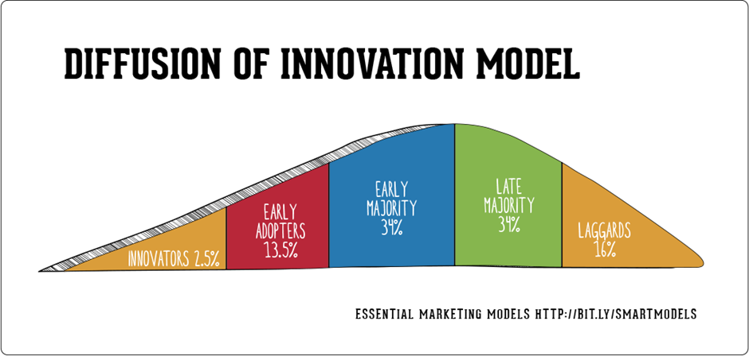
Figure(1.1) Annmarie Hanlon. (2013). What is the The Diffusion of Innovation model?. Available: https://www.smartinsights.com/marketing-planning/marketing-models/diffusion-innovation-model/. Last accessed 15/02/2018.


An investigation in to how the rise of e-commerce has impacted the retail sector
Thank you for taking some time out of your day to answer a few question.
Before taking part you must understand:
Information will not be used outsides its intended purpose.
You will not be able to ask for your information to be removed once submitted
Please answer all questions and tick one box.

Signature Date

Note about screenshots. Exporting questionnaire in to here did not work. So here are screenshots as evidence

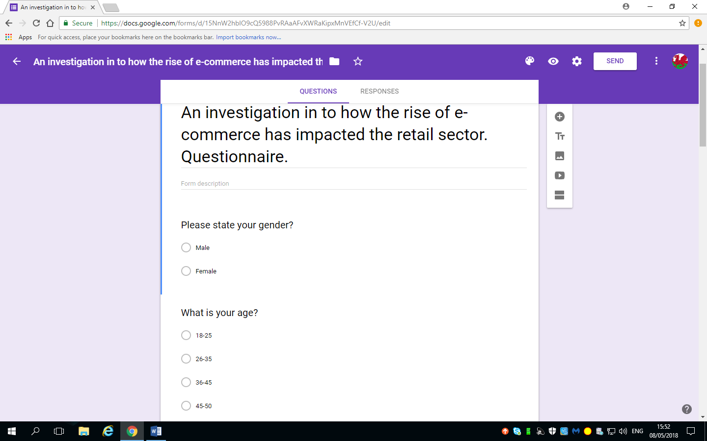

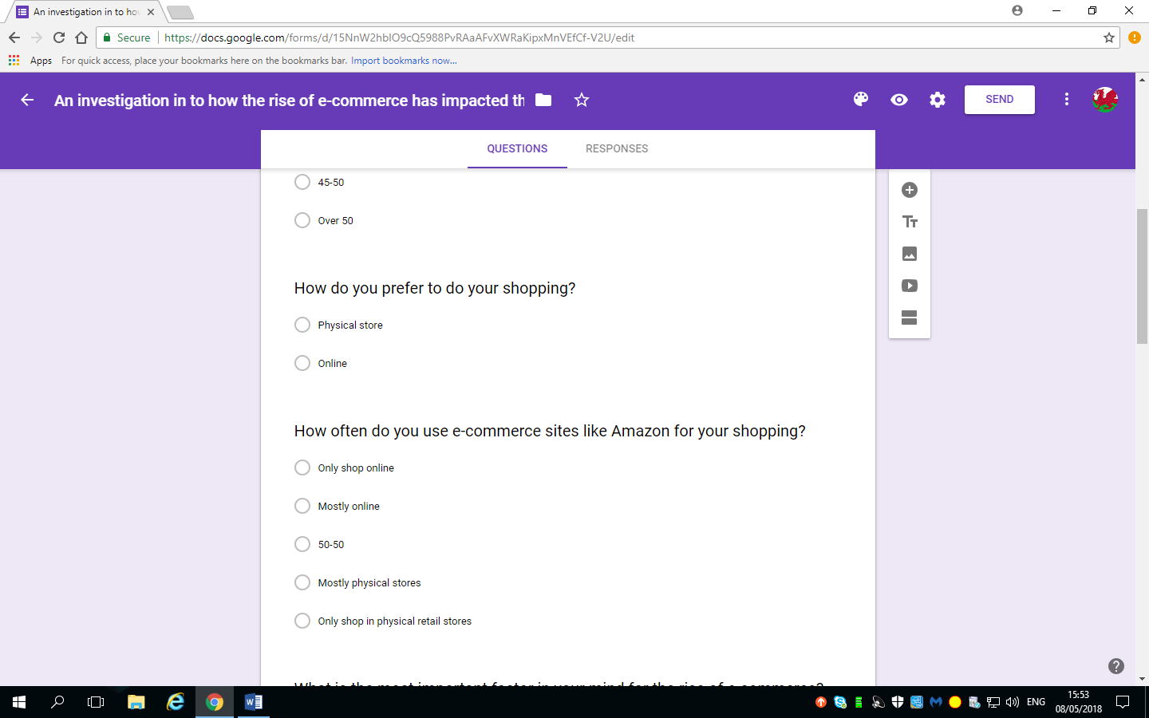

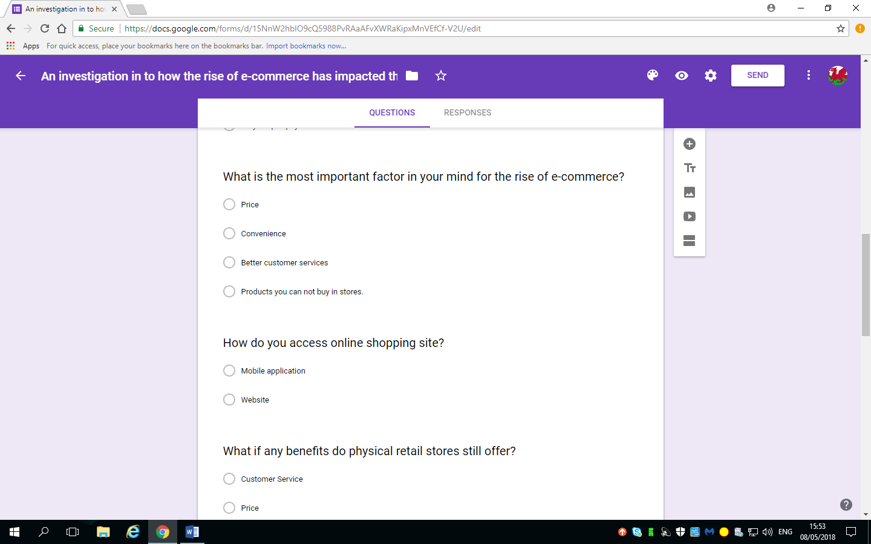

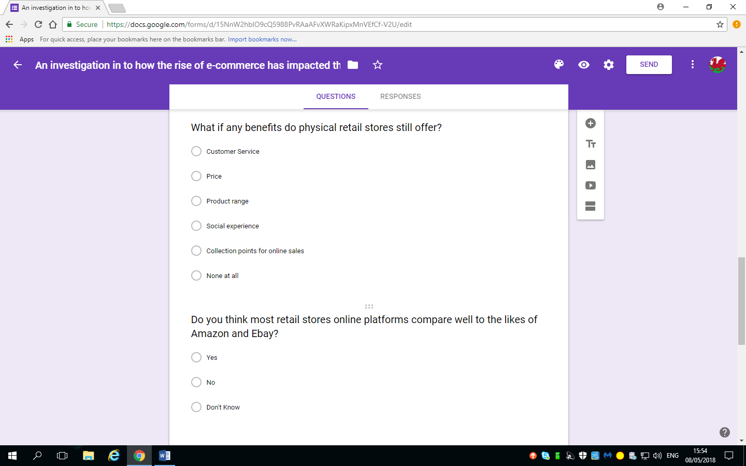

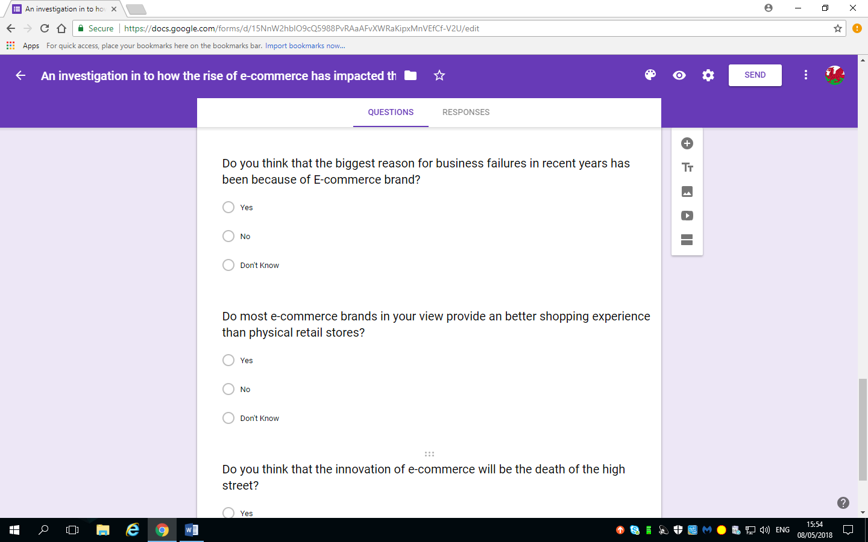

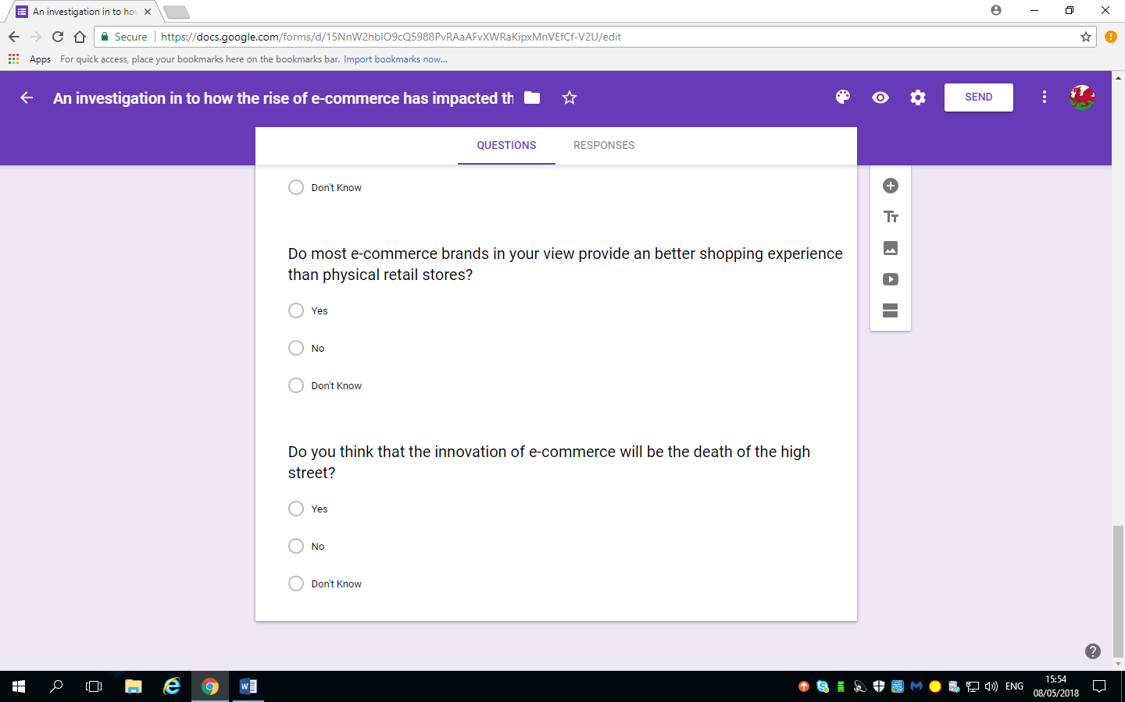

Figure (2.1)

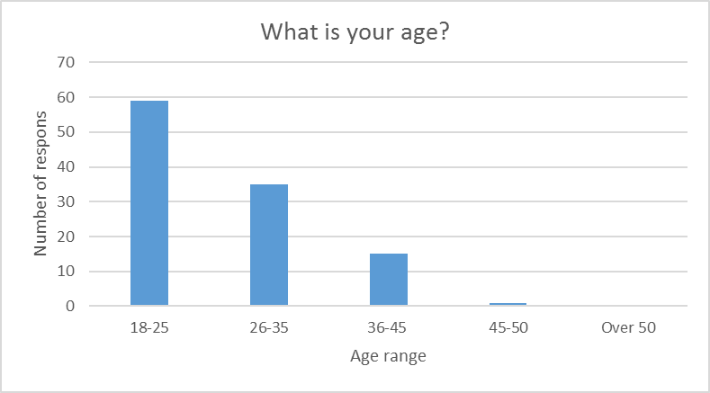 Figure (2.2)

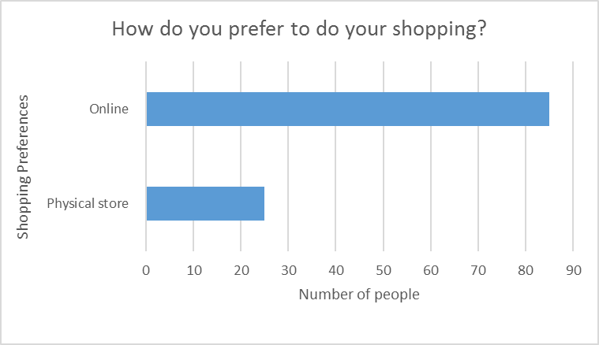 (Figure 2.3)

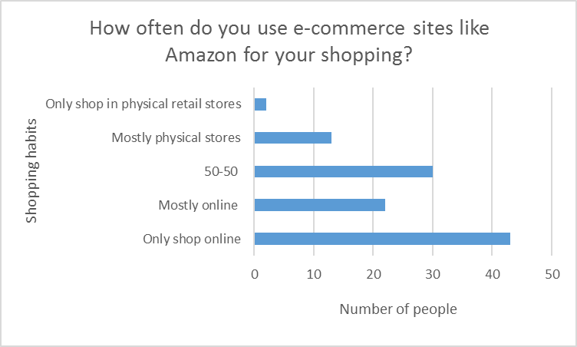 (Figure 2.4)
(Figure 2.5)
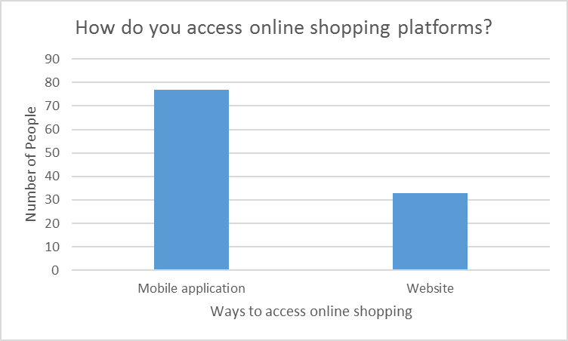 (Figure 2.6)
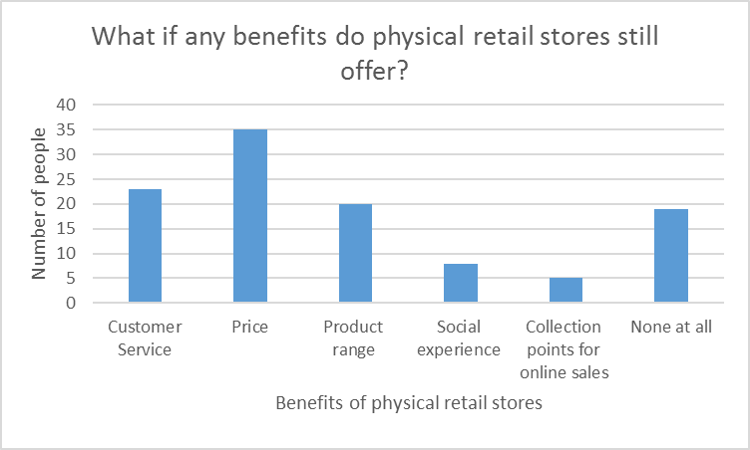 (Figure 2.7)

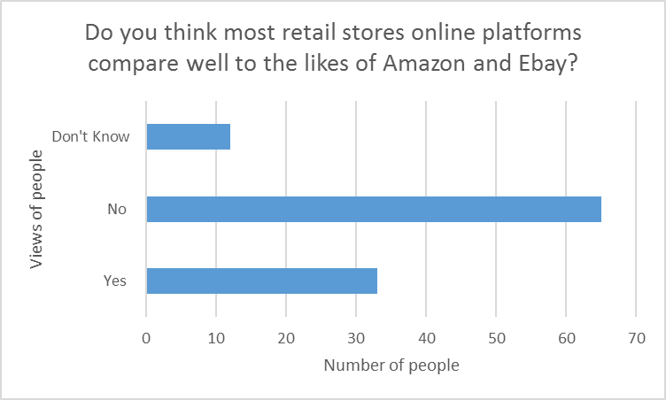 (Figure 2.8)

(Figure 2.9)

(Figure 2.10)

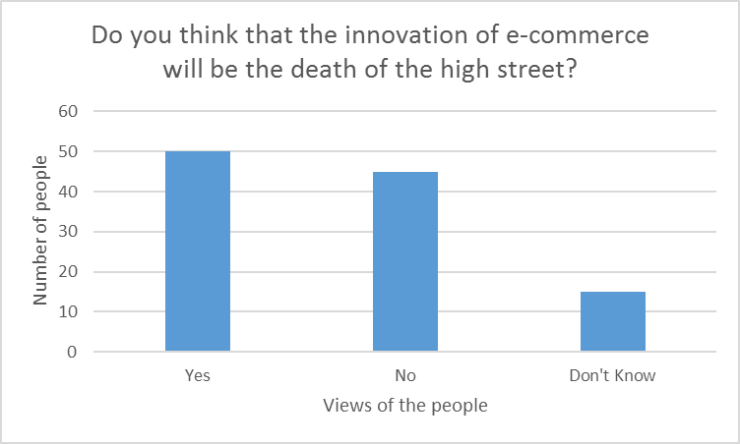 (Figure 2.11)

Case study Amazon
Amazon's business strategy, revenue model and culture of metrics: a history
I've used Amazon as a case study in my books for nearly 20 years now since I think all types of businesses can learn from their digital business strategy. From startups and small businesses to large international businesses, we can all learn from their focus on the customer, testing market opportunities made available by digital technology and their focus on testing and analysis to improve results.

I aim to keep this case study up-to-date for readers of the books and Smart Insights readers who may be interested. In it we look at Amazon's background, revenue model and sources for the latest business results.

We can also learn from their approach to digital marketing since they use digital marketing efficiently across all customer communications touchpoints in our RACE marketing planning framework:

Reach: Amazon's initial business growth based on detailed approach to SEO and AdWords targeting millions of keywords.
Act: Creating a clear simple experiences through testing and learning.
Convert: Using personalisation to make relevant recommendations and a clear checkout process that many now imitate.
Engage:
Their focus on customer experience, "Customer Obsession" as they call it is shown by the way they consistently outperform other retailers in their ACSI customer satisfaction rating too. We have our own internal experimentation platform called “Weblab” that we use to evaluate improvements.

A short history of Amazon's growth and business model evolution
So how did Amazon grow to where it is today with turover of $135 billion? Amazon has come a long way since it launched in 1995:

From:

and these offices...

to its current Seattle headquarters:

Amazon performs exceptionally efficiently measured against revenue per visitor, which is one of the key measures for any commercial website, whether it's a media site, search engine, social network or a transactional retailer or offers travel or financial services. Of course profit per user would be quite different due to the significantly lower costs of other .coms like Facebook and Google.

Note: SEC is the Securities and Exchange Commission (SEC) which is a government agency for which companies have to submit an open evaluation of their business models and marketplace conditions.

Amazon.com mission and vision
When it first launched, Amazon’s had a clear and ambitious mission. To offer:

Earth’s biggest selection and to be Earth’s most customer-centric company.

Today, with business users of its Amazon Web Service representing a new type of customer, Amazon says:

this goal continues today, but Amazon’s customers are worldwide now and have grown to include millions of Con-sumers, Sellers, Content Creators, Developers, and Enterprises. Each of these groups has different needs, and we always work to meet those needs, by innovating new solutions to make things easier, faster, better, and more cost-effective.

20 years later, Amazon are still customer-centric, in fact, in the latest Amazon Annual report, Jeff Bezos of Amazon explains what he calls True Customer Obsession :

There are many ways to center a business. You can be competitor focused, you can be product focused, you can be technology focused, you can be business model focused, and there are more. But in my view, obsessive customer fo-cus is by far the most important. Even when they don’t yet know it, customers want something better, and your desire to delight customers will drive you to invent on their behalf.

Amazon business and revenue model
I recommend anyone studying Amazon checks the latest Amazon revenue and business strategies from their SEC filings / Investor relations. The annual filings to give a great summary of eBay business and revenue models.

A good summary of the latest business model initiatives is always available in the latest Amazon annual report summary. The latest report includes a great vision for Digital Agility (reprinted from 1997 in their latest annual report) showing testing of business models that many businesses don't yet have. Amazon explain:

"We will continue to measure our programs and the effectiveness of our investments analytically, to jettison those that do not provide acceptable returns, and to step up our investment in those that work best. We will continue to learn from both our successes and our failures".

They go on to explain that business models are tested from a long-term perspective, showing the mindset of CEO Jeff Bezos:

We will continue to make investment decisions in light of long-term market leadership considerations rather than short-term profitability considerations or short-term Wall Street reactions.

The latest example of innovation in their business model is the launch of Amazon Go, a new kind of store with no checkout required. Boasting a "Just Walk Out Shopping experience",the Amazon Go app users enter the store, take the products they want, and go with no lines and no checkout.

More recently,there have been a range of business model innovations focussed on hardware and new services: Kindle e-readers, Fire Tablet, smartphone and TV, Echo (using the Alexa Artificial Intelligence voice-assistant), grocery delivery, Amazon Fashion and expansion to the business-oriented Amazon Web Services (AWS). Amazon Prime, an annual membership program that includes unlimited free shipping and then involved diversification to a media service with access to unlimited instant streaming of thousands of movies and TV episodes.

AWS is less well-known outside of tech people, but Amazon is still pursuing this cloud service aggressively. In 2011, they introduced 82 new features and services, in 2012, 159 and in 2013: 280.They now have 10 AWS regions around the world, including the East Coast of the U.S., two on the West Coast, Europe, Singapore, Tokyo, Sydney, Brazil, China, and a government-only region called GovCloud.

Amazon strategy
In their 2008 SEC filing, Amazon describe the vision of their business as to:

“Relentlessly focus on customer experience by offering our customers low prices, convenience, and a wide selection of merchandise.”

The vision is still to Consider how these core marketing messages summarising the Amazon online value proposition are communicated both on-site and through offline communications.

Of course, achieving customer loyalty and repeat purchases has been key to Amazon’s success. Many dot-coms failed because they succeeded in achieving awareness, but not loyalty. Amazon achieved both. In their SEC filing they stress how they seek to achieve this. They say:

"We work to earn repeat purchases by providing easy-to-use functionality, fast and reliable fulfillment, timely customer service, feature-rich content, and a trusted transaction environment.

Key features of our websites include editorial and customer reviews; manufacturer product information; Web pages tailored to individual preferences, such as recommendations and notifications; 1-Click® technology; secure payment systems; image uploads; searching on our websites as well as the Internet; browsing; and the ability to view selected interior pages and citations, and search the entire contents of many of the books we offer with our “Look Inside the Book” and “Search Inside the Book” features. Our community of online customers also creates feature-rich content, including product reviews, online recommendation lists, wish lists, buying guides, and wedding and baby registries."

In practice, as is the practice for many online retailers, the lowest prices are for the most popular products, with less popular products commanding higher prices and a greater margin for Amazon.

Free shipping offers are used to encourage increase in basket size since customers have to spend over a certain amount to receive free shipping. The level at which free-shipping is set is critical to profitability and Amazon has changed it as competition has changed and for promotional reasons.

Amazon communicate the fulfillment promise in several ways including presentation of latest inventory availability information, delivery date estimates, and options for expedited delivery, as well as delivery shipment notifications and update facilities.

This focus on customer has translated to excellence in service with the 2004 American Customer Satisfaction Index giving Amazon.com a score of 88 which was at the time, the highest customer satisfaction score ever recorded in any service industry, online or offline.

Round (2004) notes that Amazon focuses on customer satisfaction metrics. Each site is closely monitored with standard service availability monitoring (for example, using Keynote or Mercury Interactive) site availability and download speed. Interestingly it also monitors per minute site revenue upper/lower bounds – Round describes an alarm system rather like a power plant where if revenue on a site falls below $10,000 per minute, alarms go off! There are also internal performance service-level-agreements for web services where T% of the time, different pages must return in X seconds.

The importance of technology and an increased focus on Artificial Intelligence and Machine Learning
According to founder and CEO, Jeff Bezos, technology is very important to supporting this focus on the customer. In their 2010 Annual Report (Amazon, 2011) he said:

“Look inside a current textbook on software architecture, and you’ll find few patterns that we don’t apply at Amazon. We use high-performance transactions systems, complex rendering and object caching, workflow and queuing systems, business intelligence and data analytics, machine learning and pattern recognition, neural networks and probabilistic decision making, and a wide variety of other techniques.

And while many of our systems are based on the latest in computer science research, this often hasn’t been sufficient: our architects and engineers have had to advance research in directions that no academic had yet taken. Many of the problems we face have no textbook solutions, and so we — happily — invent new approaches”… All the effort we put into technology might not matter that much if we kept technology off to the side in some sort of R&D department, but we don’t take that approach. Technology infuses all of our teams, all of our processes, our decision-making, and our approach to innovation in each of our businesses. It is deeply integrated into everything we do”.

The quote shows how applying new technologies is used to give Amazon a competitive edge. A good recent example of this is providing the infrastructure to deliver the Kindle “Whispersync” update to ebook readers. Amazon reported in 2011 that Amazon.com is now selling more Kindle books than paperback books. For every 100 paperback books Amazon has sold, the Company sold 115 Kindle books. Kindle apps are now available on Apple iOS, Android devices and on PCs as part of a “Buy Once, Read Anywhere” proposition which Amazon has developed.

Some of the more recent applications of AI at Amazon are highly visible, for example, the Amazon Echo assistant and technology in the Amazon Go convenience store that uses machine vision to eliminate checkout lines.

In their 2017 report, they describe the increased use of machine learning and AI ‘behind the scenes’ at Amazon:

"much of what we do with machine learning happens beneath the surface. Machine learning drives our algorithms for demand forecasting, product search ranking, product and deals recommendations, merchandising placements, fraud detection, translations, and much more. Though less visible, much of the impact of machine learning will be of this type – quietly but meaningfully improving core operations".

Amazon Customers
Amazon defines what it refers to as three consumer sets customers, seller customers and developer customers.

There are over 76 million customer accounts, but just 1.3 million active seller customers in it’s marketplaces and Amazon is seeking to increase this. Amazon is unusual for a retailer in that it identifies “developer customers” who use its Amazon Web Services, which provides access to technology infrastructure such as hosting that developers can use to develop their own web services.

Members are also encouraged to join a loyalty programme, Amazon Prime, a fee-based membership program in which members receive free or discounted express shipping, in the United States, the United Kingdom, Germany and Japan.

Competition
In its 2017 SEC filing Amazon describes the environment for our products and services as ‘intensely competitive’. It views its main current and potential competitors as:

1) online, offline, and multichannel retailers, publishers, vendors, distributors, manufacturers, and producers of the products we offer and sell to consumers and businesses;
(2) publishers, producers, and distributors of physical, digital, and interactive media of all types and all distribution channels;
(3) web search engines, comparison shopping websites, social networks, web portals, and other online and app-based means of discovering, using, or acquiring goods and services, either directly or in collaboration with other retailers;
(4) companies that provide e-commerce services, including website development, advertising, fulfillment, customer service, and payment processing;
(5) companies that provide fulfillment and logistics services for themselves or for third parties, whether online or offline;
(6) companies that provide information technology services or products, including on- premises or cloud-based infrastructure and other services; and
(7) companies that design, manufacture, market, or sell consumer electronics, telecommunication, and electronic devices.
It believes the main competitive factors in its market segments include "selection, price, availability, convenience, information, discovery, brand recognition, personalized services, accessibility, customer service, reliability, speed of fulfillment, ease of use, and ability to adapt to changing conditions, as well as our customers’ overall experience and trust in transactions with us and facilitated by us on behalf of third-party sellers".

For services offered to business and individual sellers, additional competitive factors include the quality of our services and tools, their ability to generate sales for third parties we serve, and the speed of performance for our services.

From Auctions to marketplaces
Amazon auctions (known as zShops) were launched in March 1999, in large part as a response to the success of eBay. They were promoted heavily from the home page, category pages and individual product pages. Despite this, a year after its launch it had only achieved a 3.2% share of the online auction compared to 58% for eBay and it only declined from this point.

Today, competitive prices of products are available through third-party sellers in the ‘Amazon Marketplace’ which are integrated within the standard product listings. The strategy to offer such an auction facility was initially driven by the need to compete with eBay, but now the strategy has been adjusted such that Amazon describe it as part of the approach of low-pricing.

Although it might be thought that Amazon would lose out on enabling its merchants to sell products at lower prices, in fact Amazon makes greater margin on these sales since merchants are charged a commission on each sale and it is the merchant who bears the cost of storing inventory and fulfilling the product to customers. As with eBay, Amazon is just facilitating the exchange of bits and bytes between buyers and sellers without the need to distribute physical products.

Amazon Media sales
You may have noticed that unlike some retailers, Amazon displays relevant Google text ads and banner ads from brands. This seems in conflict with the strategy of focus on experience since it leads to a more cluttered store. However in 2011 Amazon revealed that worldwide media sales accounted for approximately 17% of revenue!

Amazon marketing
Amazon does not reveal much about its marketing approach in its annual reports, but there seems to be a focus on online marketing channels. Amazon (2011) states “we direct customers to our websites primarily through a number of targeted online marketing channels, such as our Associates program, sponsored search, portal advertising, email marketing campaigns, and other initiatives”. These other initiatives may include outdoor and TV advertising, but they are not mentioned specifically. In this statement they also highlight the importance of customer loyalty tools. They say: “while costs associated with free shipping are not included in marketing expense, we view free shipping offers and Amazon Prime as effective worldwide marketing tools, and intend to continue offering them indefinitely”.

How ‘The Culture of Metrics’ started
A common theme in Amazon’s development is the drive to use a measured approach to all aspects of the business, beyond the finance. Marcus (2004) describes an occasion at a corporate ‘boot-camp’ in January 1997 when Amazon CEO Jeff Bezos ‘saw the light’. ‘At Amazon, we will have a Culture of Metrics’, he said while addressing his senior staff. He went on to explain how web-based business gave Amazon an ‘amazing window into human behaviour’. Marcus says: ‘Gone were the fuzzy approximations of focus groups, the anecdotal fudging and smoke blowing from the marketing department.

A company like Amazon could (and did) record every move a visitor made, every last click and twitch of the mouse. As the data piled up into virtual heaps, hummocks and mountain ranges, you could draw all sorts of conclusions about their chimerical nature, the consumer. In this sense, Amazon was not merely a store, but an immense repository of facts. All we needed were the right equations to plug into them’.

James Marcus then goes on to give a fascinating insight into a breakout group discussion of how Amazon could better use measures to improve its performance. Marcus was in the Bezos group, brainstorming customer-centric metrics. Marcus (2004) summarises the dialogue, led by Bezos:

"First, we figure out which things we’d like to measure on the site", he said.

"For example, let’s say we want a metric for customer enjoyment. How could we calculate that?"

"There was silence. Then somebody ventured: "How much time each customer spends on the site?"

"Not specific enough", Jeff said.

"How about the average number of minutes each customer spends on the site per session" someone else suggested. "If that goes up, they’re having a blast".

"But how do we factor in purchase?" I [Marcus] said feeling proud of myself.

"Is that a measure of enjoyment"?

"I think we need to consider frequency of visits, too", said a dark-haired woman I didn’t recognise.

“Lot of folks are still accessing the web with those creepy-crawly modems. Four short visits from them might be just as good as one visit from a guy with a T-1. Maybe better’.

"Good point", Jeff said. "And anyway, enjoyment is just the start. In the end, we should be measuring customer ecstasy"

It is interesting that Amazon was having this debate in about the elements of RFM analysis (described in Chapter 6 of Internet Marketing), 1997, after already having achieved $16 million of revenue in the previous year. Of course, this is a miniscule amount compared with today’s billions of dollar turnover. The important point was that this was the start of a focus on metrics which can be seen through the description of Matt Pounds work later in this case study.

Experiments and more experiments!
Amazon have created their own internal experimentation platform called a “Weblab” that they use to evaluate improvements to our websites and products. In 2013, they ran 1,976 Weblabs worldwide, up from 1,092 in 2012, and 546 in 2011. Now many companies use AB testing, but this shows the scale of testing at Amazon.

One example of how these are applied is a new feature called “Ask an owner”. From a product page, customers can ask any question related to the product, Amazon then route these questions to owners of the product who answer.

From human to software-based recommendations
Amazon has developed internal tools to support this ‘Culture of Metrics’. Marcus (2004) describes how the ‘Creator Metrics’ tool shows content creators how well their product listings and product copy are working. For each content editor such as Marcus, it retrieves all recently posted documents including articles, interviews, booklists and features. For each one it then gives a conversion rate to sale plus the number of page views, adds (added to basket) and repels (content requested, but the back button then used). In time, the work of editorial reviewers such as Marcus was marginalised since Amazon found that the majority of visitors used the search tools rather than read editorial and they responded to the personalised recommendations as the matching technology improved (Marcus likens early recommendations techniques to ‘going shopping with the village idiot’).

Experimentation and testing at Amazon
The ‘Culture of Metrics’ also led to a test-driven approach to improving results at Amazon. Matt Round, speaking at E-metrics 2004 when he was director of personalisation at Amazon describes the philosophy as ‘Data Trumps Intuitions’. He explained how Amazon used to have a lot of arguments about which content and promotion should go on the all important home page or category pages. He described how every category VP wanted top-center and how the Friday meetings about placements for next week were getting ‘too long, too loud, and lacked performance data’.

But today ‘automation replaces intuitions’ and real-time experimentation tests are always run to answer these questions since actual consumer behaviour is the best way to decide upon tactics.

Marcus (2004) also notes that Amazon has a culture of experiments of which A/B tests are key components. Examples where A/B tests are used include new home page design, moving features around the page, different algorithms for recommendations, changing search relevance rankings. These involve testing a new treatment against a previous control for a limited time of a few days or a week. The system will randomly show one or more treatments to visitors and measure a range of parameters such as units sold and revenue by category (and total), session time, session length, etc. The new features will usually be launched if the desired metrics are statistically significantly better. Statistical tests are a challenge though as distributions are not normal (they have a large mass at zero for example of no purchase) There are other challenges since multiple A/B tests are running every day and A/B tests may overlap and so conflict. There are also longer-term effects where some features are ‘cool’ for the first two weeks and the opposite effect where changing navigation may degrade performance temporarily. Amazon also finds that as its users evolve in their online experience the way they act online has changed. This means that Amazon has to constantly test and evolve its features.

Amazon.com Technology
It follows that the Amazon technology infrastructure must readily support this culture of experimentation and this can be difficult to achieved with standardised content management. Amazon has achieved its competitive advantage through developing its technology internally and with a significant investment in this which may not be available to other organisations without the right focus on the online channels.

As Amazon explains in SEC (2005) ‘using primarily our own proprietary technologies, as well as technology licensed from third parties, we have implemented numerous features and functionality that simplify and improve the customer shopping experience, enable third parties to sell on our platform, and facilitate our fulfillment and customer service operations. Our current strategy is to focus our development efforts on continuous innovation by creating and enhancing the specialized, proprietary software that is unique to our business, and to license or acquire commercially-developed technology for other applications where available and appropriate. We continually invest in several areas of technology, including our seller platform; A9.com, our wholly-owned subsidiary focused on search technology on www.A9.com and other Amazon sites; web services; and digital initiatives.’

Round (2004) describes the technology approach as ‘distributed development and deployment’. Pages such as the home page have a number of content ‘pods’ or ‘slots’ which call web services for features. This makes it relatively easy to change the content in these pods and even change the location of the pods on-screen. Amazon uses a flowable or fluid page design unlike many sites which enables it to make the most of real-estate on-screen.

Technology also supports more standard e-retail facilities. SEC (2005) states: ‘We use a set of applications for accepting and validating customer orders, placing and tracking orders with suppliers, managing and assigning inventory to customer orders, and ensuring proper shipment of products to customers. Our transaction-processing systems handle millions of items, a number of different status inquiries, multiple shipping addresses, gift-wrapping requests, and multiple shipment methods. These systems allow the customer to choose whether to receive single or several shipments based on availability and to track the progress of each order. These applications also manage the process of accepting, authorizing, and charging customer credit cards.’

Data Driven Automation
Round (2004) said that ‘Data is king at Amazon’. He gave many examples of data driven automation including customer channel preferences; managing the way content is displayed to different user types such as new releases and top-sellers, merchandising and recommendation (showing related products and promotions) and also advertising through paid search (automatic ad generation and bidding).

The automated search advertising and bidding system for paid search has had a big impact at Amazon. Sponsored links initially done by humans, but this was unsustainable due to range of products at Amazon. The automated programme generates keywords, writes ad creative, determines best landing page, manages bids, measure conversion rates, profit per converted visitor and updates bids. Again the problem of volume is there, Matt Round described how the book ‘How to Make Love Like a Porn Star’ by Jenna Jameson received tens of thousands of clicks from pornography-related searches, but few actually purchased the book. So the update cycle must be quick to avoid large losses.

There is also an automated email measurement and optimization system. The campaign calendar used to be manually managed with relatively weak measurement and it was costly to schedule and use. A new system:

Automatically optimizes content to improve customer experience
Avoids sending an e-mail campaign that has low clickthrough or high unsubscribe rate
Includes inbox management (avoid sending multiple emails/week)
Has growing library of automated email programs covering new releases and recommendations
But there are challenges if promotions are too successful if inventory isn’t available.

Your Recommendations
Customers Who Bought X…, also bought Y is Amazon’s signature feature. Round (2004) describes how Amazon relies on acquiring and then crunching a massive amount of data. Every purchase, every page viewed and every search is recorded. So there are now to new version, customers who shopped for X also shopped for… and Customers who searched for X also bought… They also have a system codenamed ‘Goldbox’ which is a cross-sell and awareness raising tool. Items are discounted to encourage purchases in new categories!

See the original more detailed PDF article on Amazon personalisation / recommendation collaborative filtering system.

He also describes the challenge of techniques for sifting patterns from noise (sensitivity filtering) and clothing and toy catalogues change frequently so recommendations become out of date. The main challenges though are the massive data size arising from millions of customers, millions of items and recommendations made in real time.

Amazon Partnership strategy
As Amazon grew, its share price growth enabled partnership or acquisition with a range of companies in different sectors. Marcus (2004) describes how Amazon partnered with Drugstore.com (pharmacy), Living.com (furniture), Pets.com (pet supplies), Wineshopper.com (wines), HomeGrocer.com (groceries), Sothebys.com (auctions) and Kozmo.com (urban home delivery). In most cases, Amazon purchased an equity stake in these partners, so that it would share in their prosperity. It also charged them fees for placements on the Amazon site to promote and drive traffic to their sites. Similarly, Amazon charged publishers for prime-position to promote books on its site which caused an initial hue-and-cry, but this abated when it was realised that paying for prominent placements was widespread in traditional booksellers and supermarkets. Many of these new online companies failed in 1999 and 2000, but Amazon had covered the potential for growth and was not pulled down by these partners, even though for some such as Pets.com it had an investment of 50%.

Analysts sometimes refer to ‘Amazoning a sector’ meaning that one company becomes dominant in an online sector such as book retail such that it becomes very difficult for others to achieve market share. In addition to developing, communicating and delivering a very strong proposition, Amazon has been able to consolidate its strength in different sectors through its partnership arrangements and through using technology to facilitate product promotion and distribution via these partnerships. The Amazon retail platform enables other retailers to sell products online using the Amazon user interface and infrastructure through their ‘Syndicated Stores’ programme.

For example, in the UK, Waterstones (www.waterstones.co.uk) is one of the largest traditional bookstores. It found competition with online so expensive and challenging, that eventually it entered a partnership arrangement where Amazon markets and distributes its books online in return for a commission online. Similarly, in the US, Borders a large book retailer uses the Amazon merchant platform for distributing its products.

Toy retailer Toys R’ Us have a similar arrangement. Such partnerships help Amazon extends its reach into the customer-base of other suppliers, and of course, customers who buy in one category such as books can be encouraged to purchase into other areas such as clothing or electronics.

Another form of partnership referred to above is the Amazon Marketplace which enables Amazon customers and other retailers to sell their new and used books and other goods alongside the regular retail listings. A similar partnership approach is the Amazon ‘Merchants@’ program which enables third party merchants (typically larger than those who sell via the Amazon Marketplace) to sell their products via Amazon. Amazon earn fees either through fixed fees or sales commissions per-unit. This arrangement can help customers who get a wider choice of products from a range of suppliers with the convenience of purchasing them through a single checkout process.

Finally, Amazon has also facilitated formation of partnerships with smaller companies through its affiliates programme. Internet legend records that Jeff Bezos, the creator of Amazon was chatting to someone at a cocktail party who wanted to sell books about divorce via her web site. Subsequently, Amazon.com launched its Associates Program in July 1996 and it is still going strong. Googling http://www.google.com/search?q=www.amazon.com+-site%3Awww.amazon.com for sites that link to the US site, shows over 4 million pages, many of which will be affiliates. Amazon does not use an affiliate network which would take commissions from sale, but thanks to the strength of its brand has developed its own affiliate programme. Amazon has created a tiered performance-based incentives to encourage affiliates to sell more Amazon products.

Amazon Marketing communications
In their SEC filings Amazon state that the aims of their communications strategy are (unsurprisingly) to:

Increase customer traffic to our websites
Create awareness of our products and services
Promote repeat purchases
Develop incremental product and service revenue opportunities
Strengthen and broaden the Amazon.com brand name.
Amazon also believe that their most effective marketing communications are a consequence of their focus on continuously improving the customer experience. This then creates word-of-mouth promotion which is effective in acquiring new customers and may also encourage repeat customer visits.

As well as this Marcus (2004) describes how Amazon used the personalisation enabled through technology to reach out to a difficult to reach market which Bezos originally called ‘the hard middle’. Bezos’s view was that it was easy to reach 10 people (you called them on the phone) or the ten million people who bought the most popular products (you placed a superbowl ad), but more difficult to reach those in between. The search facilities in the search engine and on the Amazon site, together with its product recommendation features meant that Amazon could connect its products with the interests of these people.

Online advertising techniques include paid search marketing, interactive ads on portals, e-mail campaigns and search engine optimisation. These are automated as far as possible as described earlier in the case study. As previously mentioned, the affiliate programme is also important in driving visitors to Amazon and Amazon offers a wide range of methods of linking to its site to help improve conversion.

For example, affiliates can use straight text links leading direct to a product page and they also offer a range of dynamic banners which feature different content such as books about Internet marketing or a search box.
Amazon also use cooperative advertising arrangements, better known as ‘contra-deals’ with some vendors and other third parties. For example, a print advertisement in 2005 for a particular product such as a wireless router with a free wireless laptop card promotion will feature a specific Amazon URL in the ad. In product fulfilment packs, Amazon may include a leaflet for a non-competing online company such as Figleaves.com (lingerie) or Expedia (travel). In return, Amazon leaflets may be included in customer communications from the partner brands.

Our Associates program directs customers to our websites by enabling independent websites to make millions of products available to their audiences with fulfillment performed by us or third parties. We pay commissions to hundreds of thousands of participants in our Associates program when their customer referrals result in product sales.

In addition, we offer everyday free shipping options worldwide and recently announced Amazon.com Prime in the U.S., our first membership program in which members receive free two-day shipping and discounted overnight shipping. Although marketing expenses do not include the costs of our free shipping or promotional offers, we view such offers as effective marketing tools.
Case Study Tesco online
One of the undisputed leaders in the e-grocery business is Tesco. They have a very interesting story to tell about their ongoing journey to achieving success with their dot-com depots in the United Kingdom. In this month’s entry, I thought it would be interesting to share this story with some valuable lessons from the front line.

Tesco.Com

Tesco is one of the top three retailers in the world with 2013 annual turnover of 70.9 billion pounds. The company initially launched its dot-com business in 1996 and formally registered Tesco.com as a separate business in 2000. Today, Tesco.com has an estimated annual turnover of $US 4.3 billion within the United Kingdom. The UK happens to have the second highest online grocery market penetration in the world at 5.1%.

Although Tesco’s primary dot-com operations are based in the U.K., particularly in the greater London area, Tesco has also successfully exported their dot-com strategy to other countries including Poland, Czech Republic, Thailand and South Korea. Most importantly, Tesco is one of the few companies operating a profitable dot-com grocery business.

Tesco allows customers to place orders from any computer, mobile device, smartphone and even from virtual shopping walls in the subway. Within the U.K., Tesco offers customers the ability to “click and collect” (i.e. customer places order online and picks up the order at a local Tesco store drive-through). Tesco also offers a home delivery service in certain parts of the country where the company can provide a home delivery based on a customer’s preferred one-hour time slot. Since its launch, Tesco.com has fulfilled 170 million orders within the U.K. and expectations are that growth will rapidly surpass the company’s existing distribution capacity over the next five years.

In the beginning, Tesco fulfilled online orders from designated retail stores called “dark stores”. Customers place orders the evening before and beginning at about 4 a.m., Tesco associates travel through the store aisles with trolleys to pick and pack the orders. Delivery vans are loaded out of the back room of the store after all orders are picked so that routes can be planned with as many deliveries as possible.

The dark store strategy was inexpensive to launch, and also scalable. It quickly expanded to over 300 stores nationwide. But the strategy was not perfect. The weaknesses of fulfilling customer dot-com orders from retail stores are summarized below:

1. Fulfilling dot-com orders at retail stores is highly inefficient and labour-intensive. The typical dark store processes 220 orders per day with nine delivery vans requiring 70 associates to manage the effort.
2. The back rooms of the stores are much smaller in the U.K. compared to North America due to the high cost of space. Stores are not set up to support the efficient management of a high volume of dot-com orders. Optimizing the delivery routes is difficult at best under these circumstances.
3. The typical store assortment is 20,000 items versus the range of 30,000 SKUs offered on the Tesco.com site. This creates limitations on what the customer is allowed to order from the store and also adds complexity due to product restrictions that differ for each store.
4. Most importantly, the fact that the store aisles have Tesco associates picking dot-com orders at the same time retail shoppers are trying to shop creates an inherent conflict. In-store shoppers ultimately become turned off at having to compete for aisle space and for inventory on the retail shelf. The result is an unexpected downturn in retail store sales from in-store shoppers for “dark stores” performing dot-com fulfillment.
These issues led Tesco to seek a new business model to support the dot-com business. This strategy currently consists of a combination of dark stores to service remote regions of the country and dedicated dot-com depots to service densely populated urban markets – namely London. As time goes by, the pendulum will swing away from retail stores to dedicated depots which are more cost-effective to serve the market.

In 2006, Tesco launched its first dedicated dot-com depot in Croydon on the south side of London. This was the company’s first generation dot-com facility and it was designed with completely manual processes. Tesco associates push carts through a warehouse that stocks items in low-height shelving bins. The depot has a similar floor plan to a retail store layout. Associates pick customer orders across the dry grocery, chilled and frozen temperature zones. The pick cart holds six totes, allowing associates to pick six orders simultaneously. Tesco drivers perform the deliveries using a private fleet of vans – something the firms consider to be very important since these drivers are the face of the company and have direct interaction with the consumer.

In 2008, Tesco introduced a second depot in Aylesford and in 2010 a third depot in Greenford with the goal to establish distribution points on all sides of the London market. The depots are fed from Tesco regional distribution centres to ensure efficient procurement and inbound transportation operations.

This second generation fulfillment centre maintained the same warehouse layout utilizing standard bin shelving at floor level to stock SKUs. Operators use pick to carts to pick six orders concurrently with the use of a hand-mounted RF scanning device to increase order accuracy. At the end of the pick run, the cart is staged in a shipping lane. Totes are then manually transferred to a powered conveyor which transfers the totes into a short term storage buffer. This storage system is automated with multi-shuttle robotic carts that automatically transfer totes into and out of the buffer. As soon as the outbound routing of the delivery vans is done and the delivery vans are ready to be loaded, the automated shuttle system releases totes to a conveyor that transfers the totes to their assigned truck doors. The release of totes is sequenced by temperature zone (frozen, chilled, ambient) so that the chilled totes are always placed closest to the nose of the trailer. As well, totes are sequenced to enable the driver to load the truck in reverse-delivery sequence (i.e. the first delivery is the last to be loaded). These investments in mechanization and automation enabled a 37% increase in productivity over the first generation of depot.

In 2012, Tesco opened a fourth depot in Enfield followed by a fifth depot in Crawley in 2013. Tesco continued to improve the efficiency of the distribution operation with this third generation depot that improved picking efficiency across all temperature zones. The manual pick cart was replaced with a mechanized conveyor system to reduce order picking travel time.

As in the past, each customer order is picked to a tote but now the tote is conveyed throughout the warehouse such that it is transferred only into aisles (i.e. zones) where a stocked item needs to be picked for a customer order. Once all the items in a given aisle are picked, completed totes are transferred by conveyor to the next zone, or if the tote is completed, it is transferred to a multi-shuttle storage buffer. Given that associates are now assigned to pick zones, the fundamental challenge of this type of operation is to ensure workload balancing across all aisles so that each associate has roughly the same level of work to do. This requires slotting software to ensure that the fastest moving SKUs are equally spread out amongst the operating aisles.

Not content to rest on their laurels, Tesco launched their sixth dot-com depot in 2013 in Erith (120,000 sq. ft.). This fourth generation depot introduced a significant advancement in automation in the form of goods to person (GTP) order picking. Approximately 70% of the entire ambient SKU variety is stored in a multi-shuttle system. Chilled and frozen products are unchanged from the mechanized third generation depot.

The fourth generation process flow is described below at a high level:

1. As dry grocery products are received into the depot, they are removed from vendor cartons and placed into a standard donor tote. This enables all products to be held within a standardized entity which is an important requirement for automated material handling systems.
2. Totes are conveyed from receiving to a mini-load automated storage and retrieval (ASRS) system which transfers the totes in pairs into a storage buffer. This enables the automated put-away and storage of incoming goods.
3. A multi-shuttle system is used to bring goods to order pickers who work at fixed picking stations. The multi-shuttle receives incoming totes from the ASRS system whenever it needs to be replenished with inventory. The multi-shuttle system is designed to manage inventory for a couple of days of customer orders whereas the ASRS system is designed to hold the rest of the inventory in the depot.
4. As customer orders are released to the warehouse, the multi-shuttle robotic carts automatically pull totes from the storage system. Each vertical level of the storage system is patrolled by an electric multi-shuttle carrier robot that is responsible for moving totes into and out of the storage locations within its vertical level. By having a robotic shuttle cart working in every vertical level within an aisle, this introduces a much higher throughput capability. The multi-shuttle system also enables the ability to store a much higher variety of products within the depot because the assortment of products can be stored vertically to the full height of the building, rather than being stored at floor level only.
5. From 8:30 p.m. to 5:30 a.m., the multi-shuttle robots pull donor totes holding inventoried products and transfer them to ergonomically designed picking stations. At each picking station, an order selector picks six orders concurrently (three customer totes are positioned to the left and to the right side of where the donor tote arrives). A combination of put to light technology and computer displays enable the fastest picking productivity combined with the highest levels of accuracy.
6. Completed totes are pushed off to a conveyor and returned to the same multi-shuttle system that is used to store donor totes holding inventoried products. This is perhaps the most interesting and intelligent use of automation because the multi-shuttle system is actually dual-purpose. It serves as the storage buffer for items that need to be picked; and it is serves as the sortation system and storage buffer for completed customer orders that are awaiting release to the delivery vans in temperature / route / reverse stop sequence. Since picking wraps up at 5:30 a.m., the tote sortation and release process to load out the delivery vans starts at this time. This means that the multi-shuttle robots can be efficiently utilized first to support the GTP order picking process, and then to support the sortation process to move completed orders into the delivery trucks in the required sequence.
The results of this fourth generation depot provided an 82% improvement in labour productivity as compared to the first generation depot. As importantly, the higher level of automation is the key enabler for Tesco to move towards a profitable same day delivery service. The current business model is primarily a next day delivery service and Tesco is seeking to up the ante by moving to same day delivery in future.

All in all, it’s a remarkable story and one that is not yet finished. Next Tesco will likely continue on its brilliant journey to increase the efficiency of its dot-com service by introducing goods to person automation for perishables and frozen food. With 6 dot-com depots now in operation and undoubtedly more to follow, the company will most likely be looking at better ways to efficiently feed these facilities to minimize the inventory assets within the dot-com distribution network. As dot-com volumes increase, it will become increasingly difficult for Tesco’s regional distribution centres to support both the retail stores and the dot-com depots. Instead, a centralized fulfillment center (CFC) will be introduced to dedicated distribution center for centralized procurement and inbound transportation and the CFC will feed the dot-com depots on a daily replenishment basis.

The lessons learned from Tesco’s success at the e-Grocery business are summarized below:

1. The use of retail stores to fulfill dot-com orders may be a good initial way to get started in the e-grocery business because it is low cost and quickly scalable. However it is an inherently inefficient way to fulfill dot-com orders. Since each store offers a different assortment of products, this method imposes restrictions on the product variety that can be ordered by the dot-com customer. The use of the store back room to perform logistics operations is difficult and constrained due to a lack of space. Lastly, it is also a turn-off for in-store shoppers who now have to compete with store associates for aisle space and retail shelf inventory. Ultimately there is a decline in same store sales for stores that perform dot-com fulfillment as a result.
2. Dedicated dot-com depots make the most sense when they are positioned close to high-density high-income urban markets where efficient delivery routes can be organized. Markets like Toronto, Vancouver and Calgary make good candidates in the Canadian context.
3. Dot-com depots need to remove fingerprints to enable a profitable business model. The handling of retail units is labour intensive and various types of automated material handling systems such as mini-load ASRS systems and goods to person picking systems are being used to maximize the efficiency and accuracy of the distribution operation. While these systems are expensive to acquire and deploy, they significantly reduce labour expense at the depot. As importantly, these technologies enable a much higher product assortment to be distributed from the depot because they make full use of the vertical height of the building. These automation systems also enable automated sortation and release of customer totes to delivery vans based on exactly how the vans need to be loaded which further improves efficiency.
4. Having control over the outbound transportation function is critical to the success of the operation. The drivers represent the company when they interact with the consumer and outsourcing this function to a third party is no different than outsourcing the associates that work in the retail stores. In effect, the delivery van becomes an extension of the store in the mind of the customer.
5. The efficient purchasing and feeding of inventory to dot-com depots is typically done by initially leveraging existing retail distribution centers that are already in place to support the stores. The dot-com depot simply becomes another store that needs to be replenished with inventory. As the network of dot-com depots increase, it likely will make sense to establish a dedicated centralized distribution facility dedicated to replenishing the dot com depots. This of course depends on geography and this strategy may or may not make sense if the network of dot-com depots are close together or spread far apart.
Ethics form
 |  |  | E3 FORM
APPLICATION FOR ETHICAL APPROVAL – BA level

CAIS AM GYMERADWYAETH MOESEGOL – Lefel BA

Mae'r ffurflen hon i'w chwblhau gan bob BA myfyrwyr. Rhaid i bob ffurflen gael ei ystyried gan diwtor y modiwl.  Dylai un copi o'r ffurflen yn cael ei roi ar y ffeiliau Gyfadran ac un copi cadw ar y ffeil myfyrwyr. |  | This form is to be completed by all BA students conducting research, projects or productions. This form should be completed by the student. All forms must be considered by the Module tutor. A copy of the form must be kept centrally and on the student file.
ADRAN 1 – MANYLION MYFYRIWR |  | SECTION 1 - STUDENT DETAILS
Enw Llawn  Full Name | James Desmond Cameron
Ysgol/Cyfadran/  School/Faculty | School of business |  |  | Rhif Myfyriwr Student Number | 1501039
Cydlynydd prosiect / Tiwtor  Module Tutor/ Programme Co-ordinator | Dr Alex Bell |  |  | Enw'r Gradd  Name of Degree | BA Business management
Teitl dangosol yr Traethawd Hir: |  |  |  | Indicative Title of Dissertation:
An investigation in to how the rise of e-commerce has impacted the retail sector.

ADRAN 2 – MANYLION CYFRANOGWYR / CYNULLEIDFA |  |  | SECTION 2 - PARTICIPANT / AUDIENCE DETAILS
Pwy yw’r cyfranogwyr arfaethedig? |  | Who are the intended participants? |  |  | Ydw / Yes | Na / No
Myfyrwyr / staff Y Drindod Dewi Sant |  | Students / staff of Trinity Saint David |  |  | X
Oedolion (dros oed 16 ac yn gymwys i gydsynio) |  | Adults (over the age of 16 and competent to give consent) |  |  | X
Plant a phobl ifanc dan oed |  | Children / legal minors |  |  |  | X
Cleifion neu gleientiaid gweithwyr proffesiynol |  | Patients or clients of professionals |  |  |  | X
Rhywun sy’n cael ei gadw yn y ddalfa neu y mae’r llys wedi cymryd cyfrifoldeb amdano |  | Anyone in custodial care or for whom the court has assumed responsibility |  |  |  | X
Aelod o unrhyw sefydliad lle mae’n bosibl bod angen i unigolyn arall hefyd gydsynio. |  | A member of any organisation where another individual may also need to give consent. |  |  |  | X
Eraill: Nodwch: / Others: please identify:

Nifer, Oed a Ffynhonnell y Cyfranogwyr  Rhowch fanylion yr demograffeg y cyfranogwyr / gynulleidfa. |  |  |  | Participant / Audience Number and Age  Provide details of the demographics of the participants / audience.
Nifer o Gyfranogwyr / yn y Gynulleidfa | Participant/ Audience number |  |  | 110 Questionnaires ages 18 and above
Grŵp oedran y Cyfranogwyr/y Gynulleidfa | Participant/ Audience age group

ADRAN 3 – GWEITHGAREDD YMCHWIL |  |  | SECTION 3 – RESEARCH ACTIVITY
1. | Ydy’r prosiect yn cynnwys: | Does the project include: |  | Ydy / Yes | Nac ydy/No
Defnyddio holiadur neu offeryn ymchwil tebyg |  | Use of questionnaire or similar research instrument |  | X
Defnyddio prawf ysgrifenedig neu gyfrifiadurol |  | Use of written or computerised test |  |  | X
Cyfweliad (cysylltwch gwestiynau posibl) |  | Interview (attach provisional questions) |  |  | X
Dyddiaduron |  | Diaries
Arsylwi ar gyfranogwyr a hwythau'n ymwybodol o hynny |  | Participant observation with their knowledge |  | X
Arsylwi ar gyfranogwyr a hwythau ddim yn ymwybodol o hynny |  | Participant observation without their knowledge |  |  | X
Recordio fideo neu sain |  | Video or audio-taping |  |  | X
Mynediad i wybodaeth bersonol neu gyfrinachol heb gydsyniad penodol y cyfranogwyr |  | Access to personal or confidential information without the participants specific consent |  |  | X
Defnyddio unrhyw gwestiynau, ysgogiadau prawf, cyflwyniad y gallai rhai cyfranogwyr eu profi fel rhywbeth sy'n achosi niwed / tramgwydd corfforol, meddyliol neu emosiynol |  | Administration of any questions, test stimuli, presentation that may be experienced as physically, mentally or emotionally harmful / offensive |  |  | X
Cyflawni unrhyw weithredoedd allai achosi embaras neu effeithio ar hunan-barch |  | Performance of any acts which may cause embarrassment or affect self-esteem |  |  | X
Ymchwilio i gyfranogwyr sy’n ymwneud â gweithgareddau anghyfreithlon |  | Investigation of participants involved in illegal activities |  |  | X
Gweithdrefnau lle defnyddir twyll |  | Procedures that involve deception |  |  | X
Gweini unrhyw sylwedd, cyfrwng neu blasebo |  | Administration of any substance, agent or placebo |  |  | X
Dull arall o gasglu data neu fformat cyflwyno (esboniwch) |  | Other method of data collection or presentation format (please explain)

2. | Restru eich dull o gasglu data | List your method of data collection:

3. | Risg Posibl:  (corfforol, seicolegol, cyfreithiol, cymdeithasol neu economaidd) | Potential Risk:  (physical, psychological, legal, social or economic)
A oes unrhyw risg bosibl i: |  | Is there any potential risk to: | Ydw / Yes | Na / No
A | Cyfranogwyr? | Participants? |  | X
B | Ymchwilydd? | Researcher? |  | X
C | BrifYsgol/Cyfadran? | University? |  | X

4. | Rheoli Risg:  Os oes, beth yw'r risg a sut y bydd yn cael ei reoli? | Management of Risk:  If yes, what is the risk and how will it be managed?

5. | Os ydych yn delio â phlant a / neu oedolion agored i niwed, rhaid i chi gyflwyno eich tystysgrif DBS i'ch tiwtor goruchwylio i'w cymeradwyo cyn i unrhyw gysylltiad â cyfranogwyr hyn. | If you are dealing with children and/ or vulnerable adults you must present your DBS certificate to your supervising tutor for approval before any contact with these participants.
 |  |  |  | Ydw / Yes | Na / No
A | Ydych chi wedi gwneud cais am dystysgrif DBS? |  | Have you applied for a DBS certificate? |  | X
B | A yw eich tiwtor weld a'i gadarnhau eich tystysgrif DBS? |  | Has your tutor seen and approved your DBS certificate? |  | X

6. | A fyddwch yn cael cydsyniad gwybodus ysgrifenedig gan eich cyfranogwyr? |  | Will you obtain written informed consent from your participants?
 |  |  |  |  |  | Ydw / Yes | Na / No
A | Os na fyddwch, pam hynny? |  |  | If no, why not? |  | X
B | Os byddwch, sut byddwch yn sicrhau cydsyniad gwybodus? |  |  | If yes, how will you secure informed consent?
Rhowch eglurhad / Please explain:
Declaration at start of questionnaire laying out all legal notices and ask for signature for consent.

Cynhwyswch gopi o’r ffurflen gydsynio os ydych yn defnyddio un. |  |  |  | Please include a copy of the consent form if you are using one.

ADRAN 4 |  | SECTION 4
CEFNOGWYD /APPROVED |  | NIS CEFNOGWYD/  NOT SUPPORTED
Datganiad  Mae'r wybodaeth a gynhwysir yma yn gywir, hyd eithaf fy ngwybodaeth a’m cred. Rwyf wedi ceisio dynodi unrhyw risgiau a phroblemau sy’n gysylltiedig â’r prosiect / ymchwil neu gynhyrchiad ac rwyf yn cydnabod f’ymrwymiadau innau a hawliau’r cyfranogwyr. |  |  | Declaration  The information contained herein is, to the best of my knowledge and belief, accurate. I have attempted to identify any risks and issues related to the project/research or production and acknowledge my obligations and the rights of the participants.
Llofnodau  Dylai'r ffurflen hon gael ei chwblhau a'i llofnodi gan y myfyriwr a'r Cydlynydd y prosiect /Twitor |  |  | Signatures  This form should be completed and signed by the student and the Module tutor/Programme Co-ordinator.
Myfyriwr / Student  James Cameron |  |  |  |  | Dyddiad: / Date:  08/05/18
Cydlynydd y prosiect /Twitor  Project co-ordinator / Tutor |  |  |  |  | Dyddiad: / Date:


Cyfranogwr Rhif Adnabod:
Participant Identification Number:
CWESTIYNAU CYFWELIAD SAMPL | SAMPLE INTERVIEW QUESTIONS
TEITL Y PROSIECT: / PROJECT TITLE:

1

2

3

4

5

6

7

8

9

10

ENW A CHYFEIRIAD YR YMCHWILYDD | NAME & ADDRESS OF RESEARCHER

Cyfranogwr Rhif Adnabod:
Participant Identification Number:
FFURFLEN GANIATÂD CYFRANOGIAD | PARTICIPATION CONSENT FORM
TEITL Y PROSIECT: / PROJECT TITLE:

Name of Researcher:
Please initial box

1. I confirm that I have read and understand the information sheet dated XXXX for the above study. I have had the opportunity to consider the information, ask questions and have had these answered satisfactorily.

2. I understand that my participation is voluntary and that I am free to withdraw at any time, without giving any reason.

3. I understand that any information given by me may be used in future reports, articles or presentations by the research team.

4. I understand that my name will not appear in any reports, articles or presentations.

5. I agree to take part in the above study.

________________________ ________________ _____________________________
Name of Participant Date Signature

_________________________ ________________ _____________________________
Researcher Date Signature

You may decline to participate in this study. You may end your participation in this study at any time. If you decide to remain anonymous, maintaining your anonymity will be a priority and every practical precaution will be taken to disguise your identity. If you prefer anonymity, there will not be any identifying information on audiotapes or transcripts of this or any interview. No-one will hear any audiotapes or see any transcripts without your prior consent. All materials generated from this or any interview will remain confidential.

When completed, please return in the envelope provided (if applicable). One copy will be given to the participant and the original to be kept in the file of the research team at: PLACE:

ENW A CHYFEIRIAD YR YMCHWILYDD | NAME & ADDRESS OF RESEARCHER

Cyfranogwr Rhif Adnabod:
Participant Identification Number:
FFURFLEN GANIATÂD CYFRANOGIAD | SAMPLE PARTICIPANT INFORMATION SHEET
TEITL Y PROSIECT: / PROJECT TITLE:

*THIS FORM IS TO BE AMENDED AND ADAPTED AS NECESSARY

Dear Participant:

My name is XXXX and I am studying in the School of XXXX.

I would like to invite you to participate in my research project. This project will xxx and aims to xxx

*Attached to this letter is a short questionnaire developed by XXX which will assess XXXX. I believe your opinions will be extremely helpful to me.

Through your participation in the questionnaire and/or interviews, I hope to ascertain XXXX.

All questionnaires will be kept strictly confidential to the researchers involved and at NO time will individual questionnaires be released to the general public. This gives you a chance to express your views on your programme a confidential and anonymous forum and still be able to make a difference. Your participation in this study is completely voluntary so you can withdraw from the questionnaire at any stage.

Our questionnaire should take about XXX minutes to complete, but there is no time constraint. There are also no right or wrong answers. Attached to this letter along with the questionnaire is XXX (e.g. an instruction sheet / a consent form /a feedback sheet). As this is a new project, your feedback is also important to us and we would be much obliged if you could also complete the feedback sheet along with the questionnaire. We understand that your time is at a premium but your opinions are very valuable to us.

After careful and precise analysis of the data obtained from this questionnaire, I will be happy to provide you with a copy of the findings at your request. The results of this questionnaire will hopefully enhance my understanding of XXXX and will be stored on XXX. The results of the research will be fed back to XXX.

We thank you in advance for your time and participation. If any questions do arise, feel free to contact me at your convenience.

ENW A CHYFEIRIAD YR YMCHWILYDD | NAME & ADDRESS OF RESEARCHER

