Student Name: Kristina Masih
Student ID: 2419848
Course Title: BSc Health and Social Care
Module Title: Introduction to Physiology
Module Code: BMHP5023
Lecturer: Dr. Robert Nartowski
Submission date: 23 February 2026

Contents

Introduction ..................................................................................... 2
Risk Factors of Asthma - (Image 1A) ................................................ 3
Understanding the Structure of the Respiratory System ............... 3
Mechanical Ventilation .................................................................... 4
Gas Exchange Process ...................................................................... 4
Inflammatory Processes .................................................................. 5
Impact of Smoking, Vaping and Infection ....................................... 5
Observing Respiratory Function ...................................................... 6
Evidence-Based Lifestyle Management ........................................... 6
Conclusion ....................................................................................... 7
Appendix - Know your Asthma ................................................. 8
References ....................................................................................... 9

RESPIRATORY SYSTEM - ASTHMA
Introduction: - Asthma is a long-term lung condition. Air passages become narrow and inflamed which leads to breathing difficulty and wheezing. Asthma ranges from mild to severe. Some people have only occasional, mild symptoms. Others have constant symptoms with severe life-threatening flare ups. Asthma affects the lung’s larger and smaller airway. It is one of the most common long term respiratory conditions in the United Kingdom, affecting approximately 5.4 million people, including a significant number of adolescents (Asthma + Lung UK, 2023). In a healthcare profession studying asthma has allowed professionals to connect to the anatomical knowledge, physiological mechanisms and behavioural factors to understand how this condition affects individuals across their lifespan. It has also helped professionals and individuals to appreciate the importance of education and early intervention in preventing avoidable exacerbations.
Asthma is defined by recurring episodes of wheezing, breathlessness, chest tightness and coughing, caused by airway inflammation, bronchoconstriction and increased mucus production (NICE, 2022; WHO, 2024). One aspect has been found particularly in asthma is that the symptoms are highly variable. They fluctuate in severity and frequency and may be triggered by allergens, infections, exercise, environmental irritants or behavioural choices such as smoking and vaping (Asthma + Lung UK, 2024). This variability can sometimes lead adolescents to underestimate the seriousness of their condition, especially during periods of relative stability.
Adolescence represents a unique developmental stage marked by increasing independence, identity formation and experimentation with lifestyle behaviours. Through reviewing the literature about asthma is that the adolescents with asthma are at increased risk of exacerbations due to poor medication adherence, smoking initiation, vaping, and greater exposure to viral infections in social environments (Royal College of Physicians, 2022). This highlights the interaction between physiology and behaviour. Asthma is not managed solely through pharmacology; it requires understanding of triggers, self-monitoring and informed lifestyle choices.

Risk Factors of Asthma
In this report on asthma, it can be understood that the development of Asthma is influenced by both non-modifiable and modifiable risk factors. Genetic predisposition plays a significant role, particularly in individuals with a family history of atopy or allergic disease. Early childhood respiratory infections and exposure to environmental allergens also contribute to increased susceptibility (NHS, 2023). While these factors cannot be changed, identifying them is important for early recognition and monitoring.
More importantly from a public health perspective, modifiable risk factors significantly influence disease progression and symptom control. Exposure to tobacco smoke, air pollution, vaping aerosols and poor indoor air quality all contribute to airway irritation and inflammation. In the case for asthma specifically, identifying modifiable risks is central to health promotion and preventative care. Education about smoking cessation and avoidance of environmental triggers can substantially improve outcomes.
Understanding the Structure of the Respiratory System
To fully understand asthma, it is first needed to develop a clear understanding of normal respiratory anatomy and physiology. The respiratory system is divided into the upper and lower respiratory tracts. As shown in figure 1, The upper respiratory tract includes the nose, nasal cavity, pharynx and larynx. (Figure 1. Respiratory tract. (Wikipedia, 2026). These structures filter, warm and humidify inhaled air, protecting the lower airways from harmful particles.
Figure 1 also shows the lower respiratory tract consists of the trachea, bronchi, bronchioles and alveoli (Tortora and Derrickson, 2021). The trachea divides into the right and left main bronchi, which branch repeatedly into smaller bronchioles. These bronchioles eventually terminate in clusters of alveoli. The alveoli are microscopic, thin-walled air sacs surrounded by capillaries, forming the primary site of gas exchange.
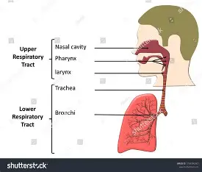
structure shows visually that how airway narrowing at any level, particularly within the bronchioles, can significantly increase airflow resistance. Because the bronchioles are already small in diameter, even minor inflammation or smooth muscle contraction can substantially restrict airflow. This structural understanding is essential when explaining asthma symptoms to patients.
Figure 1. Respiratory tract.

Mechanical Ventilation
Mechanical respiration consists of inhalation and exhalation. During inhalation, the diaphragm contracts and flattens, and the external intercostal muscles elevate the rib cage. This increases thoracic volume and decreases intrathoracic pressure, allowing air to flow into the lungs (Marieb and Hoehn, 2019). During exhalation (also known as expiration), the diaphragm relaxes, thoracic volume decreases and air is expelled as pressure increases.
In healthy individuals, this process is smooth and efficient. However, in asthma, inflammation of the airway mucosa, bronchoconstriction and mucus hypersecretion narrow the airways. The expiration is particularly affected because it is normally a passive process. When airways are narrowed, air becomes trapped in the lungs, leading to hyperinflation and the sensation of breathlessness. This explains why patients often describe difficulty “getting air out” rather than in.

Gas Exchange Process
Gas exchange occurs within the alveoli through diffusion across the alveolar-capillary membrane. Oxygen moves from an area of high partial pressure in the alveoli to a lower partial pressure in pulmonary capillary blood, where it binds to haemoglobin for systemic distribution. Carbon dioxide diffuses in the opposite direction to be exhaled (Ross and Wilson, 2018).
Effective gas exchange requires adequate ventilation, sufficient alveolar surface area and appropriate perfusion. In asthma, ventilation is primarily impaired due to airway narrowing. Some alveoli may receive insufficient airflow despite adequate blood supply, resulting in ventilation-perfusion mismatch. In mild cases, the body compensates and oxygen levels remain within normal range. However, in severe exacerbations, hypoxaemia may develop.
One important insight of Asthma is that the hypoxaemia often develops later in an asthma attack. This means that relying solely on subjective symptoms may delay recognition of deterioration. Objective monitoring tools, such as peak expiratory flow measurement, are therefore essential.

Inflammatory Processes
Asthma is characterised by chronic airway inflammation mediated by immune cells including eosinophils, mast cells and T-helper 2 lymphocytes. These cells release inflammatory mediators such as histamine, leukotrienes and cytokines (Kumar, Abbas and Aster, 2020). These mediators cause vasodilation, increased vascular permeability, mucosal oedema, smooth muscle contraction and excessive mucus production.
Understanding this inflammatory cascade has helped to appreciate why inhaled corticosteroids are central to asthma management. They target underlying inflammation rather than simply relieving bronchoconstriction. Poor adherence to preventer therapy allows persistent inflammation, increasing the risk of exacerbations.
Repeated inflammation may also lead to airway remodelling. Structural changes such as subepithelial fibrosis, smooth muscle hypertrophy and goblet cell hyperplasia can result in less reversible airflow obstruction over time. This reinforces the importance of early and consistent management.
Impact of Smoking, Vaping and Infection
Tobacco smoke contains thousands of chemicals that are pro-inflammatory and cytotoxic. Smoking damages ciliated epithelial cells, impairing mucociliary clearance and increasing susceptibility to infection (WHO, 2022). Individuals with asthma who smoke experience poorer symptom control, accelerated lung function decline and reduced responsiveness to inhaled corticosteroids (NICE, 2021).
Although vaping is often marketed as a safer alternative, aerosolised nicotine and flavouring agents can induce oxidative stress and airway irritation (McCance and Huether, 2019). From a clinical perspective, advising adolescents against both smoking and vaping is essential.
Viral respiratory infections are among the most common triggers of asthma exacerbations. Viral replication in airway epithelium amplifies inflammatory pathways, increasing bronchial hyperresponsiveness. Adolescents are particularly vulnerable due to close contact in schools and social settings.

Observing Respiratory Function
Peak expiratory flow (PEF) measurement provides an objective assessment of airway obstruction. It measures the maximum speed of expiration and reflects airway calibre. Regular monitoring allows early detection of deterioration before severe symptoms develop (GINA, 2023).
Personalised asthma action plans categorise readings into green, amber and red zones based on percentage of personal best. This structured approach enables patients to adjust medication and seek help appropriately. Recognise that self-monitoring promotes self-efficacy and supports long-term disease management.
However, evidence suggests that education alone is insufficient to ensure adherence. Ongoing reinforcement, motivational interviewing and collaborative care planning are required to maintain engagement, particularly in adolescents.
Evidence-Based Lifestyle Management
Smoking cessation is one of the most effective interventions for improving asthma outcomes (WHO, 2022). Preventing smoking initiation in adolescents is equally critical.
Adherence to inhaled corticosteroids remains fundamental to controlling airway inflammation and preventing exacerbations (GINA, 2023). Distinguishing between preventer and reliever inhalers is essential to avoid overreliance on short-acting bronchodilators. Annual influenza vaccination reduces infection-related exacerbations (NICE, 2021). Hand hygiene and avoidance of exposure to infected individuals also reduce risk. Regular physical activity should be encouraged when asthma is well controlled. Exercise improves cardiovascular fitness, psychological wellbeing and overall quality of life. Adequate sleep and balanced nutrition further support immune resilience.
The professional perspective is that the adolescent-centred care is crucial. Collaborative goal setting and shared decision-making are more effective than directive approaches in promoting adherence.

Conclusion
Studies of asthma has provided a comprehensive understanding of how respiratory anatomy, mechanical ventilation and gas exchange are disrupted by chronic airway inflammation. Asthma is a multifactorial condition influenced by genetic, environmental, and behavioural factors.
Airway narrowing, inflammation and mucus hypersecretion impair ventilation and may result in ventilation-perfusion mismatch. Exposure to smoking, vaping and viral infections intensifies inflammatory processes and increases exacerbation risk. Repeated uncontrolled inflammation may lead to airway remodelling and long-term lung function decline.
Objective monitoring through peak flow measurement, adherence to preventer therapy and lifestyle modification are essential components of effective management. Discovering this topic strengthens understanding of the relationship between physiology, behaviour, and patient education. Encouraging adolescents with knowledge and supportive guidance can significantly reduce exacerbations and improve long-term respiratory health.

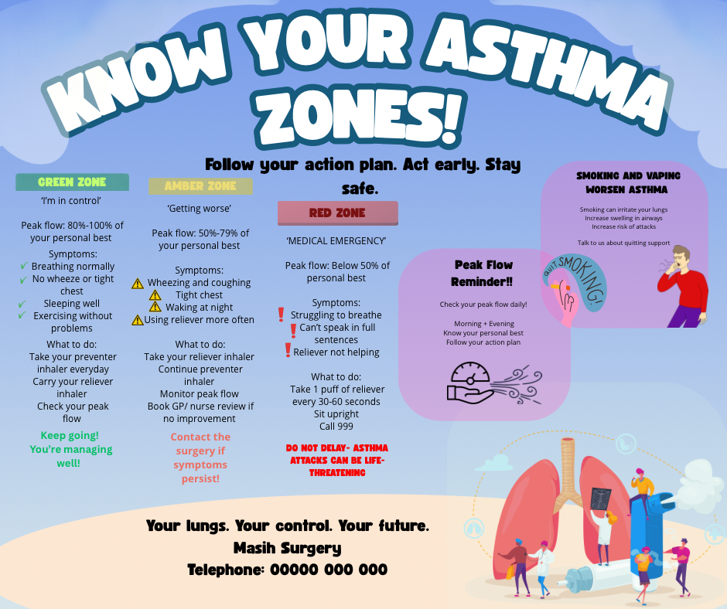

References:
Asthma + Lung UK (2024) What is Asthma? Available at: https://www.asthmaandlung.org.uk (asthmaandlung.org.uk in Bing) (Accessed: 22 February 2026).
Asthma + Lung UK (2023) Understanding asthma. Available at: https://www.asthmaandlung.org.uk (Accessed: 17 February 2026).
Global Initiative for Asthma (GINA) (2023) Global strategy for asthma management and prevention. Available at: https://ginasthma.org (Accessed: 17 February 2026).
Kumar, V., Abbas, A.K. and Aster, J.C. (2020) Robbins and Cotran pathologic basis of disease. 10th edn. Philadelphia: Elsevier.
Marieb, E.N. and Hoehn, K. (2019) Human anatomy and physiology. 11th edn. Harlow: Pearson.
McCance, K.L. and Huether, S.E. (2019) Pathophysiology: The biologic basis for disease in adults and children. 8th edn. St. Louis: Elsevier.
NHS (2023) Asthma. Available at: https://www.nhs.uk/conditions/asthma (Accessed: 17 February 2026).
NICE (2021) Asthma: diagnosis, monitoring and chronic asthma management (NG80). London: National Institute for Health and Care Excellence. Available at: https://www.nice.org.uk/guidance/ng80 (Accessed: 17 February 2026).
Ross, J. and Wilson, L. (2018) Anatomy and physiology in health and illness. 13th edn. Edinburgh: Elsevier.
Royal College of Physicians (2022) National asthma and COPD audit programme (NACAP): asthma clinical audit report. London: RCP.
Tortora, G.J. and Derrickson, B.H. (2021) Principles of anatomy and physiology. 16th edn. Hoboken: Wiley.
Respiratory tract (2026) Wikipedia. Available at https://en.wikipedia.org/wiki/Respiratory_tract (Accessed: 20 February 2026).
World Health Organization (WHO) (2022) Tobacco. Available at: https://www.who.int/news-room/fact-sheets/detail/tobacco (Accessed: 17 February 2026).

