LCHS7009
POPULATION HEALTH AND
DIGITAL HEALTH PROMOTION
COMPONENT 1 – TWO BLOGS
Cervical Cancer Prevention and Screening Among Adult Women in England
The Role of Health Promotion in Increasing Screening Uptake

Student name | Tabsssum khalifa
Student ID number | 2513494
Programme | MSc Public Health and Social Care in Practice
Lecturer | Dr Raheela Shaikh
Submission deadline | 23 October 2026, 14:00 (2:00 PM)

BLOG 1 | NHS NOTIFY • BLOG 2 | CERVICAL SCREENING CONNECT

BLOG 1
Can Digital Invitations and Reminders Increase Cervical Screening Uptake?
A critical evaluation of NHS Notify
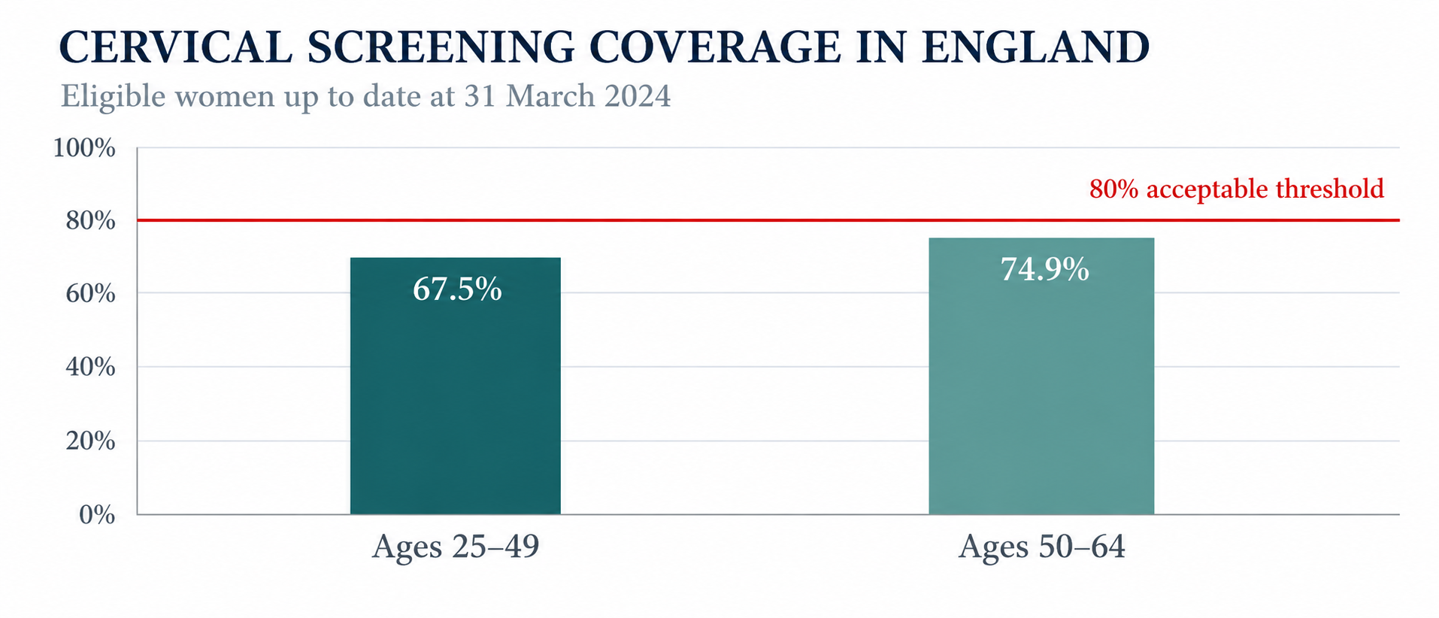
Figure 1. Cervical screening coverage by age group in England, as at March 2024.
Source: Self-developed from NHS England (2025a).
Why this matters
Cervical screening can detect high-risk human papillomavirus (HPV) infection and cell changes before cervical cancer forms, but the value depends on people getting screened. England's 2023–24 standards report noted coverage levels of 67.5% among women aged 25 to 49 and 74.9% among women aged 50 to 64; neither figure met the 80% target (NHS England, 2025a). Younger adults have lower coverage. Higher coverage is therefore a viable prevention strategy, rather than just a communication one.
How does NHS Notify assist?
NHS Notify has been used since 2025 by the Cervical Screening Administration Service to send screening communications through text messages and the NHS App. Texts can be quickly delivered, reducing lost paper letters and linking recipients to official information. Information can be provided in many languages and even braille (NHS England Digital, 2025; NHS England, 2025b). There is a link to the national leaflet explaining why screening takes place and what the person can expect.
Does it increase attendance?
This approach looks promising; however, delivery of the message is not the same as attending the screening. Healthwatch England survey conducted among 2,474 women reluctant to screen revealed fears related to pain and embarrassment; some respondents lacked accessible or translated information. Only 58% found NHS information sufficiently clear in describing HPV's role in cervical cancer (Healthwatch England, 2024). Reminder cannot, by itself, overcome fears, trauma, time constraints and appointments barriers. The benefits of communication from the service perspective should not be confused with controlled evidence of effect of digital messages on attendance.
Critical evaluation
NHS Notify may make the invitation easier to notice and manage. Limited access to the Internet, changes in telephone number, notification preferences and digital literacy will still hinder the process. Practical support is important as well: those people unable to receive an invitation should contact their GP practice (NHS Cervical Screening Administration Service, n.d.). The CQC (n.d.) also lists pain, fear, trauma, disability and convenience among barriers, revealing the importance of staff involvement. Evaluation must assess screening completion and differences by age, deprivation, disability, and ethnicity.
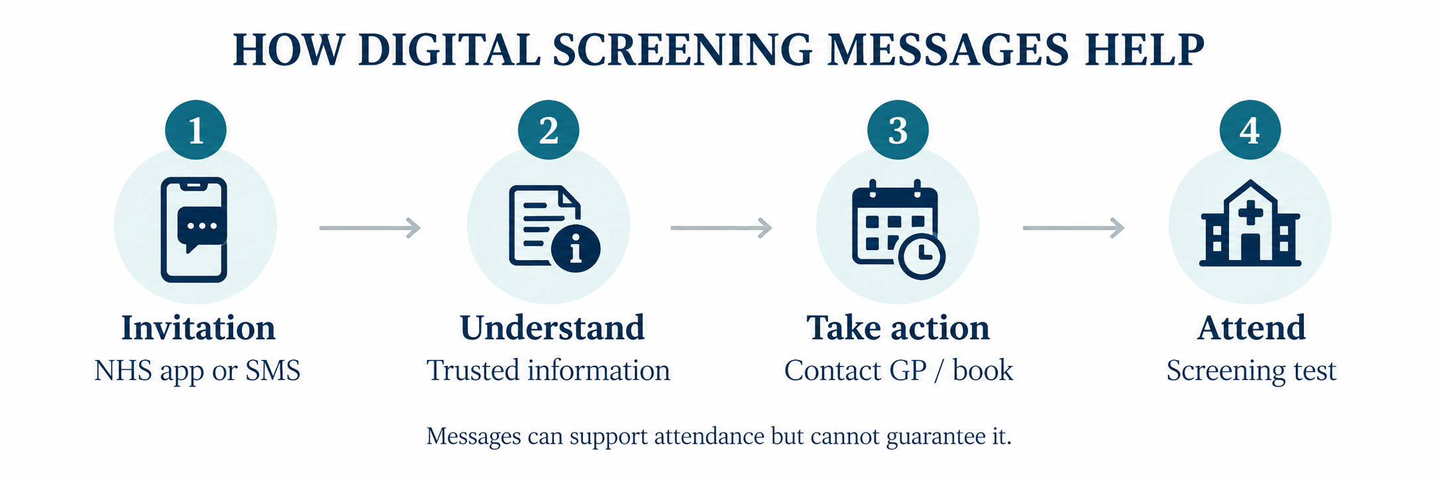
Figure 2. Illustrative pathway from digital invitation to screening attendance.
Source: Self-developed from NHS England Digital (2025).
CRITICAL TAKEAWAY Digital reminders may improve reach, but success must be judged by completed screening and equitable access.
🔗 Explore the technology: https://digital.nhs.uk/services/messaging-best-practice/transforming-cervical-screening-communications
🎥 Watch: https://www.nhs.uk/tests-and-treatments/cervical-screening/what-happens/
BLOG 1 | REFERENCES
NHS England (2025a) Cervical screening standards data report 2023 to 2024. GOV.UK. Available at: https://www.gov.uk/government/publications/cervical-screening-standards-data-report-2023-to-2024/cervical-screening-standards-data-report-2023-to-2024 (Accessed on: 22 October 2026).
NHS England Digital (2025) Transforming cervical screening communications. NHS England Digital, last updated 8 December 2025. Available at: https://digital.nhs.uk/services/messaging-best-practice/transforming-cervical-screening-communications (Accessed on: 22 October 2026).
NHS England (2025b) NHS rolls out more personalised cervical screening for millions. NHS England, 10 June 2025. Available at: https://www.england.nhs.uk/2025/06/nhs-rolls-out-more-personalised-cervical-screening-for-millions/ (Accessed on: 22 October 2026).
Healthwatch England (2024) Cervical screening – my way. National Reports Library, published 16 September. Available at: https://nds.healthwatch.co.uk/reports-library/cervical-screening-my-way (Accessed on: 22 October 2026).
NHS Cervical Screening Administration Service (n.d.) Invitations, reminders and results communications. CSAS. Available at: https://csas.nhs.uk/invitations-reminders-and-results-letters/ (Accessed on: 22 October 2026).
Care Quality Commission (n.d.) GP mythbuster 104: Cervical screening. CQC. Available at: https://www.cqc.org.uk/guidance-regulation/gps/gp-mythbusters/gp-mythbuster-104-cervical-screening (Accessed on: 22 October 2026).

BLOG 2
Cervical Screening Connect: Designing an Inclusive Digital Intervention
An original proposal to support informed screening decisions and attendance
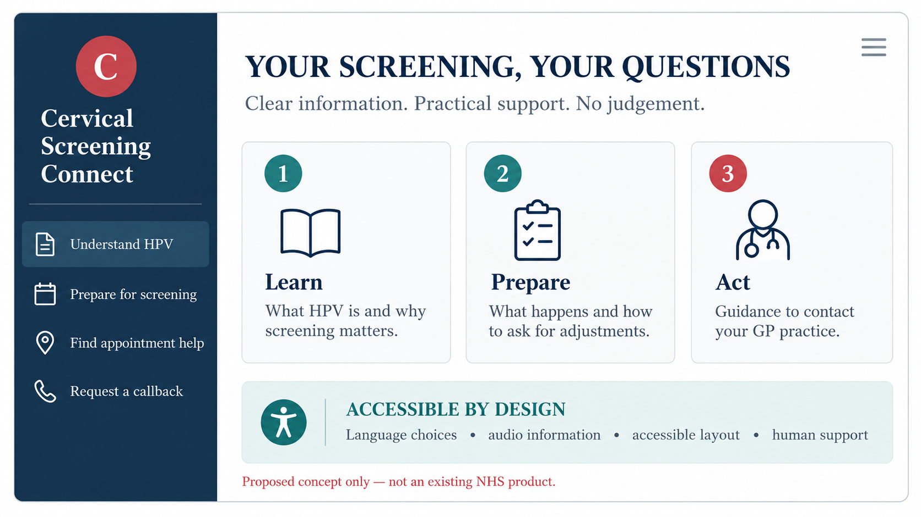
Figure 3. Cervical Screening Connect user-facing concept.
Source: Self-developed; proposed design, not a live NHS product.
Why design another tool?
Coverage falls short of the minimum 80% mark; in 2023-24, 67.5% of eligible women aged 25-49 and 74.9% aged 50-64 years were up-to-date (NHS England, 2025a). Healthwatch England finds that embarrassment, pain anticipated and confusion about HPV may prevent attendance; some women cite inaccessible and untranslated materials (Healthwatch England, 2024). CQC (n.d.) lists pain, fear, disability, past trauma and convenience as additional barriers, and messages will need to relate to support.
Introducing Cervical Screening Connect
This design concept for an accessible, mobile-compatible website linking via texts is not an NHS service. It would offer plain-English, translated and audio information on HPV and screening, myth-busters, a preparation checklist and a guided process for reaching out to a GP practice and booking an appointment (NHS Cervical Screening Administration Service, n.d.). Users could set their reminder preferences, request a callback and prepare to request adjustments, such as extra time or an accessible room. The app will gather minimal data and never diagnose any cancers. Official NHS invitation resources already include translated information, which the website would make easier to access (NHS England, 2026).
Would it influence behaviour?
The COM-B model describes capability, opportunity and motivation as components of behaviour (Michie, van Stralen and West, 2011). Clear explanations help with capability; booking guidance and adjustment prompts address opportunity; reassuring, user-controlled reminders might affect motivation. Intended effects are increased knowledge, confidence and attendance; however, all these will have to be proven. This tool needs to complement, rather than replace, discussions with clinicians.
Risks and evaluation
Digital-only communication may exacerbate inequalities among patients with limited Internet access, low literacy, disabilities and language barriers. Co-designing the website with eligible women, privacy assessment, translations, assisted access and availability of telephonic or paper-based alternatives are critical. A pilot run concurrently with NHS invites should measure how many appointments are booked and attended, patient confidence levels and differences between various groups by age, deprivation, disability and ethnicity. No number of clicks is a good outcome; true success lies in informed decision-making and attending screening appointments. Evaluation should establish if this tool adds value compared to NHS messaging efforts (Dup, 2020).
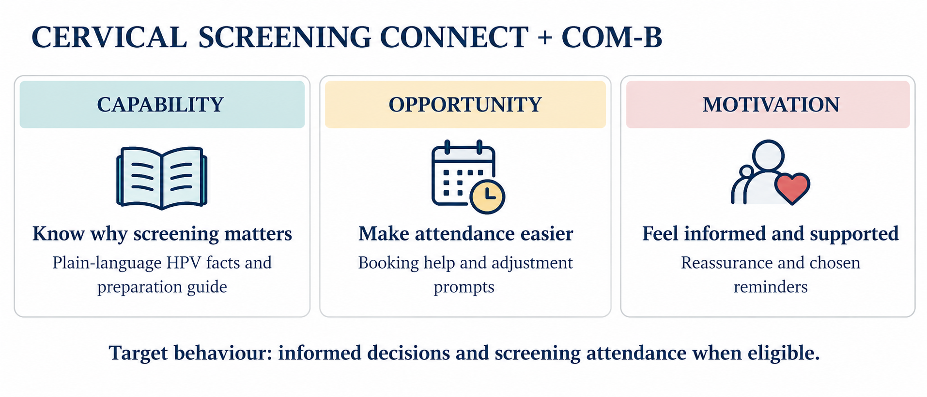
Figure 4. Applying the COM-B model to the proposed intervention.
Source: Self-developed, informed by Michie, van Stralen and West (2011).
DESIGN PRINCIPLE The tool should make screening easier to understand and access, while keeping human support and non-digital routes available.
🔗 Explore the supporting guidance: https://www.nhs.uk/tests-and-treatments/cervical-screening/how-to-book/
🎥 Watch: https://www.youtube.com/watch?v=wyt2S9lb6Gw
BLOG 2 | REFERENCES
NHS England (2025a) Cervical screening standards data report 2023 to 2024. GOV.UK. Available at: https://www.gov.uk/government/publications/cervical-screening-standards-data-report-2023-to-2024/cervical-screening-standards-data-report-2023-to-2024 (Accessed on: 22 October 2026).
Healthwatch England (2024) Cervical screening – my way. National Reports Library, published 16 September. Available at: https://nds.healthwatch.co.uk/reports-library/cervical-screening-my-way (Accessed on: 22 October 2026).
Michie, S., van Stralen, M.M. and West, R. (2011) The behaviour change wheel: a new method for characterising and designing behaviour change interventions. Implementation Science, 6, 42. Available at: https://doi.org/10.1186/1748-5908-6-42 (Accessed on: 22 October 2026).
NHS England (2026) Cervical screening: invitations. GOV.UK, updated 16 March. Available at: https://www.gov.uk/government/publications/cervical-screening-invitations (Accessed on: 22 October 2026).
Care Quality Commission (n.d.) GP mythbuster 104: Cervical screening. CQC. Available at: https://www.cqc.org.uk/guidance-regulation/gps/gp-mythbusters/gp-mythbuster-104-cervical-screening (Accessed on: 22 October 2026).
NHS Cervical Screening Administration Service (n.d.) Invitations, reminders and results communications. CSAS. Available at: https://csas.nhs.uk/invitations-reminders-and-results-letters/ (Accessed on: 22 October 2026).

