  Component One:Student Journal (learning log) 750 words +/- 10%  Contribution to Overall Module Assessment: 25% | Student No: | Ionelia Popoiu  2243056
 | Module Title: | Hotel Administration and Frontoffice Operations
 | Module Code: | BMIH4004
 | Lecturer: | Natalie Brailsford
Introduction
Gibb's model of reflection is a well-structured model used to reflect on past experiences and learning based on these events (Ningrum and Ariani, 2020). It comprises six stages to reflect on past events, which are as follows:
Description
I can recall my placement experience of getting places in the front-office department of a reputed hotel chain in the UK. I was able to comprehend new knowledge and concepts related to the tourism and hospitality industry during my placement experience. My initial responsibility after joining as front office executive after the placement was to manage the online bookings and reservations for the guests in the hotel.
Feelings
At the initial stage of my placement experience, I was feeling very excited as well as confident in my ability to work effectively and effortlessly in the role of the front-office executive in the placement organization. I was very confident in my skills and knowledge of managing an information system of the company. The role of front-office workers in hotels is to manage and onboard the guests in a professional manner in order to improve their experience with the brand (Marneros et.al 2020.). However, at one point, I experienced a situation where the system failed, and my responsibility was to manage the booking as well as the reservation of the guests on a manual basis as a result of a technology breakdown in the hotel. It was a time when I started feeling a little nervous and anxious about the role and responsibility of the front office department since it was time-consuming and very delicate work to be done. This also indicates that my stress management skills require improvement.
Evaluation
I can reflect on various good and bad experiences throughout my placement journey at the hotel. One good incident which I can recall is related to my ability to manage the information system of the hotel effectively to provide a seamless and exceptional user or guest experience to the customers. However, one of the bad experiences that I faced during my time in the placement organization was my ability to perform multiple tasks at once. Multitasking is considered to be one of the essential skills from the perspective of business in the hospitality industry (Mhaske and Patil, 2022). During one of my busy days, there was a shortage of staff in the front office as well as the back office, due to which I was supposedly required to perform multiple duties within the limited time period to control rush and chaos in the hotel. It was very challenging for me to manage my work, based on which I can reflect that my multitasking skills are one of my major weaknesses. However, my overall performance in the front-office department was satisfactory as per the feedback and reviews that I received.
Analysis
My experience of working as a front-office executive in the placement organization was considered to be one of the significant aspects of my learning curve and growth journey, where I learned about multiple skills and knowledge relevant to the hospitality and tourism industry. Customer service skills and knowledge are essential for any hospitality or tourism graduate to enter the industry and achieve better employability (Rao et.al 2021). There were times when I was assigned the responsibility of managing the doubts, grievances and queries of the in-house guests and customers over the phone calls. I believe that my customer service skills have been developed and improved as a result of this experience. One of the unlikely experiences that I had during my placement journey was that I witnessed an ethical concern in the hotel and was not able to report it. At the time of my role to coordinate with the back-office executive in the hotel, I witnessed that the employees and workers of back-office staff were discussing the ethical issue of wage or salary gap in the compensation structure, which I even noticed while working with my other peers. Unfair wage or salary structure, based on the class, origin and cultural background of the candidate, is considered to be one of the major ethical concerns in the hospitality industry (Bardi, 2011).
Conclusion
I can conclude that I have learned about various knowledge and skills, such as effective communication, customer service skills and time management skills, from this experience and these are my strengths. However, my stress management and multitasking skills are some of my weaknesses.
Action Plan
Skills | Action | Timeframe
Stress management | I look forward to staying calm during any panic situation and thinking of the best alternative solution to tackle the situation and manage my stress level. | Eight weeks
Multitasking | I will focus on prioritizing important tasks and roles first and then complete the other ones. | 12 weeks

Component Two
Contribution to Overall Module Assessment: 25%
Trip Advisor Review Response 150 words +/-10%
Dear Xlittlemissyx,

Thank you so much for your review. We are extremely happy to find that you had an amazing experience during your stay at our Novotel. We appreciate the time and effort by you to provide us with the five-star review.

Sharing in detail about the experience you had with us, we are delighted to know that you had a fantastic experience. We are satisfied to hear you loved the housekeeping service and also happy you enjoyed your breakfast the most, we like to take the upmost pride in our work. Including the amazing experiences with our receptionist as well. Your kind words of appreciation are very important to keep our employees motivated. Keeping us performing to the best in our services. Our employees give their best performance to satisfy our guests.

Once again thank you so much for your valuable feedback. Looking forward to welcoming you back soon!

Sincerely,
Ionelia Popoiu

Screen shot of referenced Trip Advisor review used:
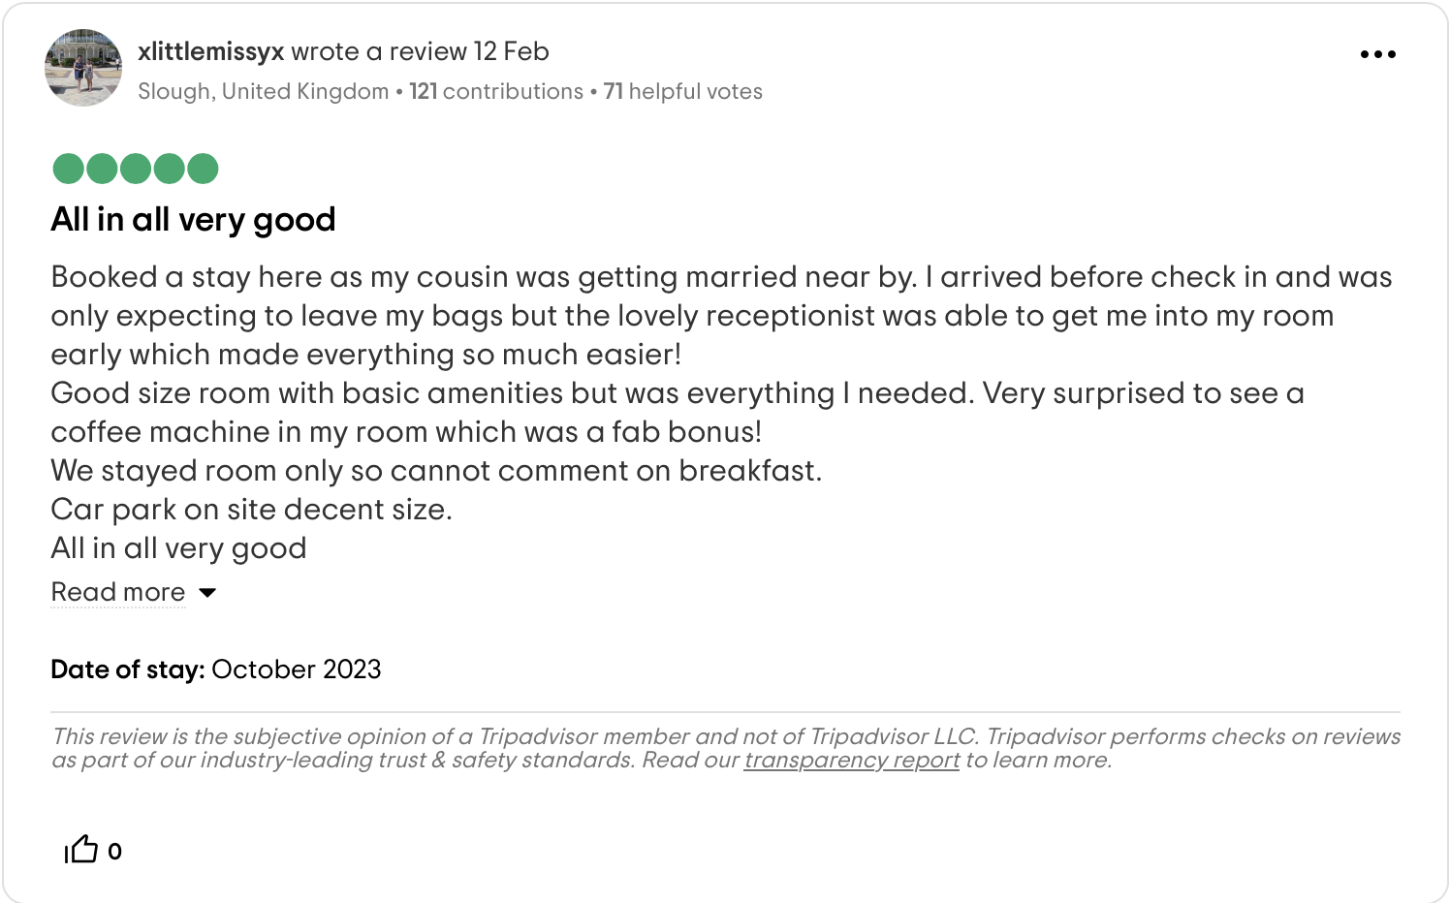
Reference List

Trip Advisor, 2024. Novotel. [Online] Available at <https://www.tripadvisor.com/Hotel_Review-g186338-d193672-Reviews-Novotel_London_West-London_England.html#REVIEWS> [Accessed on 20th February 2024].

Letter of complaint response500 words +/- 1-%
RE: Complaint
Dear Joanna Blake,

Firstly, I would like to take this opportunity to give my sincerest apologies for unsatisfactory experience you encountered during your recent stay at our Novotel. We always take feedback in with open arms as this is our catalyst that drives our continuous improvement, efforts and dedication to our commitment into making our guests feel satisfied.

Upon receipt of your feedback, I have conducted the management team for a formal investigation in order to address the concerns that you have put forward, I want to ensure that corrective measures will be taken and implemented to guarantee that future guests will have a seamless experience.

Addressing the cleanliness of the room, I offer my apologies for the substandard condition you encountered. Maintaining immaculate standards in our institution holds a heap of importance to us and therefore I assure you that protocols have been reinforced with the housekeeping team to uphold these standards to the highest degree.

We understand your frustration regarding the nature of our Wi-Fi connectivity, especially our guests with a professional obligation. We apologise for the inconvenience caused by our slow Wi-Fi and I want to assure you that our technical team is working hard to enhance our infrastructure, building and maintaining a more robust connection along with reliable connection for our esteemed guests.

Noise disturbances detract significantly from the quality of someone’s stay, it is regrettable that you were at an inconvenience from the excessive noise levels by the other guests of Novotel. Our commitment lies with having a peaceful and tranquil environment to keep noise pollution to a minimum. We will be reassessing our noise control policies to mitigate these noise issues in the future.

Your feedback concerning the quality of customer service is disheartening, as delivering care to our guests and exemplary service lies within our ethos. Rest assured, I have taken these matters and addressed all our staff, providing more extensive training to allow heightened responsiveness and attentiveness to our guests’ needs at all times during their stay at Novotel.

As a token of goodwill and to acknowledge the inconvenience that you have experienced, I would like to offer an invitation for a complimentary stay with us at your earliest connivence. It would be our honour to carry out our team ethos and demonstrate improvements that we have implemented in regard to your recent feedback, solidifying our dedication to bring you and our guests an exceptional experience.

Once again, I will offer my apologies for the shortcomings you encountered during your recent stay. Your patience and understanding are greatly appreciated, we anticipate the opportunity to welcome you back to Novotel and fulfil your expectations.

Should you have any further concerns or require any assistance to discuss your future reservations, please do not hesitate to contact me.

Thank you for affording the time to address your concerns comprehensively.

Yours sincerely,
Ionelia Popoiu
Novotel Milton Keynes

Reference List

Trip Advisor, 2024. Novotel. [Online] Available at <https://www.tripadvisor.com/Hotel_Review-g186338-d193672-Reviews-Novotel_London_West-London_England.html#REVIEWS> [Accessed on 20th February 2024].

Component Three:

Contribution to Overall Module Assessment: 50%(1000 words +/- 10%)

Writing in essay format

Key Skill 1 – Customer Service Skills

Consumer service skills are mainly associated with dealing with the consumer to ensure that aspects such as issue handling, deploying empathy, and cultural sensitivity are taken into account by the individual (Rabiul et.al 2023). It is important to understand consumer requirements and train staff in a manner that satisfies the needs of the clients visiting the hotel to a larger extent. For hotel administration and front office operations, consumer service skills mainly enhanced the positive reputation of the brand and, at the time, increased the financial performance at the end of the year. Consumer service skills for the individual are increased through encouraging feedback from guests and tracking metrics in order to make improvements in the organisation (MERINE, 2020).
Currently, the consumer service skills of individuals are also associated with digitalising their experience. It basically makes sure that the guests are offered the personalised experiences that they are demanding within the hospitality sector. Listening to consumers carefully and making them feel special is equally important in providing the service that they need within the market. Practising empathy and understanding the needs in association with the culture make sure that the consumer experience is improved and rewarded in the market. In consumer service, skills such as problem-solving, empathy, and active listening are automatically important to ensure the needs of the consumers are being attained.
Professionalism, patience, and a people-first attitude are required of an individual to build the skills of consumers. For example, Hilton, in its hotels, provides various training programs for its employees to build the attitude of consumer sensitivity (Hilton, 2024). The company believes that with a team where every employee has consumer service skills, it will be able to compete in the market with a higher success rate than its competitors.
Key Skill 2 – Communication Skills

Communication skills are demonstrated as another part of the hotel industry, which is especially important for interacting with people (Ushakov et.al 2020). The consumer in the hotel sector expects a higher level of return, and therefore, by adapting to the assertive style, individuals can fulfil the demand of the consumer. In these communication skills, one understands the needs, opinions and feelings of the clients while respecting their needs, opinions and feelings. The key communication skills also include active listening, friendliness, confidence, empathy, respect and confidence in their attitude. It is furthermore important for exchanging knowledge, opinions, ideas and findings between the client and the employees and understanding their requirements in a careful manner.
Excellent communication skills resolve conflicts and create a positive guest experience. Clear and concise communication also helps to avoid misunderstandings and miscommunication that can disrupt the flow of operations (Salas-Vallina et.al 2020). Strong hotels are able to achieve higher success only by making guests feel special through communication. Individuals with better communication skills are capable of building strong relationships with guests. Being able to create a positive working environment is getting influential with communication skills. Possessing a better understanding associated with the needs of the staff is also required in communication skills.
Key Skill 3 –Organizational Skills
Whether personnel is running the line as a cook or seating guests as a host, it is essential for restaurant employees to have a higher level of key skills. Organisation skills help the organisation because they help create a culture with teammates of properly planned, scheduled, and communicated aims set to reduce unnecessary activities or tasks. Organisation skills help in being focused on efforts to make sure that guests are satisfied and happy with the timely services provided to them, which also puts great significance on the management as a whole. For example, IHG, one of the most popular hotels, provides great accommodation and wellness services to guests, with about 345,000 colleagues working across more than 100 countries and delivers true hospitality for Good (IHG, 2024).
It is observed employees working here use organizational skills. The rationale for implementing this key skill is that it helps them interact with other workers seamlessly without any kind of difficulty. Working with organisation skills helps the team work according to needs clear and precise communication with senior staff members, and ensures that excellent services are provided to guests. As per the views of Smuts et.al (2021), organisation skills are required to work within a hotel's front office operation because it allows them to ensure organic communication or details to serve guests are mentioned.
To confront sensitive issues of guests or even other employees working in the hotel industry, it is crucial to create understanding around organisational skills as it ensures teamwork and reduces procrastination on deadlines.
Key Skill 4 –Problem Solving Skills

In the modern business environment, the way services were given before has completely changed because customers' preferences have changed. Therefore, it is essential for the person working in the position of front office operation to ensure working on problem-solving capabilities. There is also evidence that shows working with these key skills enhances workplace professionalism because it allows critical thinking, which improves analytical thinking; thus, solving customers' issues becomes easier. It is contended by Fallon and Rutherford (2011) that problem-solving is the act of determining the main causes of a problem or identifying them all and prioritizing the selected alternatives in order to find a solution.
Particularly working in the hotel industry, problem-solving competencies are crucial because they eventually encourage teamwork and collaboration among each team, where solving guests' circumstances become easier. In the hotel industry, where staff needs to be competent as it is a service-based industry, problem-solving skills ensure time management because employees learn to make effective as well as quicker decisions (Treffinger et.al 2023).
Thus, for front office operations, working on these skills means coming up with new, creative and effective solutions when guests face any difficulty and ensuring that they leave the hotel highly satisfied. Team problem-solving generates more solutions, and as a result of this, it leads to generating greater and more productive outputs than any person can generate. In the hotel industry, working on these skills is essential because it helps in giving unique services after identifying the challenges of staff members and developing solutions for them easily.

Reference List

Bardi, J. (2011) Hotel Front Office Management, Wiley, London
Fallon, M. and Rutherford, D. (2011) Hotel Management and Operations, Wiley, London
Hilton, (2024). YOUR HOTEL OUR BRAND & MANAGEMENT TEAM.[Online]. Available through: < https://managementservices.hilton.com/en/who-we-are/ >. [Accessed on: 9th February 2024].
IHG, (2024). About us. [Online]. Available through: < https://www.ihgplc.com/about-us>. [Accessed on 9th February 2024].
Marneros, S., Papageorgiou, G. and Efstathiades, A., (2020). Identifying key success competencies for the hospitality industry: the perspectives of professionals. Journal of Teaching in Travel & Tourism, 20(4), pp.237-261.
MERINE, A., (2020). Needs Analysis of English Communicative Skills of Hotel Receptionists and Future Steps towards Possible Solutions: The Case of Sheraton, Royal and Meridien Hotels in Oran (Doctoral dissertation).
Mhaske, M.K. and Patil, M.P., (2022). Information On Knowledge Management and Performance of Front Office Branch Hotel. Specialusis Ugdymas, 2(43), pp.2369-2379.
Ningrum, Y. and Ariani, N., (2020). Reflective journal writing: A review of the literature. In NEELS (National English Education, Language and Literature Seminar) Proceedings (pp. 305-313).
Rabiul, M.K., Shamsudin, F.M., Yean, T.F. and Patwary, A.K., (2023). Linking leadership styles to communication competency and work engagement: evidence from the hotel industry. Journal of Hospitality and Tourism Insights, 6(2), pp.425-446.
Rao, Y., Lao, L. and Liu, C., (2021). How do front-line employees make decisions on whether to hide their knowledge from co-workers in hospitality firms?. International Journal of Contemporary Hospitality Management, 33(5), pp.1532-1553.
Salas-Vallina, A., Pozo-Hidalgo, M. and Gil-Monte, P.R., (2020). Are happy workers more productive? The mediating role of service-skill use. Frontiers in psychology, 11, p.456.
Smuts, S., van Der Merwe, A. and Smuts, H., (2021), August. Industry 4.0 and Organisations: Key Organisational Capabilities. In Conference on e-Business, e-Services and e-Society (pp. 423-438). Cham: Springer International Publishing.
Treffinger, D.J., Isaksen, S.G. and Stead-Dorval, K.B., (2023). Creative problem solving: An introduction. Routledge.
Ushakov, R.N., Kryukova, E.M., Khetagurova, V.S., Mukhomorova, I.V. and Zelenov, V.V., (2020). Efficiency of hotel management. Training of specialists in hotel industry field. Journal of Environmental Management & Tourism, 11(2 (42)), pp.388-395.

