Reception Department Experience



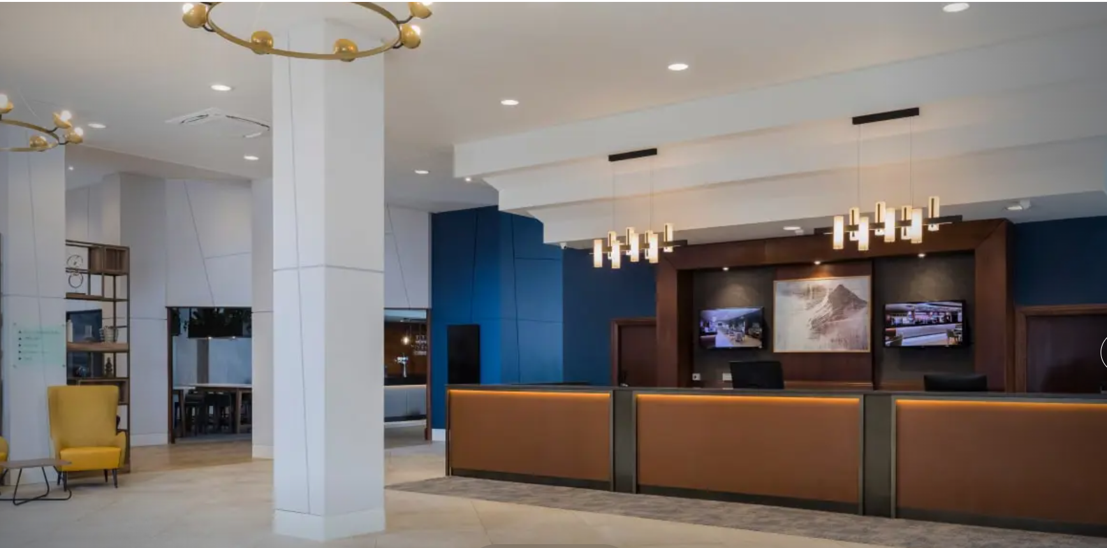Ashford International Hotel & Spa (2025)

Module: BMIH6004 – Managing Hotel Administration
Student Name: Georgiana Camelia Otesanu
Student ID: 2239363
Hotel: Ashford International Hotel & Spa
Lecturer name: Daniel Payne

Contents

1. Introduction. 3
2. Reflection on Experience 1 – Language Barrier at Reception 4
3. Reflection on Experience 2 – Integration of New Digital Payment System. 6
4. Personal and Professional Development. 7
5. Conclusion and Development Goals 8
6.Reference List 9

Introduction.

My Level 6 placement at the Ashford International Hotel & Spa has given me the opportunity to develop my administrative and supervisory skills within the Front Office department. I worked closely with Kyle, the Front Office Manager, as well as Anna and Julie, who both supported my development and allowed me to shadow a range of reception tasks. Their guidance helped me understand the expectations of a supervisory role, especially during busy periods when quick decision-making and calm communication were essential.
For this reflection, I am using Gibbs’ Reflective Cycle (1988) because it allows me to explore both the emotional and practical elements of my experiences. Unlike my Level 4 placement, which was more task-based, the Level 6 placement required me to apply academic knowledge, make independent judgements, and link theory to real-life hotel operations.
My reflection will connect two of my key experiences to modules previously studied, including Foreign Languages and Cultural Awareness and Business Skills for Hospitality. A major part of my development has been understanding how academic learning about communication, culture, and guest behaviour directly influences the quality of front office operations. These experiences have shaped my confidence, my professional identity, and my understanding of what effective hotel administration requires.

(By Bing,2025)

Reflection on Experience 1 – Language Barrier at Reception
Description
One of the most significant scenarios during my placement occurred when a large group of German tourists arrived for check-in. Only two of us were on reception, and my colleague spoke only English. The guests attempted to explain room preferences and some special requests, but communication quickly became difficult. Their frustration increased, and our check-in process slowed down considerably. Eventually, the group’s tour guide stepped in to translate, and we managed to complete the check-in. Although the situation ended well, it highlighted a clear challenge: no one on shift could communicate with them directly in German.
Feelings
I felt embarrassed and unprepared, especially because I had previously studied elements of German and French in my Foreign Languages and Cultural Awareness module. At that time, I underestimated how important languages were in hospitality, assuming English would be enough. During this incident, however, I realised how essential multilingual skills are at reception. I also felt stressed, as I worried the guests would form a negative opinion of the hotel because of the initial confusion.
Evaluation
The positive aspect of the situation was the guide’s willingness to help and our ability to remain polite and professional. However, the negative side was clear: the hotel had no linguistic support available for international guests. This slowed down operations, created tension, and placed unnecessary pressure on the team. For a hotel that receives frequent overseas visitors, this is a weakness in both HR planning and service strategy.
Analysis
This situation directly links back to theoretical content from Level 4. In the Foreign Languages and Cultural Awareness module, we learned that language barriers can influence guest satisfaction, service speed, and emotional comfort. At the time, this seemed theoretical, but this placement showed me its real-world impact. Johnston and Clark (2012) argue that effective service delivery relies heavily on clear communication, and this incident demonstrated that principle clearly.
Furthermore, Wood (2013) emphasises that Front Office staff act as the primary communication hub of a hotel, especially for international guests. My experience confirmed this; the front desk sets the tone for the entire stay, and when communication fails, overall satisfaction is at risk.
Conclusion
I realised that I could have taken small steps that would have helped—using basic German phrases, visual aids, or translation tools. Even a simple attempt at communication might have reassured the guests.
Action Plan
In the future, I plan to revise basic German and French vocabulary relevant to reception tasks, encourage the team to use simple multilingual cheat sheets, and suggest short internal training on dealing with non-English-speaking guests. I also aim to apply what I learned in Level 4 more actively, recognising its value in daily hotel operations.

(By Bing,2025)

Reflection on Experience 2 – Integration of New Digital Payment System.
Description
During my placement, the hotel introduced a new PMS-integrated card payment system. Previously, receptionists had to enter payment amounts manually, which increased the risk of errors. The new system automated the process, linking transactions directly to guest bookings. Although it was an improvement, staff initially struggled with network delays, technical issues, and uncertainty about the new workflow.
Feelings
I felt nervous at first, especially when handling payments during busy times. I worried about making mistakes or slowing down check-outs. However, as I practised and received guidance from Kyle and Anna, my confidence grew. Over time, I began to appreciate the efficiency it created.
Evaluation
The system had clear advantages: quicker transactions, fewer errors, and a more seamless guest experience. However, the early stages caused frustration among staff, and some were resistant to the change. The lack of initial training contributed to this uncertainty.
Analysis
This experience connects closely with Level 4 learning, particularly from Business Skills for Hospitality where we studied operational processes and the role of technology in service delivery. Sigala (2020) emphasises that digital transformation in hospitality relies heavily on continuous learning and adaptability. Our team’s experience reflected this: although sceptical at first, everyone eventually adapted and recognised the benefits.
The scenario also aligns with Bardi’s (2010) argument that technology enhances service quality only when staff are confident using it. Once I understood the system properly, I was able to communicate more freely with guests because the administrative burden was reduced. This shift reminded me that technology should support, not replace, human interaction.

Conclusion & Action Plan
In future supervisory roles, I would ensure that training is provided early and that feedback is collected regularly when new systems are introduced. I would also support colleagues who struggle with technical changes, encouraging a positive learning environment.
(By Bing,2025)

4. Personal and Professional Development.
Working in the Front Office allowed me to observe different leadership styles. Kyle demonstrated calm and rational decision-making, especially during difficult guest interactions. Anna communicated with clarity and confidence, while Julie’s organisational approach ensured smooth operations even during peak check-ins and check-outs. Observing them helped me understand what good supervisory practice looks like.
Through my placement experiences, I have developed key skills essential for hotel administration: clearer communication, increased confidence when handling service challenges, and adaptability to change. The language barrier incident taught me the importance of cultural awareness and reinforced the value of my Level 4 modules. Meanwhile, the digital integration process improved my resilience and problem-solving abilities.
These experiences align with Goleman’s (2011) concept of emotional intelligence, which highlights empathy, self-awareness, and calmness as essential qualities for effective leaders. My goal moving forward is to continue building these attributes while also strengthening my multilingual abilities to better support international guests.

5. Conclusion and Development Goals
Reflecting on my placement through Gibbs’ model has helped me understand how much I have progressed since Level 4. The challenges I faced—particularly the communication issues with the German group and the introduction of the new digital payment system—highlighted how academic learning interacts with real operational practice. These experiences taught me that adaptability, emotional intelligence, and cultural awareness are essential to front office success.
My short-term development goal is to revise beginner-level German and French terminology relevant to hotel operations, so that I am better prepared for international guests. My long-term goal is to develop stronger supervisory skills by continuing reflective practice and seeking additional training in hospitality systems. I plan to take part in a hospitality technology course and continue learning languages to increase my employability and confidence in future management roles.
Overall, this placement has shown me that successful hotel administration relies on a balance between people, communication, and technology—three areas I am committed to developing further.
(By Bing,2025)

6.Reference List
Ashford International Hotel & Spa (no date) Ashford International Hotel & Spa, Kent [online]. Available at: Ashford International Hotel & Spa | 4 Star Hotel in Kent (Accessed: 30 October 2025).
Bardi, J. (2010) Hotel Front Office Management. 5th edn. Hoboken, NJ: John Wiley & Sons.
Bohdanowicz, P. and Zientara, P. (2009) ‘Hotel companies’ contribution to improving the quality of life of local communities and the wellbeing of their employees’, Tourism and Hospitality Research, 9(2), pp. 147–158.
CPD UK (no date) What is the difference between personal and professional learning? [online]. Available at: What is the difference between personal and professional learning? (Accessed: 2 November 2025).
Johnston, R. and Clark, G. (2012) Service Operations Management. 4th edn. Harlow: Pearson Education.
Kolb, D. A. (1984) Experiential Learning: Experience as the Source of Learning and Development. Englewood Cliffs, NJ: Prentice Hall.
Lashley, C. (2018) Hospitality Management: A Brief Introduction. London: Routledge.
Norwich University Online (no date) The 4 Components of the Experiential Learning Cycle [online]. Available at: The 4 Components of the Experiential Learning Cycle | Norwich University - Online (Accessed: 26 October 2025).
Smartsheet (no date) How to Write SMART Goals: Step-by-Step, Examples & Template [online]. Available at: https://www.smartsheet.com/blog/essential-guide-writing-smart-goals (Accessed: 3 November 2025).
Tomkins, L. and Ulus, E. (2016) ‘“Oh, was that “experiential learning”?!”: Spaces, synergies and surprises with Kolb’s learning cycle’, Management Learning, 47(2), pp. 158–178. https://doi.org/10.1177/1350507615587451
Vallen, G. and Vallen, J. (2014) Check-In Check-Out: Managing Hotel Operations. 9th edn. Harlow: Pearson Education.
Wood, R. C. (2013) Key Concepts in Hospitality Management. London: Sage Publications.

I confirm that I have not used any AI tools in the research and creation of this assignment.
I confirm that I have not presented any AI generated materials as my own work.
I confirm I have copies of my drafts, notes, and other resources I used, which I may be asked to provide in evidence.

