Module: International Business Communications
Module code: BMBM6021
Student ID: 2207918
Student Name: Vimal Maddichetti

Introduction 3
Skills and competencies required in facilitating successful International Business Communication 3
Skills in relation to building relationships 5
Impact of a potential failure of IBC relationship building 6
Possible reasons for the failure 8
Hofstede's Cultural Dimensions theory 9
Approach to developing skills and Benefits for the company 10
Conclusion 11
References 12

Introduction
International businesses, like Clark's, must communicate across cultures to develop into varied markets like Asia. For instance, many Asian cultures value relationships and trust above commerce and understanding these cultural differences helps firms adapt to local customs. Effective cross-cultural communication allows firms to show real interest and respect for their partners, strengthening connections. Direct communication in Western cultures may be impolite or hostile in indirect Asian societies. Businesses may reduce miscommunication and improve communication by using cross-cultural communication tactics.
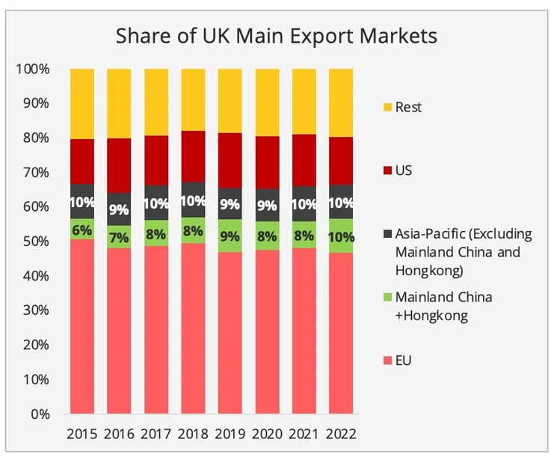
Fig. 1: Share of UK Main Export Markets
(Source: Zhang, 2023)

Skills and competencies required in facilitating successful International Business Communication
Cross-cultural Communication
Learning how to connect with people of different cultural backgrounds is a skill that is vitally necessary, regardless of whether the person in question is a colleague, a client, or a consumer (Fan et al., 2021). There is a significant level of diplomacy, sensitivity, and respect that is required for this. In addition to that, it is necessary to have an open mind and often do some study. By gaining an awareness of, for example, how individuals from different cultures perceive conflict in the workplace or even something as basic as keeping eye contact, it is possible to reduce the likelihood of misunderstandings and improve communication in the workplace.
Networking Skills
Developing a robust network of contacts outside of the native country is absolutely necessary if a firm wishes to engage in the field of international business. A good capacity to network in person is still one of the most important talents for success in an international company, despite the fact that internet platforms such as LinkedIn make it simpler to locate and keep professional relationships overseas. When it comes to networking chances, attending business school is often considered to be among the most important available to ambitious individuals working in international companies. These individuals will possess a wide variety of talents and knowledge, which makes them excellent prospects for future collaborations or colleague opportunities.
Collaboration
A vital skill in the world of business is the capacity to work together with others and to cooperate in order to achieve a shared goal. When working in an international corporate setting, it is very useful to collaborate with members of a team who come from different cultural backgrounds (Caligiuri et al., 2022). It is common for the most successful and inspirational business leaders to be the finest collaborators. They are aware that the combined intelligence of their employees may speed up the development of their firm.
Interpersonal Relationships
The most successful corporate executives acquire influence by cultivating positive professional connections and establishing respect for themselves and their colleagues. It is a talent that will serve well in international companies with regard to pitching for new business, negotiating agreements, and inspiring teams that are comprised of members from a variety of backgrounds.
Adaptive Thinking
Adaptive minds are able to flourish in an environment that is always changing, which puts them in a fortunate position to achieve success in an international company. Adaptive thinking refers to the practice of taking deliberate action rather than giving in to impulsion in situations when a prompt reaction is required in very important business situations. The ability to think in an adaptive manner was traditionally reserved for military leaders, who were responsible for taking decisive action in times of danger and uncertainty.
Emotional Intelligence
It is widely acknowledged that having a high level of emotional intelligence is an essential ability when it comes to doing business on a global scale (Mura, et al., 2021). This is because it has an impact on almost every facet of the relationship that takes place in business. People who are emotionally intelligent are self-aware and in control of their feelings, which means that they are better equipped to respond calmly in stressful or important business circumstances and adapt more easily to change. They have above-average interpersonal skills and a strong sense of empathy, which allows them to work together successfully, collaborate, and communicate effectively.
Resilience
It is necessary to possess mental toughness and resilience in order to achieve success in an international company. When it comes to the practical side of things, working across different cultures and time zones requires long hours. The ability to rise to face the inevitable difficulties of global business, sustain motivation, overcome risks, and recover rapidly from adversity are all essential components of success. Resilience, which goes hand in hand with emotional intelligence, is a fundamental trait for success (Estrada et al., 2021).

Skills in relation to building relationships
Teamwork Abilities
Through the cultivation of strong connections with the members of a team, the firm may improve the efficiency with which they collaborate (Prada, et al., 2022). The development of team-building abilities may be accomplished in a variety of ways, including demonstrating respect for the opinions of others, assisting the team in effectively completing tasks, and practising effective communication.
Empathy
Empathic understanding is yet another essential component of successful relationship formation. Being empathetic with friends and colleagues implies that a person makes an effort to comprehend the sentiments and emotions that they are experiencing.
Attentive Listening
As a result of the fact that active listening is a crucial component of communication, the development of abilities in active listening may often be more beneficial than learning how to speak at a meeting (Kluger and Itzchakov, 2022). Making eye contact, being aware of non-verbal signs, and asking questions that demonstrate an interest in the discourse are all components of active listening. It is important to have the ability to actively listen in order to have effective communication in the workplace.
Verbal Communication
When it comes to developing good connections, verbal communication is also a vital component. In the event that someone participates in a meeting with their coworkers, for instance, they will have the opportunity to hone their verbal communication skills by identifying chances to give ideas and ask questions.
Non-verbal Communication Abilities
Sending and receiving messages without the use of words is an example of non-verbal communication. This kind of communication is often accomplished via the use of body language, facial expressions, and eye contact (Schumacher et al., 2020). It is possible to strengthen relationships by learning how to properly transmit and receive signals via the use of non-verbal communication so that you can communicate effectively.

Impact of a potential failure of IBC relationship building
Market Entry Challenges
For many Asian markets, it is essential to have links with the partners, suppliers and customers. When there is a lack of communication, it is likely for the business partners involved to develop misunderstandings over the tastes they have towards particular products, the advertisements that they support as well as the negotiating positions that they should assume (Kumar and Epley, 2020). In order to eliminate the many challenges that are offered by the complicated and rather inclined legal systems of the countries in Asia, it is necessary to establish linkages with organizations of the particular country. Less understanding of the regional standards of regulation may lead to troubles with compliance or delays in market entry if the creation of relations does not occur. Strong partnerships can be very informative as to the kinds of customers and the general trends in the market. Otherwise, the retail firm may struggle to successfully market and adapt its products to suit the local populace where it does not have such contacts.
Brand Reputation
The most important factor for a brand while venturing into new markets is the so-called ‘image’. Counterparties with who potential business may be conducted may develop negative perceptions due to misunderstanding or false assumptions. High levels of cultural insensitivity or unreliability in the handling of connections would harm the image of the retail group and its potential to create a successful market entrant (Zahoor et al., 2021). One of the besetting sins of Asian corporate culture is the deterioration of trust and credibility. If the retail group does not form beneficial relationships it will not become a well-regarded market player, which can lead to stakeholder distrust.
Operational Inefficiencies
It is important to have a healthy relationship with the suppliers so that the supply chain does not get a break. Concerning the issue of inventories and the availability of goods, one is bound to realize that these partnerships present certain vulnerabilities arising from a lack of trust between partners. Lost relationships may increase operational costs due to poor organization of supply chain transport, direct procurement of local raw materials since current networks are unavailable, and legal issues arising from damaged interpersonal communication.
Financial Losses
When one is venturing into a new market a lot of capital is usually invested. Market penetration or operational problems as well as a lack of appropriate outcomes in relationship development can hinder these efforts from paying off as initially envisaged (Najafi-Tavani et al., 2022). New development strategies of the firm and its profitability might be affected depending on the continued performance on social media.
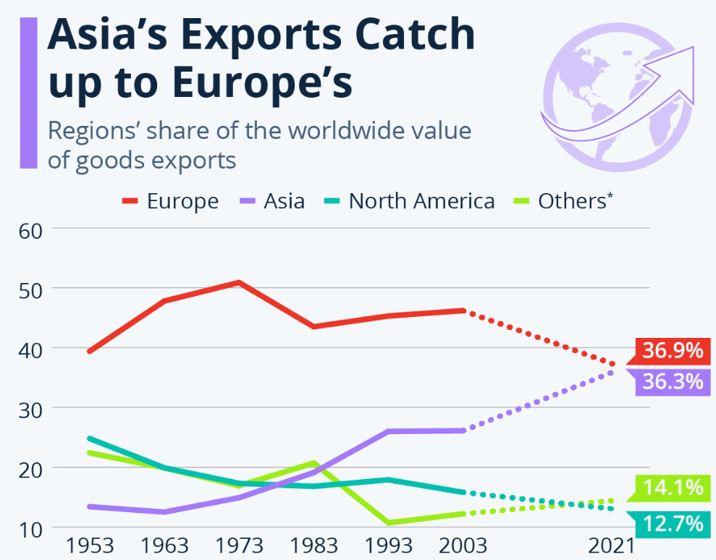
Fig. 2: Asia's Exports Catch up to Europe's
(Source: Statista, 2022)

Possible reasons for the failure
Cultural Misunderstandings
Cultural miscommunications are a major cause of IBC relationship failure in Asia. Asia has distinct cultural norms, attitudes, and business methods that vary from Western ones. Chinese terms like “face” emphasize reputation and social position, which may lead to misunderstandings if not respected. Many Asian cultures include hierarchical systems that impact communication and decision-making (Arun and Kahraman Gedik, 2020). A retail organization that fails to identify and adapt to these cultural differences may alienate prospective partners or customers, resulting in unsuccessful partnerships.
Lack of Local Knowledge
Lack of local market, customer, and regulatory expertise hinders relationship development. Retailers entering Asian markets without study may overestimate market demands or miss regulatory requirements (Wang, et al., 2023). Understanding local customer preferences is important since a product that sells well in one place may not be in another owing to different tastes or buying patterns. Businesses without this expertise risk launching unsuccessful marketing tactics or items that do not suit local needs.
Poor Communication Methods
Many Asian cultures favour indirect communication over confrontation or criticism. The simple retail conversation may seem impolite or insensitive. Even in popular languages like English, subtleties and idioms may cause misunderstandings (Ye, 2024). Communicating clearly and adjusting to local norms is key to creating relationships.
Insufficient Relationship Development Investment
Building solid Asian connections takes time and effort beyond transactional encounters. Many Asian cultures value long-term relationships above short-term advantages, so corporations must network and nurture ties before expecting returns (Klaunig, et al., 2024). A retail organization may struggle to create trust and rapport if it pursues relationships with an aggressive sales strategy rather than attending social gatherings or participating in community projects.
Economic and Political Unrest
Foreign corporations may struggle to create relationships in Asian nations with political or economic instability. Economic downturns may drastically modify customer buying habits, so a retail business that does not adapt risks alienating prospective partners who are also struggling.
Neglecting Digital Engagement
In Asia, where consumers and companies use digital communication, neglecting to use online channels for interaction might hurt relationship development. Social media platforms like WeChat in China and LINE in Japan are vital for business communication with clients and partners (Giudice, 2020). A retail organization that ignores these channels may miss interaction opportunities that strengthen connections.
Adaptation resistance
Finally, organisational opposition to Asian market-appropriate business models or practices might hinder relationship development. Companies have developed strategies based on their native markets, but rigidity without adaptability might alienate prospective partners who demand localized engagement.

Hofstede's Cultural Dimensions theory
Power Distance Index
In high-PDI countries such as India and China, the structural practices that dominate the business and social organizations are the hierarchical ones (Trombley, 2024). The employees of Clark’s must show respect for authority and understand that the leaders of the nations in which it is opening partnerships or operations may make decisions without consulting subordinates. Instead of bargaining with a Chinese partner using its agents such as Clark directly with staff that are not authorized to make decisions the agents should bargain directly with high-ranking executives.
Individualism Vs Collectivism
Japanese, Indonesians and most Asians prefer harmony in the group on which the individual does not focus. This is why Clark’s marketing should focus on the aspects of communal interest but not that of individual thinkers. A campaign that targets a family value to be promoted or community participation in Japan may receive a better reception than one focusing on luxury or success.
Masculinity Vs Femininity
It is considered more masculine, hence competitive themes of promotion will perhaps be more effective there than in Thailand where nurturing appeals may sell more effectively. Clark’s might advertise performance-oriented products in Japan and comfort and care in Thailand.
Uncertainty Avoidance Index
South Korea has high UAI scores and is more comfortable with norms and predictability in their business interactions, so Clark’s should provide detailed plans and risk assessment when presenting new initiatives (Yun, et al., 2021). The elimination of launch fears may be helped by explaining market research data before a new product line is introduced in South Korea.
Long term Vs Short term Orientation
The reason for suggesting such a setup is the imperative need for long-term, strategic partnerships in locations such as China. Clark’s could use before venturing into the introduction of items to gain the trust of local partners instead of focusing on achieving high sales.
Indulgence Vs Restraint
Malaysians are conservative, therefore marketing should not infringe on their conservative consumption patterns (Hakala, 2023). Moderate promotions are more effective in Malaysia than excessive ones that are quite acceptable in Western markets.
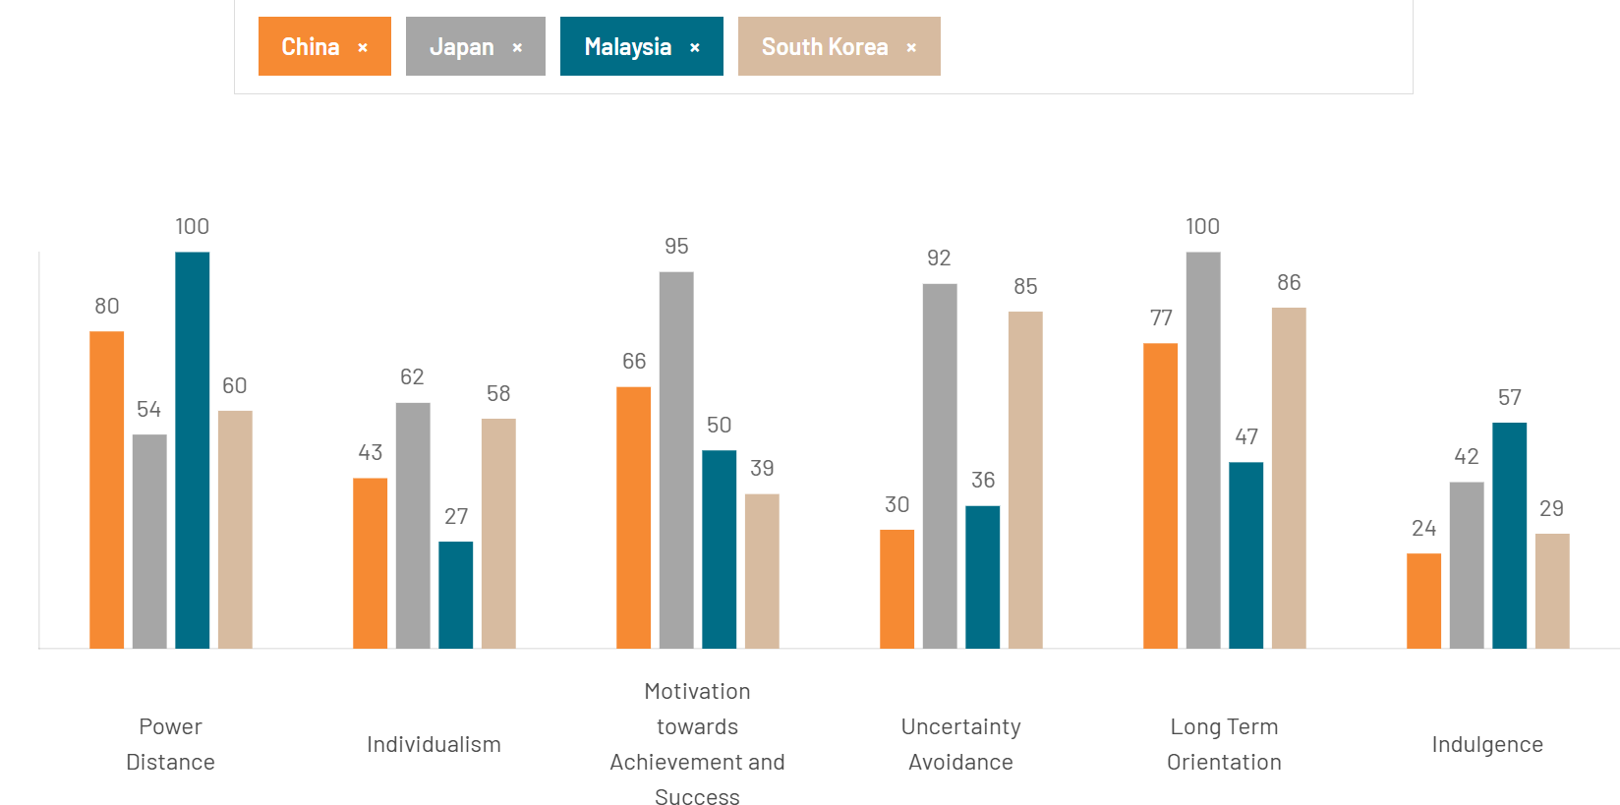
Fig. 3: Country Comparison between Asian Countries
(Source: Hofstede Insights, 2020)

Approach to developing skills and Benefits for the company
Since Clark’s is venturing into Asia as a market, cross-cultural business communication is particularly vital for good relations. A good observation is that various countries have different cultures, different people have different values, and of course, various countries have different rules for doing business (Calza, et al., 2020). Japanese and Chinese businesspeople must build relationships first (guanxi) and these cultural differences should be brought up in training programs to curb such occurrences. English is widely practised in the business world, however local language may enhance understanding and customer wholesale interactions. Foreign language or bilingual workers might enhance interaction with the local partners on the company’s behalf (Aljarelah, 2024). This is very important because different cultures interpret different signs differently. Consequently, nonverbal communication skills should be learned in training. A firm may gain some potential partners at trade shows or expos, industry conferences, or local business networking events. Culture, experience, and coordination are used by Clark’s grasp partner to influence feedback mechanisms that indicate the need for new strategies.
Clark's may reap several advantages by learning international business communication and relationship-building. As any long-term cooperation is based on trust, proper communication has a great impact on the formation of the partner’s trust (Chen and Sriphon, 2021). The relationships may enhance the understanding of market demand and distribution channels for new market entry. One good thing that was advocated for is that every person should learn the culture of his/her counterpart because the use of force to solve any dispute was strongly discouraged. Clark’s can develop long-term bonds that can assist the area to flourish since it is major on the relations other than the mere interactions.

Conclusion
To conclude, Asia has some of the fastest-growing economies, including China, India, Vietnam, and Indonesia. India's retail industry is growing due to a youthful population and rising disposable income. Vietnam and Indonesia are urbanizing and hence Clark must understand Asian customer tastes to succeed. Urban Asian youth are increasingly drawn to Western fashion trends. Many Asian marketplaces favour local companies owing to their expertise in regional tastes and pricing tactics. Thus, Clark's should pursue joint ventures or franchising with local partners that understand market dynamics better than international newcomers.

References
Aljarelah, A.K. (2024). LANGUAGE AND INTERNATIONAL COMMUNICATION THE IMPACT OF LANGUAGE ON INTERNATIONAL UNDERSTANDING AND DIPLOMATIC RELATIONS. The American journal of social science and education innovations, [online] 6(6), pp.144–175. Available at: https://inlibrary.uz/index.php/tajssei/article/view/35474.
Arun, K. and Kahraman Gedik, N. (2020). Impact of Asian cultural values upon leadership roles and styles. International Review of Administrative Sciences, [online] 88(2), p.002085232093598. Available at: https://journals.sagepub.com/doi/abs/10.1177/0020852320935982.
Caligiuri, P., Cieri, H.D., Minbaeva, D., Verbeke, A.L. and Zimmermann, A. (2022). International HRM Insights for Navigating the COVID-19 Pandemic: Implications for Future Research and Practice. JIBS special collections, [online] pp.417–454. Available at: https://link.springer.com/chapter/10.1007/978-3-030-80383-4_17.
Calza, F., Cannavale, C. and Zohoorian Nadali, I. (2020). How do cultural values influence entrepreneurial behavior of nations? A behavioral reasoning approach. International Business Review, [online] 29(5), p.101725. Available at: https://www.sciencedirect.com/science/article/pii/S0969593120300688.
Chen, J.K.C. and Sriphon, T. (2021). Perspective on COVID-19 Pandemic Factors Impacting Organizational Leadership. Sustainability, [online] 13(6), p.3230. Available at: https://www.mdpi.com/2071-1050/13/6/3230.
De Prada, E., Mareque, M. and Pino-Juste, M. (2022). Teamwork skills in higher education: is university training contributing to their mastery? Psicologia: Reflexão e Crítica, [online] 35(1). Available at: https://prc.springeropen.com/articles/10.1186/s41155-022-00207-1.
Estrada, M., Monferrer, D., Rodríguez, A. and Moliner, M.Á. (2021). Does Emotional Intelligence Influence Academic Performance? The Role of Compassion and Engagement in Education for Sustainable Development. Sustainability, [online] 13(4), p.1721. Available at: https://www.mdpi.com/2071-1050/13/4/1721.
Fan, A., Van Hoof, H.B., Dou, X. and Serrano, A.L. (2021). The impact of linguistic style on customer satisfaction: A cross-cultural empirical study in ecuador. International Hospitality Review, [online] 37(1). Available at: https://doi.org/10.1108/IHR-04-2021-0028.
Giudice, F. (2020). WeChat: the impact of the super app on Chinese society. dspace.unive.it. [online] Available at: http://dspace.unive.it/handle/10579/17293.
Hakala, E. (2023). Opposing western liberal values through cultural conservatism : comparative analysis of the political systems of Malaysia and Poland. jyx.jyu.fi. [online] Available at: https://jyx.jyu.fi/handle/123456789/92129.
Hofstede Insights (2020). Country comparison tool. [online] Theculturefactor.com. Available at: https://www.theculturefactor.com/country-comparison-tool?countries=china%2Cjapan%2Cmalaysia%2Csouth+korea.
Klaunig, K., Khan, S.K. and Reichelt, M. (2024). ‘My life is not to be called a failure’: how family reputation in the origin affects return considerations among South Asian migrants in the Gulf. Journal of Ethnic and Migration Studies, [online] 50(20), pp.5127–5146. Available at: https://www.tandfonline.com/doi/full/10.1080/1369183X.2024.2346179 [Accessed 6 Dec. 2024].
Kluger, A.N. and Itzchakov, G. (2022). The power of listening at work. Annual Review of Organizational Psychology and Organizational Behavior, [online] 9(1), pp.121–146. Available at: https://www.annualreviews.org/content/journals/10.1146/annurev-orgpsych-012420-091013.
Kumar, A. and Epley, N. (2020). It’s surprisingly nice to hear you: Misunderstanding the impact of communication media can lead to suboptimal choices of how to connect with others. Journal of Experimental Psychology: General, [online] 150(3). Available at: https://doi.org/10.1037/xge0000962.
Mura, L., Zsigmondn, T. and Machová, R. (2021). The effects of emotional intelligence and ethics of SME employees on knowledge sharing in Central-European countries. Oeconomia Copernicana, [online] 12(4), pp.907–934. Available at: https://www.ceeol.com/search/article-detail?id=1068820.
Najafi-Tavani, S., Zaefarian, G., Robson, M.J., Naudé, P. and Abbasi, F. (2022). When customer involvement hinders/promotes product innovation performance: The concurrent effect of relationship quality and role ambiguity. Journal of Business Research, [online] 145, pp.130–143. Available at: https://www.sciencedirect.com/science/article/pii/S0148296322002296.
Schumacher, R., Bruehl, S., Halai, A.D. and Ralph, M.A.L. (2020). The verbal, nonverbal and structural bases of functional communication abilities in aphasia. Brain Communications, [online] 2(2). Available at: https://academic.oup.com/braincomms/article/2/2/fcaa118/5880550.
Statista (2022). Infographic: Asia’s Exports Catch up to Europe’s. [online] Statista Daily Data. Available at: https://www.statista.com/chart/28986/regions-share-of-the-worldwide-value-of-goods-exports/.
Trombley, J. (2024). Correlation Between Culture and Music Used in Advertising. [online] 6(1), pp.166–209. Available at: https://www.researchgate.net/publication/385008288_Correlation_Between_Culture_and_Music_Used_in_Advertising.
Wang, Z., Zhang, J. and Ullah, H. (2023). Exploring the Multidimensional Perspective of Retail Investors’ Attention: The Mediating Influence of Corporate Governance and Information Disclosure on Corporate Environmental Performance in China. Sustainability, [online] 15(15), pp.11818–11818. Available at: https://www.mdpi.com/2071-1050/15/15/11818.
Ye, Z. (2024). Language Barriers in Intercultural Communication and Their Translation Strategies. Language Barriers in Intercultural Communication and Their Translation Strategies, [online] 6(1), pp.p178–p178. Available at: https://cpcig-colepuli.com/uploads/soft/20240703/1-240F3225441O5.pdf.
Yun, Y., Oh, H. and Myung, R. (2021). Statistical Modeling of Cultural Differences in Adopting Autonomous Vehicles. Applied Sciences, [online] 11(19), p.9030. Available at: https://www.mdpi.com/2076-3417/11/19/9030.
Zahoor, N., Khan, Z., Arslan, A., Khan, H. and Tarba, S.Y. (2021). International open innovation and international market success: an empirical study of emerging market small and medium-sized enterprises. International Marketing Review, [online] ahead-of-print(ahead-of-print). Available at: https://www.emerald.com/insight/content/doi/10.1108/imr-12-2020-0314/full/html.
Zhang, G. (2023). UK’s Indo-Pacific Tilt: what trade tells us. [online] Upply.com. Available at: https://market-insights.upply.com/en/uks-indo-pacific-tilt-what-trade-tells-us [Accessed 6 Dec. 2024].

