University of Wales Trinity Saint David
London Campus

Module name: Professional Career Development
Module Code: BMSW4005
Lecturer: Husam Alharahsheh
Student: Bogdan Draghici
Student ID:2027588

Table of Contents
- Introduction……………………………………......Page 2
- Personal Reflection on Roleplay…………….... Page 2
- Self-Evaluation review………………………..... Page 3
- Personal development planning………………. Page 4
  - Swot Analysis…………………………………….... Page 4
  - Johari Window Model……………………………... Page 4
  - Professional Development Plan as a table……... Page 6
- Today`s Jobs Market……………………………. Page 7
- Conclusions………………………………………. Page 7
- References………………………………………… Page 8
- Appendices………………………………………... Page 9
  - Appendix 1 …………………………………………. Page 9
  - Appendix 2 …………………………………………. Page 10

1. Introduction
This report discusses the journey that I have taken to get where I am today and my plans for my future development. My upbringing and education in my early years of life played a crucial role in my development into the person I am today. In the country where I was born and raised, there are a lot of prejudices and beliefs that now, after emigrating to the United Kingdom, I find primitive, discouraging, and sometimes can have a negative effect on one`s life. One`s success is a combination of accomplishments in both personal and professional life (Why is Personal and Professional Development Important? PPD, 2022). Although now I am not in a not-so-good place in my life, at least I have an idea about the direction.
I graduated high school in Romania before I got into my twenties, with no skills, no direction, or an idea of what I wanted to do. I have started some jobs that helped me gain important skills like using a computer, cash management, till reconciliation, how to spot counterfeit currency, and anti-money laundering. This led to me obtaining a job in a multinational bank and opened a new path to my development as a professional.
After having a life-changing accident that left me with a disability, I decided to move to England. This was an eye-opening experience because I have gained skills and discovered that I am capable to have a more meaningful job that will satisfy me as a professional and as a human being.
Starting University courses in my forties sounded like a challenge, and I was sceptical at the beginning when I realized that is not easy to write an academic report or when I have discovered that I struggled my entire life with learning disabilities without knowing. I have found tools and techniques that will help me succeed as a professional and evolve as a person
2. Personal Reflection on Roleplay
For the roleplay (Appendix 1), my partner and I had to simulate an interview. I have done a lot of interviews during my life, but this is the first interview that I have prepared for. I know this was not a real-life setting but being prepared helped me to overcome my emotions and to perform well (Everything You Need to Know About Job Interview Etiquette | Indeed.com, 2022). I never perform well in interviews and even if I try to prepare, I will forget everything, even if I am very familiar with the job. The difference this time is that I have managed to experience the proper way of how I should behave in an interview. By behaving in this way, I have managed to observe the non-verbal language of my partner and try to conduct the interview instead of me being led. I have already learned from the Communication Module class at the UWTSD, that nonverbal communication is playing a key role in one`s both personal and professional life and I have used those tools to try and control my behaviour. For the first time, I was able to use the freshly learned skills in the correct way to get my dream job. It was a very useful experience from which I have drawn a lot of lessons and even if I will fail more interviews, I will be able to improve and eventually get where I want to be.
As the Interviewer, I have tried to be impartial, to understand the person in front of me. As a hiring manager, you must be open-minded, and objective and you need to have a desire to build a good relationship between the employees and the management. You need to be able to communicate well, face the challenges that are arising from this role, and to be able to solve problems (A Day in the life of an HR manager | CIPD, 2022). In my opinion, you must be a caring person to be a human resource manager. Coincidentally, my partner`s desired job was to become a human resources manager. I know from our roleplay preparations meetings that she was taking specific training classes provided by her company. Therefore, as a person which has changed a lot of jobs, in different industries, and different companies with different cultures and policies, I have tried to see if their attitude were what I would like to see in an employer. I have learned that it is hard to be objective, especially when you already built a rapport with the person in front of you and you know that your opinions or beliefs are similar. This is human nature, and it will take a lot of training and experience to overcome it. I am not in favour of using artificial intelligence in the recruitment process, because in many cases people have anxieties or mental issues that prevent them to perform well (Forbes Coaches Council, 2022).
3. Self-Evaluation review.
It takes a lot of courage to take care of people who are in need and want care and attention. It might seem very easy, but it requires a lot of courage to be there and help them through their treatment. There are a lot of patients who need an extra amount of care and treatment. The motto of the hospital that I am working for is to provide the best possible treatment to their patients. I have never worked in a hospital or healthcare, but I learn fast, and only after one month of working and observing my colleagues, I was confident enough to take the responsibility of documenting a real case. It was a terrifying experience, the case was complicated, and my knowledge about medicine or anatomy is very limited, but with the support of my colleagues I managed to get through it and learn a lot of new things.
I have concluded that my learning style is based more on trial and error than on studying the instructions. To help the reader understand what I am trying to say I will explain by saying that I am the person who throws away the instructions from an IKEA furniture box. I know how a bed looks, I have the resources in the box, and I just do it. This is not a very good style; it made it harder for me over the years. I was able to find this out by using the tools that I discovered during my university courses. Tools like Gibbs Model of Reflection, SWOT analysis, Models of Communication, and a few more. Also, I have tried to control this way of doing things and the best way to retrain my brain is to build LEGO.
I have a strong work ethic, I enjoy taking on new responsibilities and trying new things, this will ensure my development in the long term, in all aspects of my life. Academic, professional, and personal.
4. Personal development planning.
To build a sustainable development plan, I have decided to use SWOT Analysis and the Johari Window model.
4.1 Swot Analysis.
My strength is that I believe in helping people and providing them with the best possible treatment and solution for their problems.
My weakness is that I get overwhelmed and emotionally attach to the patient, which hinders at some point in providing them with the solution.
The opportunities that I have got while working for this hospital have improved a lot of things in me. Firstly, I got huge exposure to dealing with patients. The overwhelming feeling of dealing with their emotions and getting carried away has reduced.
The biggest threat that I have working in this field is my disability. It is a very physical job because my responsibilities include handling patients, heavy equipment, and delicate instruments. I am aware of the Equality Act 2010, but I am also realistic, and self-aware of my abilities and especially my inabilities.

4.2 Johari Window Model.
I have chosen this model for its simplicity. According to the literature that I have researched, this model is about self-awareness. Self-awareness is the ability to focus on oneself and how one`s actions, thoughts, or feelings match or disagree with one's internal standards. You can assess yourself objectively, control your emotions, align your behavior with your values, and appreciate how others perceive you. (Betz, 2021)
The model works using four area quadrants. Anything I know about myself and am willing to share is part of my open area. Any aspect that I do not know about myself, but others within the group have become aware of, is in my blind area. There are also aspects about yourself that you are aware of but might not want others to know, this quadrant is known as your hidden area. There are also things about myself that either I or anyone else are not aware of. This is called the unknown area. (Self Awareness, 2013)
I have done a practical exercise with a friend to better understand myself and to explain to the readers this method. The Johari Window model has a list of 56 adjectives that are used. For this exercise, I have selected a few, and together with my partner, I have compiled the diagram that is shown below.
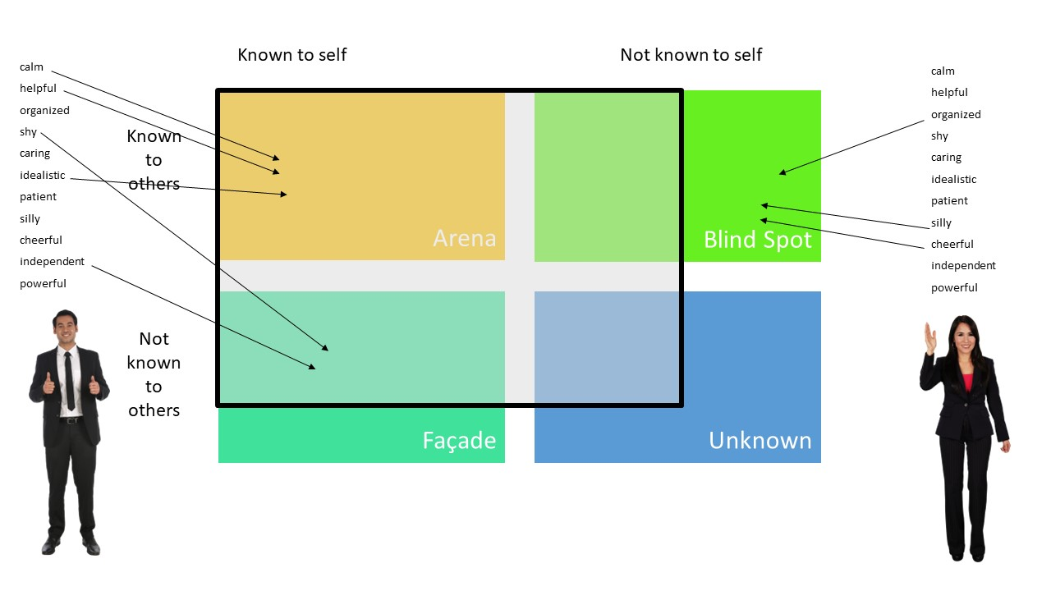
I have started with 4 equal zones, and I have found what my partner thinks about me. To expand the Arena into the Blind Spot, I should ask for feedback. But I must keep in mind that people are not always happy to give feedback and I might not be happy with the feedback that I will receive. To reduce the Façade area, I must share more with my team, this will help build trust. I believe that I should reduce that Unknown area, this will help me learn more about myself and improve as a professional. This can be done by shared discovery and intentional observation. I did not realize until now when I am writing this paper that I have progressed so much from when I started this university. I can write a two-thousand-words academic paper, I have discovered so many new things about myself, and now I am confident that I can have a successful career.

4.3 Professional Development Plan as a table
I have compiled a PDP table using the resources provided in class to manage my goals, expectations, and resources needed to achieve them.
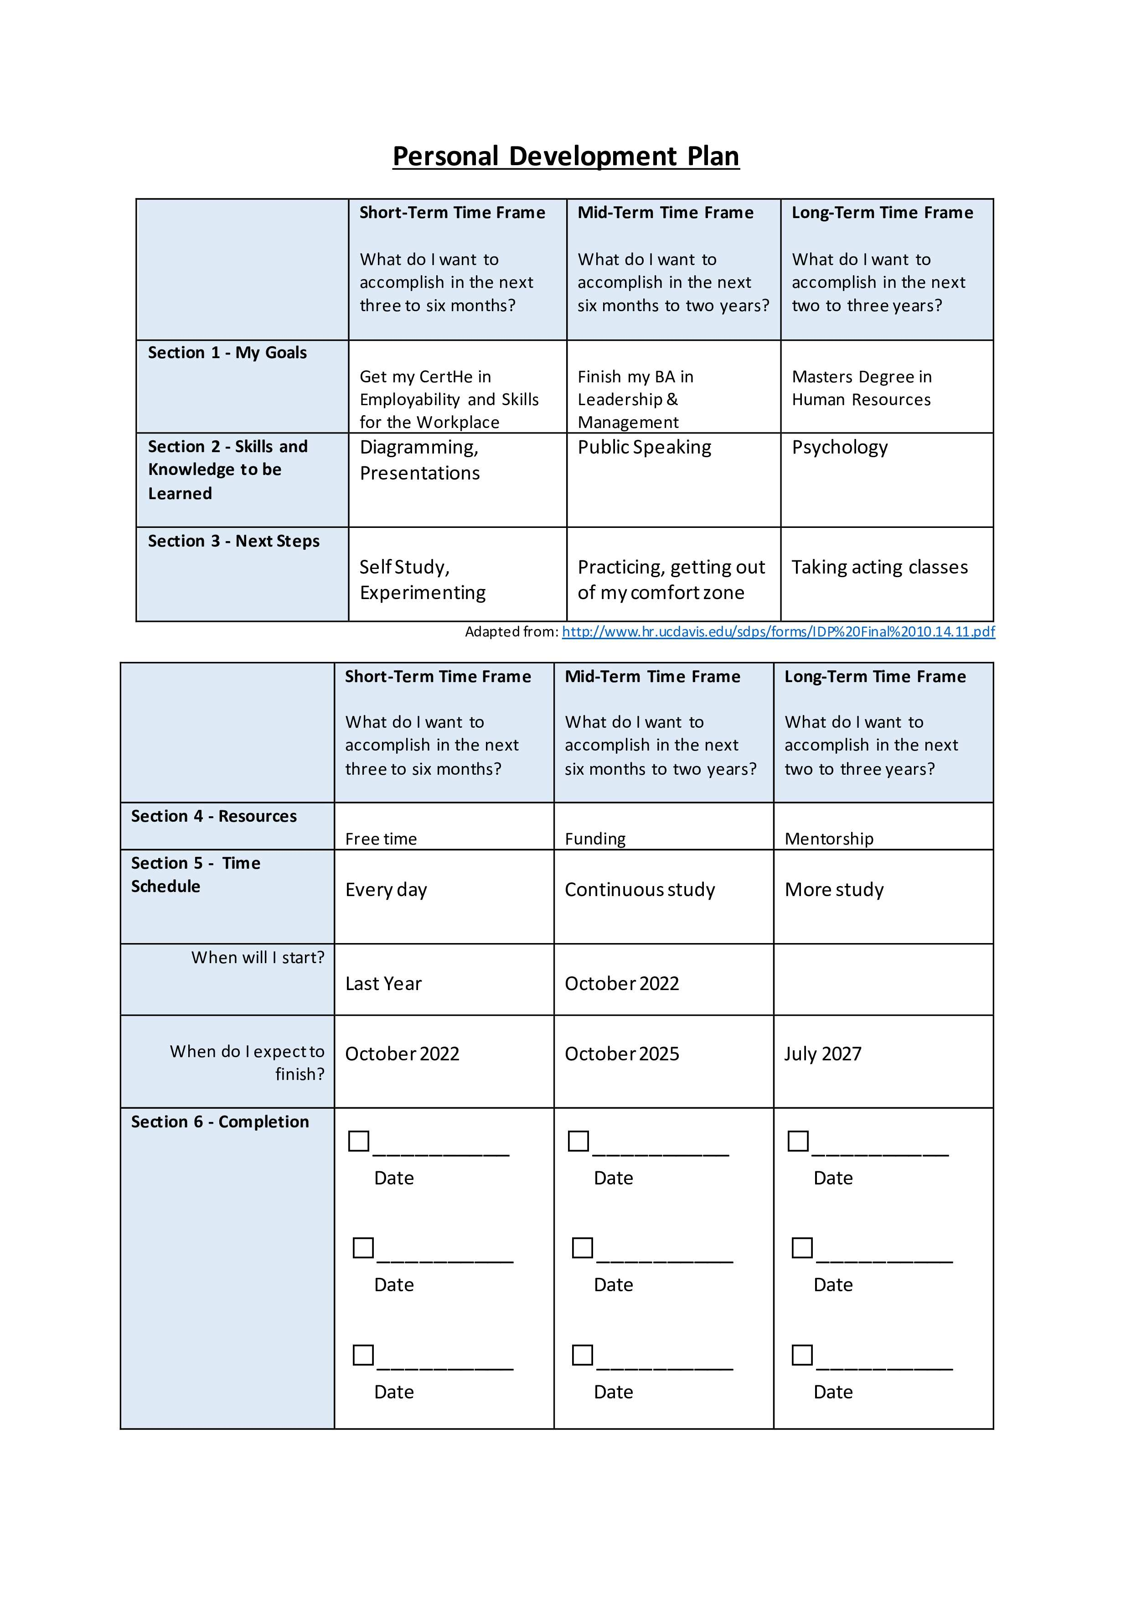

5. Today`s Jobs Market
There are more opportunities in today`s employment market than there were in the years before the COVID-19 outbreak. The unemployment rates are at the lowest and between Feb-Apr 2022 the number of job vacancies was 1295 mil (Labour market overview, UK - Office for National Statistics, 2022). Jobseekers are looking for more flexible work, hybrid work from home, and in-office time, which allows them to manage their work-life balance. At the same time, employers are looking for a better-motivated workforce. There is an important argument between the advocates of WFH and in-office work which cannot be ignored or viewing it from just one perspective (Home and away | Barclays Corporate & Investment Bank, 2022).
6. Conclusions
We are living in an age where everything is changing, transforming, and evolving at a rate that we have never seen before. It is difficult to predict what is going to happen in three, five, or twenty years from now, but I believe that now is a good time to reset my career goals, and by using the tools that the university gave me, combined with my experience, beliefs, and ambitions, I will be able to achieve things that I could not comprehend ten years ago. I am more confident now than I was a year ago, and I have managed to understand the rationale behind the things I already knew. I have plans for now, but I think that because of my adaptability skills I will manage to achieve great things and become a better human being and an even better professional.

7. References
- Betz, M., 2021. What Is Self-Awareness, and Why Is It Important. [online] Betterup.com. Available at: <https://www.betterup.com/blog/what-is-self-awareness> [Accessed 20 August 2022].
- Cib.barclays. 2022. Home and away | Barclays Corporate & Investment Bank. [online] Available at: <https://www.cib.barclays/our-insights/The-economic-side-effects-of-flexible-working.html?cid=paidsearch-textads_google_google_themes_flexiblefuture_uk-we_research_flexiblefuture_10458451&gclid=CjwKCAjwx7GYBhB7EiwA0d8oexJjaFGONfRz9XfslWATnI9Br4KElFkkatITAEWdBy4M_wu_xvnvWhoCu3EQAvD_BwE&gclsrc=aw.ds> [Accessed 29 August 2022].
- CIPD. 2022. A day in the life of an HR manager | CIPD. [online] Available at: <https://www.cipd.co.uk/careers/career-options/hr-roles/day-in-hr-manager#gref> [Accessed 18 August 2022].
- Conversations With Impact. 2022. Why is Personal and Professional Development Important? PPD. [online] Available at: <https://conversationswithimpact.co.uk/personal-professional-development/> [Accessed 18 August 2022].
- Council, F., 2022. Council Post: 10 Downsides Of Using Artificial Intelligence In The Hiring Process. [online] Forbes. Available at: <https://www.forbes.com/sites/forbescoachescouncil/2019/08/14/10-downsides-of-using-artificial-intelligence-in-the-hiring-process/?sh=589a65e6685e> [Accessed 18 August 2022].
- Indeed Career Guide. 2022. Everything You Need To Know About Job Interview Etiquette | Indeed.com. [online] Available at: <https://www.indeed.com/career-advice/interviewing/job-interview-etiquette> [Accessed 18 August 2022].
- Ons.gov.uk. 2022. Labour market overview, UK - Office for National Statistics. [online] Available at: <https://www.ons.gov.uk/employmentandlabourmarket/peopleinwork/employmentandemployeetypes/bulletins/uklabourmarket/may2022> [Accessed 29 August 2022].

8. Apendices
8.1 Appendix 1
1. Where do you see yourself in 5 years?
This is my first job working in a hospital as a member. I am sure I will enjoy and
develop a career in healthcare. Also, I am looking for an admin-related opportunity as
a back.
2. Where do you want to live?
Most probably out of London, in the countryside or on the ear beach.
3. What are the skills that you think you have and are fit for the job?
Communication, dedicated assistance, timely management, adaptability exhibiting
judgment is the skills that I have and am fit for the job.
4. Do you have any experience related to this field?
I worked in an NGO before, which worked for old age people. So, it has helped me
develop new skills and find new opportunities.
5. How many hours would you work weekly in 5 years?
Only 40 hours, as I want to enjoy the time and spend my earnings.
6. Are you happy working for a non-managerial post?
Yes, I am very happy.
7. What organization you are willing to work for?
Most probably public, private, and charitable.
8. Do you want to change your career?
Yes, I will have to change because I can’t carry on with my disability.
9. What do you look for in an organization?
I look for stability, work and life balance, job security, and new opportunities.
10. What is your vision related to your personal and professional aspects?
I haven’t had a job for a long time which is affecting my mental health. So, I am
excited to start a new job. Also, I’m happy and scared at the same time.

Appendix 2
Job application form
Application for Nursing Assistant
Your details
Name: Bogdan Draghici
Education and training
Please give details:

Highschool – Romania -Graduated in 1999
CertHE Employability and Skills for the workplace- London, UK – in progress
Qualifications
Please give details:

Mental Health first aid- London – 2018
Level 2 Certificate in Sage Cloud Payroll
Employment history
Your current or most recent employer

Name of employer: Royal Free Hospital

Job title: Nursing Assistant

Length of time with employer: 1 Month

Reason for leaving: N/A

Duties:
Supporting the team to provide the best care for our patients.

Previous employers
Please tell us about other jobs you have done and about the skills you used or learned in those jobs.

I have worked in an NGO, which works for providing healthcare to old age people.
I have learned how to manage these people and dedicate timely assistance to all those who are in need. This job has helped me to manage time effectively.

Supporting statement
Please tell us why you applied for this job and why you think you are the best person for the job.

I am a caring individual who seeks a job that is stimulating, in a company that values its employees, and creates a productive and creative environment. During my life, I have acquired a vast range of skills that can be used in this setting where the well-being of our patients and our colleagues come first

Right to work in the UK
Do you need a work permit to work in the UK? Yes / No
NO
References
Please give the names and contact details of 2 people who we can ask to give you a reference. We may ask them before an employment offer is made. We will not ask your current employer until we get your permission.
Declaration
I confirm that to the best of my knowledge the information I have provided on this form is correct and I accept that providing deliberately false information could result in my dismissal.

Name: Bogdan Draghici
Signature:
Date:

