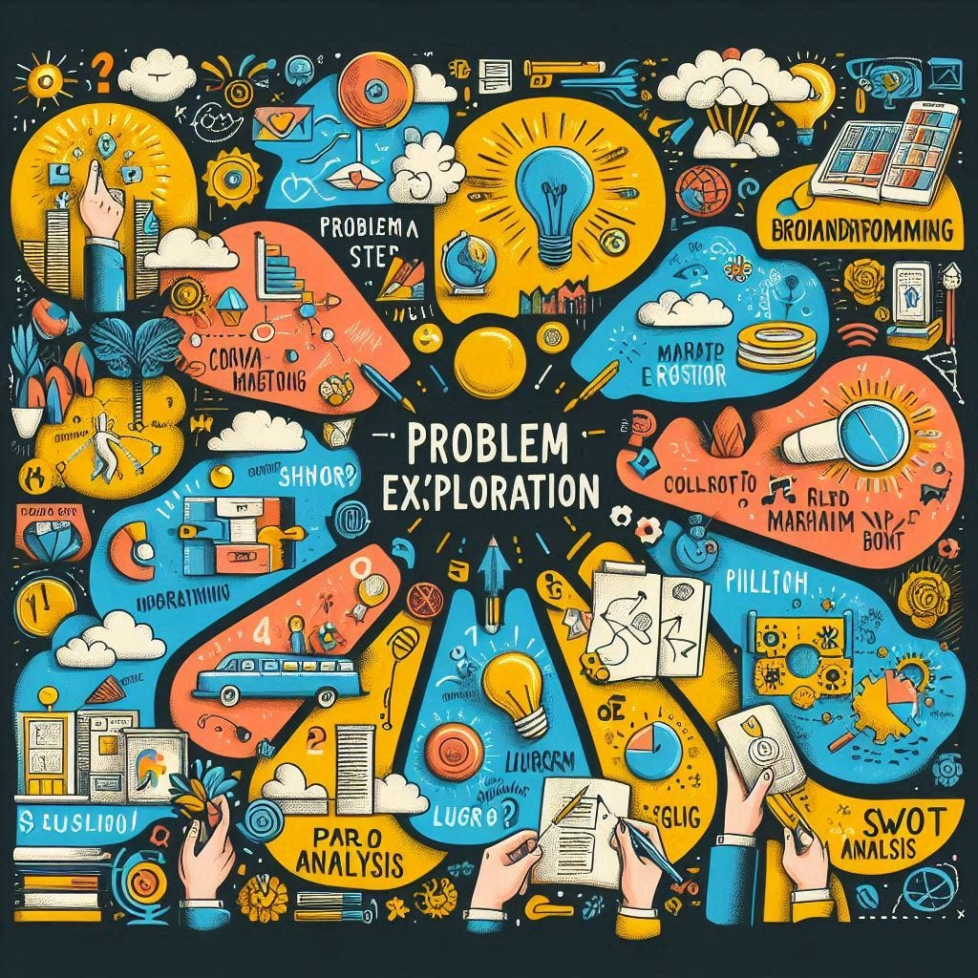
Analyzing and Solving Problems
Darina Tsoneva
Darina Tsoneva
ACCA4019 2423106

Contents
Introduction 1
1.Problem Summary 1
2.System Context 2
3. MoSCoW Analysis 2
3.1 Must-Have 2
3.2 Should-Have Requirements 3
3.3 Could-Have Requirements 3
3.4 Won’t-Have 4
4. IPO 4
Input 4
Processes 5
Outputs 5
4.1 Variable identification 5
5.Decomposition of the Vehicle Routing Optimisation Problem 6
6.Proposed Solution and Explanation 6
Pseudocode 9
7.Explanation of the Approach 10
8.Addressing Core Objectives 11
9.Problem-Solving Strategies Used 11
10.Justification of the Approach 11
11.References 13

Introduction
Modern online delivery platforms depend heavily on efficient route optimisation to maintain cost efficiency, customer satisfaction, and reliable service delivery. GrocerQuick, a rapidly expanding online grocery delivery service, is currently experiencing operational challenges due to inefficient route planning. These inefficiencies result in excessive fuel consumption, delayed deliveries, and inconsistent service quality. Addressing this problem requires a structured and systematic problem-solving approach that incorporates abstraction, decomposition, and established optimisation techniques.
This assignment analyses GrocerQuick’s routing problem by identifying core objectives, system constraints, and prioritised requirements. Using the MoSCoW method, an Input–Process–Output (IPO) model, and heuristic optimisation algorithms, a practical and scalable solution is proposed to minimise travel distance, reduce fuel consumption, and ensure timely delivery.

1.Problem Summary
GrocerQuick faces increasing difficulty in allocating customer orders efficiently as demand grows. The current routing approach leads to overlapping delivery areas, unnecessary travel distances, rising fuel costs, and inconsistent delivery times. These inefficiencies negatively affect profitability and customer satisfaction.
The routing challenge is driven by three interdependent objectives:
Efficient allocation of orders to vehicles – Orders must be assigned to delivery vehicles while considering geographical proximity, vehicle capacity constraints, and delivery time windows.
Minimisation of fuel consumption – Fuel costs represent a major operational expense. Reducing total travel distance lowers costs, vehicle wear, and environmental impact.
On-time delivery performance – All orders must be delivered within their promised delivery windows, with a maximum allowable lateness of 30 minutes.
Balancing these objectives transforms the problem into a constrained Vehicle Routing Problem (VRP). A solution must simultaneously account for distance minimisation, time sensitivity, and capacity limits, requiring a multi-criteria optimisation approach.

2.System Context
GrocerQuick operates within a dynamic delivery environment involving several interacting components:
- A continuous stream of customer orders, each defined by location, delivery window, priority, and size or weight
- A finite fleet of delivery vehicles with fixed capacity constraints
- A central warehouse acting as the depot for all routes
- A road network with variable distances, traffic conditions, and travel times
The system must generate efficient delivery routes that minimise total distance while ensuring feasibility with respect to capacity limits and delivery deadlines. Real-time or near-real-time order arrivals further increase system complexity, requiring adaptable routing strategies.

3. MoSCoW Analysis
The MoSCoW prioritisation method, introduced by Clegg and Barker (1994), provides a structured way to distinguish essential system requirements from desirable or optional features. Applying this framework to GrocerQuick’s delivery-routing system clarifies which capabilities are critical for initial functionality and which can be deferred.

3.1 Must-Have
Efficient allocation of orders to delivery routes:
By allowing a window of waiting time to double check if there are any on-going orders to the same location to make sure, they are all sent at once and by that we ensure efficient allocation of orders to delivery routes.
Minimisation of total travel distance:
The system should optimise delivery routes so that the total distance travelled across all vehicles is as low as possible. This includes selecting the shortest viable paths, consolidating nearby deliveries, and dynamically adjusting routes based on real-time conditions to avoid unnecessary detours.
No delivery more than 30 minutes late:
The system must ensure that all deliveries are completed within a maximum delay tolerance of 30 minutes beyond the scheduled delivery time. If a risk of exceeding this threshold is detected, the system should trigger corrective actions such as re-routing or re-prioritising tasks to prevent late arrivals.
Basic distance/time estimation functionality:
The system must provide fundamental capabilities to estimate the distance and expected travel time between two or more locations. These estimations should serve as the baseline for routing, scheduling, and delivery-time predictions.
Ability to handle vehicle capacity limits:
The system must account for each vehicle’s capacity constraints—including volume, weight, and item count—when generating delivery routes. Orders should only be assigned to vehicles that have sufficient remaining capacity, ensuring that no vehicle is overloaded and that routing plans remain feasible.

3.2 Should-Have Requirements
Dynamic traffic estimation:
The system must estimate current traffic conditions in real time and adjust routes dynamically to minimise delays and improve delivery efficiency.
Order prioritisation based on delivery slots:
The system must prioritise orders according to their scheduled delivery time slots, ensuring timely deliveries and optimising route planning.
Re-routing for predicted delays:
The system must automatically re-route deliveries if a risk of being late is detected, ensuring on-time arrival and maintaining overall route efficiency.

3.3 Could-Have Requirements
Driver interface with turn-by-turn navigation:
The system must provide drivers with a user-friendly interface that offers real-time, turn-by-turn navigation to guide them along the optimal delivery route.
Real-time customer tracking:
The system must allow customers to track their deliveries in real time, providing accurate location updates and estimated arrival times.
Order prioritisation based on delivery slots:
The system must prioritise orders according to their scheduled delivery time slots to ensure timely deliveries and efficient route planning.

3.4 Won’t-Have
Integration with aerial drones:
The system must support coordination with aerial drones for deliveries, enabling efficient route planning, real-time tracking, and timely order fulfilment.
Fully autonomous routing using Level-5 vehicles:
The system must support fully autonomous routing with Level-5 autonomous vehicles, enabling end-to-end delivery without human intervention while optimizing efficiency and safety.
Cross-warehouse synchronisation:
The system must coordinate inventory and deliveries across multiple warehouses to optimise order fulfillment, reduce delays, and improve overall route efficiency.

4. IPO

Input
List of customer orders, including:
Order ID
Delivery location (coordinates/address)
Delivery deadline/time window
Order size/weight/volume
Priority
Fleet of delivery vehicles, including:
Vehicle ID
Capacity limits (volume, weight, item count)
Current location
Distance and travel-time matrix between all locations
Real-time traffic data (for dynamic traffic estimation)
Warehouse/hub location
Processes
Preprocessing: validate orders, check vehicle capacity feasibility, compute distances and estimated delivery times
Initial route generation using Clarke–Wright Savings algorithm: merge orders into cost-effective routes while respecting constraints
Local optimisation using 2-opt algorithm: refine routes to reduce total distance and remove route crossings
Delivery time estimation: predict arrival times at each stop and flag potential late deliveries
Dynamic re-routing: adjust routes in response to predicted delays or real-time traffic
Order prioritisation: sequence deliveries based on time slots, deadlines, and priority
Validation: ensure all routes respect vehicle capacities, deadlines, and lateness thresholds
Output calculation: total travel distance, estimated fuel consumption, and optimised route sequences

Outputs
Optimised delivery routes for each vehicle (ordered list of stops)
Estimated delivery times at each customer location
Total distance travelled per vehicle and across fleet
Estimated fuel consumption Flags for any potential late deliveries
Data for driver interface (turn-by-turn navigation)
Optional: real-time customer tracking updates`

4.1 Variable identification
Variables | Description
 | The complete set of customer orders received by GrocerQuick.
  Set
  Order
  Individual customer order $i$, including location, delivery deadline, priority, and size/weight.
Set | The set of delivery vehicles available in the fleet.
Vehicle | Individual vehicle $j$with specific capacity constraints.
Constant
  Maximum carrying capacity of vehicle $j$(volume, weight, or item count).
Location | Geographic coordinates or address of customer order $i$.

5.Decomposition of the Vehicle Routing Optimisation Problem
The vehicle routing optimisation problem was divided into several structured sub-problems to simplify analysis and improve solution efficiency. The first stage focuses on order collection and preprocessing, where incoming orders are parsed, customer locations are retrieved, and distances and travel times are calculated. Operational constraints such as vehicle capacity and delivery deadlines are also validated at this stage to ensure feasibility. The second stage involves route generation, during which initial routes are created using heuristic and metaheuristic methods. Techniques such as the Nearest Neighbour algorithm, Clarke–Wright Savings, Genetic Algorithms, and Simulated Annealing are applied to construct starting solutions that balance computational speed with route quality. Next, delivery time estimation is performed to predict arrival times at each stop. This step identifies any deliveries likely to exceed the allowable 30-minute lateness threshold, prompting route adjustments where necessary. Following this, the route optimisation loop iteratively refines stop sequences to reduce total travel distance while preserving time-window and capacity constraints.
Finally, candidate solutions are assessed during the route selection phase. Routes are compared based on total distance, potential lateness, and the number of vehicles required. The best-performing solution is then selected for implementation.

6.Proposed Solution and Explanation
The proposed solution applies a two-stage optimisation strategy to generate efficient delivery routes while ensuring operational feasibility. In the first stage, the Clarke–Wright Savings algorithm constructs an initial set of routes by identifying cost-reducing opportunities when combining individual customer trips. This algorithm calculates “savings” for merging routes, ranks them, and progressively builds consolidated tours that reduce total travel distance and the number of required vehicles. Its computational efficiency makes it well-suited for real-time or large-scale logistics planning. The second stage applies a local search heuristic, specifically the 2-opt optimisation method, to refine the initial routes. While the Clarke–Wright algorithm provides a strong baseline, its solutions are not always optimal. The 2-opt process iteratively removes pairs of edges and reconnects them in alternative configurations, eliminating route crossings and further reducing total travel cost. This enhancement typically yields shorter, more practical delivery sequences. The workflow includes preprocessing input data, computing savings, merging compatible routes, validating delivery time windows, and applying 2-opt refinement before final dispatch. Together, this hybrid approach delivers a strong balance of solution quality and speed, consistent with widely adopted methods in professional vehicle routing and logistics optimisation.
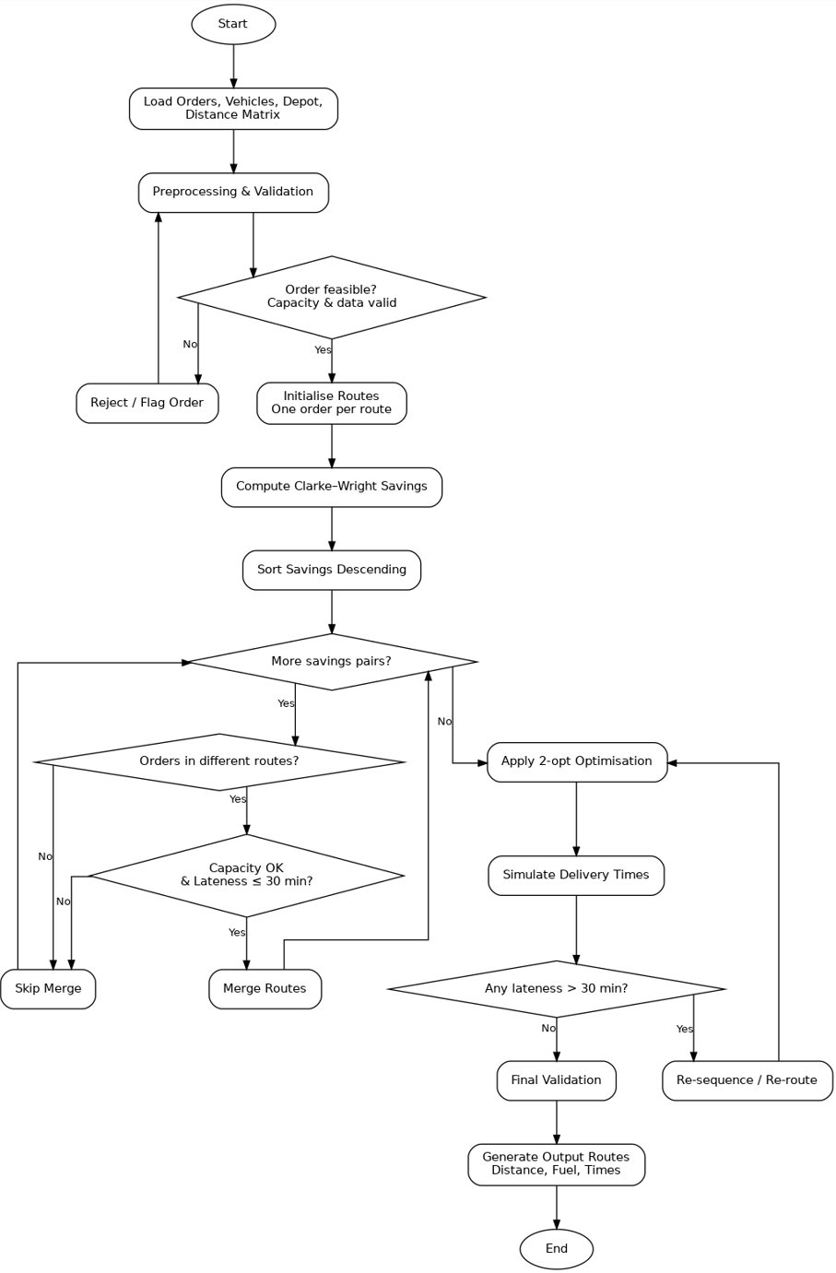

Pseudocode
BEGIN

LOAD Orders, Vehicles, DepotLocation
LOAD DistanceMatrix, TravelTimeMatrix
LOAD (optional) RealTimeTrafficData

// Preprocessing Phase
FOR each Order i in Orders DO
IF Order i data is invalid THEN
FLAG Order i as infeasible
ENDIF
IF Order i exceeds max vehicle capacity THEN
FLAG Order i for manual handling
ENDIF
ENDFOR

REMOVE infeasible orders from Orders

// Initial Route Setup
INITIALISE RouteSet
FOR each valid Order i DO
CREATE Route r = [Depot -> i -> Depot]
ASSIGN r to RouteSet
ENDFOR

// Clarke–Wright Savings Calculation
INITIALISE SavingsList
FOR each pair of orders (i, j), i ≠ j DO
savings = Distance(Depot, i) + Distance(Depot, j) - Distance(i, j)
ADD (i, j, savings) to SavingsList
ENDFOR

SORT SavingsList by savings DESCENDING

// Route Merging Phase
FOR each (i, j, savings) in SavingsList DO
FIND RouteRi containing i
FIND RouteRj containing j

IF RouteRi ≠ RouteRj THEN
IF Capacity(RouteRi ∪ RouteRj) ≤ VehicleCapacity AND
EstimatedLateness(RouteRi ∪ RouteRj) ≤ 30 minutes THEN
MERGE RouteRi and RouteRj
ENDIF
ENDIF
ENDFOR

// Local Optimisation Phase
FOR each Route r in RouteSet DO
improved = TRUE
WHILE improved = TRUE DO
improved = APPLY_2_OPT(r)
ENDWHILE
ENDFOR

// Time Validation Phase
FOR each Route r in RouteSet DO
CALCULATE ArrivalTimes(r)
IF any ArrivalTime > Deadline + 30 minutes THEN
FLAG r for re-optimisation
ENDIF
ENDFOR

// Output Phase
CALCULATE TotalDistance(RouteSet)
CALCULATE EstimatedFuelConsumption(RouteSet)

OUTPUT OptimisedRoutes, ArrivalTimes, TotalDistance, FuelConsumption

END

7.Explanation of the Approach
The proposed route-optimisation system follows a structured, multi-stage methodology designed to produce efficient, feasible, and time-responsive delivery routes. The process begins with comprehensive data loading and preprocessing, where order records, vehicle capacities, customer coordinates, and road-network matrices are imported. During this stage, invalid orders are filtered out, customers with strict delivery deadlines are flagged, and order sizes are checked against vehicle limits to prevent infeasible allocations.The first major optimisation step is the Clarke–Wright Savings algorithm, a constructive heuristic widely used for Vehicle Routing Problems. Initially, each order is assigned its own individual route from the depot. The algorithm then calculates pairwise “savings” values, which represent the reduced travel cost achieved by merging two routes. Routes are combined greedily in descending order of these savings, producing a strong initial route structure that significantly reduces travel distance.During all merging operations, strict constraint checks are enforced. Vehicle capacity limits, estimated delivery times, and maximum lateness thresholds (≤ 30 minutes) ensure that no illegal or impractical routes are formed. After initial construction, the system applies a 2-opt local optimisation procedure, which iteratively removes inefficient path segments to reduce detours and improve overall route geometry.Once candidate routes are refined, the system conducts detailed delivery-time validation, estimating travel durations, arrival times, and any deviations from promised delivery windows. Routes failing to meet the maximum allowable lateness are flagged for revision.Finally, the system generates a comprehensive output, including optimised vehicle routes, estimated fuel consumption, total distance travelled, and projected delivery times.

8.Addressing Core Objectives
This approach supports efficient order allocation through proximity-based merging and capacity validation. Fuel consumption is minimised through a combination of Clarke–Wright construction and 2-opt refinement. Timely delivery is ensured via continuous lateness monitoring during each optimisation phase, aligning the solution with GrocerQuick’s delivery-performance standards.

9.Problem-Solving Strategies Used
In addressing the vehicle routing problem (VRP), I employed a combination of abstract thinking, problem decomposition, and heuristic methods. Abstract thinking was crucial in translating real-world logistics into a formal computational model. Vehicles were conceptualised as capacity-constrained carriers, roads as weighted edges representing distances or travel times, orders as nodes requiring service, and feasible routes as paths connecting these nodes. This abstraction allowed the problem to be represented as a graph structure amenable to algorithmic analysis and optimisation.
Problem subdivision further enhanced manageability. The VRP was broken down into distinct components: preprocessing input data, generating initial routes, calculating potential savings, merging routes, checking feasibility, optimising solutions, and producing outputs. Each component could be approached independently, enabling targeted development and iterative refinement. This decomposition mirrors systems thinking principles, highlighting how complex logistics networks can be understood as interconnected but separable subsystems.
Heuristic strategies were central to generating effective solutions within practical time frames. The Clarke–Wright savings algorithm provided a rapid, high-quality initial solution, leveraging simple yet powerful insights into route consolidation. Subsequent refinement using the 2-opt algorithm allowed local optimisation by iteratively exchanging route edges to reduce total travel distance. The combination of these heuristics enabled efficient solution generation for NP-hard VRP instances, balancing solution quality and computational cost.

10.Justification of the Approach
The selected hybrid optimisation approach—combining the Clarke–Wright Savings algorithm with 2-opt local search—was chosen because it provides an effective balance between computational efficiency, solution quality, and practical feasibility for GrocerQuick’s delivery-routing requirements. Given the NP-hard nature of the Vehicle Routing Problem (VRP), exact optimisation methods (such as integer linear programming) become computationally infeasible as the number of orders increases. Therefore, heuristic-based methods are more appropriate for a fast-growing, real-world delivery system where timely decision-making is essential. The Clarke–Wright Savings algorithm was selected as the primary construction heuristic due to its proven reliability in logistics and distribution planning. Its core strength lies in its ability to rapidly generate high-quality initial routes by identifying cost-saving opportunities when combining individual customer deliveries. By explicitly quantifying the “savings” gained from merging routes, the algorithm aligns directly with GrocerQuick’s objective of minimising total travel distance and fuel consumption. Additionally, Clarke–Wright is flexible enough to incorporate key operational constraints—such as vehicle capacity limits and delivery time windows—making it suitable for GrocerQuick’s constrained delivery environment. However, while Clarke–Wright efficiently produces near-optimal route structures, it is inherently greedy and may result in locally suboptimal path geometries, including route crossings or inefficient stop sequences. To address this limitation, the 2-opt local search heuristic was incorporated as a refinement stage. The 2-opt algorithm systematically improves route quality by removing and reconnecting pairs of edges, which is particularly effective at reducing unnecessary detours and improving overall route compactness. This enhancement directly supports the secondary objective of further reducing fuel consumption while preserving delivery-time feasibility. The integration of these two heuristics creates a complementary optimisation framework. Clarke–Wright rapidly constructs a strong baseline solution, while 2-opt incrementally refines that solution without incurring excessive computational overhead. This hybrid approach reflects best practice in operational research, where layered heuristics are commonly employed to achieve practical, high-quality solutions for large-scale routing problems. Importantly, the combined method supports scalability, allowing GrocerQuick to handle increasing order volumes without significant degradation in performance. From a systems perspective, this approach also supports adaptability and modularity. Each optimisation stage—route construction, constraint validation, and local improvement—can be independently modified or extended in the future. For example, additional heuristics or real-time traffic adjustments could be integrated without redesigning the entire system. As a result, the proposed method not only addresses GrocerQuick’s current operational challenges but also provides a robust foundation for future enhancements. In summary, the hybrid Clarke–Wright and 2-opt approach was justified by its computational efficiency, empirical effectiveness in vehicle routing applications, ability to respect real-world constraints, and suitability for scalable, real-time logistics operations. Rather than pursuing theoretical optimality at the expense of practicality, the chosen methodology prioritises reliable, high-quality routing decisions that align with GrocerQuick’s business objectives and operational realities.

11.References
[1]
H. M. Hauff and G. J. Fogarty, “Analysing probem solving behaviour of successful and unsuccessful statistics students,” vol. 24, no. 6, pp. 397–409, 1996.
[2]
F.-R. Kuo and G.-J. Hwang, “A structural equation model to analyse the antecedents to students’ web-based problem-solving performance,” vol. 31, no. 4, 2015.
[3]
R. Kelly, E. McLoughlin, and O. E. Finlayson, “Analysing student written solutions to investigate if problem-solving processes are evident throughout,” vol. 38, no. 11, pp. 1766–1784, 2016.
[4]
L. J. Ball, J. St. BT Evans, I. Dennis, and T. C. Ormerod, “Problem-solving strategies and expertise in engineering design,” vol. 3, no. 4, pp. 247–270, 1997.
[5]
M. A. Van Rees, “Analysing and evaluating problem-solving discussions,” vol. 9, no. 2, pp. 343–362, 1995.
[6]
M. J. Baker, “Forms of cooperation in dyadic problem-solving.,” vol. 16, no. 4–5, pp. 587–620, 2002.
[7]
D. Keim, J. Kohlhammer, G. Ellis, and F. Mansmann, Mastering the information age solving problems with visual analytics. Eurographics Association, 2010.
[8]
M. J. Baker, “Forms of cooperation in dyadic problem-solving.,” vol. 16, no. 4–5, pp. 587–620, 2002.
[9]
M. Santos-Trigo, “Problem solving in mathematics education: tracing its foundations and current research-practice trends,” vol. 56, no. 2, pp. 211–222, 2024.
[10]
G. M. Mills, Analysing Learning Strategies Through Microcomputer-Based Problem Solving Tasks. in Advances in Computer-Based Human Assessment. Springer, 1991, pp. 189–204.

