LCHS7009 Population Health and Digital Health Promotion



2 Blogs - Digital Health Innovation

Student name: Simona Maria Dinu
Student ID: 2229007
Lecturer Name: Dr. Raheela Shaikh

BLOG 1
Your step-by-step guide to post-partum mental health
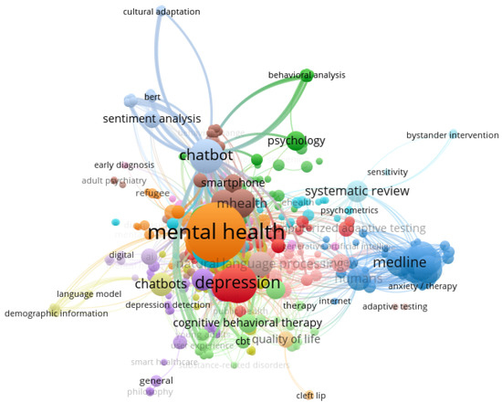
Figure 1 Keyword co-occurrence network Map (Algumaei et al., 2025).
Our innovative support system
Mental health is at risk thru perinatal and postnatal period, 1 in 4 women are mentally affected during this time with a range of conditions like depression, anxiety, PTSD, or postpartum psychosis. The number of women experiencing these conditions reaches about 130.000/year which implies about 8.1 billion pounds cost/year (O’Brien and Lally, 2026).
Transforming postpartum care. We empower new mothers by seamlessly blending innovative digital tools with compassionate emotional support. We offer a distinctive combination of technology and empathetic guidance created to cover support along your postpartum journey.
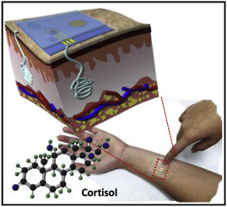
Figure 2. 3D Image of the Cortisol Patch and how it actioned.
Cortisol detection patch (Lee et al., 2020)
Continuous monitor stress outside of a clinical setting, the researchers created a wearable, non-invasive microfluidic patch that detects sweat cortisol. It utilizes an engineered, pseudoknot-assisted aptamer for high specificity and integrates pH correction for real-time accuracy and cortisol fluctuations for up to 90 minutes (Singh et al., 2023)
Mental Health Chat bot
Engage with our intelligent chat bot for instant support, personalised advice and copping strategies tailored to your specific mental health needs. A 24/7 trusted helper.


Figure 3. Mental Health Chatbot Woebot Shown to Help with Postpartum Depression and Anxiety (Uhlig, 2025)
- Advantages of the chatbots: 24/7 availability, cost-effective, personalisation, can handle multiple queries at the same time, can handle a wide range of questions, automate repetitive tasks, natural sounding conversations. (Uhlig, 2025)
- Limitations: Limited capability for understanding emotions, difficulty in handling complex requests, reliance on accurate data. (Uhlig, 2025)
The integrated well-being
By coming data from your cortisol patch and from the chat bot interaction, we provide holistic support vision helping you make informed decisions.


Figure 4. Business analyst analysing financial data and charts on a futuristic holographic interface, interacting with a tablet in a modern office setting. (Ftcdn, 2026)
Community and Resources
Access to resources, articles and connect with other new mothers sharing their journeys and offering encouragement and not letting you forget you are not alone on this trip.


Figure 5. Young moms with their kids. (Ftcdn, 2026)

Q & A +
Testimonialises +
Get in touch +
Address: “London Street, London, W1C 00A UK”
E-mail address: Your/step-by-step/guide/to/postpartum/mental/health@co.org
Telephone: 0800 800 800
0290 999 999.
Connect with us

Figure 6. Social Media Logos.

BLOG 2
Your step-by-step guide to postpartum mental health- Talking about the Technology

Postpartum mental health contains a range of conditions, from the common, short-term condition as "baby blues" to severe illnesses like postpartum psychosis. Postpartum affects about 1 in 4 women. Symptoms can develop anytime along the pregnancy up to one year or two years postpartum and require professional care. (Maternal Mental Health Alliance, 2023; NHS, 2026).
Using Technology Acceptance Model (TAM) is a theoretical framework created to calculate the possible results of a new technology used by individuals or organisations, this theory works on two essential elements: perceived ease of use and perceived usefulness. (Dziak, 2024).
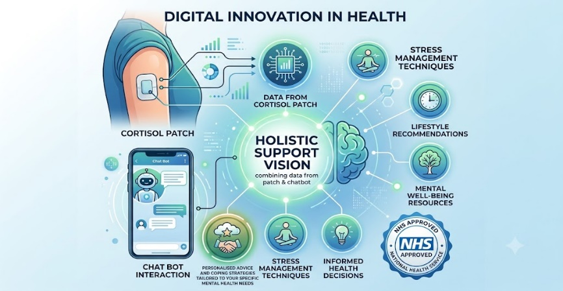
Our team of specialist came out with a new revolutionary combined technology comprising skin patches measuring the cortisol levels in real-time and a chat bot, resulting in data analysis made from our experts in order to provide you with further help if needed.
Figure 1. Self-created image (generated with the Gemini app)
How does the skin patches work: A particular layer within the patch purposely connects to cortisol. When the cortisol blends, it alters the electrical current or transfers ions, displaying data on a monitor or an app about your cortisol concentration in real-time. (Campbell, 2025; News Centre, 2018).
Barriers: According to Medical Device and Diagnostic Industry (2026) among other concerns reading the results of the cortisol skin patches is harder than reading the glucose test because of the molecular complexity. Another limitation of the patch is that it can only be use once. (Medical Device and Diagnostic Industry, 2026).
Benefits: Along site the clinical advantage and the practical use of the skin patch, in mental health could help for early burnout warnings and therapeutic tracking (Psychology Today, 2021; Singh et al., 2023).
How the Chat bot work: An Artificial Intelligence Chatbot work with a blending technology that relate to each other together to create a complex system. (Uhlig, 2025).
Chat bots are more and more popular these days. Other domains using them other than for medical purpose, are, On-Site Customer Service & E-commerce (for different purposes like checking deliveries, booking appointments), Public Sector & Government (Closed-Domain) and Third-Party Generative AI (Open-Domain) with the purpose of Information research, content creation, and technical support. (Vale, 2025; For, 2024).
Barriers: The most important concern is the inability to replicate genuine human empathy (Khawaja and Belisle-Pipon, 2023), risks of providing inappropriate or harmful advice in a crisis (Wells, 2025), strict data privacy worries (Meadi et al., 2025), and an overall inability to accurately understand complex emotional implication (Khawaja and Bélisle-Pipon, 2023; Meadi et al., 2025; Wells, 2025).
Benefits: According to AMFM (2026) the most important aspects of using this digital tool are, 24/7 availability, reduced cost barriers, decreased stigma. (AMFM Mental Health Treatment, 2026). Other important aspects could be evidence-based skills, administrative efficacy and bridging care gaps. (Clark and Bailey, 2024; Farzan et al., 2024; Olawade et al., 2024).

‌

‌ References

Algumaei, A., Yaacob, N.M., Doheir, M., Al-Andoli, M.N. and Algumaie, M. (2025). Symmetric Therapeutic Frameworks and Ethical Dimensions in AI-Based Mental Health Chatbots (2020–2025): A Systematic Review of Design Patterns, Cultural Balance, and Structural Symmetry. Symmetry, 17(7), p.1082. Doi: https://doi.org/10.3390/sym17071082 (Accessed: 29.06.2026).
Campbell, D. (2025). What If You Could See Your Stress? - Johns Hopkins University Engineering Design Center. Johns Hopkins University Engineering Design Center. Available at: https://engineering.jhu.edu/designcenter/2025/05/05/what-if-you-could-see-your-stress/. (Accessed: 30.06.2026).
Clark, M. and Bailey, S. (2024). Chatbots in health care: Connecting patients to information: Emerging health technologies. PubMed. Ottawa (ON): Canadian Agency for Drugs and Technologies in Health. Available at: https://www.ncbi.nlm.nih.gov/books/NBK602381/. (Accessed: 02.07.2026).
Deepti Shroff Karhade (2025). Mental Health Chatbot Woebot Shown to Help with Postpartum Depression and Anxiety. [online] 2 Minute Medicine. Available at: https://www.2minutemedicine.com/mental-health-chatbot-woebot-shown-to-help-with-postpartum-depression-and-anxiety-2/ (Accessed: 29.06.2026).
Dziak, M. (2024). Technology acceptance model (TAM). EBSCO Information Services, Inc. Available at: https://www.ebsco.com/research-starters/technology/technology-acceptance-model-tam. (Accessed: 02.07.2026).
Farzan, M., Ebrahimi, H., Pourali, M. and Sabeti, F. (2024). Artificial Intelligence-Powered Cognitive Behavioral Therapy Chatbots, a Systematic Review. Iranian Journal of Psychiatry, 20(1). doi:https://doi.org/10.18502/ijps.v20i1.17395 (Accessed: 02.07.2026)
For, D. (2024). Government’s experimental AI chatbot to help people set up small businesses and find support. GOV.UK. Available at: https://www.gov.uk/government/news/governments-experimental-ai-chatbot-to-help-people-set-up-small-businesses-and-find-support. (Accessed: 01.07.2026).
Ftcdn.net. (2026). Available at: https://as2.ftcdn.net/v2/jpg/20/25/59/77/1000_F_2025597798_hIgPDU32mFVXUbjwwt2rBZKnWvvrwZ6F.jpg. (Accessed 29 Jun. 2026).
Ftcdn.net. (2026). Available at: https://as1.ftcdn.net/v2/jpg/01/97/02/18/1000_F_197021867_CrGNw7s3palBI4FNLHZ9W12b5SKlsnsv.jpg. (Accessed 29 Jun. 2026).
Future Prospects. Journal of medicine, surgery, and public health, 3(3). doi:https://doi.org/10.1016/j.glmedi.2024.100099 (Accessed: 02.07.2026).
Khawaja, Z. and Bélisle-Pipon, J.-C. (2023). Your robot therapist is not your therapist: understanding the role of AI-powered mental health chatbots. Frontiers in digital health, 5(5). doi:https://doi.org/10.3389/fdgth.2023.1278186 (Accessed: 02.07.2026).
Lee, H.-B., Meeseepong, M., Trung, T.Q., Kim, B.-Y. and Lee, N.-E. (2020). A wearable lab-on-a-patch platform with stretchable nanostructured biosensor for non-invasive immunodetection of biomarker in sweat. Biosensors and Bioelectronics, 156, p.112133. doi:https://doi.org/10.1016/j.bios.2020.112133 (Accessed: 29.06.2026).
Meadi, M.R., Sillekens, T., Metselaar, S., Balkom, A. van, Bernstein, J. and Batelaan, N. (2025). Exploring the Ethical Challenges of Conversational AI in Mental Health Care: Scoping Review. JMIR Mental Health, 12, pp.e60432–e60432. Doi: https://doi.org/10.2196/60432 (Accessed: 02.07.2026).
Medical Device and Diagnostic Industry. (2026). Cortisol Monitoring: Why It’s Harder Than Glucose. Available at: https://www.mddionline.com/diabetes/why-building-cortisol-sensors-is-so-much-harder (Accessed 2 Jul. 2026).
‌Singh, N.K., Chung, S., Chang, A.-Y., Wang, J. and Hall, D.A. (2023). A non-invasive wearable stress patch for real-time cortisol monitoring using a pseudoknot-assisted aptamer. Biosensors and Bioelectronics, 227, p.115097. doi:https://doi.org/10.1016/j.bios.2023.115097 (Accessed: 29.06.2026).
NHS website (2026). Postnatal depression. nhs.uk. Available at: https://www.nhs.uk/mental-health/conditions/postnatal-depression/ (Accessed: 30.06.2026).
Maternal Mental Health Alliance (2023). About Maternal Mental Health | Maternal Mental Health Alliance. maternalmentalhealthalliance.org. Available at: https://maternalmentalhealthalliance.org/about-maternal-mental-health/. (Accessed: 30.06.2026).
News Center. (2018). Wearable device designed to measure cortisol in sweat. Available at: https://med.stanford.edu/news/insights/2018/07/wearable-device-designed-to-measure-cortisol-in-sweat.html. (Accessed: 30.06.2026).
O’Brien, A. and Lally, C. (2026). Mental health during and after pregnancy. POST. Available at: https://post.parliament.uk/research-briefings/post-pn-0765/. (Accessed: 02.07.2026).
Olawade, D.B., Wada, O.Z., Odetayo, A., David-Olawade, A.C., Asaolu, F. and Eberhardt, J. (2024). Enhancing Mental Health with Artificial Intelligence: Current Trends and Future Prospects. Journal of medicine, surgery, and public health, 3(3). doi:https://doi.org/10.1016/j.glmedi.2024.100099. (Accessed: 02.03.2026).
Psychology Today. (2021). Cortisol Sensor Uses Sweat to Monitor a Biomarker of Burnout. Available at: https://www.psychologytoday.com/gb/blog/the-athletes-way/202102/cortisol-sensor-uses-sweat-monitor-biomarker-burnout. (Accessed: 02.07.2026).
Uhlig, M. (2025). How Do AI Chatbots Work: Exploring the Basics. Aryza. Available at: https://www.aryza.com/news/how-ai-chatbots-work/. (Accessed: 30.06.2026).
Vale, A. (2025). AI search experiences are on the rise: Here’s what you need to know. Infinity.co. Available at: https://www.infinity.co/uk/resources/news-and-views/ai-search-experiences-are-on-the-rise-heres-what-you-need-to-know. (Accessed 30 Jun. 2026).
Walsall for All. (2022). Walsall for All CIC – Building Stronger Communities. Available at: https://www.walsallforall.co.uk/home. (Accessed: 30.06.2026).
Wells, S. (2025). Exploring the Dangers of AI in Mental Health Care | Stanford HAI. Stanford.edu. Available at: https://hai.stanford.edu/news/exploring-the-dangers-of-ai-in-mental-health-care. (Accessed: 02.07.2026).

‌

‌

‌

‌

‌

‌

‌
‌

