

Financial Management for the Hotel Industry

Name: Buddhini Wewelwala
Student ID : 222645
Lecthure Name : Tristan Hawkins
Module No : BMIH5007

Table of Contents
Introduction 3
Trends and patterns in Urban Heights Hotel's financial performance 4
Identifying the key reasons behind the decline in profitability 6
A comprehensive turnaround strategy to revitalize the hotels’ financial health 8
Conclusion 10
References 11

Introduction
Financial performance is an indicator of the sustainability of an organisation. The success of an organisation is measured by using the financial performance of an organisation. Decision-making is a critical task for an organisation. Financial performance helps in making efficient decisions. Organisations measure financial performance to maintain investor’s trust in them (Walker, 2021). At the same time, financial performance impacts the respect and valuation of a company in the market. This report will deal with the financial performance of Urban Heights Hotel. The financial performance of Urban Heights Hotel over the past three years will be evaluated. Revenue, expenses, profitability and liquidity will be focused on the measurement of financial performance.

Trends and patterns in Urban Heights Hotel's financial performance
Urban Heights Hotel operates in the hospitality industry, where customer attraction is the key element. The following graph shows the revenue performance of Urban Heights Hotel.
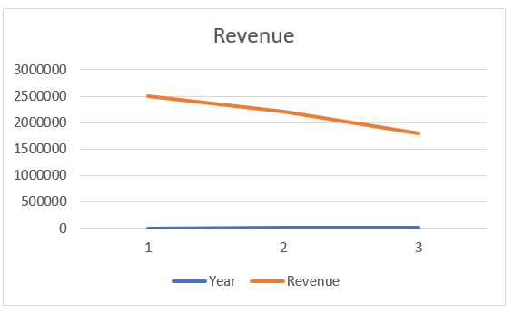

Figure: Revenue of Urban Heights
Urban Heights has observed a decline in revenue in the previous three years. This decline in revenue is responsible for its low net income. The following graph also shows the operational expenses of Urban Heights Hotel.
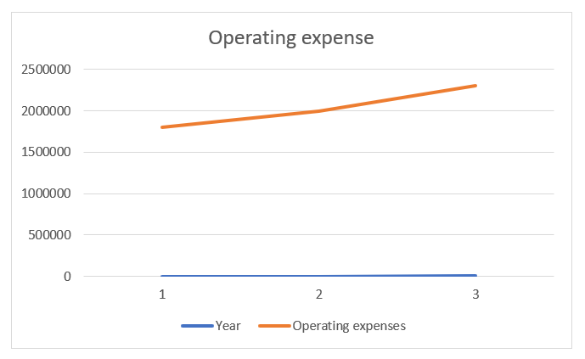

Figure: Operating expense
Operating expenses of Urban Heights Hotel are increasing. In the past three years, operating expenses increased at a significant rate. The decline in revenue and increase in operating expenses is not a good signal for the Urban Heights Hotel. This incident is responsible for the decline in net profit. In 2023, Urban Heights Hotel secured a negative net profit.

The profitability ratio of Urban Heights Hotel is calculated below:
Ratio | Formula | 2021 | 2022 | 2023
Net Profit Margin | (Net Income / Revenue) x 100 | 28.00% | 9.10% | -27.78%

The above table shows the net profit margin of Urban Heights Hotel for the last three years. In 2021, the NPM was 28%. In 2022, NPM was 9.10% and in 2023, NPM went negative. This year, net profit was negative, which made NPM negative. This decline in profitability ratio suggests that the company is struggling to generate cash to support the business (Seal, 2019). This low NPM ratio shows that Urban Heights Hotel is not generating more sales to increase its profit.

Liquidity ratio of Urban Heights Hotel is calculated below:
Ratio | Formula | 2021 | 2022 | 2023
Current Ratio | (Current Assets / Current Liabilities) | 1.82 | 1.48 | 1
Quick Ratio | (Current Assets - Inventory) / Current Liabilities | 1.32 | 0.98 | 0.5

Both the current and quick ratios of Urban Heights Hotel have decreased over three years. A low current ratio implies that the organisation does not have enough current assets to meet its short-term liabilities. At the same time, a decrease in quick ratio means that most liquid assets are not highly available for meeting current liabilities (Drury, 2021). Both the current and quick ratios are following a decreasing trend over the past three years.

Ratio | Formula | 2021 | 2022 | 2023
Debt-to-Equity Ratio | (Total Liabilities / Equity) | 1.48 | 1.79 | 2.4

The debt to equity ratio increased over the past three years. The debt-to-equity ratio shows how much dependent a company is on debt financing. In the previous three years, Urban Heights Dependence on debt capital has increased at a significant rate (Jagels, 2007). Urban Heights Hotel is highly dependent on debt compared to shareholder’s equity. That’s why this company has a lower solvency ratio.
The above analysis shows that the Urban Heights Hotel is facing great problems in maintaining the operations of the business. In 2021, it ensured a net profit of 28%. But in 2023, the net profit went negative, which means that Urban Heights is not only generating lower revenue but also incurring huge losses. This loss will be responsible for the bankruptcy of the organisation. Urban Heights Hotel is also having trouble managing its current assets and current liabilities. The current liabilities of Urban Heights increased at a significant rate, which is not a good signal for Urban Heights Hotel (Shapiro and Hanouna, 2019). The dependence of Urban Heights on debts has also increased over the three years. Increasing debt is responsible for a burden. Debt comes with an interest burden. As Urban Heights does not have enough money to support its business, it will be difficult for Urban Heights to pay the interest expenses of debt. Urban Heights cannot maintain the interest incurred from the debt. At the same time, Urban Heights does not have enough assets to meet the loan obligations.

Identifying the key reasons behind the decline in profitability
The travel and tourism industry across the world was impacted adversely in the previous years. During the Covid-19 pandemic, this industry faced a huge loss. The tourism industry faced a loss of USD 4.5 trillion during 2019 and 2020 (Khan et al, 2020). Urban Heights Hotel is also an organisation in the tourism industry. The following reasons were responsible for the decline in profitability.
Impact of Covid-19
Covid-19 incurred losses to all businesses across the world. Travel restrictions were imposed across the world, which was a problem for the travel and tourism industry. These restrictions were responsible for the decline in the customer base. At the same time, during the Covid-19 pandemic tourism organisations also had to maintain a huge operational cost. This cost was responsible for bankruptcy. In 2020, international tourists did not have any focus on travelling. International tourism decreased by 74% during 2020. Urban Heights Hotel maintained a healthy financial performance during that time (Škare, Soriano and Porada-Rochoń, 2021). But gradually, the financial performance of Urban Heights decreased at a significant rate. Post-COVID-19 impact was harmful for Urban Heights Hotel. After Covid-19, people had to experience different financial problems. In the UK, people observed a 9.3% decrease in disposable income during the pandemic (Almeida and Sılva, 2020). People had to compromise their lifestyles to survive the adverse situation. That’s why they had to spend their savings so that they could continue their life. After the pandemic, people started focussing on their savings. That’s why they did not engage themselves in travelling.
Low demand for tourism
Tourism is an optional service for an individual. This service does not fulfil the basic needs of people. People faced adverse effects from the pandemic. Across the world, 63 million jobs were lost. At the same time, businesses observed a loss of USD 4.5 trillion in the tourism industry. This loss was responsible for an adverse effect on the tourism industry. That’s why demand for tourism decreased (Bakar and Rosbi, 2020). Supporting industries of tourism also faced a loss. Flights were closed in almost all countries in the world. That’s why tourists did not get the opportunity to travel. This low demand was responsible for low revenue in the tourism industry. Health concerns, travel restrictions and economic downturns are the major reasons for the low demand for tourism.
Increased cost of operations
After Covid-19, businesses in the tourism industry started recovering the losses. After the pandemic, prices of all essential goods increased, which was responsible for high operating costs. All businesses are increasing the price of products so that they can recover the previous losses incurred by their businesses. An increase in the price of raw materials was responsible for the decrease in profitability (Riadil, 2020). The labour shortage was also a problem during the post-COVID-19 situation. Skilled labour was not available during that time, which was responsible for the loss in the tourism industry.
Hike in energy prices
In the past two years, there was another reason for the decline in profitability. The Russia and Ukraine war was a reason for increase in the energy prices. Energy prices increased significantly in the past two years. The Russia-Ukraine war was responsible for increase in the energy prices across the world. The tourism industry is energy-consuming. This industry requires a huge level of energy. As a result, electricity and other energy costs are a burden for the tourism industry. Crude oil prices increased by 52.33% due to the Russia-Ukraine war (Sass, 2022). This price hike increased the cost of electricity prices across the world.
High inflation rates
Global inflation is another burden for the tourism industry. Inflation rate across the world increased at a good rate. The global inflation rate is 8.8% in 2022, which is an alarming situation. People cannot purchase their required products due to this increased inflation (Akbarlı et al, 2022). Increased inflation is responsible for the decrease in the profitability of the tourism industry. Increasing prices is also not possible for businesses due to increased inflation across the world. Without increasing prices, a business cannot ensure growth in revenue during an inflationary environment.

A comprehensive turnaround strategy to revitalize the hotels’ financial health
Urban Heights is struggling with maintaining the operations of its business. Urban Heights is facing problems in maintaining a stable revenue. At the same time, increasing cost is also a burden for the poor financial health of Urban Heights. The following steps can be used by Urban Heights to recover its financial health.
Revenue generation
Urban Heights can enter into new markets so that new customers can be attracted. Entering new markets will help Urban Heights in creating a new customer base. Budget travellers and business clients can be approached with marketing efforts that can help Urban Heights increase its customer engagement. After entering into the new markets, Urban Heights can focus on localised service. It can update its service by providing the local facilities available (Bhattacharyya and Malik, 2020). To increase revenue for the hotel, Urban Heights can increase direct booking through its website. Direct booking will help Urban Heights generate good revenue without any commission. Ensuring booking without any high commission will help Urban Heights increase its revenue.
Reduction in costs
It is visible from the financial statements of Urban Heights that this hotel is incurring a high cost of operations. Urban Heights can reduce the cost to increase profitability. Urban Heights can negotiate with the suppliers to reduce the price of raw materials. At the same time, Urban Heights can use energy efficiency techniques to reduce the cost of energy. Urban Heights can implement solar panels so that it can use free energy by utilising solar light. Urban Heights also need to increase its operational efficiency. It should focus on enhancing the guest experience. Improving guest experience can help increase operational efficiency, which is also a key term for reducing cost.
Implementation of technology
Technology can ensure the growth of a business. In the tourism industry, the use of technology can ensure the success of the business. Urban Heights can focus on social media marketing so that it can attract new customers across the world. At the same time, Urban Heights can enrich its website so that customers can have an insight into the hotel. There are 4.9 billion social media users across the world (Dana et al, 2022). These active social media users are highly influenced by the social media marketing techniques of different brands. Urban Heights can also implement technology in the hotels. Urban Heights can ensure the utilisation of technology to increase the customer's service efficiency.

Conclusion
Urban Heights is struggling with its operational performance. This hotel is facing problems in generating adequate revenue to support its operational activities. At the same time, the financial ratios of Urban Heights show that Urban Heights is in trouble. Urban Heights can focus on revenue generation, cost reduction and implementation of technology. These three elements can ensure the fluent operations of Urban Heights. Implementation of these three strategies will require financial support. However, Urban Heights cannot support its business. Urban Heights can only focus on cost cost-reduction strategy. Cost reduction can help ensure advancements in the operational efficiency of Urban Heights Hotel.

References
Akbarlı, A., ÖndeŞ, E.B., Gezer, D. and Açıkel, B. (2022). The Impact of the Ukraine-Russia Conflict on the Aviation Sector: February-May 2022. Journal of Aviation, 6(3), pp.346-354.
Almeida, F. and Sılva, O. (2020). The impact of COVID-19 on tourism sustainability: Evidence from Portugal. Advances in Hospitality and Tourism Research (AHTR), 8(2), pp.440-446.
Bakar, N.A. and Rosbi, S. (2020). Effect of Coronavirus disease (COVID-19) to tourism industry. International Journal of Advanced Engineering Research and Science, 7(4), pp.189-193.
Bhattacharyya, S.S. and Malik, A. (2020). Development of an integrated canvas on turnaround strategy. International Journal of Organizational Analysis, 28(2), pp.523-554.
Dana, L.P., Salamzadeh, A., Mortazavi, S. and Hadizadeh, M. (2022). Investigating the impact of international markets and new digital technologies on business innovation in emerging markets. Sustainability, 14(2), p.983.
Drury C (2021) (11th Ed) Management and Cost Accounting, London, Prentice Hal
Jagels,M. (2007) Hospitality Management Accounting, London, Wiley.
Khan, N., Hassan, A.U., Fahad, S. and Naushad, M. (2020). Factors affecting tourism industry and its impacts on global economy of the world. Available at SSRN 3559353.
Riadil, I.G. (2020). Tourism industry crisis and its impacts: investigating the Indonesian tourism employees perspectives’ in the pandemic of COVID-19. Jurnal Kepariwisataan: Destinasi, Hospitalitas Dan Perjalanan, 4(2), pp.98-108.
Sass, E. (2022). The impact of eastern Ukrainian armed conflict on tourism in Ukraine. Geo Journal of Tourism and Geosites, 30, pp.880-888.
Seal W (2019) (6th Ed) Management Accounting, London, McGraw Hill
Shapiro, A.C. and Hanouna, P. (2019). Multinational financial management. John Wiley & Sons.
Škare, M., Soriano, D.R. and Porada-Rochoń, M. (2021). Impact of COVID-19 on the travel and tourism industry. Technological Forecasting and Social Change, 163, p.120469.
Walker J (2021) Introduction to Hospitality, Harlow, Pearson

