

EXAMINATION PAPER
MARKS AND COMMENTS SHEET

PROGRAMME | OME Degree Apprenticeship
LEVEL | 4
MODULE | ACDB4011 Chemistry
STUDENT I.D. | 2414411
EXAMINER | Ewa Kazimierska | INTERNAL VERIFIER
Once completed marks only should be transferred onto the front of the examination paper (no comments other than ticks or crosses on the examination paper)

Question  Number | Comments | Marks available | Marks awarded | 2nd marker (sample) | 3rd marker (where necessary)
1 | 9/10 correct in True/False. Very strong understanding of key atomic, bonding, and thermodynamic principles. | 15 | 13.5
2 | Correct answers to a and b; c and d were incomplete; missing non-bonding pairs and bond multiplicity. | 11 | 6.5
3 | Incomplete application of equations; orbital filling and unpaired electrons incorrect; colour explanation correct. | 11 | 2
4 | Equation unbalanced; no attempt at calculation or further gas law problems. | 16 | 1
5 | No attempt on OB definition, calculation, or reaction enthalpy. | 14 | 0
6 | No energy profile or reaction type assessment attempted. | 7 | 0
7 | First part not answered, but phase transitions and properties addressed well in b–d. | 11 | 9
8 | No titration or ionic equation attempt. | 5 | 0
9 | No response on calorimetry task. | 5 | 0
10 | Redox processes not attempted. | 5 | 0
 |  |  | 32

1st Marker Name | Ewa Kazimierska | 1st Marker Signature | 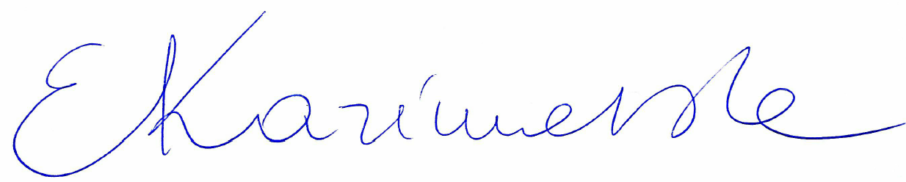
2nd Marker Name |  | 2nd Marker Signature
3rd Marker Name |  | 3rd Marker Signature
Reasons for awarding the final mark where there is more than one marker
Notes:
- The 3rd marker may be used where there is more than a 10 percentage point difference (in the TOTAL mark) between markers 1 and 2 OR when it is not possible to get agreement between markers 1 and 2. Reasons must be given where an agreed mark is given.
- This form is for internal use only and is NOT to be returned to the student. The final agreed marks must be transferred to the student feedback sheet in the assignment specification.
- The external examiner MUST be shown this form.

