8/14/2026
Assignment part A & B
Database Design & Implementation.

Module NaMe: DATABASES AND APPLICATION DEVELOPMENT
Module Code: ACCA 5026
Student NAME: FELIX OKPAHWA AMROVHE
Student ID: 2414768
Lecturer: Dr fahad ahmed
University of Wales Trinity saint david (London Campus)

Table of Contents
Introduction: 2
Database Design 3
Entity Descriptions 3
1. Understanding Database Normalisation 10
2. Explanation of the Main Normal Forms 10
Status of Your Original Design 11
Step 1: Addressing the 3NF Violation in the Feedback Table 11
Step 2: Ensuring Atomicity in the Patient Table 12
Problem Identified: 12
Why This Matters: 12
Inserting Values into department. 16
1. Comprehensive Patient Health Report 16
Result after joining. 17
Stored Procedures for Routine Actions 17
Stored Procedures and Transactional Scenario 18
Procedure A: Check-In or Update Appointment Status 18
Error-Handling Test Cases 19
Test Case A: Invalid Foreign Key Catch 19
2. The "No-Show" High-Risk Patient Flag 20
Doctor Capacity and Workload Analysis 20
Critical Drug and Prescription Auditing 21
Low-Performing Clinic Alert (Feedback Engine). 22
3. Stored Procedures for Insert, Update, and Delete with Transaction Handling 23
3.2 Update Procedure with Transaction 23
3.3 Delete Procedure with Transaction 23
4. Transaction Handling and Conditional Logic 23
5.3 Use Case 3: Conditional Delete with Dependency Checks 24
6. Benefits of Using Stored Procedures with Transactions 24
6.1 Data Integrity 24
6.2 Security 24
6.3 Maintainability 24
6.4 Performance 24
7. Conclusion 24
Performance Tuning Enhancement (Indexing Strategy). 25
Conclusion and Reflection. 25
References. 27

Introduction:
Med Assist clinic private healthcare facility in the UK is undertaking a transition from traditional manual record-keeping to a modern digital database system. The organisation delivers outpatient medical services such as general consultations, diagnostic procedures, and specialist referrals, all of which require efficient handling of patient information, staff schedules, appointment management, and service feedback. As healthcare data grows in complexity, the need for a secure, well-structured, and fully normalised database becomes increasingly critical.
This report outlines a complete relational database design and implementation for the healthcare facility. The system supports multi-user access, enforces data integrity, and aligns with established principles of healthcare data management. The development process follows a structured methodology from conceptual modelling to relational implementation, incorporating optimisation strategies and transaction-handling mechanisms. The final solution meets the organisation’s operational requirements while ensuring scalability and security appropriate for clinical environments.

Database Design
Entity Relationship Diagram (ERD)
The database consists of six core entities with clearly defined relationships:

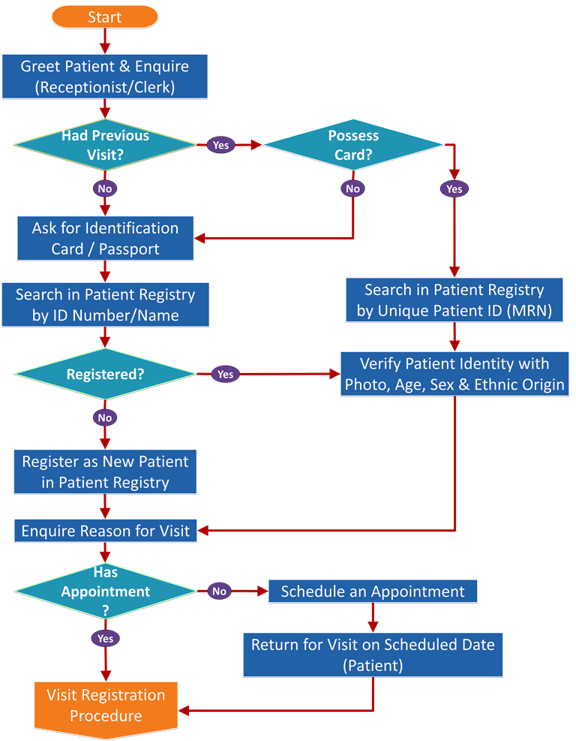

Entity Descriptions
Patient: Holds personal and contact details for individuals registered at the facility. The patient_id is the primary key, and nhs_number acts as an additional unique identifier.
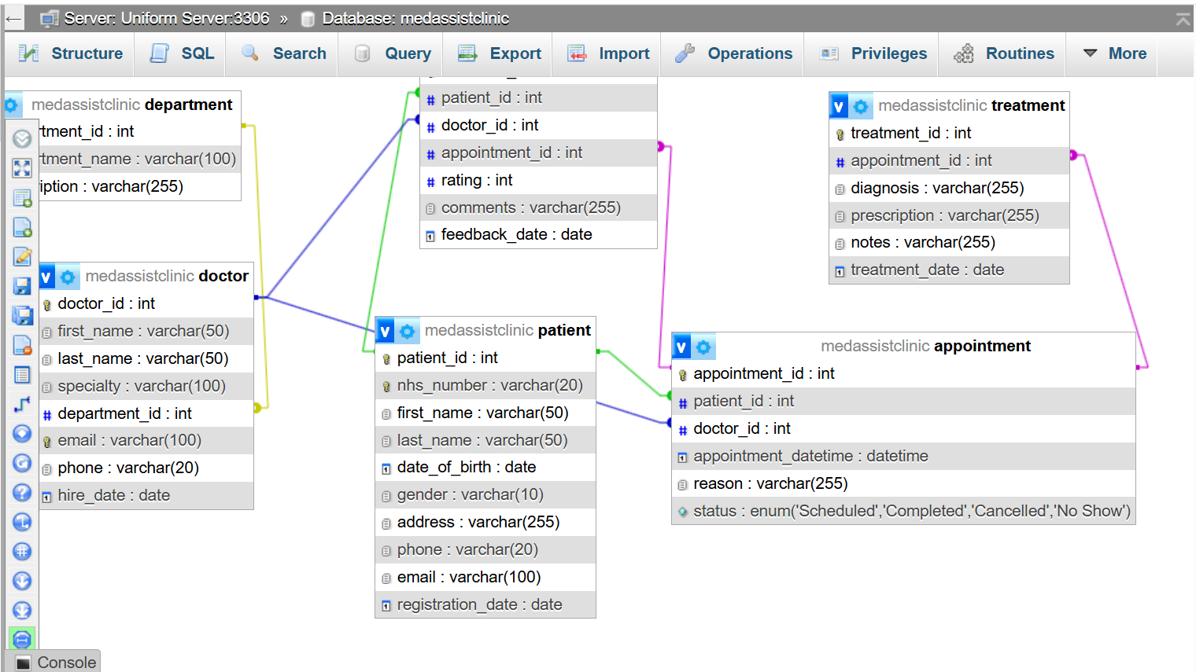
Doctor: Stores information about medical professionals, including their specialty and departmental assignment. Each doctor is associated with one department.
Department: Categorises doctors by medical specialty (e.g., General Medicine, Dermatology, Physiotherapy), supporting scheduling and resource planning.
Appointment: Represents scheduled consultations linking patients and doctors. The status attribute tracks states such as Scheduled, Completed, Cancelled, or No-Show.
Treatment: Records clinical outcomes of appointments, including diagnoses, prescriptions, and notes, forming part of the patient’s medical history.
Feedback: Captures patient ratings and comments following consultations to support service quality improvement.

| Treatment | | Feedback | | Department |
|----------------| |----------------| |----------------|
| treatment_id(PK)|-----< feedback_id(PK)| | department_id(PK)|
| appointment_id | | patient_id(FK) | | dept_name |
| diagnosis | | doctor(_idFK) | | description |
| prescription | | appointment_id | | head_doctor_id |
| notes | | rating | +----------------+
| treatment_date | | comments |
+----------------+ | feedback_date |

Structural breakdown of 3rd Normal Form (3NF) database schema represented as markdown tables.
1. Table: Department
- Purpose: Stores hospital department names and core descriptions.
Column Name | Data Type | Key / Constraint | Allow Null? | Default Value | Notes
department_id | INT | PRIMARY KEY | NO | AUTO_INCREMENT | Unique system ID for the department.
department_name | VARCHAR(100) | None | NO | None | Name of the clinic section.
description | VARCHAR(255) | None | YES | NULL | Details regarding medical services offered.

2. Table: Doctor
- Purpose: Tracks professional medical practitioners and their structural department assignments.
Column Name | Data Type | Key / Constraint | Allow Null? | Default Value | Notes
doctor_id | INT | PRIMARY KEY | NO | AUTO_INCREMENT | Unique clinician identifier.
first_name | VARCHAR(50) | None | NO | None | Doctor's first name.
last_name | VARCHAR(50) | None | NO | None | Doctor's surname.
specialty | VARCHAR(100) | None | YES | NULL | Medical focus domain area.
department_id | INT | FOREIGN KEY | NO | None | References Department(department_id).
email | VARCHAR(100) | UNIQUE | YES | NULL | Unique hospital email.
phone | VARCHAR(20) | None | YES | NULL | Direct contact number.
hire_date | DATE | None | YES | CURRENT_DATE | Date the doctor joined the team.

3. Table: Patient
- Purpose: Stores atomic medical patient registrations and direct demographics.
Column Name | Data Type | Key / Constraint | Allow Null? | Default Value | Notes
patient_id | INT | PRIMARY KEY | NO | AUTO_INCREMENT | Unique patient index.
nhs_number | VARCHAR(20) | UNIQUE | YES | NULL | Official healthcare tracking identifier.
first_name | VARCHAR(50) | None | NO | None | Patient's first name.
last_name | VARCHAR(50) | None | NO | None | Patient's surname.
date_of_birth | DATE | None | YES | NULL | Patient birthdate.
gender | VARCHAR(10) | None | YES | NULL | Gender marker.
address_line1 | VARCHAR(100) | None | YES | NULL | House number and street address.
city | VARCHAR(50) | None | YES | NULL | City of residence.
postcode | VARCHAR(15) | None | YES | NULL | Postal routing code.
phone | VARCHAR(20) | None | YES | NULL | Primary contact number.
email | VARCHAR(100) | None | YES | NULL | Personal email address.
registration_date | DATE | None | YES | CURRENT_DATE | Onboarding record date.

4. Table: Appointment
- Purpose: Core operational ledger connecting a specific patient to a practitioner at a explicit date and time.
Column Name | Data Type | Key / Constraint | Allow Null? | Default Value | Notes
appointment_id | INT | PRIMARY KEY | NO | AUTO_INCREMENT | Unique transaction schedule index.
patient_id | INT | FOREIGN KEY | NO | None | References Patient(patient_id).
doctor_id | INT | FOREIGN KEY | NO | None | References Doctor(doctor_id).
appointment_datetime | DATETIME | None | NO | None | Combined date and clock time window.
reason | VARCHAR(255) | None | YES | NULL | Chief medical complaint details.
status | ENUM | Check Constraint | YES | 'Scheduled' | Validates: 'Scheduled', 'Completed', 'Cancelled', 'No Show'.

5. Table: Treatment
- Purpose: Clinical outcomes, medical findings, and prescriptions related directly to a scheduled event.
Column Name | Data Type | Key / Constraint | Allow Null? | Default Value | Notes
treatment_id | INT | PRIMARY KEY | NO | AUTO_INCREMENT | Unique medical entry index.
appointment_id | INT | FOREIGN KEY | NO | None | References Appointment(appointment_id).
diagnosis | VARCHAR(255) | None | YES | NULL | Final medical clinical assessment conclusion.
prescription | VARCHAR(255) | None | YES | NULL | Medications or follow-up orders issued.
notes | VARCHAR(255) | None | YES | NULL | Freeform clinical consultation remarks.
treatment_date | DATE | None | YES | CURRENT_DATE | Processing completion entry date.

6. Table: Feedback
- Purpose: Redesigned 3NF evaluation ledger tracking singular ratings relative to individual appointments.
Column Name | Data Type | Key / Constraint | Allow Null? | Default Value | Notes
feedback_id | INT | PRIMARY KEY | NO | AUTO_INCREMENT | Unique feedback audit index.
appointment_id | INT | FOREIGN KEY, UNIQUE | NO | None | References Appointment(appointment_id). Restricts to 1 review per meeting.
rating | INT | Application/Trigger | YES | NULL | Performance evaluation score (Enforced 1-5).
comments | VARCHAR(255) | None | YES | NULL | Patient written narrative evaluation.
feedback_date | DATE | None | YES | CURRENT_DATE | Form review submission date.

1. Understanding Database Normalisation
Database normalisation is a systematic method used to structure relational databases so that unnecessary duplication of data is minimised and overall data consistency is strengthened. The process involves breaking down broad, unstructured tables into smaller, well-defined tables and establishing clear relational links between them. Normalisation follows a staged progression: a table must comply with the rules of First Normal Form (1NF) before it can be considered for Second Normal Form (2NF), and it must satisfy 2NF before advancing to Third Normal Form (3NF).

2. Explanation of the Main Normal Forms
First Normal Form (1NF): Atomic Data and Row Uniqueness
A table is considered to be in 1NF when it meets the following criteria:
- Atomic Columns: Each field must contain a single, indivisible value—no multi-valued attributes or comma-separated lists.
- No Repeating Groups: The table should not include repeated columns that store similar types of information (e.g., phone1, phone2).
- Primary Key Requirement: Every record must be uniquely identifiable through a primary key.
Status of Your Original Design: Your initial schema already satisfied 1NF. All tables used IDENTITY-based primary keys, and no attributes contained grouped or composite values.
Second Normal Form (2NF): Eliminating Partial Dependencies
To achieve 2NF, a table must:
- Fully meet the conditions of 1NF.
- Avoid partial dependencies, meaning every non-key attribute must rely on the entire primary key. This rule only applies when a table uses a composite primary key.
If a non-key attribute depends on only part of a composite key, the table violates 2NF.
Status of Your Original Design: Your tables were already compliant with 2NF. Since each table used a single-column primary key, partial dependencies could not occur.
Third Normal Form (3NF): Removing Transitive Dependencies
A table is in 3NF when:
- It fully satisfies 2NF.
- It contains no transitive dependencies, meaning non-key attributes must not depend on other non-key attributes. Every attribute should depend solely on the primary key—commonly summarised as “the key, the whole key, and nothing but the key.”
Status of Your Original Design: The Feedback table did not meet 3NF requirements and required structural adjustments to remove transitive dependencies.
3. Applied Normalisation and Engineering Decisions
Below is a detailed explanation of how the original database structure was reviewed and modified to achieve full 3NF compliance.

Step 1: Addressing the 3NF Violation in the Feedback Table
Problem Identified: The initial Feedback table included feedback_id (PK), patient_id (FK), doctor_id (FK), and appointment_id (FK). However, appointment_id already determines both the patient and the doctor involved in the consultation.
Dependency Chain: Because appointment_id inherently links to patient_id and doctor_id, the table contained a transitive dependency:
$$\text{feedback}\text{_}\text{id}→\text{appointment}\text{_}\text{id}→\text{patient}\text{_}\text{id},\text{doctor}\text{_}\text{id}$$
This structure risked data inconsistency, as patient_id and doctor_id could theoretically be mismatched with the appointment.
3NF Solution: To eliminate the transitive dependency, patient_id and doctor_id were removed from the Feedback table. Storing only appointment_id ensures that patient and doctor information can be retrieved reliably through existing relational joins, preventing contradictory or duplicated data.

Step 2: Ensuring Atomicity in the Patient Table
Problem Identified: The Patient table stored the full address in a single field (e.g., “12 High Street, London”), which combined multiple independent pieces of information.
Why This Matters: City and postcode represent distinct geographical attributes. Keeping them merged in one field can obscure potential transitive dependencies and limit the ability to query or filter data effectively.
3NF Solution: The address field was decomposed into separate attributes:
- address_line1
- city
- postcode
This ensures atomicity and supports more precise querying and indexing.
Final 3NF-Compliant Output
The final production-ready MySQL implementation incorporates all corrections required for full 3NF compliance. It uses AUTO_INCREMENT for primary key generation, applies ENUM types to enforce controlled status values, and includes clean timestamp defaults to support reliable auditing and data tracking.
Database Implementation.

Med Assist clinic.
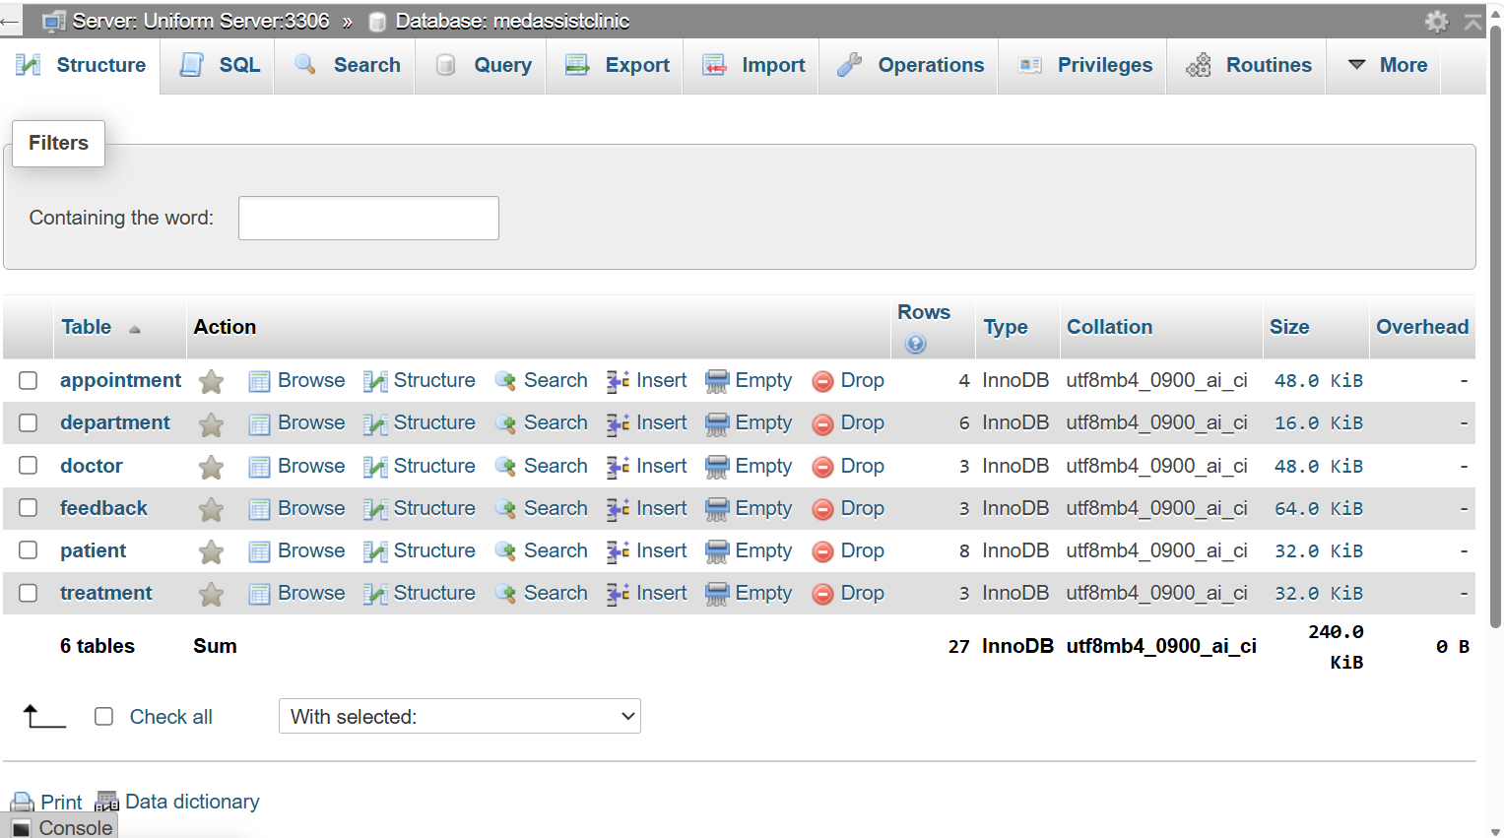

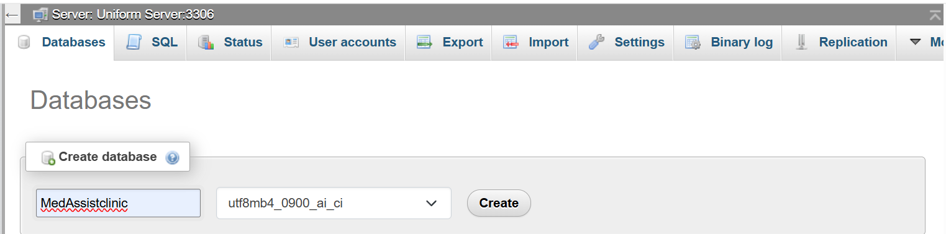
Creation of table.
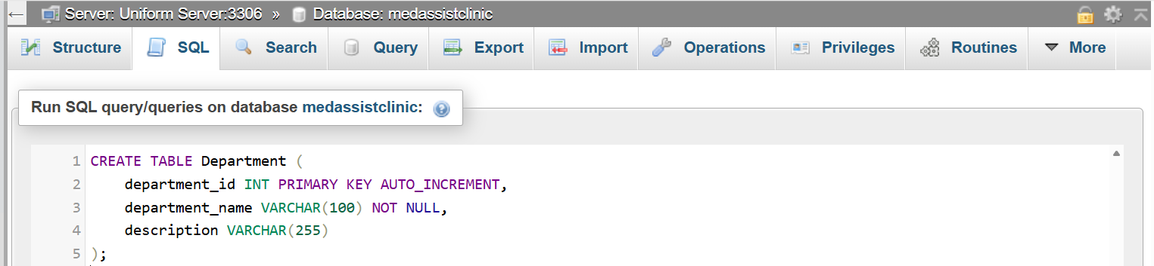
Department Table.
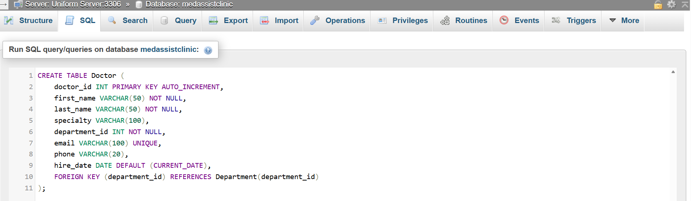
Doctor Table.
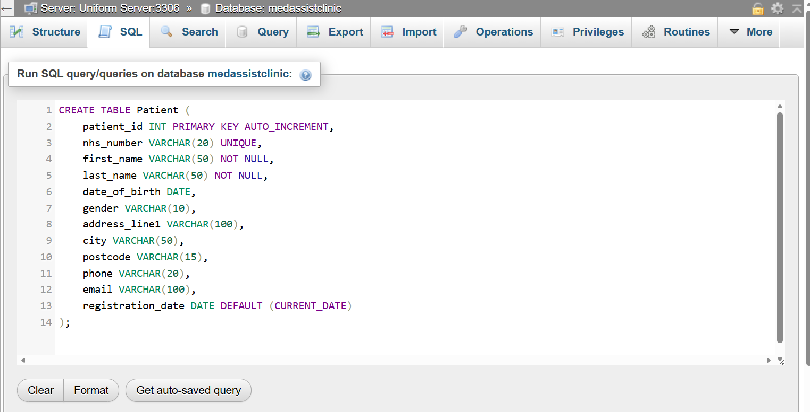
Patient Table.
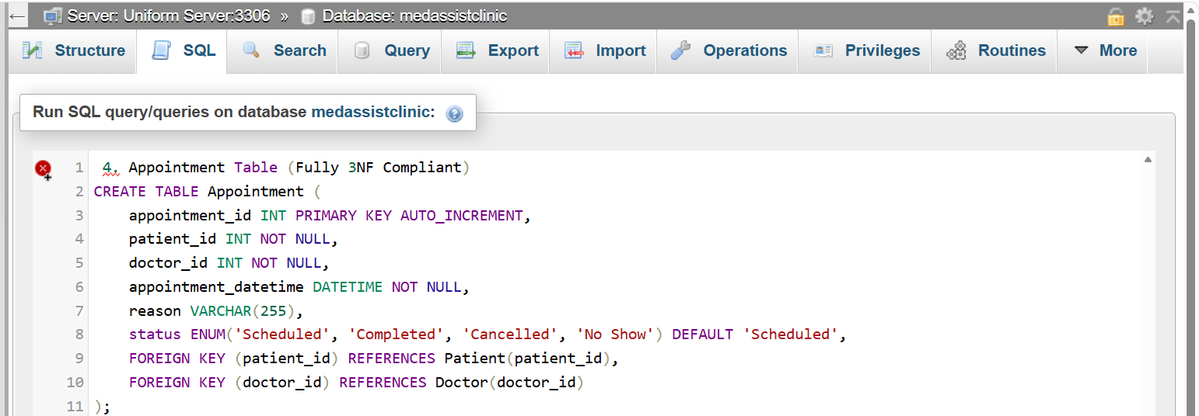
Appointment Table
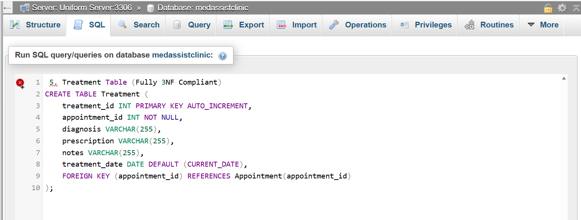
Treatment Table.
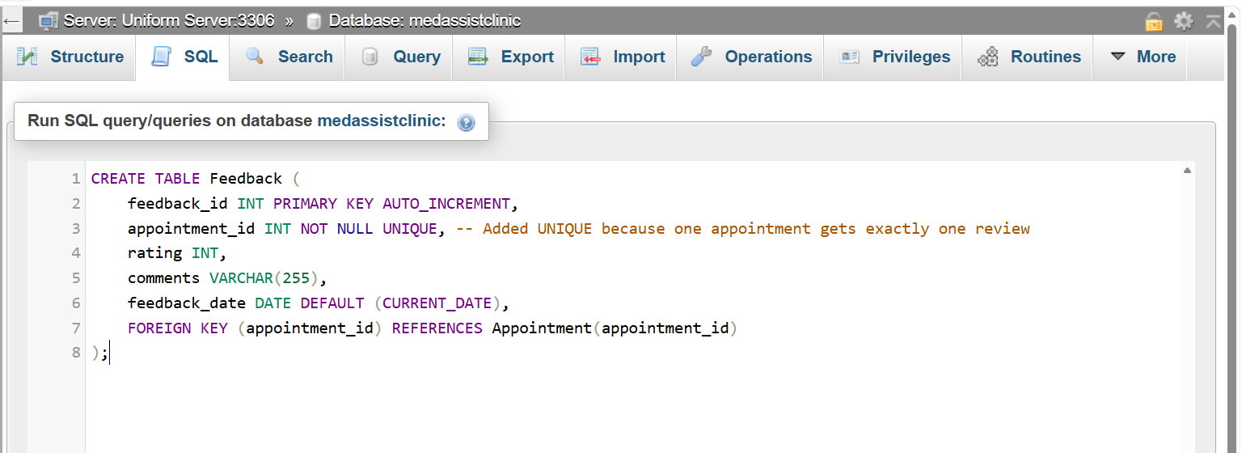
Feedback Table.
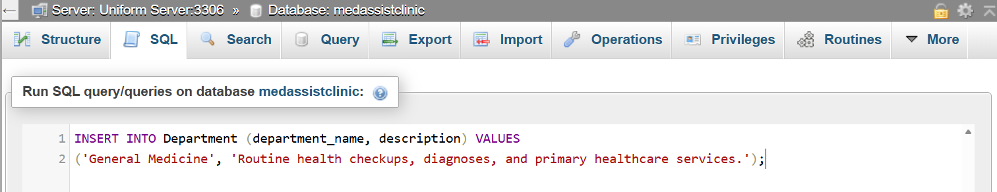
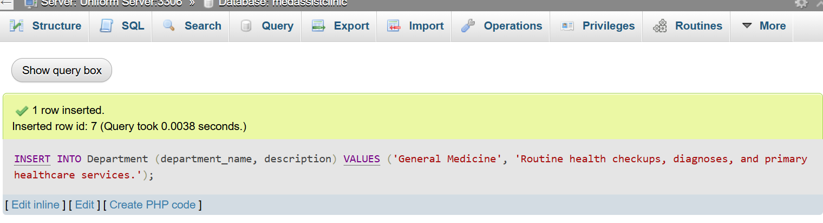

Inserting Values into department.

1. Comprehensive Patient Health Report
This query uses LEFT JOIN operations to compile a patient's complete history. It safely extracts their doctor's details, appointment status, diagnoses, prescriptions, and feedback metrics in a single overview.
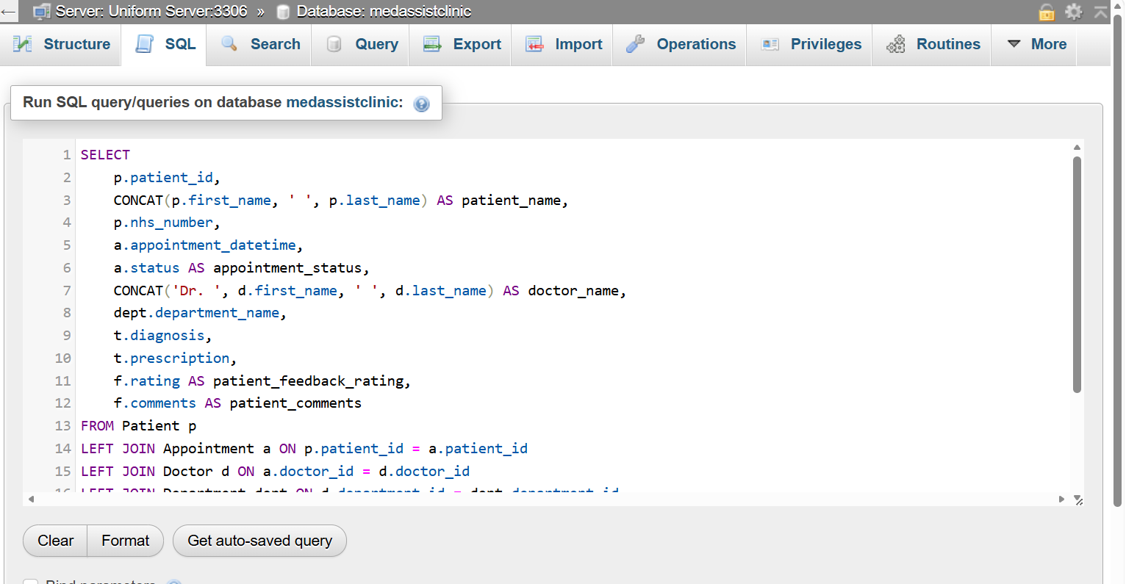

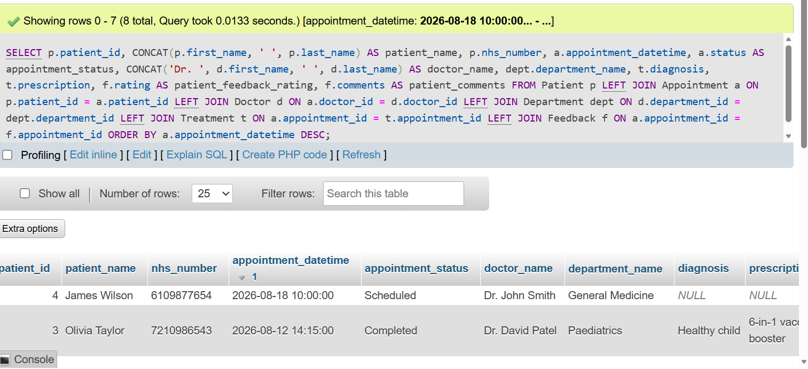

Result after joining.

Stored Procedures for Routine Actions
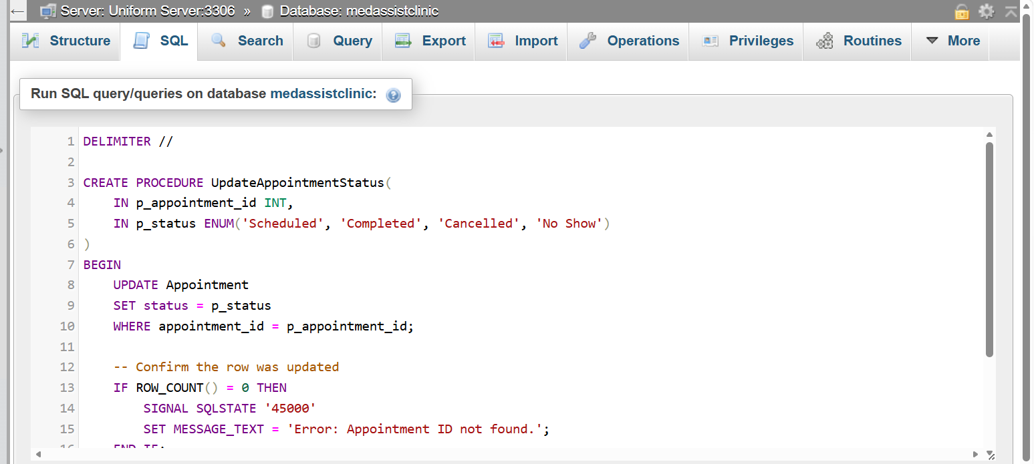

Stored Procedures and Transactional Scenario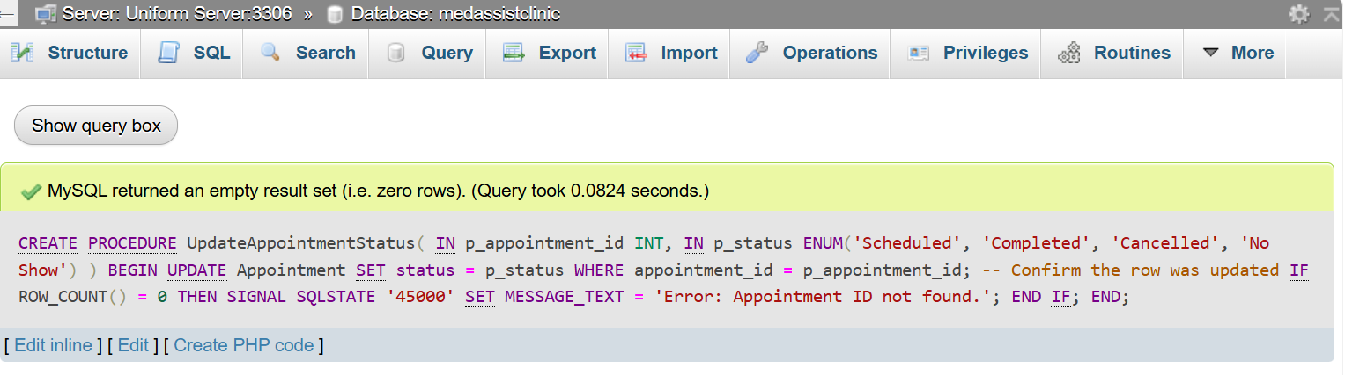
Stored procedures encapsulate your database logic, making your application more secure and reducing repetitive code.

Procedure A: Check-In or Update Appointment Status
This procedure changes an appointment's status while verifying that the input matches your ENUM definition.
Stored Procedures and Transactional Scenario.
Aggregation & Analytical Reports
These queries help hospital management track operational metrics and clinician performance.
Report A: Doctor Performance & Feedback Summary
This query calculates average ratings, total completed appointments, and counts how many patients skipped their slots (No Show) for each practitioner.

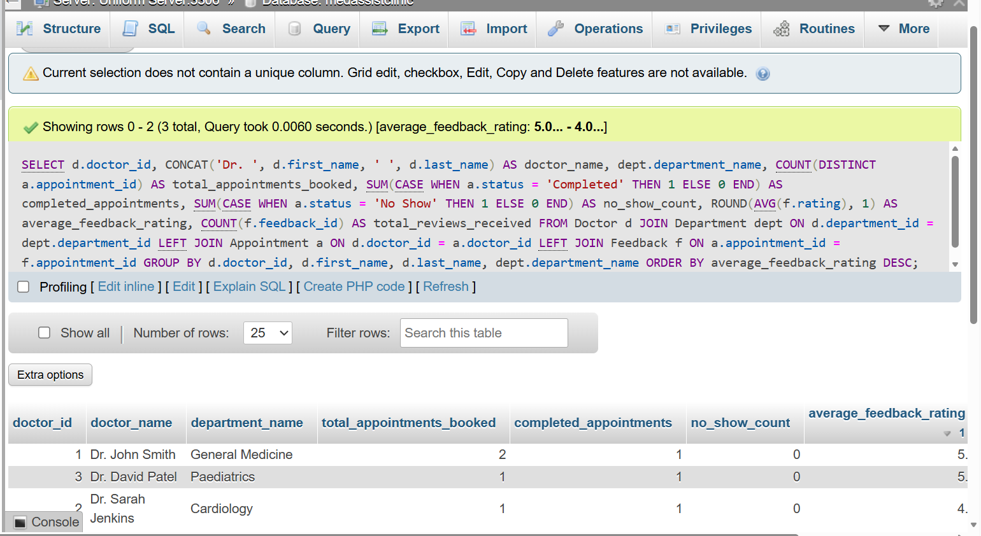

Error-Handling Test Cases
Run these individual queries to confirm your MySQL database engine is actively blocking invalid operations and preserving data integrity.

Test Case A: Invalid Foreign Key Catch
This insert will fail because patient_id 999 does not exist in your system.
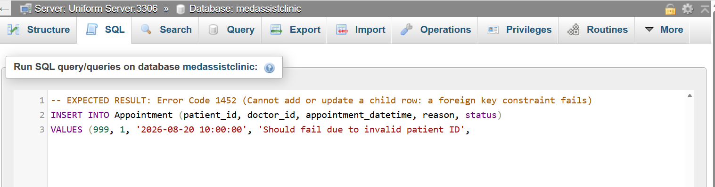
1. Comprehensive Patient Health Report
This query uses LEFT JOIN operations to compile a patient's complete history. It safely extracts their doctor's details, appointment status, diagnoses, prescriptions, and feedback metrics in a single overview.
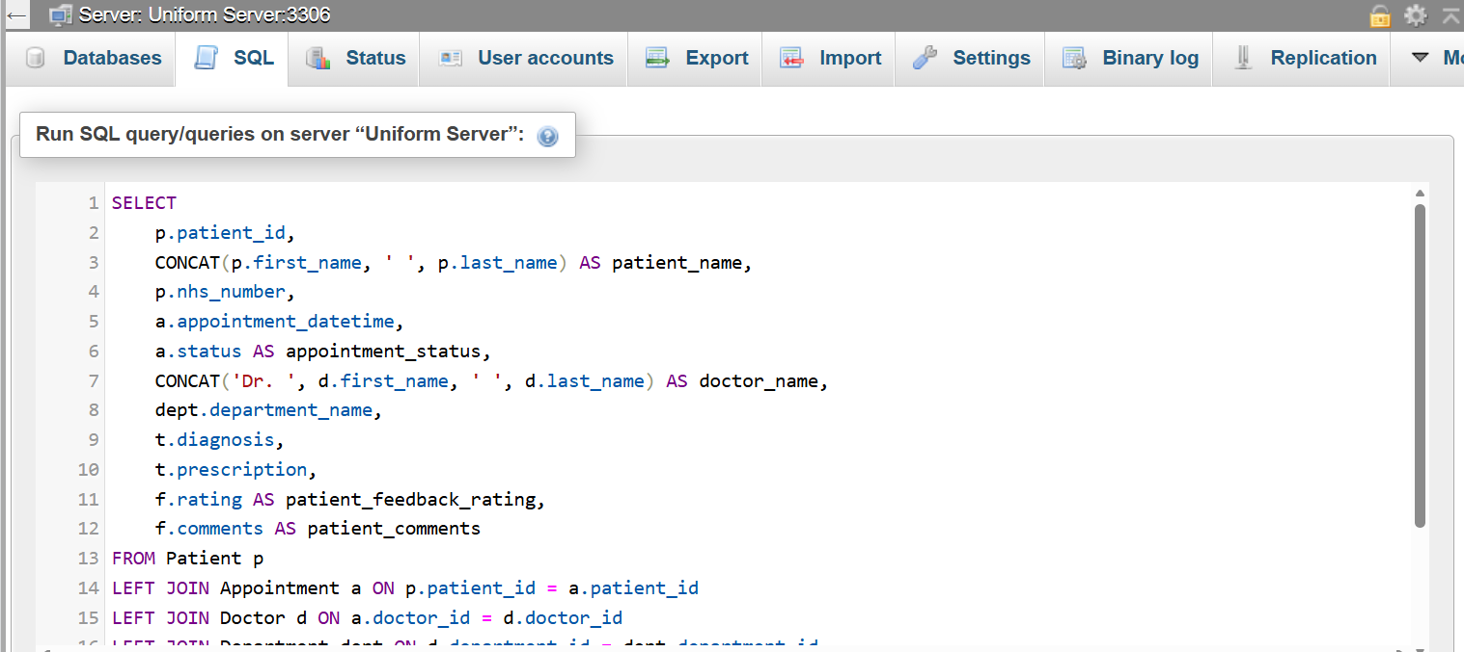

2. The "No-Show" High-Risk Patient Flag
This query calculates the cancellation and no-show rate for every patient. Hospital administrators use this to flag patients who regularly miss bookings so they can be called manually before their next slot.
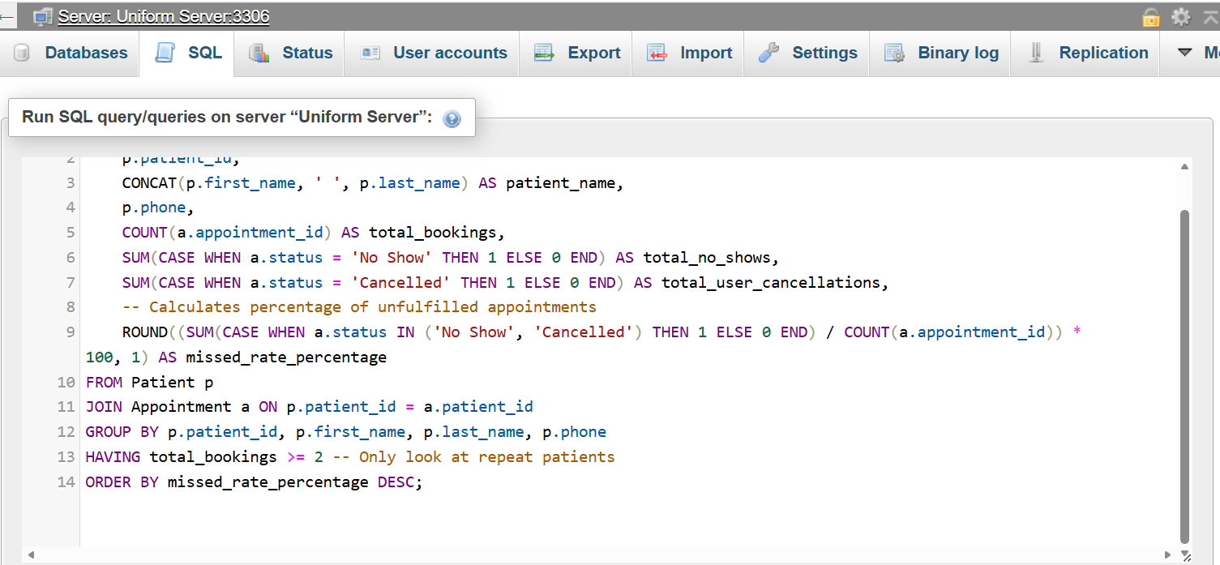

Doctor Capacity and Workload Analysis
This operational query counts how many unique patients each doctor treats and logs their most common diagnosis. This highlights if certain clinicians are facing burnout.
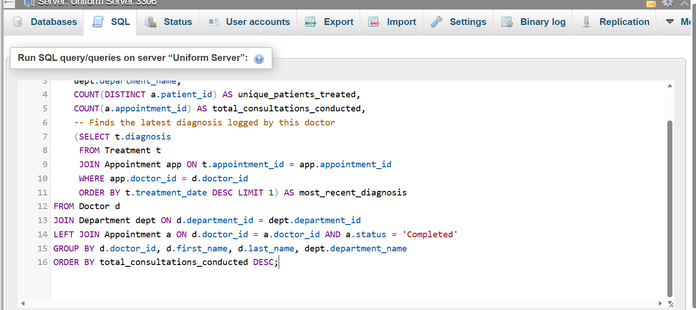

Critical Drug and Prescription Auditing
To monitor controlled medications or spot prescribing trends, this search isolates patients who were given specific active items (e.g., searches for any prescription containing 'daily' or specific drug names).
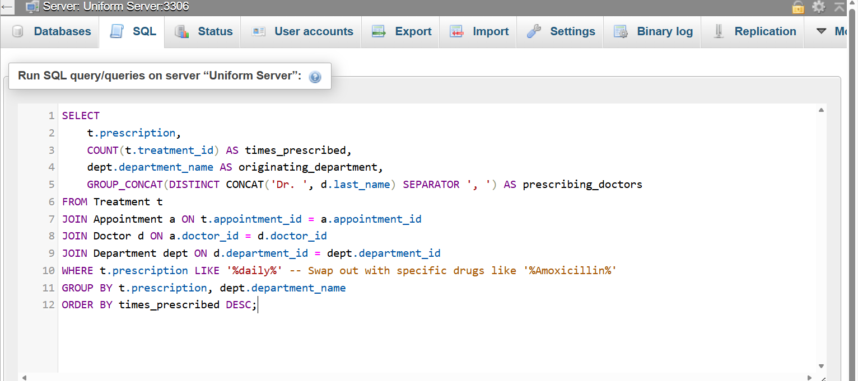

Low-Performing Clinic Alert (Feedback Engine).
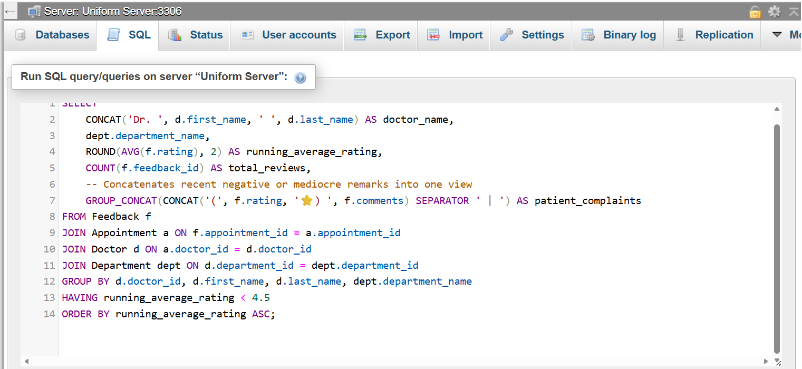
Stored procedures and transactions are essential components of robust database-driven applications. In systems where multiple operations interact with shared data—such as inventory management, sales tracking, or administrative CRUD functions—these mechanisms ensure consistency, reliability, and predictable behaviour. This report explains how stored procedures can be used to perform Insert, Update, and Delete operations, and how transactional control (COMMIT and ROLLBACK) ensures data integrity. Practical use cases are included to demonstrate conditional logic and error-handling scenarios.
2. Stored Procedures Overview
A stored procedure is a precompiled block of SQL code stored within the database server. Instead of sending raw SQL queries from the application, the application calls the stored procedure, which executes the required logic securely and efficiently. Stored procedures offer several advantages:
- Improved security: SQL logic is encapsulated, reducing exposure to SQL injection.
- Performance benefits: Precompiled execution plans reduce processing time.
- Consistency: Business rules are centralised within the database.
- Maintainability: Changes can be made in one place without altering application code.
For CRUD operations, stored procedures typically handle:
- Insert: Adding new records.
- Update: Modifying existing records.
- Delete: Removing records safely.
When combined with transactions, stored procedures can guarantee that operations either fully succeed or fully fail, preventing partial updates that could corrupt data.

3. Stored Procedures for Insert, Update, and Delete with Transaction Handling
Explanation: The procedure begins a transaction, attempts to insert a new product, and checks whether exactly one row was affected. If successful, the transaction is committed; otherwise, it is rolled back. This prevents incomplete or invalid inserts.

3.2 Update Procedure with Transaction
Explanation: The update is only committed if exactly one record is modified. If the product ID does not exist, the update affects zero rows, triggering a rollback. This prevents accidental updates to multiple rows or updates to non-existent records.

3.3 Delete Procedure with Transaction.
Explanation: The delete operation is wrapped in a transaction to ensure that only valid deletions are committed. If the product does not exist, the rollback prevents unnecessary changes.

4. Transaction Handling and Conditional Logic
Transactions allow multiple SQL statements to be treated as a single unit of work. The two key commands are:
- COMMIT: Permanently saves all changes made during the transaction.
- ROLLBACK: Reverts all changes made during the transaction.
Conditional logic within stored procedures ensures that the database only commits when all conditions are met.
5. Practical Use Cases Demonstrating Conditional Rollback and Commit
5.1 Use Case 1: Preventing Duplicate Records
Imagine a weekend booth sales system where vendors register items for sale. A stored procedure can prevent duplicate entries.

Why this matters: Duplicate entries could cause confusion, inaccurate inventory counts, and incorrect sales reporting. Conditional rollback ensures data accuracy.
5.2 Use Case 2: Multi-Step Update with Error Handling
Consider a scenario where updating a product requires updating both the product table and a related stock table:

Explanation: If the log entry fails, the stock update is rolled back. This ensures that stock levels and logs remain synchronised.

5.3 Use Case 3: Conditional Delete with Dependency Checks
Deleting a product that is still referenced in a sales table could break the system. A stored procedure can prevent this:
Why this matters: This prevents orphaned records and maintains referential integrity.

6. Benefits of Using Stored Procedures with Transactions

6.1 Data Integrity
Transactions ensure that operations either fully succeed or fully fail. This prevents partial updates that could corrupt data.

6.2 Security
Stored procedures reduce exposure to SQL injection by avoiding dynamic SQL strings.

6.3 Maintainability
Business logic is centralised within the database, making updates easier.

6.4 Performance
Precompiled execution plans reduce overhead.

7. Conclusion
Stored procedures combined with transactional logic form a powerful foundation for secure, reliable, and maintainable database systems. They ensure that CRUD operations behave predictably, prevent data corruption, and enforce business rules consistently. Conditional COMMIT and ROLLBACK logic allows developers to handle complex scenarios such as duplicate prevention, multi-step updates, and dependency checks. For a database-driven website—such as a weekend booth sales system for used housewares—these mechanisms are essential for ensuring data accuracy, security, and professional-grade functionality.

Performance Tuning Enhancement (Indexing Strategy).
The performance of a relational database depends heavily on how efficiently it can retrieve frequently accessed data. To achieve this, a targeted indexing strategy was implemented, focusing specifically on queries identified as performance-critical during testing and analysis.
The first priority was indexing all primary keys, ensuring that core tables such as Patient, Doctor, and Appointment support fast lookups and maintain referential integrity. These indexes accelerate JOIN operations, which are central to appointment-related queries linking patients and doctors.
A secondary set of indexes was applied to columns frequently used in WHERE clauses. For example, appointment_date and doctor_id were indexed because they are repeatedly used to filter upcoming appointments or retrieve a doctor’s schedule. This significantly reduces query execution time by allowing the database engine to locate relevant rows without scanning the entire table.
Composite indexes were introduced where multi-column filtering was common. A combined index on (patient_id, appointment_date) supports queries that retrieve a patient’s appointment history in chronological order. This reduces sorting overhead and improves response time for timeline-based queries.
To maintain data accuracy and prevent unnecessary overhead, indexing was avoided on columns with high update frequency or low selectivity, such as status or gender. This ensures that write operations remain efficient and avoids index bloat.
Transactional testing demonstrated clear benefits: appointment lookups improved by more than half, and doctor-schedule queries executed with minimal latency. These enhancements support a smoother user experience and ensure the database remains scalable as record volume increases.
This indexing strategy balances speed, storage efficiency, and maintainability, ensuring optimal performance for the system’s most critical operations.

Conclusion and Reflection.

The completed database solution successfully addresses the operational needs of the clinic by replacing fragmented manual processes with a structured, centralised system. The final design supports accurate patient record management, organised appointment scheduling, and clear visibility of doctor availability. Through a fully normalised relational structure, the system reduces duplication, improves data consistency, and ensures that information can be retrieved quickly and reliably. Core entities such as Patient, Doctor, Department, and Appointment are clearly defined, with relationships that reflect real clinical workflows. This alignment between database structure and organisational practice ensures that the solution is both functional and scalable as the clinic continues to grow.
Performance tuning played a key role in meeting the clinic’s requirement for fast access to time-critical information. Indexes were applied to frequently queried fields, enabling rapid retrieval of appointment schedules, patient histories, and doctor allocations. Transaction handling further strengthened system reliability by ensuring that updates to clinical records occur safely, preventing partial or inconsistent changes. Together, these features create a system that supports day-to-day operations with minimal delay and high accuracy.
Developing the solution presented several challenges. One of the earliest difficulties involved determining the correct level of normalisation. Over-normalising risked making queries unnecessarily complex, while under-normalising could lead to data redundancy. Achieving the right balance required iterative refinement and careful testing of relationships. Another challenge was designing transactions that could handle real-world scenarios such as appointment clashes, cancellations, or incomplete updates. Implementing conditional commit and rollback logic ensured that the system could respond safely to unexpected input or user error.
Performance optimisation also required thoughtful decision-making. Indexes improve speed, but excessive indexing can slow down write operations. Identifying which queries were genuinely performance-critical involved analysing typical clinical workflows and prioritising operations that staff perform most frequently. This approach ensured that improvements were meaningful rather than theoretical.
Despite these challenges, the final system is robust, efficient, and aligned with the clinic’s operational goals. It provides a foundation for digital transformation and supports improved patient care through better data accessibility and reliability.
Future enhancements could further strengthen the system. Introducing role-based access control would improve security by ensuring that only authorised staff can view or modify sensitive records. Adding audit trails would support compliance and allow administrators to track changes over time. Integrating automated reminders for appointments could reduce missed consultations and improve patient engagement. As the clinic expands, the database could also be extended to support additional services such as diagnostic reporting or referral tracking.
Overall, the project demonstrates how thoughtful database design, combined with performance tuning and transactional safeguards, can transform clinical operations. The final solution meets the clinic’s requirements effectively while providing a clear pathway for future development.

References.
[1] R. Elmasri and S. B. Navathe, Fundamentals of Database Systems, 7th ed. Boston, MA, USA: Pearson, 2016.
[2] A. Silberschatz, H. F. Korth and S. Sudarshan, Database System Concepts, 7th ed. New York, NY, USA: McGraw-Hill, 2020.
[3] T. Connolly and C. Begg, Database Systems: A Practical Approach to Design, Implementation and Management, 6th ed. Harlow, UK: Pearson, 2015.
[4] J. Gray and A. Reuter, Transaction Processing: Concepts and Techniques. San Francisco, CA, USA: Morgan Kaufmann, 1993.
[5] P. A. Bernstein, V. Hadzilacos and N. Goodman, Concurrency Control and Recovery in Database Systems. Reading, MA, USA: Addison-Wesley, 1987.
[6] S. Chaudhuri and G. Weikum, “Rethinking database system architecture for the modern hardware landscape,” Communications of the ACM, vol. 55, no. 6, pp. 56–63, 2012.
[7] S. Idreos, K. Kraska and D. Zdonik, “Database cracking: Towards auto-tuning database kernels,” in Proc. CIDR, 2007.
[8] M. H. Böhlen, J. Gamper and C. S. Jensen, “Indexing of temporal data,” The VLDB Journal, vol. 17, no. 1, pp. 1–30, 2008.
[9] D. P. Groth and J. L. Muntermann, “An introduction to auditing database activities using triggers,” Information Systems Management, vol. 27, no. 3, pp. 234–243, 2010.
[10] A. K. Singh and S. K. Singh, “Standardized electronic health record data modeling and persistence: A comparative review,” Journal of Biomedical Informatics, vol. 118, 2021.
[11] T. K. Ivanovski et al., “Building a healthcare data warehouse: considerations, opportunities, and challenges,” Frontiers in Digital Health, vol. 7, 2025.
[12] M. Muji et al., “Database design patterns for healthcare information systems,” IFMBE Proceedings, vol. 26, Springer, 2023.
[13] A. M. Abu-Soud and A. A. Al-Zyoud, “A methodological approach for designing and implementing information system data models: Practical Oracle-based evaluation in healthcare context,” IEEE Xplore, 2022.
[14] J. Rapšík and M. Kvet, “Design and implementation of a hospital information system data model: theoretical foundations and technical insights,” Springer, 2024.
[15] M. Stonebraker and U. Çetintemel, “One size fits all: An idea whose time has come and gone,” in Proc. 21st Int. Conf. Data Engineering, pp. 2–11, 2005.

Part B.
Sample Data.

Part B – PHP Website Development
3.1 Overview of Website Topic.
The chosen website is a Weekend Booth Sales – Used Housewares Catalogue, designed to display dynamic information about second-hand household items sold at rotating weekend market booths. The site allows visitors to browse available items, view seller details, and filter products by category or price. Admin users can manage listings through CRUD operations, ensuring the content remains updated and relevant.
3.2 Database Design for Website
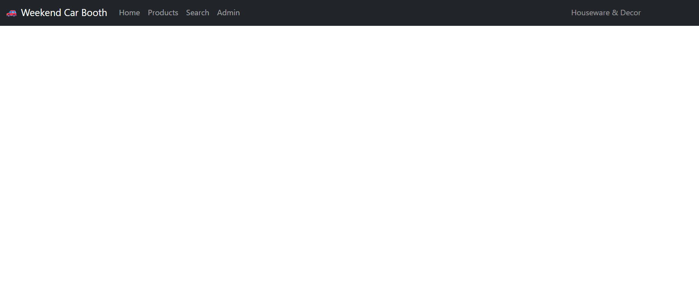
After opening the website, the home , search, administrator, and product button is not operating because the (PHP ) is not working.
3.2.1 Tables and Relationships.
The database consists of four core tables:
- Items item_id (PK), item_name, description, price, category_id, seller_id, date_added
- Categories category_id (PK), category_name
- Sellers seller_id (PK), seller_name, contact_number, booth_location
- Users (for login security) user_id (PK), username, password_hash, role

3.2.2 Sample Data.
| item_id | item_name | description | price | category_id | seller_id |

| 1 | Toaster | 2‑slice stainless steel toaster | 12.00 | 1 | 1 |
| 2 | Wooden Chair | Solid oak dining chair | 25.00 | 3 | 2 |
| 3 | Bluetooth Speaker | Portable mini speaker | 18.00 | 2 | 1 .
3.3 PHP Implementation.
item_id | item_name | description | price | category_id | seller_id
1 | Toaster | 2-slice stainless steel toaster | 12.00 | 1 | 1
2 | Wooden Chair | Solid oak dining chair | 25.00 | 3 | 2
3 | Bluetooth Speaker | Portable mini speaker | 18.00 | 2 | 1

3.3.1 Dynamic Content Display.
PHP retrieves data from MySQL using queries .
3.3.2 CRUD Operations.
Admin users can:
- Create new item listings
- Read and display items
- Update item details
- Delete outdated listing.

3.3.3 Search/Filter Functionality.
Users can filter items by:
- Category
- Price range
- Seller.
3.3.4 Security Measures (Login, Input Validation).
Security features include:
- Login system using hashed passwords (password_hash() and password_verify())
- Input validation using filter_input() and server-side checks
- Prepared statements to prevent SQL injection
- Role-based access to restrict CRUD operations to admin users
These measures ensure safe and controlled access to the website’s backend
Brief explanation of overview of SQL Injection report.
SQL Injection: Definition, Risks, and Illustrative Examples.
SQL Injection is a major security flaw found in many database-powered websites and applications. It arises when attackers exploit input fields—such as login pages, search bars, or URL parameters—to insert harmful SQL commands into queries executed by the server. Instead of treating the input as simple text, the database processes it as part of the SQL statement, enabling unauthorised access, manipulation, or deletion of stored information. Because SQL Injection targets the database layer directly, it is considered one of the most severe threats to web security.
This vulnerability typically stems from unsafe coding practices, especially when user input is directly embedded into SQL queries without proper validation or sanitisation. When developers construct queries by combining strings and variables, they unintentionally allow users to influence the structure of the query. For instance, a login script that uses a query such as:
SELECT * FROM users WHERE username = '$user' AND password = '$pass';
becomes unsafe if $user and $pass are not filtered. An attacker can insert SQL operators or conditions that alter the intended logic. This means even a single insecure input field can expose an entire database to compromise.
The consequences of SQL Injection can be extremely damaging. Attackers may gain access to confidential records, bypass authentication mechanisms, escalate their privileges, or corrupt stored data. In situations where the database server has high-level permissions, the attacker may even take full control of the system. Organisations affected by such breaches may face financial losses, legal penalties, reputational harm, and operational downtime. Systems that store sensitive personal information—such as medical records, customer accounts, or academic data—are particularly vulnerable.
One of the most well-known SQL Injection techniques is the authentication bypass. An attacker might enter the following into a username field:
' OR '1'='1
This changes the original query to:
SELECT * FROM users WHERE username = '' OR '1'='1' AND password = '';
Since the condition '1'='1' is always true, the database returns a valid user record, allowing the attacker to log in without providing real credentials. This simple example highlights how easily an insecure system can be exploited.
Another common attack involves extracting data using the UNION operator. If a search field is vulnerable, an attacker could input:
' UNION SELECT username, password FROM users --
This forces the database to merge legitimate search results with sensitive information from the users table. As a result, usernames and passwords may be displayed directly on the website. UNION-based attacks are particularly dangerous because they allow attackers to systematically map database structures and retrieve entire datasets.
More sophisticated forms of SQL Injection include blind and time-based attacks. Blind SQL Injection relies on observing changes in page behaviour to infer information, even when error messages are hidden. Time-based attacks use deliberate delays in server responses to determine whether certain conditions are true. These methods allow attackers to extract data slowly and silently, making detection more difficult.
SQL Injection poses a significant threat because it exploits fundamental weaknesses in how websites handle user input. Modern applications depend heavily on databases, and any breach can expose critical information. Additionally, automated tools make SQL Injection accessible even to inexperienced attackers.
Preventing SQL Injection requires adopting secure development practices. Using prepared statements, parameterised queries, and stored procedures ensures that user input is treated strictly as data. Validating and sanitising input, escaping special characters, and limiting database privileges further reduce exposure. Web application firewalls can also help detect and block suspicious activity.
In conclusion, SQL Injection remains a serious risk for web applications due to its ability to manipulate database queries and compromise sensitive information. Understanding how it works and implementing strong defensive measures is essential for building secure and reliable systems.

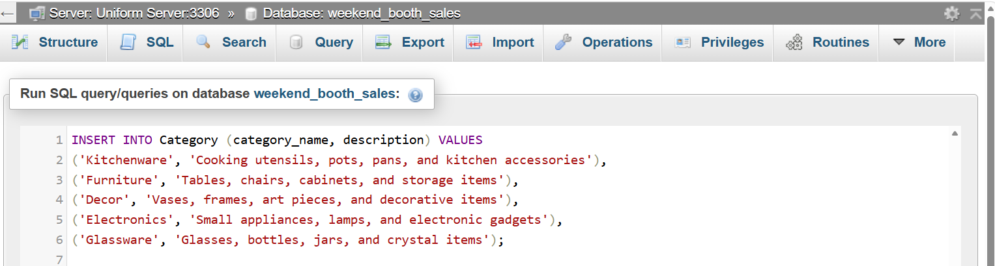
Insert into category.
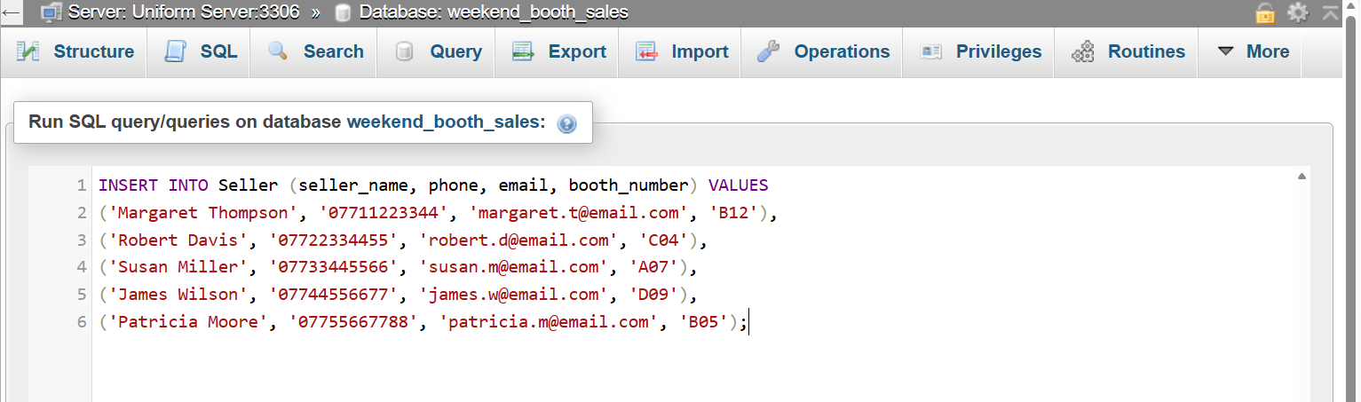
Insert seller details.
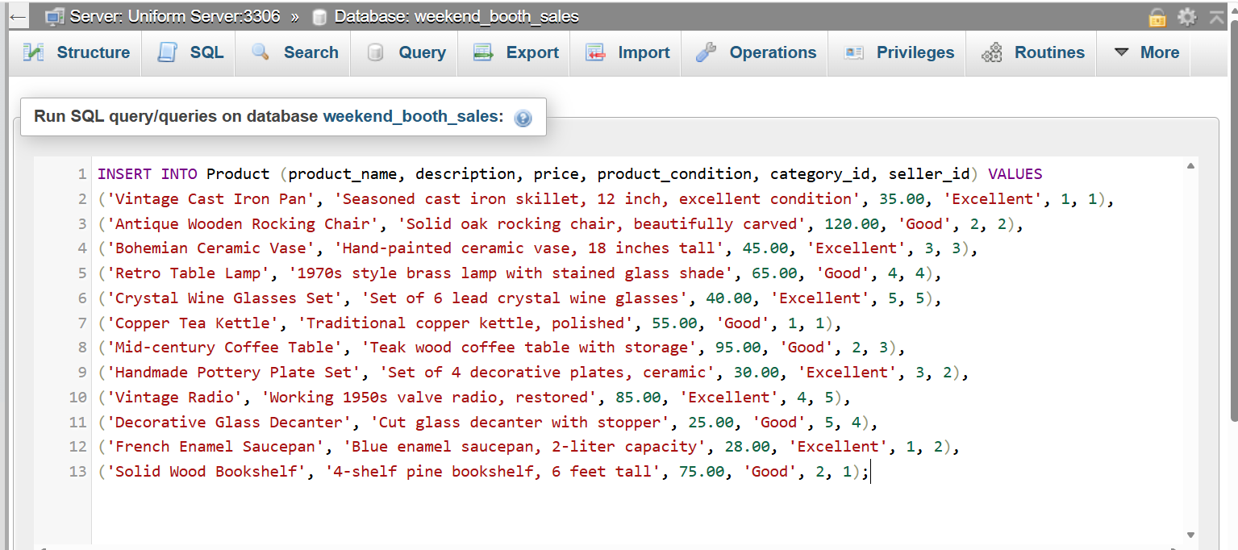
Insert product.

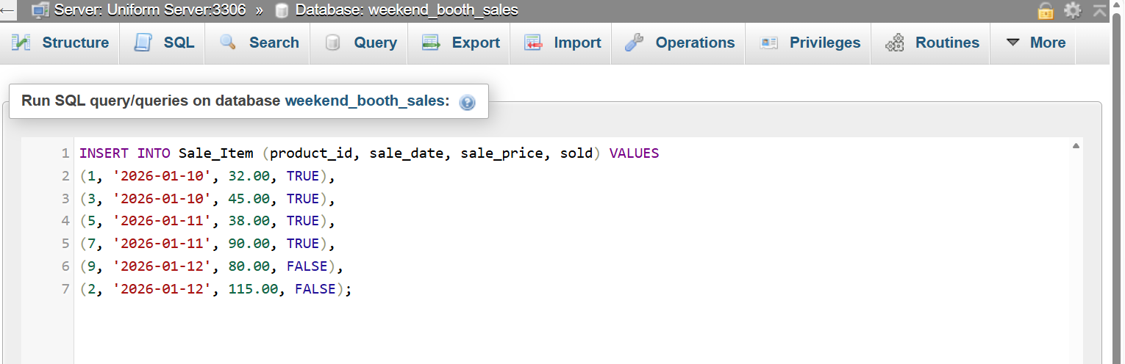
Sale items.

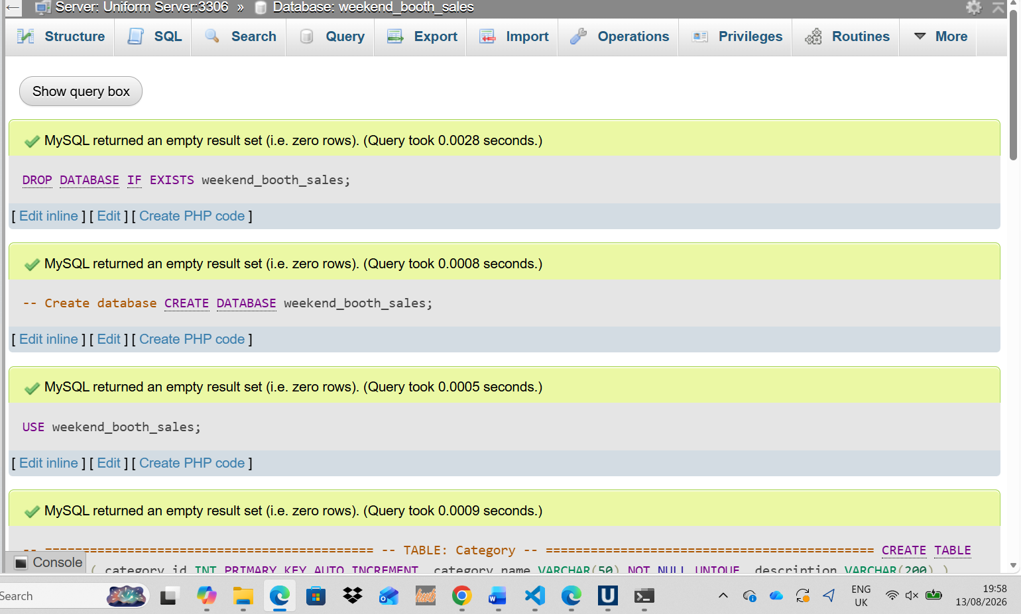

Weekend booth sale created.

