  - University of Wales Trinity Saint David
  - London campus
  - EFFECTIVE TEAM WORKING AND COMMUNICATION
BMSW4004
Lecturer: Diya Ganguly
Communication at the Workplace
Student: Sabrina de los Ángeles Moncayo Casanova
Student ID: 2007929
Table of Contents
1. Introduction 1
2. Communication skills 2
2.1 Verbal Communication 2
2.2 Non-verbal Communication 2
2.3 Listening 2
3. Refer to case studies 3
4. Models of Communication 3
4.1. Shannon-Weaver´s Model 3
4.2. Berlo´s SMRC Model 4
4.3. Schramm´s Model 5
5. Communication at Workplace 6
6. How to improve communication skills at workplace? 6
7. Conclusions 7
8. Appendix 8
9. References 10

1. Introduction
In the following report, I will be talking about communication in general, and in the workplace, enhancing the importance it has in how effective a team is. I will be doing this by providing an explanation of some of the different models of communication we have studied, and by giving examples of some problems that I know have happened because of a communication mistake. An important part of my report is also the section where I talk about communication skills, and some case studies that we have revised in class and analyse them to try to understand what the problem was.

2. Communication skills
Communication is the procedure of transmitting and obtaining ideas through nonverbal or verbal techniques, including speech, or spoken communication, writing and graphic representations and signs, gestures, and behaviour. More easily, communication is understood as "the creation and exchange of meaning."
(Nordquist, 2019)

2.1 Verbal Communication
Verbal Communication is a type of communication which sends a message through spoken words, it has the ability two transmit feelings, (such as surprise, anger, joy) ideas, and opinions in different ways, for example presentations, face to face conversations, discussions, and debates. Depending on the situation, you will have to adequate your tone of voice, or the pitch you want to give, make sure the language you are using is appropriate for the occasion, being able to differentiate between formal and informal vocabulary is a necessary communication skill every employee should have.

2.2 Non-verbal Communication
Nonverbal communication is a type of communication who uses gestures, facial expressions, postures, and movement, to express or communicate, for example sign language and Makaton. It can also use writing channels to transmit a message, such as e-mails, letters, and text messages. People with hearing diseases or people with learning disabilities might need to communicate through nonverbal communication. In the other hand, at work it is very common to communicate through emails, letters and even text messages, because the message we want to transmit goes faster and gets to the other person in a quicker and more effective way.

2.3 Listening
Active and empathetic listening is key when communicating with others, but you must make sure that you listen in a proper way, to avoid making the other person feel uncomfortable. When you are actively listening to someone, make sure you have direct eye contact, and an open body language, because this will let the other person know that you are interested in what is being said, avoid looking the other way, or using your mobile phone while someone is talking to you, this will help you understand better the conversation and it will demonstrate that you are respectful and polite.
In the other hand, when you are empathetically listening to others, delicate physical contact will make a difference, in this type of conversations is normal to feel sympathy for the other so placing one hand in the persons back or passing your arm above the other persons shoulders will show that you are caring and understanding with him/her.

3. Refer to case studies
As we can see in Appendix 1 Barry is facing a language barrier in his workplace because of the different ethnicities and backgrounds of his employees, he is not able to communicate effectively with his team, that is why there is misunderstandings within the tasks that need to be done because Barry as the manager has the responsibility to ensure that in the kitchen everything runs smoothly. There is also a culture barrier that Barry is facing, people in his team think that food needs to be storage as they would do normally at their homes, but that is not true, they need to follow some guidance and some rules that are being stipulated to have everyone, meaning the clients and members of staff, safe.
As we can see in appendix 2 the professor is facing a terminology barrier, he lives in a small town where his sophisticated language is not understandable for the people. In the town the individuals have different terminologies for things that he wanted to express, that is why when he started shouting that his “edifice was being consumed by a conflagration” the people didn't understand, instead what he could have done was start shouting “there is a fire” and the people would have helped him. That is why you need to know where you have to use certain, formal or informal, language so this type of problems doesn’t occur.

4. Models of Communication

4.1. Shannon-Weaver´s Model
The Shannon and Weaver Model of Communication is a numerical concept of communication that contends that social interaction can be broken into six crucial notions:
- Sender: is the individual (or object) who has the data to start with.
- Encoder: can be the device (or person) that transforms the concept into signs that can be transmitted from the transmitter to the recipient.
- Channel: is the infrastructure that obtains data from the sender and transmitter all through to the decoder and receiver.
- Noise: is a dysfunctional part, any intervention with the message spread along the channel will disturb to the signal received, remaining distinct from the message that the source sent.
- Decoder: is the opposite of encoding, is a machine that can decode a message from binary characters or waves into a system that can be identified by the receiver.
- Receiver: is the step where the individual finally gets the message, or what is left after the noise interference.
Was first suggest by Claude Shannon and Warren Weaver in 1948. This is a lineal model that presents a structure for examining how messages are sent and received. It describes how messages can be interspersed and misunderstood in the procedure between transmitting and obtaining the information.
(Drew, n.d.)
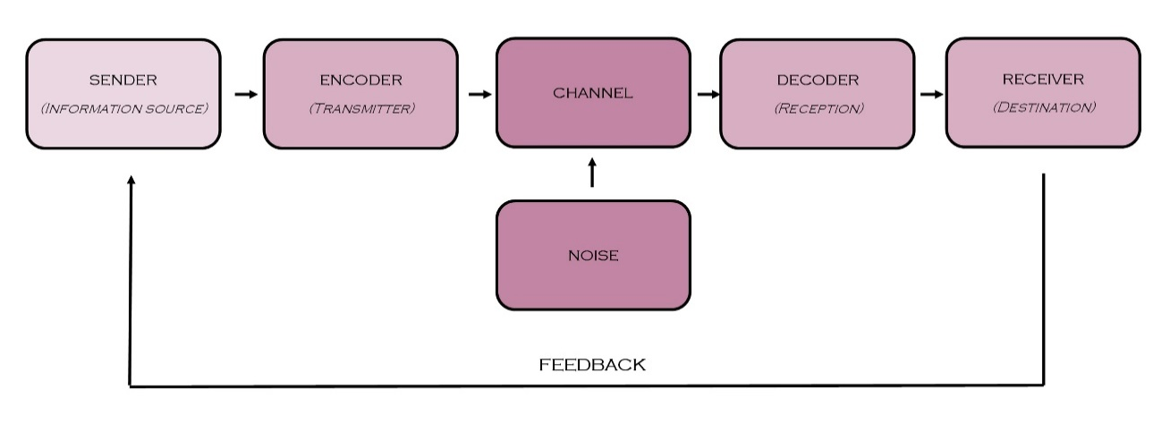

4.2. Berlo´s SMRC Model
David Berlo’s SMCR Model of Communication signifies the procedure of interaction in its easiest way. The abbreviation SMCR stands for Sender, Message, Channel, and Receiver.
Berlo’s SMCR Model of Communication was created in 1960 and explains the diverse elements that can shape the fundamental method of interaction. This communication tool also highlights the coding and decoding of the message and it can be applied for more effective communication.
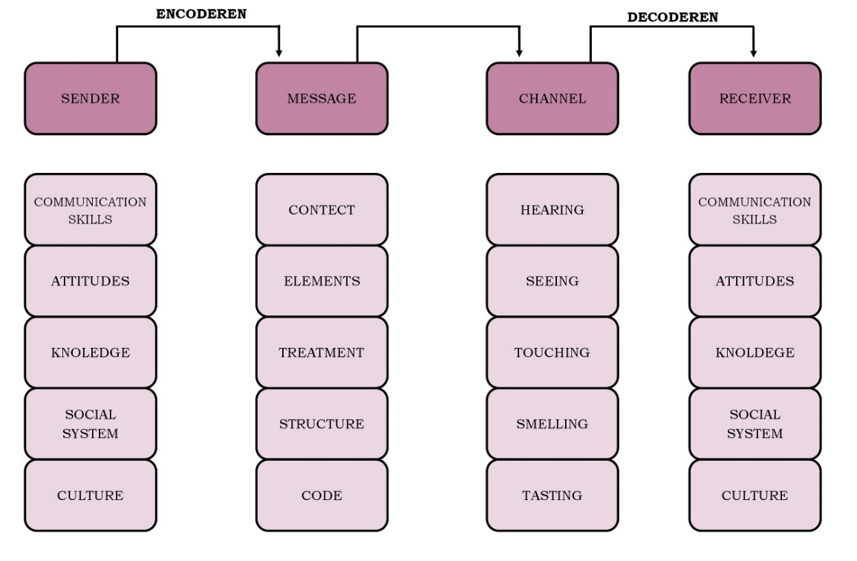
- Sender: The source, also called the sender is where the process of exchanging information begins. Is where someone transfers the data to the receiver after cautiously putting his ideas into words.
- Message: This happens when a person transforms his ideas into words, a message is formed. The procedure is also called Encoding.
- Channel: This refers to the way how the data goes from the source to the receiver.
- Receiver: When the message arrives to the receiver, he tries to comprehend what the listener needs to communicate and then answers appropriately. This is also called as decoding.
(Juneja, n.d)

4.3. Schramm´s Model
The Osgood-Schramm model of communication is described as a circular model that reveals that messages move in two ways. The four key principles that the model has are:
- Communication is circular not linear.
- Is mostly equal and reciprocal.
- Messages need an analysis.
- This model has three steps for communicating: encoding, decoding, and interpreting.
(Drew, n.d.)
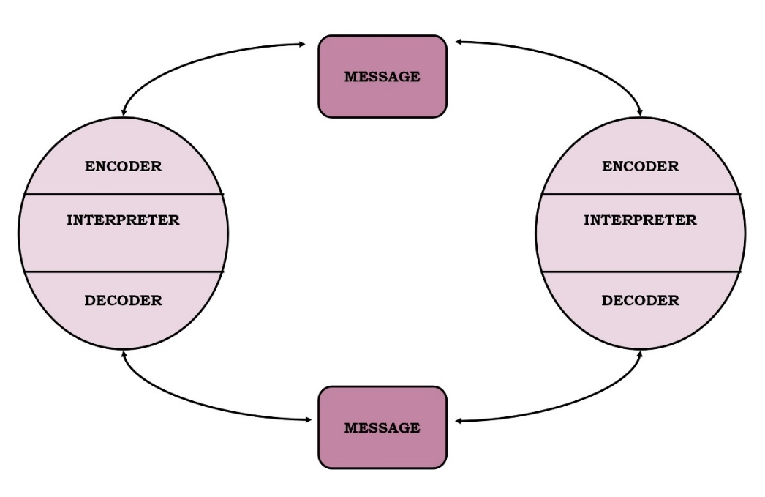

5. Poor communication at Workplace
Communication at workplace is one of the most important parts for the success of an organisation. This needs to be effective and trust-based so the employees, employers and every single person in the team feels confident. This will help to keep effective relationships between everyone and ensure that there is a happy and fun environment where working is not only a duty, but it is also something that everyone enjoys. By having good communication at workplace, we enhance the team productivity, and we help to improve everyone’s self-esteem. There are some cases where misunderstandings or mistakes happen because of the poor communication at workplace, that is why I am showing here some cases where there has been a poor communication because of several barriers that have stopped us from having an effective communication system, everything I am mentioning can be solved in order to create strong workers and strong competitors in the working sector.
- My friend works doing the cleaning of an spa, she is Hispanic so her first language is Spanish, she has been in the UK for a short period of time which makes difficult for her communicate with the team in her job, for example one day she got at work and her manager had left a note communicating her that someone was going to be in the spa to deliver some stuff that was needed, she didn't know what the note meant and she didn't stay for long enough to wait for the delivery, this caused her a discount on her salary because of the mistake that was committed, this is a good example of bad communication at workplace because of the language barrier. This would be solved by having a translator, and start teaching my friend some English related to her job exclusively.
- Mt sister works as a babysitter, and one of the biggest problems she faces is being unable to comprehend what the kid she babysits is saying, because she has not lived with the kid for long enough to understand what she tries to say, a good solution for this type o problem, would be asking for the mums help, the mum can write what she means or explain to the nanny.

6. How to improve communication skills at workplace?
According to (LLoyd, 2019) there are some rational motives for the absence of trust, and he named some harmful habits that can be trust-crushers.
Some of the points he considers damaging for an organisation are the following:
- Lengthy email chains: it is simple to fall into this situation, mostly when the employee and employer are in different geographical position. Generally, these type of dialogues gets more controversial and defensive as longer as the conversation keeps going.
- Talking about instead of talking with others: this occurs when people talk about each other’s instead of talk to each other’s. Very often leaders think they must listen and then try to fix what they have just heard about, but that normally just aggravates the situation. The reason is that instead of making the individual take ownership and solve his/her personal disagreements, the leader ends up in the middle.
- Playing the blame game: This happens when employees begin to point the finger one to each other.
For these points, he contemplates that the following advice is especially useful to eradicate some of the habits that are harmful for a company.
In the first case, with lengthy email chains, the employee must stop the chain, but when and how he must do this? The answer for this question is easy, when, at the third email in chain and how, he can pick up the phone and call the person that he was chatting with.
In the second case, people need to be initially listened, then, support them with conversation points, send them back to the individual they should be speaking with, and look for the person to report back on how it went to someone else for solving the problem. If that does not work, the leader must get implicated more precisely.
In the last case, the employer must create a place where people can have group sessions and build team goals that force everyone to be more collaborative. Keep calmness and in “coaching mode” when errors are produced. Accept the intentions and recommend each person to do the same.

7. Conclusions
Effective communication at the workplace is important yet difficult to acquire, there are many barriers that keeps us from having an effective communication system, working on that will lead to everyone’s satisfaction. Good communication in the workplace its key, because it helps us keeping a healthy and happy environment, in the organisation we work in. By having good communication, we do better our responsibilities as a team, which leads to pride and success. But this is not only beneficial in the workplace, also in our personal life, it makes us be more comprehensive and understanding of the world we live in. Effective communication is a skill we all should have, it turns us into strong competence in the working field we choose, but it also turns us into amazing human beings.

8. Appendix

8.1. Appendix 1 (Case study)
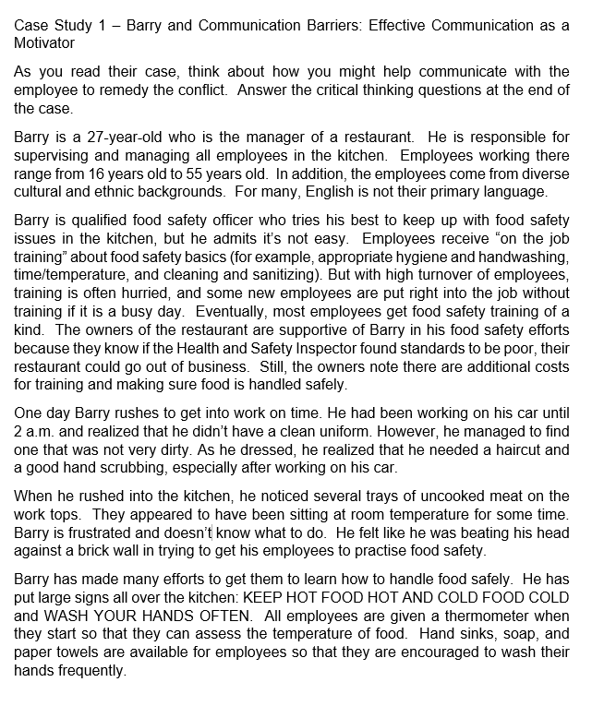
(University of Wales Trinity Saint David, 2021)

8.2. Appendix 2 (Case study)
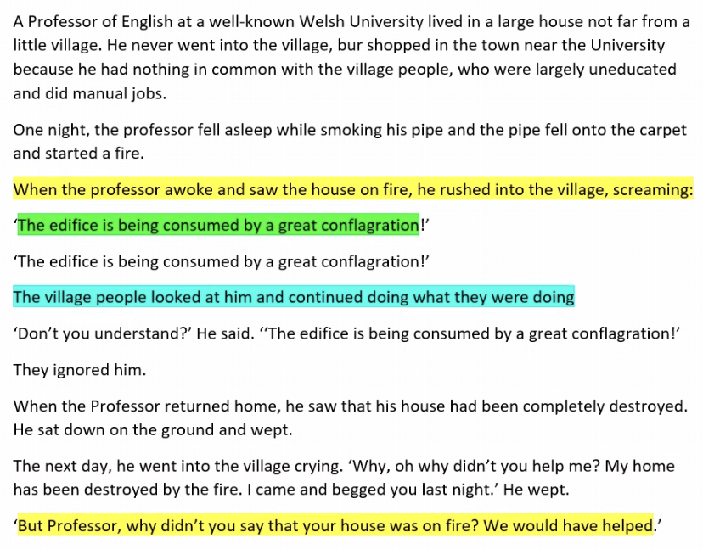

8.3. Appendix 3 (Class activity)

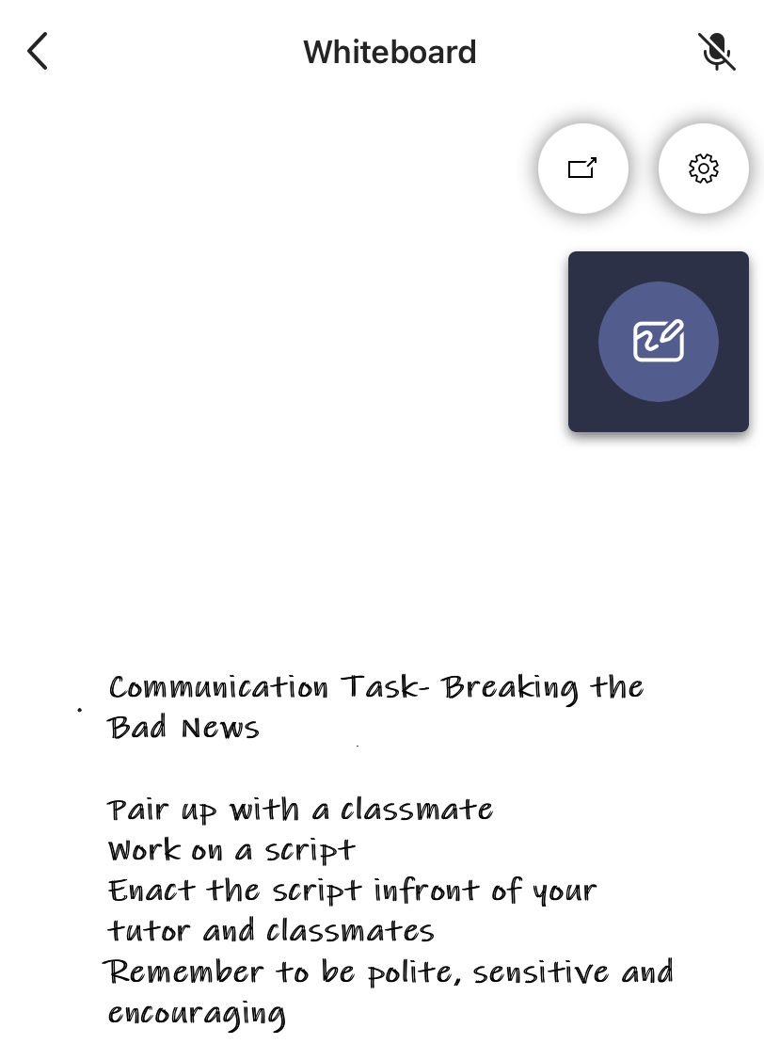

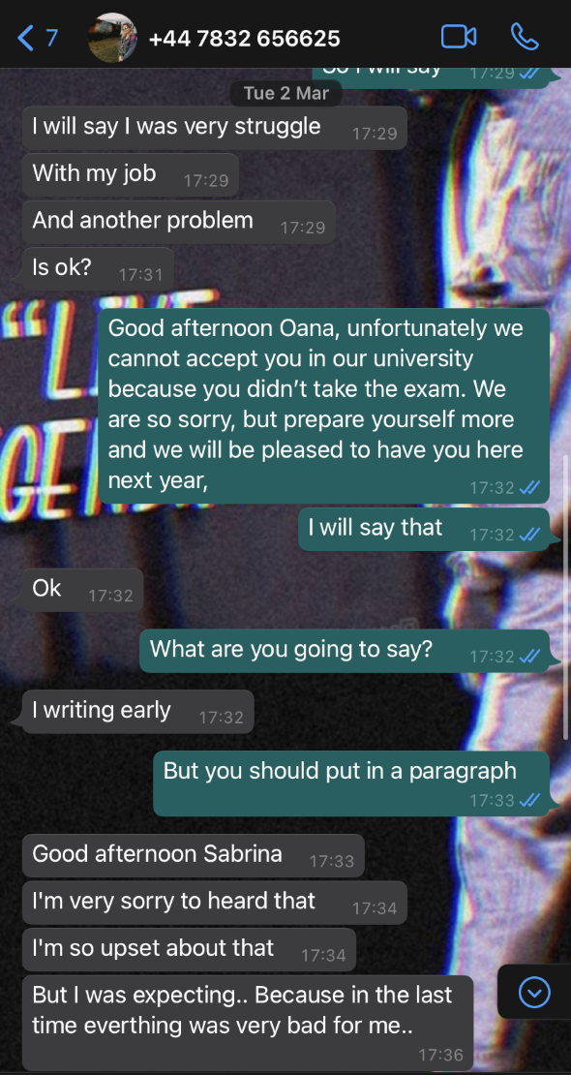
8.4 Appendix 4 (Class activity)
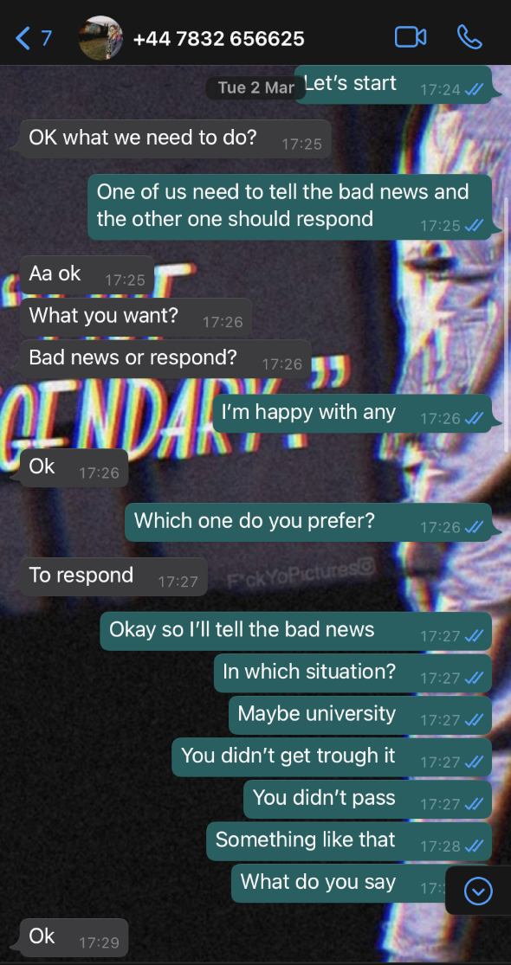

9. References

Drew, C., n.d.. HelpfulProfessor.com. [Online]
Available at: https://helpfulprofessor.com/shannon-weaver-model/#:~:text=Definition%20of%20the%20Shannon%20and%20Weaver%20Model.%20The,the%20process%20between%20sending%20and%20receiving%20the%20message.
[Accessed 19 April 2021].
Drew, C., n.d.. HelpfulProfessor.com. [Online]
Available at: https://helpfulprofessor.com/osgood-schramm/
[Accessed 27 April 2021].
Juneja, P., n.d. Management Study Guide. [Online]
Available at: https://www.managementstudyguide.com/berlo-model-of-communication.htm
[Accessed 24 April 2021].
LLoyd, J., 2019. Tips to improve workplace communication. Health Care Registration, 28(11), pp. 4-6.
Nordquist, R., 2019. ThoughtCo. [Online]
Available at: https://www.thoughtco.com/what-is-communication-1689877
[Accessed 27 April 2021].
University of Wales Trinity Saint David, 2021. Moodle. [Online]
Available at: https://moodle.uwtsd.ac.uk/mod/resource/view.php?id=341833
[Accessed 28 04 2021].

