Carmarthen Business School
Distinctiveness and Regeneration (BMSP4005)
Lecturer: Anthony Burns
Peter Todorov (1705088)

Llanelli in the Industrial Revolution

This fieldwork report will look at Llanelli during the industrial revolution with the main industries in Llanelli during the time being the coal mining and metal industries in the area. Due to the increase of these industries in the area the railways within the Carmarthenshire area increased due to the Llanelly Railway and Dock Company (Craig et al., 2002). The Llanelly Railway and Dock Company was formed in 1828 after an Act of Parliament was obtained which allowed for the railway construction to begin with the railway line in Llanelly opening in 1833 and the wet dock opening in July of 1834 (Craig et al., 2002). By 1873 the Llanelly Railway and Dock Company had expanded their railway lines to multiple areas in Carmarthenshire such as Kidwelly, Pembrey and many other areas. Great Western Railway and London & North Western Railway in 1873 took over the running of the trains and then purchased Llanelly Railway in 1889 (Craig et al., 2002; Evans-Hurley, 2012).
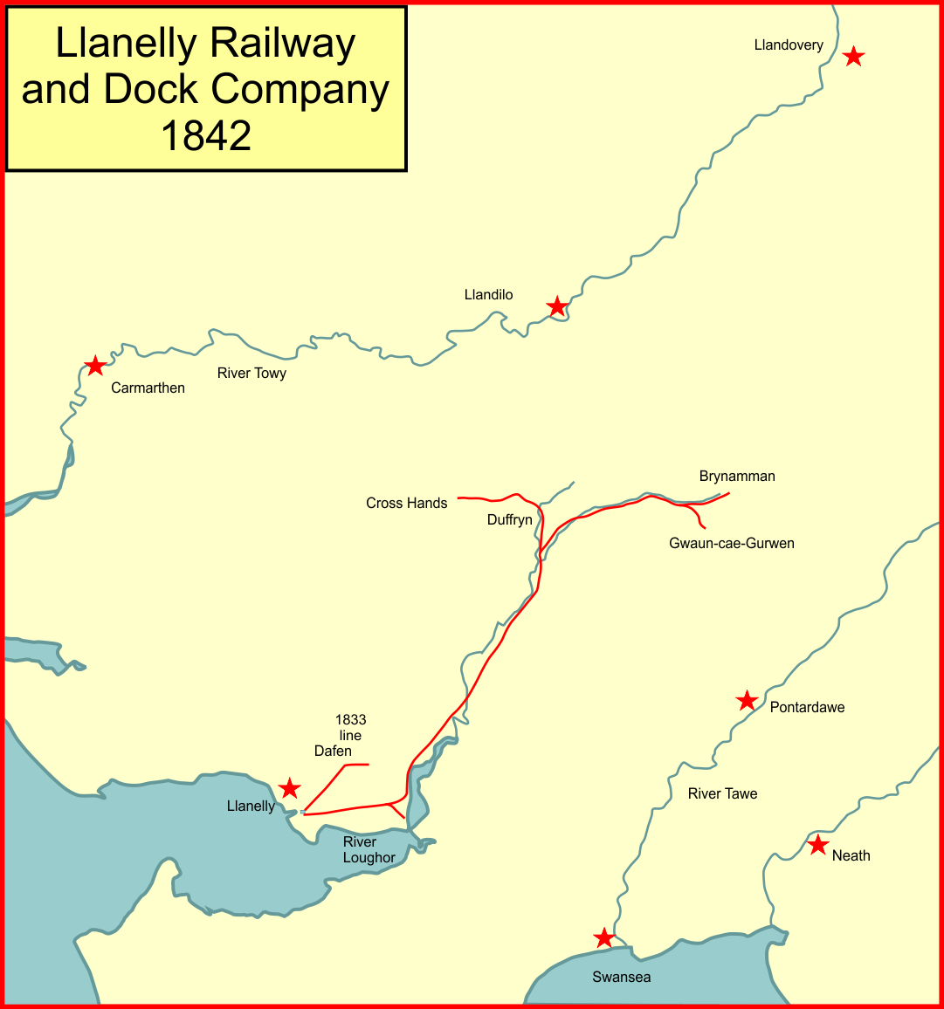
Picture One – Llanelly Railway and Dock Company in 1842 (Wikipedia, 2016)

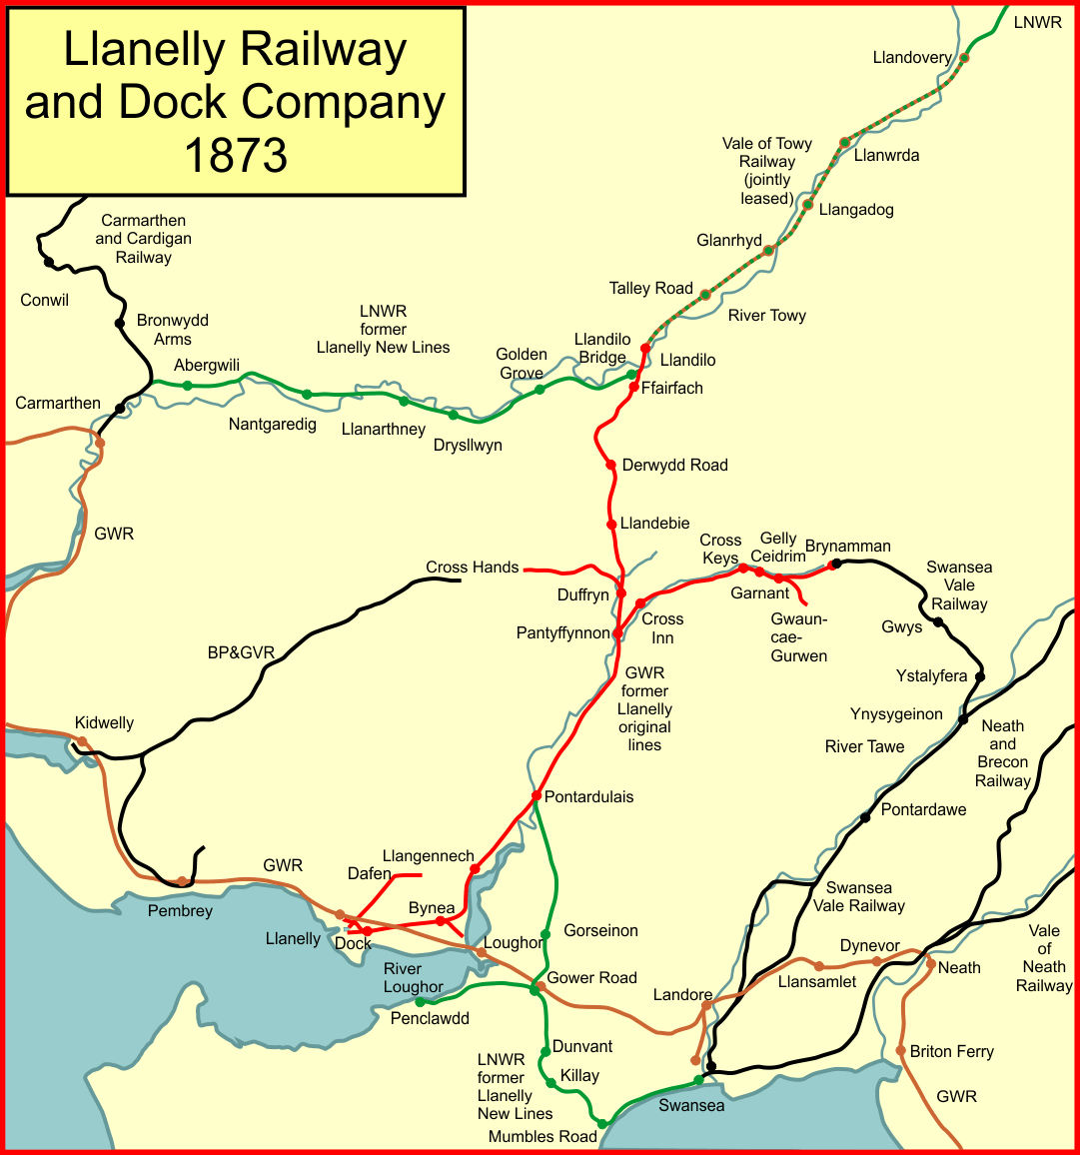
Picture Two – Llanelly Railway and Dock Company in 1873 (Wikipedia, 2016)

The pictures show that the expansion of the railway played an important part in the growth of the population in these areas (Table One). Due to the railway expanding across Carmarthenshire it allowed for the mining and iron industry to expand and increase their productions due to the railways been local to the mines in the area. It would allow for the product to be shipped quicker and therefore production would need to increase to meet the demand therefore more people would move to the area as there would be jobs available to them when there may not be any in the area which they lived in previously (Tables Two, Three, Four and Five).

Population for Llanelli Area
Year | Men | Percentage | Women | Percentage | Population Total
1841 | 5,578 | 50.2 | 5,530 | 49.8 | 11,108
1851 | 6,756 | 49.6 | 6,861 | 50.4 | 13,617
1861 | 8,482 | 49.3 | 8,710 | 50.7 | 17,192
1871 | 10,873 | 49.1 | 11,279 | 50.9 | 22,152
1881 | 14,392 | 49.7 | 14,587 | 50.3 | 28,919
1891 | 16,525 | 49.4 | 16,939 | 50.6 | 33,464
Table One – Population for Llanelli Area (Craig et al., 2002)

The table shows the increase in the population for men, women and then an overall increase between the census updates from 1841 to 1891. It shows a steady increase in the population in Llanelli over the sixty years with the first three census’s having a small increase and then it increases in larger increments (+5000 increase in population) between each census data collection between 1861-1891.

Population in Llanelli Which is Born in Carmarthenshire or Outside Carmarthenshire
Year | Population with known place of birth | Born CMN |  | Not Born CMN
Year | Population with known place of birth | Numbers | % | Numbers | %
1841 | 10,927 | 9,538 | 87.3 | 1,389 | 12.7
1851 | 13,531 | 11,339 | 83.8 | 2,192 | 16.2
1861 | 16,784 | 13,933 | 83.0 | 2,851 | 17.0
1871 | 21,982 | 18,188 | 82.7 | 3,794 | 17.3
1881 | 28,789 | 23,416 | 81.3 | 5,373 | 18.7
1891 | 33,337 | 27,635 | 82.9 | 5,702 | 17.1
Table Two – Population in Llanelli Which is Born in Carmarthenshire or Outside Carmarthenshire (Craig et al., 2002)

The table shows the population of Llanelli and if they were born in Carmarthenshire or outside the area. People born in the area of Carmarthenshire increased during each census data collection from 1841 to 1891 (although the percentage of people born in Carmarthenshire dropped from 87.3% in 1841 to 82.9% in 1891). For the population in Llanelli who were born outside of Carmarthenshire it also increased during each census data collection from 1841 to 1891 (the percentage of people born outside of Carmarthenshire increased from 12.7% in 1841 to 17.1% in 1891 (although for 1881 the percentage was 18.7% but it dropped to 17.1% in 1891 despite the increase in the number of people arriving in the area from outside Carmarthenshire)).

Population Comparison for Carmarthenshire and Llanelli
Year | Carmarthenshire | Llanelli Area
1801 | 67,317 | 2,818 (E)
1811 | 77,217 | 4,050 (E)
1821 | 90,239 | 5,730 (E)
1831 | 100,740 | 7,815 (E)
1841 | 106,326 | 11,108
1851 | 110,632 | 13,617
1861 | 111,796 | 17,192
1871 | 115,710 | 22,152
1881 | 124,864 | 28,919
1891 | 130,566 | 33,464
Table Three – Population Comparison for Carmarthenshire and Llanelli (Craig et al., 2002)

The population comparison shows the overall growth in population in Carmarthenshire and compares it to Llanelli. The table shows the growth in population was mirrored for Carmarthenshire and Llanelli.

Llanelli Area – Male and Female Workforce
Year | Male Workforce |  | Female Workforce |  | M/F Ratio
Year | Number | % of Male Population | Number | % of Female Population | M/F Ratio
1841 | 3,780 | 67.8 | 699 | 12.6 | 5.4
1851 | 4,338 | 64.2 | 1,219 | 17.8 | 3.6
1861 | 5,413 | 63.8 | 1,716 | 19.7 | 3.2
1871 | 6,718 | 61.8 | 2,210 | 19.6 | 3.0
1881 | 8,681 | 60.3 | 2,775 | 19.0 | 3.1
1891 | 10,503 | 63.6 | 3,548 | 20.9 | 3.0
Table Four – Llanelli Area – Male and Female Workforce (Craig et al., 2002)

The percentage of the male and female population in work shows that the majority of men (67.8%) work in 1841 with it decreasing slowly and in 1891 it had decreased by 4.2% to 63.6%. For women the percentage of women in employment increase from 12.6% in 1841 to 20.9% in 1891 which is an increase of 8.3% of women in employment. With this change in the numbers of men and women in employment it changed the male to female ration from 5.4 in 1841 to 3.0 in 1891.

Main Male Occupations in Llanelli
Year | Total Male Workforce | Coal Mining | Metal Industry | Agriculture | The Port | Railways | Other Occupations
1841 | 3,780 | 1,029 | 300 | 451 | 174 | 7 | 1,819
1851 | 4,338 | 1,104 | 616 | 491 | 240 | 55 | 1,832
1861 | 5,413 | 1,283 | 994 | 409 | 301 | 98 | 2,328
1871 | 6,718 | 1,278 | 1,950 | 363 | 372 | 139 | 2,616
1881 | 8,681 | 1,160 | 3,452 | 332 | 354 | 351 | 3,032
1891 | 10,503 | 1,237 | 4,541 | 303 | 356 | 323 | 3,743
Table Five – Main Male Occupations in Llanelli (Craig et al., 2002)

The main occupations for Llanelli were coal mining, metal industry, agriculture, the port and railways. Apart from agriculture the other main industries experienced a boost in their production due to the industrial revolution and therefore the number of jobs required for the industries increased to meet demands of the economy.

Charles Nevill in 1805 founded the Llanelly Copperworks Company when he relocated his business to Llanelli (Craig et al., 2002). The company was then expanded to include coal mining (to allow for the supply to be steady to produce their products) and transport (to allow products to be transported by either through shipping and/or rail) (Hassan, 2019). In 1856 Richard Janion Nevill (son of Charles Nevill) died with his son Charles William Nevill inherited his father’s business ventures (Llanelli Copperworks Company) (Craig et al., 2002).

Alexander Raby who was initially an ironmaster however he did have interests in Wales and England in iron, copper and coal, first invested in the area when he fincanced John Gevers and Thomas Ingman who established an iron furnace on the Stradey Estate in 1791 and Raby acquired a lease in 1797 for the Stradey Estate coal (Craig et al., 2002; John, 2019). Additionally, in 1797 John Smith died with his sons Charles and Henry Smith inheriting their father’s interests but they would surrender the leases of the region’s coalfield five years later (Craig et al., 2002). The production of coal in Llanelli in 1840 was 212,044 tons with it increasing to 229,245 tons in 1851 and then in 1874 it dropped slightly to 222,000 tons being produced within Llanelli (Evans & Saunders, 2015). This shows that the industry was continuesly growing in the area with the population growing continuously with it to meet the demand of the customers of the industry.

The growth in Llanelli during the industrial revolution shows that Llanelli grew in a number of different ways which include the population of the area, transport links through the railway and docks to allow for the movement of goods to and from the area, the increase of people arriving in the area from outside the area to live and work in the local industries and the increase in the female workforce from 1841 to 1891.

Word Count: 1041
Reference List

Craig, R.S., Protheroe Jones, R., Symons, M.V. (2002).
The Industrial and Maritime History of Llanelli and Burry Port 1750 to 2000. Carmarthenshire County Council

Evans, C., & Saunders, O. (2015). A World of Copper: Globalizing the Industrial Revolution, 1830-70. Journal of Global History, 10(1), 3-26.

Evans-Hurley, K. (2012). The Inside Story of the Llanelly Railway & Dock Company. Available at: https://www.westwaleschronicle.co.uk/blog/2012/12/05/the-inside-story-of-the-llanelly-railway-a-dock-company/

Hassan, D. (2019). The Rise of Llanelli Through the Industrial Period. Available at: https://www.westwaleschronicle.co.uk/blog/2019/11/01/the-rise-of-llanelli-through-the-industrial-period/

John, L. (2019). Alexander Raby – Ironmaster and Coalmaster. Available at: https://www.llanellich.org.uk/files/395-alexander-raby-ironmaster-coalmaster

