

Strategic Human Capital Renewal at Helios Urban Mobility: Enhancing Organisational Socialisation, Innovative Job Design and Future Workforce Capability

University Logo

Programme: MBA

Module: Human Capital Management (LCMB7023)

Report Title: Strategic Human Capital Renewal at Helios Urban Mobility

Student Name & ID Sohil QAMRAN

Lecturer Name ENO MOINICO

Submission Date 26-06-2026

Table of Contents
Executive Summary 2
1. Introduction 4
1.1 Company Background 4
1.2 Human Capital Challenges 4
1.3 Purpose of the Report 4
2. Task A: Socialisation, Identity and Business Activism 4
2.1 Critical Evaluation of Traditional Onboarding versus Strategic Organisational Socialisation 4
2.2 Strategic Socialisation Framework for Helios 5
2.3 Developing Organisational Citizenship and Business Activism 6
3. Task B: Strategic Job Design for Innovation and Engagement 7
3.1 Innovative Job Design Strategy 7
3.2 Impact on Motivation and Innovation 9
4. Task C: Reflective Report 10
4.1 Responsible Use of AI as a Decision-Support Tool 10
4.2 Personal Capability Development Plan 10
SMART Development Plan 10
5. Conclusion 11
REFERENCE 12

Executive Summary
Helios Urban Mobility (HUM) additionally manages the quickly evolving electric mobility business, providing synthetic intelligence driven mobility solutions and intelligent infrastructure analytics in Berlin, London and Singapore. However, it still has plenty of human capital hurdles to overcome including an engagement score of just 54%, weak socialisation of employees, long training period of employees (8 months), high graduate attrition etc. In this report a strategic Human capital renewal strategy is forwarded, developed around the fields of Organizational socialisation, Innovative job design and Workforce capability development for the future. Structured socialisation practice, Skills based job structure and initiative for innovation by employees are the suggested practices. These will be expected to lead to greater engagement, retention, more enhanced capability building and boost organizational performance.

1. Introduction

1.1 Company Background
Helios Urban Mobility is an electric mobility startup specializing in intelligent mobility solutions and smart analytics on smart infrastructure – all powered by artificial intelligence. HUM works in three cities: London, Berlin and Singapore, promoting new mobility technologies that will make sustainable mobility solutions tangible in the future city (Iunius, 2025). Combining concepts of artificial intelligence, data analytics and urban systems to optimize the city of tomorrow.

1.2 Human Capital Challenges
This technological development introduces some HUM problems, such as those to the workforce, which affects the organizational effectiveness. Eight months ramp up due to weak organisational socialisation. There is poor engagement (54%) and high staff turnover amongst the Graduate employees, impacting capability and continuity of innovation.

1.3 Purpose of the Report
The report aims at proposing possible strategies in human capital renewal for HUM, namely: making improvements in the socialisation of the HUM organisations; redesigning their occupations in order to boost their innovative capacities; and improving the workforce's capacities in HUM (Madanchian and Taherdoost, 2024). The recommended options seek to increase employee retention, increase employee involvement and achieve a workplace culture which supports ongoing successful business operations and provides a competitive advantage.

2. Task A: Socialisation, Identity and Business Activism

2.1 Critical Evaluation of Traditional Onboarding versus Strategic Organisational Socialisation
Traditional onboarding is the formal procedure that introduces new hires to critical details, assists them to finish induction forms and helps understand laid-out organisation processes. This is beneficial in many ways including establishing initial clear expectations around role and setting risks and expectations for the workplace. A traditional orientation will focus more on getting the new employee up and going in the present, rather than having them fully included in the company. Can have a long term deficit in developing a strong sense of identity, belonging and commitment in the organisation (Caros, 2023). Strategic organisational socialisation has a long-term employee integration view (more broadly). Onboarding is not a single event, it's a process of creating a worthwhile relationship, shared values and cultural match. Organisations bring about employee adjustment by using a combination of socialisation tactics which is referred to as Socialisation Theory by Van Maanen and Schein. Structured mentoring and formal development plans provide consistency and support, and structured approaches provide space and discipline for employees to contribute their voice and perspective.
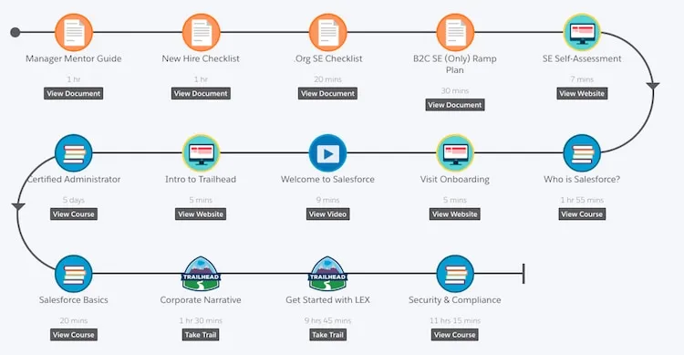
Figure: Employee onboarding process journey
(Source: Caros, 2023)

The strategic socialisation is more suitable for being done by HUM, however, because it needs innovation, collaboration and the use of advanced technical skills to succeed. According to Psychological Contract Theory, workers' expectations towards their employers have an additional influence on trust and commitment. Organisations that offer employees development opportunities and worthwhile support exhibit higher levels of employee loyalty. Another point that can also be emphasised, according to Identifier Construction Theory, is that workers develop a sense of belonging within the organisation as a result of their experiences in the organisation (Geddes, 2023). But the current situation of Low attention for socialisation which is faced by HUM may become the problem in terms of their employees' connectivity in forming the organizational goals may be troublesome. In turn this has reduced what was once believed to be the five key components of onboarding to no longer include cultural element of integration; innovative behaviour and long term engagement.

2.2 Strategic Socialisation Framework for Helios
There are three strategic areas of socialisation opportunities for HUM pre-boarding, first 90 days and first year integration. The pre-boarding process should begin prior to an employee taking up his/her job with the company. Implement a digital platform onboarding practices for HUM with organisational values, innovation priorities and workplace information. Welcome communication from leadership is one way to make early connections, and informal guidance can be supplied through having employee buddies to assist with minimising uncertainty (Lawlor and Sher, 2023). HUM needs to have a phased induction plan within the first 90 days that includes technical training, culture awareness and the development of relationships. Employees new to the organization should get cross functional exposure by collaborating with customers across teams to work with AI, mobility systems and infrastructure analytics. Access to an effective mentoring arrangement should be made use for transferring knowledge together with information and ideas and internal feedback discussions should be held regularly to address any concerns.
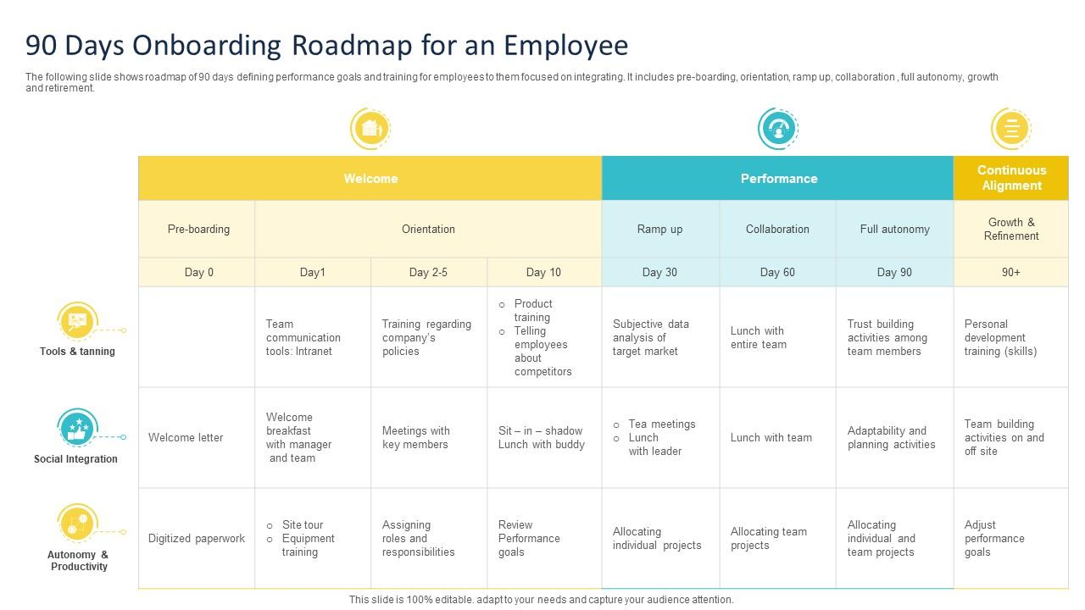
Figure: Employee lifecycle preboarding onboarding first 90 days integration
(Source: Lawlor and Sher, 2023)

The emphasis of the year 1 integration stage should be on developmental aspects of employees over time. There can be discussion around the topic of career planning, interaction with leaders and engagement in innovation activities that can contribute towards maintaining commitment for the organisation. In addition, internal networking in the form of global team working is important; between London and Berlin and Singapore. This approach helps to achieve HUM's strategic goals by helping to speed up the process of employee acclimatisation, boost employee engagement and deepen retention (Annunziata, 2024). The working of the embedded strategy of socialisation, in a structured, but flexible approach provides a better understanding of what staff do along with an understanding of the mission of the organisation. Hence, with cultural appropriateness, it is possible for HUM to give a technically competent and culturally synchronised work force for future innovation in it.

2.3 Developing Organisational Citizenship and Business Activism
Organisational citizenship describes behaviors that voluntary employees take to help an organisation be successful which transcend job related behaviors or the duties outlined in the job specification. HUM's organisational citizenship can be achieved through a more organisational identification and ethical professionalism and business activist attitude. Organisational identification is when employees identify their values with organisational purpose (Dodgson and Gann, 2026). This interdependency could be strengthened through a communication between HUM on the contribution towards sustainable urban mobility and smarter cities. Helping to build a culture of commitment, collaboration and proactivity can start with having employees who understand the impact their work is making.
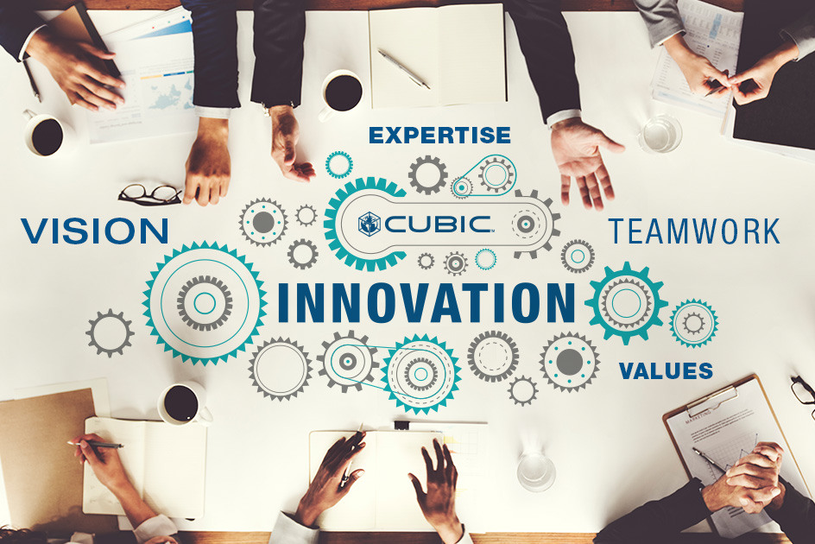
Figure: Employees collaborating innovation culture corporate teamwork
(Source: Dodgson and Gann, 2026)

Ethical professionalism is crucial on the basis of artificial intelligence, mobility and data that HUM is based on. Training employees responsible for AI principles, Data responsibility and Professional accountability. This gives employees an incentive to think about social issues regarding technological selection, and promotes the creation of technology that meets ethical requirements. Insightfully nurturing a “business activist” mindset, and having employees strategically engaged as contributors rather than again just as performers. Ulrich's HR Business Partner lens indicates that people today need to be doing more than just supporting a transformation—they need to be helping to shape it and make it happen through a discovery and supporting a strategy. In HUM employees are able to be innovation drivers, by sharing ideas, optimizing processes and questioning existing usages. Responsibility towards customers, communities and society is also boosted by the stakeholder capitalism perspective, which advocates for the approach (Teppers et al., 2024). Employees of HUM can help to develop mobility solutions which have a positive social impact. The organisational citizenship and business activism can entail several benefits. Stronger commitment can help to better retention and stronger collaborations can help to better innovation outcome. Employees who are "bought in" to the purpose of each organisation are more apt to be able to supply innovative solutions and to back the efforts going into continuous improvement. Hence, HUM ought to develop an atmosphere where employees can be responsible innovators contributing to the success of the organisation.

3. Task B: Strategic Job Design for Innovation and Engagement

3.1 Innovative Job Design Strategy
Helios Urban Mobility needs a job design strategy capable of accommodating innovation, employee motivation, as well as a continuous development of capabilities. Especially when job specializations perform narrowly defined tasks, their narrower exposure to this function may hinder or reduce employee motivation or creativity. Therefore, in order to enrich this design process, the concepts of innovative job design that are in accordance with Job Characteristics Model, Job Crafting Theory and skills-based workforce architecture should be used in job design process in HUM. The Hackman and Oldham Field Concept of Job Redesign – Job Characteristics Model is a very useful model in the redesign process. The model focuses on five basic job characteristics which relate to motivation and performance. Improving Skill variety at HUM can be done by forming multi-disciplinary project teams to include experts from AI, software development, mobility engineering and urban analytics. This allows staff to develop and practise a number of skills and sharing information between departments (Kapoor, 2024). Task identity should be more enhanced by engaging the employees so that they have more impact and/or ownership next to the project rather than limited activities. For smart mobility use cases, it is important to get their buy-in already in the initial concepts and also throughout implementation and assessment, e.g. This is to increase the connection between what the employee does, and the outcome.
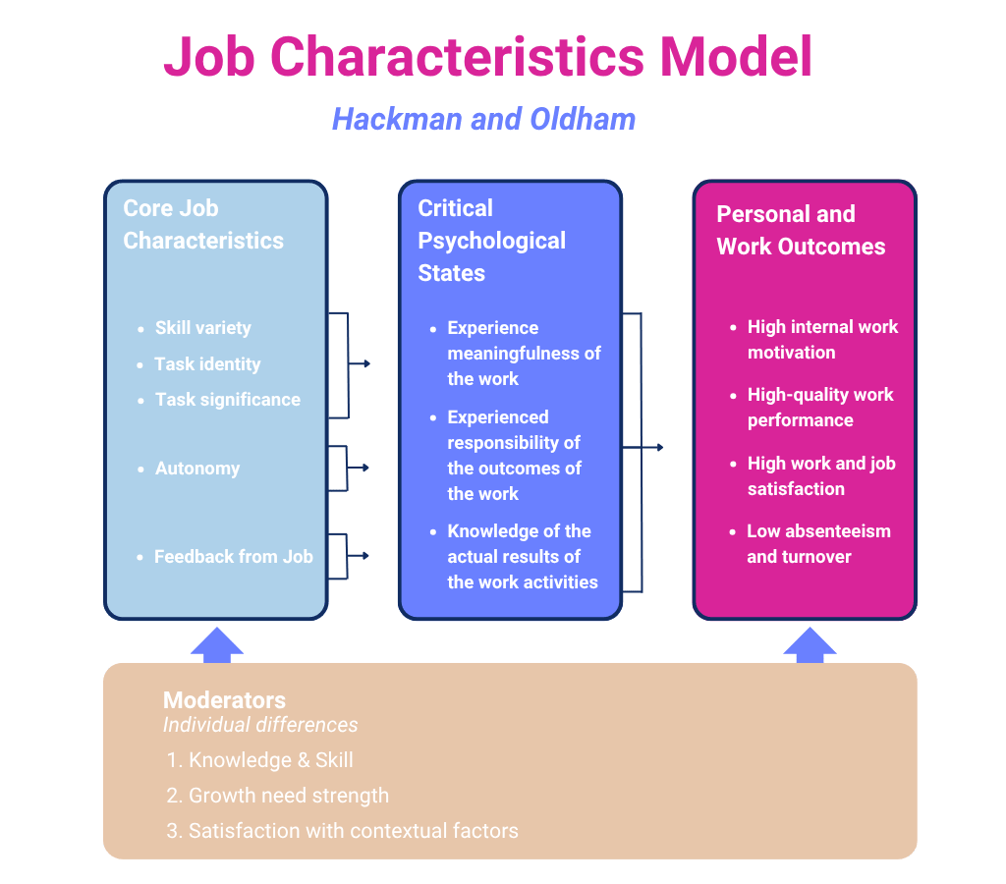
Figure:Job design model skill variety autonomy feedback diagram Hackman Oldham
(Source: Kapoor, 2024)

The importance of the task may be increased by pointing to the human dimension, social and environmental services of HUM's activities. But having the knowledge about how their projects help to create sustainable cities is more likely to give employees meaningfulness in their work. Another aspect of autonomy that can be built is to give the workers more choices on decision making, experiments, problem solving. This promotes innovation and enhances accountability. Feedback systems are needed regularly to facilitate learning and improvement. Feedback on likes and action to their training partner, or going over projects and discussing experiences can be useful in making it very clear that progress has been made and there are opportunities to develop. The Job Crafting Theory also commits to the Job's change for HUM by emphasizing that people can make changes to their Job. A person has the ability to manipulate the task to leverage on his/her strengths and interests. Relationships based on relational crafting create opportunities for improved group collaborations, improved communication, and innovation (Nicaise et al., 2024). In the case of cognitive crafting, employees see their role as part of a more complex process of sustainable mobility instead of a mere technical piece. The flexibility can be further promoted by using a skills-based approach to the workforce. The traditional method where one labels one's work employee according to his or her job should be replaced by an evaluation of employee abilities by HUM. An internal talent marketplace may be able to line up employees with innovation projects by their skills and career objectives. On going learning and bolstered employee retention can be done through the use of career readiness programs that include a skill component.

3.2 Impact on Motivation and Innovation
For employees, innovative job design is a key enabler of working to their motivation, engagement and innovation levels in HUM. The provision of significant and flexible work opportunities and interesting tasks can help to engage the workforce and develop their skills for the future. Self-Determination Theory (SDT) suggests that employee motivation increases if there are three psychological factors considered in employee motivation, which is autonomy, competence and relatedness. By enabling employees to make decisions and share ideas, employees can be empowered to contribute to autonomy and HUM. When asked to take more on itself, people tend to really think, rather than just do. Competence can be built continuously by the use of learning opportunities, project based assignments and learning programmes based on the development of skills (Chen, 2023). When employees also gain experience in cutting-edge technologies such as AI and electric mobility, their confidence and competence in comprehending and staying in line with the goals of the organization are boosted. HUM's international activities, with co-created teams and knowledge networks can contribute to fostering relatedness. Additionally, reengineered jobs that add to employee engagement are to be promoted. If a worker feels like he or she is an owner and he or she believes it is important, then they will be more enthusiastic, and more committed.People who feel as an owner, and they feel it is important, will be more enthusiastic and more committed. Having meaningful work may result in higher psychological involvement with the organisation, and/or higher satisfaction with the organisation and lower turnover.
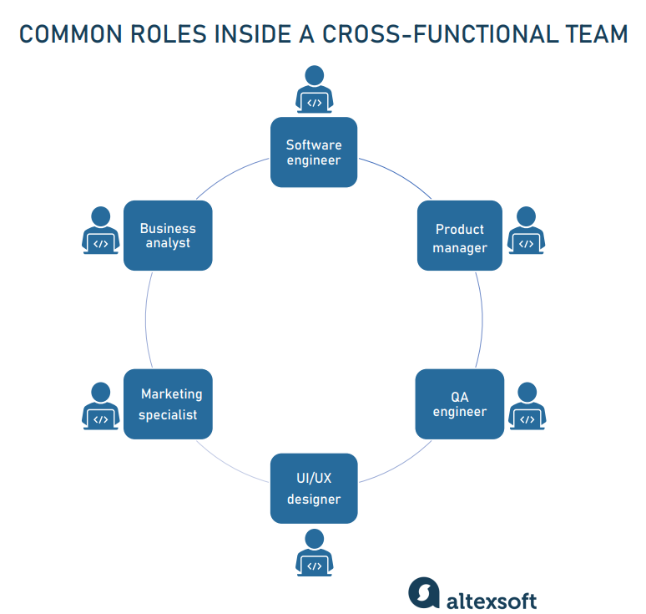
Figure: Cross functional team innovation workshop technology
(Source: Chen, 2023)

The other key benefit is being innovative. HUM is in a very technology intensive area where Innovation is a crucial competitive factor. By using the cross functional team approach, information and knowledge will be shared and it may lead to the exchange of different perspectives when addressing complex issues. They can enable those who are not directly participating in the product discovery cycle, to come up with creative solutions for both mobility and customer outcome. The proposed job design will also contribute to retention since the worker will have mobility within the proposed job and development opportunities. Employees in the last few years who experienced high levels of attrition can be at a higher risk for attriting if opportunities for growth and skill development are not transparent. But may present some problems in implementing innovative job design. Staff may be uncomfortable with giving up their scheduling and supervision of mainstream careers, and managers may have a difficult time maintaining the accountability of their organizations and autonomy of their staff. These can be overcome through managing change effectively, structured change management and good communication, as well as leadership development. In general, innovative job design delivers an effective strategy to HUM's development of a motivated, skilled and adaptable workforce. By linking employee needs to the goals of organisations, a company that adopts HUM can improve employee engagement, accelerate the generation of its innovations and draw in the company's future in the more competitive mobility landscape.

4. Task C: Reflective Report

4.1 Responsible Use of AI as a Decision-Support Tool
Strategic human capital management benefits from AI in predicting patterns, via workforce analytics, and with better decision-making. In the context of HUM, AI tools might be used to analyze employee engagement trends, and forecast the needs of the workforce, assisting in the decisions for talent development. These capacity-building attributes can assist HR specialists make evidence- and information-based decisions. But, there are risks to AI adoption too! Poor data quality or past trends with unfair assumptions can have an effect on recommendations through algorithmic bias. Issues of privacy may arise in the process of employee data gathering and data analysis. There's also the danger of becoming too reliant on the technology – to relying on the AI outputs without using professional judgement. My wisdom is, AI should be treated as a tool used in conjunction with, but not in place of, human decision-making. Empathy, ethical thinking, and insights into worker experiences are essential for effective HR practice. Again, human judgment plays an important part to ensure tech facilitates fair, responsible and ethical human resources decisions.

4.2 Personal Capability Development Plan
HR workers of the future must have analytical, technological and strategic skills. Creating data literacy is undoubtedly an essential focus as the HR profession becomes more and more data-driven and analytical. This will be targeted for improvements in training within 6 months. Additionally, responsible use of the new technologies demands the skills to be supplemented by AI. By joining AI and HR based Certification, I aim to improve my ability to effectively and responsibly leverage AI tools within 6 months or less. One has to develop skills for strategic influencing to communicate recommendations and manage stakeholders. During the 12-month period of the leadership development activities, my communications and leadership skills will be enhanced. Furthermore, an awareness of global mobility is needed as HUM is an organisation in operation worldwide. An international HR study for a year, which further develops the cross-cultural competences, will provide a better understanding of issues in the international HR arena. I will be able to help in human capital transformation strategically in the future, based on this development plan.

SMART Development Plan
Capability | Current Level | Development Activity | Timeline
Data Literacy | Intermediate | HR Analytics Course | 6 Months
AI Skills | Intermediate | AI & HR Certification | 6 Months
Strategic Influencing | Developing | Leadership Training | 12 Months
Global Mobility Awareness | Developing | International HR Research | 12 Months

5. Conclusion
Helios Urban Mobility has realised that action on people is essential and that strategic renewal of human resources will be key to their future. The report details how, when managed properly, strategic organizational socialisation can create a sense of belonging, engagement, and retention among employees by encouraging employees to think that their employees and their purpose are related to each other. Innovative job design processes can create autonomy, collaborative and development opportunities to enhance motivation, creativity and capabilities. Copes can also evolve in their role from becoming a strategic contributor in the organization and in the business by showing organizational citizenship and business activism. With the continuous advancement of AI technology and a focus on skill development, current HR practitioners will be fully equipped to face the future with confidence. Taken together, they have the potential to greatly enhance the engagement of employees, reduce graduate attrition, foster innovation and long-term organisational performance outcomes with respect to HUM.

References
Iunius, R.F., 2025. The future of human capital in hospitality. The amplifying power of intellectual capital in the contemporary era. https://books.google.com/books?hl=en&lr=&id=whvHEQAAQBAJ&oi=fnd&pg=PA3&dq=Strategic+Human+Capital+Renewal+at+Helios+Urban+Mobility:+Enhancing+Organisational+Socialisation,+Innovative+Job+Design+and+Future+Workforce+Capability&ots=eGyZ120w0r&sig=Y-vQq4qqBBuHHlNXBrU5VsTdl4g
Madanchian, M. and Taherdoost, H., 2024, October. HR Management for the Next Generation of Smart Mobility. In International Conference on SmartRail, Traffic and Transportation Engineering (pp. 231-240). Singapore: Springer Nature Singapore. https://link.springer.com/chapter/10.1007/978-981-96-7441-1_22
Caros, N.S., 2023. Preparing urban mobility for the future of work: impacts and adaptation. Massachusetts Institute of Technology. https://search.proquest.com/openview/dde7cd08b4e54d7d4c57e54243f413a0/1?pq-origsite=gscholar&cbl=18750&diss=y
Lawlor, D. and Sher, M., 2023. Systems psychodynamics: Innovative approaches to change, whole systems and complexity. Routledge. https://api.taylorfrancis.com/content/books/mono/download?identifierName=doi&identifierValue=10.4324/9781003368663&type=googlepdf
ANNUNZIATA, A., 2024. Mega-Events: Organization, Impact, and Legacy A Case Study of the Paris 2024 Olympics. https://unitesi.unive.it/handle/20.500.14247/28481
Dodgson, M. and Gann, D., 2026. The Search for Viable Fusion Energy: In Pursuit of the Sun Gods. Springer Nature. https://books.google.com/books?hl=en&lr=&id=A6CvEQAAQBAJ&oi=fnd&pg=PT11&dq=Strategic+Human+Capital+Renewal+at+Helios+Urban+Mobility:+Enhancing+Organisational+Socialisation,+Innovative+Job+Design+and+Future+Workforce+Capability&ots=-JnkqMFVO2&sig=ZR34Fr4ihUDamjvrsvb9LaHY2sA
Teppers, E., Nicaise, I., Mertens, N. and Leonori, L., 2024. PERSON FIRST Towards Person-Centred and Integrated Services for Homeless People. https://lirias.kuleuven.be/handle/20.500.12942/749876
Kapoor, A., 2024. HUMANITY’S MAGNUM OPUS: Book of Existence: Vol 11. Xlibris Corporation.https://books.google.com/books?hl=en&lr=&id=VaQJEQAAQBAJ&oi=fnd&pg=PT5&dq=Strategic+Human+Capital+Renewal+at+Helios+Urban+Mobility:+Enhancing+Organisational+Socialisation,+Innovative+Job+Design+and+Future+Workforce+Capability&ots=Q7LGA2nGaP&sig=Kfgh8AOtnZaiSyPex7bgy8Ay8yo
Nicaise, I., Teppers, E., Mertens, N. and Leonori, L., 2024. Person First. Towards person-centered and integrated services for homeless people. https://lirias.kuleuven.be/retrieve/791467
Chen, D., 2023. The era of longevity: Transformation of aging, health and wealth (p. 207). Springer Nature. https://library.oapen.org/handle/20.500.12657/62438
Elwood, B. and Moran, A., 2024. Gods, Heroes and Groups: Relational Dynamics Through Mythic Archetypes. ISD. https://www.torrossa.com/it/resources/an/5940645
Geddes, B., 2023. Politician's dilemma: building state capacity in Latin America (Vol. 25). Univ of California Press. https://books.google.com/books?hl=en&lr=&id=l6e_FYnmmMoC&oi=fnd&pg=PR9&dq=Strategic+Human+Capital+Renewal+at+Helios+Urban+Mobility:+Enhancing+Organisational+Socialisation,+Innovative+Job+Design+and+Future+Workforce+Capability&ots=HbmmCOWaGR&sig=kOk11ECwmAurWdPz4THEggNAWH0
Marques, F., Almeida, L. and Batista, M., 2024. ONGOING EVALUATION OF THE NEW STRATEGIES TO HELP HOMELESS PEOPLE IN THE CITY OF LISBON. https://www.academia.edu/download/83094074/ENGLISH_20FINAL_ONGOING_EVALUATION_21_1_2012.pdf
Parsloe, T., 2022. Arriving through Infrastructures: Berlin's institutional shelters for refugees 2015-2019 (Doctoral dissertation). https://www.repository.cam.ac.uk/items/8df902ec-2e7a-4f31-9377-7599b05ae3e7
Lepere, M., 2023. Crises, CEO Accountability and Corporate Responsibility (Doctoral dissertation, King's College London). https://kclpure.kcl.ac.uk/ws/portalfiles/portal/225221940/2023_Lepere_Marc_1661784_ethesis.pdf

