Student Name: Jodie Bond
P number: 2205011
Programme of Study: BA Graphic Design
Module: ADAD4019 Ways of Perceiving
Tutor’s Name: Martin Bush

Word Count: 1268

The Art of Activism - An Exhibition
To curate work for an exhibition is to gather or arrange a selection of items to be presented as a collection. An example would be to curate an exhibition by gathering pieces of work that all link in with an overarching theme. This exhibition will display the career of famous English-based artist Banksy as we walk through a small selection of their many politically driven pieces. An article published by the BBC entitled Banksy: Who is Banksy? What we know about the anonymous graffiti artist believes Banksy’s work dates all the way back to the 90s stating “Banksy first got noticed for spray-painting trains and walls in his home city of Bristol during the early 1990s” (BBC, 2020).

Banksy is still active as of present day, Sky News reported on his most recent piece entitled Valentine’s Day Mascara described as “a 1950s housewife with a swollen eye and missing tooth who appeared to have shoved her male partner into a real-life chest freezer” (Lynch, 2023). The piece is a clear commentary on the rise of domestic violence during valentines day and is a perfect example of the type of work this exhibition will display. This exhibition is designed to showcase Banksy’s activism throughout the years and the impact he makes through a can of spray paint. The overall idea is to inspire people to create change as this is something Banksy strives to do with every piece.
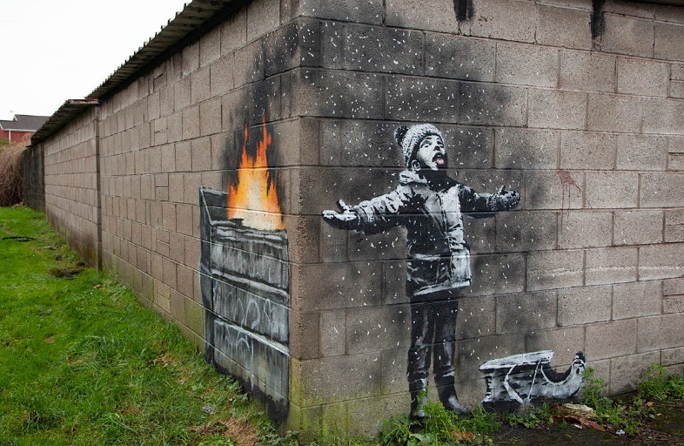
Artifacts
Fig 1, Season’s Greetings, Banksy, 2018

Season’s greetings appeared in Taibach, Port Talbot around December 2018 on a garage close to the steelworks. The ash floating from the fire to the other side of the wall is a clear representation of the impact the nearby steelworks has on pollution and how this affects the houses nearby. In an article published by BusinessLive entitled Port Talbot steelworks to be offered hundred of millions in taxpayers’ money to go green they report the plant is “the biggest industrial contributor to carbon emissions in Wales at around 5.8 million tonnes a year” (Barry, 2023). The meaning behind its creation however is so much more than a commentary on pollution, its depiction of a young child playing in the snow symbolises how this problem will impact our future generations. It exhibits innocence, the world through the eyes of a child and how we continue to normalise these global issues to young people by actively ignoring the problem. It fits neatly into the concept of art designed to make a difference and have an impact on the viewer because of its brilliant execution and location.

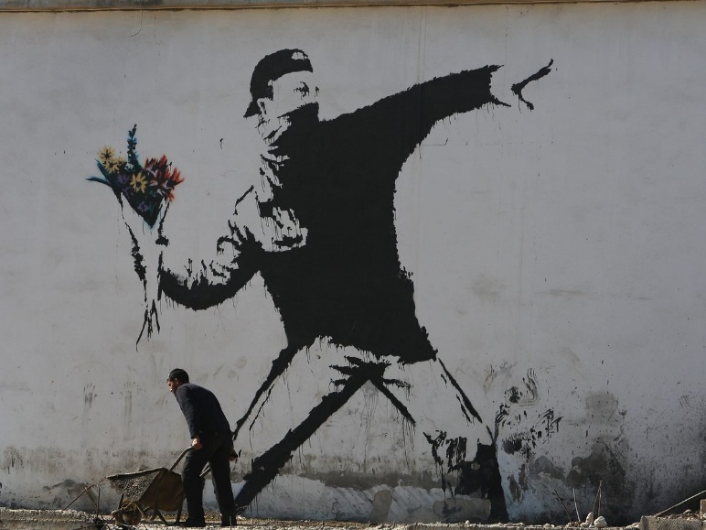
Fig 2, Rage, The Flower Thrower, Banksy, 2003

Rage, The Flower Thrower was originally created in Bethlehem, Jerusalem 2003 on the West Bank Wall shortly after its construction. In an article posted by Thursd they explain that the wall spans “760km” (Thursd, 2021) and adds a comment from Banksy stating the wall “essentially turns Palestine into the world’s largest open prison” (Thursd, 2021). In a post on website ILR School the writer claims the piece is “speculated to be in response to violence in the Middle East or three people being stabbed during a parade” (Petrulla, 2019). It is undeniable that the work reflects making peace and bringing an end to war which is heavily implied by its location. Its intention is to replace acts of war and violence with flowers and gifts, this is elaborated on in the ILR School post explaining “If these communities were to be thrown money and effectively reinvested in, then the outcome would be significantly more positive and beneficial” (Petrulla, 2019). Its context continues with the theme of using art to change peoples perspective and make a difference.

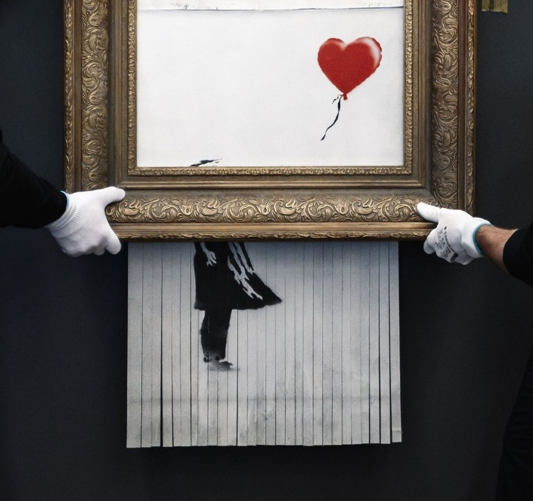
Fig 3, Love is in the bin, Banksy, 2018

Love is in the bin was created during a Sotheby Contemporary Art Evening Auction in October 2018. The artwork was originally titled “Girl with Balloon” and was made to symbolise the loss of a child’s innocence however it was revealed mid auction Banksy had installed a hidden shredder inside the frame of the picture to prevent it being sold at auction. This new piece according to LSU Media is “a direct representation of the artist’s attitude towards the selling of art” (LSU Media, 2022). The piece was destroyed as it was sold as a statement to show we all have lost what creating art is all about. We have lost our admiration and appreciation for art because we are blinded by its monetary value. An article by Artsy reported that the artwork ultimately sold for “£18.5 million, more than tripling its presale high estimate of £6 million” (Sutton, 2021). Through this we can see that the statement Banksy set out to make was proven right and robs the artwork of the respect it deserves. It is a powerful example of creating art to make a statement and encourage change.
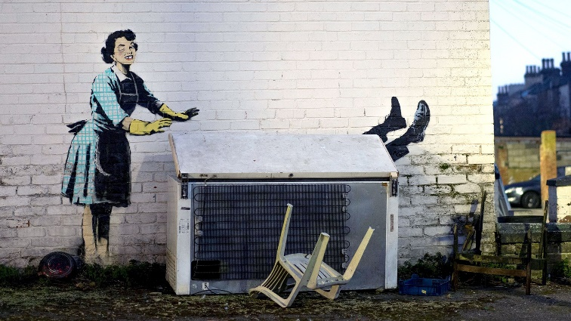
Fig 4, Valentine’s Day Mascara, Banksy, 2023

Valentine’s Day Mascara was created in Margate, Kent in February 2023 on the side of a house. It’s clear the intention of the piece is to highlight the rise in domestic violence cases against women on valentines day, even the name of the piece supports this. The word “Mascara” hints at the idea of covering something up which could be referencing women who cover up their injuries as well as referencing the piece itself where the 1950s housewife is covering up her husband’s murder. The choice of using a 1950s housewife could also be an intentional choice due to the history behind it. It was much harder for women to speak up about domestic violence in the 50s due to societies norms at the time to obey your husband therefore this choice could be a way of reminding people that these issues are still relevant in present day. Due to these reasons it’s clear that this piece follows the theme of starting the conversation about serious issues and sparking change.

Location
Fig 5, Map of the Glynn Vivian Gallery, 2023
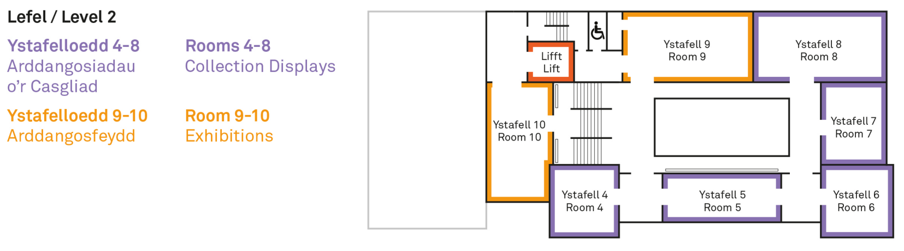
The location for this exhibition would be in the Glynn Vivian gallery with each piece placed in their own separate room as due to their different meanings, they should be displayed in separate locations. We start in room 7 with Seasons greetings, the room will have a fog effect to represent the pollution and the temperature will be cold due to the weather at the time of its creation. We will then move to room 8 which will contain Rage, The Flower Thrower. There with be the sound or war sirens and gunfire to emulate the war like atmosphere but will also contain a bed of flowers which will represent the hope for peace. We would then move to room 5 which will contain Valentine’s Day Mascara. The space all around the piece will be set in a 1950s style kitchen and music from the 50s to fit in with the 1950s housewife in the piece. Lastly, we would move to room 4 containing the Love is in the Bin piece where the space will be set up in the style of an auction house.
Conclusion
To conclude, the overall effect the exhibition will have is to enlighten the public, Banksy’s work has had a huge impact on people around the world and this exhibition is a way to remind people of his influential work. Personally, I feel that all the pieces I have chosen tie together nicely as they all share one artist and the idea of sparking change in people. The idea is to unite people who follow work like this and want to see change in the world.
Bibliography
Banksy Explained (2023) ‘Valentine’s Day Mascara, 14 February 2023’ Available at: https://banksyexplained.com/valentines-day-mascara-14-february-2023/ (Accessed: 13th April 2023).
Barry, S (2023) ‘Port Talbot steelworks to be offered hundred of millions in taxpayers' money to go green’ Available at: https://www.business-live.co.uk/manufacturing/port-talbot-steelworks-offered-hundred-26045499 (Accessed 13th March 2023).
BBC (2020) ‘Banksy: Who is Banksy? What we know about the anonymous graffiti artist’ Available at: https://www.bbc.co.uk/newsround/51504255 (Accessed: 13th March 2023).
Livemint (2023) ‘Valentine's Day mascara: Banksy's powerful mural against domestic abuse’ Available at: https://www.livemint.com/news/world/valentines-day-mascara-banksy-s-powerful-mural-against-domestic-abuse-11676374852749.html (Accessed: 13th April 2023).
LSU Media (2021) ‘Banksy’s ‘Love is in the Bin’’ Available at: https://media.lsu.co.uk/2021/10/31/banksys-love-is-in-the-bin/ (Accessed: 4th April 2023).
Lynch, N (2023) ‘Members of the public 'have taken parts' of Banksy's new artwork in Margate’ Available at: https://news.sky.com/story/members-of-the-public-have-taken-parts-of-banksys-new-artwork-in-margate-12812505 (Accessed: 13th March 2023).
Petrulla, S (2019) ‘Rage, Flower Thrower’ Available at: https://d7.ilr.cornell.edu/post/rage-flower-thrower (Accessed: 18th March 2023).
Shaw, A (2020) ‘Banksy loses trademark battle over his famous Flower Thrower image’ Available at: https://www.theartnewspaper.com/2020/09/17/banksy-loses-trademark-battle-over-his-famous-flower-thrower-image (Accessed: 18th March 2023).
Sutton, B (2021) ‘Banksy’s “Love is in the Bin” explained’ Available at: https://www.artsy.net/article/artsy-editorial-banksys-love-bin-explained (Accessed: 4th April 2023).
Syer, J (2021) ‘Banksy’s Shredded Artwork, Love Is In The Bin, sells for record £18.6M’ Available at: https://www.myartbroker.com/artist-banksy/articles/banksys-love-is-in-the-bin-the-greatest-pr-stunt-of-all-time (Accessed: 4th April 2023).
Thursd (2021) ‘Banksy Advocates for Peace With 'Rage, the Flower Thrower'’ Available at: https://thursd.com/articles/banksy-rage-the-flower-thrower#:~:text=Advocating%20For%20Peace&text=The%20flowers%20themselves%20in%20the,in%20a%20high%2Dconflict%20area. (Accessed: 18th March 2023).

List of Figures
Figure 1, Seasons Greetings (2018) Available at: https://news.sky.com/story/banksys-seasons-greetings-to-leave-wales-after-vandals-attack-artwork-12535906 (Accessed: 13th March 2023).
Figure 2, Rage, The Flower Thrower (2003) Available at: https://d7.ilr.cornell.edu/post/rage-flower-thrower (Accessed: 18th March 2023).
Figure 3, Love is in the Bin (2018) Available at: https://media.lsu.co.uk/2021/10/31/banksys-love-is-in-the-bin/ (Accessed: 4th April 2023).
Figure 4, Valentines Day Mascara (2023) Available at: https://www.livemint.com/news/world/valentines-day-mascara-banksy-s-powerful-mural-against-domestic-abuse-11676374852749.html (Accessed: 13th April 2023).
Figure 5, Map of the Glynn Vivian (2023)

