
Database report
HND Applied computing; Information Engineering

April 20, 2020
Thomas James samuel Phillips
Phi17833288

Contents
SQL 2
Creating a Querry 2
Linking to access 2
Userguid 4
Introduction 5
Navigation 5
Viewing records 5
Viewing reports 6
Miscolanious buttons explained 8
Buttons on Forms 8
Buttons on reports 8

Designing database

ER Diagram
To design the database I used an ER diagram to decide what primary keys and forenkeys I would have. This also allowed me to plan what relationships I woulf have with each table. Below is the ER Diagram.
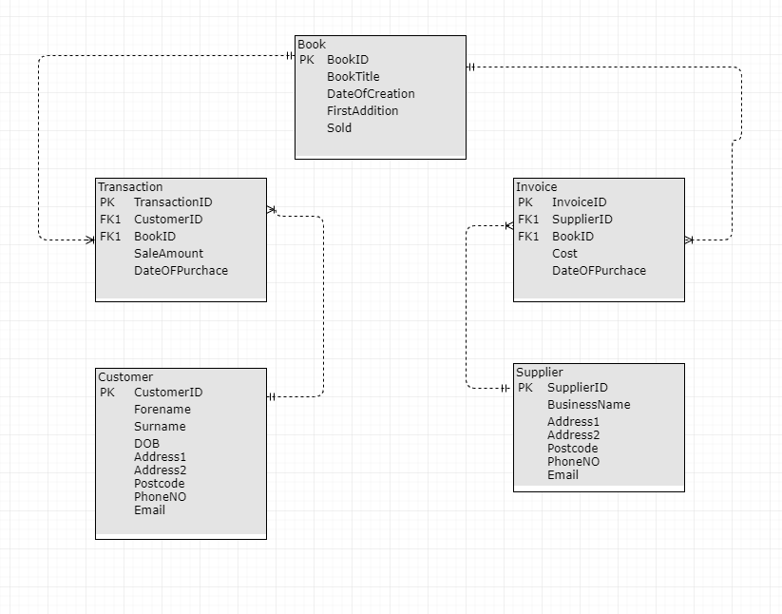

SQL

Creating tables
To create tables I used a query to create all the tables within the database. This allowed me to determine what columns I would have what datatype and what column would be primary key in each table.
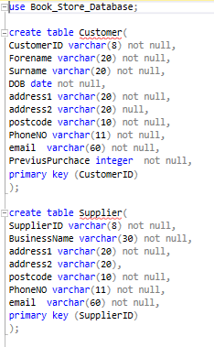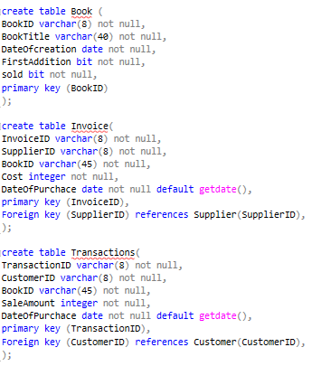

Showing relationships
Once creating all the tables I was able to create a diagram that shows all the relationships between the tables and what type of relationship they were.
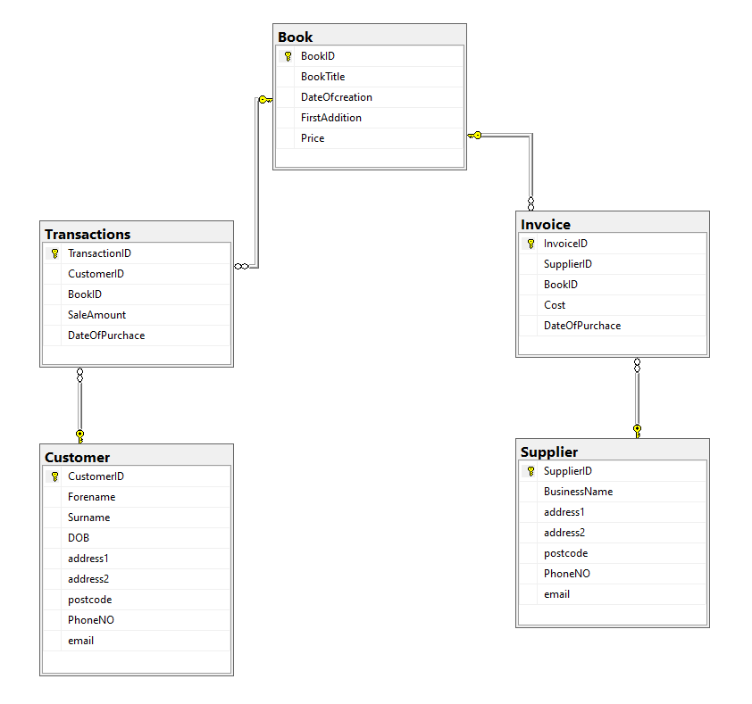

Creating a Query
I created a query that could be used to tell the employees what books have been sold and what books haven’t. this would allow the employ to get back to the potential customer with the books they have in stock.
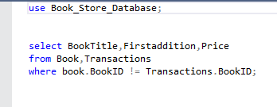

Linking to access
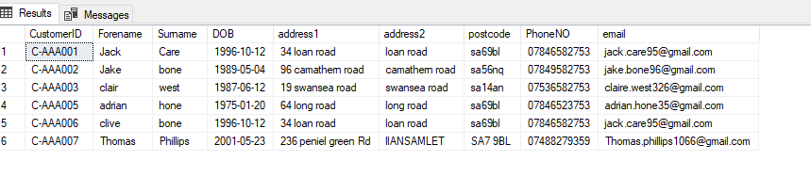
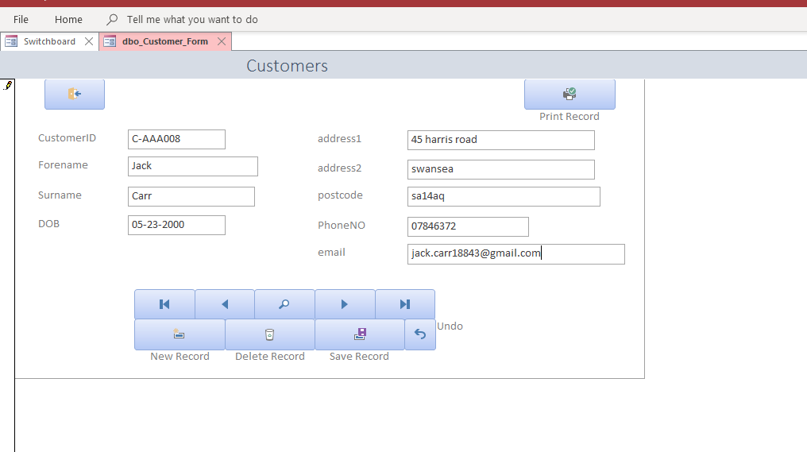

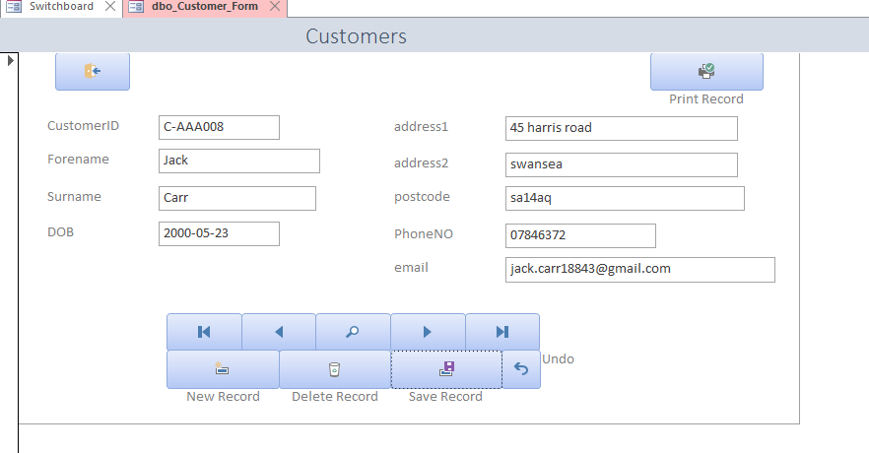
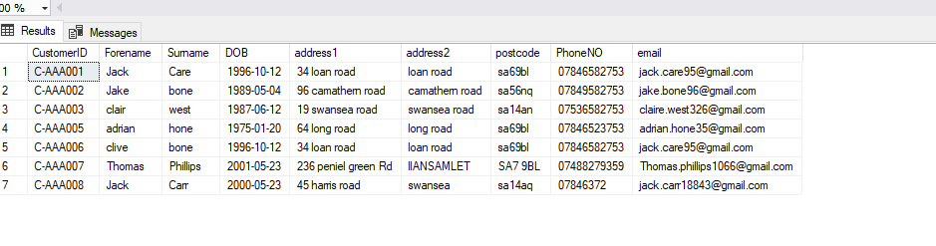

User-guide

Contents
Userguid 2
Introduction 3
Navigation 3
How to preform actions on a record 3
Adding a record 3
Editing a record 3
Saving an edited report 3
Deleting a record 3
Printing a record 3

Introduction
Within this user-guide you will be taken step by step though the database and its features, it will go through features like viewing record, viewing reports as well as features just for records

Navigation
The navigation system is very simple, you just click the area that you wish to navigate to. The database will always launch to this screen.
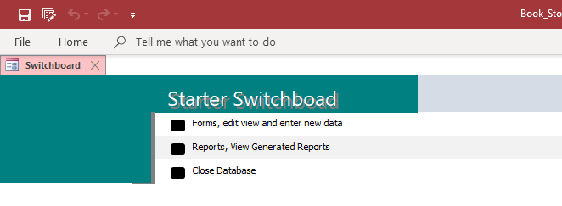
From here you will choose your option

Viewing records
To view any records, you would click the button that is linked to forms. From there it will take you to another switchboard where you can choose what part of the data base you would like to view, such as the customer records. It will then launch the customer records form
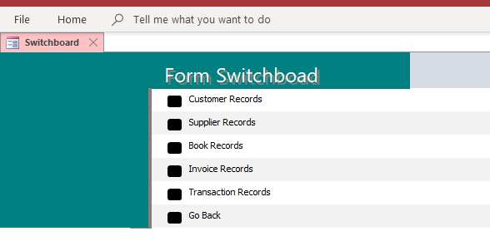
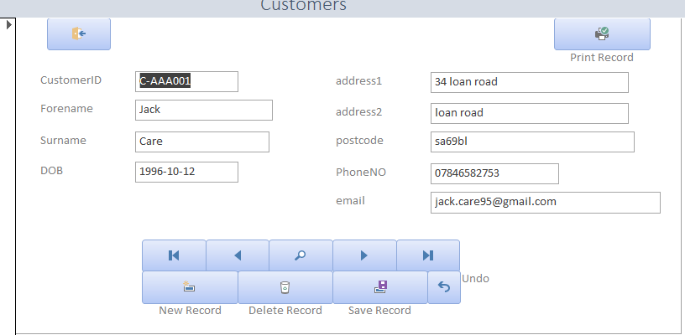
When on the selected database, you can then navigate through the records in the database by using the arrows
1
2

3

4

5
- This will take you to the very first record
- This will take you to the previous record you viewed
- This allows you to search for a specific ID an will take you to that record
- This will take you to the next record
- This will take you to the last record

Viewing reports
Viewing reports are just as easy. You will just navigate to the reports then select what report you want to view.
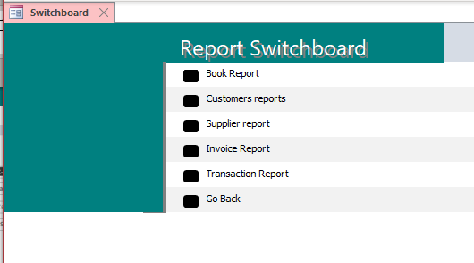
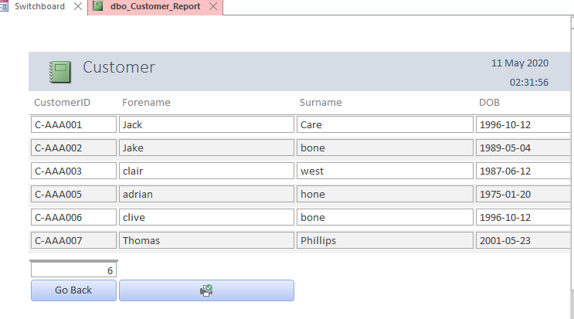

Miscellaneous buttons explained

Buttons on Forms
2

4

6

5

3

1
- This will exit the form and take you back to the switchboard
- This will begin the creation of a new record. However, the save button must be pressed to write the new record to the database
- This will delete the current record on display
- This will save any changes made to the current record
- This will undo any changes to the record. Note: it will only take back to the point where you first edited something, and once the selected record has been un-displayed the undo will not work.
- This will print the current record

Buttons on reports
1

2

2

1
- This will close the report
- This will print the report

