Qualification: CIPD Diploma in Applied Human Resources
Module Name: Developing Professional Practice in Human Resources
Activity 2 – CIPD Profession Map

Word Count: 1092

Student Name: David Harris
Student Number: 1907534
CIPD Membership Number: 55479883

By signing below, I confirm that the work/evidence presented is my own, unaided work. I understand the regulations pertaining to candidate malpractice and the action that may be taken as a result.

Signed: 
Date: 07.01.20

Introduction

This report is an evaluation of the CIPD Profession Map and how this is used by allow HR Professionals in their roles, along with why the differing areas of the Map are vital elements of any HR professional’s role.

Report
Being professional is a key factor of being an HR practitioner and provides the evidence and legitimacy to be truly effective. This is demonstrated by the high quality of work that an HR Professional delivers (Johns T, Perkins G).
To assist in their career, the Chartered Institute of Personnel and Development (CIPD, 2019) (CIPD) developed a Profession Map (known within the report as the Map) in 2013. This report sets out to explain the Map’s purpose, along with how it can be used to benefit HR Professionals in their continued HR journey.
The Map contains several sections – a) eight behaviours b) ten professional areas and c) four bands of professional competence. These identify the different skills and behaviour traits that any HR Professional should demonstrate to be truly effective in their role. It allows them to benchmark their ability within their HR career, as well as identify actions needed for progression. This is done via self-assessment against each of the Map’s sections, referring these to the competence band that relates to their role. To this end, the Map acts as a life-long career tool, fitting with the that Continual Professional Development (CPD) is just that, a continual life-long commitment to maintain and develop knowledge (Woodhams C et al).
The CIPD (CIPD HR Profession Map, 2019) has purposefully designed the Map to drive HR practitioners to be the best that they can be and identifies the behaviours and skills of the very best HR professionals. An image of the Map can be seen below:
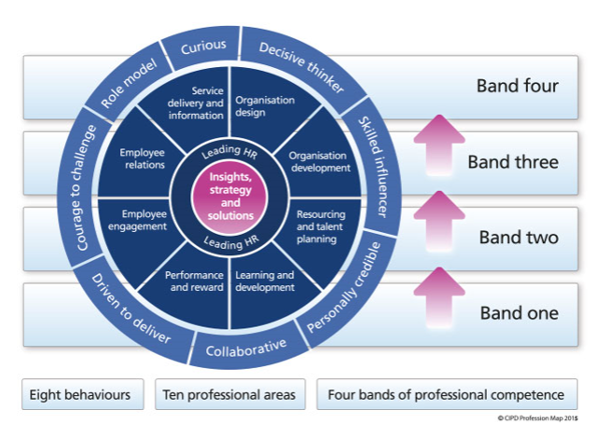
Figure 1 CIPD Profession Map 2015
The Map identifies what HR professionals need to do to be fully effective, as well as how these must be done. These are divided into ten professional areas (what they must do) and eight behaviour (how they must do them). The two areas found at the centre of the map show the two traits that are applicable to all areas of HR and are the responsibility of all HR practitioners. The remaining eight professional areas are more suited to HR specialists and specialisms. The behaviours identify how HR practitioners should act if they wish to be successful within their roles. These are vital traits and something that is supported by organisations in how they deliver their HR provision. This can be seen in Tesco, who became the first organisation to attain the CIPD People Development Partner status. This demonstrates their collaboration with the CIPD to develop their HR provision (CIPD, 2019). In addition, public service organisations, particularly policing, have shifted their recruitment processes to place greater emphasis on the values of their employees rather than purely on their ability. This demonstrates organisational belief in the values displayed within the Map (College of Policing, 2017).
The final section describes the four bands of professional competence. These bands identify the differing levels within an HR professional’s career; starting at band one being a tactical day to day HR practitioner, to band four - a strategic HR professional responsible for leading an organisation. Whatever the band, the Map identifies the characteristics and behaviours that individuals display and engage in at each level.

Figure 2. Profession Map Behaviour Areas
“It is becoming increasingly important for HR Professionals to be ‘thinking performers”. The nature of the HR Professionals role has changed dramatically from one that was seen to be administrative to one that is a more influencial role, adding value to an organisation (Woodhams C, Perkins G). Thinking performers are individuals who carry out tasks but also who consider the wider impact of their decisions and how these fit with the organisational strategy and purpose.
HR Professionals need to be taken seriously in their organisation and this can only be achieved by demonstrating the behaviours identified within the Map. The CIPD term this as being ‘business savvy’ (Johns T & Perkins, G) and state that this consists of 4 elements, which fit with the Map’s behaviour areas. These are:
- Understanding the business model in depth
- Generating insight through evidence and data
- Connecting with curiosity, purpose and impact
- Leading with integrity, consideration and challenge

The HR professional that is able to display the above areas in their work is someone who is able to be fully effective and to provide the most impact for their organisation. This requires individuals to display many different qualities, including the ability to ask questions of their organisation and processes, whilst ensuring that their organisation’s business model is fully understood. This is vital in ensuring that organisational strategy is considered when decisions are being reached.
In addition, being a skilled influencer is vital in enabling change and ensuring that all parties are engaged. To be a truly skilled influencer, this requires developed communication skills. Managers often revert to instructing people to do things, however the results for this are limited. By being a fully effective communicator and basing ones communication success on the response it gets from the audience, this provides the best possible chance of positive results (Yemm, 2008).
Finally, the need to be a role model for the organisation, as well as being personally credible is key in ensuring that the HR Professional’s role is one that both continually evolves, but also develops fellow colleagues. These individuals display high levels of integrity and act in a consistent manner. They offer guidance and advice to colleagues and do so in a manner that is supportive and fosters an organisation environment where shared knowledge and learning is both supported and promoted.

Conclusion
In conclusion, the CIPD Profession Map is a vital tool for all HR professionals, irrelevant of their role within HR, or their length of service. It provides a well-structured and intuitive model for benchmarking any HR practitioner’s current abilities, while providing tangible and realistic objectives to allow for further progression, either within their role or to allow progression to a higher role in HR. The elements within it are the basis for the development of sound HR practice and are the necessary behaviours and values which all HR Professionals must demonstrate.

Recommendations
- All HR Professionals should undertake a self-assessment against key areas of the Map, identifying objectives to develop in their role.

- HR Professionals should ensure that they are fully aware of their organisation’s strategic objectives and vision, to allow this to be considered when carrying out HR work.

Bibliography
Carol Woodhams, G. P. (n.d.). Developing the Knowledge and Skill of the HR Professional. In Studying Human Resource Management (pp. 109-126). London: Chartered Institute of Personnel and Development.
CIPD HR Profession Map. (2019, Dec 10th). Retrieved from CIPD: https://www.cipd.co.uk/learn/profession-map/2013-profession-map
CIPD launches status for organisations excelling at HR's own development. (2019, December 30th). Retrieved from HR Magazine: http://www.hrmagazine.co.uk/article-details/cipd-launches-status-for-organisations-excelling-at-hrs-own-development
Introducing a new competency and values framework for policing. (2017). Retrieved from College of Policing: https://www.college.police.uk/What-we-do/Development/competency-and-values-framework/Pages/Competency-and-Values-framework.aspx
Perkins, T. J. (n.d.). Developing Professional Practice. In Studying Human Resource Management (pp. 68-87). London: Chartered Institute of Personnel and Development .
Yemm, G. (2008). Influencing Others - a key skill for all.

Qualification: CIPD Diploma in Applied Human Resources
Module Name: Developing Professional Practice
Team Dynamics and Internal Politics

Word Count: 1147

Student Name: David Harris
Student Number: 1907534
CIPD Membership Number: 55479883

By signing below, I confirm that the work/evidence presented is my own, unaided work. I understand the regulations pertaining to candidate malpractice and the action that may be taken as a result.

Signed:
Date: 07.01.20

Introduction
This report is an evaluation of team member characteristics and the impact that this can have achieving team objectives. It also evaluates the models for team dynamics and how internal politics can affect organisational change.

Report
Teams exist in all walks of life and play a vital part in achieving the goals set for them as long as they are effectively managed. The difference between teams and groups of individuals relate to their shared goals and shared accountability to achieve these goals (Smith, 1992). Smith states “A team is a small number of people with complementary skills who are committed to a common purpose, performance goals, and approach for which they hold themselves mutually accountable”, therefore differentiating a team from a simple group of individuals.
HR professional often work in teams, either with other HR professionals or in wider teams, such as with trade unions, employees or line managers. Huczynski and Buchanan (2017) describe teams fitting into one of four categories; Action, Advice, Project or Production, with organisations using teams more frequently to undertake specific team tasks (Lacarenza et al, 2018).
There are several models which explain team dynamics and what impacts on their effectiveness. Smith (1992) describes individuals finding it difficult to work beyond being an ‘individual’ and shying away sharing responsibility for their colleague’s performance and vice versa. This is overcome by focusing less on becoming a team and more on the fundamental characteristics of being effective. Smith describes this as a triangle identifying three areas; Skills, Accountability and Commitment, and suggest these are needed to be an effective team. This is not dissimilar to Belbin’s model, where individual characteristics are categorised into one of nine roles. This, and Smith’s triangle model are shown below:

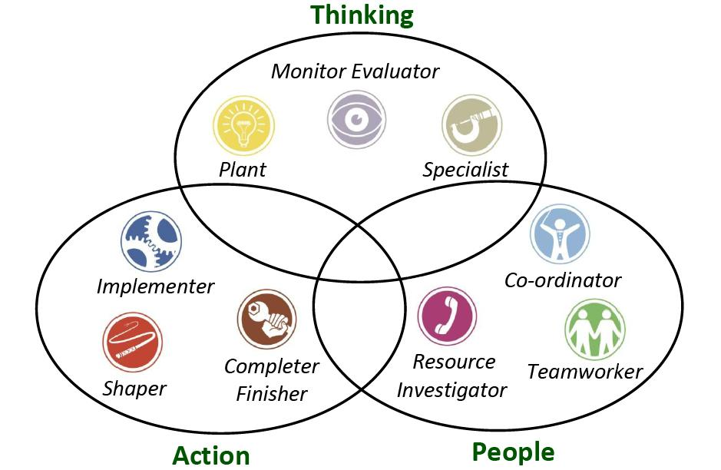
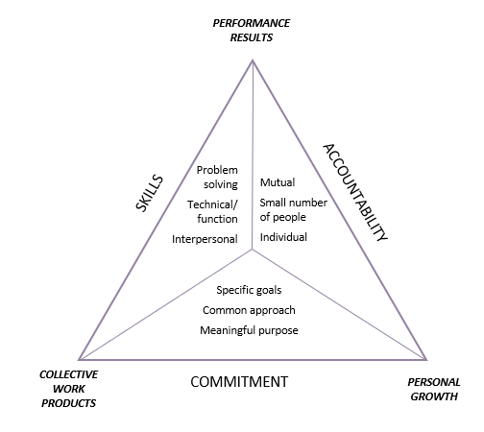

Fig 1. Katzenbach and Smith
Fig 2. Belbin

Belbin’s model identifies character traits and how this affects their team’s strengths and weaknesses. It also allows their teams to be managed effectively and tasked accordingly. This can assist in achieving team goals. (Why Use Belbin, 2019).
To understand your team’s characteristics there are a number of questionnaires available, aimed at identifying team skills and which of the roles each person naturally leans towards. Whilst most individuals tend to have a predominance towards one, it is possible for some people to portray traits of more than one.
Whilst the above models focus on the characteristics of individuals, Tuckman’s theory of team development focuses on how teams develop and the different stages teams go through. Tuckman describes this as a four-stage process as shown in fig 3 below.

Fig 3. Tuckman’s Model

The model (initially created in 1965) refers to the path which teams follow as they develop. It describes four separate stages teams move through from initial forming, through fully functioning and high performing. It is a vital tool for team leaders to be aware of as it both maps the way team members act, but also the importance of how team leaders must act at each stage, and how team goals can be negatively affected if the process is managed ineffectively (Miller, 2014).
Teams often begin politely and positive about their goals and tend not to question processes of procedures. They have high expectations of each other and the team’s goals. The ‘Forming‘ stage requires team leaders to be more directive to ensure that goals are set for the team. As they move into the ‘Storming’ stage they start to question each other and the negative character traits of individuals start to appear. It is vital for team leaders to be able to manage their teams at this stage and to help them identify each other’s skills.
As teams start to work closely together and recognise each other’s abilities, they begin to work in harmony and begin performing better. At this stage of the process a team leader starts to become more of a facilitator and is able to allow the team to manage their own performance, whilst supporting and develop team members. If this continues well, the final stage of the process is ‘Performing’, where the team take on more responsibility and become more positive about their ability in achieving their goals and objectives.
What is vital during this process is that line managers are both aware and equipped with the necessary skills to understand how and why their team is acting in a certain way. Understanding this model allows line managers to predict patters of behaviours as well as assisting their team progress through the stages as smoothly as possible.
The above models are key to understanding how individual team members act as well as how teams develop, this is not always enough to ensure that objectives are achieved. This is evident in change management processes, where it is demonstrated that informal coalitions exist and play a key part in organisation’s ability to manage such processes (Rodgers, 2006). The Business Dictionary define organisational politics as ”the pursuit of individual agendas and self-interest in an organisation without regard to their effect on the organisations efforts to achieve its goals”, which can make this seem negative. Rodgers, however suggests that internal politics are both necessary and inevitable.
Whatever management’s view is of change, teams of individuals will inevitably speak about what they want to and will decide for themselves how the change process will work. Rodgers describes the normal change process as below, identifying the three different management styles:
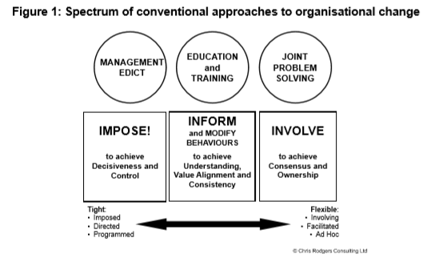
This suggests a clear difference from ‘tight’ to ‘flexible’ management styles, however what is important to understand and accept is that whatever management style is adopted, managers cannot stop their teams discussing whatever is important to them. This is where the informal coalitions are made. This is an important viewpoint to understand, as it recognises how powerful conversations, discussions and internal politics can be.

Rodgers suggests that internal politics are a necessary and unavoidable step in any process, particularly when change impacts on team’s resources or workload. Whilst politics can be seen as a negative issue, this is the reality and to avoid it will delay any process being completed. Team leaders and managers should embrace organisational politics and engage with their teams to work through these processes rather than trying to fight against them.

Conclusion
To conclude, it is important for team leaders to be aware of how their teams are made up and their differing skills and abilities. Additionally, it is also key to understand the processes that teams move through and how these can be managed to assist in achieving team goals. Lastly, whilst the above allows managers to be better equipped to manage their team, they must also be aware of how internal politics in their organisation play out and how these can assist in achieving their objectives.

Recommendations
- All team leaders should seek to assess their team’s abilities by using a Belbin style questionnaire to ensure that they are equipped to effectively manage their staff.

Bibliography
Christina Lacarenza, S. M. (2018). Team Development Interventions: Evidence-Based Approaches for Improving Teamwork. American Psychologist, 73(4), 517-531.
Miller, T. (2014, May). Engaging Leadership. Training Journal, 22-27.
Rodgers, C. (2006). Informal Coalitions. Organisations and People.
Smith, J. K. (1992). The Wisdom of Teams: Creating the High-Performance Organisation. Harvard Business Press.
Why Use Belbin? (2019, November 29). Retrieved from Belbin.com: https://www.belbin.com/about/why-use-belbin/

