DS 1 Template

My Screenshots/Photos
- Please add 4–6 screenshots or photos of your digital life.
- You can use your phone or laptop.
- For each screenshot, write one or two sentences explaining what it shows.

Screenshot/Photo 1
[Insert Photo/Screenshot below]
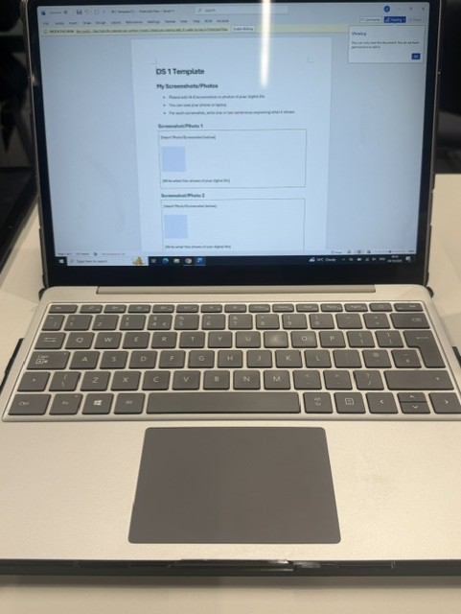
I use my laptop to study, do my homework and learn new things,my laptop is an important part of my didital life,I use it to search for information,complete school task and communicate with others .

Screenshot/Photo 2
I use google every day to search for information,find answers to my questions and learn new things ,it helps me with my homework and school projects ,I can also use google to discover new websites,watch videos and find useful information for my studies ,google makes it easier and faster to find what I need. 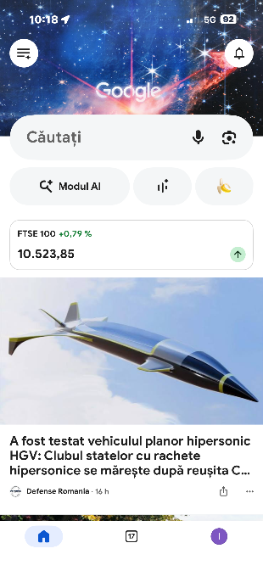

Screenshot/Photo 3

Insert Photo/Screenshot below]
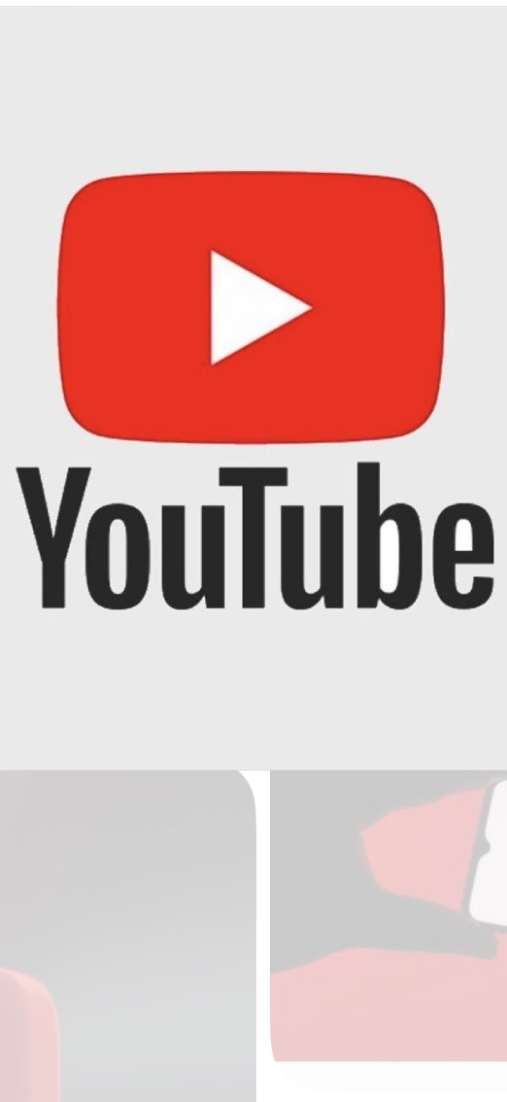
I use youtube to watch videous,listen to music and learn new things,I also enjoy watching videous in my free time,youtube helps me relax and discover interesting content.

Screenshot/Photo 4
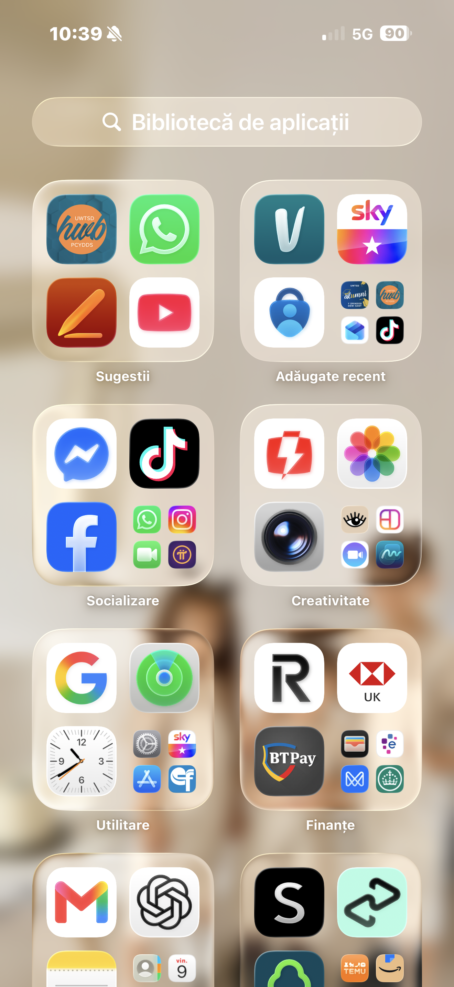
I use my phone every day to cumunicate with friends and family,take photos ,watch videous and use social media,it is an important part of my daily life.

Screenshot/Photo 5
[Insert Photo/Screenshot below]
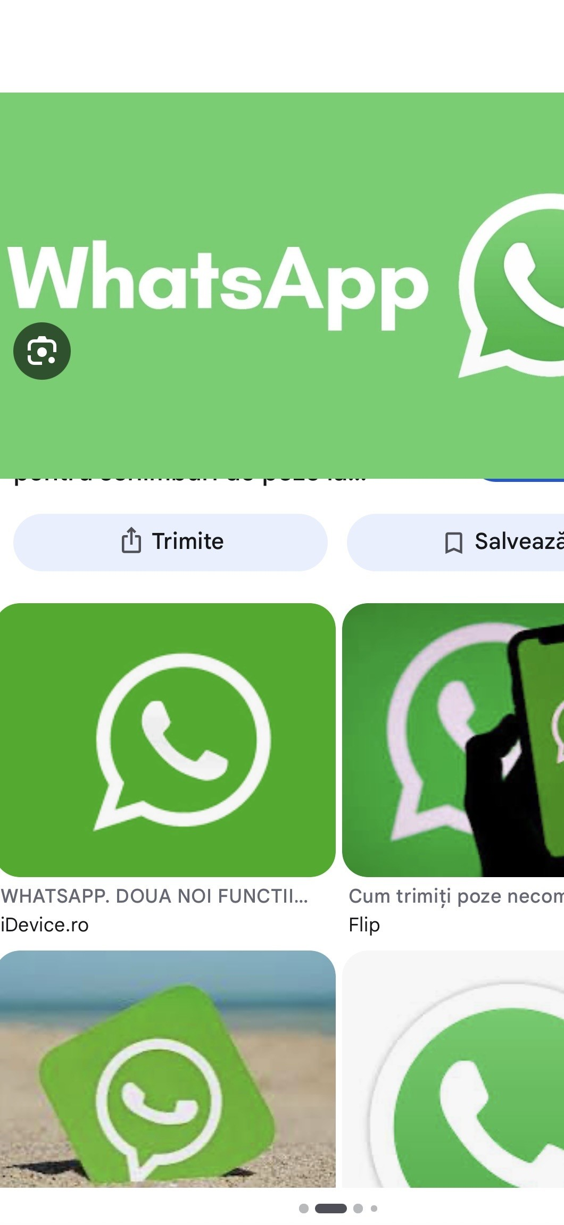
I use whatsapp to communicate with my friends and family,I send messages,share photos and make calls,whatsapp helps me stay in touch with the people I care about.

Screenshot/Photo 6
[Insert Photo/Screenshot below]
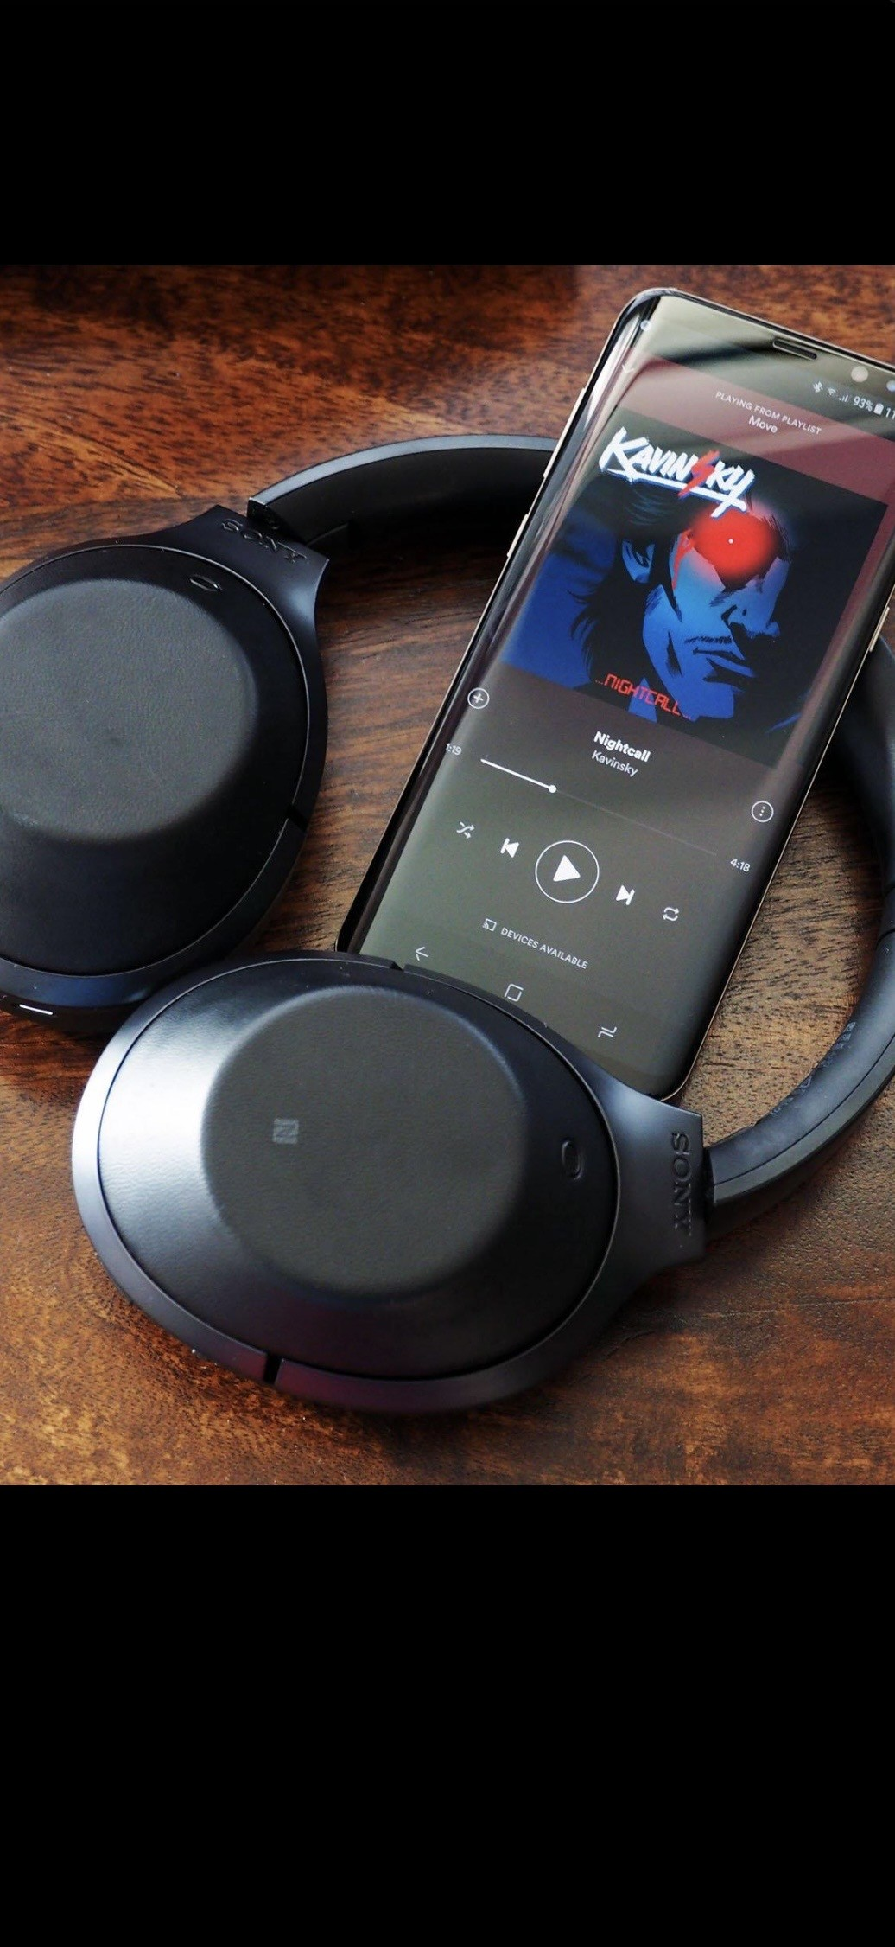
I listen to music on my phone every day,music helps me relax and makes me feel happy,I enjoy listening to my favourite songs in my free time.

My Short Reflection
- Write 5–8 simple sentences about your digital life.
- You can use the sentence starters below if helpful.
I use digital tools to communicate with my friends and learn new things for school every day.
I feel confident when I use text editors to format documents and search for information online .
I want to improve my skills in using advanced spreadsheet functions and presentation design.
I often use these tools my smartphone for quick updates,a laptop for homework,and the Microsoft word application.
I sometimes feel nervous about online privacy and the security of my personal data.
I hope this module will help me become more efficient and professional when working on computer projects.
Digital skills are important for me because they are essential for future jobs and everyday modern communication.

Sentence starters
- I use digital tools to …
- I feel confident when I …
- I want to improve …
- I often use these tools: …
- I sometimes feel nervous about …
- I hope this module will help me …
- Digital skills are important for me because …
You can write more if you want.

Submission Checklist
Before you submit, please check:
​​​ ☒ I added 4–6 screenshots
☒ I wrote short sentences for each screenshot
☒ I wrote my short reflection
☒ My work is my own
☒ My file opens correctly
​​☒ My file opens correctly

