Presentation Framework

According to Kozlowski and Bell (2003), a team is a group of people ‘who exist to perform organisationally relevant tasks, share one or more common goals, interact socially, maintain and manage boundaries…’ (p334).
A team is seen by Morgan (2017) as ‘a number of individuals working as one to achieve a particular goal to which they are mutually committed’. In this way, a team may be viewed as different from a group in that the latter may meet simply because they have a common interest.
Teams therefore exist to accomplish specific tasks that are related to common goals.

- BENEFITS of TEAM WORKING

Team working can make work more efficient and fun. Working with others enables members to:
- Increase productivity (Synergy – 1+1 = 3)
- Pool their ideas and see problems from different perspectives.
- Attempt tasks that could not be accomplished by an individual, combining a variety of skills and expertise to tackle more complex and larger-scale problems.
- Group work gives members the chance to learn from each other. There are many benefits from analysing, discussing and exploring their own ideas and questions and gaining feedback from other members.
- Give support to each other
- Improve their career prospects
- Attract the best talent.

Are Teams ready to function when they are formed?
This will depend on how the team develops. Psychologist Bruce Tuckman (1965)
identified 5 stages of team development:

- STAGES OF TEAM DEVELOPMENT (TUCKMAN)

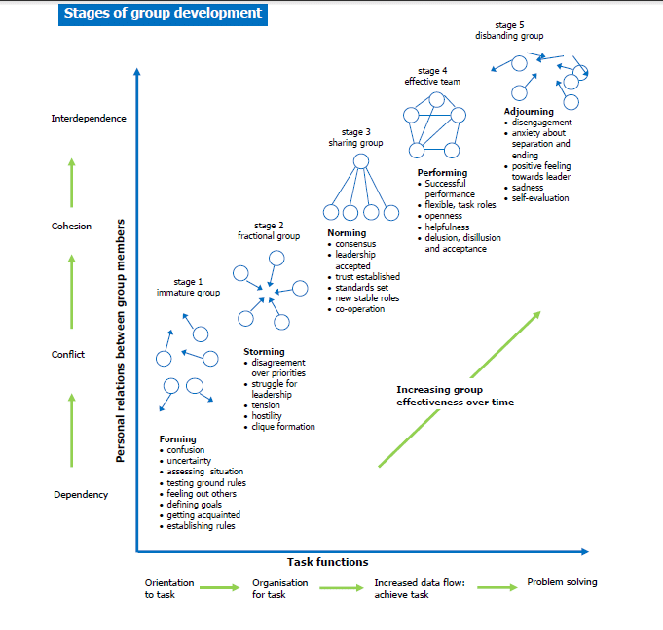

Some experts argue that not all teams experience Tuckman’s stages because some of them may set norms at their first meeting while others move from storming and performing and back again. Wheelan (1999) argues that only about a quarter of all teams progress through the normal stages of development and reach their full potential.

3.TEAM ROLES (BELBIN)
Research shows that the most successful teams are made up of a diverse mix of behaviours.
They discovered that there are nine clusters of behaviour - these were called 'Team Roles'. Each team needs access to each of the nine Team Role behaviours to become a high performing team. However, this doesn't mean that every team requires nine people! Most people will have two or three Team Roles that they are most comfortable with, and this can change over time. Each Team Role has its strengths and weaknesses, and each has equal importance. However, not all are always required at the same time - it is important to first look at the team objectives and work out which tasks need to be undertaken. Once this has been done, discussions can take place regarding which and when each Team Role behaviour should be utilised.

Belbin’s research identified 9 team roles based on personality:

Resource Investigator
Strengths: Outgoing, enthusiastic. Explores opportunities and develops contacts.
Allowable weaknesses: Might be over-optimistic, and can lose interest once the initial enthusiasm has passed.
Don't be surprised to find that: They might forget to follow up on a lead.

Teamworker
Strengths: Co-operative, perceptive and diplomatic. Listens and averts friction.
Allowable weaknesses: Can be indecisive in crunch situations and tends to avoid confrontation.
Don't be surprised to find that: They might be hesitant to make unpopular decisions.

Co-ordinator
Strengths: Mature, confident, identifies talent. Clarifies goals.
Allowable weaknesses: Can be seen as manipulative and might offload their own share of the work.
Don't be surprised to find that: They might over-delegate, leaving themselves little work to do.

Plant
Strengths: Creative, imaginative, free-thinking, generates ideas and solves difficult problems.
Allowable weaknesses: Might ignore incidentals, and may be too preoccupied to communicate effectively.
Don't be surprised to find that: They could be absent-minded or forgetful.

Monitor Evaluator
Strengths: Sober, strategic and discerning. Sees all options and judges accurately.
Allowable weaknesses: Sometimes lacks the drive and ability to inspire others and can be overly critical.
Don't be surprised to find that: They could be slow to come to decisions.

Specialist
Brings in-depth knowledge of a key area to the team.
Strengths: Single-minded, self-starting and dedicated. They provide specialist knowledge and skills.
Allowable weaknesses: Tends to contribute on a narrow front and can dwell on the technicalities.
Don't be surprised to find that: They overload you with information.

Shaper
Provides the necessary drive to ensure that the team keeps moving and does not lose focus or momentum.
Strengths: Challenging, dynamic, thrives on pressure. Has the drive and courage to overcome obstacles.
Allowable weaknesses: Can be prone to provocation, and may sometimes offend people's feelings.
Don't be surprised to find that: They could risk becoming aggressive and bad-humoured in their attempts to get things done.

Implementer
Needed to plan a workable strategy and carry it out as efficiently as possible.
Strengths: Practical, reliable, efficient. Turns ideas into actions and organises work that needs to be done.
Allowable weaknesses: Can be a bit inflexible and slow to respond to new possibilities.
Don't be surprised to find that: They might be slow to relinquish their plans in favour of positive changes.

Completer / Finisher
Most effectively used at the end of tasks to polish and scrutinise the work for errors, subjecting it to the highest standards of quality control.
Strengths: Painstaking, conscientious, anxious. Searches out errors. Polishes and perfects.
Allowable weaknesses: Can be inclined to worry unduly, and reluctant to delegate.
Don't be surprised to find that: They could be accused of taking their perfectionism to extremes.

For the presentation you need to explain the groupings and GIVE a Detailed example of ONE role in each group.

Belbin identified nine team roles and he categorized those roles into three groups: Action Oriented, People Oriented, and Thought Oriented. Each team role is associated with typical behavioural and interpersonal strengths.
Belbin also defined characteristic weaknesses that tend to accompany each team role. He called the characteristic weaknesses of team roles the "allowable" weaknesses; as for any behavioural weakness, these are areas to be aware of and potentially improve.

Figure 1: Belbin's Team Roles
Action Oriented Roles | Shaper | Challenges the team to improve.
Action Oriented Roles | Implementer | Puts ideas into action.
Action Oriented Roles | Completer Finisher | Ensures thorough, timely completion.
People Oriented Roles | Coordinator | Acts as a chairperson.
People Oriented Roles | Team Worker | Encourages cooperation.
People Oriented Roles | Resource Investigator | Explores outside opportunities.
Thought Oriented Roles | Plant | Presents new ideas and approaches.
Thought Oriented Roles | Monitor-Evaluator | Analyzes the options.
Thought Oriented Roles | Specialist | Provides specialized skills.

Not every team role will be necessary in every team, but Belbin’s theory suggests that the more the team reflects all the team roles, the better the team’s performance is likely to be.
While Belbin’s theory has its critics, the model has been used extensively in business to form teams (Morgan).

But can the right balance of a team, as proposed by Belbin, lead to success?
Paul Hersey and Ken Blanchard developed a model of ‘situational leadership’, which matches 4 leadership styles (Telling, Selling, Participating and Delegating) to 4 levels of maturity of their team. Indeed, the Hersey-Blanchard Situational Leadership Theory is one that is based around variable leadership, depending on a variety of circumstances. When a leader can adapt to the situation as quickly as possible, everyone will benefit in the end.
Specifically, this theory has to do with the maturity of those who are being led. To those who have worked as leaders in the past, it is no surprise that maturity should be considered when working on finding the right leadership style. For example, someone who is inexperienced in their field will likely lack the skills or confidence to take on tasks that would be comfortable for a more experienced employee.
Hersey and Blanchard identified 4 Maturity levels: D1, D2, D3 and D4 and matched them with 4 styles of leadership: S1, S2, S3 and S4.

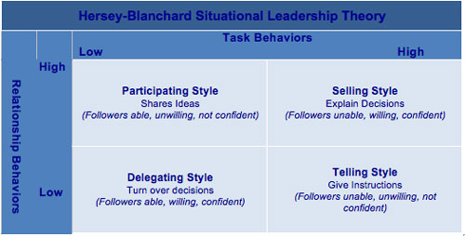

4.MANAGING CONFLICT
When individuals come together in teams, their differences can create conflict. This is because we are dealing with people’s lives, jobs, ego, pride and values.
To avoid the negative effects of such conflict, action should be taken promptly.
This can be managed by using the widely accepted Thomas-Kilman model:
Competition
Collaboration
Compromise
Avoidance
Accommodation
Thomas, K. W., and Kilmann, R. H. The Thomas-Kilmann Conflict Mode Instrument (Mountain View, CA: CPP, Inc., 1974).

However, not all conflict is negative.
Cooperative conflict can contribute to effective problem-solving and decision-making by motivating people to examine a problem.

BUT

No method of managing conflict will work without mutual respect and a willingness to disagree and resolve disagreements. Each person on the team must be willing to:
-Listen
-Acknowledge
-Respond
- Resolve differences.

5: SUCCESSFUL TEAM DEVELOPMENT
Effective teamwork is an important aspect of any organisation's success. To keep teamwork going, you need to establish regular and open lines of communication and monitor how the group interacts. Learning to communicate effectively is not a simple one step process and requires work from all sides.

SUCCESSFUL TEAM DEVELOPMENT
How can a leader make sure that a team develops and keeps developing?

10 Steps in Building a Strong Team

- Understand responsibilities.
Make sure that everyone knows what is expected of them.
2) Cover the Belbin Roles As far as possible, the leader should ensure that the team covers the eight Belbin Team roles.
3) Have common goals.
Be sure each team member shares the same objectives.
- Deal with change.
Be prepared for the worst-case scenario, or the smallest event, that could require a change of direction or plan.
- Deal with conflict.
Have a plan to deal with conflicts that may arise in the course of team working.
- Share Information:
Be transparent with information between team members. The more each team member understands the needs and
circumstances of other members within the group, the easier it is for the team to succeed.
- Share ideas.
Share innovations with the entire team to improve task completion, and to ultimately bring greater success to the team. I
- Develop trust. This is the most important component of keeping a team focused on the goal, so constantly work on earning the trust of other team members.

- Adapt
The leader should be able to adapt their style to suit the maturity of the team

- Socialise:
Get to know each other outside the workplace.
In these ways, team members will trust each other and perform as a team.

.
55.55is because we are dealing with people’s lives, jobs, ego, pride and values

References
Belbin, R.M. (1981) Management Teams – Why they Succeed or Fail: Oxford; Butterworth-Heinemann.
Hersey, P. and Blanchard, K. H. (1969). Management of Organizational Behavior – Utilizing Human Resources. New Jersey/Prentice Hall
Kozlowski, J. & Bell, S. (2001) Work Groups and Teams in Organizations, Cornell University, bb92@cornell.edu
Morgan, P. (2017) The Business Student’s Guide to Study and Employability, London: Sage Publications Ltd.
Thomas, K. W., and Kilmann, R. H. The Thomas-Kilmann Conflict Mode Instrument (Mountain View, CA: CPP, Inc., 1974).
Tuckman, B.W. (1965), ‘Developmental Sequence in Small Groups’, Psychological Bulletin 6.

