Component A
Hotel: Six Senses
Student name:
Student ID:

Table of Contents
1 Introduction 3
2 . Situational Analysis 3
2.1 5Cs 3
2.1.1 Company: SWOT analysis 3
2.1.2 Customer 3
2.1.3 Competitor 4
2.1.4 Collaborators 4
2.1.4 Climate 5
2.1.5 Marketing Mix 6
3 Objectives 6
4 Strategies 7
4.1 The Ansoff Matrix 7
4.2 Modifications to the Marketing Mix 8
5 Techniques 8
5.1 Marketing Strategies 8
5.1.1 Product Details 8
5.1.2 pricing of Hotels 8
5.1.3 Place 8
5.1.4 Promotion 9
5.2 Tactics 9
5.3 Action 9
6 Control 10
7 Conclusion 10
8 References 12
9 Appendix – Presentation 14

Introduction
This report examines the luxury hotel chain Six Senses' marketing strategy. The objective of this advertising campaign is to increase hotel revenue by drawing in more first-time visitors and returning clients. The current marketing plan for Six Senses was created in-house. The plan includes, among other things, Bowman's strategy clock, the four Ps of marketing, and the SOSTAC marketing planning model. With the aid of this framework, Six Senses' marketing initiatives can focus on opportunities that will enable them to develop a thorough plan for accomplishing their mission

. Situational Analysis

5Cs

Company: SWOT analysis
Strengths  - Excellent and high-quality services from a luxury brand.  - Environmentally responsible actions. | Weakness  - Due to its lavish services, it is quite pricey for the bulk of the people.  - Less presence than competitors on the international stage.
Opportunity  - Eco-friendly procedures that encourage sustainable tourism.  - Entering new economies and the potential for profitability to expand | Threat  - the threat that enchants is the increasing number of organisations offering comparable high-end services.

Customer
Segmentation
- Demographic: High-income people vary from 25-60
- Psychographic: Worth luxurious experiences, emphasise health and feasibility, and seek special, customised travelling events.
- The motive of travel: Freedom, health, or nature-loving person.
- Location: Guests are interested in travelling to luxurious destinations in worthful locations (Chandran, 2021).
- Overall, Six Senses appeals to wealthy individuals, famous people, and businesspeople.
Targeting
Six Senses select organisational travellers, freedom travellers and different types of families. Similarly, it targets young people, luxury seekers, and visitors who care about the environment (Tanford and Malek, 2015). According to SimilarWeb, people between the ages of 25 and 34 make up the majority of Six Senses' visitors.
Positioning
Six Senses stands as a luxurious hotel that provides high-end, feasible, and special events.

Competitor
Banyan Tree Hotels is a rival to Six Senses in terms of offering opulent services and emphasising patron wellbeing (Shen, 2015). Also, Aman Resorts, a premium hotel renowned for its exquisite services and great guest experiences, competes with Six Senses in the market (Cheng, 2016).
Bowman’s strategy clock
The Six Senses can differentiate itself from the competition while upholding its high standards for luxury and ethical business conduct by hosting distinctive and individualised events. Businesses that can innovate through a blend of contrast and value leadership by offering distinctive experiences at reasonable prices while maintaining high-quality, consistent service will find using Bowman's strategy clock to be motivating (Chung, 2020).

2.1.4 Collaborators
Six Senses has increased its B2B partnerships, collaboration, and permits in order to widen its offerings and give its visitors more choices. Several examples are:
- The Six Senses has partnered with other upscale tour companies to offer their customers special discounts.
- In order to offer unique spa amenities and specialised treatments, Six Senses has teamed up with the medical community.
- Other brand property owners and planners can benefit from the same rewards and opportunities thanks to Six Senses' range of franchises.

Climate
Political | -Worldwide travelling prohibits impact on the hospitality industry.  -Shortage of staff.  - Political instability as a result of UK policy changes following Brexit, which has an influence on the hotel's profitability.
Economic | -Tourist tax rate= 8%.  -Economic decline and currency differences can affect travelling requests and incomes.  - Global economic crisis, increasing inflation as a result of higher gasoline costs following the Russia-Ukraine war.
Social | -Media marketing use has uplifted.  -Changing customer choices and trends.  - Shifts in visitor tastes towards ecotourism, health, and wellness.
Technological | -Supremacy of technology, like social media platforms, online platforms, apps in mobile, and AI usage, are increasing the customer experience and enhancing planning.  - Increased reliance on online reservations as a result of the fast evolution of technology.
Legal | -Regulations towards wellness and safety, employees, data security, and analytical influence hotel programs.  -- A staffing deficit for the hotel was brought on by immigration regulations following Brexit.
Environmental | -Environmental changes and advantages like greenhouse gases and emissions regulations are impacting hotels and operating a focus on supportable systems.  -More environmentally concerned tourists favour sustainable practises and environmental protection.

Marketing Mix
Marketing Mix | Key Points
Product | - Luxurious services, spa and wellness programmes, and exquisite activities.
Price | - Extremely pricey goods and services.
Place | - A global presence with hotels that are deftly positioned in beautiful environments.
Promotions | - Online advertising strategies like social media marketing.

Objectives
The main goals of the marketing strategy for the hotels are to enhance brand recognition, fascinate new guests, and increase guests’ devotion by selecting marketing movements (Palmatier, 2019).
The objectives are as follows:
- To improve regional response and raise awareness worldwide
- To position Six Senses as a luxury hospitality brand that harmoniously merges with the global community while conserving and honouring the unique culture and traditions of the region.
- To enhance its social media presence in order to draw in more visitors.
- To boost website user experience to increase direct reservations by 20% over the course of the following year.

Strategies
The hotel serves as a hub for ideas and knowledge as well as a location for engaging in interesting and healthy activities. The company's revenue is generated by providing clients with rare and elusive services. Six Senses' value proposition is influenced by the brand's worth, marketing efforts, and various customer experiences. Hotel rooms are a valuable service in and of themselves because they are made to make guests feel at home and encourage interaction with the staff. The proportion of Six Senses' three customer segments that are eco-aware, health-aware, or open to new experiences correlates with the quality of service provided (Perez-Aranda, 2019). Focusing on meeting the needs of these visitors will increase the effectiveness of the hotel's marketing and branding initiatives. This gives us an edge over hotels in the market.

The Ansoff Matrix
- Diversification: Introduce additional countries to the company to increase diversification
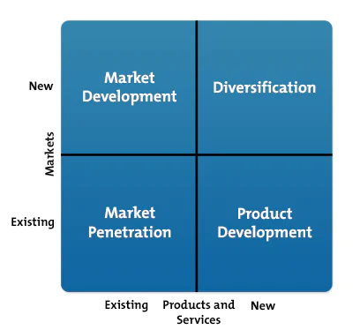

Modifications to the Marketing Mix
- Pricing: Modifying pricing to reflect customer preferences in order to increase visitor traffic.
- Product: To offer fresh services like sporting events and festivals.
- Place: In developing markets.

Techniques

Marketing Strategies

Product Details
The hotel Six Senses provides luxury services and is known in some of the most amazing and breathtaking locations in the entire world. Each hotel is made to provide a special and mesmerising experience for customers, health and normalising culture (Rahmi, 2021). The hotel gives a wide variety of customised services, from private bungalows to beach-facing rooms and a different range of hotel services, covering top-class food, spas, and adventurous experience.

Pricing of hotels
The price plans for Six Senses Hotels in the UK are built for a surcharge pricing, giving back the luxury and different nature of the services the hotel is providing and unique experiences. The business makes sure to search the market for their demands about the pricing of hotels, benefits of the customers, and the marketing plans to make sure the proper pricing and offers. There are different ranges of prices for guests based on the locality and accommodation of customers; normally, there are at the higher part of the market (Reyes-Menendez, 2019 ). The price is shown on multiple social media platforms, on the Six Senses official website, travelling agencies.

Place
Currently, there are 19 Six Senses hotels and resorts located in 14 different countries. This group includes countries like Thailand, Vietnam, the Maldives, Oman, Portugal, China, and many more. More five-star resorts will be added by the Six Senses hotel chain in far-flung locales around the globe.

Promotion
While promoting Six Senses hotels and their resorts, the business will make use of a variety of different marketing plans. These can include printing and online marketing, social media ads, influencer collaboration, and unique marketing programs. Six Senses strengthens its brand value for a luxury experience to attract customers who are excited to try new and improved services and experiences (Sharma, 2019).

Tactics
Reach | Increase social media presence and use targeted digital marketing efforts to raise brand awareness and draw in more customers internationally.
Act | Engage and catch the interest of your target audience by hiring well-known bloggers and celebrities.
Convert | The website and booking process may be made more efficient to increase sales conversions and customer satisfaction. Make the website appealing and simple to use.
Engage | Obtain client input using social networking channels. Participate in the discussion threads on various social media sites, including Facebook and Instagram.

Action
Successful marketing strategies and awareness are crucial in executing different marketing plans. Prioritising the customers and the hotel management, in addition to effective time control, is the key to achieving different results. The Gantt chart used shows an arrangement of marketing strategies, with a centre of attention towards social media platforms such as Facebook, including trendsetters, to reach the desired audience.
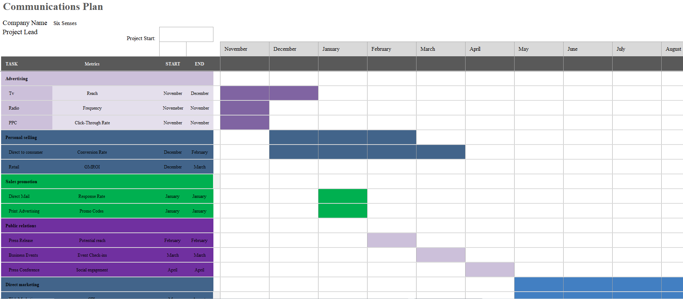

Control
To make sure the victory of Six Senses' marketing strategy, different benchmarks should be made to achieve, depending upon the marketing aims. The new benchmark is to attract new customers through digital media platforms like Facebook, Instagram etc. The benchmark is set to maintain the hotel's reputation and gain new customer's interest towards the brand, which will gain through reviews, evaluation on social media, and website reviews. Additionally, increasing sales and profits will be beneficial for marketing strategy. The overall performance of the unique marketing platforms will be evaluated through regular checking, and making changes will help to correct them (Xia, 2020). Daily reviews of social media activities' benefiting the hotel to make sure that marketing strategies are being done and to evaluate areas for better development.

Conclusion
In this report, the strategic marketing plan for the hotel Six Senses has suffered from many challenges, with high-level competition and influenced by visible factors like in times of pandemic. To get a better outcome of these difficulties, the strategy is to provide suggestions for focusing on distinctive services, partnerships with investors, and using different digital marketing platforms. However, The Six Senses hotel brand is committed to improving positioning and client engagement. In Addition, Ansoff's Matrix is used by the Six Senses Hotel brand to encourage variety. However, six Senses employs the RACE approach, allowing the company to reach a larger audience globally. Therefore, regular checking on the updated trends and analysing the marketing trends are also important to make sure about the desired target that is achieved and to ensure chances for better improvement.

References
Andrade, J.F., Kalakou, S. and Lopes da Costa, R., 2022. Exploratory analysis of seaplane operations in Greece: insights of a survey and SWOT analysis. European Planning Studies, pp.1-21.
Chandran, C. and Bhattacharya, P., 2021. Hotel's best practices as strategic drivers for environmental sustainability and green marketing. In Consumer Behaviour in Hospitality and Tourism (pp. 66-81). Routledge.
Cheng, F.W., 2016. Constructing hotel brands. Ibérica, (31), pp.83-108.
Chow, B.C., Choi, P.H.N., Huang, W.Y. and Pan, C.Y., 2020. Promoting physical activity in group home settings: Staff perspectives through a SWOT analysis. International Journal of Environmental Research and Public Health, 17(16), p.5805.
Chung, K.C., 2020. Green marketing orientation: Achieving sustainable development in green hotel management. Journal of Hospitality Marketing & Management, 29(6), pp.722-738.
Palmatier, R.W., Martin, K.D., Palmatier, R.W. and Martin, K.D., 2019. Effective Privacy Marketing Strategies. The Intelligent Marketer’s Guide to Data Privacy: The Impact of Big Data on Customer Trust, pp.169-181.
Perez-Aranda, J., Vallespín, M. and Molinillo, S., 2019. Hotels’ online reputation management: benefits perceived by managers. International Journal of Contemporary Hospitality Management, 31(2), pp.615-632.
Rahmi, E., Zaini, M., Muslim, M. and Junaris, I., 2021. Marketing strategies education oriented market, customers and advantages competitive. Journal of Education and Teaching Learning (JETL), 3(3), pp.29-40.
Reyes-Menendez, A., Saura, J.R. and Martinez-Navalon, J.G., 2019. The impact of e-WOM on hotel management reputation: exploring TripAdvisor review credibility with the ELM model. Ieee Access, 7, pp.68868-68877.
Sharma, R. and Heidari, D., 2019. SWOT Analysis of Corporate Social Responsibility in the Hotel Industry. Journal of Information and Computational Science, 9(9), pp.840-849.
Shen, H., 2015. Critical success factors for leading hotel brands in Asia: a case study of Banyan Tree. International Journal of Marketing Studies, 7(3), p.19.
Sofronov, B., 2019. The development of marketing in the tourism industry. Annals of Spiru Haret University. Economic Series, 19(1), pp.117-127.
Tanford, S. and Malek, K., 2015. Segmentation of reward program members to increase customer loyalty: The role of attitudes towards green hotel practices. Journal of Hospitality Marketing & Management, 24(3), pp.314-343.
Xia, H., Vu, H.Q., Law, R. and Li, G., 2020. Evaluation of hotel brand competitiveness based on hotel features ratings. International Journal of Hospitality Management, 86, p.102366.

Appendix – Presentation



