

Introduction to Health and Social Care
Component 1: Portfolio – Two Tasks
Student Name: Thahmida Khanom
Student ID: 2531916
Module Code: LCHS4003
Lecturer: Sam parket
Internal Verifier: Dr Besty Jose
Page 2 of 10

Page 3 of 10

Task 1 Report: Ambulance Services in the UK
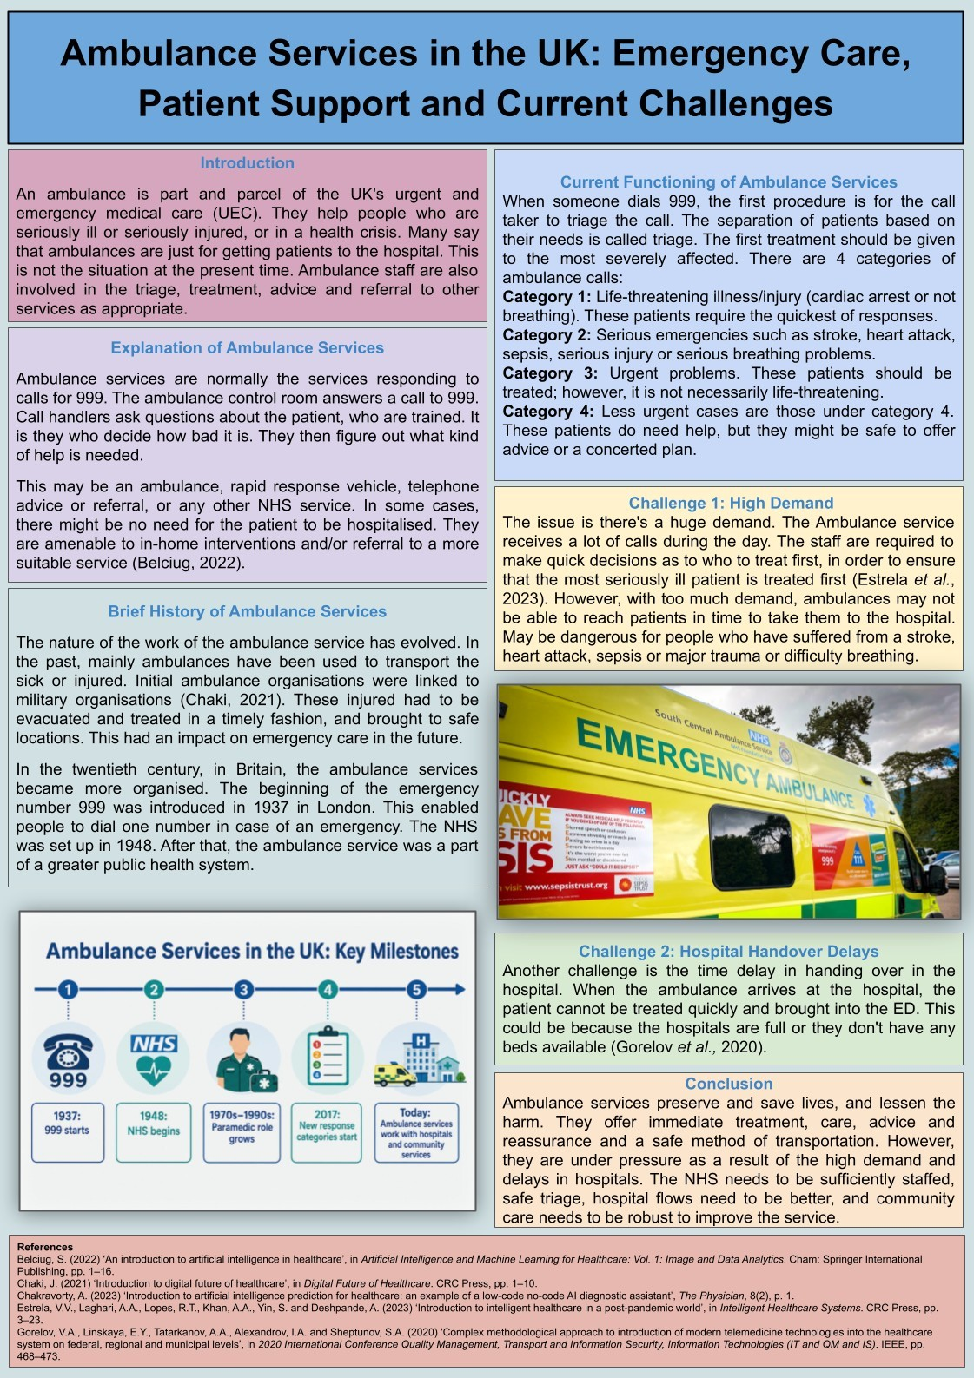
Page 4 of 10

Introduction
An ambulance is part and parcel of the UK's urgent and emergency medical care (UEC). They help people who are seriously ill or seriously injured, or in a health crisis. Many say that ambulances are just for getting patients to the hospital. This is not the situation at the present time. Ambulance staff are also involved in the triage, treatment, advice and referral to other services as appropriate.The following is an explanation of the ambulance services (this report). It also offers a short historical context as well as the current functioning of the service, and two big challenges. These are high demands and delays in handover in the hospitals.

Explanation of Ambulance Services
Ambulance services are normally the services responding to calls for 999. The ambulance control room answers a call to 999. Call handlers ask questions about the patient, who are trained. It is they who decide how bad it is. They then figure out what kind of help is needed.
This may be an ambulance, rapid response vehicle, telephone advice or referral, or any other NHS service. In some cases, there might be no need for the patient to be hospitalised. They are amenable to in-home interventions and/or referral to a more suitable service (Belciug, 2022).
Ambulance services consist of a call handler, dispatcher, paramedics, emergency medical technicians, advanced paramedics, clinical adviser or sometimes mental health staff. They are mainly there to ensure the right care, at the right time and to the right patient.

Brief History of Ambulance Services
The nature of the work of the ambulance service has evolved. In the past, mainly ambulances have been used to transport the sick or injured. Initial ambulance organisations were linked to military organisations (Chaki, 2021). These injured had to be evacuated and treated in a timely fashion, and brought to safe locations. This had an impact on emergency care in the future.
In the twentieth century, in Britain, the ambulance services became more organised. The beginning of the emergency number 999 was introduced in 1937 in London. This enabled people to dial one number in case of an emergency. The NHS was set up in 1948. After that, the ambulance service was a part of a greater public health system.
The more time, the better the skills of the ambulance personnel. No longer was it just a job driving. They were trained as health workers and were able to evaluate, give medicines, use
Page 5 of 10
equipment, and make clinical decisions. Urgent care is now provided by Ambulance services to the individual before he/she reaches hospital.

Current Functioning of Ambulance Services
When someone dials 999, the first procedure is for the call taker to triage the call. The separation of patients based on their needs is called triage. The first treatment should be given to the most severely affected. There are 4 categories of ambulance calls:
Category 1: Life-threatening illness/injury (cardiac arrest or not breathing). These patients require the quickest of responses.
Category 2: Serious emergencies such as stroke, heart attack, sepsis, serious injury or serious breathing problems.
Category 3: Urgent problems. These patients should be treated; however, it is not necessarily life-threatening.
Category 4: Less urgent cases are those under category 4. These patients do need help, but they might be safe to offer advice or a concerted plan.
Ambulance personnel arrive to look in on the patient. They may include the measurement of breathing, pulse, blood pressure, oxygen, pain, blood sugar and mental status. They can give first aid, oxygen, drugs and life-saving (Chakravorty, 2023). They will be able to take the patient to the hospital. They may also be able to give home care or a referral to another service.
The Ambulance liaises closely with NHS 111, A&E, GP, Urgent Treatment Centre, Mental Health Crisis Team, Community Nurse and Social Care.

Challenge 1: High Demand
The issue is there's a huge demand. The Ambulance service receives a lot of calls during the day. The staff are required to make quick decisions as to who to treat first, in order to ensure that the most seriously ill patient is treated first (Estrela et al., 2023). However, with too much demand, ambulances may not be able to reach patients in time to take them to the hospital. May be dangerous for people who have suffered from a stroke, heart attack, sepsis or major trauma or difficulty breathing.
Staff are also under a great deal of stress due to the high demand. Paramedics and call handlers are in stressful situations. This can impact their well-being and health.
Page 6 of 10

Challenge 2: Hospital Handover Delays
Another challenge is the time delay in handing over in the hospital. When the ambulance arrives at the hospital, the patient cannot be treated quickly and brought into the ED. This could be because the hospitals are full or they don't have any beds available (Gorelov et al., 2020).
Time delays in handover can hurt the patient. They may not be allowed to attend the hospital, and will be forced to wait in an ambulance. This also hinders emergency services from attending to new 999 calls from ambulance crews.

Conclusion
Ambulance services preserve and save lives, and lessen the harm. They offer immediate treatment, care, advice and reassurance and a safe method of transportation. However, they are under pressure as a result of the high demand and delays in hospitals. The NHS needs to be sufficiently staffed, safe triage, hospital flows need to be better, and community care needs to be robust to improve the service.
Page 7 of 10

Task 2: Essay

Community Mental Health Services
Mental health services in the community assist a person with mental health problems who is not in a hospital. These services are designed to help people live safely at home and within their community. They also contribute to the dignity, independence and recovery. The essay will outline how community mental health services developed, the current state of services and how community mental health services help people who use them have a better quality of life. It will also shed light on some of the current problems in the service.
In the UK, the historically most prominent way to provide mental health services was through the use of asylums, and this was largely based in hospitals. Many with mental illnesses were deprived of a normal community life. Several stayed at institutions for lots of years. This resulted in a lessening of their freedom and independence (Greenhalgh and Dijkstra, 2024). It also helped to create a stigma in that the mentally ill were seen as different. Times and attitudes changed in the 20th Century. The new medicines, new ideas of social care and human rights brought care into the community. This transition was enabled by the Mental Health Act 1959, which took a step towards care in the community and in hospitals and away from old-style asylums. The notion of care being delivered outside of the hospital, if this is suitable, was further emphasised the next year with the NHS and Community Care Act 1990.
Today, community mental health services are usually multidisciplinary, personnel provide. These teams may be comprised of psychiatrists, mental health nurses, psychologists, social workers, occupational therapists, peer support workers, support workers and pharmacists. They assess and monitor individuals and plan for crisis care, provide therapy, and manage risk (Gupta and Sedamkar, 2020). They may also be able to help you with housing, benefits, employment, health and social issues. This is important as mental health is linked to so much more than symptoms.
There are several good features to the existing service. Supports people to receive care in their local community. It can help them to stay with their family, keep up a daily routine and avoid going to the hospital. Trust can be developed by good community teams, and service users can be involved in the care plan. Can help others to feel valued and 'listened to' (Martin and Yap, 2026).
There are problems, as well. Lots of need for mental health services. It takes a long time for some to seek assistance. The waiting may worsen mental health issues. Others only get help
Page 8 of 10
at the crisis point. Staff may also have limited time with people due to a lack of staffing and/or high caseloads.
Having community-based mental health services can be beneficial to the quality of life. They can help manage symptoms, administer safe medications, reduce the risk for relapse and crisis planning (Tanwar, Parekh and Evans, 2020). They can further assist with housing, employment and education, relationships and social life. This can help people to be more independent and less isolated.
The conclusion is that the community mental health services were a result of "the shift in society from long-stay institutional care". Now they have an important role in mental health assistance. They improve the quality of life, but need to be supported with a shorter waiting time, more resourcing and better links with social care and community services.
Page 9 of 10

References
Belciug, S. (2022) ‘An introduction to artificial intelligence in healthcare’, in Artificial Intelligence and Machine Learning for Healthcare: Vol. 1: Image and Data Analytics. Cham: Springer International Publishing, pp. 1–16. DOI:10.1007/978-3-031-11154-9_1
Chaki, J. (2021) ‘Introduction to digital future of healthcare’, in Digital Future of Healthcare. CRC Press, pp. 1–10. DOI:10.1201/9781003198796-1
Chakravorty, A. (2023) ‘Introduction to artificial intelligence prediction for healthcare: an example of a low-code no-code AI diagnostic assistant’, The Physician, 8(2), p. 1.
DOI:10.38192/1.8.2.7
Estrela, V.V., Laghari, A.A., Lopes, R.T., Khan, A.A., Yin, S. and Deshpande, A. (2023)
‘Introduction to intelligent healthcare in a post-pandemic world’, in Intelligent Healthcare Systems. CRC Press, pp. 3–23. DOI:10.1201/9781003196822
Gorelov, V.A., Linskaya, E.Y., Tatarkanov, A.A., Alexandrov, I.A. and Sheptunov, S.A. (2020) ‘Complex methodological approach to introduction of modern telemedicine technologies into the healthcare system on federal, regional and municipal levels’, in 2020 International Conference Quality Management, Transport and Information Security, Information
Technologies (IT and QM and IS). IEEE, pp. 468–473.
DOI:10.1109/ITQMIS51053.2020.9322864
Greenhalgh, T.M. and Dijkstra, P. (2024) How to Read a Paper: The Basics of EvidenceBased Healthcare. John Wiley and Sons.
Gupta, S. and Sedamkar, R.R. (2020) ‘Machine learning for healthcare: introduction’, in Machine Learning with Health Care Perspective: Machine Learning and Healthcare. Cham: Springer International Publishing, pp. 1–25. DOI:10.1007/978-3-030-40850-3_1
Martin, B.C. and Yap, G.A. (2026) Strategic Planning in Healthcare: An Introduction for Health Professionals. Springer Publishing.
Tanwar, S., Parekh, K. and Evans, R. (2020) ‘Blockchain-based electronic healthcare record system for Healthcare 4.0 applications’, Journal of Information Security and Applications, 50, article 102407. DOI:10.1016/j.jisa.2019.102407
Page 10 of 10

