

Research Project in Contemporary Cosmology

Word count: 5245
For completion by the student:
Student Name: Patryk Lesner

Student University Email: 2522032@student.uwtsd.ac.uk
Module code: HPCA7016  Module title: Researching Contemporary Cosmologies | Student ID number:  2522032 |  |  | Educational support needs:  No
Assignment title: Research Project in Contemporary Cosmology

Assignment due date: 30/04/2026
This assignment is for the 1st 2nd 3rd 4th 5th 6th module of the degree
Plagiarism declaration
I confirm that this is my original work and that I have adhered to the University policy on plagiarism.

Artificial Intelligence (AI) declaration

I confirm that I have not used any AI tools in the research and creation of this assignment. I confirm that I have not presented any AI generated materials as my own work. I confirm I have copies of my drafts, notes, and other resources I used, which I may be asked to provide in evidence.

Signed: 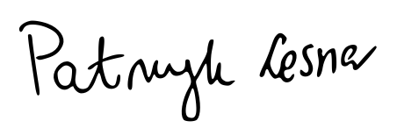
Date: 29.04.2026

Assignment Mark
1st Marker’s Provisional mark
2nd Marker’s/Moderator’s provisional mark
External Examiner’s mark (if relevant)
Final Mark

NB. All marks are provisional until confirmed by the Final Examination Board.

For completion by Marker 1 :
Comments:

Marker’s signature: |  |  | Date:
For completion by Marker 2/Moderator:

Comments:

Marker’s Signature: |  | Date:
External Examiner’s comments (if relevant)

External Examiner’s Signature: |  | Date:

Introduction
According to a report by the Pew Research Center, in 2024, 27 percent of American adults declared a belief in astrology to some extent. The report indicates, citing historical data from 2017, that the numbers did not change significantly and remained in the range of 27 to 29 percent. Moore in the Gallup poll from 2005 provides similar figures, which is 25 percent, but also provides figures from historical surveys, from 23 percent in 1994 to 28 percent in 2001. Campion reported similar figures from research conducted in 2002 among students at Bath Spa University College with 23.6 percent of those who believe at least moderately in astrology. Campion also conducted research in 2003 among golf club members, with 31 percent of participants declaring at least a moderate belief in astrology. The numbers remain pretty constant when the whole population is studied, but in the case of particular groups, such as members of the National Federation of Spiritual Healers from Glastonbury studied by Campion in 2004, the statistics may be significantly higher, with 91.1 percent of those who believe at least moderately in astrology.
The research question was, ‘What IT engineers think about astrology?’. Thus, this study explores the beliefs, personal experiences, and attitudes towards astrology among technical specialists working in the IT industry in Poland and the Czech Republic. The purpose of this research was to understand the perception of astrology among members of a specific occupational group of adults. Studies on how people view astrology have already been conducted. In 2011, Sugarman et al. published a study on a group of undergraduate students at the University of Arizona. Campion, in 2012, published study conducted from 2002 to 2004 on groups of undergraduate students, golf club members, and dance festival participants. In 2025, Edwards et al. published an analysis of the General Social Survey from 1974 to 2024. However, studies on how technical IT professionals view astrology are rare. Thus, this field remains barely explored.

Rationale
To some extent, Edwards et al. give an idea of ​​what the possible answer to the research question might be concluding that education level, more than other factors, correlates to disbelief in astrology. According to Eurostat, in 2025 around 75 percent of IT workers within European Union held higher education degree. Campion’s research revealed that the extent of astrological beliefs is not homogenous among various groups. Based on this, it seems reasonable to claim that the study group of people who mostly hold higher education degrees should demonstrate belief in astrology at a lower level than the whole population. However, without checking, it would be harmful and superficial to say that IT specialists are down-to-earth people and therefore do not believe in astrology. Therefore, the actual state.
This research provides insight into one of the many aspects of spirituality, i.e. astrological beliefs, and the perception of astrology among IT professionals. It does not only contribute to the academic field but also can help participants understand their professional group. It may also help companies decide on workplace initiatives related to the spirituality of their employees.

Current academic discourse
There are reports and studies conducted on the extent of belief in astrology. For example, in 2011 Sugarman et al. published research where 29.1 percent of fine arts and humanities students declared that they perceive astrology as ‘not at all scientific’ whereas college students of science declared the same view in 51.9 percent of cases. Brady, scientist associated to studies on astrology, published in 2025 research on a group of 1062 astrologers, however, the focus was put on their perception of fate. In 2021, Temcharoenkit and Johnson published results of the research on the group of 253 Thai people and their beliefs in fortune telling. There is also analysis conducted by Noy et al. in 2025 about the role of astrology in the contemporary world. Finally, Andersson et al. analyse the relationship between personality, intelligence and believing in astrology. However, astrology is not often the main subject but rather one of many elements of a wider set of beliefs. Gallup provides survey data at least from years between 1990 and 2005, but astrology is treated as a part of paranormal phenomena not as a main subject. Pew Research Center also provides survey data, but also treat astrology as a part of set of beliefs. Astrology appears in the same configuration in the research published in 2023 by Silva. The latest research and reports found examine astrology beliefs in relation to political views, gender, religious associations, race and ethnicity, orientation, age, or LGBT identity, but rarely to the occupational group. Among mentioned research, only Sugarman and Campion studied attitude towards only astrology among the members of college and university students’ groups, therefore it is possible to link the educational background with occupational pathway and examine their relation to astrological beliefs, which is not possible in case of much research. This research attempts to investigate such a relationship.
Research on attitudes towards astrology in a particular group, such as IT professionals, are not available, but there is research on the relationship between religiosity or spirituality and occupational pathways, and engagement in work is also a subject for research. For example, Skrzypińska and Atroszko in 2015 concluded that personality, including spirituality, is an important factor related to the choice of a career path. In 2020, Rożnowski and Zarzycka concluded that highly religious employees may be less career-oriented compared to their less religious coworkers. Rożnowski and Zarzycka also note that gender may influence that relationship. Dudeck noted that relation between intrinsic work values and spirituality level is stronger compared to extrinsic values. Despite these studies do not refer directly to astrology, it can be concluded that spirituality, including astrological beliefs, with gender playing a moderate role, may correlate with working style and chosen career direction.
The relationship between spirituality and working style has been discussed in academic discourse, similar to the conflict between science and religion or beliefs in astrology. Edwards et al. noted that education is a good predictor of astrological disbelief. In addition, Damper also concludes that the conflict is the only possible and inevitable relation between science and religion. However, Kaden argues that religious beliefs are often eclectic and consistent with the scientific views of individuals, and therefore the conflict between science and religion is something individual and not general. Taking this into account, it is not unexpected that some participants in this study perceived astrology as complementary to science or accepted the possibility that it may not be merely a superstition.
This research attempts to explore the relationship between technical education background and belief in astrology, enrich academic knowledge by examining the perception of astrology among IT professionals, and explore how personal beliefs in astrology can coexist with working in the specific IT industry. In addition, the role of gender cannot be ignored in research. From the current academic discourse, the conclusion is that astrological beliefs and working in the tech industry do not often coexist.

Methodology
Mixed methods were used in this research, which were divided into two phases. First, a questionnaire was selected as a quantitative method to examine the participants’ perceptions of astrology, experience with it, and knowledge about it. Most of the questions included in the questionnaire were adapted from previous research, i.e. Bauer and Durant published in 1997, and Campion in 2012. In addition, questions specific to the IT industry were added, i.e. about the perception of believing in astrology. Another added part was open-ended questions about personal experiences in relation to the answers to closed-ended questions. The questionnaire began with preliminary questions regarding gender, age range, nationality, job category, and education. The questionnaire ended with a voluntary open-ended question asking for any thoughts or comments, following the work of Brady, who highlighted the importance of giving the participants the possibility to express their own thoughts that may not be necessarily an answer to a specific question. Four participants shared their thoughts. All questions were either optional or had the option ‘Prefer not to say’ or ‘No opinion’ where relevant, allowing participants to provide as little personal data as they preferred.
The questionnaire was initially shared with four people, including two working in the IT industry, to check whether it was understandable. After a few minor amendments, two identical forms were prepared and distributed online. The data were collected online from 19th to 31st of March 2026 among the residents of Poland and the Czech Republic. The first copy marked L1, was distributed on social media platforms such as LinkedIn, Czech and Polish Facebook groups, and one Discord server, as well as directly to personal contacts on LinkedIn. Prior to sharing the link to the questionnaire, permission was obtained from the administrators and owners of the online spaces where required. Seven records were obtained using this questionnaire. The second copy, marked W1, was shared on Teams at the researcher's workplace with prior agreement from the HR department and six former coworkers of the researcher. The coworkers later shared links with their colleagues. Thirty-three records were collected through this questionnaire, which indicates high efficiency of the snowball sampling method as argued by Hennink et al. that it is particularly suitable in the case of participants with very specific characteristics, i.e. occupation, residency, location and remote work making it difficult to reach out to them in person. The questionnaire is attached in Appendix A.
In addition, according to Hennink et al. the quantitative method allows gathering relatively large sample of answers, further analysis and identification of patterns of attitudes, correlations, and divisions into groups. However, Bell et al. argues that one of the disadvantages of this method is that it does not allow to get an insight into the personal experience, thoughts and feelings of the individual. In addition, Guetterman et al. argue that mixed methods provide more nuanced understanding of the studied phenomenon because of integrating data from quantitative methods and personal insights collected by qualitative methods, hence the qualitative method was employed as a second phase of the data collection phase.
Based on the answers provided through the questionnaires, six participants were selected from those who gave prior consent to be contacted, and invitations for an interview were sent. Eventually, three interviews were conducted: one with a participant who slightly believed in astrology, named Linda, one with a participant who described herself as an ‘uninformed sceptic’ who did not believe at all, and the last one with a participant, named Grace, who strongly believed in astrology. After each interview, the participants received an email with an anonymised transcript for confirmation. All recordings and transcripts on Teams were deleted after confirmation was obtained from participants.
Anonymity was ensured by the voluntary provision of an email address and other demographic data. The demographic questions themselves were also constructed in a way that participants could not be identified based on the answers provided, for example, asking about age range instead of exact age, or job category instead of exact job title. The answers provided were pseudonymised during the data collection phase. Eventually, after the end of the data collection phase, the answers were anonymised, meaning that the participants were no longer identifiable. The interviewees were informed about anonymity and confidentiality through the introduction to the questionnaire, as well as through the interview consent form attached as appendix B, and during the interviews. The survey was conducted in English with supporting examples in Polish and Czech, and the interviews were conducted in Polish, because this was the native language of the researcher and the interviewees. The answers were translated as they were spoken. The names of participants were changed in way that their genders were reflected. The answers from the questionnaires retained the original spelling, with minor corrections that did not change the meaning. The research procedure was conducted in line with British, Polish, and Czech ethical guidelines, and policies from university.

Problems
Due to the differences in the educational systems of Poland and the Czech Republic, it was difficult to set up a set of possible answers to the question about the education level that would be common for both countries, considering that participants could have degrees obtained in educational systems from other countries. In 2021, Schneider presented unified framework based on International Standard Classification of Education (ISCED) allowing to join possible education levels for both countries in one question. It was cross-checked with data provided by European Education and Culture Executive Agency about the educational systems in both countries. The division consisted of five educational levels encompassing the most common ones, with supporting examples in English, Polish, and Czech. Despite the questionnaire being sent to four people to check the clarity of questions, during the data collection phase, for two participants who held a PhD. degree, it was unclear which level should be chosen. After it was noticed in the answers during the data collection phase, an additional example was added to the question. To create a question regarding job category that maintained anonymity, reflected the diversity of technical positions in the industry, and provided a limited number of options to make the choice simple for the participants, a question was asked to the IT community on the LinkedIn platform, with an initial division into categories and a request for feedback and suggestions. Seven groups were selected based on the answers provided.
Observations suggest that during the interviews, the interviewees responded with some hesitation. This may have been due to the personal acquaintance of the researcher and the interviewees, which could have led the interviewees to potentially attempt to provide answers that would satisfy or not offend the researcher. Furthermore, participants may have that felt their knowledge was being tested despite assurances that the study was not a knowledge test and therefore, they may not have responded to the best of their knowledge. One participant explicitly stated during a conversation that before opening the questionnaire, they needed ‘to learn everything about astrology’ because they might have incorrect knowledge about it, despite assurances that every opinion is valuable and that the study does not focus on knowledge of astrology.

Study group
A total of 40 participants provided their answers. Five did not consent to participate and process their personal data resulting in five empty forms. Therefore, only those who provided their consent were included in the statistics. The study group comprised mostly men, people aged 25-34, higher education degree holders, Poles, and QA engineers and testers. The most numerous group was QA engineers and testers, which was 19, and ten software developers.

Table 1. Characteristics of the study group
Variable | N | %
Sex
Female | 8 | 23%
Male | 27 | 77%
Age
18-24 | 1 | 3%
25-34 | 23 | 66%
35-44 | 11 | 31%
Education
Tertiary/Higher education | 28 | 80%
Upper secondary | 7 | 20%
Nationality
Czech | 6 | 17%
Polish | 28 | 80%
Ukrainian | 1 | 3%
Job Category
Developers | 10 | 29%
Infrastructure and DevOps | 4 | 11%
QA Engineers and Testers | 19 | 54%
Technical Managers | 2 | 6%
Note. N=35

According to Eurostat, in 2025, men made up 83 percent of all ICT employees in European Union, while the numbers are higher in Poland and Czechia, which was 87 percent and 93 percent respectively. Therefore, the gender division in the study group seems to differ slightly from that for the entire occupational group. Eurostat also report that the higher education degree holders made up 75 percent in European Union in 2025 and 60 up to 61 percent in Poland and Czechia respectively. In the research group, 80 percent had higher education. The same data show that the quantitative ratio of Polish to Czech IT employees is approximately 4.7, which is reflected in the study group. Based on that, the study group differed slightly from the general occupational group in terms of gender and education, which, as mentioned, are factors influencing the perception of astrology or the level of spirituality.

Findings

The extent of disbelief
From the data collected through the questionnaire, it seems that only eight participants believe in astrology at least slightly, which is 22 percent, including two participants who believe strongly. The figure is slightly lower compared to the whole population and similar to Campion’s research on the college students. The majority of the study group, 21 participants, declared that they do not believe in astrology at all. Six participants did not have an opinion or were neutral. The results are presented in Figure 1. Aggregated statistics from closed-ended questions are attached in appendix C.
The participants remained consistent in their responses when they described their experience with astrology, and most of them (20) declared that they do not read horoscopes, whereas 17 answered that they do not take it seriously at all. On the other hand, 15 participants read the horoscope columns, but not more than once a month, and nine of them also do not take it seriously at all. The results are shown in Figure 2. However, only one respondent declared that they do not know their sun sign. In addition, three participants declared that they knew their Moon sign and six declared that they knew their rising sign, but these were participants who believed to some extent in astrology or remained neutral. This shows that popular astrology is known at least at a basic level, even among those who do not believe in it.
Figure 1. The extent of belief in astrology among participants | Figure 2. Frequency of reading and attitude to horoscopes

Figure 3. Kinds of attitude among participants | Figure 4. The extent of belief in astrology for education degrees
Most of the participants reject astrology, and most of them said that belief in it is widely regarded as something negative or they do not treat it as something serious. The results are presented in Figure 3. The most often view declared is that, in the IT industry, belief in astrology is met with scepticism highlighting the importance of technical background as one respondent wrote
I guess engineering roles (both IT and elsewhere) could imply a more mechanistic understanding of the world, hence astrology perceived negatively/sceptically. This is probably not universal. For people in IT who are working in less technical roles I would guess that there is no correlation at all.
Another respondent similarly highlighted the importance of a scientific approach among IT employees, saying, ‘I believe that most of the IT people take a practical approach based on facts and science and do not focus on such areas’. However, those who declared belief in astrology at least to some extent held higher degree diploma, as shown in Figure 4, nevertheless, they were minority. This confirms the hypothesis adopted by Edwards et al. regarding negative corelation between level of education and belief in astrology.
A scientific attitude does not have to mean total rejection of astrology. One participant holding PhD. degree, called herself Uninformed Sceptic and she declared no belief in astrology at all, however she admits, as a scientist, the possibility that astrology may work sometimes saying
My mother is Leo and yes, Leos like to rule just like my mother […] personal horoscope, the one of my father, for me, also seemed to suit him, at least in some aspects […] there were always some traits that actually coincided with […] these horoscopes and I managed to find something in my father and in my brother […] Nowadays I am not interested in it at all, it doesn’t suit me at all, it does not suit … well, to knowledge, to science, to such a passion for scientific and verifiable stuff and such testable things describing truth and so on.
When asked how she thought it might work, she replied
Well, I don't know, because it doesn't make sense... that it could work, but damn... it works a bit too much for it to be a coincidence and it gives me a syntax error and I don't like it.
This shows that nonbelievers may feel uncomfortable because of contradictory views and observations. Except scepticism, another attitude demonstrated by nine participants was thinking about astrology as something not serious. The interviewee, called Linda, bases her attitude on her sympathy for a believing person writing in the questionnaire
I think it can be seen as a silly hobby, harmless and quite charming, it all depends on the person and their character, if we like that person then it is a nice addition to the character, if not necessarily then we can see it as a negative trait
Based on this, believing in astrology may not only be frowned upon among coworkers in the IT industry but also in non-work life. Another participant confirmed this in the survey, stating that ‘in general it's mostly a subject of jokes and not treated seriously’. Treating astrology as something not serious is not yet on the extreme end of the disbelief spectrum. Four participants declared negative attitudes, and one connected believing in astrology with lower intelligence. The opinions of those who do not believe in astrology were less radical, and these participants just declared no belief in it at all.
In all job categories, disbelief is the prevailing attitude. Figure 5 shows that only one technical manager out of two and seven QA engineers and testers out of 19 declared that they believe in astrology, at least slightly. On the other hand, all software developers rejected believing in astrology. This, as mentioned by another participant, may be related to the extent of the technicality of the work done by these groups. Software developers work closely with a code, whereas QA engineers and testers’ work varies from very technical and direct work with a code to work where no technical background is needed, hence the latter may be a group with more diverse attitudes towards astrology. Damper’s argument about inevitable conflict between science and religion has been confirmed in the case of the study group. However, the minor group of respondents who do not reject astrology confirms Kaden’s claim about the conflict between science and religiosity as something personal, hence some members of the study group accept astrology.
Figure 5. The extent of belief in astrology for job categories | Figure 6. The extent of belief in astrology for genders

The role of gender
The participants mentioned how belief in astrology is perceived in terms of gender, as expected based on the current academic discourse. The first view was that people working in the IT industry tend not to believe in astrology because this industry is dominated by men who are seen as those who do not believe in astrology. The two female participants assumed that ‘since it's a mostly male environment, I don't think they're particularly bothered by it’ and ‘the division is very similar to other industries in that it seems to me that mostly women are interested in or believe in astrology and men are not’ whereas one male participant wrote that ‘It's less frowned upon when the believer is a woman’ seeing astrology as something more appropriate to women. On the other hand, the interviewees did not fully share the view that astrology is something typical for women exclusively, but they noted that women are seen as those who tend to believe in astrology more often. Uninformed Sceptic did not even notice the relationship saying that age is a factor playing more significant role. Linda claimed that she did not notice such relationship among men in her surroundings. Grace, as the only one, claimed that ‘men are much more sceptical of the whole concept’. These kinds of views are coherent with the answers from the whole study group. Figure 6 shows that three women, which is 40 percent of all women participants, and five men, which is 19 percent of men participants, declared a belief in astrology. Such result corresponds with results of study Dudeck where gender influence the extent of spirituality.

The extent of belief
Regarding personal readings, only two participants have ever met with an astrologer for consultation. The first one declared that he does not read horoscopes and does not take them seriously at all, but believes slightly in astrology, and the astrologer’s reading was useful for him as he wrote, ‘I did a few personal readings with an astrologer. He gave me some pretty good advice which turned out well in time’. In addition, this participant declared that he could change his behaviour because of what he read in his horoscope, but only if it confirmed his observations, claiming, ‘I would take this as another piece of the puzzle’. The second participant, named Grace, declared that she reads horoscopes less often, and do not take them very seriously, but she strongly believes in astrology believing that science and astrology are not in conflict saying
I think that they are absolutely not contradictory in the sense that I would never separate them, it's a bit for me... it's a bit like medicine and physiotherapy ... that ... uh ... that this is despite the fact that doctors will probably say, for example, that physiotherapy is a lie, and people, for example scientists or some ... standing on the side of some hard scientific premises ... I think that … that it is in a certain way complementary, it is certainly not mutually exclusive. Yes, yes, at least that's what I think, and I think that both can successfully coexist.
In addition, she gives an example of personal experience of the influence of planets on human affairs saying
[…] if you hadn't told me that there is such a thing as planets that turn retrograde, well, I thought that people have, I don't know, a bad day or a bad three weeks [laughing] but for me, the representative example is the fact that I have to ask you if it's retrograde, and if it is, you can't get along with people, but you can't get along in a way that you say something to someone in the same language that you communicate with them on a daily basis and there is a wall and I don't know, these people hear something different. I ... I don't know, it's … it's incomprehensible. […] Perhaps I don't fully understand it […] but I see an absolute correlation that if there is such a decline somewhere at the level in the communication area, there is always something in retrograde.
Linda, a participant slightly believing in astrology also do not see the conflict between science and astrology saying
I used to think that the more educated a person, the more experience, or the higher their academic degree, it wouldn't be compatible with any religion or belief beyond the field of tangible and scientifically provable stuff. But lately, it seems to me that the higher academic degree one has, or the more one learns, the more I realize that not everything can be described scientifically, and that science ends somewhere and the non-scientific area begins. Either some scientists decide it's a black hole and don't want to delve into it at all, or there are scientists who are just going deep into astrology or some other religion or belief of their own. There's […] This actress, she's a neurologist, no, she has some sort of doctorate in brain science. She played one of the leading female roles in "The Big Bang Theory", and she's a high-ranked scientist. She has many these academic degrees, and yet she's very vocal about what a believer she is and how science has helped her become even more firmly established in that faith. She's realized that at some point, science ends and it's beyond... beyond the scale of what happens next, and only faith can describe this reality for her. So, I used to think the two were incompatible. Now I think the two don't exclude each other.
She does not find astrology as something serious, but rather a form of entertainment. Even though, she notes the influence of the sky on the human affairs saying
Agriculture, it is now the time, you know, for planting and so on. Even my parents wait for a full moon. Maybe after the first full moon or something, and only then we can plant or put things in the ground, so that's all ... we don't even realize we believe in it until we think about it more deeply. Because when we arranged our meeting, I started wondering what I actually know about astrology. Well, I know almost nothing, I know only that I know my zodiac sign and that's it, but then [...] it turns out it's not completely abstract, because somewhere in our lives we can see manifestations of the fact that we supposedly don't believe, but maybe we do.
This is a slightly different approach compared to most participants who perceive the influence of celestial bodies as mechanistic. In addition, the Uninformed Sceptic noted that
Science, rather […] is not in line with broadly understood esotericism, whether it's astrology [...] or anything else, and there isn't much scientific research on this topic, and if there is, it doesn't prove any ... mmm ... there's no scientific evidence, not much to support this type of … mmm ... beliefs. But, as a scientist, I'll also emphasize this. It's always possible to prove that something exists, but in most cases, ... it's much more difficult to prove, or... if it's even possible at all, with complete certainty, that something doesn't exist. [...] a true scientist who understands what science is and what the scientific method is and how it works should nevertheless remember [...] that it's difficult to prove that something doesn't exist. So, they should keep in mind that just because it hasn't been proven it doesn't mean that it doesn't exist.
The quotes above show that even sceptics or people who believe only slightly in astrology do not consider the conflict thesis as valid noting that these two domains can be complementary to each other, or at least, they approach the topic with scientific openness, according to which not everything can be understood and described with a scientific approach. In addition, the participants are aware of the influence of the sky on particular areas of human affairs, such as agriculture.

Conclusions
To thoroughly understand the perception of astrology in the study group, more interviews are necessary. The case of Uninformed Sceptic shows that even though the person rejects astrology, they may present a more complex view when they are allowed to express their opinion more freely than by merely selecting an answer in the closed-ended question. This confirms the need of employing qualitative methods in studies on human beliefs as Hennink et al. argue that qualitative methods allow for a contextualised understanding of phenomena. In addition, in the questionnaires, the participants presented a wide plethora of opinions which had to be categorised to discuss and analyse the results while also keeping this paper not too long. Therefore, this study only explores a part of the complex phenomenon, and more extensive analysis and further research are needed to obtain results that would provide a more comprehensive picture of the subject.
Based on discussed examples, it seems clear that the results comply with the findings of Edwards et al. about the education level as a primary factor for disbelief in astrology. Most of the participants had a higher education and rejected belief in astrology on a higher level than the other research shows. However, this conclusion is drawn from quantitative data, and as noted above, those with negative attitudes towards astrology may demonstrate more complex views in the interviews. In addition, Damper’s conclusions about the conflict between science and religion seem reflected in the results. However, Kaden individual religious beliefs and scientific views also seem confirmed since a minor part of the study group to some extent declared the coexistence of science and astrology showing that the study group is not homogenous in terms of believing in astrology. The role of gender cannot be ignored. It is clear that women tend to believe in astrology more often which correspond with findings of Dudeck regarding spirituality. Nevertheless, most of the study group rejected astrology in favour of science, with which astrology is in conflict in their opinion, with a few exceptions who did not see this conflict.

References
Andersson, Ida, Julia Persson, and Petri Kajonius, ‘Even the Stars Think That I Am Superior: Personality, Intelligence and Belief in Astrology’, Personality and Individual Differences, 187 (2022), p. 111389, doi:https://10.1016/j.paid.2021.111389
Bauer, Martin, and John Durant, ‘Belief in Astrology: A Social-Psychological Analysis’, Culture and Cosmos, 1.01 (1997), pp. 55–71, doi:http://doi.org/10.46472/CC.0101.0211
Bell, Judith, Stephen Waters, and Helen Johnson, Doing Your Research Project : A Guide for First-Time Researchers, 8th edn (Maidenhead: Open University Press, 2024)
Brady, Bernadette, The Shape of Fate: From Classical Philosophy to Astrological Practice (Ceredigion, Wales: Sophia Centre Press, 2025)
British Educational Research Association, ‘Ethical Guidelines for Educational Research, Fourth Edition (2018)’, Ethical Guidelines for Educational Research, Fourth Edition (2018), 13 August 2019 <https://www.bera.ac.uk/publication/ethical-guidelines-for-educational-research-2018-online> [accessed 18 April 2026]
Campion, Nicholas, Astrology and Popular Religion in the Modern West: Prophecy, Cosmology and the New Age Movement, 1st ed (London: Taylor and Francis, 2016)
Damper, R. I., ‘Science and Religion in Conflict, Part 2: Barbour’s Four Models Revisited’, Foundations of Science, 29.3 (2024), pp. 703–40, doi:https://10.1007/s10699-022-09871-z
Dudeck, Jennifer M., ‘The Influence of Spirituality on the Career Development of College Seniors: An Examination of Work Values’, College Student Affairs Journal (Charlotte, United States), 23.2 (2004), pp. 185–96 <https://www.proquest.com/docview/224818209/abstract/5BEB146F64664229PQ/1?sourcetype=Scholarly%20Journals> [accessed 12 April 2026]
Edwards, Tobias, and others, ‘Intelligence and Individual Differences in Astrological Belief’, Journal of Individual Differences, 46.1 (2025), pp. 50–57, doi:https://10.1027/1614-0001/a000434
European Education and Culture Executive Agency, ‘Higher Education’, European Education and Culture Executive Agency, 18 September 2025 <https://eurydice.eacea.ec.europa.eu/eurypedia/czechia/higher-education> [accessed 14 April 2026]
——, ‘Overview’, European Education and Culture Executive Agency, 26 June 2025 <https://eurydice.eacea.ec.europa.eu/eurypedia/poland/overview> [accessed 14 April 2026]
——, ‘Single-Structure Primary and Lower Secondary Education’, European Education and Culture Executive Agency, 1208 2025 <https://eurydice.eacea.ec.europa.eu/eurypedia/poland/single-structure-primary-and-lower-secondary-education> [accessed 14 April 2026]
——, ‘Single-Structure Primary and Lower Secondary Education’, European Education and Culture Executive Agency, 21 October 2025 <https://eurydice.eacea.ec.europa.eu/eurypedia/czechia/single-structure-primary-and-lower-secondary-education> [accessed 14 April 2026]
——, ‘Upper Secondary and Post-Secondary Non-Tertiary Education’, European Education and Culture Executive Agency, 8 December 2025 <https://eurydice.eacea.ec.europa.eu/eurypedia/poland/upper-secondary-and-post-secondary-non-tertiary-education> [accessed 14 April 2026]
——, ‘Upper Secondary and Post-Secondary Non-Tertiary Education’, European Education and Culture Executive Agency, 16 December 2025 <https://eurydice.eacea.ec.europa.eu/eurypedia/czechia/upper-secondary-and-post-secondary-non-tertiary-education> [accessed 14 April 2026]
Eurostat, ‘Employed Persons with Information and Communications Technology (ICT) Education by Educational Attainment Level’, Eurostat, 2025, doi:https://10.2908/ISOC_SKI_ITEDU
——, ‘Employed Persons with Information and Communications Technology (ICT) Education by Sex’, Eurostat, 2025, doi:https://10.2908/ISOC_SKI_ITSEX
Górski, Andrzej, and others, Code of Ethics for Researchers, 4 December 2024 <https://pan.pl/app/uploads/2025/06/Code_of_ethics_for_researchers_2024.pdf> [accessed 15 April 2026]
Guetterman, Timothy C., and others, ‘Contemporary Approaches to Mixed Methods–Grounded Theory Research: A Field-Based Analysis’, Journal of Mixed Methods Research, 13.2 (2019), pp. 179–95, doi:https://doi.dox.org/10.1177/1558689817710877
Hennink, Monique, Inge Hutter, and Ajay Bailey, Qualitative Research Methods, Second edition (Los Angeles London New Delhi Singapore Washington DC Melbourne: SAGE, 2020)
‘ISO/IEC/IEEE 24765:2010(En), Systems and Software Engineering — Vocabulary’, n.d. <https://www.iso.org/obp/ui/#iso:std:iso-iec-ieee:24765:ed-1:v1:en> [accessed 17 April 2026]
Kaden, Tom, ‘The Sociological Study of Science and Religion and the Invisible Religion: Conditions of Possibility for the “Conflict Thesis”’, Human Studies, published online 25 September 2025, doi:https://10.1007/s10746-025-09817-x
‘Mayim Bialik | UCLA’, n.d. <https://www.ucla.edu/about/notable-bruins/43-mayim-bialik> [accessed 20 April 2026]
Moore, David W., ‘Three in Four Americans Believe in Paranormal’, Gallup.Com, 16 June 2005 <https://news.gallup.com/poll/16915/Three-Four-Americans-Believe-Paranormal.aspx> [accessed 13 April 2026]
Noy, Shiri, and others, ‘Contemporary Views and Uses of Astrology in the United States: A Descriptive, Mixed-Methods Analysis’, Social Currents, 12.5 (2025), pp. 456–71, doi:https://10.1177/23294965251360016
Průcha, Jan, and Roman Švaříček, ETHICAL CODEX FOR THE CZECH EDUCATIONAL RESEARCH: PROPOSAL AND ITS JUSTIFICATION, 7 September 2010 <https://capv.cz/wp-content/uploads/2019/08/CAPV09_Pru_Etick.pdf> [accessed 15 April 2026]
Rotolo, Chip, 30% of Americans Consult Astrology, Tarot Cards or Fortune Tellers (Pew Research Center, 2025) <https://www.pewresearch.org/wp-content/uploads/sites/20/2025/05/PR_2025.05.21_astrology-tarot-cards-fortune-tellers_report.pdf> [accessed 13 April 2026]
Rożnowski, Bohdan, and Beata Zarzycka, ‘Centrality of Religiosity as a Predictor of Work Orientation Styles and Work Engagement: A Moderating Role of Gender’, Religions, 11.8 (2020), p. 387, doi:https://10.3390/rel11080387
Schneider, Silke L., ‘The Classification of Education in Surveys: A Generalized Framework for Ex-Post Harmonization’, Quality & Quantity, 56.3 (2022), pp. 1829–66, doi:https://doi.org/10.1007/s11135-021-01101-1
Silva, Tony, ‘Masculinity, Femininity, and Reported Paranormal Beliefs’, Journal for the Scientific Study of Religion, 62.3 (2023), pp. 709–22, doi:https://10.1111/jssr.12862
Skrzypińska, Katarzyna, and Paweł Atroszko, ‘Ścieżka Zawodowa w Relacji Do Osobowości i Duchowości Człowieka/Occupational Pathway in Relation to Human Personality and Spirituality’, PSYCHOLOGIA ROZWOJOWA (Kraków, Poland), 20.2 (2015), pp. 41–56, doi:https://10.4467/20843879PR.15.009.3481
Sugarman, Hannah, and others, ‘Astrology Beliefs among Undergraduate Students’, Astronomy Education Review, 10.1 (2011), pp. 010101-010101–09, doi:https://10.3847/AER2010040
‘Syntax Error - Glossary | MDN’, MDN Web Docs, 11 July 2025 <https://developer.mozilla.org/en-US/docs/Glossary/Syntax_error> [accessed 19 April 2026]
Temcharoenkit, Sasiwimon, and Donald A. Johnson, ‘Factors Influencing Attitudes toward Astrology and Making Relationship Decisions Among Thai Adults’, Scholar (Bangkok, Thailand), 13.1 (2021), pp. 15–27 <https://www.proquest.com/docview/2802441115/abstract/D4B157C47DD74535PQ/1> [accessed 12 April 2026]

Online resources
British Educational Research Association, ‘Ethical Guidelines for Educational Research, Fourth Edition (2018)’, Ethical Guidelines for Educational Research, Fourth Edition (2018), 13 August 2019 <https://www.bera.ac.uk/publication/ethical-guidelines-for-educational-research-2018-online> [accessed 18 April 2026]
European Education and Culture Executive Agency, ‘Higher Education’, European Education and Culture Executive Agency, 18 September 2025 <https://eurydice.eacea.ec.europa.eu/eurypedia/czechia/higher-education> [accessed 14 April 2026]
——, ‘Overview’, European Education and Culture Executive Agency, 26 June 2025 <https://eurydice.eacea.ec.europa.eu/eurypedia/poland/overview> [accessed 14 April 2026]
——, ‘Single-Structure Primary and Lower Secondary Education’, European Education and Culture Executive Agency, 1208 2025 <https://eurydice.eacea.ec.europa.eu/eurypedia/poland/single-structure-primary-and-lower-secondary-education> [accessed 14 April 2026]
——, ‘Single-Structure Primary and Lower Secondary Education’, European Education and Culture Executive Agency, 21 October 2025 <https://eurydice.eacea.ec.europa.eu/eurypedia/czechia/single-structure-primary-and-lower-secondary-education> [accessed 14 April 2026]
——, ‘Upper Secondary and Post-Secondary Non-Tertiary Education’, European Education and Culture Executive Agency, 8 December 2025 <https://eurydice.eacea.ec.europa.eu/eurypedia/poland/upper-secondary-and-post-secondary-non-tertiary-education> [accessed 14 April 2026]
——, ‘Upper Secondary and Post-Secondary Non-Tertiary Education’, European Education and Culture Executive Agency, 16 December 2025 <https://eurydice.eacea.ec.europa.eu/eurypedia/czechia/upper-secondary-and-post-secondary-non-tertiary-education> [accessed 14 April 2026]
Eurostat, ‘Employed Persons with Information and Communications Technology (ICT) Education by Educational Attainment Level: [ED3-8] Upper Secondary, Post-Secondary Non-Tertiary and Tertiary Education (Levels 3-8) for European Union, Poland, and Czechia in 2025’, Eurostat, 2025,
<https://ec.europa.eu/eurostat/databrowser/bookmark/4212554b-023c-4f5c-864d-cb60f8d93d44?lang=en&createdAt=2026-04-20T09:47:19Z> [accessed 20 April 2026]
——, ‘Employed Persons with Information and Communications Technology (ICT) Education by Educational Attainment Level: [ED3-4] Upper secondary and post-secondary non-tertiary education (levels 3 and 4) for European Union, Poland, and Czechia in 2025’, Eurostat, 2025,
<https://ec.europa.eu/eurostat/databrowser/bookmark/e6d94614-cc11-497f-a9fd-93a131756b8f?lang=en&createdAt=2026-04-20T09:58:12Z> [accessed 20 April 2026]
——, ‘Employed Persons with Information and Communications Technology (ICT) Education by Educational Attainment Level: [ED5-8] Tertiary education (levels 5-8) for European Union, Poland, and Czechia in 2025’, Eurostat, 2025,
<https://ec.europa.eu/eurostat/databrowser/bookmark/ea0cd8d7-677c-4e09-bfbe-c8b3a55f1901?lang=en&createdAt=2026-04-20T09:58:49Z> [accessed 20 April 2026]
——, ‘Employed persons with information and communications technology (ICT) education by sex: Total for European Union, Poland, and Czechia in 2025’, Eurostat, 2025, <https://ec.europa.eu/eurostat/databrowser/bookmark/8d66f091-0d27-441f-9cbc-14b498d33e4d?lang=en&createdAt=2026-04-20T10:07:03Z> [accessed 20 April 2026]
——, ‘Employed persons with information and communications technology (ICT) education by sex: Females for European Union, Poland, and Czechia in 2025’, Eurostat, 2025, <https://ec.europa.eu/eurostat/databrowser/bookmark/3861b6e2-9fe5-4190-b6fa-cbef9038d298?lang=en&createdAt=2026-04-20T10:08:00Z> [accessed 20 April 2026]
——, ‘Employed persons with information and communications technology (ICT) education by sex: Males for European Union, Poland, and Czechia in 2025’, Eurostat, 2025, <https://ec.europa.eu/eurostat/databrowser/bookmark/7f6fef48-cb02-41db-bf33-83e3f3d6f0e7?lang=en&createdAt=2026-04-20T10:07:38Z> [accessed 20 April 2026]
Górski, Andrzej, and others, Code of Ethics for Researchers, 4 December 2024 <https://pan.pl/app/uploads/2025/06/Code_of_ethics_for_researchers_2024.pdf> [accessed 15 April 2026]
‘ISO/IEC/IEEE 24765:2010(En), Systems and Software Engineering — Vocabulary’, n.d. <https://www.iso.org/obp/ui/#iso:std:iso-iec-ieee:24765:ed-1:v1:en> [accessed 17 April 2026]
Moore, David W., ‘Three in Four Americans Believe in Paranormal’, Gallup.Com, 16 June 2005 <https://news.gallup.com/poll/16915/Three-Four-Americans-Believe-Paranormal.aspx> [accessed 13 April 2026]
‘Syntax Error - Glossary | MDN’, MDN Web Docs, 11 July 2025 <https://developer.mozilla.org/en-US/docs/Glossary/Syntax_error> [accessed 19 April 2026]
Průcha, Jan, and Roman Švaříček, ETHICAL CODEX FOR THE CZECH EDUCATIONAL RESEARCH: PROPOSAL AND ITS JUSTIFICATION, 7 September 2010 <https://capv.cz/wp-content/uploads/2019/08/CAPV09_Pru_Etick.pdf> [accessed 15 April 2026]
Rotolo, Chip, 30% of Americans Consult Astrology, Tarot Cards or Fortune Tellers (Pew Research Center, 2025) <https://www.pewresearch.org/wp-content/uploads/sites/20/2025/05/PR_2025.05.21_astrology-tarot-cards-fortune-tellers_report.pdf> [accessed 13 April 2026]

APPENDIX A

Questionnaire – blank copy

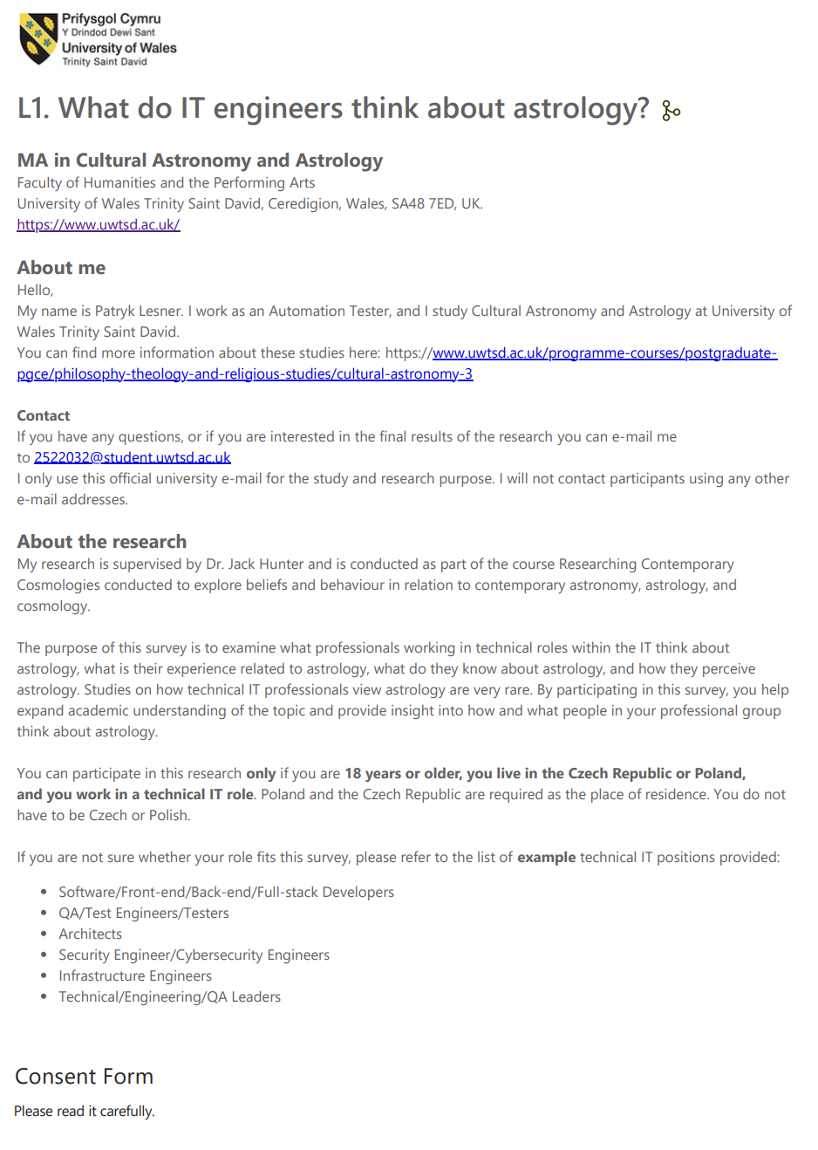
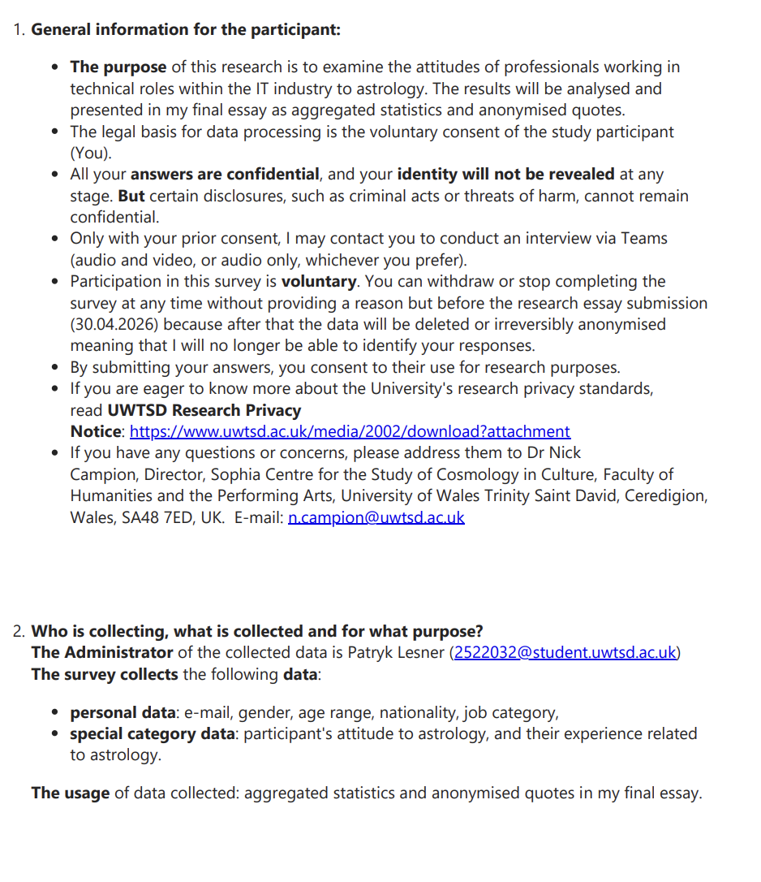

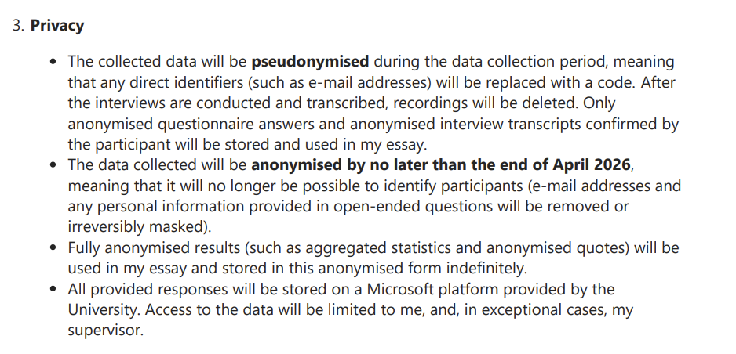

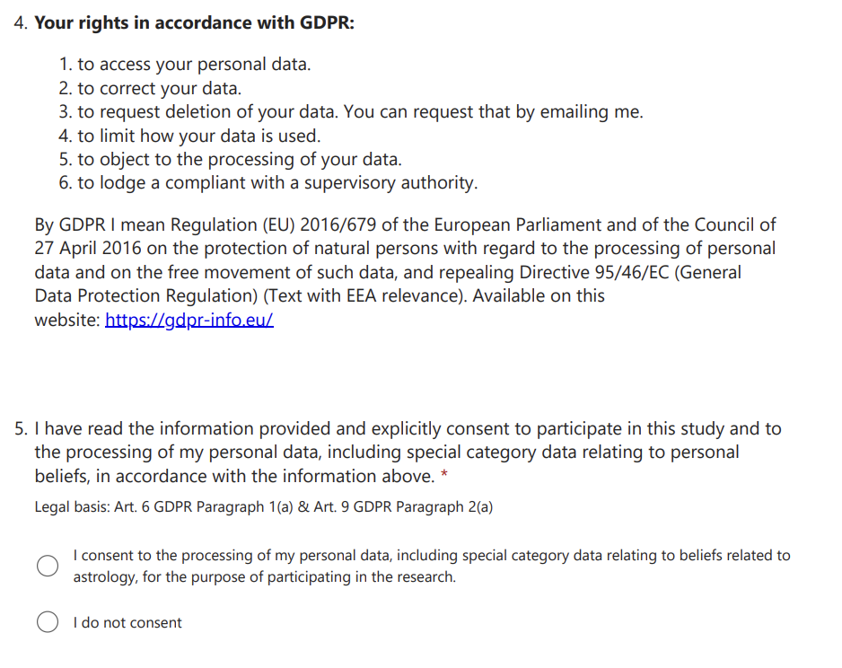

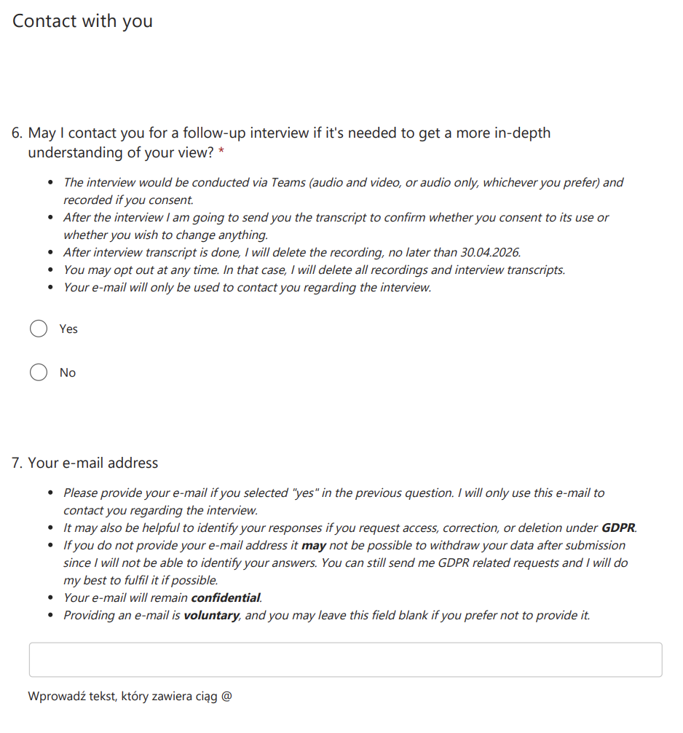
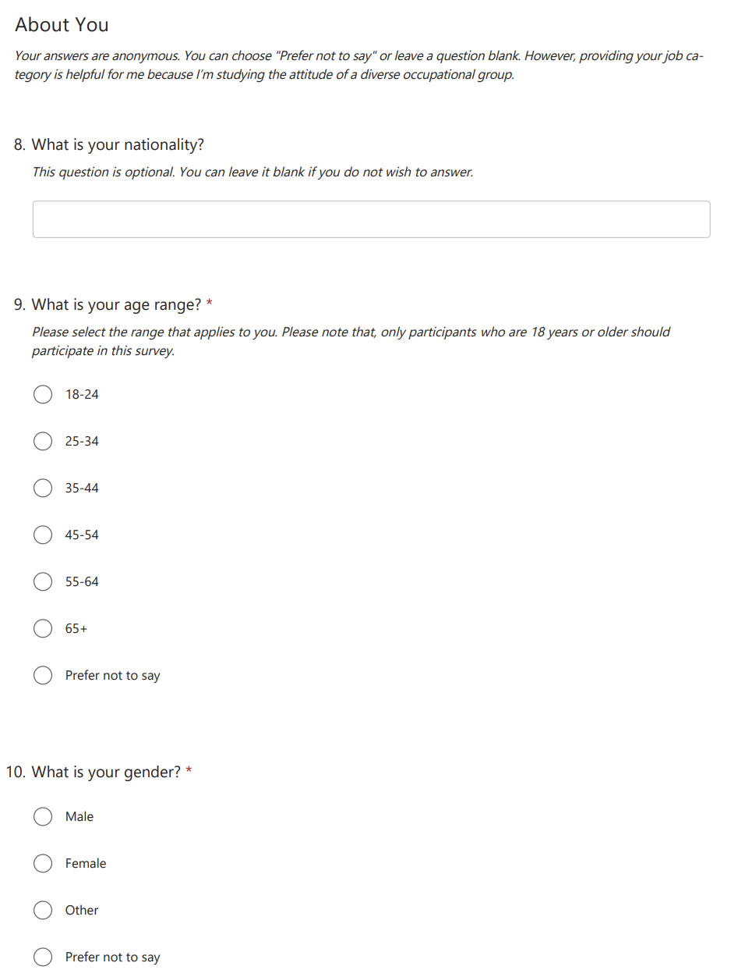

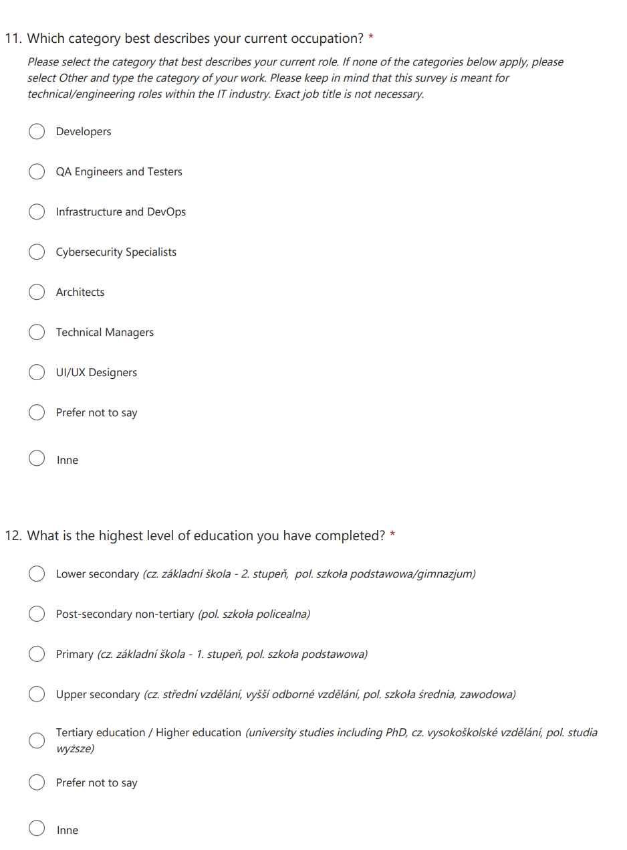
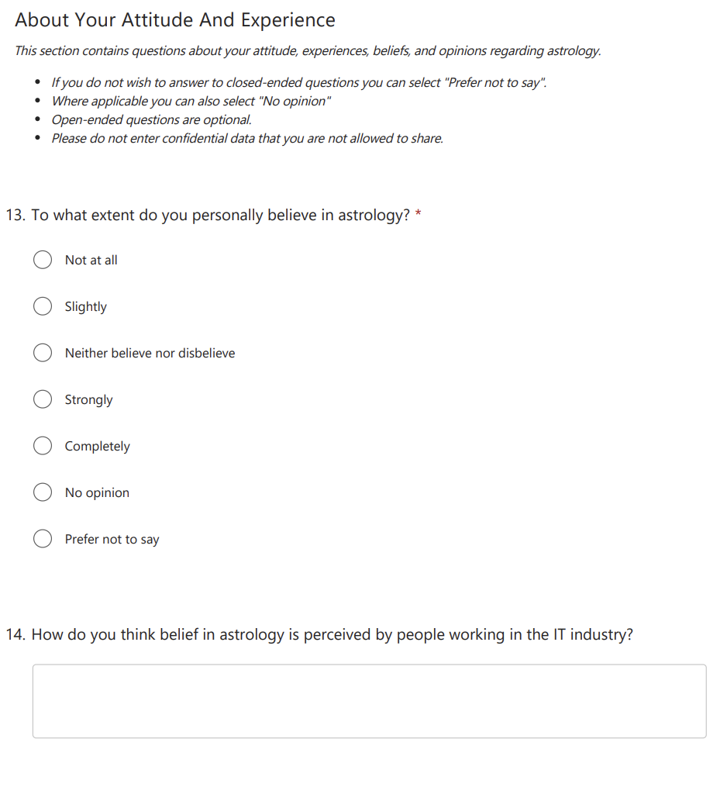
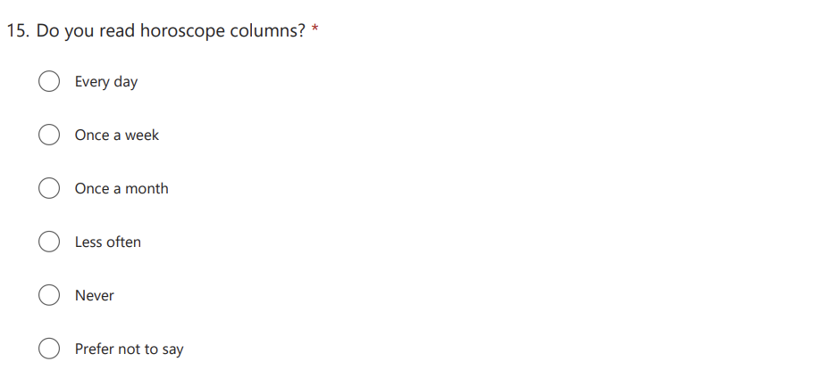
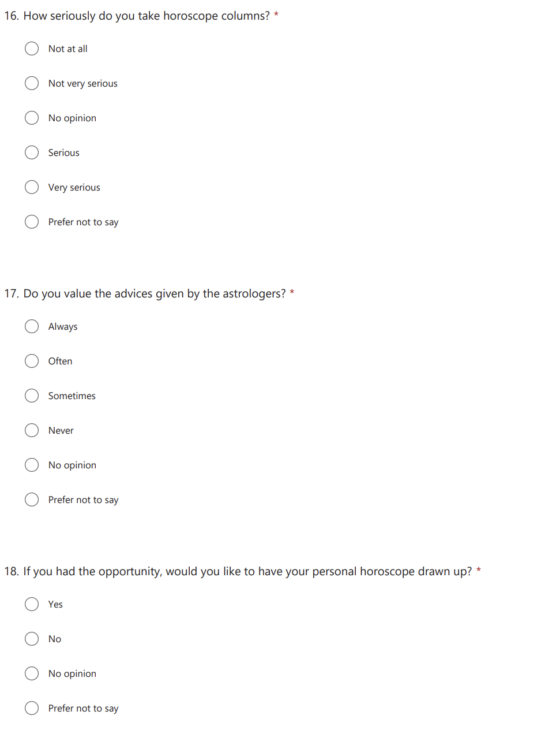
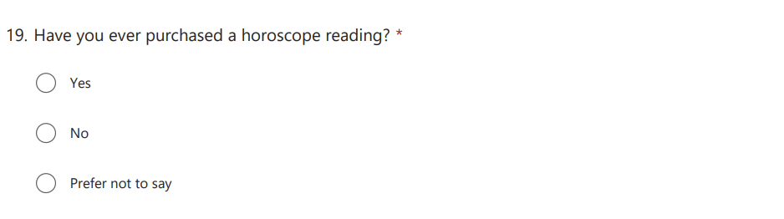
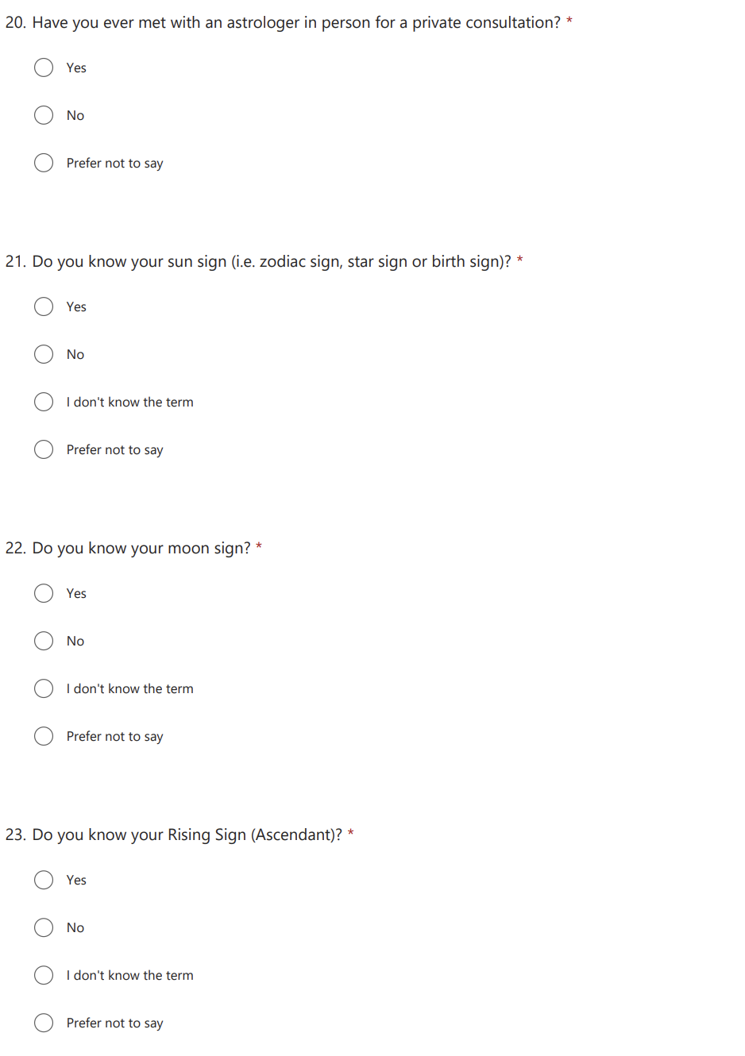

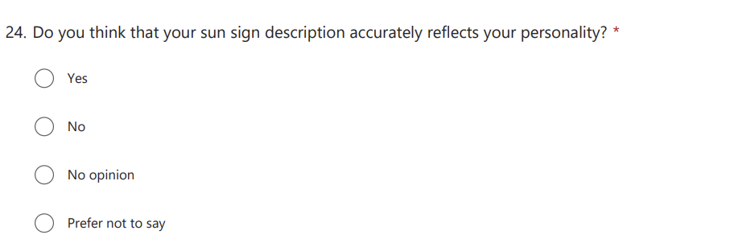
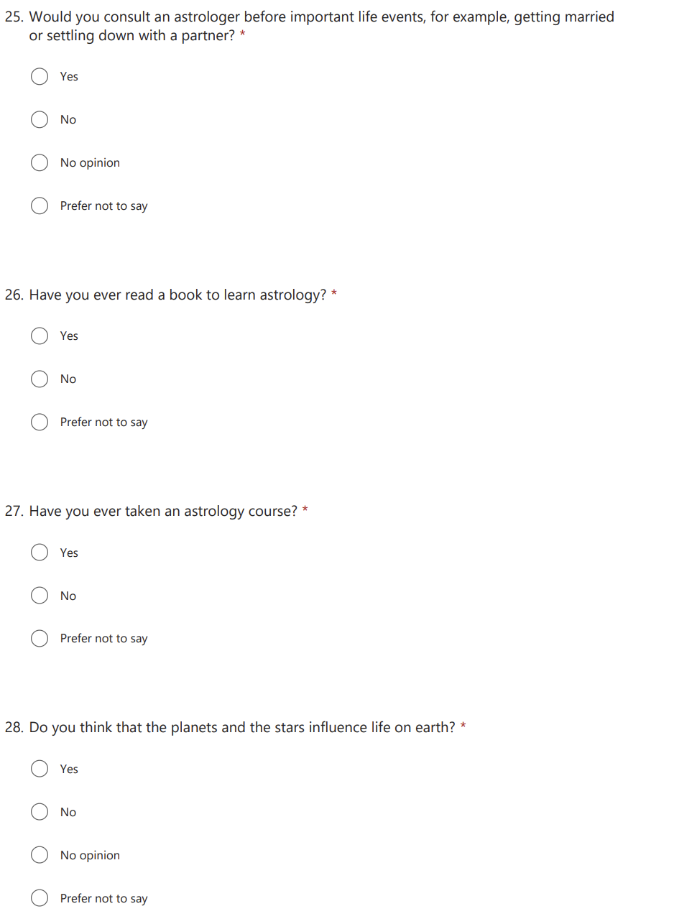
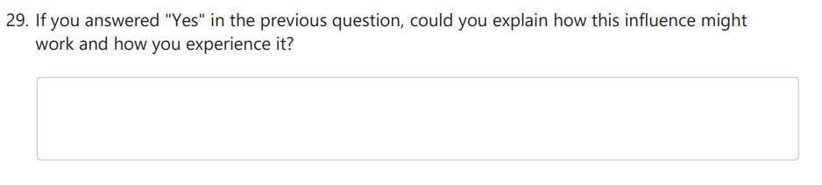

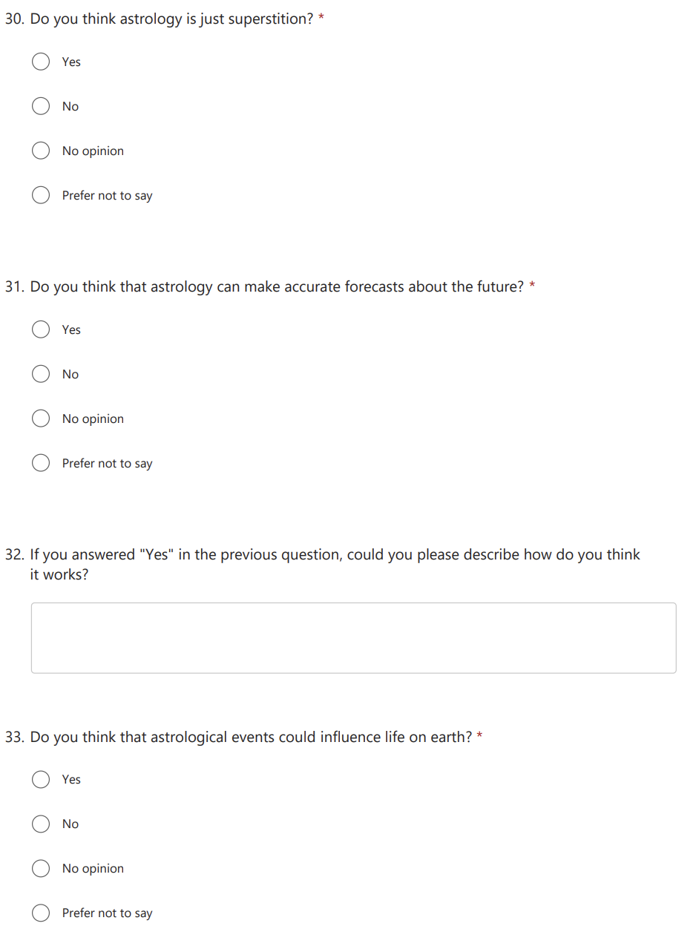
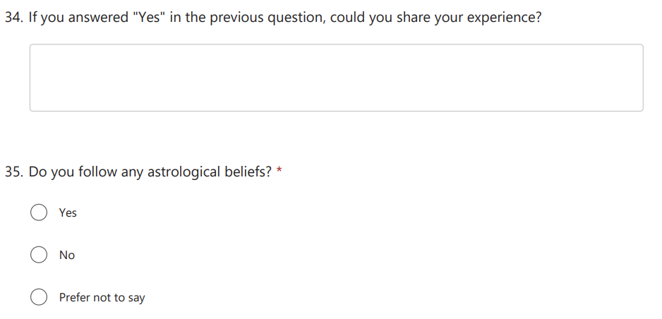
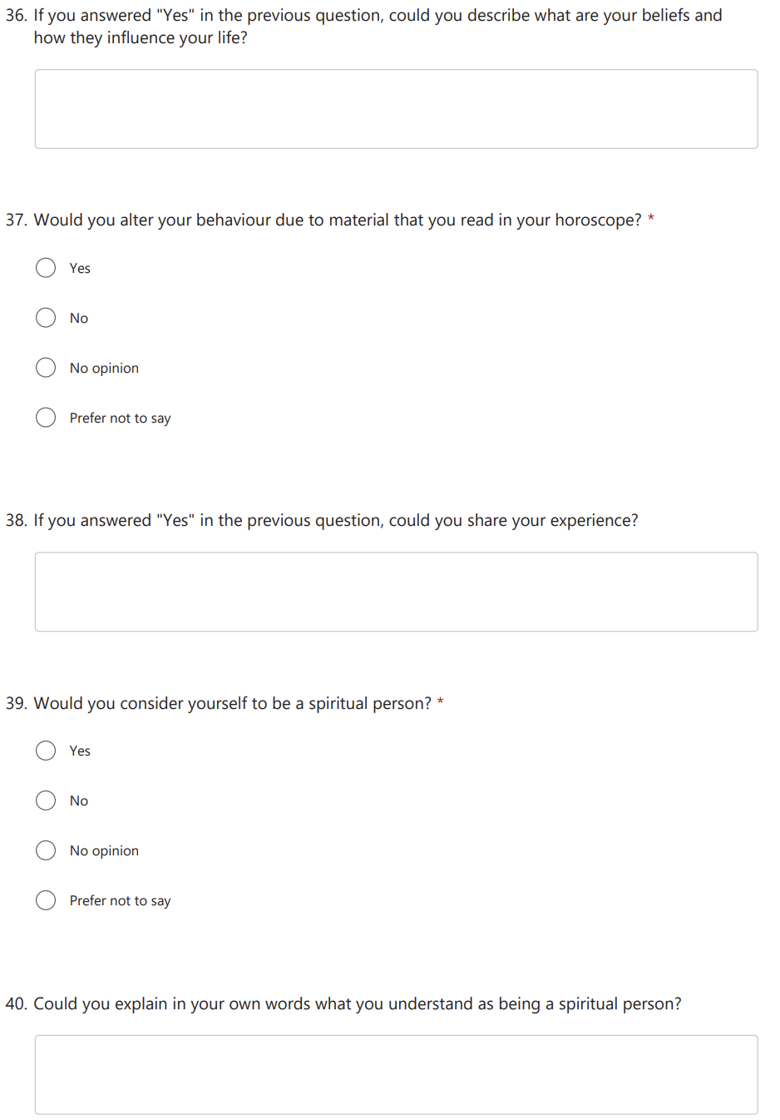

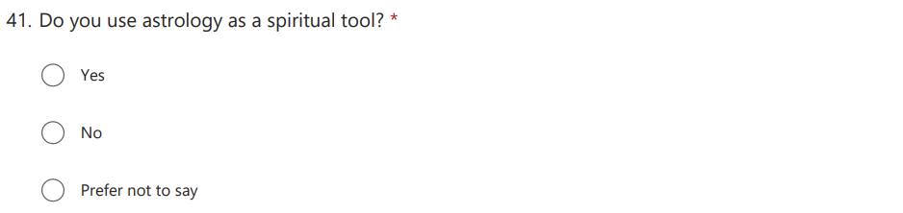
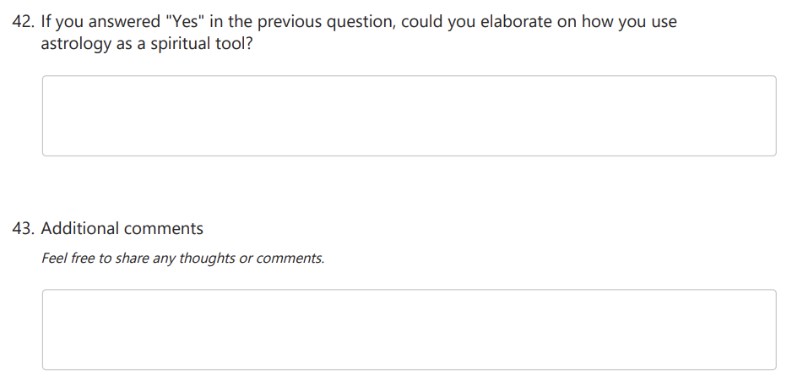

Appendix B

Interview Release Form

MA in Cultural Astronomy and Astrology
Faculty of Humanities and the Performing Arts
University of Wales Trinity Saint David, Ceredigion, Wales, SA48 7ED, UK.
https://www.uwtsd.ac.uk/about

Interview Release Form
Research: What do IT engineers think about astrology?

Researcher name and e-mail: Patryk Lesner 2522032@student.uwtsd.ac.uk

Participant’s name and email: ……………………………………………….

This form has been created to ensure that the material gathered during your (participant) interview with Patryk Lesner (researcher) is used only in accord with your wishes.

The purpose of the research is to examine the attitudes of professionals working in technical roles within the IT industry to astrology. The results will be analysed and presented in my final essay as aggregated statistics and anonymised quotes.

The Administrator of the collected data is Patryk Lesner (2522032@student.uwtsd.ac.uk)
During the recorded interview the following data may be collected:
- personal data: gender, age range, nationality, job category,
- special category data: participant's attitude to astrology, and their experience related to astrology.

How will the interview look like? The meeting will take place on Teams and will be recorded (audio & video, or audio only). I'll send you an invitation with a link. I would like to talk about your responses to the questionnaire What do IT engineers think about astrology? and additional details related to the research topic. After the interview ends, it will be transcribed and the recording will be deleted. Next, I am going to send the anonymised interview transcript to you. Only anonymised interview transcript confirmed by you will be stored and used in my essay. The recording will be deleted soon after the transcript is completed, but no later than 30.04.2026.
You may opt out at any time (even during the interview) before the research is completed which is at 30.04.2026. In that case, I will delete all recordings and interview transcripts. Your participation is voluntary.

Privacy: The recordings and transcripts will be kept safely on the University’s OneDrive. The data collected will be processed in accordance with the GDPR. Your identity will remain confidential. During the research, personal data will be pseudonymised as soon as possible. After the data collection period ends (10.04.2026), the research data will be anonymised. Fully anonymised results (such as aggregated statistics and anonymised quotes) may be used in my essay and stored in this anonymised form indefinitely.

Consents:
1. Do you consent to the processing of your personal data, including special category data relating to beliefs related to astrology, and the recording of the meeting on Teams for the purpose of participating in the study?
Yes, I do consent No, I do not consent

Signature of interviewee _______________________________ date __________

Signature of interviewer _______________________________ date __________

Note to interviewee: if you have any questions or concerns, please address them to Dr Nick Campion, Director, Sophia Centre for the Study of Cosmology in Culture, Faculty of Humanities and the Performing Arts, University of Wales Trinity Saint David, Ceredigion, Wales, SA48 7ED, UK. E mail: n.campion@uwtsd.ac.uk

APPENDIX C

Aggregated answers to closed-ended questions

 | Czech | Polish | Ukrainian
What is your nationality? | 6 | 28 | 1
 | 18-24 | 25-34 | 35-44
What is your age range? | 1 | 23 | 11
 | Female | Male
What is your gender? | 8 | 27
 | Developers | Infrastructure and DevOps | QA Engineers and Testers | Technical Managers
Which category best describes your current occupation? | 10 | 4 | 19 | 2
 | Upper secondary | Tertiary education / Higher education | Ph.D.
What is the highest level of education you have completed? | 7 | 26 | 2
 | Neither believe nor disbelieve | No opinion | Not at all | Slightly | Strongly
To what extent do you personally believe in astrology? | 4 | 2 | 21 | 6 | 2
 | Less often | Never | Once a month
Do you read horoscope columns? | 13 | 20 | 2
 | Not at all | Not very serious
How seriously do you take horoscope columns? | 26 | 9
 | Never | No opinion | Sometimes
Do you value the advices given by the astrologers? | 23 | 4 | 8
 | No | No opinion | Yes
If you had the opportunity, would you like to have your personal horoscope drawn up? | 13 | 7 | 15
 | No | Yes
Have you ever purchased a horoscope reading? | 34 | 1
 | No | Yes
Have you ever met with an astrologer in person for a private consultation? | 33 | 2
 | I don't know the term | Yes
Do you know your sun sign (i.e. zodiac sign, star sign or birth sign)? | 1 | 34
 | I don't know the term | Yes | No
Do you know your moon sign? | 15 | 3 | 17
 | I don't know the term | Yes | No
Do you know your Rising Sign (Ascendant)? | 12 | 5 | 18
 | No | No opinion | Yes
Do you think that your sun sign description accurately reflects your personality? | 11 | 14 | 10
 | No | Yes
Would you consult an astrologer before important life events, for example, getting married or settling down with a partner? | 33 | 2
 | No | Yes
Have you ever read a book to learn astrology? | 34 | 1
 | No
Have you ever taken an astrology course? | 35
 | No | No opinion | Yes
Do you think that the planets and the stars influence life on earth? | 9 | 7 | 19
 | No | No opinion | Yes
Do you think astrology is just superstition? | 4 | 7 | 24
 | No | No opinion | Yes
Do you think that astrology can make accurate forecasts about the future? | 27 | 6 | 2
 | No | No opinion | Yes
Do you think that astrological events could influence life on earth? | 19 | 6 | 10
 | No | Yes
Do you follow any astrological beliefs? | 33 | 2
 | No | No opinion | Yes
Would you alter your behaviour due to material that you read in your horoscope? | 31 | 3 | 1
 | Prefer not to say | No | No opinion | Yes
Would you consider yourself to be a spiritual person? | 1 | 23 | 5 | 6
 | No | Yes
Do you use astrology as a spiritual tool? | 34 | 1

Chip Rotolo, 30% of Americans Consult Astrology, Tarot Cards or Fortune Tellers (Pew Research Center, 2025), p. 4 <https://www.pewresearch.org/wp-content/uploads/sites/20/2025/05/PR_2025.05.21_astrology-tarot-cards-fortune-tellers_report.pdf> [accessed 13 April 2026].
Rotolo, 30% of Americans Consult Astrology, Tarot Cards or Fortune Tellers, p. 4.
David W. Moore, ‘Three in Four Americans Believe in Paranormal’, Gallup.Com, 16 June 2005, sect. Survey Methods <https://news.gallup.com/poll/16915/Three-Four-Americans-Believe-Paranormal.aspx> [accessed 13 April 2026].
Nicholas Campion, Astrology and Popular Religion in the Modern West: Prophecy, Cosmology and the New Age Movement, 1st ed (London: Taylor and Francis, 2016), pp. 152–53.
Campion, Astrology and Popular Religion in the Modern West, pp. 152–53.
Campion, Astrology and Popular Religion in the Modern West, pp. 152–53.
Hannah Sugarman and others, ‘Astrology Beliefs among Undergraduate Students’, Astronomy Education Review, 10.1 (2011), pp. 010101-010101–09, doi:https://10.3847/AER2010040.
Campion, Astrology and Popular Religion in the Modern West, pp. 150–53.
Tobias Edwards and others, ‘Intelligence and Individual Differences in Astrological Belief’, Journal of Individual Differences, 46.1 (2025), pp. 50–57, doi:https://10.1027/1614-0001/a000434.
Edwards and others, ‘Intelligence and Individual Differences in Astrological Belief’, p. 50.
Eurostat, ‘Employed Persons with Information and Communications Technology (ICT) Education by Educational Attainment Level’, Eurostat, 2025, tbl. [ED3-8] Upper secondary, post-secondary non-tertiary and tertiary education (levels 3-8), [ED5-8] Tertiary education (levels 5-8), doi:https://10.2908/ISOC_SKI_ITEDU.
Campion, Astrology and Popular Religion in the Modern West, p. 153.
‘Astrology Beliefs among Undergraduate Students’, p. 5.
Bernadette Brady, The Shape of Fate: From Classical Philosophy to Astrological Practice (Ceredigion, Wales: Sophia Centre Press, 2025), chs 7, 8.
Sasiwimon Temcharoenkit and Donald A. Johnson, ‘Factors Influencing Attitudes toward Astrology and Making Relationship Decisions Among Thai Adults’, Scholar (Bangkok, Thailand), 13.1 (2021), pp. 15–27 <https://www.proquest.com/docview/2802441115/abstract/D4B157C47DD74535PQ/1> [accessed 12 April 2026].
Shiri Noy and others, ‘Contemporary Views and Uses of Astrology in the United States: A Descriptive, Mixed-Methods Analysis’, Social Currents, 12.5 (2025), pp. 456–71, doi:https://10.1177/23294965251360016.
Ida Andersson, Julia Persson, and Petri Kajonius, ‘Even the Stars Think That I Am Superior: Personality, Intelligence and Belief in Astrology’, Personality and Individual Differences, 187 (2022), p. 111389, doi:https://10.1016/j.paid.2021.111389.
Moore, ‘Three in Four Americans Believe in Paranormal’, sect. GALLUP NEWS SERVICE.
Rotolo, 30% of Americans Consult Astrology, Tarot Cards or Fortune Tellers.
Tony Silva, ‘Masculinity, Femininity, and Reported Paranormal Beliefs’, Journal for the Scientific Study of Religion, 62.3 (2023), pp. 709–22, doi:https://10.1111/jssr.12862.
Sugarman and others, ‘Astrology Beliefs among Undergraduate Students’; Campion, Astrology and Popular Religion in the Modern West, pp. 152–53.
Katarzyna Skrzypińska and Paweł Atroszko, ‘Ścieżka Zawodowa w Relacji Do Osobowości i Duchowości Człowieka/Occupational Pathway in Relation to Human Personality and Spirituality’, PSYCHOLOGIA ROZWOJOWA (Kraków, Poland), 20.2 (2015), pp. 41–56 (p. 54), doi:https://10.4467/20843879PR.15.009.3481.
Bohdan Rożnowski and Beata Zarzycka, ‘Centrality of Religiosity as a Predictor of Work Orientation Styles and Work Engagement: A Moderating Role of Gender’, Religions, 11.8 (2020), p. 387 (p. 8), doi:https://10.3390/rel11080387.
Rożnowski and Zarzycka, ‘Centrality of Religiosity as a Predictor of Work Orientation Styles and Work Engagement’, p. 9.
Jennifer M. Dudeck, ‘The Influence of Spirituality on the Career Development of College Seniors: An Examination of Work Values’, College Student Affairs Journal (Charlotte, United States), 23.2 (2004), pp. 185–96 (pp. 192–93) <https://www.proquest.com/docview/224818209/abstract/5BEB146F64664229PQ/1?sourcetype=Scholarly%20Journals> [accessed 12 April 2026].
Dudeck, ‘The Influence of Spirituality on the Career Development of College Seniors’, pp. 192–93.
Edwards and others, ‘Intelligence and Individual Differences in Astrological Belief’, p. 56.
R. I. Damper, ‘Science and Religion in Conflict, Part 2: Barbour’s Four Models Revisited’, Foundations of Science, 29.3 (2024), pp. 703–40 (p. 729), doi:https://10.1007/s10699-022-09871-z.
Tom Kaden, ‘The Sociological Study of Science and Religion and the Invisible Religion: Conditions of Possibility for the “Conflict Thesis”’, Human Studies, published online 25 September 2025, sect. Abstract, Conclusion, doi:https://10.1007/s10746-025-09817-x.
Martin Bauer and John Durant, ‘Belief in Astrology: A Social-Psychological Analysis’, Culture and Cosmos, 1.01 (1997), pp. 55–71 (pp. 57–58), doi:http://doi.org/10.46472/CC.0101.0211; Campion, Astrology and Popular Religion in the Modern West, pp. 150–51.
Brady, The Shape of Fate, p. 103.
Monique Hennink, Inge Hutter, and Ajay Bailey, Qualitative Research Methods, Second edition (Los Angeles London New Delhi Singapore Washington DC Melbourne: SAGE, 2020), p. 104.
Hennink, Hutter, and Bailey, Qualitative Research Methods, pp. 16–17.
Judith Bell, Stephen Waters, and Helen Johnson, Doing Your Research Project : A Guide for First-Time Researchers, 8th edn (Maidenhead: Open University Press, 2024), p. 35.
Timothy C. Guetterman and others, ‘Contemporary Approaches to Mixed Methods–Grounded Theory Research: A Field-Based Analysis’, Journal of Mixed Methods Research, 13.2 (2019), pp. 179–95 (p. 180), doi:https://doi.dox.org/10.1177/1558689817710877.
Jan Průcha and Roman Švaříček, ETHICAL CODEX FOR THE CZECH EDUCATIONAL RESEARCH: PROPOSAL AND ITS JUSTIFICATION, 7 September 2010 <https://capv.cz/wp-content/uploads/2019/08/CAPV09_Pru_Etick.pdf> [accessed 15 April 2026]; Andrzej Górski and others, Code of Ethics for Researchers, 4 December 2024 <https://pan.pl/app/uploads/2025/06/Code_of_ethics_for_researchers_2024.pdf> [accessed 15 April 2026]; British Educational Research Association, ‘Ethical Guidelines for Educational Research, Fourth Edition (2018)’, Ethical Guidelines for Educational Research, Fourth Edition (2018), 13 August 2019 <https://www.bera.ac.uk/publication/ethical-guidelines-for-educational-research-2018-online> [accessed 18 April 2026].
Silke L. Schneider, ‘The Classification of Education in Surveys: A Generalized Framework for Ex-Post Harmonization’, Quality & Quantity, 56.3 (2022), pp. 1829–66 (pp. 1838, 1843, 1845), doi:https://doi.org/10.1007/s11135-021-01101-1.
European Education and Culture Executive Agency, ‘Single-Structure Primary and Lower Secondary Education’, European Education and Culture Executive Agency, 21 October 2025, para. 1 <https://eurydice.eacea.ec.europa.eu/eurypedia/czechia/single-structure-primary-and-lower-secondary-education> [accessed 14 April 2026]; European Education and Culture Executive Agency, ‘Upper Secondary and Post-Secondary Non-Tertiary Education’, European Education and Culture Executive Agency, 16 December 2025, sect. Upper secondary schools <https://eurydice.eacea.ec.europa.eu/eurypedia/czechia/upper-secondary-and-post-secondary-non-tertiary-education> [accessed 14 April 2026]; European Education and Culture Executive Agency, ‘Higher Education’, European Education and Culture Executive Agency, 18 September 2025, sect. Higher education institutions <https://eurydice.eacea.ec.europa.eu/eurypedia/czechia/higher-education> [accessed 14 April 2026]; European Education and Culture Executive Agency, ‘Overview’, European Education and Culture Executive Agency, 26 June 2025, sect. Key features of the Education System, Primary education, Secondary education (ISCED 3), Post-secondary non-tertiary education <https://eurydice.eacea.ec.europa.eu/eurypedia/poland/overview> [accessed 14 April 2026]; European Education and Culture Executive Agency, ‘Single-Structure Primary and Lower Secondary Education’, European Education and Culture Executive Agency, 1208 2025, para. 1 <https://eurydice.eacea.ec.europa.eu/eurypedia/poland/single-structure-primary-and-lower-secondary-education> [accessed 14 April 2026]; European Education and Culture Executive Agency, ‘Upper Secondary and Post-Secondary Non-Tertiary Education’, European Education and Culture Executive Agency, 8 December 2025, sect. Types of schools <https://eurydice.eacea.ec.europa.eu/eurypedia/poland/upper-secondary-and-post-secondary-non-tertiary-education> [accessed 14 April 2026].
QA denotes quality assurance, which according to ISO 24765:2010 is planned and systematic set of actions needed to provide confidence of required level that software meets requirements. ‘ISO/IEC/IEEE 24765:2010(En), Systems and Software Engineering — Vocabulary’, n.d., sect. 3.2383 quality assurance <https://www.iso.org/obp/ui/#iso:std:iso-iec-ieee:24765:ed-1:v1:en> [accessed 17 April 2026].
According to ISO 24765:2010, software developers are professionals manufacturing software products, e.g. writing the code of software. ‘ISO/IEC/IEEE 24765:2010(En), Systems and Software Engineering — Vocabulary’, sect. 3.2774 software product developer.
Eurostat, ‘Employed Persons with Information and Communications Technology (ICT) Education by Sex’, Eurostat, 2025, doi:https://10.2908/ISOC_SKI_ITSEX.
Eurostat, ‘Employed Persons with Information and Communications Technology (ICT) Education by Educational Attainment Level’.
Eurostat, ‘Employed Persons with Information and Communications Technology (ICT) Education by Educational Attainment Level’; Eurostat, ‘Employed Persons with Information and Communications Technology (ICT) Education by Sex’.
Campion, Astrology and Popular Religion in the Modern West, p. 153.
Edwards and others, ‘Intelligence and Individual Differences in Astrological Belief’, p. 51.
According to Mozilla Developer Network’s Web Docs page, syntax error is a condition caused by the incorrect usage of a command in code and causes error during the compilation of that code. In this context, it means that the participant does not know how to process the observed facts and what to do. ‘Syntax Error - Glossary | MDN’, MDN Web Docs, 11 July 2025, para. 1 <https://developer.mozilla.org/en-US/docs/Glossary/Syntax_error> [accessed 19 April 2026].
Damper, ‘Science and Religion in Conflict, Part 2’, p. 734.
Kaden, ‘The Sociological Study of Science and Religion and the Invisible Religion’, sect. Conclusion.
Dudeck, ‘The Influence of Spirituality on the Career Development of College Seniors’, p. 193.
According to website of University of California, this is most likely Dr. Mayim Bialik playing neurobiologist Dr. Amy Farrah Fowler on the CBS hit Big Bang Theory ‘Mayim Bialik | UCLA’, n.d. <https://www.ucla.edu/about/notable-bruins/43-mayim-bialik> [accessed 20 April 2026].
Hennink, Hutter, and Bailey, Qualitative Research Methods, p. 16.
Edwards and others, ‘Intelligence and Individual Differences in Astrological Belief’, p. 56.
Damper, ‘Science and Religion in Conflict, Part 2’, p. 729.
Kaden, ‘The Sociological Study of Science and Religion and the Invisible Religion’, pp. 1, 13.
Dudeck, ‘The Influence of Spirituality on the Career Development of College Seniors’, p. 193.
This section was added to make it easier to access the online resources that have a DOI address but does not lead directly to the resource but to the landing page.

