MARKETING MANAGEMENT
Student Name: Mandeep Kaur
Student Id: 2224381
Lecturer’s Name: Tushara Balendran
Executive Summary
This report is focused on the marketing strategies and value proposition of Sainsbury. Further, discuss the SWOT analysis that focused on diversification and expansion of the product range. The value proposition is focused on consumer service and the sustainability approach of the company to gain a competitive advantage. The marketing strategies are focused on a product that specifies taste the difference, pricing strategy, and promotion on online advertising and different social media platforms. The recommendation is based on a digital transformation and adaptation of an omnichannel approach.

Table of Contents
Introduction 4
Internal and external analysis 4
PESTLE Analysis 4
SWOT Analysis 6
Value proposition 9
Marketing strategies 10
Recommendation 11
Conclusion 12
References 13

Introduction
This report will discuss the marketing strategies and value proposition of Sainsbury. The company is the leading UK-based type of supermarket chain. The retail sector offers a wide range of products that include groceries, bakery items, and household items as a project team member has to analyze the internal and external environment of a company (Sainsburys.co.uk 2023). Effective marketing strategies are gaining a sustainable competitive advantage for the organization. The retail operations of a company are having a strong type of commitment to gaining sustainability, community types of engagement and charitable causes. Further, provide a recommendation for the future and a conclusion based on the research.

Internal and external analysis

PESTLE Analysis
PESTLE | Factors | Effect
Political | - The latest value of the political stability index is 0.54 (Theglobaleconomy.com, 2023)  - The consumer price index is rise by 9.2% in February 2023 up from 8.8% in the January (Ons.gov.uk, 2023) | Positive
Economical | - The GDP grew is 2.6% (Ons.gov.uk, 2023)  - The inflation rate is increased up to 10.4% as compared to 10.10% from the last year (Ons.gov.uk, 2023) | Neutral
Social | - The population growth rate is increased up to 0.34% (Macrotrends.net, 2023)  - Cultural barriers are found | Negative
Technological | - Technology awareness is increased  - The UK is ranking fourth in the global index ranking (Theglobaleconomy.com, 2023) | Positive
Environmental | - UK greenhouse gas emissions decreased by the 12% (Ons.gov.uk, 2023)  - Renewable sources of energy are accounted for an estimated | Positive
Legislative | - Health and safety laws are updated  - The discrimination rate is decreased | Positive
Table 1: PESTLE Analysis
(Source: Self-created)
The UK political types of environment are a significant amount of impact on the business of Sainsbury. Brexit is a political issue affecting the operation of Sainsbury and regulations have an impact on company operations. Economic types of factors such as a recession and inflation in customer spending habits significantly impact the business of the company. This is led to a transformation in customer types of spending habits that is more focused on luxury products. The company is required to consider socio-cultural types of factors such as customer transformation preferences, lifestyle transformation and the ageing population. Technology is changing in the retail industry and Sainsbury has no type of expectations. The company is utilising the technology to improve the consumer experience and that includes online shopping and mobile payments. Moreover, Sainsbury is required is staying regular update with the latest amount of technologies for remaining competitive. The company is required is comply with the legal type of requirements health and safety laws and customer protection laws. The environmental types of factors such as the transformation are gaining sustainability is crucial for the customers and taking the impact on environmental impact.
Porter’s five forces
Porter’s five forces are crucial for the identification of level of competition in the market (Gong et al. 2019). Furthermore, through the application of level this model long-term profitability can also be achieved.
Competition in the industry
Retail sector in the UK has huge competition and main competitors of the Sainsbury are Tesco, Walmart, ASDA, and others. Therefore, the company needs to take appropriate strategy for the enhancement of products and services quality to achieve competitive advantage over its competitors.
Threats of new entrants
As, Sainsbury is a giant company, for this, the threats of new entrants are low for this company. Furthermore, the new entrants require huge capital support to beat Sainsbury.
Power of suppliers
This component is also low for the company as there as numerous suppliers in the market who can supply product to the Sainsbury. Therefore, the demonstration suppliers are also required to compete adequately in the market.
Power of customers
Customers are the key to achieve success for this; the customers need to promote the aspects related to different kinds of products and strategy for this, adequate support and enhancement can be promoted. Therefore, through the aspects related to effective strategy and identification of needs and requirements of the company can provide enhanced services to their consumers.
Threats of substitute products
It can pose threat for the company as the customers can purchase other products from other companies.

SWOT Analysis
Strengths | Weakness
- They have established brand  - Diversified range of product  - Strong supplier types of relationships  - Gaining the sustainable practices | - Dependency on the UK market  - Limited international types of presence  - High cost of operating  - Inconsistent types of financial performance  - Limited differentiation of products
Opportunities | Threats
- Expansion of sales online  - Global expansion  - Investment in a technology  - Services diversification | - Intensive competition in the market  - They have economic uncertainty  - Pricing wars  - Changing customer preferences  - Disruptions of supply chains
Table 2: SWOT Analysis
(Source: Self-created)
The above table shows a SWOT Analysis of Sainsbury in the market. The company is a well-known type of brand in the UK with a long amount of history. It is having a strong type of reputation for the quality amount of its products and consumer service. The company offers diversified products range that includes financial and groceries services that support attracting a wide range of consumers. The company is heavily dependent on the UK market and that limit on its growing amount of potential (Antonopoulou and Begkos, 2020). It likes of its competitors and Sainsbury is limited in its global presence and limits its ability to grow and diversify. High operating costs are leading to higher operating costs and that includes marketing and expenses in advertising. Along with that, the limited amount of product types of differentiation in the Sainsbury products is similar to be offered by their competitors and it is having the limit to differentiate from the competition. Consistent financial performance in recent years is making it difficult for predicting the growth in future and brings profitability.
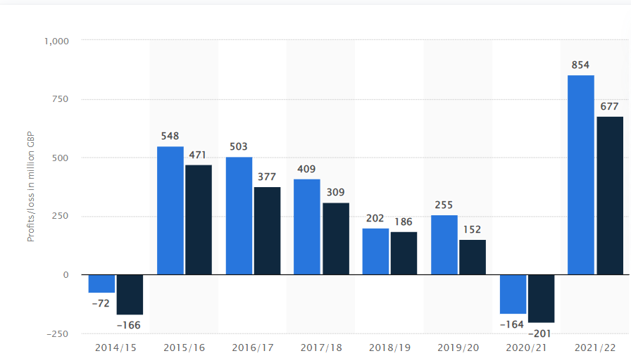
Figure 1: Annual report of Sainsbury
(Source: Statista.com, 2023)
The above figure shows an annual report of Sainsbury in the year 2014-2022. According to a graph in 2014 company is at a loss they bounce back the next year and gain a profit of 548 million GBP (Statista.com, 2023). The expansion of online sales provides the opportunity for the organization to expand their online sales and attract new consumers. The international type of expansion is when a company is in a global presence to be diversified their revenue streams and increases its share of the market. The company is trying to invest in a new type of technology for improving its supply chain, consumer service and online platform retail. The increasing focus on health and wellness is growing the interest of customers and provides the opportunity for companies to expand their range of products and attract new consumers and revenues increase. The prospects of threats are having intense types of competition and a company facing intense types of competition from different types of supermarkets to discounting retailers (Xiao et al. 2021). The economic uncertainty is included Brexit that impact on consumer spending and has an impact on sustainability and profitability. A pricing war in the supermarket-type industry is been characterised by the pricing of wars that can impact profit margins and making difficult to compete. The changing customer preferences and habits of shopping is constantly been evolved and impacted sales of Sainsbury and failed to keep up with the changing types of trends.

Value proposition
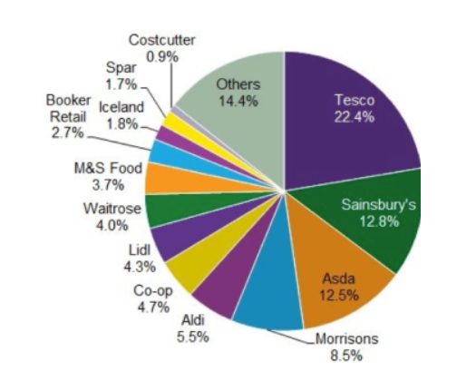
Figure 2: Value propositions of the retail sector in the UK
(Source: Galera‐Zarco et al. 2022)
The above figure shows the value proposition of the retail sector in the UK. The company Sainsbury is the largest type of supermarket in the UK with sharing of the market of around 15%. The differentiated types of value propositions in centres are delivering the quality amount of products, convenience and excellent types of consumer service. The company prides itself on providing a high amount of quality products and the company has an extensive fresh range and sustainable types of flooding options and includes locally sourced types of products. This is to differentiate a company from competitors and give consumers a reason to select a company over supermarkets (Ausloos, 2020). Sainsbury is focused on convenience and the company is invested heavily in technology and that include its websites and mobile app. It makes shopping more accessible and convenient for customers. The company offers a wide range of options and that includes day delivery and making it easier for consumers to shop on their terms.
Consumer service is an important part of Sainsbury and is differentiated from the value proposition. A company is focused on a consumer approach with employees trained for friendly, helpful and knowledgeable (Nazareth, 2019). The company offers a wide range of storage services that include the pharmacies, travel money and banking which enhances to complete the shopping experience. The company is committed to sustainability and becoming increasingly crucial to consumers. A company has a wide range of initiatives in place to decrease waste, utilising sustainable packaging and sourcing responsibly of products source. This is a commitment to sustainability that not only gains an advantage for the environment and it resonates with consumers that prioritise ethical shopping. The company is utilising the technology to improve the consumer experience and that includes online shopping and mobile payments.

Marketing strategies
In order to analyse its strategy marketing a 4P analysis is conducted that focuses on a “product, price, promotion and place”.

Figure 3: Marketing mix
(Source: Self-created)
Product
Sainsbury is in a product mix that includes wide types of range of products such as clothing, groceries, electronics and household products. A company is a private range of label types of products that include a popular “Taste the difference” and a company basics lines. The company is recently focused on increasing its range types of plant-based and vegan amount of products for appealing to its consumers with restrictions dietary (Walters et al. 2020). The company can focus on the branding strategy through which appropriate sales and other aspects can be imposed and under the branding strategy, the company can impose loyalty to their customers to retain their customers. However, rebranding strategy will not be effective for Sainsbury as the company is a brand itself. However, Sainsbury needs to focus on the store branding, as it will provide positive feelings to their consumers.
Price
The company's pricing strategy is aiming at offering value to consumers. A company is introduced a price range for promotions such as buy one get one free types of offers and get discounts on a bulk amount of purchases (Doherty and Kittipanya-Ngam, 2021). Along with that, a company's loyalty on a programme known as Nectar rewards consumers with purchase points and redeemed them for discounts on future buying. Sainsbury's pricing is to be competitive with the other supermarkets in the UK that focused on a good amount of value for the money. It likes of its competitors and Sainsbury is limited in its global presence and limits its ability to grow and diversify. The company offers a wide range of options and that includes day delivery and making it easier for consumers to shop on their terms.
Promotion
Sainsbury's advertising strategy is focused on emphasising its commitment to quality, convenience and value. A company utilised different types of channels for promoting its products that include television, online advertising and print. The company has been focusing on the digital marketing strategy through which proper target customers can be reached. The company also utilises in-store types of displays and signage to be promoting its products and offers (Godley and Hamilton, 2020). A company has a wide range of initiatives in place to decrease waste, utilising sustainable packaging and sourcing responsibly of products source.
Place
Sainsbury is a wide type of distribution with a network of over 1400 stores across the UK as well as an online store. A company is a wide type of range of store formats that include supermarkets, stores convincing and make local customers.
STP
STP helps in the identification of appropriate customers and other target area and it will help the consumers to achieve success (Liem and Arief, 2023). Furthermore, Sainsbury can implement appropriate STP model to enhance the attributes of demographic, geographic, behavioural, and other aspects.
Market segmentation | Target area | Target customers
Demography | - Age  - Gender  - Income | - Sainsbury mainly target male and female consumers  - Age ground 18 to 45  - Income group middle class
Geography | - Location | - UK  - At global level
Psychographic | - Lifestyle | - Home appliances and fashion related aspects
Behavioural | - Brand image | - The company has positive brand image which helps in consumer attraction
Table 3: STP analysis
(Source: Self-developed)
Ansoff matrix
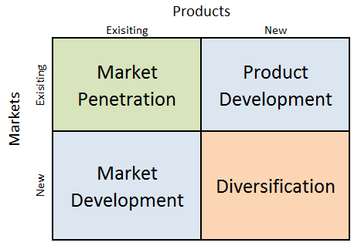
Figure 4: Ansoff matrix
(Source: Dudovskiy, 2020)
Market penetration
The company needs to focus on the enhancement of marketing investment and they must develop and design engaging communication. Furthermore, enhancement of distribution further helps in the enhancement of supply chain and other aspects.
Product development
The company needs to focus on the research and development in order to reach more customers.
Market development
Launching new products will also help them to manage the attributes related to NPD process.
Diversification
The company must adopt the vertical integration strategy though which appropriate products under the product line can be developed.

Recommendation
- Focused on a digital transformation and making sustainable practices
The company is should invest in digital types of transformation for enhancing a better consumer experience and staying competitive with the retailers of online. Further, it is recommended that it is achieved to offer personalised recommendations and improves order online and systems delivery and use big analytics of data for understanding consumer behaviour. Consumers are increasingly becoming conscious of the environment and sustainability (Yamoah, 2019). A company is improving its sustainability types of practices by decreasing waste, utilising renewable energy and promoting ethical product sourcing.
- Adopting an omnichannel approach and developing product innovation
Sainsbury will integrate its physical and digital types of channels to be developed a seamless consumer experience. It can be achieved by offering the click-and-collect amount of services, in-store types of digital experiences and integrating with consumer loyalty programmes across all channels.
- Focused on employee engagement and make collaboration with a suppliers
Sainsbury needs to invest in their employees to improve engagement and gain productivity. It is to be achieved by offering employee training programmes, developing carrier types of opportunities and make promoting a positive amount of workplace culture (Jones, 2022). It is recommended that Sainsbury needs to collaborate with their suppliers for developing sustainable types of practices and decrease the carbon footprint. It is to be achieved by the implementation of sustainable policies of sourcing and working with suppliers to decrease waste.

Conclusion
This study concludes that Sainsbury is facing external factors that impact its business operations. The understanding of the PESTLE factors is adapting to a transformation so a company remains competitive and successful in UK retail industry. It is concluded that Sainsbury is differentiated in a value proposition on delivering a high amount of quality products, excellent consumer service and sustainability commitment. These types of factors are support to differentiate a company from the competitors and provide consumers with compelling reasons.

References
Antonopoulou, K. and Begkos, C., 2020. Strategizing for digital innovations: Value propositions for transcending market boundaries. Technological Forecasting and Social Change, 156, p.120042.
Ausloos, M., 2020. Valuation Models Applied to Value-Based Management—Application to the Case of UK Companies with Problems. Forecasting, 2(4), pp.549-565.
Doherty, B. and Kittipanya-Ngam, P., 2021. The role of social enterprise hybrid business models in inclusive value chain development. Sustainability, 13(2), p.499.
Galera‐Zarco, C., Opazo‐Basáez, M., Marić, J. and García‐Feijoo, M., 2020. Digitalization and the inception of concentric strategic alliances: A case study in the retailing sector. Strategic Change, 29(2), pp.165-177.
Godley, A.C. and Hamilton, S., 2020. Different expectations: A comparative history of structure, experience, and strategic alliances in the US and UK poultry sectors, 1920–1990. Strategic Entrepreneurship Journal, 14(1), pp.89-104.
Jones, P., 2022. UK Retailers and Plant-Based Alternatives to Meat and Dairy Products. Athens Journal of Business and Economics, 8, pp.1-13.
Macrotrends.net, (2023). Population growth rate. [Online] Available at: https://www.macrotrends.net/countries/GBR/united-kingdom/population-growth-rate#:~:text=The%20current%20population%20of%20U.K.,a%200.33%25%20increase%20from%202020. [Accessed on: 2.04.2023].
Nazareth, A.P., 2019. How close is the built environment to achieving circularity?. In IOP Conference Series: Earth and Environmental Science (Vol. 225, No. 1, p. 012070). IOP Publishing.
Ons.gov.uk, (2023). Consumer price index. [Online] Available at: https://www.ons.gov.uk/economy/inflationandpriceindices/bulletins/consumerpriceinflation/february2023. [Accessed on: 2.04.2023].
Sainsburys.co.uk (2023). About company. [Online] Available at: https://www.about.sainsburys.co.uk/. [Accessed on: 2.04.2023].
Statista.com, (2023). Profits/loss for J Sainsbury plc in the United Kingdom (UK) from financial year 2014/2015 to 2021/2022, before and after tax. [Online] Available at: https://www.statista.com/statistics/386446/sainsburys-profits-united-kingdom-uk/. [Accessed on: 2.04.2023].
Theglobaleconomy.com, (2023). Political stability index. [Online] Available at: https://www.theglobaleconomy.com/United-Kingdom/wb_political_stability/#:~:text=The%20latest%20value%20from%202021,to%20compare%20trends%20over%20time. [Accessed on: 2.04.2023].
Walters, D., Helman, D., Walters, D. and Helman, D., 2020. Industry Dynamics. Strategic Capability Response Analysis: The Convergence of Industrié 4.0, Value Chain Network Management 2.0 and Stakeholder Value-Led Management, pp.35-51.
Xiao, B., Chen, Q. and Yu, Z., 2021, April. Research on the Investment Value of Sainsbury’s. In 2021 6th International Conference on Social Sciences and Economic Development (ICSSED 2021) (pp. 108-115). Atlantis Press.
Yamoah, F.A., 2019. Fairtrade UK in retrospect: from the niche genesis to the revelatory mainstreaming marketing strategy era (late 1950s-late 2000s). International Review of Management and Marketing, 9(4), p.110.
Liem, A.G. and Arief, N.N., 2023. Integrated Marketing Communication Strategy for Cosmetic Retail Company: a Study of New Central Palu. Journal of Economics and Business UBS, 12(1), pp.413-430.
Gong, Y., Liu, J. and Zhu, J., 2019. When to increase firms’ sustainable operations for efficiency? A data envelopment analysis in the retailing industry. European Journal of Operational Research, 277(3), pp.1010-1026.

