Title: A comparison of the marketing methods of two multinational hotel brands
Student name: Petruta-Roxana Toma
Student ID number: 2232075
Marketing Essentials BMIH4005
Lecturer’s name: Christopher Wilkin
Word Count: 1541

Introduction
This essay will emphasise its scientific focus on two multinational hotel brands and will be evaluating each of their marketing methods before comparing their approaches. Hence, the two hotels being considered here are the Six Senses and Moxy Hotels, both of which are established globally. For catering insightful details, the essay will be entailing findings with the aid of the analytical tool, Similarweb, followed by a brief analysis of the brands’ Marketing Mix, STP analysis and marketing communications. The essay will also underscore the brands’ consideration towards global issues and will further propose recommendations in terms of their future growth and development.

Main body
According to the Similarweb tool, Six senses hotel is a multinational brand that originated in Thailand in 1995, with its parent brand being IHG Hotels. The hotel’s customer traffic aggregate is 486.2 thousand in December of 2022. Six senses targeted audience encompasses 22.53% US audience, followed by 11.97% of the UK. Further, Six Senses market their products among 54.27% male and 45.73% female customers, where most of them lie in the age range of 25 to 34 years old. The hotel’s marketing choices revolve around its online usage because the majority of its consumers engage with its products and bookings by means of Google, online shopping and social media networks. Given that, Six Senses' top marketing channels include Google's search optimisation, for it encompasses 63.79% of its interaction with its audience, followed by 19.92% engagement physically. The brand’s most trafficked social media platform is Facebook, with 49.59% traffic. The brand's market category distribution mostly lies in the domain of Accommodation and Hotels, with 27.47% referral traffic (Similarweb, 2023a).
On the other hand, the software tool identified that Moxy Hotels' total customer traffic in December 2022 was 256.1 thousand, with its top operating country being the US, with 41.30% core audience. The hotel's top interaction topics with its customers entail Google and Internet tools such as dictionaries. The brand market its product by means of the internet, with 60.02% traffic desktop visits and 29.82% physical traffic (Similarweb, 2023b). The software further does not possess information about the hotel brand’s targeted audience, their age and the brand’s core marketing domain.
From the above-mentioned differences and similarities, it can be denoted that international customers are more familiar with the brand of Moxy Hotels than Six Senses because of Moxy’s parent organisation, Marriott International. Next, the Moxy Hotel's customer traffic was significantly less than Six Sense in 2022, which restricted the brand from effectively promoting its product line. On the other hand, Moxy Hotels’ targeted audience entails millennials, especially the ones who are travelling and seek a taste of creativity in their hotel stays (Globaltrender, 2018). Six Senses, at the same time, cater to customers who prefer a relaxing setting with luxurious spas, bedrooms and entertainment facilities. Moreover, both of the hotel brands' product lines nor marketing choices did not really alter after the pandemic struck. However, both of them increased the importance of sanitary product use and hourly cleaning services provided within their guest services.
The marketing mix is defined as a company's marketing strategy to influence its customers to purchase its products. Therefore, it involves product, price, place and promotion (Darmawan and Grenier, 2021). In terms of Six Senses Hotel, the brand’s products encompass resort and spa packages which come with related commodities in discounted offers. The pricing strategy of the hotel revolves around the relevancy of the product. If the product possesses high demand in the market, then the hotel prices it slightly more optimised than other brands (Six Senses, 2023). The hotel is present both physically in the form of its retailers and virtually on its social media webpages and official website. The promotion of the hotel is done through online and physical advertisements in magazines. The hotel's marketing is also done through programs and initiatives (Six Senses, 2023b).
Furthermore, in terms of the hotel’s STP analysis, Six Senses segments its market based on the geography, socio-demographic and psychographic and behavioural characteristics of its audience. The targeting of the hotel revolves around customers ranging between the age group of 25 to 34, which indicates that the brand's offerings rely on millennials’ preferences (IHG Plc, 2019). From both factors, it can be stated that the hotel's product positioning lies in the domain of millennial travellers who are inclined towards achieving an exotic hotel experience with peculiar products and settings.
On the other hand, the marketing mix of Moxy Hotel entails products, price, place and promotion for the organisation. The product of the hotel entails grab-and-go offerings related to the rooms, bars and amenities of the hotel, whereas its pricing circulates around the economic lifestyle of its customers. Therefore it values the products based on the potential of millennial customers to purchase them (Moxy Hotels, 2022). Further, Moxy hotel has both online and physical distribution channels, where its physical retailers monitor the bookings for the hotel, and its official website handles the online bookings. Given that, the hotel promotes itself by means of word-of-mouth technique through its infamous parent company, Marriott, and also markets its products by regularly posting its offerings on its social media accounts.
Additionally, the brand’s STP analysis claims that Moxy Hotels segments its products based on their mode of lifestyle and preferences, which are identified by their social class. Moxy Hotel targets seasoned travellers and provides smart and modern amenities (Williams and Adams, 2022). Given that, the company positions itself among the fast-paced trendy hotels in the market, which is usually preferred by millennial or teenage audiences.
The sustainable practices of the Six Senses have been rapidly recognised in the industry of hospitality, as it highly encourages and recommends sustainability in society. Six Sense takes the help of science before casting any impact of their decision on the environment and stimulating their leaders and managers to alter their teammates. They specify their target as to what they want to get under their influence. The Six Senses has organised an earth lab as well that makes sure to display their reduction in the consumption of the items that are harmful to the environment and society; hence the efforts that they put in making their business work ecosystematically are visible and noticeable to the general public (Six Senses, 2019).
On the other hand, Moxy Copenhagen has been awarded for its prestigious sustainability, which itself defines the hard work and the sincerity of the company towards society and the environment (Core, 2021). This award has had a great impact on the reputation and image of Moxy and is more than enough to do complete marketing for them. However, other than that, Moxy has also publicised its concerns, and relevant solutions, which, even though it has not cost much to the company, their needs marketing has been fulfilled due to this (Moxy, 2022).
Six Senses desire to convey a message to its customers that are delivered in a very efficient manner. It asks to listen before start talking. It means that six Sense wants its customers to raise their voices where needed. They advise to shout out, not just whisper their thoughts. Nevertheless, in their opinion, people should first listen to the whole conversation and know the complete point so that they can have a better understanding of the situation to pass a correct and unbiased judgement because this is the basis of hospitality (J-P, 2015).
Moxy also delivers its message to its customer, which is related to the industry of hospitality as well as like, Six Senses; Moxy also belongs to the industry of hospitality. They encourage their customers to cast a good reputation and make a good image of themselves while conveying their set of skills regarding hospitality. Since manners, ethics, and behaviour are the basic considerations in the sector of hospitality, they cannot be ignored. Therefore, they asked their customers to acknowledge the importance and significance of attitude (Weinstein, 2022).
After studying this topic thoroughly, it is safe to claim that there are some recommendations that can be given to these hotels belonging to the industry of hospitality, which is Six Senses and Moxy. Even though both of these hotels are doing their best in the hospitality industry, the fact that there is no limitation to advancement and betterment cannot be denied. These hotels can build the most advanced road maps to enhance the experience of the visitors by providing them with the ease of simple access. This hotel should also utilise the most modern technologies that have been introduced in society, which will have a very evident impact on the business of both of the hotels (Tavitiyaman et al., 2022).

Conclusion
The essay’s findings identified that Six Senses and Moxy Hotels differ from one another on various levels. For one, the marketing mix and STP analysis highlighted that Six Senses targets its millennial customers by providing exotic hotel experiences, while Moxy caters to trendy hotel experiences for its teenage and millennial audiences. It was also identified that Moxy, due to its renowned parental organisation Marriott, is more popular among international customers than Six Sense, but both companies possess similar marketing status global-wise. Lastly, it was identified that both hotel brands value the notion of sustainability within their production chain and operations.

References
Core Hospitality 2021 Moxy Copenhagen is awarded the prestigious Sustainability Certificate LEED Platinum, Core Hospitality. Available at: https://www.corehospitality.dk/nyheder/moxy-copenhagen-is-awarded-the-prestigious-sustainability-certificate-leed-platinum/ (Accessed: February 2, 2023).
Darmawan, D. and Grenier, E., 2021. Competitive Advantage and Service Marketing Mix. Journal of Social Science Studies (JOS3), 1(2), pp.75-80.
Globaltrender (2018) Why moxy hotels target guests who are 'fun hunters', Globetrender. Available at: https://globetrender.com/2018/02/09/moxy-hotels-fun-hunters/ (Accessed: February 2, 2023).
IHG Plc (2019). Available at: https://www.ihgplc.com/en/news-and-media/news-releases/2019/ihg-further-expands-luxury-footprint-with-acquisition-of-six-senses-hotels-resorts-spas (Accessed: February 2, 2023).
J-P 2015 The six senses of social media marketing, Smart Insights. Available at: https://www.smartinsights.com/social-media-marketing/social-media-strategy/six-senses-of-social-media-marketing/ (Accessed: February 2, 2023).
Moxy 2022 Home Cultural Heritage: Moxy Horizon Europe Research Project the Moxy Project is in pursuit of breakthrough non-contact oxygen-based technology to preserve cultural heritage for the future in a sustainable and Green Way. MOXY Project. Available at: https://www.moxyproject.eu/ (Accessed: February 2, 2023).
Moxy Hotels (2022). Available at: https://moxy-hotels.marriott.com/explore/ (Accessed: February 2, 2023).
Similarweb (2023a) Sixsenses.com Traffic Analytics & Market Share | similarweb. Available at: https://www.similarweb.com/website/sixsenses.com/ (Accessed: February 2, 2023).
Similarweb (2023b) Sixsenses.com Traffic Analytics & Market Share | similarweb. Available at: https://www.similarweb.com/website/moxy-hotels.marriott.com/#traffic/ (Accessed: February 2, 2023).
Six Senses (2023a). Six Senses Groupwide offers. Available at: https://www.sixsenses.com/en/offer (Accessed: February 2, 2023).
Six Senses (2023b). About Us. Available at: https://www.sixsenses.com/en/about-us (Accessed: February 2, 2023).
Six Senses 2019 Sustainability 2019 - six senses, Slide ! Available at: https://www.sixsenses.com/media/10155/six-senses-sustainability-2019-impacts.pdf (Accessed: February 2, 2023).
Tavitiyaman, P., Zhang, X. and Tsang, W.Y., 2022. How tourists perceive the usefulness of technology adoption in hotels: Interaction effect of past experience and education level. Journal of China Tourism Research, 18(1), pp.64-87.
Weinstein, A.T., 2022. Customer obsession–the springboard for a value creation strategy. Journal of Business Strategy, (ahead-of-print). (Accessed: February 2, 2023).
Williams, R. and Adams, P. (2022) Marriott’s Moxy Hotels gamifies hospitality with AR experience. Available at: https://www.marketingdive.com/news/marriott-moxy-hotels-gamifies-hospitality-ar-mobile/627219/ (Accessed: February 2, 2023).

Appendices

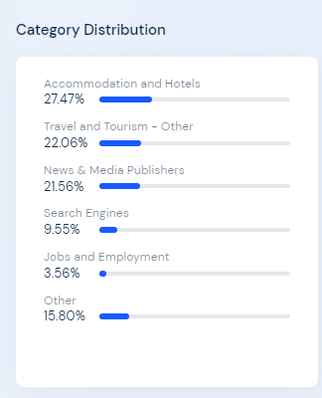
Six Senses Category distribution
Source: Similarweb
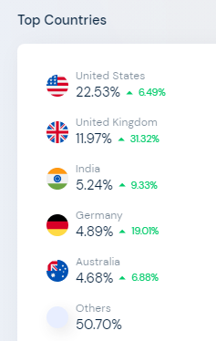
Six Senses Top operational countries
Source: Similarweb

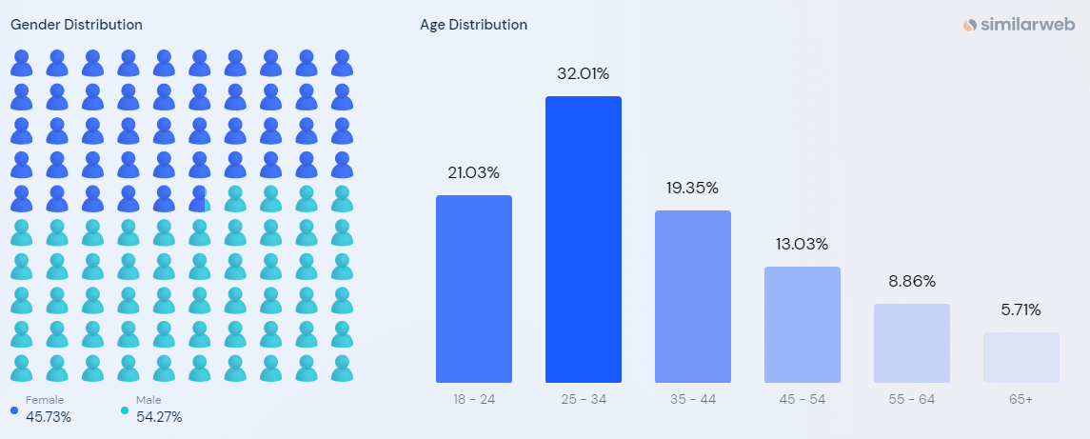
Six Senses Gender and age distribution
Source: Similarweb

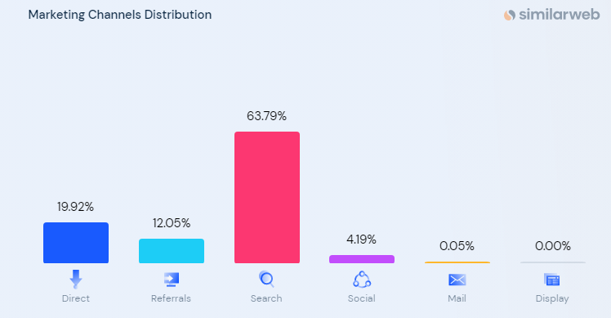
Six Senses Marketing channels distribution
Source: Similarweb

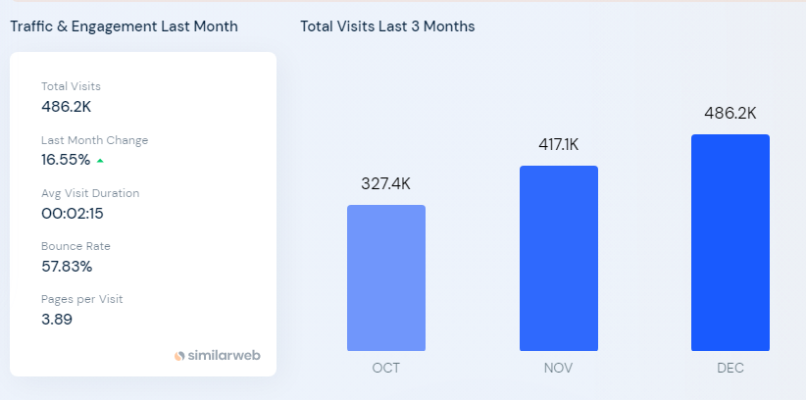
Six Senses Traffic and Engagement graph
Source: Similarweb

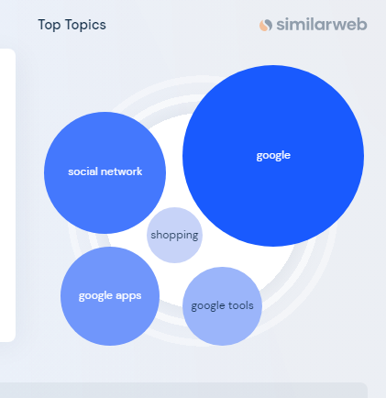
Six Senses Top interaction topics
Source: Similarweb
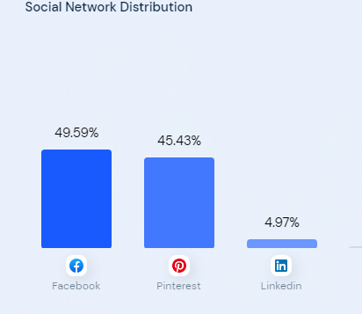
Six Senses Social network distribution
Source: Similarweb

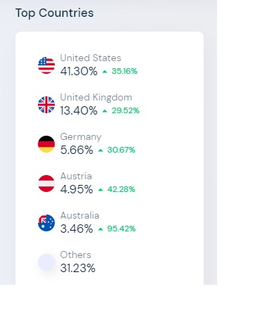
Moxy Hotels Top operational countries
Source: Similarweb

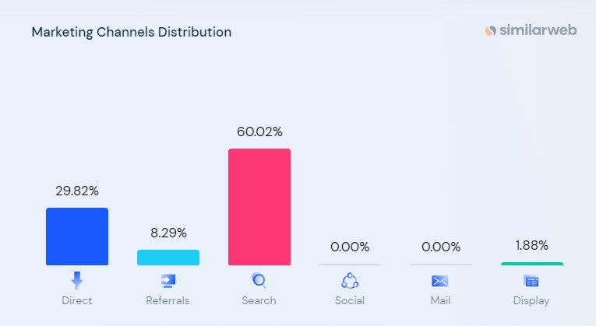
Moxy Hotels Marketing Channels Distribution
Source: Similarweb
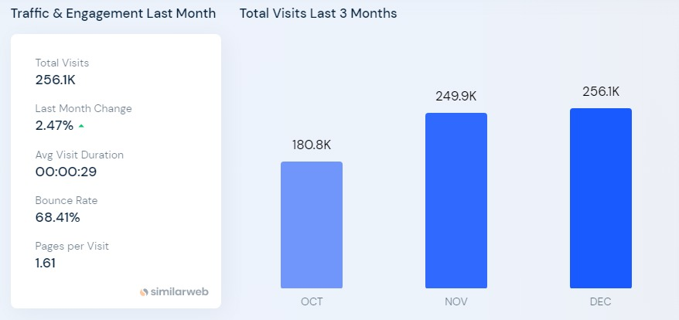
Moxy Hotels Traffic and Engagement graph
Source: Similarweb
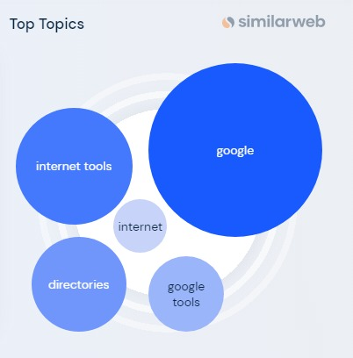
Moxy Hotels Top interaction Topics
Source: Similarweb

