Student name: Catalin Bonta
Student id: 2020747
Module name: Food & Beverage Operations BMIH4002
Lecturer name: Mary Needham

Layout

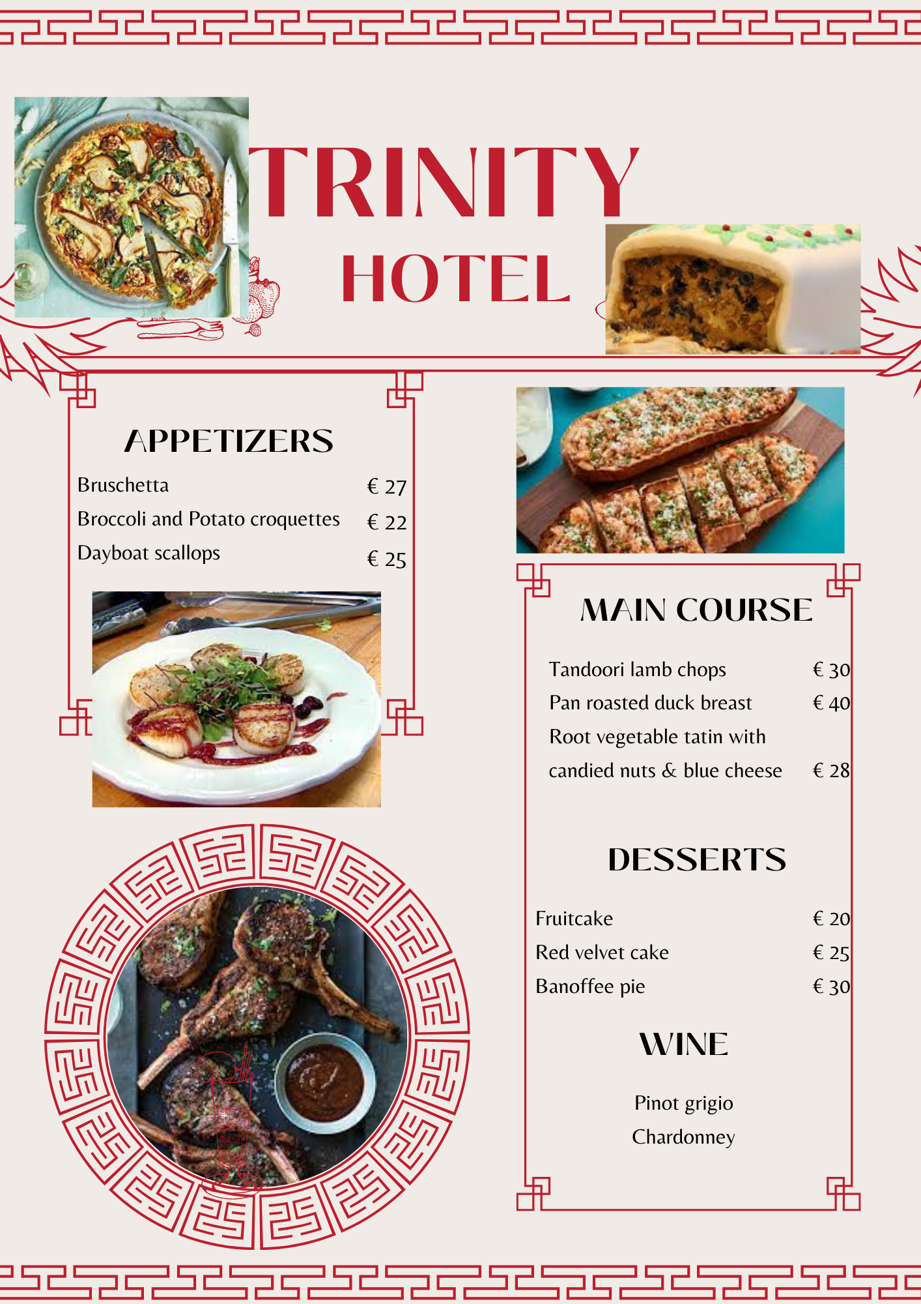
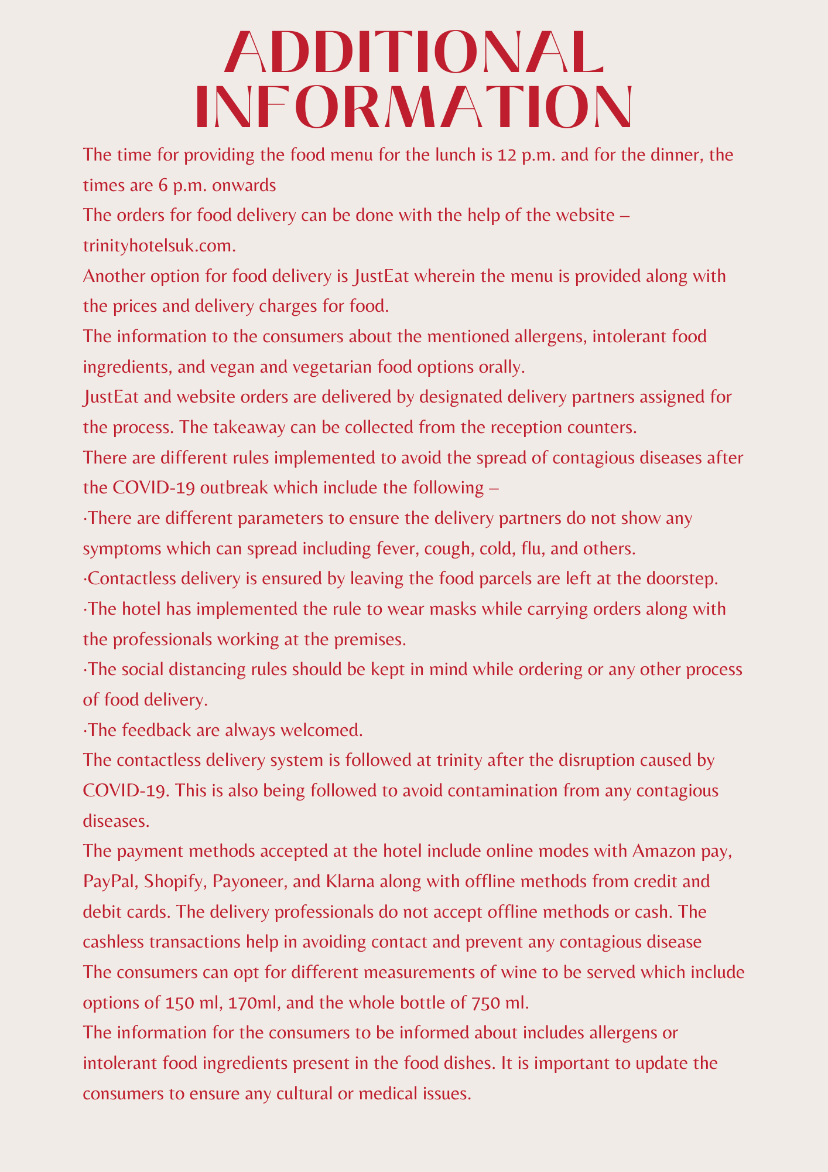

Number of dishes
Starters –
- Bruschetta
- Broccoli and Potato croquettes
- Dayboat scallops
Main course –
- Tandoori lamb chops
- Pan roasted duck breast
- Root vegetable tatin with candied nuts & blue cheese
Desserts –
- Fruitcake
- Red velvet cake
- Banoffee pie

Wine pairings with specific dishes
The wine pairing with the menu includes Pinot Grigio and Chardonnay.

Price-point
Dishes | Prices (Euros)
Starters –
Bruschetta | € 27
Broccoli and Potato croquettes | € 22
Dayboat scallops | € 25
Main course –
Tandoori lamb chops | € 30
Pan-roasted duck breast | € 40
Root vegetable tatin with candied nuts & blue cheese | € 28
Desserts –
Fruitcake | € 20
Red velvet cake | € 25
Banoffee pie | € 30

What information is needed on a menu
The information for the consumers to be informed about includes allergens or intolerant food ingredients present in the food dishes. It is important to update the consumers to ensure any cultural or medical issues (Food.gov.uk., 2022).
Dishes | Allergens and other information
Starters –
Bruschetta | Gluten and milk intolerance (Vegetarian)
Broccoli and Potato croquettes | Egg allergens and milk intolerance (Vegetarian)
Dayboat scallops | Fish allergens
Main course –
Tandoori lamb chops | Milk allergens
Pan-roasted duck breast | Non-vegetarian dish.
Root vegetable tatin with candied nuts & blue cheese | Milk and nut allergens
Desserts –
Fruitcake | Vegan and vegetarian dishes
Red velvet cake | Gluten intolerance
Banoffee pie | Gluten and milk intolerance
It is crucial to inform the consumers about the mentioned allergens, intolerant food ingredients, and vegan and vegetarian food options orally.

Time availability
The time for providing the food menu for the lunch is 12 p.m. and for the dinner, the times are 6 p.m. onwards.

Contact details –
The orders for food delivery can be done with the help of the website – trinityhotelsuk.com.
Another option for food delivery is JustEat wherein the menu is provided along with the prices and delivery charges for food.

Instructions
JustEat and website orders are delivered by designated delivery partners assigned for the process. The takeaway can be collected from the reception counters.
There are different rules implemented to avoid the spread of contagious diseases after the COVID-19 outbreak which include the following –
- There are different parameters to ensure the delivery partners do not show any symptoms which can spread including fever, cough, cold, flu, and others (Allam et al., 2022).
- Contactless delivery is ensured by leaving the food parcels are left at the doorstep.
- The hotel has implemented the rule to wear masks while carrying orders along with the professionals working at the premises.
- The social distancing rules should be kept in mind while ordering or any other process of food delivery.
- The feedback are always welcomed.

Contactless delivery
The contactless delivery system is followed at trinity after the disruption caused by COVID-19. This is also being followed to avoid contamination from any contagious diseases (Jagtap et al., 2020).

Payment Options
The payment methods accepted at the hotel include online modes with Amazon pay, PayPal, Shopify, Payoneer, and Klarna along with offline methods from credit and debit cards. The delivery professionals do not accept offline methods or cash. The cashless transactions help in avoiding contact and prevent any contagious disease.

Beverages
The consumers can opt for different measurements of wine to be served which include options of 150 ml, 170ml, and the whole bottle of 750 ml.

REFERENCES
Allam, M., Cai, S., Ganesh, S., Venkatesan, M., Doodhwala, S., Song, Z., Hu, T., Kumar, A., Heit, J., COVID-19 Study Group and Coskun, A.F., 2020. COVID-19 diagnostics, tools, and prevention. Diagnostics, 10(6), p.409.
Food.gov.uk., 2022 Allergen guidance for food businesses Online available at https://www.food.gov.uk/business-guidance/allergen-guidance-for-food-businesses. Last accessed May 2022
Jagtap, S., Bader, F., Garcia-Garcia, G., Trollman, H., Fadiji, T. and Salonitis, K., 2020. Food logistics 4.0: Opportunities and challenges. Logistics, 5(1), p.2.

