
Student Name: Mohammed Azharuddin
Student Id: 2105239

Impact of E vehicles in India in automobile industry

Table of Contents
1. Introduction 2
2. Background to the Research Topic 2
3. Rationale of the Research 3
4. Aim and Objectives 4
5. Research Questions 4
6. Literature Review 5
7. Methodological Choices 7
8. Ethical Consideration 8
9. Limitations 8
10. Conclusion 9
References 10

Introduction
With the growth of innovation and the role of the increasing investment in the automotive R&D departments for the target of sustainable vehicles, the role of the EV is considered one of the most impactful factors. For the research which is being proposed, will look for the scope for the sustainable growth of the market of India. The research that is being proposed needs to know about the background analysis of the EV industry. The scope for the success factors of the EV in India can be developed from different data which indicates the growth of the market of EV in the global arena. In this case, it is also important to consider the role of the policy development and the macro environmental factors which helps to make the project of the launch of e-vehicles in the market of India (Mehta, 2021). The research will be able to focus on the development of the role of the different macro and micro environmental factors which can help in the sustainability based on the different initiatives and probable outcome of the initiatives to look for the bigger future of the e vehicles in the Indian automobile industry.

Background to the Research Topic
With economic and social development in India, the role of the automotive industry is also being evolved to a great extent. The industry is able to reflect the role of the huge scope for the innovation in the field of the making of the vehicles. Analysis of the factor has been shown in the research of Lau, Wu and Yan, (2022), where India has been considered as one of the most visionary countries to aim the transformation of the vehicles to the EV (Electric Vehicles). With the rapid growth in the automotive industry in India, the growth rate of market share of EV is able to convey the role of the immense growth of the R&D departments of the different departments.

Figure 1: Growth of market share of EV
(Source: India Brand Equity Foundation, 2022)
According to the data of India Brand Equity Foundation, (2022), in the global share, 8.3% of the vehicles are EV whereas 4.3% global market share have been recorded in the year 2020 (figure 1). It has been seen with the huge growth in the demand of the EV, for the sustainability of the costing and environment, being a developing country, India also targets to develop the scope for the incorporation of the EV for mass use to a great extent.

Rationale of the Research
The research which is being proposed will look for some of the most important factors regarding the development of the e vehicles in the market of India. In this case, in the first place, the role of the governmental initiatives for the promotion of the market shares of the e vehicles. Apart from that, the role of the different policies, both at the country and state level and their impact on the market share (Niti Atyog, 2022). The research will look for the development of the impact of the e vehicles on the consumer satisfaction and the costing whether it is able to cope with the economic state of the market.
With the analysis of the research topic, infrastructure of the market of India has also to be considered to look for the development of the role of the capability of incorporation of the mass adaptation of the e vehicles as the part of the automotive industry. In this case, the amount of the investment and the economic and special support for the e vehicle in India will also be considered by the researcher. The sustainable development of the role of the consumers in this case will also be considered for the justification of the development of the market share of the EV in India.

Aim and Objectives
Aim
The aim of the research under proposal will look for impact of the introduction to EVs in the market of India so that the consumer and ecological perspective and the government initiatives for the development of the EV market can be understood.
Objectives
- To know about the impact of the EV in the Indian automotive sector for understanding the change in the market share
- To know about the adaptability of the consumers about the EVs in the Indian market
- To look for the knowledge development at the government initiatives for EVs for the sustainability in the Indian Market
- To look for the quality management of the EV on the market of India
- To look for the long term growth of EV on the market of India

Research Questions
- What is the impact of EV in the Indian Automotive sector for understanding the change in the market share?
- What are the adaptability of the consumers about the EVs in the Indian market?
- Why is it important to develop knowledge development at the government initiatives for EVs for the sustainability in the Indian Market?
- How is the quality management of the EV on the market of India important?
- What is the long term growth of EV on the market of India?

Literature Review
The electric vehicles production is increasing at a much greater pace than it was expected from the time of its initiation. The market has reached a growth rate of nearly 4.2% in the year of 2020 (Raut, 2022). As per Tiwari, (2022) it has been seen that the Indian market is the 5th largest automobile market in the world. With the growing demand for sustainable measures in the automobile sector the government of India had incorporated nearly £100 billion in terms of the development of the E-vehicles segments that are present in the automobile sector of India. The allocation of such a large amount of funds is being done mainly to raise the demands of E-vehicles in the market. This is effective for the growth of the industry but in some cases such spending is also creating economic burden upon the country and also the sector.
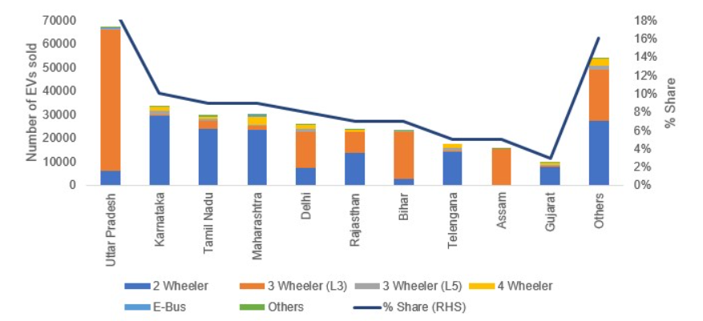
Figure 2: State wise E-vehicle sales trends in India
(Source: Mishra and Malhotra, 2019)
Whereas the studies of Mishra and Malhotra, (2019) has been able to present that though there are initiatives by the government such as financial allocation to the e-vehicles segment of the automobile sector, the growth in the demand of E-vehicles has been less than 1%. In relation to that the studies of Navalagund, Mahantshetti and Nulkar, (2020) has been critical to present that there are other barriers such as technological barriers and infrastructural barriers that have been seen in India. The majority of the technological as infrastructural focus is being implemented upon development of the traditional processes in relation to the generation and the development of the vehicles. This is also considered to be one of the barriers behind the growth and development of the E-vehicles sector. Thus from the analysis it can be stated that even though there is great potential of growth for the e-vehicles in the market of India there are a few major limitations due to which the demand of E-vehicles is not increasing in the market of India (Kurien, Srivastava and Molere, 2020).
As per the study done by Bhardwaj and Bhardwaj, (2019) it has been seen that the high valued customer perception related to E-vehicles are seen mainly in cities. One of the main factors behind such high values related to selection of E-vehicles is mainly due to the rise in the level of pollution as well as the growth of the level of congestion that is being seen in the urban centres. Whereas the studies of Mirwani and Kavitha, (2021) has also been critical to present that the majority of the city dwellers have selected E-vehicles as a source of transportation rather than basic automobiles that run on fossil fuels. The selection has mainly been made by the urban population of India due to the effective societal influence that E-vehicles exerts upon the society. Apart from that, financial benefits that are mainly seen by the customer in terms of cost reduction are considered as major causes for the selection of such vehicles. From the analysis it can be presented that there is a rise in the customer perception related to the acquisition of E-vehicles rather than traditional motorised vehicles that run on fossil fuels (RK and NithinDaniel, 2019).
As per the study of Monika, (2019) it has been seen that modern customers' perception related to E-vehicles has been growing in India. This is mainly due to the rising concern related to environmental effects as well as the minimization of natural fossil fuels reserves. This has resulted in the changes in the demand of the customer base. In relation to that the study of Natarajan, (2020) has been critical to state that the Indian market has the potential to achieve a growth of 36% CAGR by 2026 with the effective utilisations of the resources be it monetary or the effective acquisition of infrastructure.
This will help the company to grow as well as develop in relation to the demands of the modern business market. Companies such as mahindra, tata motors and hero electric are the dominant players in the markets of e-vehicle production and sales in India. Apart from that the studies of Senthilkumar et al., (2021) has been beneficial to present that E-vehicles are considered to be a disruption in the automotive industry. This is critical for the company belonging to the markets of India to minimise the rate of carbon footprint that is emerging from the automobile industry of India. The government of India has also taken major steps for the effective development of aspects such as commercial viability of E-vehicles as well as reaching a 100% e-mobility by 2030. The Indian market has huge potential for the growth of the E-vehicles segments as well as the development of the various technicalities related to this segment of the automobile sector.

Methodological Choices
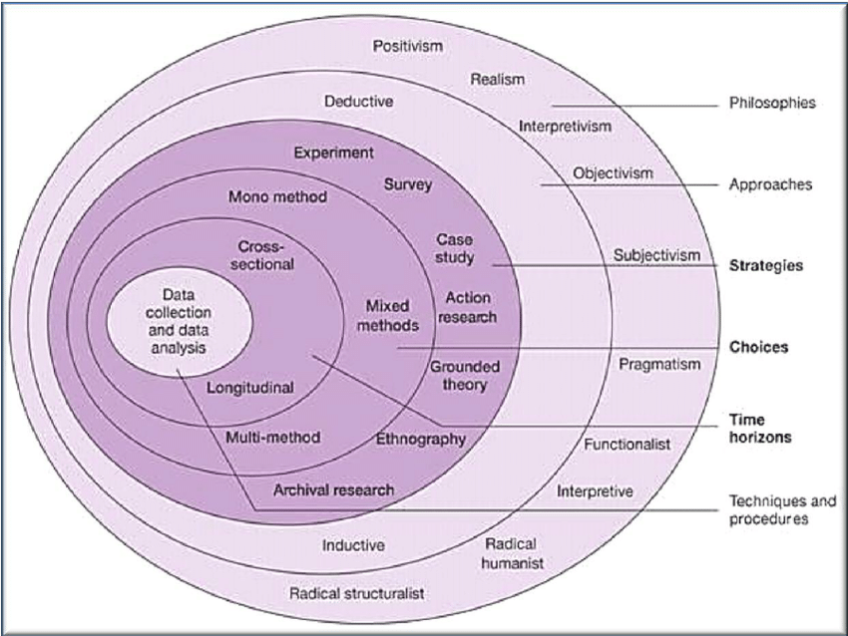
Figure 3: Saunders Research Onion
(Source: Saunders, Lewis and Thornhill, 2007)
The development and structuring of the research methodology section will be done by the researcher with the help following the model of Saunders research onion. The research onion model that has been proposed by Saunders is critical to make effective decisions in relation to design the research methodology (Melnikovas, 2018). The overall research will be conducted using secondary quantitative information By considering the research Onion framework the research will at first work upon the philosophy of the research. In this case the researcher will be selecting the interpretivism research philosophy. In relation to the approach, the researcher will be selecting the inductive approach to conduct the research. The researcher will also be selecting an explanatory Research Design as well as an qualitative research strategy for performing the research. The researcher will be collecting data from various secondary sources such as databases, for example Google scholar, IEEE xplore, ACM database etc. secondary data will also be collected from online journals such as Jstor. In relation to obtaining such data, the researcher will also be using various keywords such as Automobile industry, Electric vehicles, e-mobility, technological disruption, commercial viability of E-vehicles etc.

Ethical Consideration
While conducting the research which is being proposed, some of the ethical measures will be taken into consideration. The researcher will be using reference to maintain the authenticity of the research. The originality of the research will also be maintained through effective methodological choices. No data will be used which are confidential. The role of the plagiarism will also be carefully handled by the research so that the impact of the authenticity can be maintained throughout the research.

Limitations
There are few limitations that might be faced by the researcher while conducting the research. The first limitation that might be faced is that of obtaining mixed data sets that is related to both the mainstream automobile development as well as the development of the e-vehicles related to a particular research topic of choice and therefore there might be a major issues in terms of generalising the data. Apart from that the researcher might also obtain less data related to the practical impact of implementation of E-vehicles in modern society. The researcher might also get data points that are mainly related to the size of the Indian automobile industry and its growth rather than the emphasis being exerted upon the growth as well as the problem related to effective growth of such an important segment in the automobile Industry.

Conclusion
The analysis that will be presented by the researcher will mainly showcase that the E-vehicles are having a major impact upon the Indian automobile industry. Though the concept was present in the country for more than a decade, less work was performed in relation to the development of such aspects. But in these modern times the sector is forecasting a greater amount of growth as well as demand, changing the demand pattern of the automobile industry.

References
Bhardwaj, A. and Bhardwaj, T., 2019. Future prospects of electric vehicles in Indian market: marketing opportunities and challenges. International Journal of Management Research and Reviews, 9(3), pp.17-25.
India Brand Equity Foundation, 2022. Electric Vehicles Market in India | IBEF. [online] India Brand Equity Foundation. Available at: <https://www.ibef.org/blogs/electric-vehicles-market-in-india> [Accessed 8 July 2022].
Kurien, C., Srivastava, A.K. and Molere, E., 2020. Indirect carbon emissions and energy consumption model for electric vehicles: Indian scenario. Integrated Environmental Assessment and Management, 16(6), pp.998-1007.
Lau, Y.Y., Wu, A.Y. and Yan, M.W., 2022. A way forward for electric vehicle in Greater Bay Area: Challenges and opportunities for the 21st century. Vehicles, 4(2), pp.420-432.
Mehta, D., 2021. THE E-VEHICLE INDUSTRY IN INDIA: A POLICY ANALYSIS. St. Xavier’s College (Autonomous), p.33.
Melnikovas, A., 2018. Towards an explicit research methodology: Adapting research onion model for futures studies. Journal of Futures Studies, 23(2), pp.29-44.
Mirwani, P.M. and Kavitha, N.L., 2021. Indian Electric Vehicles Market: The Way Ahead. Embracing change & Transformation: Vision 2025, p.1.
Mishra, S. and Malhotra, G., 2019. Is India ready for e-mobility? An exploratory study to understand e-vehicles purchase intention. Theoretical Economics Letters, 9(02), p.376.
Monika, M., 2019. A STUDY ON CUSTOMER PERCEPTION TOWARDS E-VEHICLES IN BANGALORE.
Natarajan, K., 2020. Growth of E-Vehicle and De-Growth of Automobile Industry in India. A Journal of Composition Theory. ISSN, pp.0731-6755.
Navalagund, N., Mahantshetti, S. and Nulkar, G., 2020. Factors influencing purchase intention towards E-vehicles among the Potential Indian consumers-A study on Karnataka region. Journal of the Social Sciences, 48(3), pp.1598-1616.
Niti Atyog, 2022. RESOURCES. [online] E-amrit.niti.gov.in. Available at: <https://e-amrit.niti.gov.in/resources> [Accessed 8 July 2022].
Raut, S.M., 2022. A Study of Sales Trend of E-vehicles in India and Maharashtra.
RK, A. and NithinDaniel, M., 2019. Green initiatives and sustainable development in automotive industry.
Saunders, M., Lewis, P.H.I.L.I.P. and Thornhill, A.D.R.I.A.N., 2007. Research methods. Business Students 4th edition Pearson Education Limited, England.
Senthilkumar, M., Suresh, K.P., Sekar, T.G. and Pazhanimuthu, C., 2021, March. Efficient Battery Monitoring System for E-Vehicles. In 2021 7th International Conference on Advanced Computing and Communication Systems (ICACCS) (Vol. 1, pp. 833-836). IEEE.
Tiwari, D., 2022. Barriers to Adoption of e-Vehicles in India: A Literature Review and Prospects for Sustainability. ECS Transactions, 107(1), p.10325.

