The Impact of Digital Change on a Tourism/Hospitality ORGANISATION: A case study on the Live Nation – Ticketmaster merger.
Managing Change within Tourism Organisations

Paige Debbie Ford – P146228 – BMMB7011

Table of Contents
1.0 Executive Summary 2
2.0 Introduction 3
3.0 What is Change? 3
3.1 Definitions of Change 3
3.2 Typology of Change 3
3.3 Why Change is Important 4
3.4 Why Change Fails 5
3.5 What Triggers Change? 5
4.0 The Digital Economy 5
5.0 Background on Live Entertainment Industry 6
6.0 Company History and Overview 6
7.0 Reason for Change 7
8.0 Change Management 8
8.1 Lewin's Change Management Models 8
8.2 Applying Lewins Modules 10
8.3 The Eight Steps of Successful Change 12
8.4 Applying Kotter and Cohens 8 Step Theory 13
9.0 Dealing with Resistance 14
9.1 Stakeholders. 15
10.0 When is Change Complete? 18
11.0 Brexit 18
12.0 Conclusion 19
13.0 Recommendations 20
14.0 Appendices 21
15.0 Bibliography 24

Executive Summary
The purpose of this report was to examine the merger that took place between Live Nation and Ticketmaster in 2010. The report explores the concept of change, why it happens, why it fails and why it is important. Furthermore, the report examines a brief background of the live music industry and the background to the organisations that were to merge. The full main body of the report examines three different change management models and applies these models to the change undertaken by Live Nation and Ticketmaster. The final sections of this report involve a stakeholder analysis and recommendations for the organisations. In conclusion, the change undertook showed poor change management practice, based purely on the models used throughout this document.

Introduction
This report will investigate the merger between Live Nation and Ticketmaster, with a strong emphasis on the digital change that took place during the merger. The report will explore different change management models to evaluate the performance of the company’s merger and why and how they managed change. Once a conclusion has been made the report will then give recommendations based on the outcome of said conclusion.

What is Change?
This section will detail the definitions of change, typology of change, explore why change fails and what triggers change.

3.1 Definitions of Change
The Oxford English Dictionary defines change as “An act or process through which something becomes different” (Oxford University Press, 2018). For this report, a more defined definition of change is needed in regard to organisational change. A strong definition of organisational change is“A process in which an organisation shifts from being in one state to being in another state” (Ford and Ford, 1995).

3.2 Typology of Change
In order to understand a change in an organisation, it can be beneficial to understand the type of change that is occurring. Hodges and Gill (2015) developed the different typologies of change that include; How it Happens, Magnitude, Focus and Level.
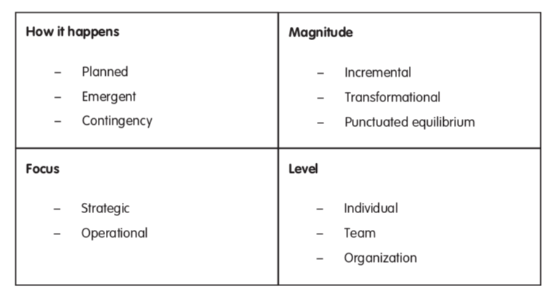
Figure 1 - Typologies of Change, Hodges and Gill (2015)
As figure 1 demonstrates, how it happens can refer to whether the change was planned, emergent or as part of a contingency plan. The Magnitude can refer to the scale of the change. Furthermore, the focus is based on whether there is a strategic or operational focus related to the change. Finally, whether the change is on an individual level, team level or organisational level.

3.3 Why Change is Important
Change is a natural occurrence in life and it will never disappear. "Technology, civilisations and creative thought will maintain their ever-accelerating drive onwards" (Paton and McCalman, 2008). With the reoccurring change happening in everyday situations it is imperative that organisation manage and adapt to change, as “businesses and managers are faced with highly dynamic and ever more complex operating environments” (Paton and McCalman, 2008) Though a simple reason, the constant change is the reason why change, in particular, change management is important within organisations.

3.4 Why Change Fails
Managing change can be difficult and “part of the problem is that there is little agreement on what factors most influence transformation initiatives” (Sirkin et al. 2005) and the majority of the time the executive is the blocker preventing successful change. This can be due to the fact that each executive has their own perspective and viewpoint of an initiative based on personal experiences and focuses on different success factors (Sirkin, Keenan and Jackson, 2005). Change Management models can be the solution to avoiding failure if followed correctly.

3.5 What Triggers Change?
Many factors can influence or trigger change, those factors being either external factors or internal factors. External factors may be new technology, changed customer needs, competitor activity, merger/acquisitions, government policy, politics and changed in social and cultural values. Internal factors can include; poor performance, relocation, new management or employees, new ideas about customer services and a lack of skills. How organisations identify these triggers and adapt can impact whether organisation change is successful or not.

4.0 The Digital Economy
Electronic business (e-business) is considered one of the most significant information technology innovations over the last decade (Geoffrion & Krishnan, 2003) Due to this, organisations that have been operating over the past 20 years have all gone through digital change, Nițescu Alina (2016) suggests that Modern means of electronic communication and online services are the main factors of change for present economies and societies. Live Nation is an example of one of the thousands of organisations that realised the upcoming trends of the digital economy and therefore sought out a change in the company, to merge with the thriving online ticket sales service Ticketmaster.

5.0 Background on Live Entertainment Industry
Roughly $21 billion was generated in live entertainment ticket sales in 2007, this being split between sporting events, that brought in around $14.3 billion, concerts that brought in around $6.7 billion and the rest then brought in by theatre performances, art exhibitions and other events utilising ticketing services (Meese and Richman, 2009).

6.0 Company History and Overview
Live Nation Entertainment (From here will be referred to as LNE) is a live entertainment and e-commerce company (Live Nation Entertainment, 2012). “The company operates in five reportable business segments: concerts, ticketing, artist nation, e-commerce and sponsorship” (Live Nation Entertainment, 2012) The company owns, operates and has booking rights in over 40 countries and in 133 venues (Live Nation Entertainment, 2012). “Live Nation, the world’s largest producer of live concerts, engages in the promotion of concerts and other events, the operation and management of live entertainment venues, various forms of entertainment-related merchandising, and the sale of tickets for events at venues it owns or operates” (Meese and Richman, 2009). The company was formed in 1996 and was originally called SFX Entertainment and was a subsidiary of Robert F. X. Silverman’s SFX Broadcasting (Hull, Hutchison and Strasser, 2011). In 2000 Silverman sold SFX to Clear Channel Communications for $4.4 billion dollars (Sisario, 2013). This later spun off into Live Nation in 2005 (Sisario, 2013). In 2009 a decision was made to merge Live Nation with the online ticket broker Ticketmaster in a $2.5 billion, all-stock deal. The Merger was completed in 2010 and both companies were then under the parent company Live Nation Entertainment (Segal, 2010).
Ticketmaster is an American ticket sales organisation that operates in many countries all over the world. Ticketmaster, a subsidiary of InterActiveCorp, was named as the world’s leading provider of online ticket services in 2004 (Ticketmaster Corp, 2004). “Ticketmaster, the world’s leading live entertainment ticketing and marketing company, sells tickets in the primary and secondary markets, licenses technology that facilitates the self-distribution of tickets for assorted venues, and manages entertainment talent” (Meese and Richman, 2009). After the merger in 2010, Ticketmaster still stands as the leader in ticketing large-scale sports and entertainment events online. After the merger which created LNE, the “ticketing giant has evolved to place a greater focus on partnering with global artists, athletes and venues to shape fully immersive entertainment experiences” (Mitchell, 2017).
Over the years the company went through many changes, however, the Live Nation – Ticket Master Merger creating LNE was a major change, for the company on all fronts, including a massive digital change.

7.0 Reason for Change
Firstly it is important to address that although Live Nation as a company had a slightly negative reputation it was still and is still the worlds leading producer of live concerts and the operation and management of live entertainment venues (Meese and Richman, 2009) However, in a growing market with competitors on the rise Live Nation wanted to create a company with dominant holdings in concert promotion and ticket sales (Adegoke, 2009). “The proposed merger was one of several and significant developments in a rapidly changing industry, and it reflects the search for new business models that capitalize on Internet technologies and respond to disruptions to previously reliable revenue flows” (Meese and Richman, 2009)

8.0 Change Management
There has always been the need for change management and it is easy to overestimate the scale of change (Elearn Limited, 2005). Despite the best efforts of senior management, major change initiatives often fail. One of the most common defining factors of failure is that the management and employees see the change differently (Strebel, 1996) Though, other factors may include; customer disapproval, competitors, government policy, finances etc. In order to achieve successful change, change management models should be used, to aim for the best outcome of change.

8.1 Lewin's Change Management Models
Kurt Lewins’ model of organisational change is well known and much quoted by managers today (Cameron and Green, 2012) His models include his force field analysis and his change management model, also referred to as Change as Three Steps (CATS) which is regarded as the classic paradigm or the fundamental approach for managing change (Cummings et al. 2016). The force field analysis examines the driving and resisting forces of change in any situation. The basic principle is that the driving forces must outweigh the resisting forces if any change is to happen (Cameron and Green, 2012).
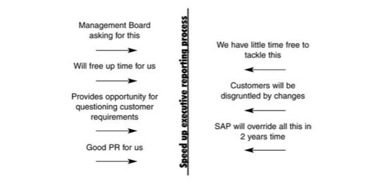
Figure 2 – Lewin's Force Field Analysis – Cameron and Green (2012)
Figure 2 above shows an example of Lewin's force field analysis being put into practice, as can be seen there are driving forces for change on the left, which outweigh the resisting forces of change on the right.
To look at the overall process of making changes Lewin proposed the organisation change has three steps (CATS), these steps include unfreezing, moving and refreezing (Cameron and Green, 2012).
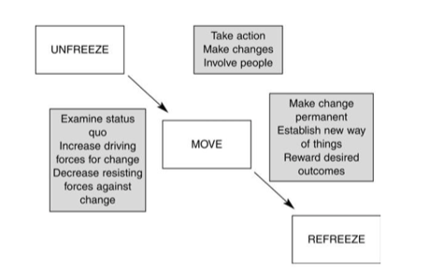
Figure 3 – Lewin's Three Step Model – Cameron and Green (2012)
To explain further, the first step ‘Unfreeze’ can be defined as unfreezing the current state of affairs; understanding the current state, surfacing the driving and resisting forces and imagining a more desirable end state (Cameron and Green, 2012). Moving forward the second step ‘Move' is the active stage of moving to a new state through participation and involvement (Cameron and Green, 2012). Finally the third step ‘Refreeze’ focuses on stabilizing the new state of affairs hence, refreezing the change, by setting policy, rewarding success and establishing new standards (Cameron and Green, 2012).

8.2 Applying Lewins Modules
Applying these modules to the merger between Live Nation and Ticketmaster can help examine the reasons for change and the performance of change undertaken by the management. Below is a Lewins' force field analysis that demonstrates the driving and resisting forces of change towards the company merger.
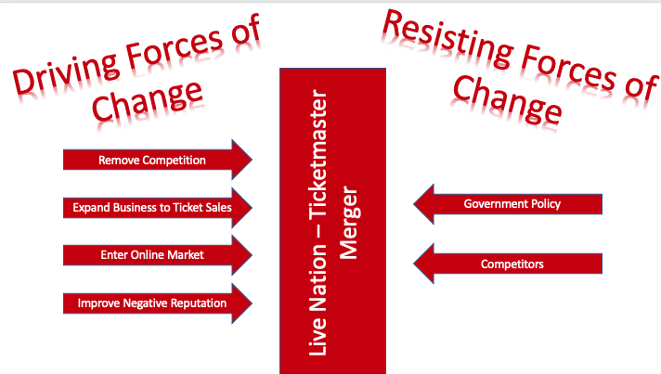
Figure 4 – Force Field Analysis – Paige Ford (2018)
The above figure shows a force field analysis for the merger between Live Nation and Ticketmaster. Firstly a more in-depth description of the forces needs to be explained. The driving forces for change are as follows; To remove competition, to expand the business and enter the ticket sales market, to enter the online ticket sales market and lastly to improve the negative reputation of the company. As clearly shown in figure 3 the driving forces of change highly outweigh the resisting forces of change, which are as follows; Government Policy may not allow such a merger to take place and secondly, competitors may try to intervene in such a major merger. Lewins’ force field analysis module is extremely easy to use when trying to determine the driving forces and resisting forces of change and is simple to understand especially when demonstrating why change is needed. However, a downside to Lewin's force field analysis is the lack of detail and it does not help when deciding how to manage change. This problem, however, can be quickly resolved by using Lewin's CATS module.
As stated previously the first action to take during the CATS module is to ‘unfreeze’. Before the merger between Live Nation and Ticket Master, Live Nation was known as an event promoter and venue management company, they were not linked to ticket sales and although had an online presence were not involved in the online ticket sales market, this was their current state of affairs and the driving and resisting forces links back then to the force field which can be observed via figure 4. Live Nation wanted to expand their organisation, and knew that if they were able to merge with an online ticket sales company they would gain revenue from every aspect of a live music event, making them a superior organisation to their competitors (Fertig, 2018) Reverting back to the CATS module, it should be made clear that the current state of affairs was as follows; Live Nation was not happy with the revenue the company produced and wanted to expand their business and market. Once this was made clear the company moved onto the next stage of the CATS module, ‘Move'. This being the action stage (Cameron and Green, 2012) Live Nation simply proposed a merger between themselves and the worlds leading organisation in online ticket sales in order to commence change. Live Nation was aware of the vast online presence Ticketmaster had and would not be able to compete with Ticketmaster had they created their own online ticket sales websites. However, there was and still is an awful lot of criticism on the proposed merger between the two organisations, as both had negative reputations in the live music industry. To elaborate Live Nation already had their shares in the revenue based on the income of in-house ticket sales, promotion of artists and the venues (Fertig, 2018) this brought upon a negative image as the organisation were creating so much revenue from different aspects of one live show. This leads on to why the merger was not the most popular business deal to take place in the industry, as Ticketmaster gained revenue from ticket sales and not only sold tickets at face value but added extra fees on top of ticket prices to rake in revenue (Anonymous, 2010). (This is where their bad reputation comes into play). Hence why the merger would create an organisation that had shares in every single aspect of a live performance and would take revenue away from the artists themselves, the revenue and suppliers as well as extra revenue sold as ticket fees. As part of the moving process where an action is taken to achieve change, live nation sort acceptance from American regulators and antitrust authorities to give the go-ahead on the merger (Anonymous, 2010). Finally, this bleeds into the final step of the CATS module ‘Refreeze'. This final step focuses on stabilizing the new state of affairs hence, refreezing the change, by setting policy, rewarding success and establishing new standards (Cameron and Green, 2012). The Department of Justice gave the go-ahead for the merger to commence, meaning that the companies were able to merge and form LNE this was the refreezing stage of the organisation change (Waddell, 2010).
Although Lewin's theories link well together due to the scale of change these theories do not help identify enough factors that may influence or cause resistance to change.

8.3 The Eight Steps of Successful Change
The eight steps of successful change developed by Kotter and Cohen (1995) can give much more insight into the issues surrounding change and can be a more detailed way of establishing a plan and analysing change. The steps are as follows;
1. “Create a sense of urgency among relevant people. Banish complacency, fear, and anger, all of which will undermine change” (Anonymous, 2018).
2. “Build a guiding team. It's vital to pull together a team of people with the credibility, connections, and authority needed to provide change leadership. Less successful organizations often try to rely on one person to produce change. That's a fatal mistake. What's needed is a strong team with the right skills, stature, and power to do the job” (Anonymous, 2018).
3. “Get the vision right. Successful organizations create clear, simple, uplifting visions. Less successful ones focus only on detailed plans and budgets which don't inspire people to change” (Anonymous, 2018).
4. “Communicate for buy-in. Even the smartest people are prone to undervalue the need for communicating a simple message over and over. Repetition is key to making sure people understand and accept the message” (Anonymous, 2018).
5. “Empower action. Remove barriers that keep people from acting on the vision” (Anonymous, 2018).
6. “Create short-term wins. Carefully select your first projects so there are enough quick successes to provide credibility and momentum” (Anonymous, 2018).
7. “Don't let up. After the first wins, keep the momentum building slowly and surely. Don't try to do too much at once, and don't let momentum slip” (Anonymous, 2018).
8. “Make change stick. Create and nurture a new culture. Organizational cultures - group norms of behaviours and shared values - take time to build, but no change will endure without a culture to support it” (Anonymous, 2018).

8.4 Applying Kotter and Cohens 8 Step Theory
Although there is little information on the change management undertaken at Live Nation, the steps can be assessed in correlation to the outcome of change. In regard to the first step, creating a sense of urgency and minimising fear, was not the outcome of LNE change management, in fact, throughout the whole process of change and even eight years on, they still face criticism (Mitchell, 2017). The second step aims to build a strong team of people with good connections and who will guide the team to success. This is one of the few steps they managed to get right. They managed to compromise with the department of justice and gain the approval for the merger (N.P, 2010). Getting the vision right is the third step, this was another disappointing effort made by LNE as there were copious amounts of negative press surrounding the merger. Though this can be overlooked by the booming success they still achieve today. The fourth step is about communicating a message, Live Nation gave the press release in 2009 that they were in the process of making a deal to merge with Ticketmaster (Live Nation, 2009) and that message was received loud and clear by the whole industry, such a shock to the industry meant that there was a lot of media coverage on merger, making everyone aware of what was going on. This can be seen as both a positive and a negative, as though the message was clear, it was twisted, and people reacted badly to the message being made. Step 6, 7 and 9 are not as relevant in this case study, and therefore, it is more appropriate to move onto the final step, Step 8 making the change stick. LNE became the merged company of Live Nation and Ticketmaster in 2010, and for the past eight years have managed to keep a united company. However this year the department of justice has opened up an investigation on LNE, once again this can evidence of a poorly managed job.
It may be prudent to say that comparing the Live Nation – Ticket Master merger to the eight steps of successful change shows that the company did not manage change well, even though the change was successful. It also demonstrates that they have not managed to keep the change, as they are now under investigation for disobeying the agreement made between LNE and the department of justice (Mitchell, 2017).

9.0 Dealing with Resistance
Firstly resistance can be defined as, "An unwillingness or inability to accept or to discuss changes that are perceived to be damaging or threatening to the individual" (Buchanan and Huckzynski, 2013). Most of the time resistance is connected to negative attitudes or counterproductive behaviours (Grama and Todericiu, 2017). It is also highly linked to individual resistance, this can be due to selective perception based on past experiences, a form of habit, inconvenience or loss of freedom, finances; such as lesser pay and finally fear of the unknown. Other resistance factors can be technical, political, cultural and structural. Dealing with resistance can be difficult, which is why it is important to create a strong relationship with the employees and create a good communication network within the company so that individual needs may be compromised when trying to adapt and make changes to the organisation (Grama and Todericiu, 2017).
In relation to the Live Nation – Ticketmaster merger, the resistance was external. The merger receives much disapproval from competitor organisations that thought it unfair that if LNE were to become reality they would have vast control over the live event industry. They also had slight concerns from the department of justice, though Live Nation handled this change well, as they compromised with the department of justice, resulting in the merger gaining the approval, all within one year.

9.1 Stakeholders.
When an organisation is going through change, they should undertake a stakeholder analysis. This can be beneficial to aid in the plan for change. Understanding stakeholder positions are essential for the delivery of organisations that deliver a service and they also have to add value to the stakeholders (Williams and Lewis, 2008). The potential number of stakeholders could be very few or very many and depends on the organisation's impact on society (ukessays.com, 2013). In brief, a stakeholder analysis looks at the interest, objectives, power and relationships of the stakeholders (Stave, Goshu and Shimelis Aynalem Zelelew, 2017). Stakeholder mapping is widely used in business management as a tool to plan development strategies and identify stakeholders, a popular model used for this is a power/interest matrix grid developed by Mendelow in 1991 (Markwick, 2000)

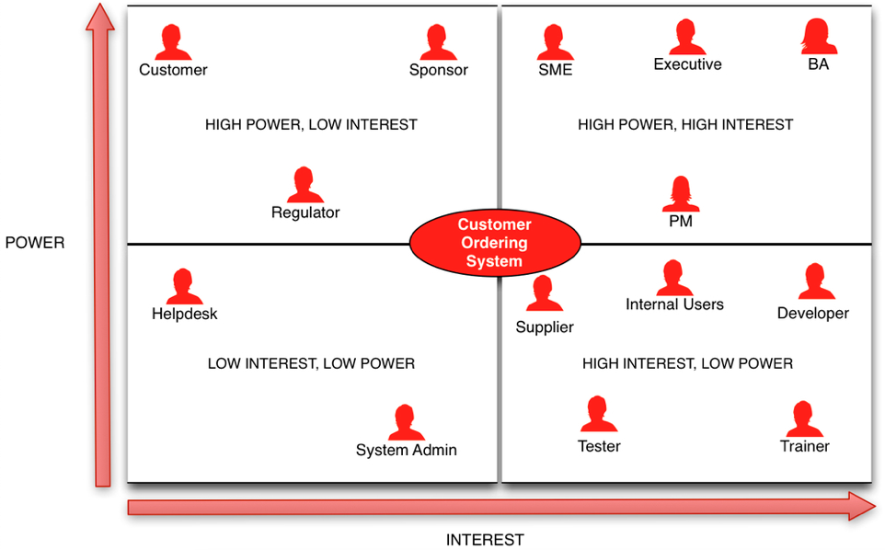

Figure 5 – Mendelows Power/Interest Matrix – Markwick (2000).

Stakeholder Mapping consists of making judgements on two factors. One being how interested each stakeholder group is in regard to the change, secondly the power those groups have to influence that change (Markwick, 2000). Figure 5 demonstrates what a power interest matrix should look like.
When applying this model to the Live Nation/Ticketmaster the list of stakeholders were endless, this is due to the fact that both organisations work within the event industry. For the purpose of this report, the most significant stakeholders will be examined and placed into a power/interest matrix.

High Power – Low Interest  Investors  Customers  Clients/Artist | High Power- High Interest  Department of Justice  Sponsors
Low Power – Low Interest  Volunteers & Stewards  Security  Contractors & Suppliers  Marketing, Advertising & Publicity | Low Power – High Interest  Website Sales (Delegates, tickets and exhibitors)  Competitors

Figure 6 – Power/Interest Grid for Live Nation/Ticketmaster Merger – Paige Ford (2018)

Above in figure 6, the different stakeholder groups are placed into different sections of the group based on their power and interest in the merger. Investors and Customers are placed in the high power – low-interest section as investors have a lot of power as they are providing the finances for the company and have low interest as they are still receiving money back from the investments. Customers also have high power as they are the reason the company is able to run. They have low interest as they will still be able to purchase and attend live music events whether the merger was to go ahead or not. For the Low Power – Low-interest section it is pretty self-explanatory, these stakeholders don't have much power within the organisation to have a significant impact on the change, they also have low interest as the change is likely not to affect them dramatically. The next section, High Power – High interest includes the department of justice, this is due to the fact that they had a significant impact on the change and nearly put a stop to the merger, this was also because they had a high interest in the merger and were worried it would affect the current market and policies. Sponsors also had high power and high interest as, they were providing funding for the organisations, which gave them power, they had high interest as well because if the merger took place, they would receive more marketing coverage across the two organisations. Finally, the last section Low Power – High interest consists of the website sales departments, as by merging with an online service organisation they were the fear of losing jobs, but also the opportunity to develop the website sales departments across both organisations, however, they have low power within the organisation. Competitors also fall into this category as they had high interest in the merger as it would make the market stronger for LNE and weaker for all the competitors. Yet clearly had no power in regard to the merger.

10.0 When is Change Complete?
To know when change is complete organisations should "think about the end at the beginning" (Mihalicz, 2013) to be more direct, organisations should have a clear vision of what the end goal is, should set up a measurement system to keep track of progress and understand who will be impacted by the change and their reactions (Mihalicz, 2013).

11.0 Brexit
Brexit was the branded name of the “national referendum determining Britains exit from the 28-nation body called the European Union (EU)” (Abu-Jamal, 2016). The merger between Live Nation and Ticketmaster took place almost 18 years before Brexit was even announced, meaning that the UK leaving the E.U will not affect the change that the company went through. However, it could potentially affect any changes they plan to make in the future, as Brexit is still an unknown future, which every organisation is struggling to prepare for.

12.0 Conclusion
To conclude a change is inevitable and is a constant occurrence in everyday life, as stated previously there are different variations of the definitions of change, however, they all have the same underlining principle, that change is something that happens and the end result is different. The typologies of change are under the categories of How it Happens, Magnitude, Focus and Level. It is also clear to see from the report that change is important in order for an organisation to grow in the constantly changing world around them. The report also examined why change fails and what triggers change. The failure of change was highly connected to but not subject to management, whereas the triggers included many factors such as changes in trends, finance, politics and interests. The digital economy was also observed, it proved that the digital is growing and will keep growing due to the innovations and developments in technology. Prior to the Merger Live Nation were the world leading event promoters and Ticketmaster were the worlds leading ticket sales company, together they created Live Nation Entertainment, making them the worlds leading provider of live music events. In order to analyse the change undertaken by Live Nation and Ticket master, three change models were used, Lewin's Force Field Analysis, Lewin's Three-Step Model and Kotter and Cohens 8 steps to successful change. After applying these models to the change, it is not clear on how the merger was as successful as it became, as the change seemed unplanned and rushed, though there must have been enough interest for the change to happen for it to become successful. However nearly eight years later and they are now under investigation, so the change may not have gone as successfully as it seems, which makes sense when looking at the models used. In regards to stakeholders, the stakeholder analysis shows that there were enough key players who had high interest and high power to make the change happen. Furthermore, looking at Brexit in regard to this change is insignificant as the change happened almost two decades before Brexit. Finally to conclude the Ticketmaster/Live Nation merger shows to have had poor change management when compared to the change management models used.

13.0 Recommendations
After examining the Live Nation/Ticketmaster merger, recommendations towards the change would have been to produce more planned documents for the change, this may have helped them in regard to the resistance from the Department of Justice and the competitors who though the merger would be unfair due to the increased shares in the market for the merged company. Other recommendations would be to have taken longer to plan the change and gain more support from stakeholders. Finally, the last recommendation would be to have followed some of the famous models, to ensure that the change remained, then they may have avoided this new investigation.

14.0 Appendices

Figure 1 Typologies of Change, Hodges and Gill (2015)

Figure 2 – Lewin's Force Field Analysis – Cameron and Green (2012)

Figure 3 – Lewin's Three-Step Model – Cameron and Green (2012)

Figure 4 - Force Field Analysis – Paige Ford (2018)

Figure 5 – Mendelows Power/Interest Matrix – Markwick (2000)

Figure 6 – Power/Interest Matrix – Paige Ford (2018)

High Power – Low Interest  Investors  Customers  Clients/Artist | High Power- High Interest  Department of Justice  Sponsors
Low Power – Low Interest  Volunteers & Stewards  Security  Contractors & Suppliers  Marketing, Advertising & Publicity | Low Power – High Interest  Website Sales (Delegates, tickets and exhibitors)  Competitors

15.0 Bibliography

Abu-Jamal, M., 2016. BREXIT. Turning the Tide, 28(8), p.4.

Adegoke, Y. (2009). Live Nation to buy Ticketmaster. Reuters. [online] Available at: https://www.reuters.com/article/us-ticketmaster-livenation/live-nation-to-buy-ticketmaster-idUSTRE5194DL20090210 [Accessed 27 Nov. 2018].

Anon, 2009. Live Nation and Ticketmaster Entertainment to Combine in Merger of Equals to create World's Premier Live Entertainment Company - Final. Fair Disclosure Wire, Fair Disclosure Wire, Feb 10, 2009.

Anonymous, 2009. Live Nation in Stock Merger Deal with Ticketmaster Entertainment. Weekly Corporate Growth Report, (1528), p.5.

Anon, 2009. Ticketmaster and Live Nation to merge? Australasian Leisure Management, (72), p.1/9.

Anon, 2009. Ticketmaster/Live Nation merger talks. Music Week, (6), p.11.

Anonymous, 2010. Business: A union of pariahs; The Ticketmaster-Live Nation merger. The Economist, 394(8667), pp.73–74.

Anonymous, 2010. Live Nation & Ticketmaster Entertainment Merger Receives Clearance. Canadian Musician, 32(2), p.16.

Anon, 2010. US Approves Live Nation Ticketmaster Merger. Australasian Leisure Management, (78), p.1/8.

Anon, 2014. David Huckabay - CIO, Live Nation Entertainment, Inc. Boardroom Insiders Profiles, p.n/a.

Anonymous, 2018. The Eight Steps of Successful Change. Nonprofit World, 36(1), p.33.

Buchanan, Badham & Badham, Richard J, 2008. Power, politics, and organizational change winning the turf game 2nd ed., Los Angeles; London: SAGE.

Cameron, E. & Green, M., 2012. Making sense of change management: a complete guide to the models, tools, and techniques of organizational change 3rd ed., London; Philadelphia: Kogan Page.

Chaffin, J., 2008, Jun 20. Strategy dispute leads to split at top of Live Nation. Financial Times, 18. ISSN 03071766.

Cummings, S., Bridgman, T. and Brown, K. G. (2016) ‘Unfreezing change as three steps: Rethinking Kurt Lewin’s legacy for change management’, Human Relations, 69(1), pp. 33–60. doi: 10.1177/0018726715577707.

Elearn Limited & Pergamon Flexible Learning, 2005. Change management, Amsterdam; Boston, MA: Elsevier, Butterworth Heinemann.

Fernandez, Joe, 2009. The Live Nation and Ticketmaster merger must benefit music fans. Marketing Week, 32(8), pp.11–12.

Fertig, E. (2018). The Live Nation and Ticketmaster Merger is Coming with Consequences. [Blog] Music Baeble. Available at: https://www.baeblemusic.com/musicblog/4-3-2018/the-live-nation-and-ticketmaster-merger-is-coming-with-consequences.html [Accessed 27 Nov. 2018].

Fisher, Eric, 2009. Live Nation, Ticketmaster deal faces scrutiny. Street & Smith's Sportsbusiness Journal, 12(4), p.1/2.

Ford, J. and Ford, L. (1995). The Role of Conversations in Producing Intentional Change in Organizations. The Academy of Management Review, 20(3), p.541.

Geoffrion, Arthur M.; Krishnan, Ramayya, 2003. E-Business and Management Science: Mutual Impacts (Part 1 of 2). Management Science, 49(10), pp.1275–1286.

Grama, B., and Todericiu, R. (2016). Change, Resistance to Change and Organizational Cynicism. Studies in Business and Economics 11, 3, 47-54

Hampp, A., 2009. LIVE NATION OUT TO KEEP MUSIC ALIVE IN RECESSION. Advertising Age, 80(14), p.14.
Hull, G., Hutchison, T. and Strasser, R. (2011). The Music Business and Recording Industry: Delivering Music in the 21st Century. 3rd ed. London: Routledge.

Hull, G., Hutchison, T. and Strasser, R. (2011). The Music Business and Recording Industry: Delivering Music in the 21st Century. 3rd ed. London: Routledge.

Lewin, K., Frontiers in group dynamics: Concept, method and reality in social science; equilibrium and social change. Human relations., 1(1), p.5.

Live Nation Entertainment, 2012. Live Nation Entertainment, Inc. Live Nation Entertainment, Inc. MarketLine Company Profile, pp.1–20.

Marino, Jonathan, 2009. U.K. Challenges Live Nation/Ticketmaster Merger. High Yield Report, 20(41), pp.16–17.

Markwick, M. (2000). Golf tourism development, stakeholders, differing discourses and alternative agendas: the case of Malta. Tourism Management, [online] 21(5), pp.515-524. Available at: https://www.sciencedirect.com/science/article/pii/S0261517799001077#BIB32 [Accessed 28 Nov. 2018].

Meese, A. and Richman, B. (2009). A Careful Examination of the Live Nation-Ticketmaster Merger. SSRN Electronic Journal. [online] Available at: https://www.researchgate.net/publication/228297023_A_Careful_Examination_of_the_Live_Nation-Ticketmaster_Merger [Accessed 27 Nov. 2018].

Mitchell, J. (2017). This Ticketing Platform is Aiming to Overthrow Ticketmaster As Global Leader. Forbes. [online] Available at: https://www.forbes.com/sites/julianmitchell/2017/06/08/this-ticketing-platform-aims-to-overthrow-ticketmaster-and-stubhub-as-global-leader/#502580641bc2 [Accessed 27 Nov. 2018].

Muret, Don, 2009. Ticketmaster: Merger plan will help teams. Street & Smith's Sportsbusiness Journal, 11(41), pp.1–3.

Nițescu Alina, 2016. TRENDS AND DIMENSIONS OF DIGITAL ECONOMY. Analele Universităţii Constantin Brâncuşi din Târgu Jiu : Seria Economie, 1(4), pp.103–107.

N. P., 2010. DOJ clears Ticketmaster/ Live Nation. International Financial Law Review, 29(2), p.9.

Oxford University Press. 2018. Definition of Change in English by Oxford Dictionaries. [Online]. [Accessed 27 November 2018]. Available from: https://en.oxforddictionaries.com/definition/change

Paterson, Jennifer, 2013. Live Nation used the merger to increase staff engagement. Employee Benefits, pp.1–2.

Paton, R. and McCalman, J. (2008). Change management : A Guide to Effective Implementation. 3rd ed. London: Sage Publications Ltd.

Segal, D. (2010). Calling Almost Everyone’s Tune. The New York Times. [Online] Available at: https://www.nytimes.com/2010/04/25/business/25ticket.html [Accessed 26 Nov. 2018].

Sirkin, H., Keenan, P. and Jackson, A. (2005). The Hard Side of Change Management. [online] Harvard Business Review. Available at: https://hbr.org/2005/10/the-hard-side-of-change-management [Accessed 27 Nov. 2018].

Sisario, B. (2013). SFX Entertainment Buys Electronic Dance Music Site. The New York Times. [online] Available at: https://mediadecoder.blogs.nytimes.com/2013/02/26/sfx-entertainment-buys-electronic-dance-music-site/ [Accessed 26 Nov. 2018].

Stave, K., Goshu, G. and Shimelis Aynalem Zelelew (2017). Social and ecological system dynamics. 1st ed. Switzerland: Springer.

Strebel, P., 1996. Why do employees resist change? Harvard Business Review, 74(3), p.86.

Sullivan, Nicola, 2011. Live Nation finds harmony after Ticketmaster merger. Employee Benefits, p.9.
Waddell, R., 2010. Upfront: Keeping Score - As the Dust Settles on the Live Nation-Ticketmaster Merger, Here's a Look at Who Benefits - and Who Doesn't. Billboard - The International Newsweekly of Music, Video and Home Entertainment, 122(5), p.6.

Ticketmaster Corp, 2004, Ticketmaster SWOT Analysis, November, p. 4, viewed 27 November 2018, <https://ezproxy.uwtsd.ac.uk/login?url=https://search.ebscohost.com/login.aspx?direct=true&db=bth&AN=14902091&site=ehost-live>.

UKEssays. November 2013. Stakeholder Analysis Of Mendelow Matrix Management Essay. [online]. Available from: https://www.ukessays.com/essays/management/stakeholder-analysis-of-mendelow-matrix-management-essay.php?vref=1 [Accessed 10 December 2018].

Waddell, R., 2010. Upfront: Keeping Score - As the Dust Settles on the Live Nation-Ticketmaster Merger, Here's a Look at Who Benefits - and Who Doesn't. Billboard - The International Newsweekly of Music, Video and Home Entertainment, 122(5), p.6.

Williams, Paul, 2009. The Live Nation/Ticketmaster merger will affect the entire industry. Music Week, (7), p.4.

Williams, W. and Lewis, D. (2008). Strategic management tools and public sector management. Public Management Review, [online] 10(5), pp.653-671. Available at: https://www.researchgate.net/publication/262862837_Strategic_management_tools_and_public_sector_management [Accessed 25 Nov. 2018].

