Project Initiation Document
Techniquest
Consultancy Project
Mhairi Price (1708315)
2020
Contents Page
Introduction 2
Project Justification 2
Project Objectives 2
Project Team 3
Communication Strategy 4
Project Plan 4
Research Methodology 4
Cost 5
Benefits to Techniquest 5
Reference List 6

Introduction
A project initiation document also known as project charters or a project brief is a document which is used for the basis of approval and prepared at the commencement of the project, taken from (Scope training, 2016). This project initiation document will include all the essential information needed to begin the consultancy project for Techniquest. The main sections included in this document will be the justification for the project, projects objectives, communication plans and the overall project plan.

Project Justification
This project will be tackling one of the organisations main issues which is to attract a wider/ diverse audience from outside of Wales. Currently Techniquest have a very limited market who visits which include Cardiff locals, families within the South Wales area and their main target market primary school visits. This project will aim to attract a wider and diverse audience to expand their target market allowing everyone to enjoy interactive experiences through the form of science.
According to (McAllister, F 2018) the most current statistics found for the number of visitors to Techniquest in 2017 was 189,000, although this number is quite high when compared to 796,000 visitors to LC2 waterpark or 480,000 to Folly Farm there is a significant difference. This project aims to increase Techniquest visitors’ number so that it is competing with other popular tourist attractions in Wales and push it up into the top three most visited attractions in Wales instead of its current 9th place.
With the opening of the Science Capital Project in May 2020 this gives Techniquest a unique selling point to entice a new audience and for this reason now is the perfect time to begin work on this project.
Upon completion of this project Techniquest will see a growth in visits to the centre from tourists outside of Wales. One of Techniquest's main aims is to educate and encourage more people to participate in science in a fun way, this project will allow this to become a reality. Lastly this project will reach the audiences that the organisation is currently struggling to reach and get people from all over the world invested, interested and involved in science.

Project Objectives
The following objectives have been created so that everyone involved in this project are clear on what steps are to be taken to reach the projects end goal.
The first objective is to investigate Techniquest’s current marketing and advertising strategies, how they currently advertise, on which social platforms and who is likely to see these advertisements. Also investigated will be successful marketing and advertisement methods of organisations like Techniquest which can then be applied to create and improve new marketing and advertisement strategies. Ideally this objective needs to be reached by the end of April 2020 before the opening of The Science Capital Project.
The second objective for this project is to work through the calendar year and select worldwide celebration dates. Selected celebrations can include Chinese New Year, Rugby Six Nations, St Patricks day and of course every four years the Olympic Games. Planning events that are tailored around well-known worldwide celebrations aim to captivate tourists that these events apply to or those who are interested in them. The idea behind this is that during these celebrations especially the Rugby Six Nation matches Cardiff city attracts a lot of tourists from around Europe. If these events are being promoted well and in advance it will reach the tourist that Techniquest are aiming to attract, and the perfect time to host these events is during a period when the city attracts a lot of tourist.
The final objective of this project is to seek promotional partnerships. Promotional partnerships are when two organisations promote each other’s organisations whether it be just by displaying leaflets or joining together to offer discounts. Therefore, partnerships I am looking at creating for this project are new ones that will be useful in promoting The Science Capital Project. Currently strong partnerships Techniquest have are with Visit Cardiff Network, Orchard Media, Pear Marketing and Waterfront Partner. All these partnerships are involved in helping to promote the centre, however more is needed. Ideally partnerships with large organisations and public transport providers would be beneficial such as Cardiff Airport, train stations etc however these come at a heavy price. To overcome this seeking partnerships with smaller organisations across the border within Bristol/ Bath where they have large number of tourists will be more realistic.

Project Team
I will be carrying out this project individually. I believe you should choose me to carry out this project for your organisation because of my experience and knowledge. I have studied Travel and Tourism for over five years, and I am at the brink of graduating. Throughout the years I have gained knowledge, skills and confidence within this industry which will help me carry out this project successfully.
During the process of running this project I will be staying in contact with the organisation as much as possible through communicating via email and on-site meetings. The final project will be delivered directly to you with clear steps and outcomes to overcome the issues faced.
As I am a student, I fortunately have access to academic resources that will be valuable when completing this project. Having easy access to academic resources will help me carry out my research and complete this project successfully for your organisation.

Communication Strategy
Communication stated in (Gizir, S 2005) “has an important role in organizational processes by increasing agreement on organizational ideas, norms, values, behaviors, and goals.” This statement supports that within organisations good communication is what will work best in order to achieve the best end goals.
Regular communication between myself and Techniquest will ensure both of us are aware of what is going on. Communication that has taken place so far has been done via email and on-site meetings. These communication methods will continue as this is what works best for myself and for the organisation. On site meetings will be helpful and very important when presenting progress on the final report and any feedback will be applied.

Project Plan
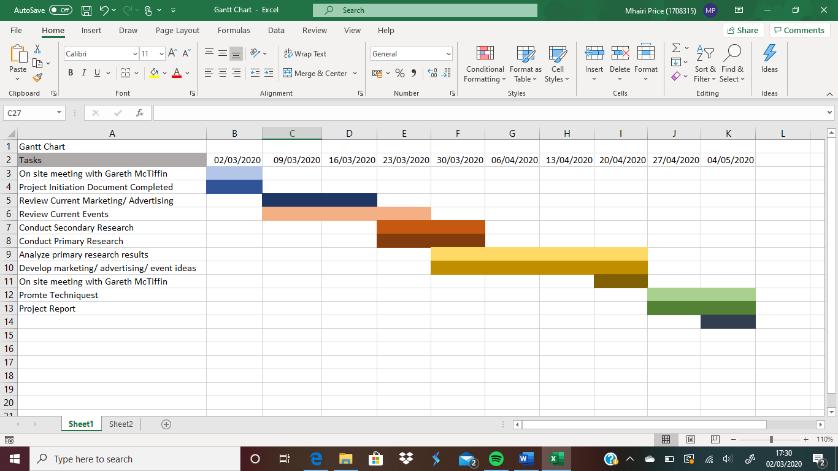
During the process of the project being organised is important to ensure deadlines are met. In order to be organised, meet deadlines and stay on track throughout this process I have created a Gantt chart shown below:
Displayed in this Gantt chart are all tasks that will take place from now until the end of the project and when then need to be completed. The organisation will have a copy of this so that they are aware of tasks I have set myself and the deadline dates.

Research Methodology
The research methods that will be used for this project will be mostly secondary research. Secondary research has been chosen to be the main form of research method because it is the most cost-effective (McCrocklin, S 2018). Secondary research allows me to explore what information is currently available before moving on to any primary research methods which will save time and money. Secondary research that will be used are online resources, newspapers, journal articles and annual surveys conducted by Techniquest that they have given me access to. The primary research that may be used if needed will be done via questionnaires to gather relevant information related to the new expansion and marketing/ advertisement strategies. Interviews with staff members of Techniquest may also be used to gather their views on improvements that can be made in terms of marketing and advertisement strategies.

Cost
At this moment of time there is no cost until the final report has been completed. The cost will be discussed between myself and the organisation in the further stages of the project, the only costs that may occur will be for marketing, advertising and promotional purposes once the final report with recommendations has been completed.

Benefits to Techniquest
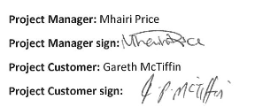
The main reason for carrying out this project is to benefit Techniquest, with the main aim to attract a wider and more diverse audience around the world, increase their target market and allowing people of all ages to enjoy science. The first benefit is the promotion of the science capital project, this is the projects main focus, in turn more people will be aware of the expansion and want to visit. Alongside the promotion of the Science Capital project marketing and advertisement strategies will be improved and therefore for any future developments the organisations will know how to advertise more effectively in order to reach a wider audience. Another benefit this project brings is new event ideas that can be used in the future to attract specific and new tourist. Lastly this project will ensure a sustainable future for Techniquest, the more footfall visiting the centre the more money generated that can be invested back into Techniquest to help with any future developments, hosting events and to keep the centre open so that all generations can enjoy the fun and interactive experiences that are on offer.

Word count: 1,488.

Reference List
Bolter, A. (2013). ‘Report highlights booming tourist trade in Cardiff’. Wales Online. 28th March. Available: https://www.walesonline.co.uk/news/wales-news/report-highlights-booming-tourist-trade-1893799. [2020, February, 28].
Douglas, W & Khalid, M. (2017). CUSTOMER SURVEY REPORT. Internal Techniquest report. Unpublished.
Gizir, S & Simsek, H. (2005). ‘Communication in an Academic Context’. Higher Education. 50(2). Pp. 197-221.
McAllister, F. (2018). Visits to Tourist Attractions in Wales 2017. Pontypridd: Beaufort research.
McCrocklin, S. (2018). ‘Primary Vs. Secondary Research’. GeoPoll. [blog]. 4th October. Available at: https://www.geopoll.com/blog/primary-vs-secondary-research/. [2020, March, 03].
Scope training. (2016). What is a project initiation document? [video]. Available: https://www.youtube.com/watch?v=KGGPo0msiKc. [2020, February 28].
Simons, N. (2015). Techniquest Half Term Survey February 2015. Internal Techniquest report. Unpublished.
Simons, N. (2016). Techniquest Half Term Survey February 2016. Internal Techniquest report. Unpublished.
Techniquest. (2016). Techniquest’s mission is to embed science in Welsh culture through interactive engagement. https://www.techniquest.org/about-us/the-story-of-techniquest/. [2020, March, 02].
Techniquest. (2018). The Science Capital. Available at: https://www.techniquest.org/about-us/the-science-capital/. [2020, March, 02].
Techniquest. (2020). What’s on at Techniquest?. Available: https://www.techniquest.org/plan-your-visit/whats-on/. [2020, March, 03].

