Student name: | Abdurrahman Ibrahim | Student ID number: | 1650352
Programme: | BSc/HND Computing (including BIS, DIS, Games, SE, and Web Streams)
Module: | Application Development
Module code: | ACCA5012 | Contribution to Overall Module Assessment (%): | 50%
Lecturer: | Dr Kemi Ademoye | Internal Verifier: | Dr Mike Dacey
Assignment Title: |  | Word count (or equivalent): | 2000 - 2500 words
Submission deadline: | 9th December 2019 | Return date of provisional marks & written feedback:

Introduction section
Application development demand is increasing daily as the world continues to rely on technology for everything, upcoming programmers like myself can focus on plenty of different trends coming up in 2019, these trends are the highest growing and most required in web development industry.
[1]

As part of the assignment it was required of me to do research on one of these trends, so I went and did my research and decided to focus my topic on mobile friendly user websites, my website will go in depth on the current stats for mobile users, why the mobile friendly user is very highly required in business and any other webpages, the key things required to make a website mobile friendly, and also business advantages this will bring for business owners as all businesses become online based and most people use their smartphones to access the internet, this method will please mobile users who according to our stats will surpass 5 billion users by the end of 2019. [2]

Application Development Concepts’ section
As stated on the introduction the number of smartphone users in 2019 will surpass 5 billion, this means that more and more people will be using their phones to access websites for all their needs, this means business will be more focused on mobile friendly web pages to have access to a higher number of customers for their products or offers. [3]
The key features to design a mobile friendly website is:
- Static content that doesn't change
Make sure the page is static when coding to help the website function properly on a mobile.
- Simplified navigation
Make Navigation simple to browse on a mobile website, Vertical navigation is preferable over horizontal navigation where scrolling is necessary. By using CTA to make the website it will make it easier for the user to navigate to any page as quickly and easy as possible.
Make sure to keep the navigation short and simple so users find it easy to go through the webpage, and if the website contains a lot of information nested menu would be a good option to help navigation.
- Images display smaller
Make the sure the images change size depending on the mobile, so it can easily be done by styling with this simple CSS code:
imp {
width: auto;
max width: 100%;
height: auto;
}
- Not reliant on a mobile operating system to function properly
Make sure the page doesn’t rely on a mobile operating system to function properly, or certain things on the page may not be displayed thus affecting the usability of the web page on a mobile device.
Responsive vs. Mobile-Friendly Websites: What's the Difference?
- Responsive is when the website can be used for all screens, from a laptop to a smartphone and a desktop computer, this gives you a great advantage when creating your website because you only need to make it once without any adjustments to the content or images and it will suit all screens. [4]

- A mobile-friendly website on the other hand is solely designed to adjust to a smartphone screen and mobile friendly websites.
- The mobile design will have lesser content but will also provide the opportunity to vie the full website if required, it only enables the more important content to be displayed on the mobile page.
- So, it’s more suited towards a business with a tighter budget and fewer requirements to create the page.

Business advantages of having a mobile-friendly website?
- What are the business advantages of having a mobile-friendly website?
- The main benefits this type of website brings is: [5]
Improved User-Experience
This mobile friendly website makes it easier for customers to view websites through their phone, if the webpage is not mobile friendly customers will easily get frustrated and take their business to other companies with mobile friendly web pages.

Higher ranking on Google’ search pages
A good mobile friendly website will also help the algorithm on google, so your business web page will come up higher on google search if user experience is good through a smartphone.

Increased User Time on Site
Viewers will stay on your page for longer, because as I stated previously viewers will get frustrated and visit a competitor's web page if the website isn't mobile friendly.
Faster Load Speeds
Mobile friendly also helps speed up the process of finding the information or product you need from a business web page, rather than searching it on a web page you can access it quickly through the site when its mobile friendly.

Requirements for webpage
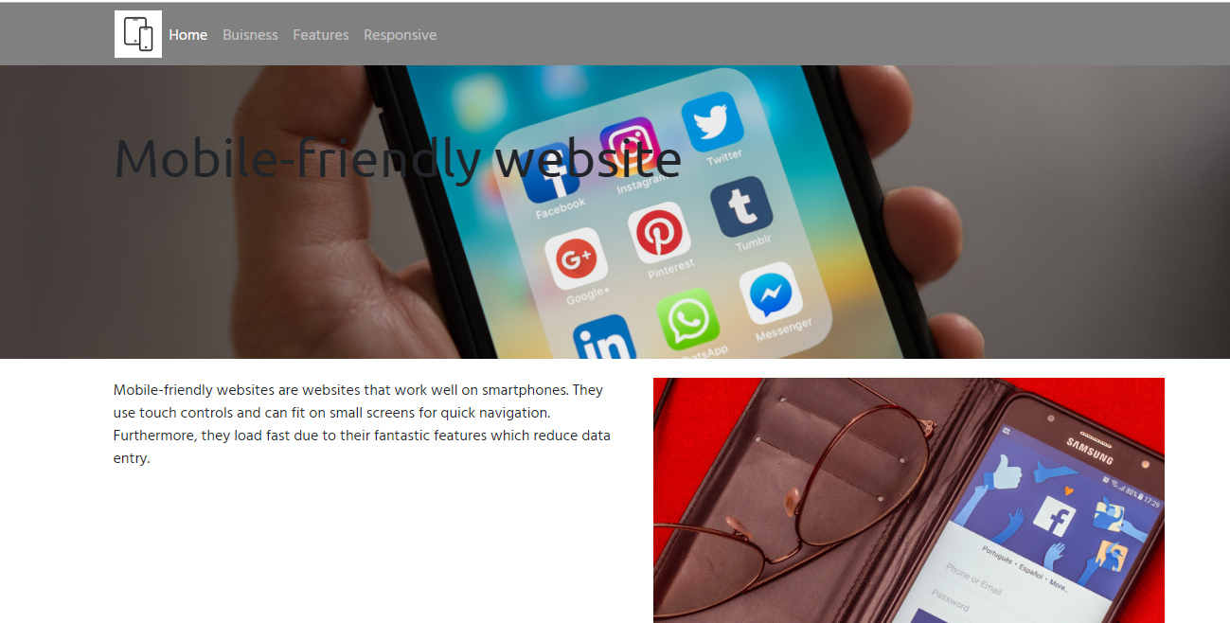
So is started of the website with the topic as the header, a brief summary on the topic and some pictures to show what the topic is about visually.
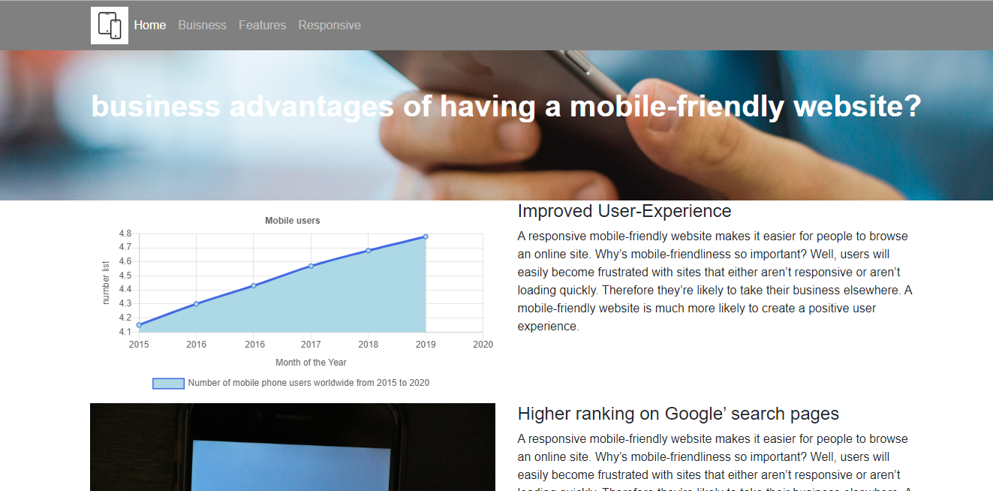
the second page is an explanation of the advantages brought by this trend, listed and described in separate columns, theirs also a chart of the increase in phone users from 2015-2019, I will post a separate screenshot of that below so you can see it more clearly.
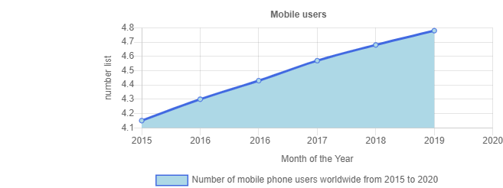
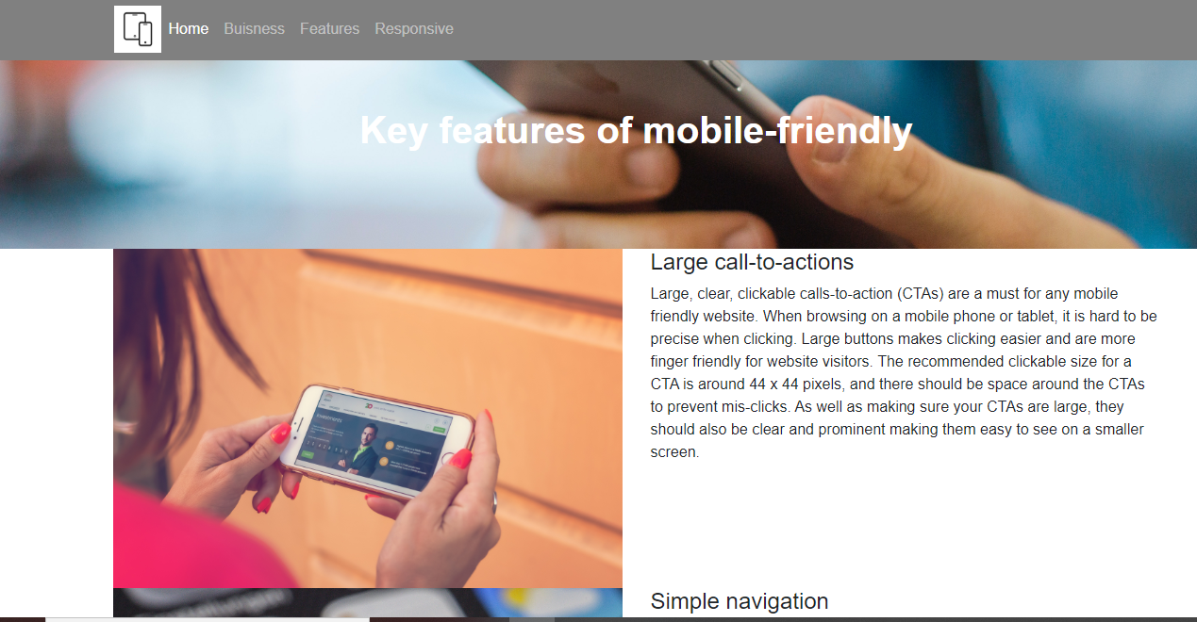
The third page is a quick explanation of 4 key features to build a mobile friendly website.
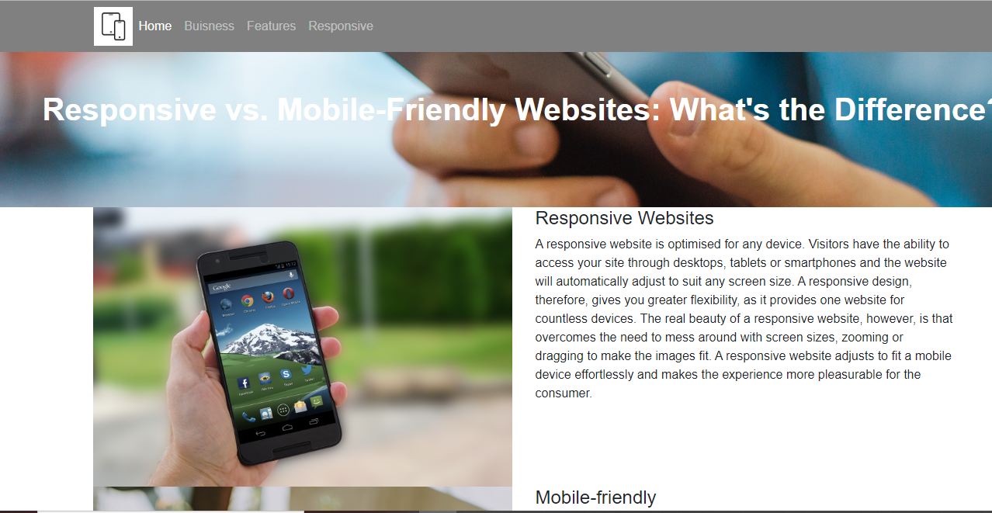

The fourth and final page of my website is about the differences between responsive websites and mobile friendly websites, some pictures to give a visual description.

Bibliography

[1] | [Online]. Available: https://www.codingdojo.com/blog/web-development-trends-of-2019​.
[2] | [Online]. Available: Statistica.com..
[3] | [Online]. Available: https://www.statista.com/statistics/274774/forecast-of-mobile-phone-users-worldwide/ ​.
[4] | [Online]. Available: https://www.searchandmore.co.uk/website-design/whats-the-difference-between-responsive-and-mobile-friendly-websites/​.
[5] | [Online]. Available: https://www.searchandmore.co.uk/website-design/whats-the-difference-between-responsive-and-mobile-friendly-websites/​.

