HNC Manufacturing Systems Engineering Operations

2019 – 2020 Plant Operations and Performance

Assignment TWO

Energy efficiency, performance & conservation

Stuart Jones

1909136

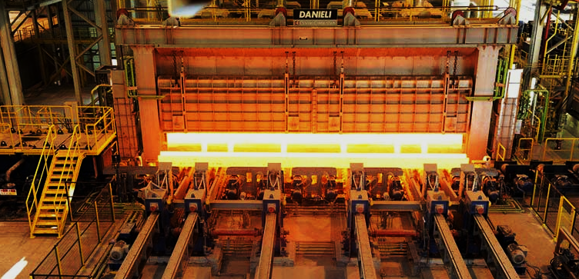

Walking Beam Reheat Furnace

Celsa Manufacturing UK

INTRODUCTION

Assignment details 3

Introduction 4

Background information 5

The Furnace 6

What is the problem? 8

Hot Charging 10

Furnace Management 11

The other projects 12

Conclusion 13

Assignment two task description:

- Identify a specific part of the plant at your place of work where energy savings/control could be made.

If this is not possible, you may consider an appropriate example from the web, Typical examples could be recovering radiated heat by adsorption radiators, minimising heat loses from pipework by insulation, using waste heat for electricity generation, hot charging, heat pumps, solar and wind electricity generation.

- Briefly explain where, and how, these energy savings are to be made, showing estimated cost savings if appropriate.

- Prepare a presentation (suggested format: PowerPoint) which should take about 10 to 15 min, after which you will be asked one or two questions about your assignment.

Introduction

At the time of writing this assignment, my current employer had taken the decision to close the manufacturing plant where I work, following Government guidelines regarding the tactical management of COVID-19.

Whilst it was closed, I was unable to access any work-based material and information to aid me with this assignment, and I was unable to engage any colleagues and peers that could have provided me with invaluable information on energy efficiency and performance of equipment at the plant.

Therefore, because of this obstacle, I decided to base this assignment on a piece of equipment based in my previous employment. I was regularly exposed to this equipment, which is on a grand industrial scale, in comparison to the equipment at my current employers premises. So I prefer to base this assignment on something I’ve had exposure to in the past, rather than make my assignment a theoretical one based on something I find online, as I can’t access anything at work right now.

I have decided to base this assignment on the Walking Beam Reheat Furnace at the Celsa Manufacturing plant in Cardiff.

Some background information

Celsa Manufacturing is a Spanish owned steel making company that has plants in several countries throughout Europe. They have one plant in the UK which is based in Cardiff.

The Cardiff site consists of 3 processing plants:

- The Melt Shop,
- The Sections mill
- The Rod & Bar mill

I spent 10 years of my career working in the Rod & Bar mill, which has a single furnace that reheats billets received from the Melt Shop. The reheat furnace will heat billets up to 1,300°C, and discharge them into the mill to be reformed into either reinforced bar, or several types of steel coil.

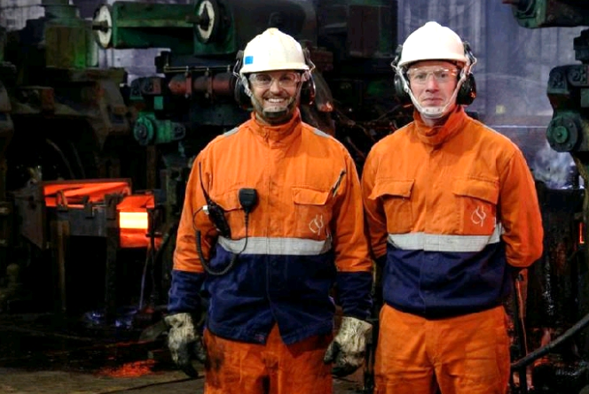
Me on the right, standing alongside a production colleague

This assignment will be about the energy efficiency, performance and conservation of the Walking Beam Reheat Furnace at the Rod & Bar mill, Celsa Manufacturing UK.

The Furnace

Billets are transported to the Rod & Bar mill by locomotive train from the Melt Shop. The billets are removed from the locomotive wagons by overhead cab-driven cranes with magnetic beams, and stored in pens in the Billet Warehouse by grade type. Depending on what grade is required, the cab-driven cranes will lift billets from the pens and deliver them to the furnace charging end for production.

The furnace walking beam system transports the billets through the furnace, eventually delivering the billets to the discharge hearth approximately 90 minutes later, at a temperature of 1,300°C, ready for discharge.

The internal walls, roof and floor of the furnace are covered in refractory bricks and cement. There are 3 points of the furnace where heat is lost, the charging curtain, the push-out door where a push-bar enters to push billets out, and the exit door, where the billet leaves the furnace.

The furnace is fueled by natural gas, which is delivered to burners situated in the roof of the furnace, firing down onto the billets. Inside the furnace here are 3 heat zones, where gas is delivered in different quantities to control the temperature of the billets.

Basic schematic of the walking beam reheat furnace.

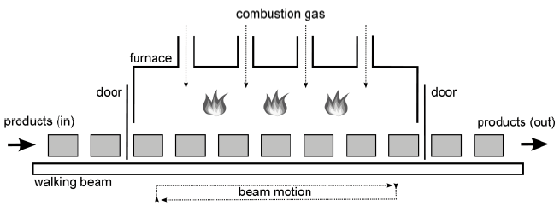
[https://www.dotxcontrol.com/files/papers/metec_2011_dnpc_furn.pdf 14.04.2020]

The gas, walking beams, push-out bar and doors are ALL controlled by the Furnace Operator, who sits in a control room and has full control over the furnace via HMI screens, CCTV monitors, control levers, and computer software.

Image below of the Rod & Bar mill Furnace Operator showing the Welsh Minister Carwyn Jones how he controls the Furnace, and me right in the middle.

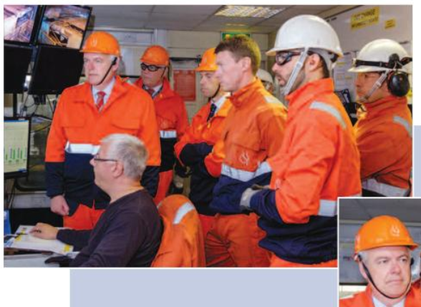
[https://issuu.com/celsasteeluk/docs/celsamatters_sept16, 13.04.2020]

What is the problem?

Gas costs!!!

Gas is a commodity used by the furnace to heat billets, which in turn produce a finished product, but how do we measure gas costs? By how much we pay for total gas consumed?

Well, whether you put 5 cakes in a domestic oven, or 50 cakes, the oven is still operating at 180°C for 20 minutes. You’d pay the same costs because the amount of gas consumed is similar, but much bigger outputs if you utilised the oven to its maximum capacity. So it’s all down to efficiencies, managing the furnace, managing the output, and managing the gas consumption.

Referring to the cake example, it’s important to know how many billets you’ve consumed, to understand if the gas consumption has been efficient and well managed. So it is an industry standard in steel making to measure gas consumption as KWh/Tonne; how much gas you’ve used, divided by how many tons you’ve produced.

Image below is a 2016 Balance Scorecard for the Rod and Bar mill. You can see that the average daily gas usage for 2010 was 459 KWh/Tonne, but by 2015 it was driven down to 353 KWh/Tonne. How?

From the image below we can see the average monthly production increased by 4,000T in 2015; that would contribute to reducing the KWh/Tonne but not by 106 KWh/Tonne each day!

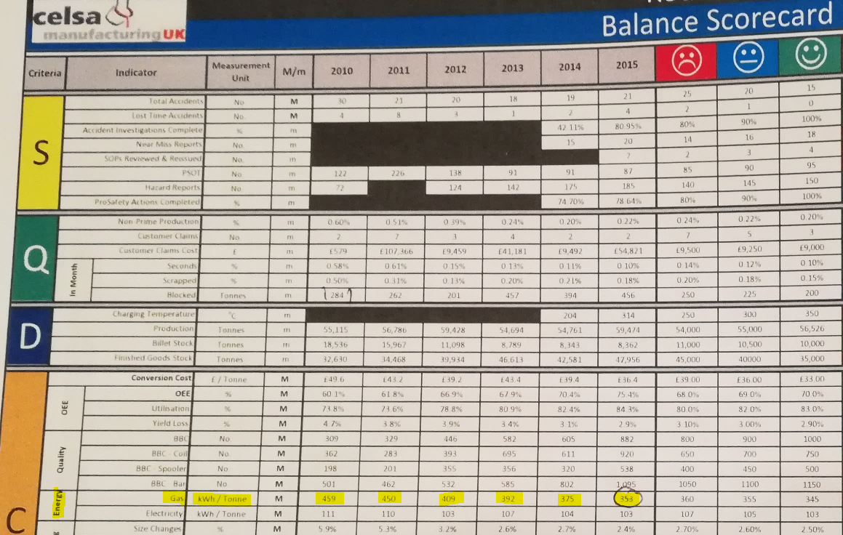
Gas reduction projects

Amongst other incentives, the two main contributors for reducing gas consumption were:

- Hot Charging
- Furnace management

Other incentives that were successful and contributed to the reduction in gas consumption:

- Increasing billet lengths
- Thermographic Surveys of the furnace
- Increased maintenance budget and PM activities

Hot charging and the management of the furnace were fundamental in achieving the reductions in gas consumption.

The other incentives, combined, were also needed to ensure we were ‘trimming the fat’ so to speak. Correct length and weight billets meant more tons, allowing us to produce more finished product.

Thermographic surveys of the furnace structure to spot areas losing heat, and an increase in Preventive Maintenance activities on the furnace, such as hydraulic and water pump efficiency testing, all contributed to the final goal.

With lots to discuss, we will start with one of the requirements of this assignment:

Hot charging.

Hot Charging

What is hot charging?
Hot Charging refers to the practice of delivering billets as quickly and efficiently as possible from the continuous caster in the Melt Shop, straight to the furnace at the RBM, while trying to prevent a significant drop in the material’s temperature.

The process aims to dramatically reduce the cooling rate of the billet, meaning that it will enter the furnace at a higher temperature. Subsequently, the amount of gas required to reheat the billet back to optimum temperature for rolling is reduced.

In 2013, Celsa UK was only managing to load 23% of billet into the RBM furnace within 8 hours after being casted. In 2014, we saw this figure rise to 36%, and 2015 saw loading up to 50% of material into the RBM furnace within 8 hours after being casted.

The introduction of metal tongs to handle the hot material was a major improvement. The Melt Shop are now able to load billets onto the wagons with a billet temperature of around 800-900°C, resulting in the billets reaching the RBM furnace at a significantly higher temperature than ever before.

Additionally, special hoods were developed in order to place over the billets whilst being transported to the Rod & Bar mill. The hoods slowed the cooling process during their 3 mile transportation by locomotive.
[https://docplayer.net/63335388-Celsa-manufacturing-environmental-statement-2015.html]

It made sense to put hot billets into a reheat furnace, other plants in the Celsa Group were doing it successfully. But in Europe the rolling mills were situated in close proximity to their respective Melt Shops. The problem in Cardiff was the Melt Shop was 3 miles away!!!

So the only way to make it successful was to completely overhaul the current process.

To start with, as steel loses its magnetism when its temperature exceeds 770°C, the age-old process of using magnets on cranes to lift billets would need to be replaced with tongs in both the Melt Shop and the Rod & Bar mill.

A local fabrication firm was tasked with making large insulated steel hoods, which were placed over the billets when they were being transported on rail wagons from the Melt Shop.

Special tools and PPE were made for the Furnace Operators so they could work at a distance from the billets, and air conditioning was fitted to the crane cabs!

Furnace Management

One of the main issues was that over time (30 years or so), the software programmes that controlled the furnace parameters per product, had been modified, duplicated, or locked out. Sometimes the Furnace Operators had 2-3 options for the same product, and each one set the furnace parameters differently.
There were too many programmes, we needed to identify the programmes that controlled the furnace in a way that gave the best efficiency, label them appropriately, and delete the rest.

This project took months, but we eventually got down to 1 programme for each product rolled, so the furnace operators had only one choice, which had been validated to be the most efficient one.

Second, the Furnace Standard Operating Procedures. Either they were out of date, or simply didn’t exist. Another task was to review the existing SOP’s, do a gap analysis to identify any missing, and create new up-to-date procedures to manage the furnace in an efficient manner.

Third, production delays! When the mill is not rolling, the furnace shouldn’t be operating at full capacity. There is room to reduce the gas when the mill is not running, but depending on what shift was on, the furnace operator would control this differently.
So the 4 Shift Managers were given the overall authority to manage the furnace gas during mill delays. Communication with the maintenance teams fixing the mill delay was key to managing the furnace gas. The maintenance teams had to give 20 minutes notice to the Shift Manager when they ‘predicted’ they were going to give the mill back to production. This was a black art and it took months to master.
But finally, the maintenance team, the Shift Manager and the furnace operator would work in unison, altering gas flow to the furnace burners whilst the mill wasn’t running.

All the projects came together to ensure the furnace wass operating at maxmium efficiency.

The other projects

The Melt Shop would occasionally send billets to the Rod & Bar mill that weren’t the correct length, width or height. Not visible to the eye unless they were measured, sometimes the billets were up to 50mm short on length, and up to 10mm on width and height. Not a great deal you may think, but when reducing the cross sectional area of a billet down to 5mm to produce steel coil, you could lose a lot of finished product over a month, which affected the KWh/Tonne calculation.
Checks were put in place for the production operators to routinely check the billet dimensions, and if any billets were found to be out of spec, a Non-Conforming Product report would be filed to the Melt Shop. Initially, the Melt Shop paid little attention to these reports, but eventually these reports were made part of the mill KPI’s which were reported to Senior Management, and the billets soon arrived back in spec again!

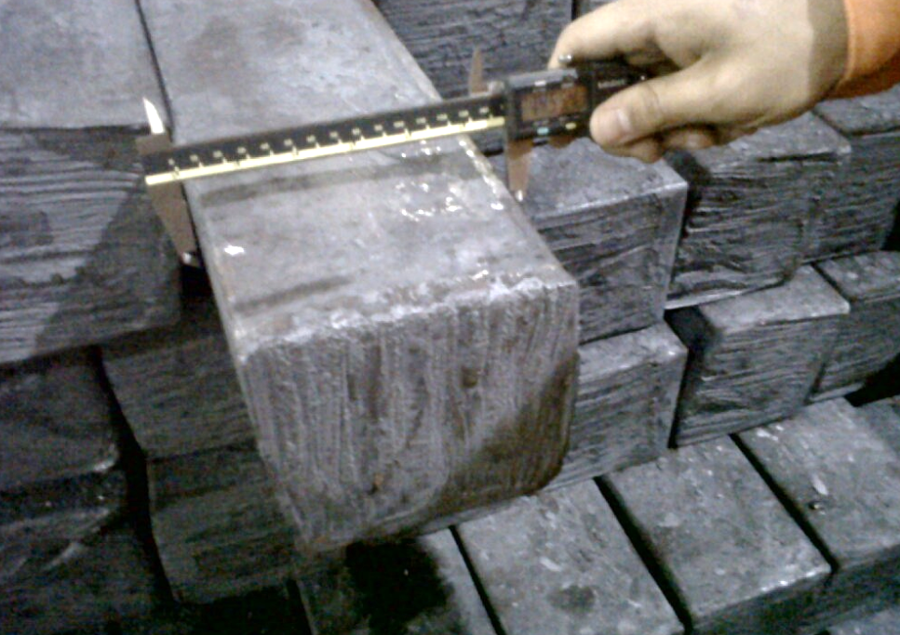

The Rod & Bar mill Engineering Manager purchased an expensive Thermographic Camera, and sent the Mechanical Engineers on a course to learn how to use it. Eventually they mastered the art of identifying areas of the furnace that was losing heat, which would be recorded and repaired during the annual shutdowns when the refractory teams went into the furnace to replace refractory bricks and cement.

In previous years the gas consumption was never a priority, but when external competition became a real threat, it was all hands on deck to save pounds wherever possible. The furnace was old but operationable, it needed modifying which cost money, and in a time of austerity, cash flow was an issue.
Having said that, Preventive Maintenance was cheap and effective and could play its part in the cost saving initiative. Visual checks of the furnace, checking temperatures of pumps, oil, water, etc. Vibration Analysis of motors, pumps, bearings, and checking pipes and welds for leaks/cracks, etc. It all contributed to returning the furnace to an efficient one.

Conclusion

The significant drop in KWh/Tonne from 2010 to 2015 is a tribute to all the hard work and cost that went into reducing the gas consumption. In terms of costs, the 106 KWh/Tonne reduction means an approximate reduction of £190,000 every month on the gas bill for the Rod & Bar mill.

And it doesn’t have to stop there. At the moment, nothing is being done with the waste heat, it is simply dispersing into the atmosphere. This heat is not harnessed and used to heat the company offices, which it could be. They are weighing up the cost of building a system to harness and deliver the waste heat to office buildings, but it could be years before they get those savings back on the office building gas bill, so who knows what will happen.

When it was first announced that the company were going to reduce the gas consumption of the 30 year old furnace, without making any expensive upgrades to the actual furnace itself, the engineers and operators were sceptical. A rep from the company that built the furnace once said “if your furnace was a car, it would be a Ferrari, it was built to perform and last. Unfortunately, it has the fuel consumption of a Ferrari too!”.

It took a long time to get the engineers and operators committed to the cause, who would believe you’d get 106 KWh/Tonne reduction on a 30 year old furnace?

But it wasn’t ALL about the furnace, it was the operators, the engineers, the maintenance teams, the crane and train drivers, the planners, and of course the hot billets, that all came together to achieve what first appeared to be impossible!

END

