Emergent Leadership Skills for the Workplace
BMSW6101_BIRM
Daniela Alina Cioranu
Task 2 Report

- Introduction
- Leadership and management
- Effective leadership styles
- Effective leadership skills
- Leadership style in emergencies times (COVID-19)
- Ethical leadership
- My personal reflection
- Conclusion
- References

- Introduction
Leaders and managers in our century developed and become two different roles, but sometimes their job overlap. There are small differences that pushed them two roles apart, small but important (Bass, 2010).
Ethical leadership is important in any area, job role, location, especially when uncertain times are upon us. Ethical leaders provide a balance at work and they inspire others to do the same (Cherry, 2006).
NHS is a very challenging environment with different issues every day, issues that need to be solved sometimes instantly. The leaders and colleagues that work for NHS are truly heroes, they were so courageous fighting and support the humanity through the Covid 19 pandemic (Storey, 2013).
This report will highlight the differences between leadership and management supported by different authors. Characteristics, insights, main skills and key points of both roles will be analysed too.
- Leadership and management – differences and characteristics
Is leadership and management same thing, process? Some will say that managers and leaders are not quite the same thing but their actions overlap (Bass, 2010) and others think that leadership and management are two completely opposite processes (Riketts, 2009).
Leaders and managers have some attributes in common and the strongest one is that that they both influence, lead and “have and eye” on others and mainly on their team. Both of them uses certain skills and tools to achieve goals in that company with help from their employees (Northouse, 2007). Usually managers maintains the way a company do things and also, they keep a smooth transition, while leaders test new ideas and processes, hoping for long term outcomes (Yukl, 1989).
The process of management was defined by Katz as the process of a group of people maintained through administrative, executive and supervisory positions. Discover and develop employees with high potential and apply ethic and discipline when dealing with issues at work are manager’s way of doing their job (Katz, 1955). The aim of a manager is to achieve a company targets in an efficient way (Kappa, 1991).
Leadership is a more complex style than management. It is a behaviour, responsibility, ability, authority, self-motivation and inspiration for others (Northouse, 2007). John Maxwell said in his work that leadership is the process to influence others (Maxwell, 1998), moreover a leader was defined as an individual who has followers and that effective leadership is when individuals that serve others and follow the leader (Drucker, 1999). Even if there are more authors with different description of a leader, all of them come dawn to the fact that the process of leadership represent the process of an individual to influence and develop people around him.
Focused on motivation and inspiration, leaders aims are long term goals, challenge existing processes in the workplace and they always have an open eye on employees benefits and development, fact that motivate the employees to follow the leaders voluntary. Using the transformational style, the leaders direct and guide its colleagues (Bass, 1990).
Confidence, communication skills (verbal and non-verbal), listening skills, strong self-esteem, integrity, creativity or creativity are characteristics that add up and define a leader (House, 1977).
The NHS (National Health System) represent one of the most important system in United Kingdom. NHS provide free treatment to around 13 million patients every year, and now, the new leader, Amanda Pritchard, need to face the current damaged created by Covid 19 and any other critic situations (Nicol, 2012).
Until not long ago, in the NHS there were just managers, they were the ones who took the last decision. Apparently, leaving leaders room to lead in the NSH could have a negative impact on its patients, because there will be too many opinions, fact that will make harder to take a decision, moreover in some cases no decision at the end. But, recently, The Commons Health Select Committee mention the need of proper committed leaders in the NHS (Storey, 2013).
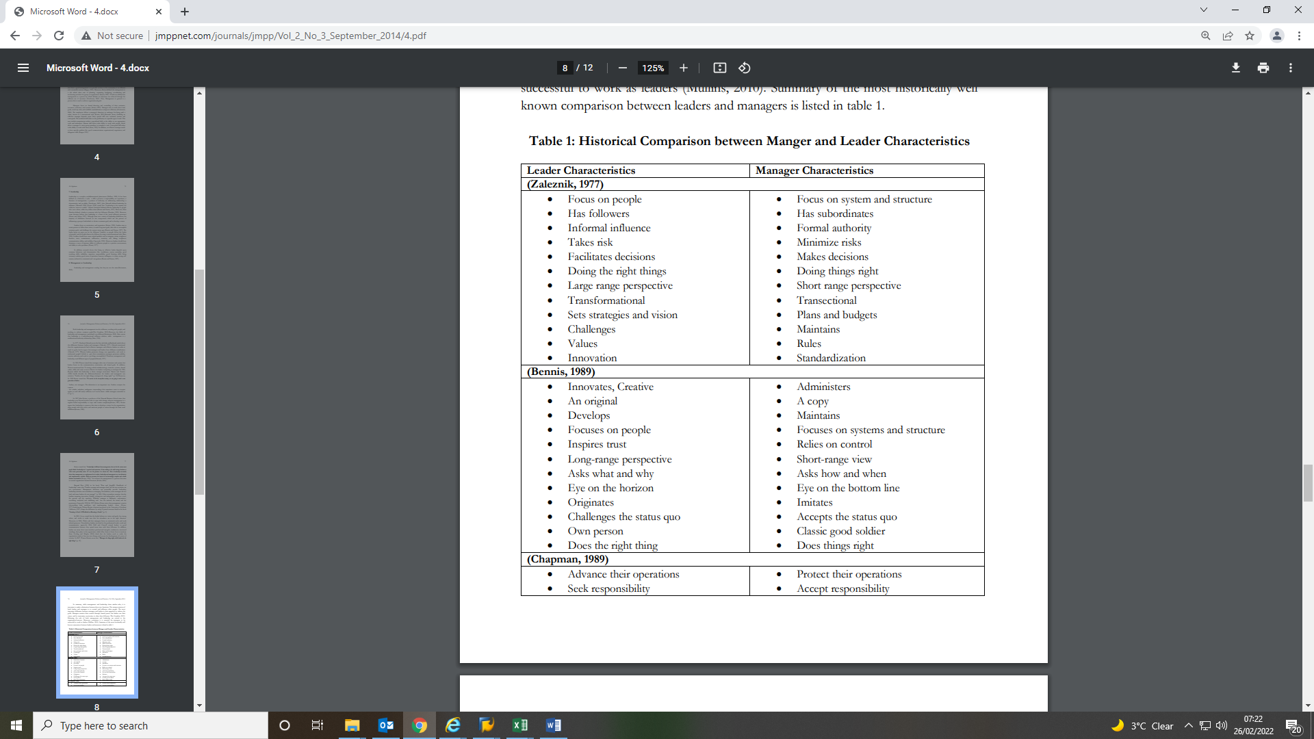
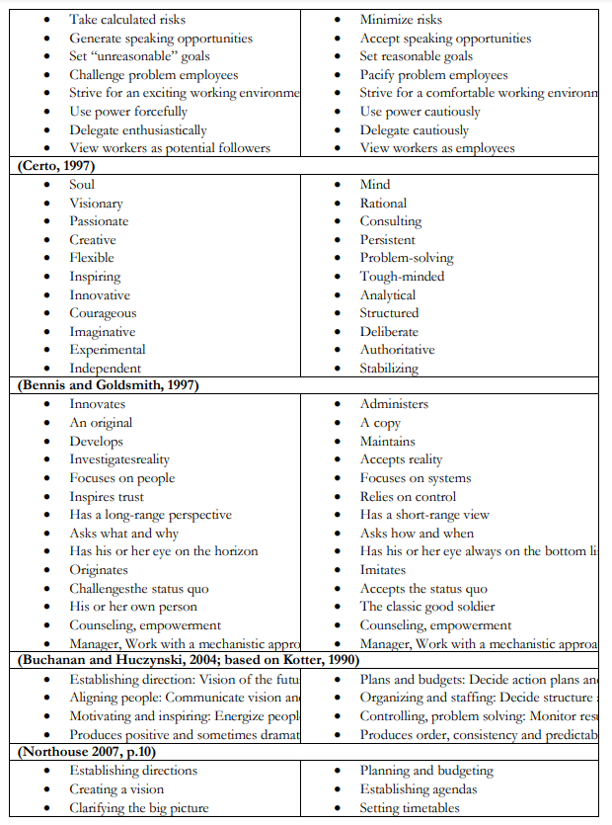
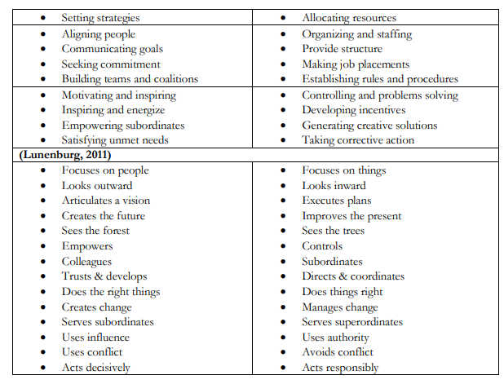
- Effective leadership styles
Leadership styles describe the way a leader act and what methods and individual use in their daily activities. Anybody can see the differences between leaders, but Lewyn described them in his work to deliver a better understanding (Cherry, 2006).
Kurt Lewin led in 1939 a group of researchers set out to describe and provide different styles of leadership. Their result was that there are three main styles: autocratic, democratic and laissez-faire leadership. Moreover, in time, different authors provide more leadership styles by expanding these three: transformational, transactional and situational leadership (Cherry, 2006).
Autocratic Leadership Style
Leaders that adopt this style provide the rest of the team with instruction about what need to be done, when and how. Focused on control of the follower and command by the leader, this style allow just a touch, or nothing from the followers when a decision need to be taken. In critical situations when rapid and decisive actions need to be applied, this style allows the leader, usually the most knowledgeable individual in the group, to do whatever he/she thinks it is best (Cherry, 2006).

Democratic Leadership Style
Lewin`s research result was that democratic leadership style, known as participative style also, is the most effective leadership style. These leaders offer to their team guidance and they support the team through the process. Usually, the results are coming slower and later but, the quality is high. Democratic leaders let their colleagues to get involved in the decision making process and motivate them by make them feel that they are an important part in the process (Cherry, 2006).
Laissez Faire Leadership Style
Individuals that use this leadership style provide very little or no indications to their colleagues, so the decision making process is out there for anyone to grab. Each colleague do what thinks is best and in their own way. If this style is implemented when leaders are dealing with highly qualified colleagues then everything is fine, but most the time, the team showed no cooperation, inability to work independently, lack of motivation and unable to fulfil the task. Moreover, the colleagues are blaming each other and take no responsibility for their own mistakes (Cherry, 2006).
Transformational Leadership
Based on opinion of different authors, this leadership style is the most effective. Leaders that implement this style are passionate about their work, emotionally intelligent and self-motivated. They inspire the rest of their colleagues which are following them into positive changes and outcomes in a company. Moreover, the leaders that apply this leadership style, are not focused only on helping on the growth of the company, but developing the rest of the team too (Cherry, 2006).
Transactional Leadership
In this leadership style the employer – employee relation is well defined from the start. The employees accept the position of the leader and they are following and listen to their leader in exchange for compensations. The leader possess direction and supervision, if needed (Gandolfi, Stone, 2017).
In NHS the leadership style that proved to be the most effective is transformational leadership. They motivate and inspire the rest of the team for two main objectivities: organization`s goals and their personal goals (Lumbers, 2018).
- Effective Leadership Skills
A leader that is successful in leading, organizing, planning or leading, for sure that leader possess effective leadership skills. The greater your managerial status is, the more skills you have to enhance and develop (Cacioppe, 1998).
All leadership skills are divided in tree basic categories: conceptual, technical and human relations (Mukarromah et. all, 2019).
Conceptual Skills
In 1970, the author Katz said that conceptual skills represent the logical ideas of a leader, the ability to shape concepts, the ability to create new ideas and find fast problem solving or the ability to anticipate problems and changes. Danim in 2010 stated that these skills represent the ability of a leader to understand theories related to their work environment, the ability to organize ideas and thoughts and that the leader`s actions are based on the each individual theoretical abilities (Mukarromah et. all, 2019).
Technical Skills
Katz (1970) described technical skills as the methods, processes, techniques and procedures that are put in place when special activities need to be done. The skills that are needed to operate the machines when certain activities are done, represent part of technical skills (Mukarromah et. all, 2019). In other authors view, like Handoko (1992), technical skills allow the leader to implement whatever mechanism are needed to carry out certain task (Mukarromah et. all, 2019).
Human Relations Skills
Represent the skills that help individuals to build different kind of relationships and connections between each other. According to Katz (1970) these skills represent each individual knowledge about each person behaviour, the relation between different persons and the ability that each individual poses to help him understand the feelings of people surrounding him. Others authors, Stoner and Freeman (1992), said that human skills represent the capacity to work in a team and be able to communicate, motivate and understand each other (Mukarromah et. all, 2019).
In NHS all the skills described must be enhanced, developed and applied on a daily basis. Working in NHS demands certain skills, such as: caring for people, knowledge of science and technology, organising and managing, etc.
There are three big leadership skills that people who work in NHS should poses, such as: setting direction (intellectual flexibility, seizing the future, drive for results, broad scanning), delivering the service (leading change through people, empowering others, collaborative working, effective and strategic influencing) and personal qualities ( self-belief, self-awareness, self-management, drive for improvement, personal integrity). Whit these skills and qualities, the NHS in able to achieve a smooth transition between departments and take care of people in the whole United Kingdom (Parker, Sorensen, 2088).
- Leadership style in emergencies times (COVID-19)
On March 11, 2022 one of the most aggressive viruses, COVID-19, spread real fast around the globe and infected approximately 19.3 million people, moreover, around 700.000 people died. To cope with the global pandemic (declared by the World Health Organization) leaders should apply five elements: collaboration, communication, coordination, staying calm and providing support (Nicola et. all, 2020).
Unfortunately, during our career some emergencies will appear. Some leaders consider that this is the time for them to show off and demonstrate to their supervisors and colleagues that they have everything under control. Act like that do not represent the right attitude. That is the time when each leader should accept the situation and switch to new rules and implement new ideas (Bianchi et. all).
In uncertain times is best for leaders to focus on transparency, authenticity and collaboration (Bianchi et. all).
The most suitable leadership style in these situations will be the transformational one because it helps the leaders to understand better the crisis before applying any solutions and offer any responses. Leaders that lead in a transformation style seek advice from the people that work the closest to the problem and create together a flexible and logical step by step plan. Because the strength of transformational leaders do not come from following certain rules, they are better at manoeuvring and adapt the company effectively when “the unknown” hits that company (Desyatnikov, 2020).
Under pressure, authentic leaders, are prepared to find a way through an emergency because they always poses a clear sense of principles and boundaries. Effective leaders will find responses that are strong related to innovation, knowledge and collaboration (Kaul et. all, 2020).
The practice that leaders should implement when situations like COVID-19 appear unexpected can be based on Kouzes and Posner model that include five leadership commitments:
- Be a proactive leader: from a leadership point of view, the proactivity can be divided in proactivity before the crisis starts that refer to leaders anticipate and prepare a plan in case of something happen and, the proactivity during the crisis that refer to the actions that are implemented in real time and the modelling of the dynamic.
- Clarify governance for the crisis: the existent governance structure require change and development as new ad hoc jobs are required to manage the crisis. The new structure is communicate clearly to everyone in the workplace.
- Quickly act: leaders need to find solutions and implement them fast as the urgency can be seen by everyone. Is it natural that some of the actions will be wrong but efficient leaders will re – think their actions and new solutions will remedy the past ones.
- Active communication: from the very beginning the communication must be frequent, simple and through all media so everyone will be informed. Communication is a critical skill that will keep the team have a smooth transition with all stakeholders.
- Build a realistic and optimistic vision: one important part in the job of a leader when a crisis hit is to maintain two different attitudes in its mind and still be able to function right. Having a optimistic view during the COVID-19 pandemic created for leaders enough stamina to go above and beyond.
(Stoller, 2020)
- Ethical leadership
Ethical leadership refer to leaders that demonstrate and promote an appropriate conduct at work through their personal and interpersonal relations. To create a positive environment and an ethical culture leadership skills represent a crucial factor. Employees, customers moreover, the company as a whole will benefit from this. The short term benefits that an ethical leadership will bring to a company are boosting employee’s morale, help improve their motivation and engagement. In the long term it can protect the company from any kind of scandal or ethical dilemmas, issues (Brown, Trevino, 2006).
An ethical leader should:
- Lead by example: the leader should work alongside its employee and support him through the whole process. The leader should lead and take decision in an ethical way so the employees around him will follow his example later on.
- Willing to develop: efficient leaders need to adapt and evolve with the business. Being ready to change, adapt or merge are keys in its career. Acting like this the employees will trust and follow that leader.
- Treat everyone fair: respect is the main characteristic in an ethical leadership. Treating superiors and inferiors with the same respect will create an ethical at work. Respect everyone in the same way will eliminate any chance of someone feeling disrespect, unfairness.
- Communicate efficiently: possess a high level of communication skills with the outcome of an honest and trusty environment. Having good and honest conversations with everyone will motivate employees to do the same.
- Manage stress: leaders should not let personal of professional problems to affect their ability to lead the team. If stress is bigger that the leader ability to manage it, the team will suffer some negative impact.
- Fairness: ethical leaders are kind and compassionate when it comes to their team, so they are able to support and deal with other people`s problems in a way that is fair for everyone. After an argument leaders need to bring everyone back on track to be able to work in a team.
(Çelik et. all, 2015)
In NHS ethical leadership is very important and all the staff is applying it. The staff combine ethical leadership with transformational leadership to create a friendly and safe environment, moreover, the combination of the two leadership styles improve patient care and satisfaction (Jambawo, 2018).
- My personal reflection
Leadership traits
Leaders exist from the beginning on time, some of them have good qualities and others bad. People came up with lots and lots of good traits that leader should possess, but authors been able to narrow that list to five important one:
- Intelligence: developing strong verbal communication, ability to gather and enhance information and knowledge, improved problem solving and decision making skills.
- Confidence: possess feelings like self-assurance and self-esteem. Positive feelings about oneself and how it make a difference. Having a mentor, asking for feedback, practice and engagement will build a leader confidence.
- Determination: the attribute that push each leader to get the job done, to take pride in the work delivered. Dominance, persistence, initiative are all characteristics that build a leader determination. Clear goals, proactive attitude, perseverance and focus are the keys that strengths determination.
- Integrity: qualities as honesty, fairness, trust, all goes under integrity and represent the basic skills to a strong leader. Integrity force each leader, or individual, to take responsibility for its actions.
- Sociability: creating a culture, environment and a team are things that leaders can create by implementing their social skills. They act in a diplomatic, friendly, tactful way and they care about their colleague’s well-being or needs. Sociability provides good interpersonal skills that brings followers to the leader and ability to influence people around them.
(Kornør, Nordvik, 2004)
Two years ago I started a job at Pets at Home Warehouse is Stoke on Trent as a piker. It was the lowest position in that warehouse. Just after a few months several managers noticed my potential and started to invest in me by training me in different areas, showing me more of what their job is about. After six months I received a promotion as a goods in administrator permanent weekends. Usually we did not had a manager on shift to delegate us, so I had to do that and deal with all the other problems that might appear on a daily basis. After one year since I started the second job, I applied for a manager position but I was unsuccessful because I had no experience whatsoever, but they offered me a leadership course whit in the company just to give me a better understanding of what managers should and should not do. The company offer different courses for its employee to develop in them (Pets at Home, 2022). Few months passed and I was finally successful in my application for a first line manager.
The leadership style that I chose to adopt and I felt that it will suit me good is the people oriented one. The soon you start a job in this company, its values are presented and each individual need to respect them. The values company are to be honest, courageous, and respectful, support your colleagues and inspire the people around you (Pets at Home, 2022). In this warehouse, the environment is friendly, positive, all the managers are looking for ways to support its colleagues and the people that want to develop have lots of opportunities to do so. As different authors said that is the company’s culture that influence the type of leadership (Cherry, 2006), so this company is all about people.
This module is focused on leadership and the key responsibilities of leaders that need to be applied to achieve good outcomes. This module helped me understand better the main skills and abilities that I should possess to be successful in my new role, what skills I need to improve and what attitudes I need to leave behind. I understand that a people orientated leader is focused on the team, colleagues, led by example providing continuing support, assurance, and look for colleagues to go into development.
- Conclusion
In conclusion we can say that the leadership model is in a continuous process of improving the attitude of leaders towards employees and colleagues. These days, the employees require more than orders from their superiors. They require skills polishing, reassurance, stability, development, motivation, and feedback in order to avoid changing jobs and no interest towards the company they work for (Bass, 2010).
- References
Bass, B. (1990). Bass and Stogdill's Handbook of Leadership: Theory, Research & Managerial Applications, 3rd Ed., the Free Press, New York, NY.
Bass, B. (1985). Leadership and performance beyond expectations. New York, Free Press, 1985.
Bass, B. (2010). The Bass handbook of leadership: Theory, research, and managerial applications. New York, NY: Simon & Schuster.
Bianchi, M., Prandi, C. and Bonetti, L., 2021. Experience of middle management nurses during the COVID‐19 pandemic in Switzerland: A qualitative study. Journal of nursing management, 29(7), pp.1956-1964.
Brown, M.E. and Treviño, L.K., 2006. Ethical leadership: A review and future directions. The leadership quarterly, 17(6), pp.595-616.
Cacioppe, R., 1998. An integrated model and approach for the design of effective leadership development programs. Leadership & Organization Development Journal.
Çelik, S., Dedeoğlu, B.B. and İnanir, A., 2015. Relationship between ethical leadership, organizational commitment and job satisfaction at hotel organizations. Ege Academic Review, 15(1), pp.53-64.
Cherry, K., 2006. Leadership styles. Retrieved from.
Desyatnikov, R., 2020. Council Post: Management In Crisis: The Best Leadership Style To Adopt In Times Of Crisis. [Online] Forbes.
Gandolfi, F. and Stone, S., 2017. The emergence of leadership styles: A clarified categorization. Revista De Management Comparat International, 18(1), p.18.
Jambawo, S., 2018. Transformational leadership and ethical leadership: their significance in the mental healthcare system. British Journal of Nursing, 27(17), pp.998-1001.
Kaul, V., Shah, V.H. and El-Serag, H., 2020. Leadership during crisis: lessons and applications from the COVID-19 pandemic. Gastroenterology, 159(3), pp.809-812.
Kornør, H. and Nordvik, H., 2004. Personality traits in leadership behaviour. Scandinavian Journal of Psychology, 45(1), pp.49-54.
Lumbers, M., 2018. Approaches to leadership and managing change in the NHS. British Journal of Nursing, 27(10), pp.554-558.
Mukarromah, I., Mudjito, M. and Purbaningrum, E., 2019. The Effect of managerial skills (conceptual, human, and technical) of headmasters to the effectiveness of Islamic senior high schools in jombang district. International Journal for Educational and Vocational Studies, 1(6), pp.539-544.
Nicol, E.D., 2012. Improving clinical leadership and management in the NHS. Journal of Healthcare Leadership, 4(15), pp.59-69.
Nicola, M., Sohrabi, C., Mathew, G., Kerwan, A., Al-Jabir, A., Griffin, M., Agha, M. and Agha, R., 2020. Health policy and leadership models during the COVID-19 pandemic: A review. International journal of surgery, 81, pp.122-129.
Parker, P.A. and Sorensen, J., 2008. Emotional intelligence and leadership skills among NHS managers: An empirical investigation. International Journal of Clinical Leadership, 16(3).
Pets at Home. 2022. Learning & Development in Retail | Pets at Home Jobs & Careers. [Online] Available at: <https://www.petsathomejobs.com/retail-jobs/learning-and-development>
Pets at Home. 2022. Our values | Pets at Home Jobs & Careers. [Online] Available at: <https://www.petsathomejobs.com/about-us/our-values>
Riketts, A. (1977), ‘Managers and Leaders: Are They Different? Harvard Business Review, May/June, p. 67-78.
Storey, J. and Holti, R., 2013. Towards a New Model of Leadership for the NHS.
Stoller, J.K., 2020. Reflections on leadership in the time of COVID-19. BMJ Leader.
Yukl, G., 1989. Managerial Leadership: a review of theory and research. Journal of Management, Vol. 15 Issue 2, p. 251-290

