Lighting Layout, Heat and Sound
ACBA4006
APPENDIX GA36a
Keaton Lewis Davies
(2320042)

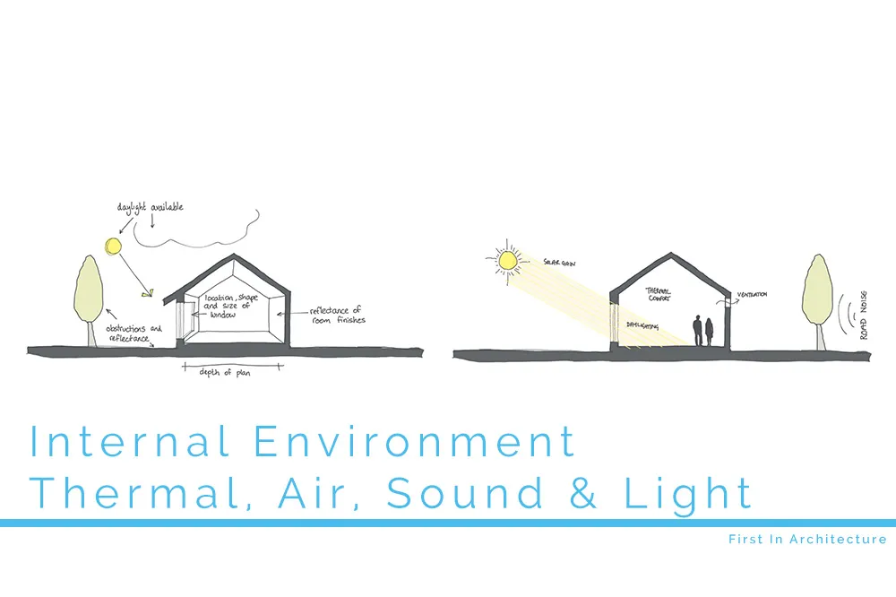

Table of Contents
Task A 3
Part 1: 3
Part 2: 5
Part 1: 7
What is frequency and wavelength? 7
Part 2 10
(a) 10
Thermal Transmittance and Thermal Resistance 10
Relationship between Thermal Transmittance and Thermal Resistance 11
Implications for Calculating Heat Loss through Building Fabric 11
(b) 13
Material Type 13
Distance 13
14
References 15

Task A

Part 1:
A production area in a factory measures 60 metres x 24 metres x 8 metres in height. The factory’s work benches are set at a height of 1m above the floor level. The area’s reflectance's are 0.3 for the ceiling and 0.5 for the walls. The Lighting design specifies fluorescent lamps in recessed louvre with DLOR of 50%.
A Lighting Design Lumen (LDL) output of 18,000 lumens is required.
The illumination required for the factory area is 200 lux at the working plane.
Light Loss Factor = 0.75

- The Room Index
R = L x W / h (L + W)
R = 60 x 24 / 7 (60+24) = 2.45
R = 2.45
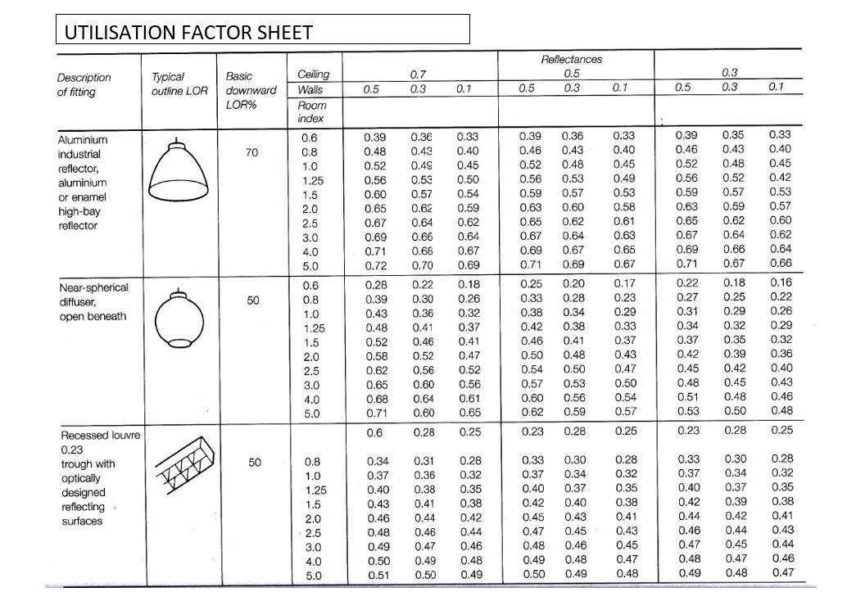
- The utilisation Factor From Tables = 0.46

- The number of lamps required.
N = E x A / F x UF x LLF
N = 200 x 1440 / 18000 x 0.46 x 0.75 = 46.38 lamps
As shown in the calculation of the number of lamps required, it is impossible to have 46.38 lamps. In this case, the number of lamps would have to be rounded up to the nearest full number to achieve better results for the required lux. If the number of lamps were to be rounded down then the desired lux would not be achieved due to the calculations being incorrect. It is vital to have true accuracy when measuring, calculating and carrying out the work.
- A Suitable layout (value of S) for the lamp fitting
Height = 8m
Working plane = 1m
H – Working plane = 8m – 1m = 7m
S = 1.5 x H
S = 1.5 x 7
S = 10.5m

Part 2:
Draw the plan layout on a scale drawing of the factory floor indicating your ‘best fit’ design for the luminaire installation.

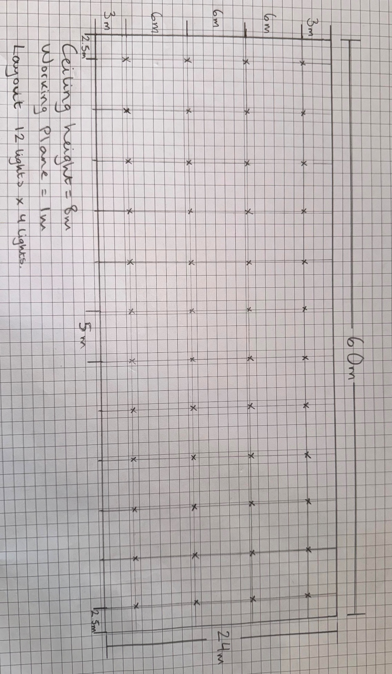
Task B:

Part 1:

What is frequency and wavelength?
The number of wave vibrations or cycles that take place in a specific amount of time is referred to as frequency. When it comes to sound, the human ear senses pitch based on frequency, where higher frequencies are associated with higher pitches and lower frequencies associated with lower pitches. Wavelength and frequency in sound are inversely related, therefore sounds with higher frequencies have shorter wavelengths and lower frequencies have longer wavelengths.
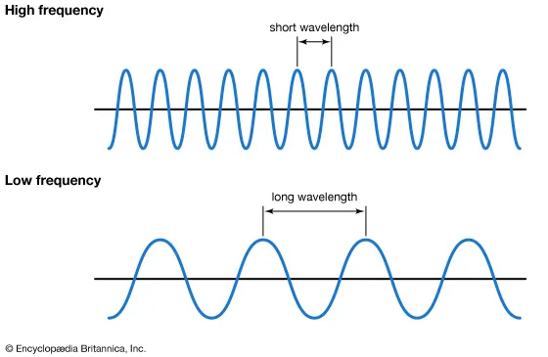
(Britannica Kids, 2019)

A building’s internal design and services support
Understanding the significance of sound frequency and wavelength in building design and support services is essential to designing settings that are both comfortable and functional. First, in order to maximise acoustics, certain areas inside a structure would need to pay particular attention to certain frequencies and wavelengths. For example, in order to properly measure and arrange acoustic panels, baffles, and other sound-absorbing materials in auditoriums or concert halls where sound clarity and reverberation control are crucial, architects must take into account the wavelengths of various frequencies. Additionally, the design of HVAC (Heating, Ventilation, and Air Conditioning) systems can be influenced by the frequency characteristics of sound. For example, specific mechanical noise frequencies from HVAC units may echo with a room's size, making the noise more noticeable and uncomfortable for the residents.
Furthermore, the wavelength and frequency of sound waves affect how well they travel through building materials. High-frequency sounds are more easily absorbed by materials, whereas low-frequency sounds tend to pass through them more easily. This information helps with choosing building materials that will improve room soundproofing or reduce outside noise disturbance. Maintaining acoustic isolation in settings like recording studios or theatres, where privacy and maximum clarity of sound are vital, requires a grasp of the link between material qualities, frequency, and wavelength.

A partition wall construction technique
The way a partition wall is built needs to take sound wave transmission through the material into consideration. High-frequency sounds, like music or conversation, are more easily absorbed by materials, whereas low-frequency noises, like those generated by traffic or equipment, tend to pass through them more easily. As a result, it is important to minimise the transmission of both low- and high-frequency noises when choosing building materials and techniques. For instance, adding layers of different densities or using acoustic insulation materials can absorb higher-frequency noises, while thick materials like mass-loaded vinyl or gypsum board, among others, can assist in attenuating low-frequency noise in the wall assembly.
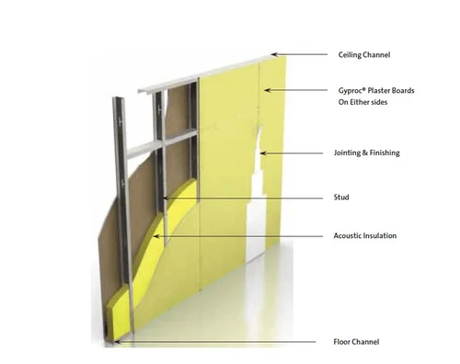
The partition wall's capacity to stop sound transmission is also influenced by its thickness and structure. The capacity of a wall to reduce lower frequency sounds is directly associated with its thickness since thicker walls have more bulk to stop sound waves from travelling through them. Adding solid channels or buffering layers, for example, may be necessary in addition to thickness increases to effectively block higher frequency noises and stop sound vibrations from entering the structure. Additionally, possible weak spots in the wall, including spaces around electrical outlets or seams between panels, where sound might seep through, should be addressed during construction.

(indiamart.com, n.d.)

The choice of Insulation types available.
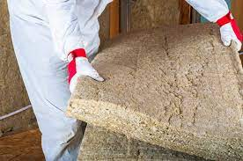
The kind of insulation used in a structure has a big influence on how well it reduces sound at various frequencies. The absorption and blocking of sound waves by insulation materials varies; some are more effective at specific frequencies than others. For instance, fibreglass insulation is frequently utilised for its ability to insulate against heat and has strong sound-absorbing qualities, especially when it comes to higher frequency sounds like music or conversation. Fibreglass, however, might not be as good at blocking out low-frequency noises, as those generated by loud machinery or traffic.
(Johnson, 2020)
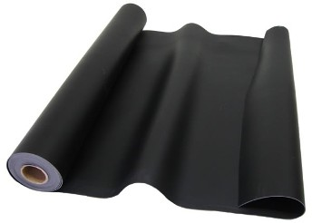
Due to their greater mass and density, other forms of insulation such as thick materials like mass-loaded vinyl or rockwool are more effective at preventing the transmission of low-frequency sound waves. These materials are especially helpful in areas where industrial facilities or busy roads are nearby, and low-frequency noise intrusion is a potential problem. Furthermore, building multi-layered walls with various insulation materials can offer a more complete method of sound insulation, successfully addressing both high-frequency and low-frequency sound transmission.
(Expert, 2017)
Moreover, maximising the efficiency of insulation over a variety of frequencies depends heavily on how it is manufactured and installed. Sound leakage may be avoided by properly sealing the building envelope's cracks and seams, and sound absorption and blocking properties of insulation can be improved by installing it with the right density and thickness. Resilient channels and buffering methods can also be used in wall assemblies to minimise vibration transmission and lower sound transmission through structural components.

Part 2

(a)

Thermal Transmittance and Thermal Resistance
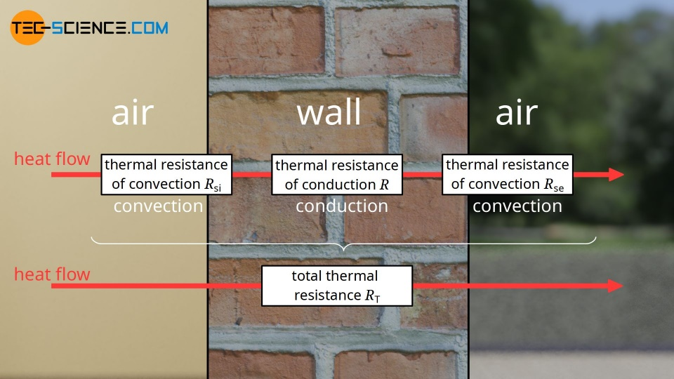
Thermal transmittance and thermal resistance are essential concepts especially when considering construction technology and energy efficiency. The rate of heat transfer through a material or assembly per unit area and per unit temperature differential across it is measured by thermal transmittance, also known as U-value. U-value essentially shows the ease with which heat moves through a building; larger values correspond to faster rates of heat transfer, while lower values correspond to better insulating qualities. The reciprocal of U-value, thermal resistance, or R-value indicates a material's capacity to withstand heat flow. R-values indicate more resistance and lower heat transfer rates. It shows how well a material or assembly obstructs the flow of heat.
(Thermal transmittance (U-value) - tec-science, 2020)
In practical terms, the thermal performance of building systems and components especially the building exterior is greatly influenced by thermal transmittance and resistance. The exterior components that provide a partition between the internal and outdoor spaces, such as floors, walls, roofs, windows, and doors, are included in the envelope of the structure. Architects and engineers may create building envelopes that efficiently control heat flow, maintain pleasant interior temperatures, and use less energy by comprehending and adjusting the thermal characteristics of materials and assemblies. Buildings that are both ecologically friendly and energy-efficient may be achieved by, choosing windows with low U-values and insulating materials with high thermal resistance to reduce heat absorption and loss in the summer.
Many parameters, including material composition, thickness, density, and installation processes, affect thermal transmittance and resistance. Foam board and fibreglass insulation are examples of low-thermal conductivity materials that are good insulators because they have lower thermal transmittance and better thermal resistance. Furthermore, in order to guarantee energy efficiency and occupant comfort, building codes and regulations frequently include minimum thermal performance criteria for building envelopes. To demonstrate a building's dedication to sustainability and energy saving, compliance with these requirements is necessary to get construction licences and certifications. All things considered, designing buildings that are not only pleasant, healthy, and ecologically conscious, but also energy-efficient requires an understanding of the optimisation of thermal transmittance and resistance.

Relationship between Thermal Transmittance and Thermal Resistance
Understanding the relationship between thermal transmittance and thermal resistance is essential to understanding the flow of heat through assemblies and building materials. The rate of heat transmission per unit area and per unit temperature difference across a material or assembly is measured by thermal transmittance. In simple terms, it shows the ease with which heat moves through a building. Higher U-values indicate faster rates of heat transfer and worse insulating qualities. On the other hand, thermal resistance, which is the opposite of the U-value and indicates a material's capacity to withstand heat flow, is represented by the R-value. Better insulation performance and increased resistance to heat flow are indicated by a higher R-value.
For the purpose of planning energy-efficient buildings and choosing the right insulation components and materials, it is important to understand this relationship. Architects and engineers may design buildings that efficiently regulate heat flow, maintain acceptable interior temperatures, and use less energy by adjusting the thermal characteristics of building components. Buildings that are both environmentally friendly and energy-efficient may be achieved by, installing windows with lower U-values and using insulation materials with stronger thermal resistance to reduce heat absorption and loss in the summer.

Implications for Calculating Heat Loss through Building Fabric
Calculating heat loss through building fabric is a critical aspect of designing energy-efficient buildings and ensuring occupant comfort. The implications of accurately assessing heat loss extend beyond energy conservation to encompass thermal comfort, indoor air quality, and overall building performance. Several key factors and considerations come into play when calculating heat loss through the building fabric, each with significant implications for design, construction, and operation.
Firstly, understanding the thermal properties of building materials is essential for accurate heat loss calculations. Different materials have varying thermal conductivities, densities, and specific heat capacities, all of which influence their ability to conduct, store, and resist heat. By selecting materials with high thermal resistance and low thermal transmittance, designers can minimize heat loss through the building envelope, resulting in energy-efficient structures that require less heating and cooling energy to maintain comfortable indoor temperatures.
Secondly, the geometry and construction of the building envelope significantly impact heat loss calculations. Factors such as wall thickness, insulation placement and air leakage paths all affect the overall thermal performance of the building fabric. For instance, increasing the thickness of insulation in walls or roofs can reduce conductive heat transfer through the envelope, while properly sealing air leaks and minimizing thermal bridging can prevent convective heat loss and improve overall thermal efficiency.
Moreover, the thermal boundary conditions surrounding the building fabric must be carefully considered when calculating heat loss. External factors such as outdoor temperature, solar radiation, wind speed, and humidity levels can influence heat transfer rates through the envelope. For instance, colder outdoor temperatures increase the temperature gradient across the building fabric, leading to higher rates of heat loss, while solar radiation can contribute to heat gain through windows and external walls. By incorporating these boundary conditions into heat loss calculations, designers can better predict and mitigate thermal discomfort and energy inefficiency.
Additionally, building occupancy and usage patterns play a crucial role in determining heat loss through the building fabric. Factors such as internal heat gains from occupants, lighting, appliances, and mechanical systems can offset or contribute to overall heat loss. For example, buildings with high internal heat gains may require less heating energy during the winter but may experience higher cooling loads in the summer. By accurately accounting for internal heat gains and losses, designers can optimize building energy performance and ensure occupant comfort year-round.
Furthermore, climate considerations are important when calculating heat loss through the building fabric. Different climate zones experience varying temperature extremes, humidity levels, and seasonal weather patterns, all of which affect building energy demand and thermal comfort requirements. For instance, buildings in colder climates may prioritize insulation and air sealing to minimize heat loss during the winter, while buildings in warmer climates may focus on shading and ventilation strategies to reduce cooling loads in the summer. By tailoring heat loss calculations to specific climate conditions, designers can optimize building envelope performance and energy efficiency.
Lastly, regulatory requirements, energy codes, and sustainability goals influence the approach to calculating heat loss through the building fabric. Many jurisdictions have established minimum thermal performance standards for new construction and renovations to reduce energy consumption and greenhouse gas emissions. Compliance with these standards is essential for obtaining building permits and certifications, which demonstrates a commitment to sustainability and environmental responsibility. By adhering to regulatory requirements and implementing best practices in building exterior design, construction, and operation, designers can create buildings that are not only energy-efficient but also comfortable, healthy, and environmentally sustainable.

(b)
Usually, a variety of experimental methods that entail heating a substance and measuring its temperature change over time are used to determine thermal conductivity. The steady-state heat flow technique is an effective method that involves measuring the rate of heat flow and creating a temperature gradient over a sample with defined dimensions.
According to Fourier's Law of Heat Conduction, the heat flow (Q) through a material is directly proportional to the temperature difference (ΔT) across it and inversely proportional to its thermal conductivity (k) and the cross-sectional area (A) through which the heat flows, as well as inversely proportional to the thickness (d) of the material, as expressed by the equation Q = k x A x (ΔT / d). (BYJU’s, 2016.)

Material Type
The ability of different materials to transmit heat varies. The material's fundamental quality is measured by its thermal conductivity coefficient (k). For example, materials like wood or plastic have lower thermal conductivity, but metals like copper or aluminium have high thermal conductivity, meaning they can transport heat fast. As a result, the rate at which heat moves through a material depends greatly on its type.

Distance
The rate of heat transmission can also be affected by the length of time that heat moves through a material. The material's thickness (d) in the formula Q = k x A x (ΔT / d) represents this. In comparison to a thinner material, a thicker one will resist heat flow more strongly. As a result, the material's ability to transmit heat is affected by the distance between its hot and cold surfaces. Reduced heat transmission over longer distances results in a lower thermal conductivity value. On the other hand, a shorter distance results in more heat transfer and a greater thermal conductivity rating.
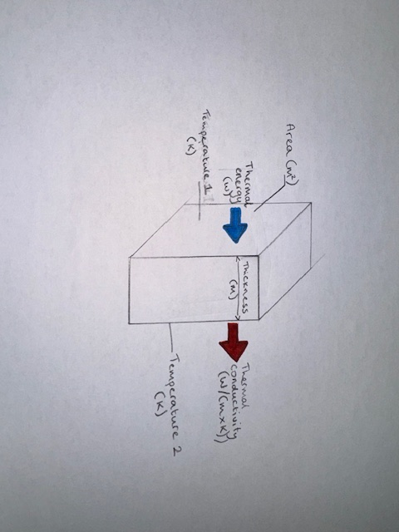
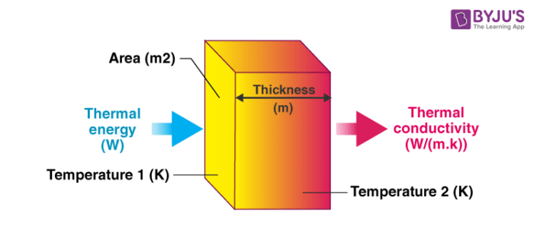
Available at: https://cdn1.byjus.com/wp-content/uploads/2016/06/Thermal-Conductivity-700x327.png.

‌

References
Acoustiblok UK. (n.d.). Soundproof Walls | Acoustic Wall Insulation | Acoustiblok. [online] Available at: https://www.acoustiblok.co.uk/acoustiblok-wall-applications [Accessed 28 Mar. 2024].
BYJU'S (2016). Thermal conductivity. [online] BYJUS. Available at: https://byjus.com/chemistry/thermal-conductivity
C-Therm Technologies Ltd. (n.d.). Understanding the Difference Between Thermal Resistance & Thermal Conductance. [online] Available at: https://ctherm.com/resources/helpful-links-tools/thermalresistanceandconductivity [Accessed 14 Mar. 2024].
Expert, A. (2017). MLV Barrier: When to Use Mass Loaded Vinyl. [online] Commercial Acoustics®. Available at: https://commercial-acoustics.com/mlv-barrier-use-mass-loaded-vinyl [Accessed 18 Mar. 2024].
First in Architecture (2019). Internal Environment - Thermal, Air, Sound and Light. [online] First In Architecture. Available at: https://www.firstinarchitecture.co.uk/internal-environment-thermal-air-sound-and-light
indiamart.com. (n.d.). Gypsum Board Partition Wall. [online] Available at: https://www.indiamart.com/proddetail/gypsum-board-partition-wall-2852864548812 [Accessed 28 Mar. 2024].
Johnson, T. (2020). Three Reasons You Should Consider Rockwool Insulation. [online] Attic & Crawl Space Insulation, Cleaning and More! | Attic Projects. Available at: https://www.atticprojectscompany.com/three-reasons-you-should-consider-rockwool-insulation [Accessed 28 Mar. 2024].
Lymath, A. (2015). What is a U-value? Heat loss, thermal mass and online calculators explained. [online] NBS. Available at: https://www.thenbs.com/knowledge/what-is-a-u-value-heat-loss-thermal-mass-and-online-calculators-explained

tec-science (2020). Difference between thermal conductivity, diffusivity, transmittance, resistance and heat transfer coefficient. [online] tec-science. Available at: https://www.tec-science.com/thermodynamics/heat/difference-between-thermal-conductivity-diffusivity-transmittance-resistance-and-heat-transfer-coefficient [Accessed 28 Mar. 2024].
Thermal transmittance (U-value) - tec-science. (2020). tec-science. [online] 23 Jan. Available at: https://www.tec-science.com/thermodynamics/heat/thermal-transmittance-u-value
www.steelconstruction.info. (n.d.). Acoustic performance of walls. [online] Available at: https://www.steelconstruction.info/Acoustic_performance_of_walls.

‌

‌

‌

‌

‌

‌

‌

‌
‌

‌

‌

‌

‌

